SEC Form 5
FORM 5 |  | UNITED STATES SECURITIES AND EXCHANGE COMMISSION  Washington, D.C. 20549  ANNUAL STATEMENT OF CHANGES IN BENEFICIAL OWNERSHIP  Filed pursuant to Section 16(a) of the Securities Exchange Act of 1934  or Section 30(h) of the Investment Company Act of 1940
  OMB APPROVAL
  OMB Number: | 3235-0362
  Estimated average burden
  hours per response: | 1.0
 | Check this box if no longer subject to Section 16. Form 4 or Form 5 obligations may continue. See Instruction 1(b).
 | Form 3 Holdings Reported.
 | Form 4 Transactions Reported.
 | Check this box to indicate that a transaction was made pursuant to a contract, instruction or written plan for the purchase or sale of equity securities of the issuer that is intended to satisfy the affirmative defense conditions of Rule 10b5-1(c). See Instruction 10
1. Name and Address of Reporting Person*  (Street) | 2. Issuer Name and Ticker or Trading Symbol  Array Technologies, Inc. [ ARRY ] | 5. Relationship of Reporting Person(s) to Issuer  (Check all applicable)
  Hostetler Kevin G.
  (Last) | (First) | (Middle)
  3901 MIDWAY PLACE NE
  ALBUQUERQUE | NM | 87109
  (City) | (State) | (Zip)
   | Director |  | 10% Owner
   | Officer (give title below) |  | Other (specify below)
  Chief Executive Officer
3. Statement for Issuer's Fiscal Year Ended (Month/Day/Year)
12/31/2025
 | 4. If Amendment, Date of Original Filed (Month/Day/Year) | 6. Individual or Joint/Group Filing (Check Applicable Line)
  Form filed by One Reporting Person
  Form filed by More than One Reporting Person
Table I - Non-Derivative Securities Acquired, Disposed of, or Beneficially Owned
1. Title of Security (Instr. 3) | 2. Transaction Date (Month/Day/Year) | 2A. Deemed Execution Date, if any (Month/Day/Year) | 3. Transaction Code (Instr. 8) | 4. Securities Acquired (A) or Disposed Of (D) (Instr. 3, 4 and 5) |  |  | 5. Amount of Securities Beneficially Owned at end of Issuer's Fiscal Year (Instr. 3 and 4) | 6. Ownership Form: Direct (D) or Indirect (I) (Instr. 4) | 7. Nature of Indirect Beneficial Ownership (Instr. 4)
 |  |  |  | Amount | (A) or (D) | Price |  | 6. Ownership Form: Direct (D) or Indirect (I) (Instr. 4) | 7. Nature of Indirect Beneficial Ownership (Instr. 4)
Common Stock, par value $0.001 per share | 06/30/2025 |  | A(1) | 2,500 | A | $5.02 | 188,919 | D
Common Stock, par value $0.001 per share | 12/31/2025 |  | A(2) | 1,227 | A | $5.64 | 190,146 | D
Table II - Derivative Securities Acquired, Disposed of, or Beneficially Owned
(e.g., puts, calls, warrants, options, convertible securities)
1. Title of Derivative Security (Instr. 3) | 2. Conversion or Exercise Price of Derivative Security | 3. Transaction Date (Month/Day/Year) | 3A. Deemed Execution Date, if any (Month/Day/Year) | 4. Transaction Code (Instr. 8) | 5. Number of Derivative Securities Acquired (A) or Disposed of (D) (Instr. 3, 4 and 5) |  | 6. Date Exercisable and Expiration Date (Month/Day/Year) |  | 7. Title and Amount of Securities Underlying Derivative Security (Instr. 3 and 4) |  | 8. Price of Derivative Security (Instr. 5) | 9. Number of derivative Securities Beneficially Owned Following Reported Transaction(s) (Instr. 4) | 10. Ownership Form: Direct (D) or Indirect (I) (Instr. 4) | 11. Nature of Indirect Beneficial Ownership (Instr. 4)
 |  |  |  |  | (A) | (D) | Date Exercisable | Expiration Date | Title | Amount or Number of Shares
Explanation of Responses:
1. The reporting person is voluntarily reporting the acquisition of the Issuer's common stock pursuant to the Array Technologies, Inc. 2021 Employee Stock Purchase Program ("ESPP") for the ESPP purchase period of January 1, 2025 through June 30, 2025. This transaction is exempt from Rule 16b-3.
2. The reporting person is voluntarily reporting the acquisition of the Issuer's common stock pursuant to the Array Technologies, Inc. ESPP for the ESPP purchase period of July 1, 2025 through December 31, 2025. This transaction is exempt from Rule 16b-3.
Remarks:
Exhibit 24 - Power of Attorney
 | /s/ Ashton Wiebe as Attorney-in-Fact | 02/13/2026
 | ** Signature of Reporting Person | Date
Reminder: Report on a separate line for each class of securities beneficially owned directly or indirectly.
* If the form is filed by more than one reporting person, see Instruction 4 (b)(v).
** Intentional misstatements or omissions of facts constitute Federal Criminal Violations See 18 U.S.C. 1001 and 15 U.S.C. 78ff(a).
Note: File three copies of this Form, one of which must be manually signed. If space is insufficient, see Instruction 6 for procedure.
Persons who respond to the collection of information contained in this form are not required to respond unless the form displays a currently valid OMB Number.
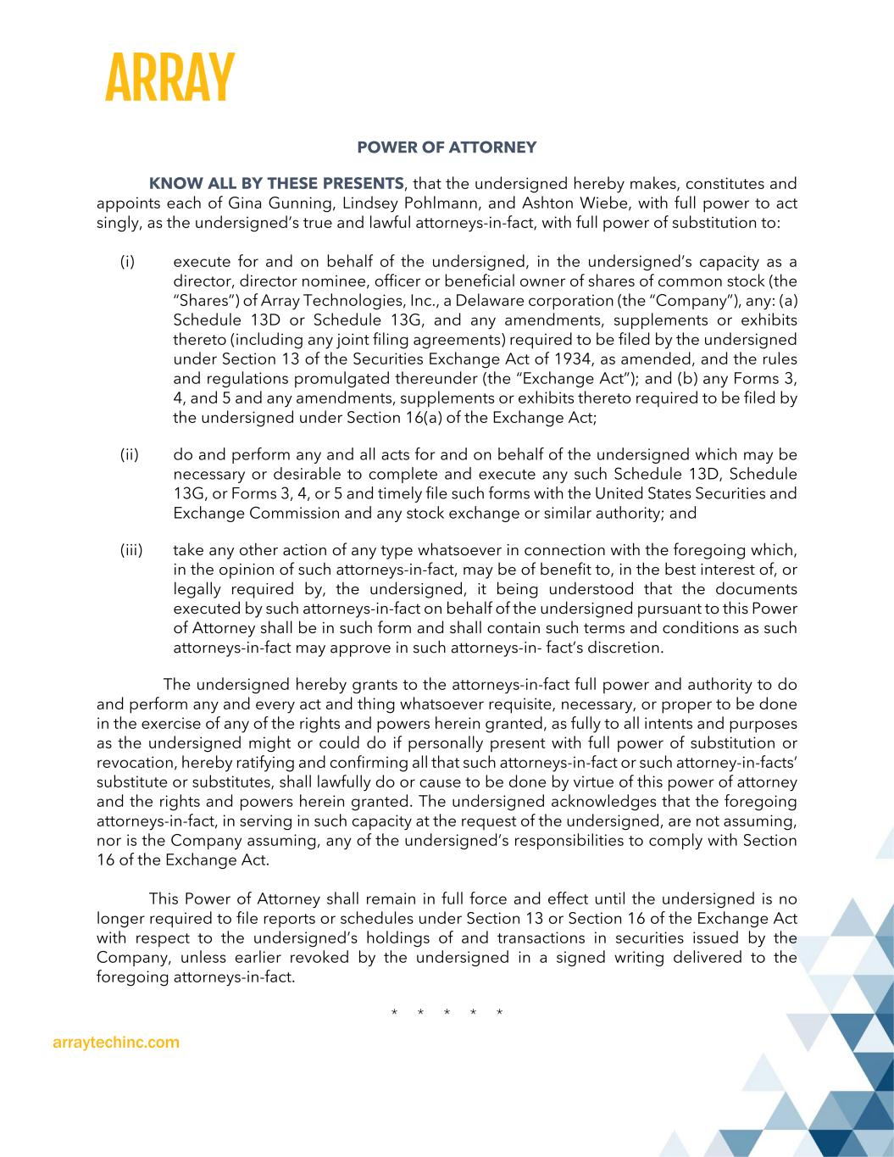
arraytechinc.com POWER OF ATTORNEY KNOW ALL BY THESE PRESENTS, that the undersigned hereby makes, constitutes and appoints each of Gina Gunning, Lindsey Pohlmann, and Ashton Wiebe, with full power to act singly, as the undersigned’s true and lawful attorneys-in-fact, with full power of substitution to: (i) execute for and on behalf of the undersigned, in the undersigned’s capacity as a director, director nominee, officer or beneficial owner of shares of common stock (the “Shares”) of Array Technologies, Inc., a Delaware corporation (the “Company”), any: (a) Schedule 13D or Schedule 13G, and any amendments, supplements or exhibits thereto (including any joint filing agreements) required to be filed by the undersigned under Section 13 of the Securities Exchange Act of 1934, as amended, and the rules and regulations promulgated thereunder (the “Exchange Act”); and (b) any Forms 3, 4, and 5 and any amendments, supplements or exhibits thereto required to be filed by the undersigned under Section 16(a) of the Exchange Act; (ii) do and perform any and all acts for and on behalf of the undersigned which may be necessary or desirable to complete and execute any such Schedule 13D, Schedule 13G, or Forms 3, 4, or 5 and timely file such forms with the United States Securities and Exchange Commission and any stock exchange or similar authority; and (iii) take any other action of any type whatsoever in connection with the foregoing which, in the opinion of such attorneys-in-fact, may be of benefit to, in the best interest of, or legally required by, the undersigned, it being understood that the documents executed by such attorneys-in-fact on behalf of the undersigned pursuant to this Power of Attorney shall be in such form and shall contain such terms and conditions as such attorneys-in-fact may approve in such attorneys-in- fact’s discretion. The undersigned hereby grants to the attorneys-in-fact full power and authority to do and perform any and every act and thing whatsoever requisite, necessary, or proper to be done in the exercise of any of the rights and powers herein granted, as fully to all intents and purposes as the undersigned might or could do if personally present with full power of substitution or revocation, hereby ratifying and confirming all that such attorneys-in-fact or such attorney-in-facts’ substitute or substitutes, shall lawfully do or cause to be done by virtue of this power of attorney and the rights and powers herein granted. The undersigned acknowledges that the foregoing attorneys-in-fact, in serving in such capacity at the request of the undersigned, are not assuming, nor is the Company assuming, any of the undersigned’s responsibilities to comply with Section 16 of the Exchange Act. This Power of Attorney shall remain in full force and effect until the undersigned is no longer required to file reports or schedules under Section 13 or Section 16 of the Exchange Act with respect to the undersigned’s holdings of and transactions in securities issued by the Company, unless earlier revoked by the undersigned in a signed writing delivered to the foregoing attorneys-in-fact. * * * * *

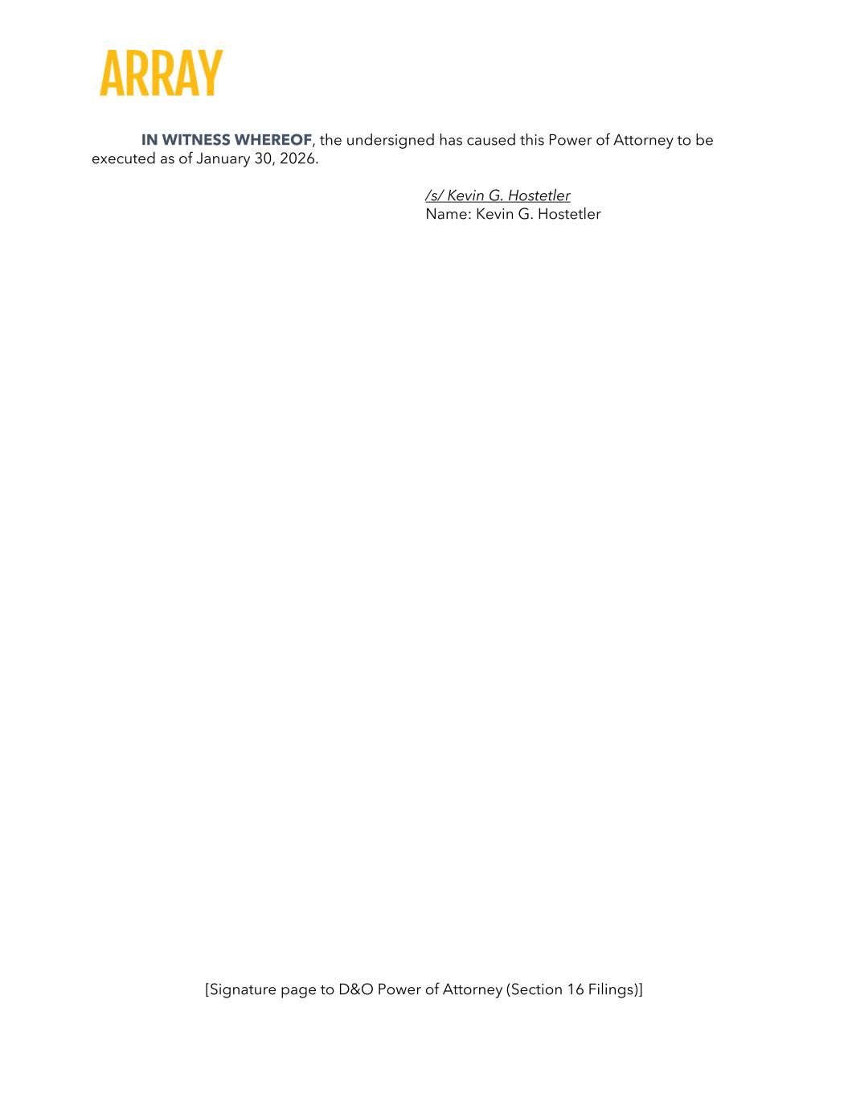
[Signature page to D&O Power of Attorney (Section 16 Filings)] IN WITNESS WHEREOF, the undersigned has caused this Power of Attorney to be executed as of January 30, 2026. /s/ Kevin G. Hostetler Name: Kevin G. Hostetler

