UNITED STATES
SECURITIES AND EXCHANGE COMMISSION
WASHINGTON, D.C. 20549

FORM 8-K

CURRENT REPORT
Pursuant to Section 13 or 15(d)
of the Securities Exchange Act of 1934
Date of report (Date of earliest event reported): August 20, 2026
ARRAY TECHNOLOGIES, INC.
(Exact Name of Registrant as Specified in its Charter)

Delaware |  |  |  |  |  | 001-39613 |  |  |  |  |  | 83-2747826
(State or Other Jurisdiction  of Incorporation) |  |  |  |  |  | (Commission  File Number) |  |  |  |  |  | (IRS Employer  Identification No.)
3901 Midway Place NE
Albuquerque, New Mexico 87109
(Address of Principal Executive Offices) (Zip Code)
Registrant’s telephone number, including area code: (505) 881-7567
Check the appropriate box below if the Form 8-K filing is intended to simultaneously satisfy the filing obligation of the registrant under any of the following provisions:
☐ |  |  |  |  |  | Written communications pursuant to Rule 425 under the Securities Act (17 CFR 230.425)
☐ |  |  |  |  |  | Soliciting material pursuant to Rule 14a-12 under the Exchange Act (17 CFR 240.14a-12)
☐ |  |  |  |  |  | Pre-commencement communications pursuant to Rule 14d-2(b) under the Exchange Act (17 CFR 240.14d-2(b))
☐ |  |  |  |  |  | Pre-commencement communications pursuant to Rule 13e-4(c) under the Exchange Act (17 CFR 240.13e-4(c))
Securities registered pursuant to Section 12(b) of the Act:
Title of each class |  |  |  |  |  | Trading  Symbol(s) |  |  |  |  |  | Name of each exchange  on which registered
Common Stock, $0.001 Par Value |  |  |  |  |  | ARRY |  |  |  |  |  | Nasdaq Global Market
Indicate by check mark whether the registrant is an emerging growth company as defined in Rule 405 of the Securities Act of 1933 (§230.405 of this chapter) or Rule 12b-2 of the Securities Exchange Act of 1934 (§240.12b-2 of this chapter).
Emerging growth company ☐
If an emerging growth company, indicate by check mark if the registrant has elected not to use the extended transition period for complying with any new or revised financial accounting standards provided pursuant to Section 13(a) of the Exchange Act. ☐

Item 7.01 Regulation FD Disclosure.
Array Technologies, Inc. (the “Company”) hosted its previously announced Investor Technology Showcase webcast on August 20, 2026. A press release and investor presentation relating to the Investor Technology Showcase are attached hereto as Exhibits 99.1 and 99.2, respectively, and are incorporated by reference herein.
The information included in Item 7.01 of this Current Report on Form 8-K and Exhibits 99.1 and 99.2 attached hereto are being furnished and shall not be deemed “filed” for purposes of Section 18 of the Securities Exchange Act of 1934, as amended (the “Exchange Act”), or otherwise subject to the liabilities of that section, nor shall it be deemed incorporated by reference into any other filing under the Securities Act of 1933, as amended, or the Exchange Act, regardless of any general incorporation language in any such filing.

Item 9.01 Financial Statements and Exhibits.
(d) Exhibits.

The following exhibits are being furnished with this Current Report on Form 8-K:

Exhibit No. |  |  |  |  |  | Description
99.1 |  |  |  |  |  | Press Release of Array Technologies, Inc., dated August 20, 2026.
99.2 |  |  |  |  |  | Investor Presentation of Array Technologies, Inc., dated August 20, 2026.
104 |  |  |  |  |  | Cover Page Interactive Data File (embedded within the Inline XBRL document).

SIGNATURE
Pursuant to the requirements of the Securities Exchange Act of 1934, the registrant has duly caused this report to be signed on its behalf by the undersigned hereunto duly authorized.

 |  |  |  |  |  | Array Technologies, Inc.
Date: August 20, 2026 |  |  |  |  |  | By: |  |  |  |  |  | /s/ Gina K. Gunning
 |  |  |  |  |  |  |  |  |  |  |  | Name: Gina K. Gunning
 |  |  |  |  |  |  |  |  |  |  |  | Title: Chief Legal Officer and Corporate Secretary

ARRAY Technologies to Detail Balance-of-System Strategy and APA Long-Term Growth Opportunities at the APA Investor Technology Showcase Today

ARRAY to highlight strategy to expand beyond trackers through technically integrated, interoperable energy infrastructure solutions

ALBUQUERQUE, N.M., August 20, 2026 (GLOBE NEWSWIRE) -- ARRAY Technologies (NASDAQ: ARRY) (“ARRAY” or the “Company”), a leading global provider of solar tracking technology and fixed-tilt products, foundation solutions, software systems and services, will host its previously announced APA Investor Technology Showcase today, Thursday, August 20, 2026, beginning at 9:00 a.m. ET.

During the event, CEO Kevin Hostetler and ARRAY’s leadership team, including senior members of APA Solar’s (APA) leadership team will detail the Company’s strategy to evolve from a pure-play tracker company into a more technically integrated energy infrastructure platform. Management will also discuss APA’s progress approximately one year following its acquisition, including its long-term financial profile and growth opportunities.

Key themes of the APA Investor Technology Showcase will include:
•Building a more integrated balance-of-system platform: Expanding across foundations, trackers, wire management, controls, software and AI, with technical interoperability and integrated engineering at the center of ARRAY’s strategy.
•Delivering on the APA investment thesis: Highlighting APA’s progress approximately one year post-acquisition, including integration, commercial momentum, realized synergies and opportunities for continued profitable growth.
•Expanding addressable market and share of wallet: Extending into critical layers of utility-scale solar infrastructure through APA and following the expected close of the Company’s pending acquisition of Affordable Wire Management (AWM)(1), creating opportunities to earn a greater project share.
•Responding to complex customer needs through differentiated innovation: Advancing technically integrated solutions that simplify installation, reduce project risk and improve total cost of ownership, anchored by five major product launches in 2026.
•Executing a disciplined capital allocation strategy: Balancing continued investment in organic growth, while strengthening its capital structure and pursuing disciplined strategic M&A.

“ARRAY is evolving beyond trackers into a technically integrated energy infrastructure platform, building on the engineering, innovation and customer partnerships that have long differentiated our business,” said Kevin Hostetler, Chief Executive Officer of ARRAY Technologies. “By bringing together complementary technologies that are engineered to work together, we believe we can deliver greater value to our customers, increase our project share and create additional opportunities for profitable growth. APA is tangible evidence of that strategy in action, and our pending acquisition of AWM represents another important step in expanding our platform. We see significant opportunity to continue building on this model over time.”

Registration for the live webcast is available through the Investor Relations section of the Company's website at investors.arraytechinc.com. The webcast will begin at 9:00 a.m. ET, and an archived replay of the event will be available following its conclusion.

(1) The transaction is expected to close in the third quarter of 2026, subject to receiving any required regulatory approvals and the satisfaction of other customary closing conditions

About ARRAY Technologies
ARRAY Technologies (NASDAQ: ARRY) is a leading global provider of solar tracking technology and fixed-tilt systems to utility-scale and distributed generation customers, who construct, develop, and operate solar PV sites. With solutions engineered to withstand the harshest weather conditions, ARRAY’s high-quality solar trackers, fixed-tilt systems, software platforms, foundation solutions, and field services combine to optimize energy production and deliver value to our customers for the entire lifecycle of a project. Founded and headquartered in the United States, ARRAY is rooted in manufacturing and driven by technology - relying on its domestic manufacturing, diversified global supply chain, and customer-centric approach to design, deliver, commission, train, and support solar energy deployment around the world. For more news and information on ARRAY, please visit arraytechinc.com.

Investor Relations Contact:
Investor Relations
505-437-0010
investors@arraytechinc.com

Media Contact:
Steven Kirsch
505-738-6923
steven.kirsch@arraytechinc.com

Forward Looking Statements
This press release contains forward-looking statements that are based on our management’s beliefs and assumptions and on information currently available to our management. Forward-looking statements include information concerning our possible or assumed future results of operations, business strategies, technology or product developments, financing and investment plans, dividend policy, competitive position, industry and regulatory environment, including potential regulatory reform related to energy credits, uncertainty relating to the implementation of tariffs and changes in trade policy, including the reduction or elimination of certain government incentives, ability to provide 100% domestic content trackers, expectations regarding the macroeconomic environment and geopolitical developments, including the effects of tariffs and changes in trade policy, potential growth opportunities and the effects of competition. Forward-looking statements include statements that are not historical facts and can be identified by terms such as “anticipate,” “believe,” “could,” “estimate,” “expect,” “intend,” “may,” “plan,” “potential,” “predict,” “project,” “seek,” “should,” “will,” “would,” “positioned,” “designed to” or similar expressions and the negatives of those terms.
Our actual results and the timing of events could materially differ from those anticipated in such forward-looking statements as a result of certain risks, uncertainties and other factors, including without limitation: changes in growth or the rate of growth in demand for solar energy projects; factors outside of our control affecting the variability and demand for solar

energy, including but not limited to, the retail price of electricity, availability of in-demand components like high-voltage breakers, various policies related to the permitting and interconnection costs of solar plants, and the availability of incentives for solar energy and solar energy production systems, which makes it difficult to predict our future prospects; competitive pressures within our industry; competition from conventional and renewable energy sources; a loss of one or more of our significant customers, their inability to perform under their contracts, or their default in payment; a drop in the price of electricity derived from the utility grid or from alternative energy sources; fluctuations in our results of operations across fiscal periods, which could make our future performance difficult to predict and could cause our results of operations for a particular period to fall below expectations; any increase in interest rates, or a reduction in the availability of tax equity or project debt capital in the global financial markets, which could make it difficult for customers to finance the cost of a solar energy system and reduce the demand for our products; existing electric utility industry policies and regulations, and any subsequent changes or new related policies and regulations, including as a result of the One Big Beautiful Bill Act, which may present technical, regulatory and economic barriers to the purchase and use of solar energy systems and may significantly reduce demand for our products or harm our ability to compete; the interruption of the flow of materials from international vendors, which could disrupt our supply chain, including as a result of the imposition of new and/or additional duties, tariffs and other charges or restrictions on imports and exports; changes in the global trade environment, including the continuation or imposition of import tariffs or other import restrictions; geopolitical, macroeconomic and other market conditions unrelated to our operating performance including but not limited to a pandemic, the Russia-Ukraine war, attacks on shipping in the Red Sea and Strait of Hormuz, conflict in the Middle East (including, but not limited to, the war in Iran), changing trade policies, inflation and interest rates; our ability to convert our orders in backlog into revenue; the reduction, elimination or expiration, or our failure to optimize the benefits of government incentives for, or regulations mandating the use of, renewable energy and solar energy, particularly in relation to our competitors, which could reduce demand for solar energy systems; failure to, or incurrence of significant costs in order to, obtain, maintain, protect, defend or enforce, our intellectual property and other proprietary rights; delays in construction projects and any failure to manage our inventory; significant changes in the cost of raw materials; disruptions to transportation and logistics, including increases in shipping costs; defects or performance problems in our products, which could result in loss of customers, reputational damage and decreased revenue; delays, disruptions or quality control problems in our product development operations; the development, deployment and commercialization of new products, including DuraTrack D2STM, OmniTrack 2.0, the 60 degree variant of DuraTrack, and our ARRAY AtlasTM suite of foundation-to-tracker solutions; our ability to retain our key personnel or failure to attract additional qualified personnel; additional business, financial, regulatory and competitive risks due to our continued planned expansion into new markets; cybersecurity or other data incidents, including unauthorized disclosure of personal or sensitive data or theft of confidential information and the use of artificial intelligence by cyber threat actors; a failure to maintain an effective system of integrated internal controls over financial reporting, which may impair our ability to report our financial results accurately; our substantial indebtedness, risks related to actual or threatened public health epidemics, pandemics, outbreaks or crises; changes to laws and regulations, including changes to tax laws and regulations, that are applied adversely to us or our customers; our ability to complete the acquisition of Affordable Wire Management, LLC (“AWM”) on the anticipated terms and timetable, including the possibility that closing conditions may not be satisfied or waived; our ability to successfully integrate APA Solar, LLC

(“APA”) and AWM into our existing operations, realize the anticipated benefits or synergies of the acquisitions of APA and AWM and achieve strategic and other objectives relating to the acquisitions; risks related to any unforeseen liabilities of AWM; and other factors listed and described in more detail in the section captioned “Risk Factors” in our Annual Report on Form 10-K, our Quarterly Reports on Form 10-Q, and our other documents on file with the U.S. Securities and Exchange Commission.
Given these uncertainties, you should not place undue reliance on forward-looking statements. Also, forward-looking statements represent our management’s beliefs and assumptions only as of the date of this presentation. You should read this presentation with the understanding that our actual future results may be materially different from what we expect. Except as required by law, we assume no obligation to update these forward-looking statements, or to update the reasons actual results could differ materially from those anticipated in these forward-looking statements, even if new information becomes available in the future.
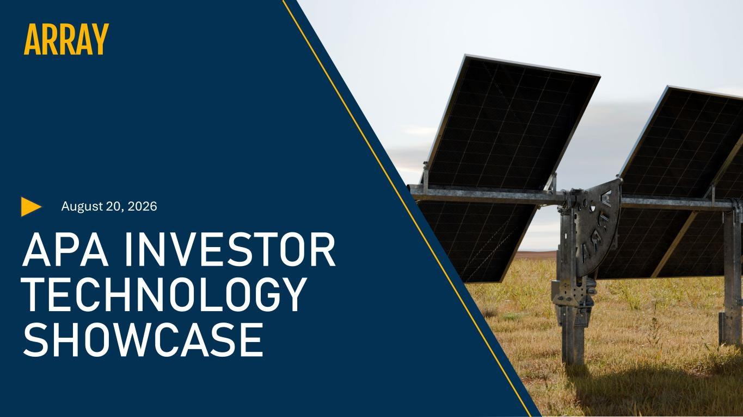

August 20, 2026 APA INVESTOR TECHNOLOGY SHOWCASE

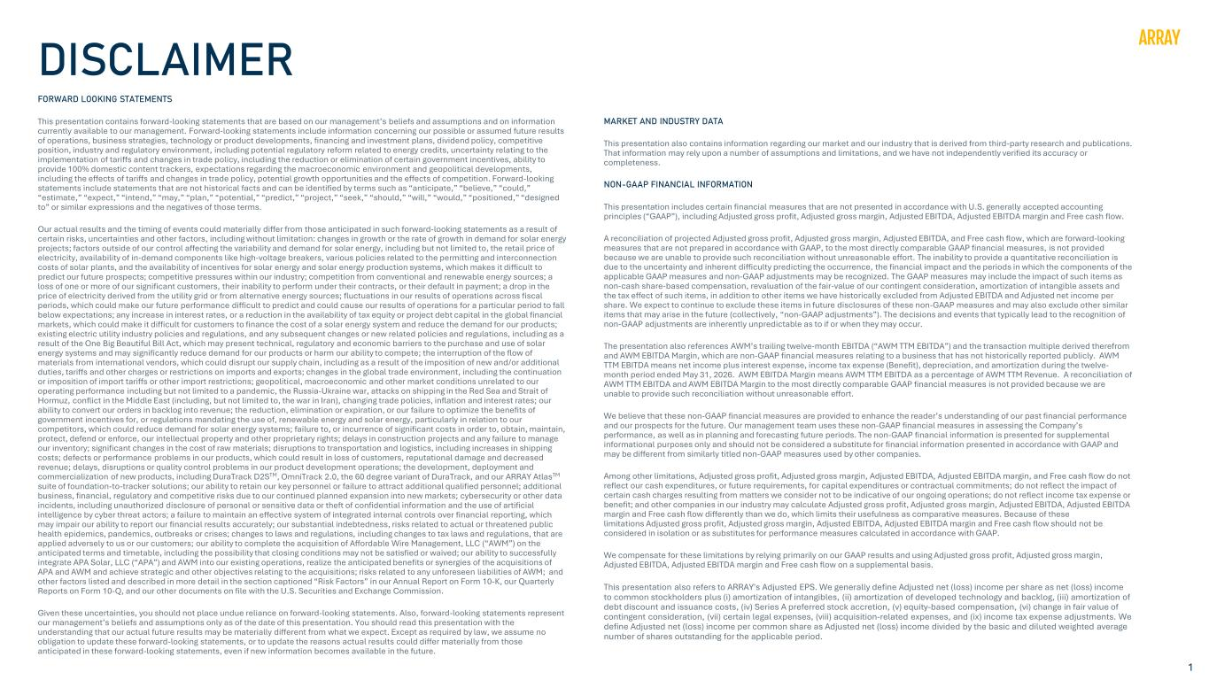
1 DISCLAIMER FORWARD LOOKING STATEMENTS This presentation contains forward-looking statements that are based on our management’s beliefs and assumptions and on information currently available to our management. Forward-looking statements include information concerning our possible or assumed future results of operations, business strategies, technology or product developments, financing and investment plans, dividend policy, competitive position, industry and regulatory environment, including potential regulatory reform related to energy credits, uncertainty relating to the implementation of tariffs and changes in trade policy, including the reduction or elimination of certain government incentives, ability to provide 100% domestic content trackers, expectations regarding the macroeconomic environment and geopolitical developments, including the effects of tariffs and changes in trade policy, potential growth opportunities and the effects of competition. Forward-looking statements include statements that are not historical facts and can be identified by terms such as “anticipate,” “believe,” “could,” “estimate,” “expect,” “intend,” “may,” “plan,” “potential,” “predict,” “project,” “seek,” “should,” “will,” “would,” “positioned,” “designed to” or similar expressions and the negatives of those terms. Our actual results and the timing of events could materially differ from those anticipated in such forward-looking statements as a result of certain risks, uncertainties and other factors, including without limitation: changes in growth or the rate of growth in demand for solar energy projects; factors outside of our control affecting the variability and demand for solar energy, including but not limited to, the retail price of electricity, availability of in-demand components like high-voltage breakers, various policies related to the permitting and interconnection costs of solar plants, and the availability of incentives for solar energy and solar energy production systems, which makes it difficult to predict our future prospects; competitive pressures within our industry; competition from conventional and renewable energy sources; a loss of one or more of our significant customers, their inability to perform under their contracts, or their default in payment; a drop in the price of electricity derived from the utility grid or from alternative energy sources; fluctuations in our results of operations across fiscal periods, which could make our future performance difficult to predict and could cause our results of operations for a particular period to fall below expectations; any increase in interest rates, or a reduction in the availability of tax equity or project debt capital in the global financial markets, which could make it difficult for customers to finance the cost of a solar energy system and reduce the demand for our products; existing electric utility industry policies and regulations, and any subsequent changes or new related policies and regulations, including as a result of the One Big Beautiful Bill Act, which may present technical, regulatory and economic barriers to the purchase and use of solar energy systems and may significantly reduce demand for our products or harm our ability to compete; the interruption of the flow of materials from international vendors, which could disrupt our supply chain, including as a result of the imposition of new and/or additional duties, tariffs and other charges or restrictions on imports and exports; changes in the global trade environment, including the continuation or imposition of import tariffs or other import restrictions; geopolitical, macroeconomic and other market conditions unrelated to our operating performance including but not limited to a pandemic, the Russia-Ukraine war, attacks on shipping in the Red Sea and Strait of Hormuz, conflict in the Middle East (including, but not limited to, the war in Iran), changing trade policies, inflation and interest rates; our ability to convert our orders in backlog into revenue; the reduction, elimination or expiration, or our failure to optimize the benefits of government incentives for, or regulations mandating the use of, renewable energy and solar energy, particularly in relation to our competitors, which could reduce demand for solar energy systems; failure to, or incurrence of significant costs in order to, obtain, maintain, protect, defend or enforce, our intellectual property and other proprietary rights; delays in construction projects and any failure to manage our inventory; significant changes in the cost of raw materials; disruptions to transportation and logistics, including increases in shipping costs; defects or performance problems in our products, which could result in loss of customers, reputational damage and decreased revenue; delays, disruptions or quality control problems in our product development operations; the development, deployment and commercialization of new products, including DuraTrack D2STM, OmniTrack 2.0, the 60 degree variant of DuraTrack, and our ARRAY AtlasTM suite of foundation-to-tracker solutions; our ability to retain our key personnel or failure to attract additional qualified personnel; additional business, financial, regulatory and competitive risks due to our continued planned expansion into new markets; cybersecurity or other data incidents, including unauthorized disclosure of personal or sensitive data or theft of confidential information and the use of artificial intelligence by cyber threat actors; a failure to maintain an effective system of integrated internal controls over financial reporting, which may impair our ability to report our financial results accurately; our substantial indebtedness, risks related to actual or threatened public health epidemics, pandemics, outbreaks or crises; changes to laws and regulations, including changes to tax laws and regulations, that are applied adversely to us or our customers; our ability to complete the acquisition of Affordable Wire Management, LLC (“AWM”) on the anticipated terms and timetable, including the possibility that closing conditions may not be satisfied or waived; our ability to successfully integrate APA Solar, LLC (“APA”) and AWM into our existing operations, realize the anticipated benefits or synergies of the acquisitions of APA and AWM and achieve strategic and other objectives relating to the acquisitions; risks related to any unforeseen liabilities of AWM; and other factors listed and described in more detail in the section captioned “Risk Factors” in our Annual Report on Form 10-K, our Quarterly Reports on Form 10-Q, and our other documents on file with the U.S. Securities and Exchange Commission. Given these uncertainties, you should not place undue reliance on forward-looking statements. Also, forward-looking statements represent our management’s beliefs and assumptions only as of the date of this presentation. You should read this presentation with the understanding that our actual future results may be materially different from what we expect. Except as required by law, we assume no obligation to update these forward-looking statements, or to update the reasons actual results could differ materially from those anticipated in these forward-looking statements, even if new information becomes available in the future. MARKET AND INDUSTRY DATA This presentation also contains information regarding our market and our industry that is derived from third-party research and publications. That information may rely upon a number of assumptions and limitations, and we have not independently verified its accuracy or completeness. NON-GAAP FINANCIAL INFORMATION This presentation includes certain financial measures that are not presented in accordance with U.S. generally accepted accounting principles (“GAAP”), including Adjusted gross profit, Adjusted gross margin, Adjusted EBITDA, Adjusted EBITDA margin and Free cash flow. A reconciliation of projected Adjusted gross profit, Adjusted gross margin, Adjusted EBITDA, and Free cash flow, which are forward-looking measures that are not prepared in accordance with GAAP, to the most directly comparable GAAP financial measures, is not provided because we are unable to provide such reconciliation without unreasonable effort. The inability to provide a quantitative reconciliation is due to the uncertainty and inherent difficulty predicting the occurrence, the financial impact and the periods in which the components of the applicable GAAP measures and non-GAAP adjustments may be recognized. The GAAP measures may include the impact of such items as non-cash share-based compensation, revaluation of the fair-value of our contingent consideration, amortization of intangible assets and the tax effect of such items, in addition to other items we have historically excluded from Adjusted EBITDA and Adjusted net income per share. We expect to continue to exclude these items in future disclosures of these non-GAAP measures and may also exclude other similar items that may arise in the future (collectively, “non-GAAP adjustments”). The decisions and events that typically lead to the recognition of non-GAAP adjustments are inherently unpredictable as to if or when they may occur. The presentation also references AWM’s trailing twelve-month EBITDA (“AWM TTM EBITDA”) and the transaction multiple derived therefrom and AWM EBITDA Margin, which are non-GAAP financial measures relating to a business that has not historically reported publicly. AWM TTM EBITDA means net income plus interest expense, income tax expense (Benefit), depreciation, and amortization during the twelve- month period ended May 31, 2026. AWM EBITDA Margin means AWM TTM EBITDA as a percentage of AWM TTM Revenue. A reconciliation of AWM TTM EBITDA and AWM EBITDA Margin to the most directly comparable GAAP financial measures is not provided because we are unable to provide such reconciliation without unreasonable effort. We believe that these non-GAAP financial measures are provided to enhance the reader’s understanding of our past financial performance and our prospects for the future. Our management team uses these non-GAAP financial measures in assessing the Company’s performance, as well as in planning and forecasting future periods. The non-GAAP financial information is presented for supplemental informational purposes only and should not be considered a substitute for financial information presented in accordance with GAAP and may be different from similarly titled non-GAAP measures used by other companies. Among other limitations, Adjusted gross profit, Adjusted gross margin, Adjusted EBITDA, Adjusted EBITDA margin, and Free cash flow do not reflect our cash expenditures, or future requirements, for capital expenditures or contractual commitments; do not reflect the impact of certain cash charges resulting from matters we consider not to be indicative of our ongoing operations; do not reflect income tax expense or benefit; and other companies in our industry may calculate Adjusted gross profit, Adjusted gross margin, Adjusted EBITDA, Adjusted EBITDA margin and Free cash flow differently than we do, which limits their usefulness as comparative measures. Because of these limitations Adjusted gross profit, Adjusted gross margin, Adjusted EBITDA, Adjusted EBITDA margin and Free cash flow should not be considered in isolation or as substitutes for performance measures calculated in accordance with GAAP. We compensate for these limitations by relying primarily on our GAAP results and using Adjusted gross profit, Adjusted gross margin, Adjusted EBITDA, Adjusted EBITDA margin and Free cash flow on a supplemental basis. This presentation also refers to ARRAY's Adjusted EPS. We generally define Adjusted net (loss) income per share as net (loss) income to common stockholders plus (i) amortization of intangibles, (ii) amortization of developed technology and backlog, (iii) amortization of debt discount and issuance costs, (iv) Series A preferred stock accretion, (v) equity-based compensation, (vi) change in fair value of contingent consideration, (vii) certain legal expenses, (viii) acquisition-related expenses, and (ix) income tax expense adjustments. We define Adjusted net (loss) income per common share as Adjusted net (loss) income divided by the basic and diluted weighted average number of shares outstanding for the applicable period.

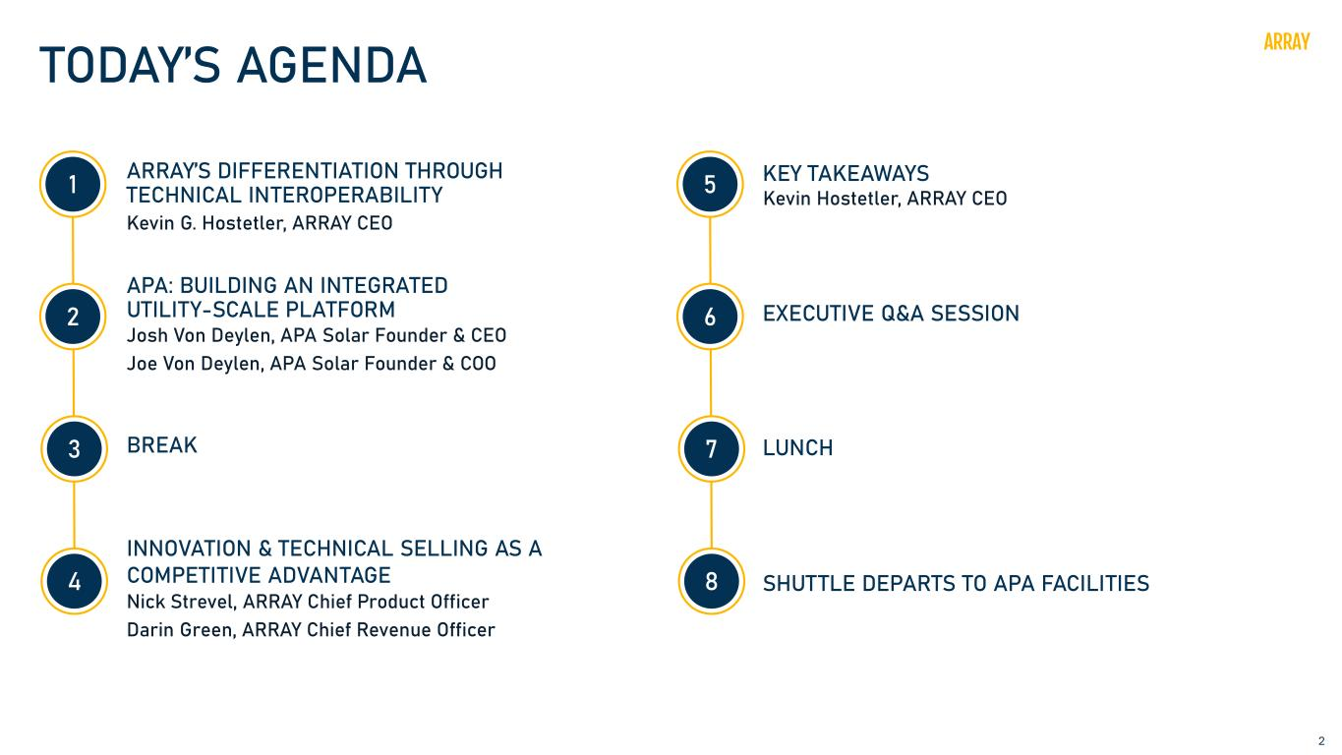
2 TODAY’S AGENDA ARRAY’S DIFFERENTIATION THROUGH TECHNICAL INTEROPERABILITY Kevin G. Hostetler, ARRAY CEO APA: BUILDING AN INTEGRATED UTILITY-SCALE PLATFORM Josh Von Deylen, APA Solar Founder & CEO Joe Von Deylen, APA Solar Founder & COO BREAK INNOVATION & TECHNICAL SELLING AS A COMPETITIVE ADVANTAGE Nick Strevel, ARRAY Chief Product Officer Darin Green, ARRAY Chief Revenue Officer KEY TAKEAWAYS Kevin Hostetler, ARRAY CEO EXECUTIVE Q&A SESSION SHUTTLE DEPARTS TO APA FACILITIES 1 2 3 4 5 6 7 8 LUNCH

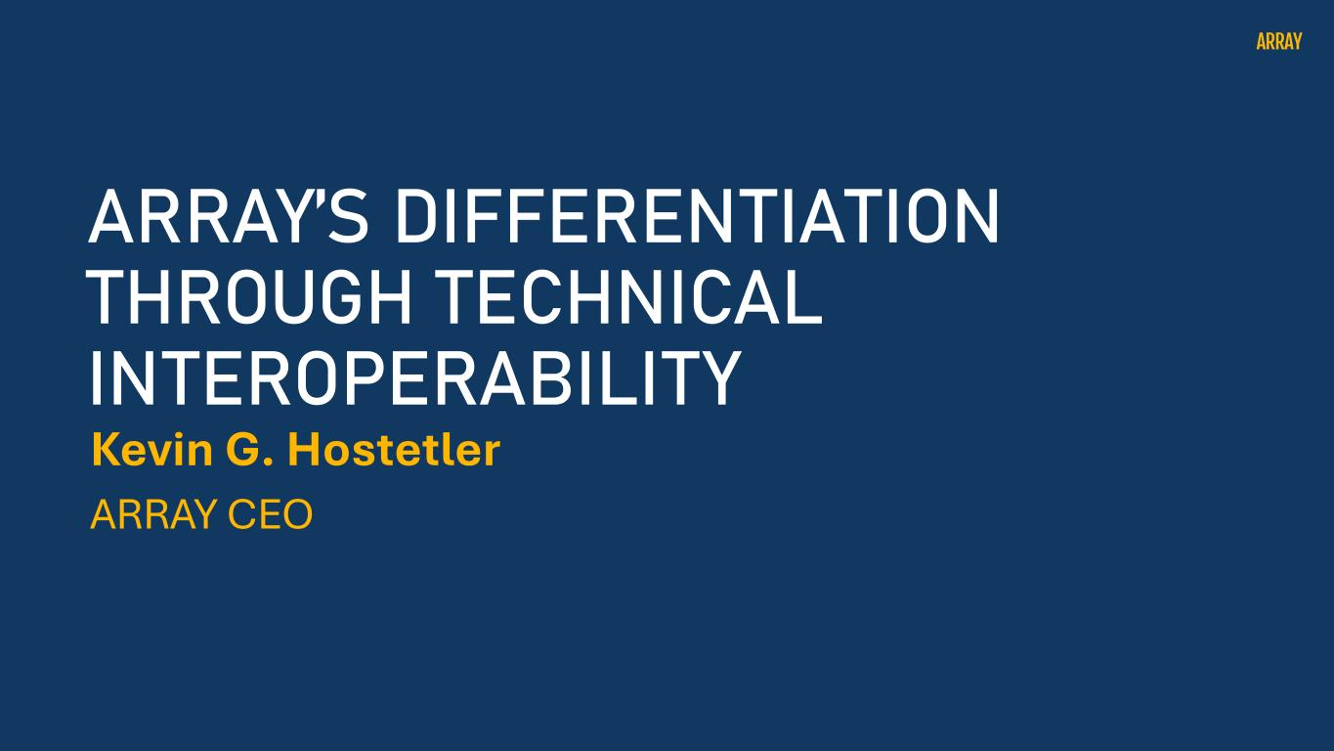
Kevin G. Hostetler ARRAY CEO ARRAY’S DIFFERENTIATION THROUGH TECHNICAL INTEROPERABILITY

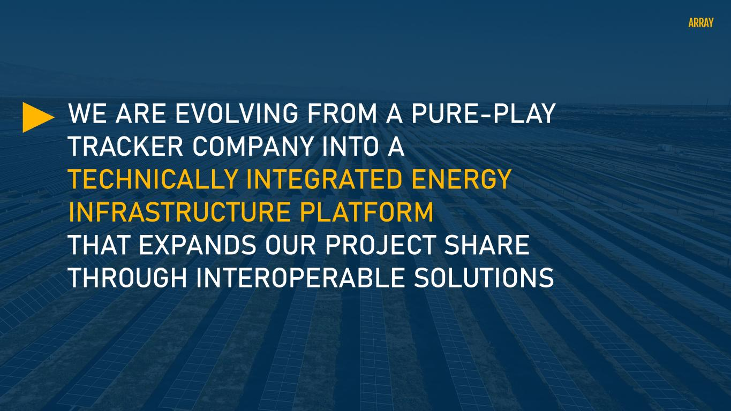
WE ARE EVOLVING FROM A PURE-PLAY TRACKER COMPANY INTO A TECHNICALLY INTEGRATED ENERGY INFRASTRUCTURE PLATFORM THAT EXPANDS OUR PROJECT SHARE THROUGH INTEROPERABLE SOLUTIONS

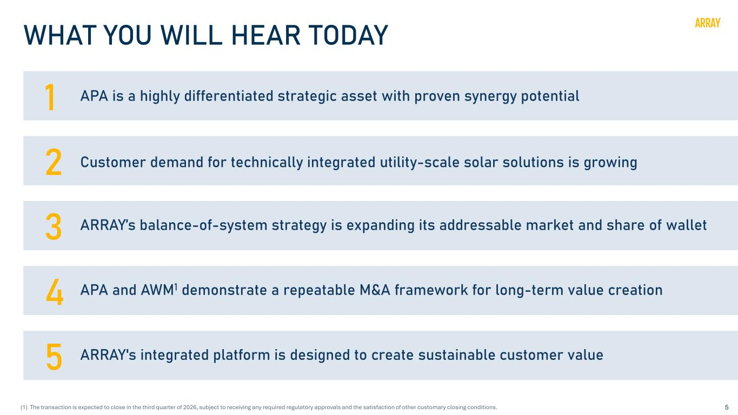
5 WHAT YOU WILL HEAR TODAY 1 APA is a highly differentiated strategic asset with proven synergy potential 2 Customer demand for technically integrated utility-scale solar solutions is growing 3 ARRAY’s balance-of-system strategy is expanding its addressable market and share of wallet 4 APA and AWM1 demonstrate a repeatable M&A framework for long-term value creation 5 ARRAY's integrated platform is designed to create sustainable customer value (1) The transaction is expected to close in the third quarter of 2026, subject to receiving any required regulatory approvals and the satisfaction of other customary closing conditions.

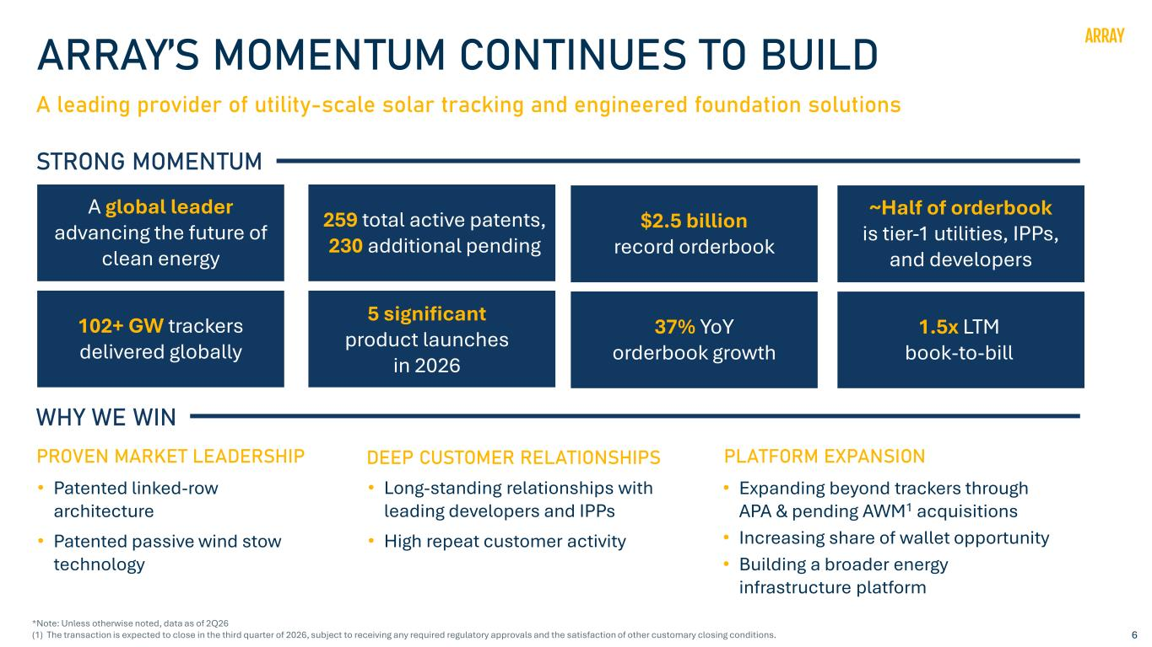
6 ARRAY’S MOMENTUM CONTINUES TO BUILD A leading provider of utility-scale solar tracking and engineered foundation solutions STRONG MOMENTUM A global leader advancing the future of clean energy 102+ GW trackers delivered globally 5 significant product launches in 2026 ~Half of orderbook is tier-1 utilities, IPPs, and developers 259 total active patents, 230 additional pending $2.5 billion record orderbook 1.5x LTM book-to-bill WHY WE WIN • Patented linked-row architecture • Patented passive wind stow technology PROVEN MARKET LEADERSHIP • Long-standing relationships with leading developers and IPPs • High repeat customer activity DEEP CUSTOMER RELATIONSHIPS • Expanding beyond trackers through APA & pending AWM1 acquisitions • Increasing share of wallet opportunity • Building a broader energy infrastructure platform PLATFORM EXPANSION 37% YoY orderbook growth *Note: Unless otherwise noted, data as of 2Q26 (1) The transaction is expected to close in the third quarter of 2026, subject to receiving any required regulatory approvals and the satisfaction of other customary closing conditions.

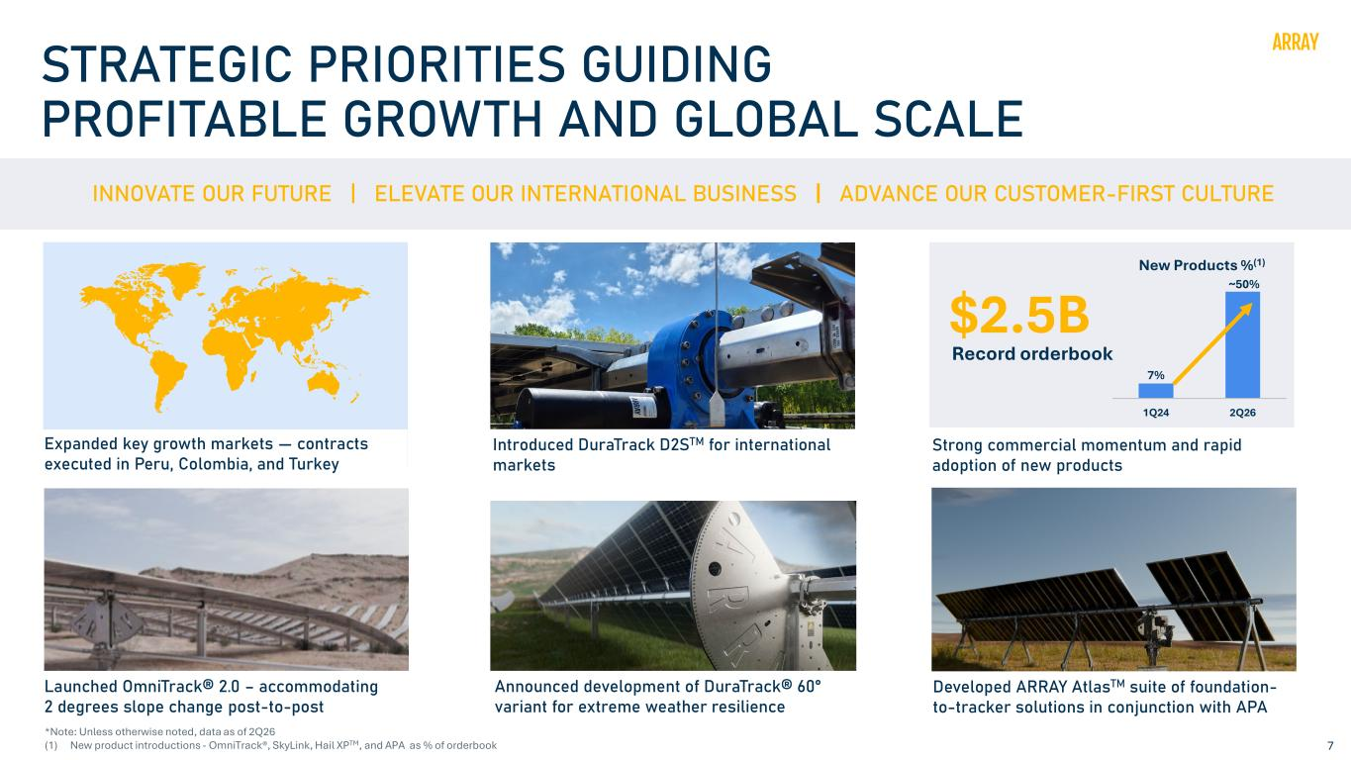
7 STRATEGIC PRIORITIES GUIDING PROFITABLE GROWTH AND GLOBAL SCALE INNOVATE OUR FUTURE | ELEVATE OUR INTERNATIONAL BUSINESS ADVANCE OUR CUSTOMER-FIRST CULTURE Introduced DuraTrack D2STM for international markets 7% ~50% 1Q24 2Q26 New Products %(1) $2.5B Record orderbook Launched OmniTrack® 2.0 – accommodating 2 degrees slope change post-to-post Strong commercial momentum and rapid adoption of new products Developed ARRAY AtlasTM suite of foundation- to-tracker solutions in conjunction with APA Announced development of DuraTrack® 60° variant for extreme weather resilience Expanded key growth markets — contracts executed in Peru, Colombia, and Turkey *Note: Unless otherwise noted, data as of 2Q26 (1) New product introductions - OmniTrack®, SkyLink, Hail XPTM, and APA as % of orderbook

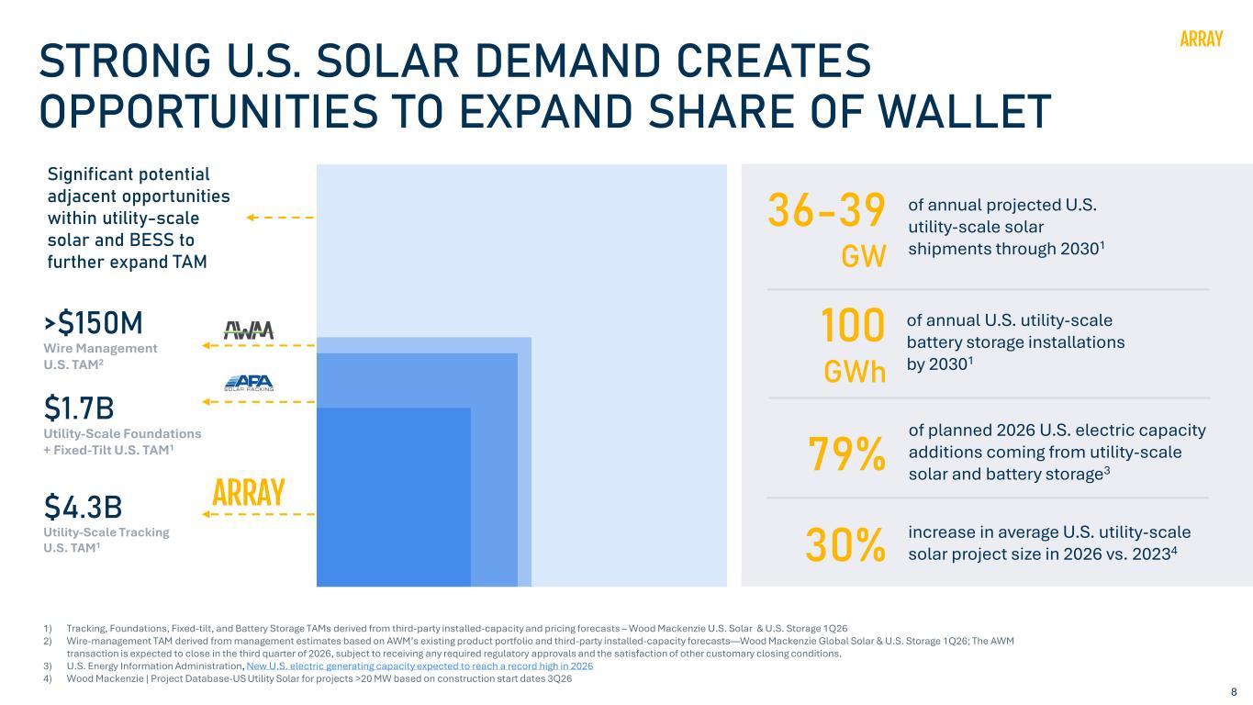
8 STRONG U.S. SOLAR DEMAND CREATES OPPORTUNITIES TO EXPAND SHARE OF WALLET �4.3B Utility-Scale Tracking U.S. TAM1 �1.7B Utility-Scale Foundations + Fixed-Tilt U.S. TAM1 of annual projected U.S. utility-scale solar shipments through 20301 36-39 GW 1) Tracking, Foundations, Fixed-tilt, and Battery Storage TAMs derived from third-party installed-capacity and pricing forecasts – Wood Mackenzie U.S. Solar & U.S. Storage 1Q26 2) Wire-management TAM derived from management estimates based on AWM’s existing product portfolio and third-party installed-capacity forecasts—Wood Mackenzie Global Solar & U.S. Storage 1Q26; The AWM transaction is expected to close in the third quarter of 2026, subject to receiving any required regulatory approvals and the satisfaction of other customary closing conditions. 3) U.S. Energy Information Administration, New U.S. electric generating capacity expected to reach a record high in 2026 4) Wood Mackenzie | Project Database-US Utility Solar for projects >20 MW based on construction start dates 3Q26 30% increase in average U.S. utility-scale solar project size in 2026 vs. 20234 of planned 2026 U.S. electric capacity additions coming from utility-scale solar and battery storage379% Significant potential adjacent opportunities within utility-scale solar and BESS to further expand TAM >�150M Wire Management U.S. TAM2 of annual U.S. utility-scale battery storage installations by 20301 100 GWh

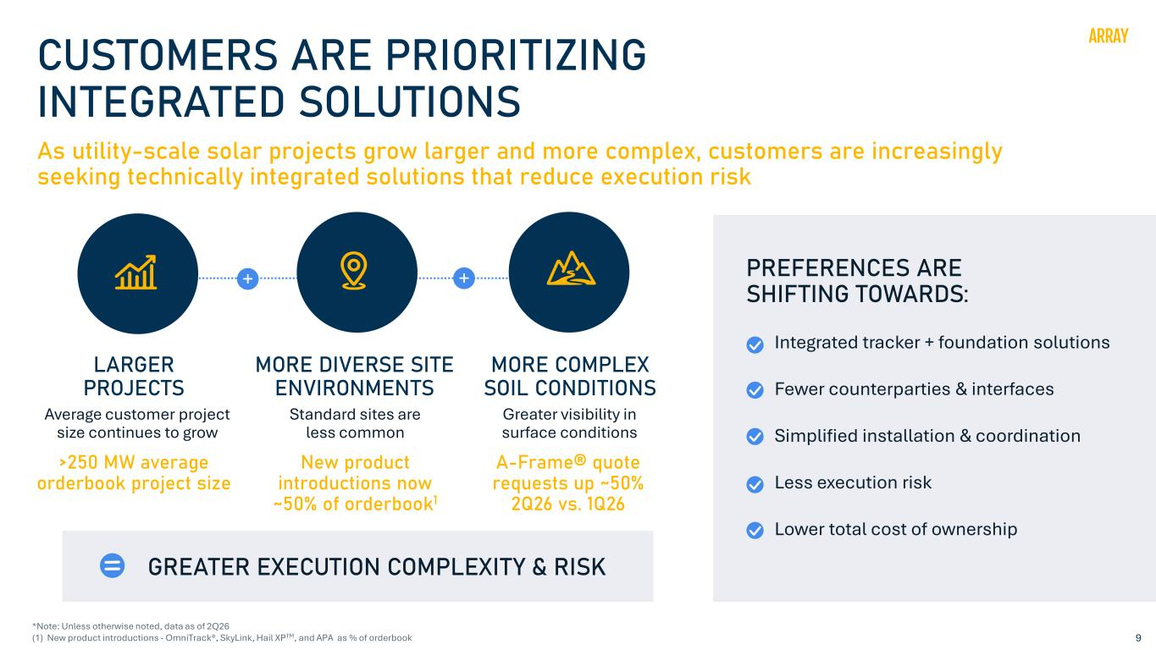
9 CUSTOMERS ARE PRIORITIZING INTEGRATED SOLUTIONS As utility-scale solar projects grow larger and more complex, customers are increasingly seeking technically integrated solutions that reduce execution risk Average customer project size continues to grow MORE DIVERSE SITE ENVIRONMENTS Standard sites are less common MORE COMPLEX SOIL CONDITIONS Greater visibility in surface conditions PREFERENCES ARE SHIFTING TOWARDS: Integrated tracker + foundation solutions Fewer counterparties & interfaces Simplified installation & coordination Less execution risk Lower total cost of ownership GREATER EXECUTION COMPLEXITY & RISK LARGER PROJECTS >250 MW average orderbook project size A-Frame® quote requests up ~50% 2Q26 vs. 1Q26 + + New product introductions now ~50% of orderbook1 *Note: Unless otherwise noted, data as of 2Q26 (1) New product introductions - OmniTrack®, SkyLink, Hail XPTM, and APA as % of orderbook

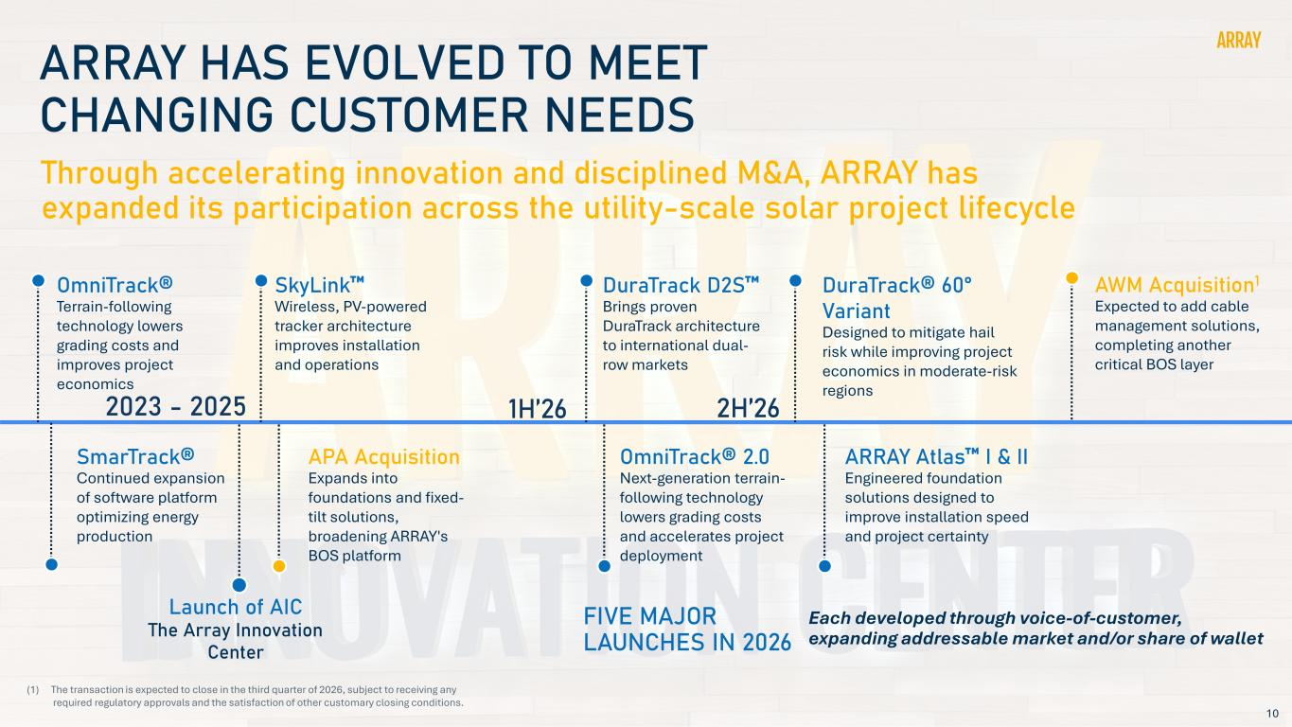
10 ARRAY HAS EVOLVED TO MEET CHANGING CUSTOMER NEEDS Through accelerating innovation and disciplined M&A, ARRAY has expanded its participation across the utility-scale solar project lifecycle APA Acquisition Expands into foundations and fixed- tilt solutions, broadening ARRAY's BOS platform SkyLink Wireless, PV-powered tracker architecture improves installation and operations OmniTrack® 2.0 Next-generation terrain- following technology lowers grading costs and accelerates project deployment DuraTrack® 60° Variant Designed to mitigate hail risk while improving project economics in moderate-risk regions DuraTrack D2S Brings proven DuraTrack architecture to international dual- row markets AWM Acquisition1 Expected to add cable management solutions, completing another critical BOS layer ARRAY Atlas I & II Engineered foundation solutions designed to improve installation speed and project certainty OmniTrack® Terrain-following technology lowers grading costs and improves project economics 2023 - 2025 1H’26 2H’26 Each developed through voice-of-customer, expanding addressable market and/or share of wallet FIVE MAJOR LAUNCHES IN 2026 (1) The transaction is expected to close in the third quarter of 2026, subject to receiving any required regulatory approvals and the satisfaction of other customary closing conditions. SmarTrack® Continued expansion of software platform optimizing energy production Launch of AIC The Array Innovation Center

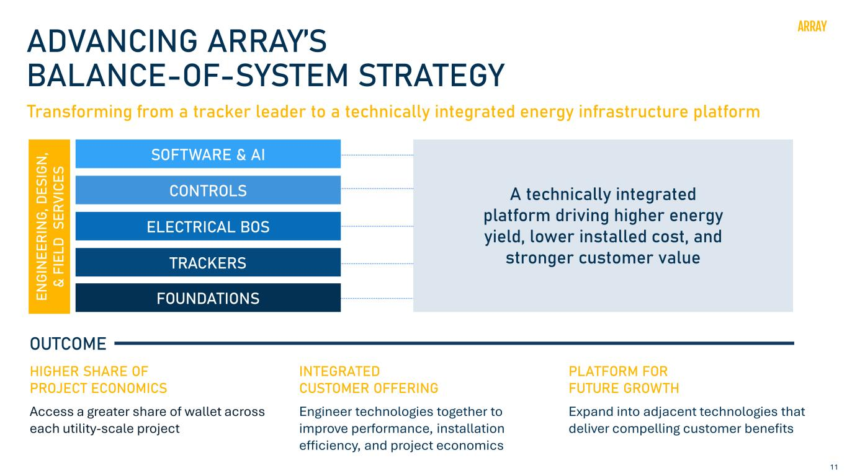
11 ADVANCING ARRAY’S BALANCE-OF-SYSTEM STRATEGY SOFTWARE & AI CONTROLS ELECTRICAL BOS TRACKERS FOUNDATIONS A technically integrated platform driving higher energy yield, lower installed cost, and stronger customer value Transforming from a tracker leader to a technically integrated energy infrastructure platform HIGHER SHARE OF PROJECT ECONOMICS Access a greater share of wallet across each utility-scale project INTEGRATED CUSTOMER OFFERING Engineer technologies together to improve performance, installation efficiency, and project economics PLATFORM FOR FUTURE GROWTH Expand into adjacent technologies that deliver compelling customer benefits OUTCOME EN GI N EE RI N G, D ES IG N , & FI EL D S ER VI CE S

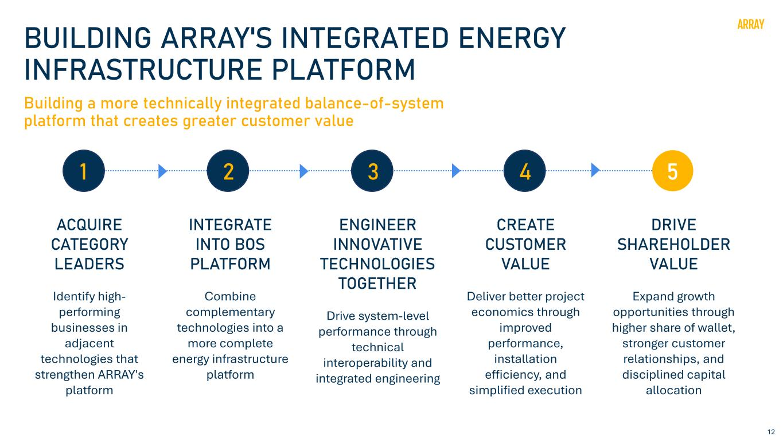
12 BUILDING ARRAY'S INTEGRATED ENERGY INFRASTRUCTURE PLATFORM Building a more technically integrated balance-of-system platform that creates greater customer value ACQUIRE CATEGORY LEADERS Identify high- performing businesses in adjacent technologies that strengthen ARRAY's platform INTEGRATE INTO BOS PLATFORM Combine complementary technologies into a more complete energy infrastructure platform CREATE CUSTOMER VALUE Deliver better project economics through improved performance, installation efficiency, and simplified execution ENGINEER INNOVATIVE TECHNOLOGIES TOGETHER Drive system-level performance through technical interoperability and integrated engineering DRIVE SHAREHOLDER VALUE Expand growth opportunities through higher share of wallet, stronger customer relationships, and disciplined capital allocation 1 2 3 4 5

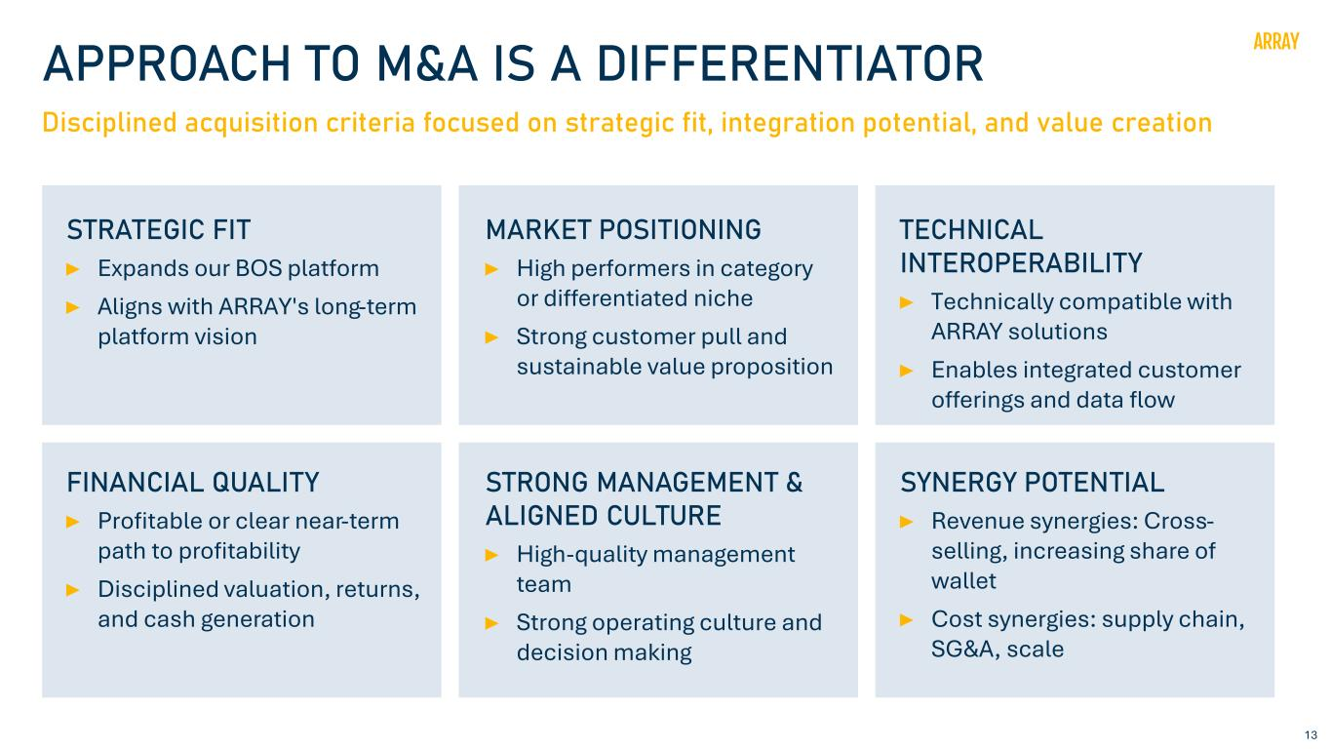
13 APPROACH TO M&A IS A DIFFERENTIATOR Disciplined acquisition criteria focused on strategic fit, integration potential, and value creation STRATEGIC FIT Expands our BOS platform Aligns with ARRAY's long-term platform vision MARKET POSITIONING High performers in category or differentiated niche Strong customer pull and sustainable value proposition TECHNICAL INTEROPERABILITY Technically compatible with ARRAY solutions Enables integrated customer offerings and data flow FINANCIAL QUALITY Profitable or clear near-term path to profitability Disciplined valuation, returns, and cash generation STRONG MANAGEMENT & ALIGNED CULTURE High-quality management team Strong operating culture and decision making SYNERGY POTENTIAL Revenue synergies: Cross- selling, increasing share of wallet Cost synergies: supply chain, SG&A, scale

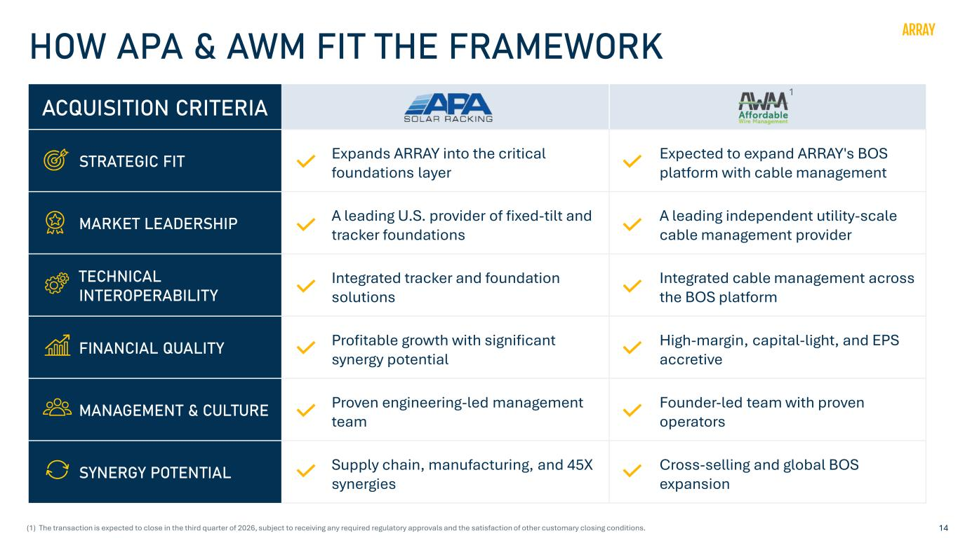
14 HOW APA & AWM FIT THE FRAMEWORK ACQUISITION CRITERIA STRATEGIC FIT Expands ARRAY into the critical foundations layer Expected to expand ARRAY's BOS platform with cable management MARKET LEADERSHIP A leading U.S. provider of fixed-tilt and tracker foundations A leading independent utility-scale cable management provider TECHNICAL INTEROPERABILITY Integrated tracker and foundation solutions Integrated cable management across the BOS platform FINANCIAL QUALITY Profitable growth with significant synergy potential High-margin, capital-light, and EPS accretive MANAGEMENT & CULTURE Proven engineering-led management team Founder-led team with proven operators SYNERGY POTENTIAL Supply chain, manufacturing, and 45X synergies Cross-selling and global BOS expansion 1 (1) The transaction is expected to close in the third quarter of 2026, subject to receiving any required regulatory approvals and the satisfaction of other customary closing conditions.

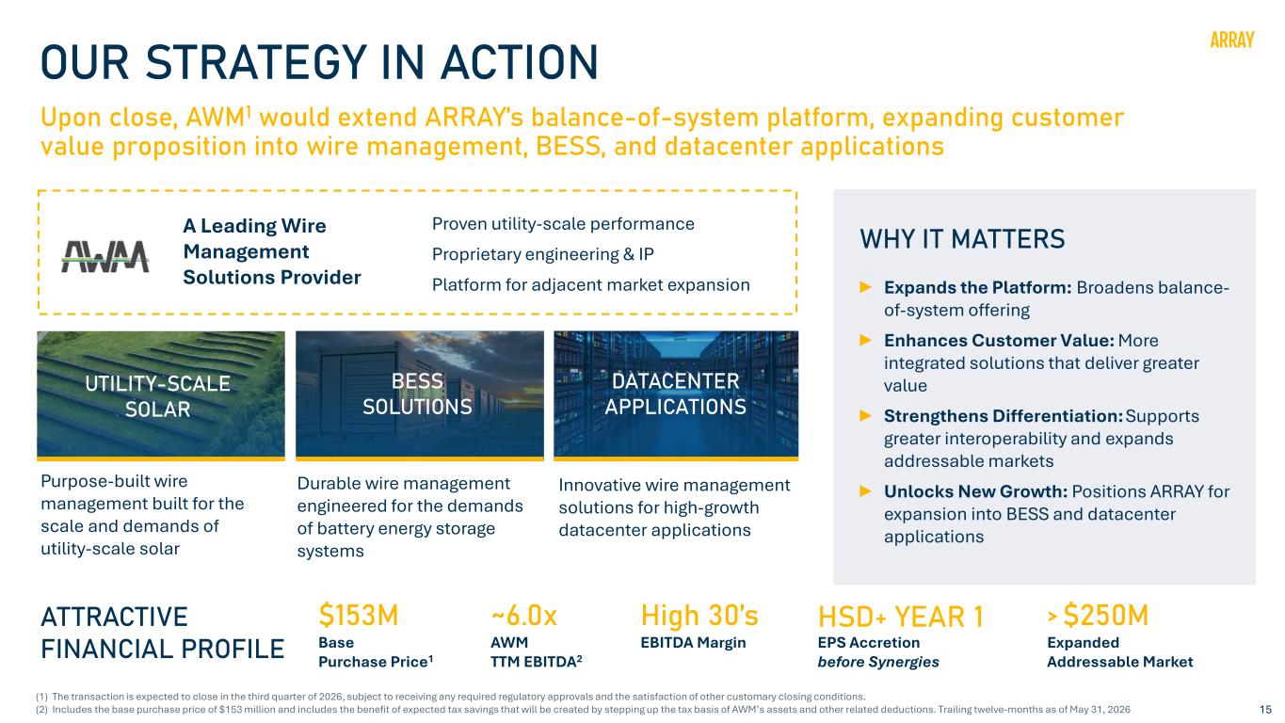
15 OUR STRATEGY IN ACTION Upon close, AWM1 would extend ARRAY’s balance-of-system platform, expanding customer value proposition into wire management, BESS, and datacenter applications WHY IT MATTERS Expands the Platform: Broadens balance- of-system offering Enhances Customer Value: More integrated solutions that deliver greater value Strengthens Differentiation: Supports greater interoperability and expands addressable markets Unlocks New Growth: Positions ARRAY for expansion into BESS and datacenter applications ATTRACTIVE FINANCIAL PROFILE �153M Base Purchase Price1 ~6.0x AWM TTM EBITDA2 HSD+ YEAR 1 EPS Accretion before Synergies > �250M Expanded Addressable Market Purpose-built wire management built for the scale and demands of utility-scale solar Durable wire management engineered for the demands of battery energy storage systems Innovative wire management solutions for high-growth datacenter applications UTILITY-SCALE SOLAR BESS SOLUTIONS DATACENTER APPLICATIONS Proven utility-scale performance Proprietary engineering & IP Platform for adjacent market expansion A Leading Wire Management Solutions Provider (1) The transaction is expected to close in the third quarter of 2026, subject to receiving any required regulatory approvals and the satisfaction of other customary closing conditions. (2) Includes the base purchase price of $153 million and includes the benefit of expected tax savings that will be created by stepping up the tax basis of AWM’s assets and other related deductions. Trailing twelve-months as of May 31, 2026 High 30’s EBITDA Margin

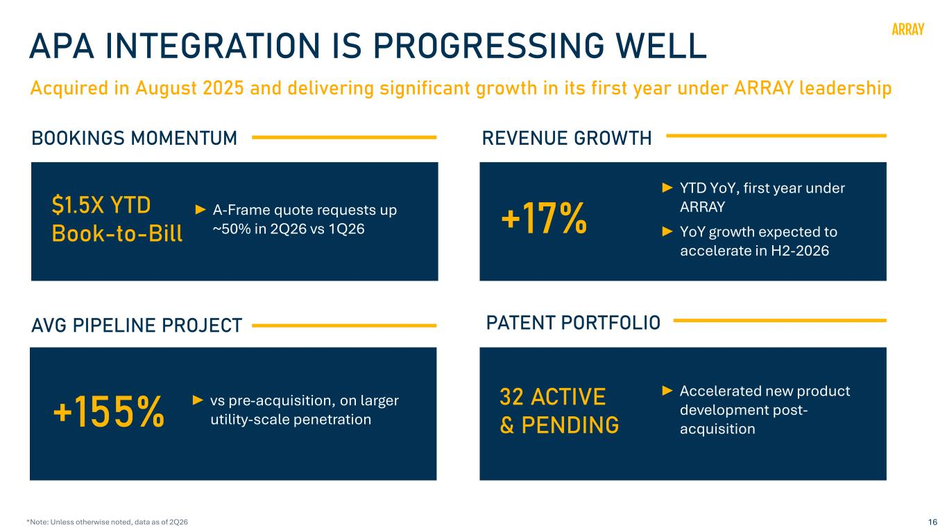
16 Acquired in August 2025 and delivering significant growth in its first year under ARRAY leadership APA INTEGRATION IS PROGRESSING WELL BOOKINGS MOMENTUM REVENUE GROWTH AVG PIPELINE PROJECT PATENT PORTFOLIO �1.5X YTD Book-to-Bill A-Frame quote requests up ~50% in 2Q26 vs 1Q26 +155% vs pre-acquisition, on larger utility-scale penetration +17% YTD YoY, first year under ARRAY YoY growth expected to accelerate in H2-2026 32 ACTIVE & PENDING Accelerated new product development post- acquisition *Note: Unless otherwise noted, data as of 2Q26

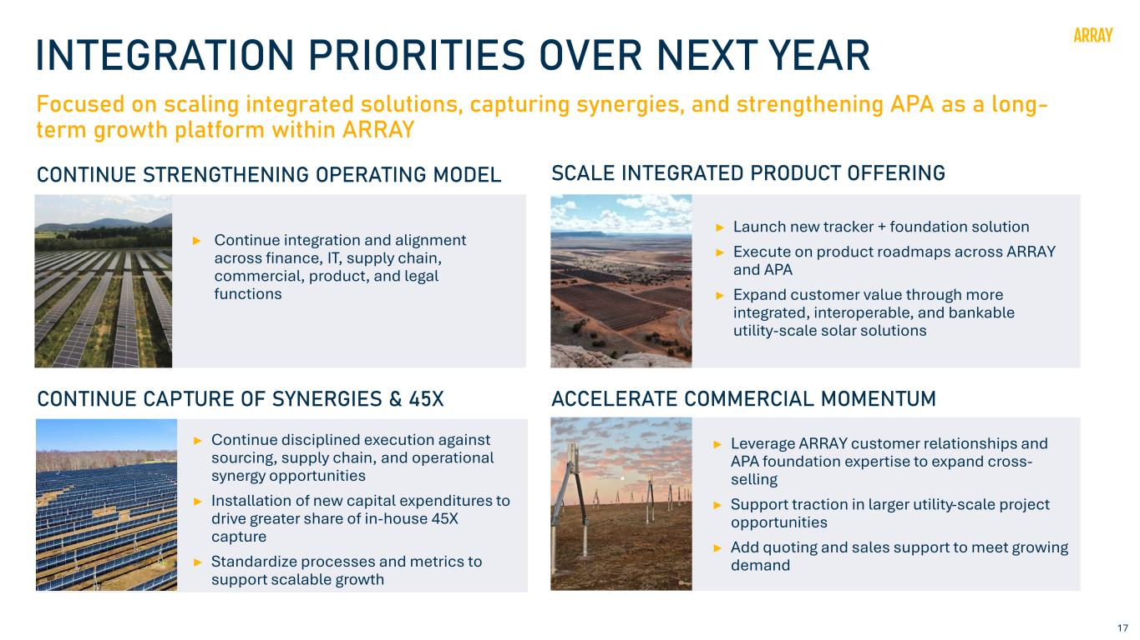
17 Focused on scaling integrated solutions, capturing synergies, and strengthening APA as a long- term growth platform within ARRAY INTEGRATION PRIORITIES OVER NEXT YEAR ACCELERATE COMMERCIAL MOMENTUM Continue disciplined execution against sourcing, supply chain, and operational synergy opportunities Installation of new capital expenditures to drive greater share of in-house 45X capture Standardize processes and metrics to support scalable growth CONTINUE STRENGTHENING OPERATING MODEL Continue integration and alignment across finance, IT, supply chain, commercial, product, and legal functions Leverage ARRAY customer relationships and APA foundation expertise to expand cross- selling Support traction in larger utility-scale project opportunities Add quoting and sales support to meet growing demand SCALE INTEGRATED PRODUCT OFFERING Launch new tracker + foundation solution Execute on product roadmaps across ARRAY and APA Expand customer value through more integrated, interoperable, and bankable utility-scale solar solutions CONTINUE CAPTURE OF SYNERGIES & 45X

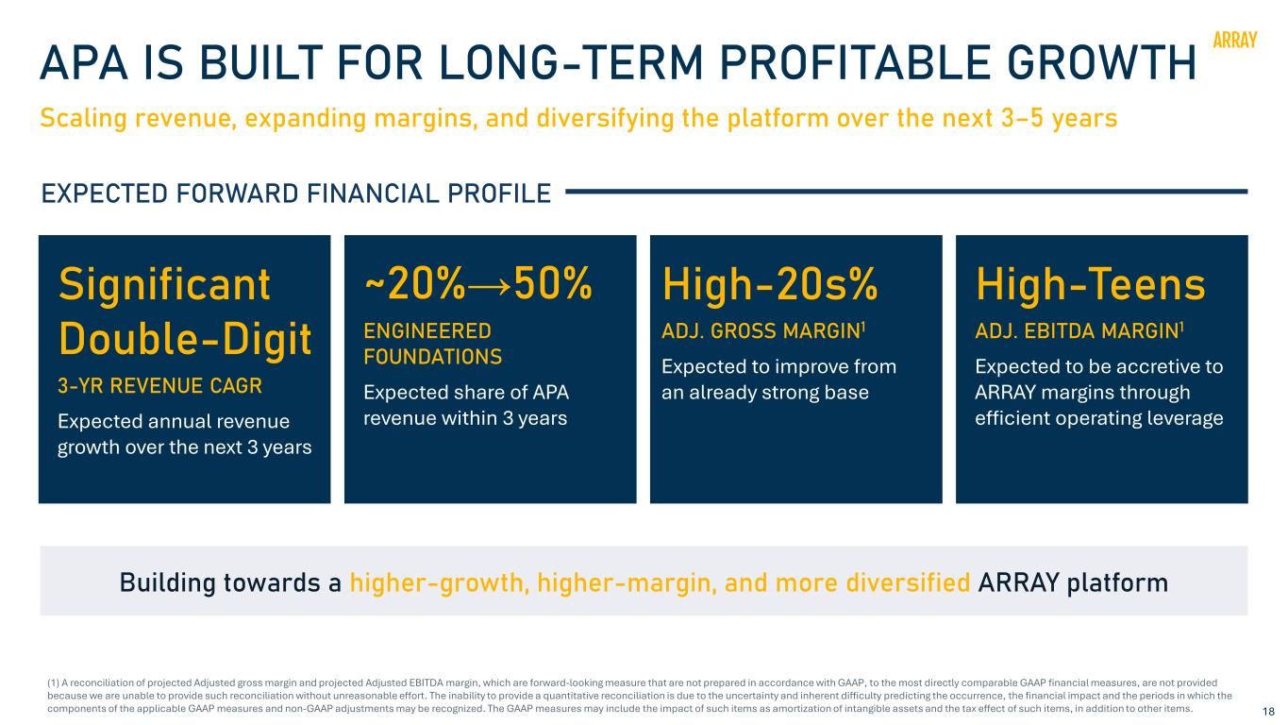
18 APA IS BUILT FOR LONG-TERM PROFITABLE GROWTH Scaling revenue, expanding margins, and diversifying the platform over the next 3–5 years EXPECTED FORWARD FINANCIAL PROFILE High-Teens ADJ. EBITDA MARGIN1 Expected to be accretive to ARRAY margins through efficient operating leverage Significant Double-Digit 3-YR REVENUE CAGR Expected annual revenue growth over the next 3 years ~20%→50% ENGINEERED FOUNDATIONS Expected share of APA revenue within 3 years Building towards a higher-growth, higher-margin, and more diversified ARRAY platform (1) A reconciliation of projected Adjusted gross margin and projected Adjusted EBITDA margin, which are forward-looking measure that are not prepared in accordance with GAAP, to the most directly comparable GAAP financial measures, are not provided because we are unable to provide such reconciliation without unreasonable effort. The inability to provide a quantitative reconciliation is due to the uncertainty and inherent difficulty predicting the occurrence, the financial impact and the periods in which the components of the applicable GAAP measures and non-GAAP adjustments may be recognized. The GAAP measures may include the impact of such items as amortization of intangible assets and the tax effect of such items, in addition to other items. High-20s% ADJ. GROSS MARGIN1 Expected to improve from an already strong base

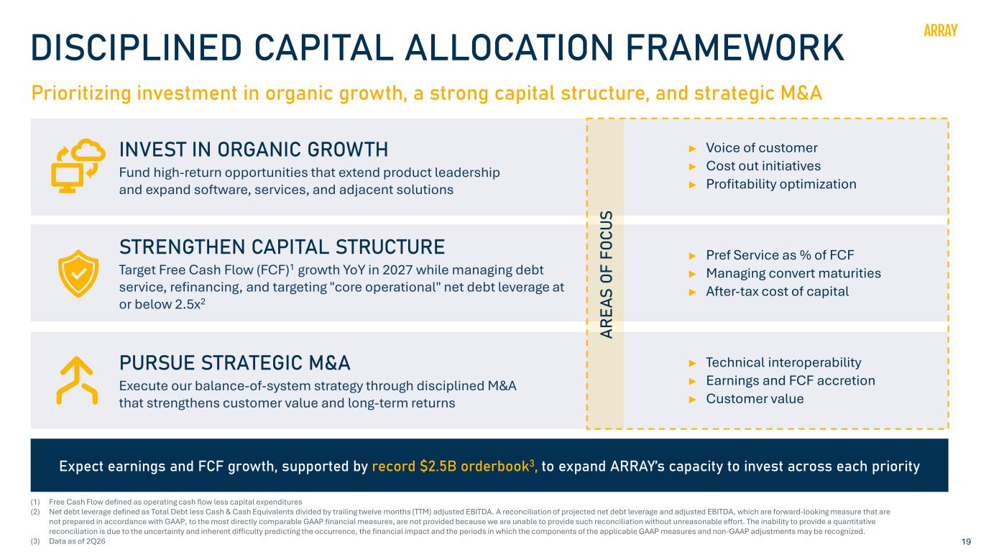
19 DISCIPLINED CAPITAL ALLOCATION FRAMEWORK Prioritizing investment in organic growth, a strong capital structure, and strategic M&A INVEST IN ORGANIC GROWTH Fund high-return opportunities that extend product leadership and expand software, services, and adjacent solutions ► Voice of customer ► Cost out initiatives ► Profitability optimization STRENGTHEN CAPITAL STRUCTURE Target Free Cash Flow (FCF)1 growth YoY in 2027 while managing debt service, refinancing, and targeting "core operational" net debt leverage at or below 2.5x2 ► Pref Service as % of FCF ► Managing convert maturities ► After-tax cost of capital PURSUE STRATEGIC M&A Execute our balance-of-system strategy through disciplined M&A that strengthens customer value and long-term returns ► Technical interoperability ► Earnings and FCF accretion ► Customer value Expect earnings and FCF growth, supported by record �2.5B orderbook3, to expand ARRAY’s capacity to invest across each priority AR EA S OF F OC US (1) Free Cash Flow defined as operating cash flow less capital expenditures (2) Net debt leverage defined as Total Debt less Cash & Cash Equivalents divided by trailing twelve months (TTM) adjusted EBITDA. A reconciliation of projected net debt leverage and adjusted EBITDA, which are forward-looking measure that are not prepared in accordance with GAAP, to the most directly comparable GAAP financial measures, are not provided because we are unable to provide such reconciliation without unreasonable effort. The inability to provide a quantitative reconciliation is due to the uncertainty and inherent difficulty predicting the occurrence, the financial impact and the periods in which the components of the applicable GAAP measures and non-GAAP adjustments may be recognized. (3) Data as of 2Q26

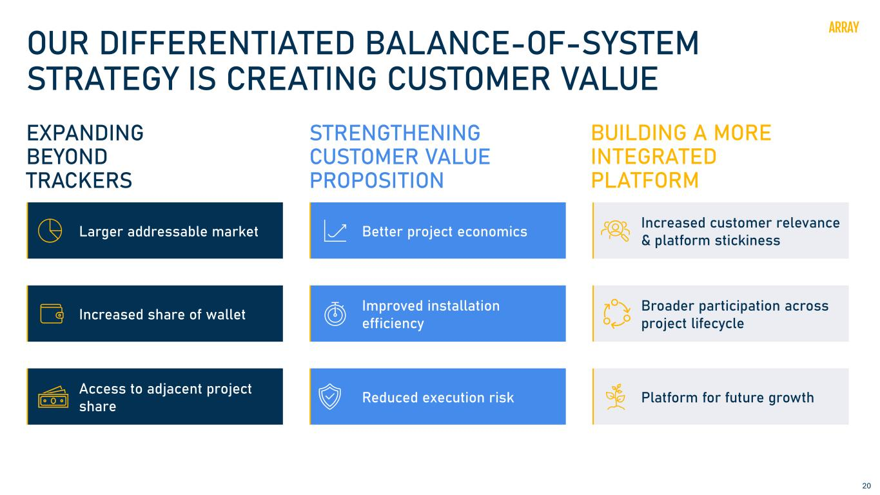
20 OUR DIFFERENTIATED BALANCE-OF-SYSTEM STRATEGY IS CREATING CUSTOMER VALUE STRENGTHENING CUSTOMER VALUE PROPOSITION Better project economics Improved installation efficiency Reduced execution risk BUILDING A MORE INTEGRATED PLATFORM Increased customer relevance & platform stickiness Broader participation across project lifecycle Platform for future growth EXPANDING BEYOND TRACKERS Larger addressable market Increased share of wallet Access to adjacent project share

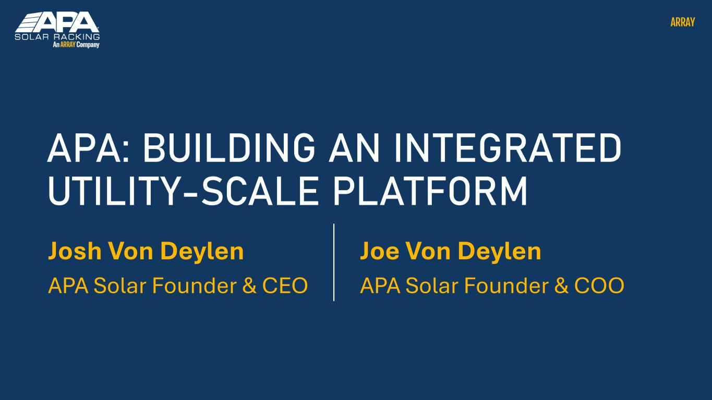
Josh Von Deylen APA Solar Founder & CEO APA: BUILDING AN INTEGRATED UTILITY-SCALE PLATFORM Joe Von Deylen APA Solar Founder & COO

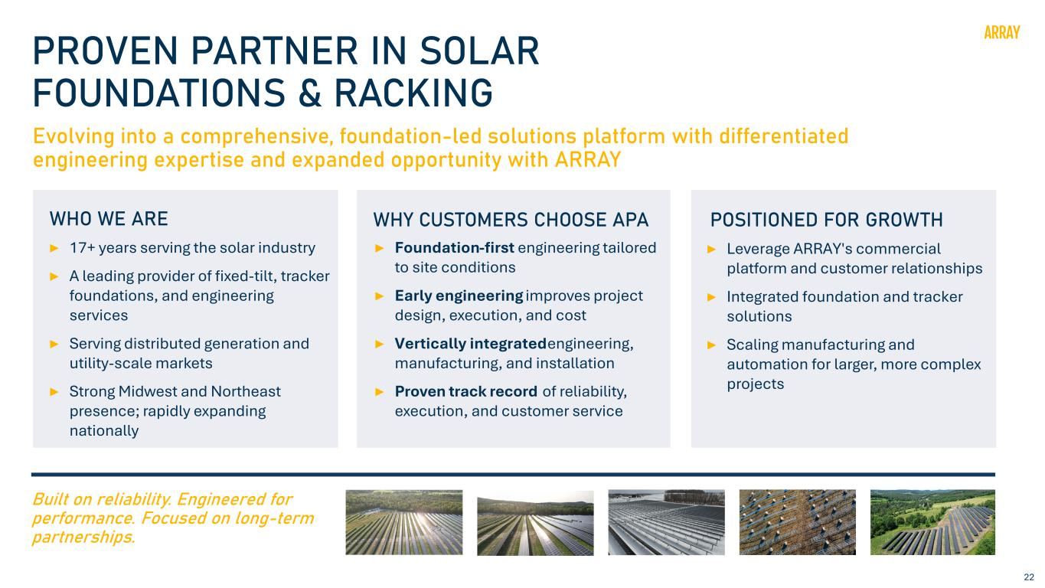
22 PROVEN PARTNER IN SOLAR FOUNDATIONS & RACKING Evolving into a comprehensive, foundation-led solutions platform with differentiated engineering expertise and expanded opportunity with ARRAY 17+ years serving the solar industry A leading provider of fixed-tilt, tracker foundations, and engineering services Serving distributed generation and utility-scale markets Strong Midwest and Northeast presence; rapidly expanding nationally WHO WE ARE Foundation-first engineering tailored to site conditions Early engineering improves project design, execution, and cost Vertically integrated engineering, manufacturing, and installation Proven track record of reliability, execution, and customer service WHY CUSTOMERS CHOOSE APA Leverage ARRAY's commercial platform and customer relationships Integrated foundation and tracker solutions Scaling manufacturing and automation for larger, more complex projects POSITIONED FOR GROWTH Built on reliability. Engineered for performance. Focused on long-term partnerships.

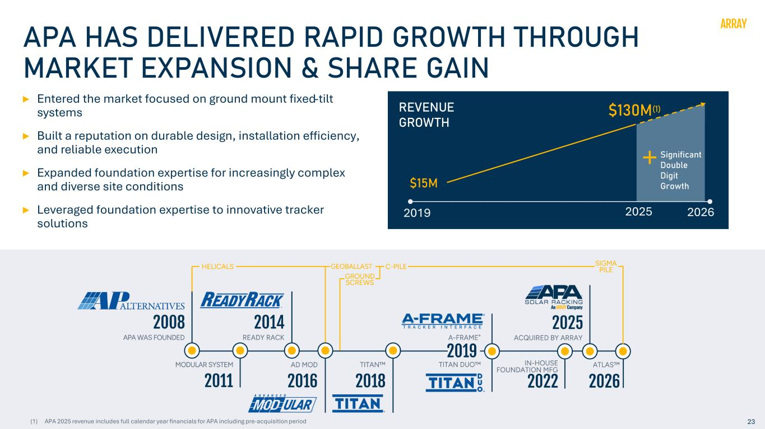
23 APA HAS DELIVERED RAPID GROWTH THROUGH MARKET EXPANSION & SHARE GAIN Entered the market focused on ground mount fixed-tilt systems Built a reputation on durable design, installation efficiency, and reliable execution Expanded foundation expertise for increasingly complex and diverse site conditions Leveraged foundation expertise to innovative tracker solutions �15M 2019 2026 REVENUE GROWTH 2025 Significant Double Digit Growth �130M(1) 23(1) APA 2025 revenue includes full calendar year financials for APA including pre-acquisition period

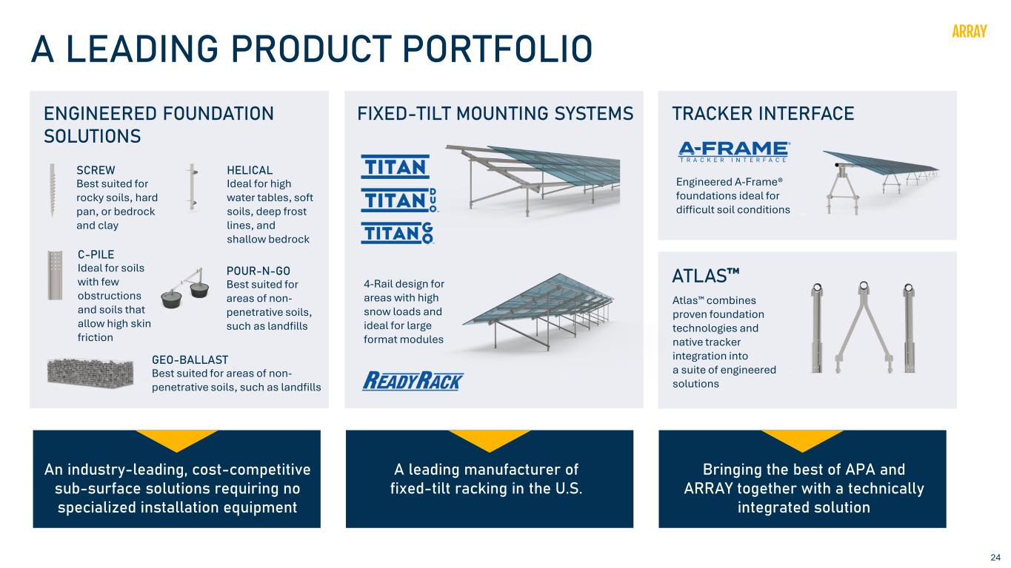
24 A LEADING PRODUCT PORTFOLIO ENGINEERED FOUNDATION SOLUTIONS FIXED-TILT MOUNTING SYSTEMS TRACKER INTERFACE ATLAS HELICAL Ideal for high water tables, soft soils, deep frost lines, and shallow bedrock C-PILE Ideal for soils with few obstructions and soils that allow high skin friction POUR-N-GO Best suited for areas of non- penetrative soils, such as landfills GEO-BALLAST Best suited for areas of non- penetrative soils, such as landfills SCREW Best suited for rocky soils, hard pan, or bedrock and clay Engineered A-Frame® foundations ideal for difficult soil conditions 4-Rail design for areas with high snow loads and ideal for large format modules Atlas combines proven foundation technologies and native tracker integration into a suite of engineered solutions An industry-leading, cost-competitive sub-surface solutions requiring no specialized installation equipment Bringing the best of APA and ARRAY together with a technically integrated solution A leading manufacturer of fixed-tilt racking in the U.S.

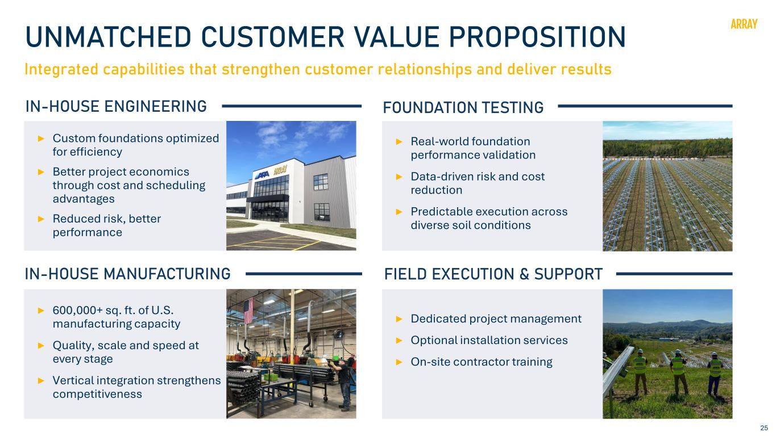
25 UNMATCHED CUSTOMER VALUE PROPOSITION Integrated capabilities that strengthen customer relationships and deliver results IN-HOUSE ENGINEERING Custom foundations optimized for efficiency Better project economics through cost and scheduling advantages Reduced risk, better performance FOUNDATION TESTING Real-world foundation performance validation Data-driven risk and cost reduction Predictable execution across diverse soil conditions IN-HOUSE MANUFACTURING 600,000+ sq. ft. of U.S. manufacturing capacity Quality, scale and speed at every stage Vertical integration strengthens competitiveness FIELD EXECUTION & SUPPORT Dedicated project management Optional installation services On-site contractor training

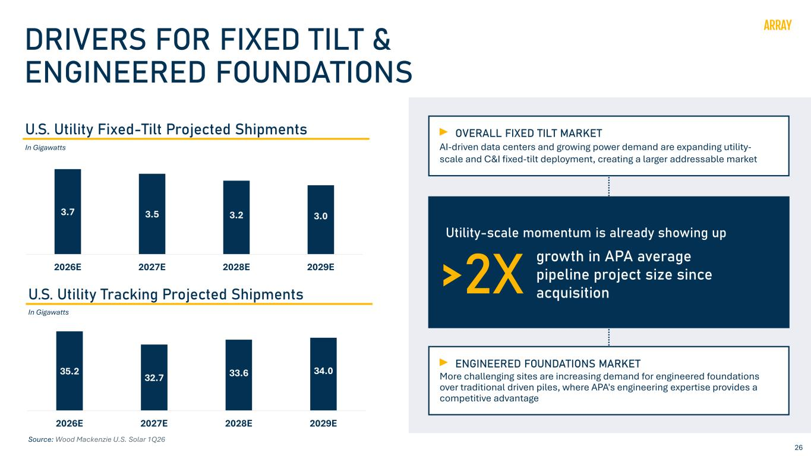
26 DRIVERS FOR FIXED TILT & ENGINEERED FOUNDATIONS 35.2 32.7 33.6 34.0 20 22 24 26 28 30 32 34 36 2026E 2027E 2028E 2029E U.S. Utility Fixed-Tilt Projected Shipments U.S. Utility Tracking Projected Shipments Source: Wood Mackenzie U.S. Solar 1Q26 In Gigawatts In Gigawatts Utility-scale momentum is already showing up AI-driven data centers and growing power demand are expanding utility- scale and C&I fixed-tilt deployment, creating a larger addressable market OVERALL FIXED TILT MARKET More challenging sites are increasing demand for engineered foundations over traditional driven piles, where APA's engineering expertise provides a competitive advantage ENGINEERED FOUNDATIONS MARKET >2X growth in APA average pipeline project size since acquisition 3.7 3.5 3.2 3.0 2026E 2027E 2028E 2029E

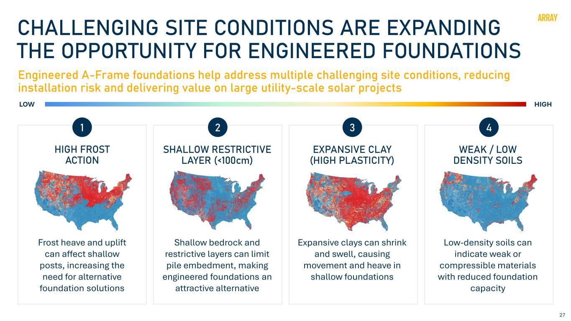
27 CHALLENGING SITE CONDITIONS ARE EXPANDING THE OPPORTUNITY FOR ENGINEERED FOUNDATIONS Engineered A-Frame foundations help address multiple challenging site conditions, reducing installation risk and delivering value on large utility-scale solar projects HIGH FROST ACTION Frost heave and uplift can affect shallow posts, increasing the need for alternative foundation solutions SHALLOW RESTRICTIVE LAYER (<100cm) Shallow bedrock and restrictive layers can limit pile embedment, making engineered foundations an attractive alternative EXPANSIVE CLAY (HIGH PLASTICITY) Expansive clays can shrink and swell, causing movement and heave in shallow foundations WEAK / LOW DENSITY SOILS Low-density soils can indicate weak or compressible materials with reduced foundation capacity 1 2 3 4

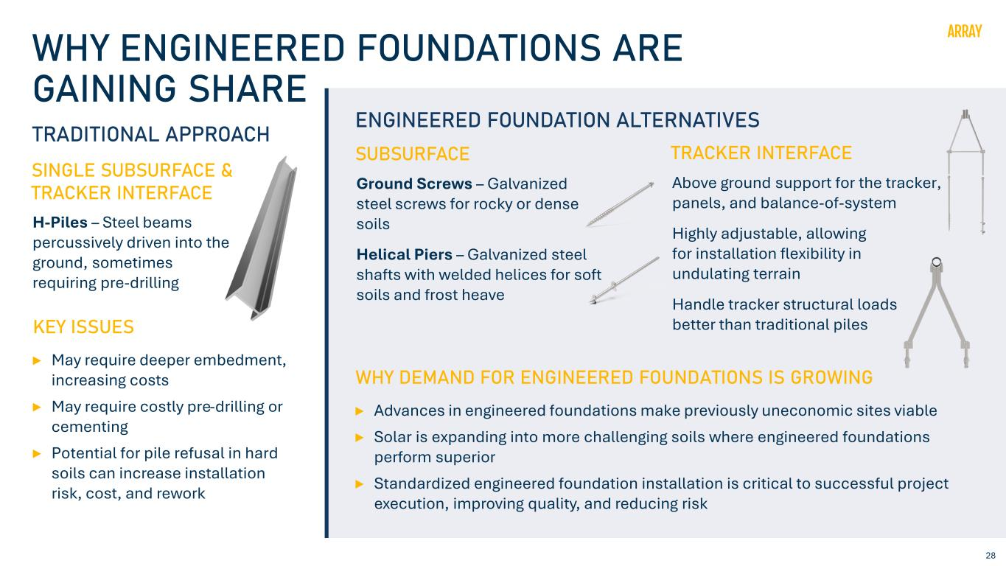
28 WHY ENGINEERED FOUNDATIONS ARE GAINING SHARE TRADITIONAL APPROACH SINGLE SUBSURFACE & TRACKER INTERFACE H-Piles – Steel beams percussively driven into the ground, sometimes requiring pre-drilling KEY ISSUES May require deeper embedment, increasing costs May require costly pre-drilling or cementing Potential for pile refusal in hard soils can increase installation risk, cost, and rework ENGINEERED FOUNDATION ALTERNATIVES SUBSURFACE Ground Screws – Galvanized steel screws for rocky or dense soils Helical Piers – Galvanized steel shafts with welded helices for soft soils and frost heave TRACKER INTERFACE Above ground support for the tracker, panels, and balance-of-system Highly adjustable, allowing for installation flexibility in undulating terrain Handle tracker structural loads better than traditional piles WHY DEMAND FOR ENGINEERED FOUNDATIONS IS GROWING Advances in engineered foundations make previously uneconomic sites viable Solar is expanding into more challenging soils where engineered foundations perform superior Standardized engineered foundation installation is critical to successful project execution, improving quality, and reducing risk

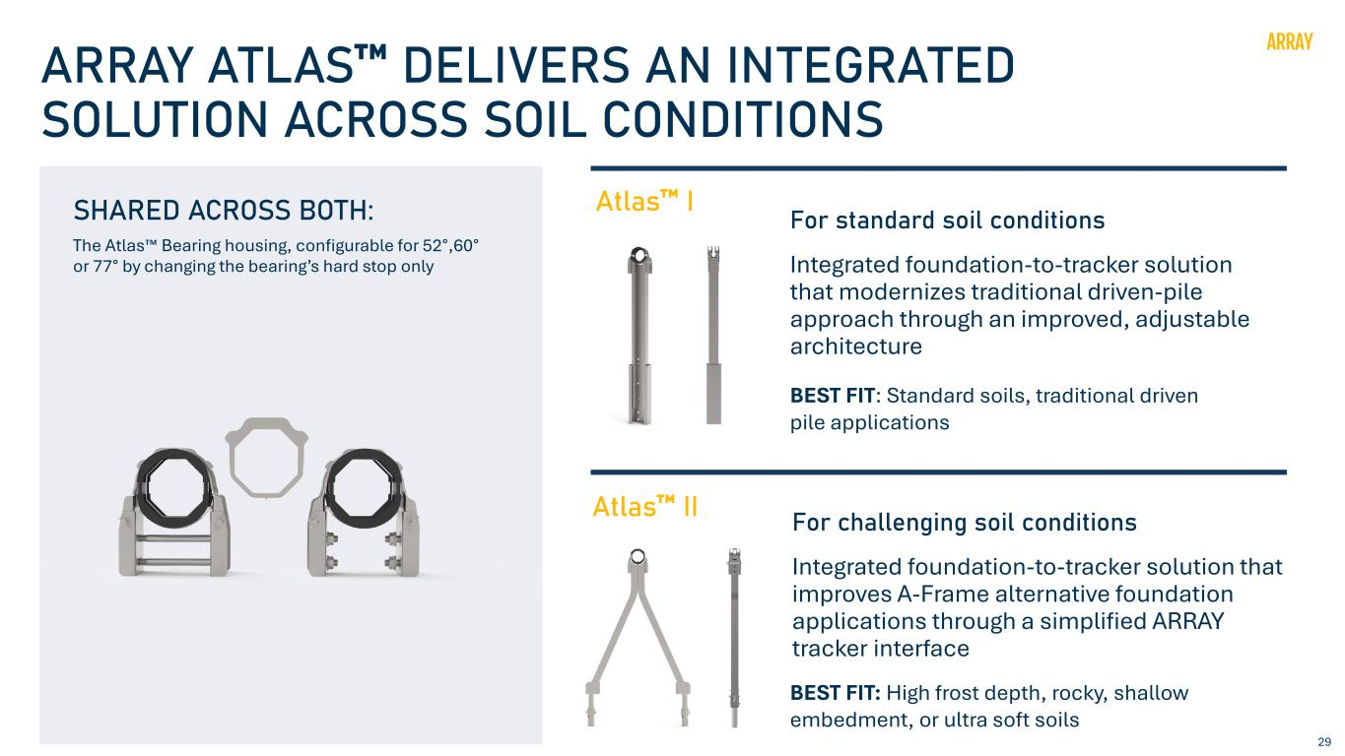
29 ARRAY ATLAS DELIVERS AN INTEGRATED SOLUTION ACROSS SOIL CONDITIONS SHARED ACROSS BOTH: Atlas II The Atlas Bearing housing, configurable for 52°,60° or 77° by changing the bearing’s hard stop only Atlas I Integrated foundation-to-tracker solution that modernizes traditional driven-pile approach through an improved, adjustable architecture For standard soil conditions BEST FIT: Standard soils, traditional driven pile applications Integrated foundation-to-tracker solution that improves A-Frame alternative foundation applications through a simplified ARRAY tracker interface For challenging soil conditions BEST FIT: High frost depth, rocky, shallow embedment, or ultra soft soils

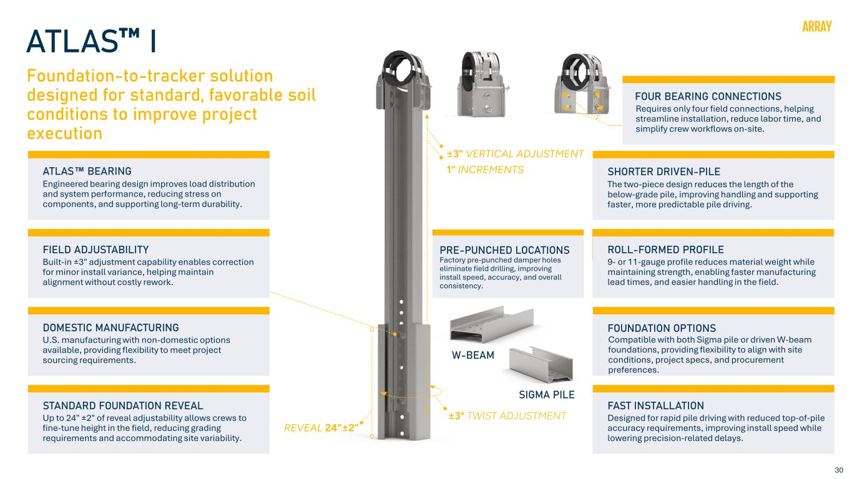
30 ATLAS I Foundation-to-tracker solution designed for standard, favorable soil conditions to improve project execution Pre-galvanized roll-formed sigma profile, available in 9 or 11 gauge. Shorter than a full W-beam, stiffer edge profile improves driving performance, less bending moment, less deformation risk during impact driving. Ideal for sandy soils and lean clays. Roll-formed C-channel (Pre-galvanized G90, 80ksi, 9 gauge) bolted to sigma or W- beam foundation. Never driven. Tracker interface is always pristine. Adjustable bolt- hole pattern allows height correction in the field. Bearing housing connection reduced to 4 bolts vs. 6 in the current ARRAY configuration. Configure 52°, 60° or 77° by changing bearing’s hard stop only - no stamping or bolts changes. W8 / W6 beam: Interface and bearing components are identical, only the driven pile changes. H-beam is best used for sites with high corrosion, high tracker loads, or stiffer/rockier soil conditions. ATLAS BEARING Engineered bearing design improves load distribution and system performance, reducing stress on components, and supporting long-term durability. W-BEAM SIGMA PILE FAST INSTALLATION Designed for rapid pile driving with reduced top-of-pile accuracy requirements, impr ving nstall speed while lowering precision-related delays. SHORTER DRIVEN-PILE The two-piece design reduces the length of the below-grade pile, improving handling and supporting faster, more predictable pile driving. FIELD ADJUSTABILITY Built-in ±3" adjustment capability enables correction for minor install variance, helping maintain alignment without costly rework. ROLL-FORMED PROFILE 9- or 11-gauge profile reduces material weight while maintaining strength, enabling faster manufacturing lead times, and easier handling in the field. PRE-PUNCHED LOCATIONS Factory pre-punched damper holes eliminate field drilling, improving install speed, accuracy, and overall consistency. FOUNDATION OPTIONS Compatible with both Sigma pile or driven W-beam foundations, providing flexibility to align with site conditions, project specs, and procurement preferences. DOMESTIC MANUFACTURING U.S. manufacturing with non-domestic options available, providing flexibility to meet project sourcing requirements. STANDARD FOUNDATION REVEAL Up to 24" ±2" of reveal adjustability allows crews to fine-tune height in the field, reducing grading requirements and accommodating site variability. FOUR BEARING CONNECTIONS Requires only four field connections, helping streamline installation, reduce labor time, and simplify crew workflows on-site.

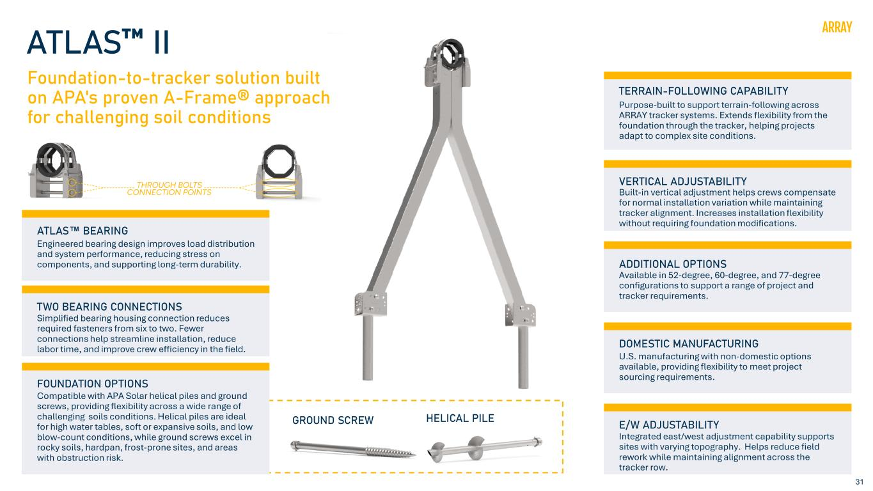
31 ATLAS II Foundation-to-tracker solution built on APA's proven A-Frame® approach for challenging soil conditions ATLAS BEARING Engineered bearing design improves load distribution and system performance, reducing stress on components, and supporting long-term durability. TWO BEARING CONNECTIONS Simplified bearing housing connection reduces required fasteners from six to two. Fewer connections help streamline installation, reduce labor time, and improve crew efficiency in the field. DOMESTIC MANUFACTURING U.S. manufacturing with non-domestic options available, providing flexibility to meet project sourcing requirements. E/W ADJUSTABILITY Integrated east/west adjustment capability supports sites with varying topography. Helps reduce field rework while maintaining alignment across the tracker row. GROUND SCREW HELICAL PILE ADDITIONAL OPTIONS Available in 52-degree, 60-degree, and 77-degree configurations to support a range of project and tracker requirements. TERRAIN-FOLLOWING CAPABILITY Purpose-built to support terrain-following across ARRAY tracker systems. Extends flexibility from the foundation through the tracker, helping projects adapt to complex site conditions. VERTICAL ADJUSTABILITY Built-in vertical adjustment helps crews compensate for normal installation variation while maintaining tracker alignment. Increases installation flexibility without requiring foundation modifications. FOUNDATION OPTIONS Compatible with APA Solar helical piles and ground screws, providing flexibility across a wide range of challenging soils conditions. Helical piles are ideal for high water tables, soft or expansive soils, and low blow-count conditions, while ground screws excel in rocky soils, hardpan, frost-prone sites, and areas with obstruction risk.

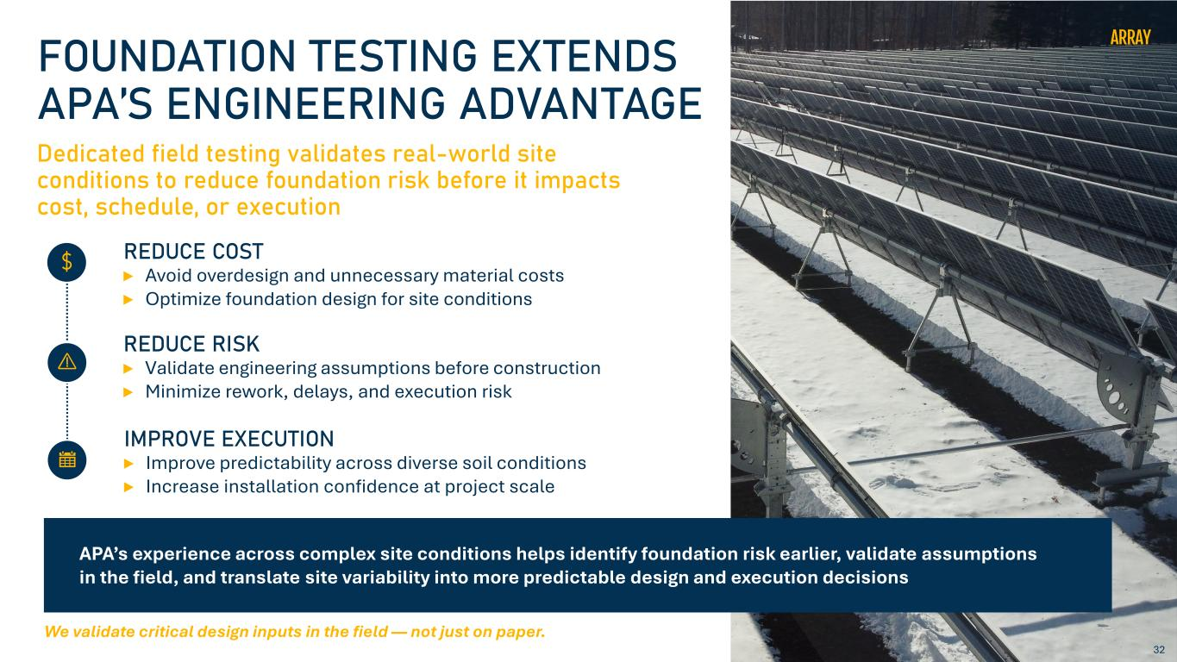
32 FOUNDATION TESTING EXTENDS APA’S ENGINEERING ADVANTAGE Dedicated field testing validates real-world site conditions to reduce foundation risk before it impacts cost, schedule, or execution REDUCE COST Avoid overdesign and unnecessary material costs Optimize foundation design for site conditions REDUCE RISK Validate engineering assumptions before construction Minimize rework, delays, and execution risk IMPROVE EXECUTION Improve predictability across diverse soil conditions Increase installation confidence at project scale APA’s experience across complex site conditions helps identify foundation risk earlier, validate assumptions in the field, and translate site variability into more predictable design and execution decisions We validate critical design inputs in the field — not just on paper.

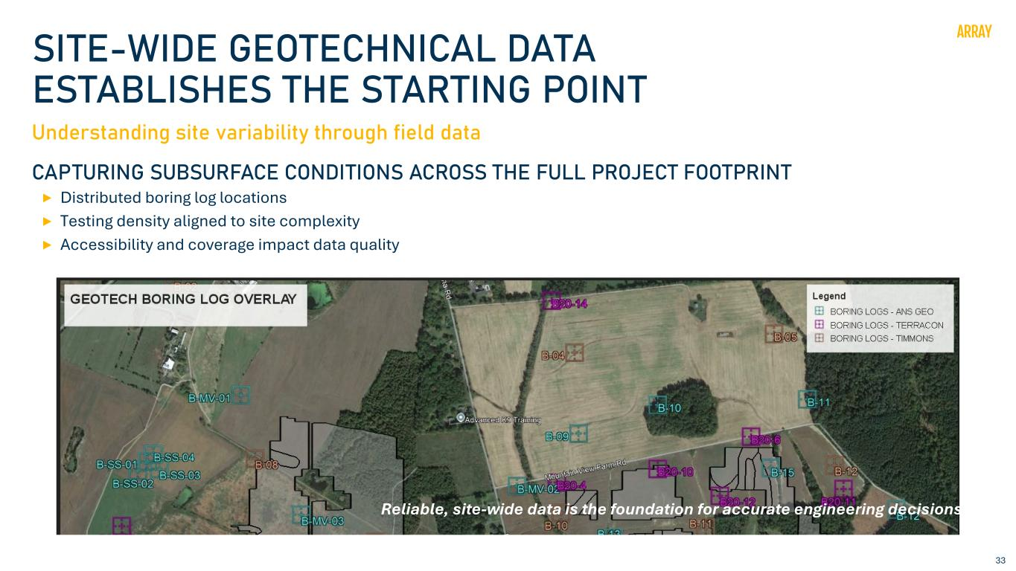
33 SITE-WIDE GEOTECHNICAL DATA ESTABLISHES THE STARTING POINT Understanding site variability through field data CAPTURING SUBSURFACE CONDITIONS ACROSS THE FULL PROJECT FOOTPRINT Distributed boring log locations Testing density aligned to site complexity Accessibility and coverage impact data quality Reliable, site-wide data is the foundation for accurate engineering decisions.

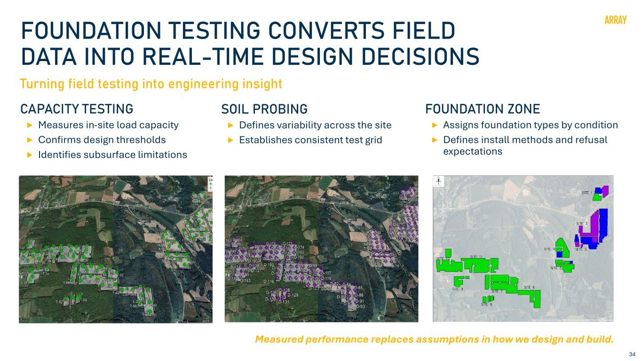
34 FOUNDATION TESTING CONVERTS FIELD DATA INTO REAL-TIME DESIGN DECISIONS Turning field testing into engineering insight CAPACITY TESTING Measures in-site load capacity Confirms design thresholds Identifies subsurface limitations SOIL PROBING Defines variability across the site Establishes consistent test grid FOUNDATION ZONE Assigns foundation types by condition Defines install methods and refusal expectations Measured performance replaces assumptions in how we design and build.

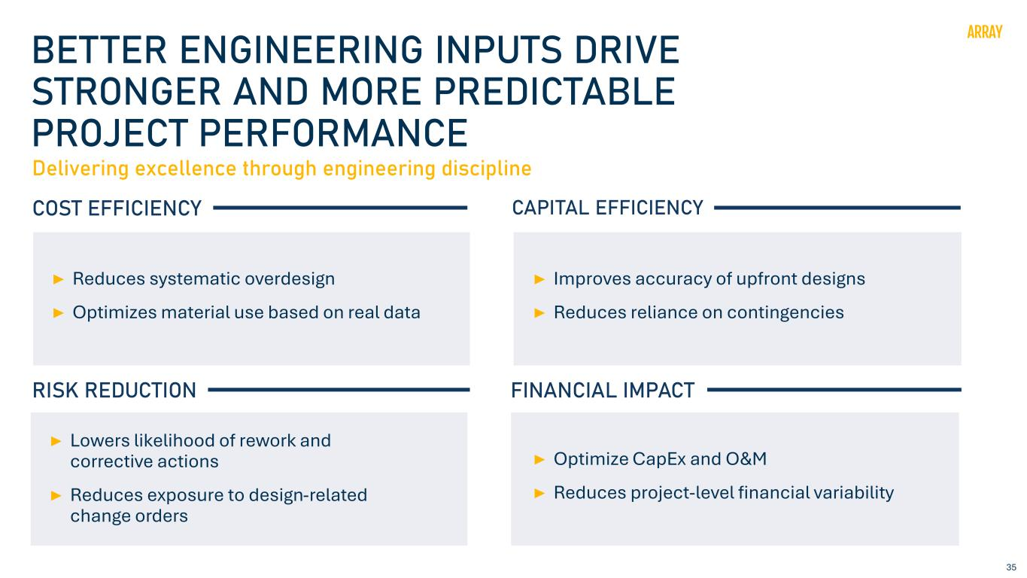
35 COST EFFICIENCY BETTER ENGINEERING INPUTS DRIVE STRONGER AND MORE PREDICTABLE PROJECT PERFORMANCE Reduces systematic overdesign Optimizes material use based on real data Delivering excellence through engineering discipline RISK REDUCTION Lowers likelihood of rework and corrective actions Reduces exposure to design-related change orders CAPITAL EFFICIENCY Improves accuracy of upfront designs Reduces reliance on contingencies FINANCIAL IMPACT Optimize CapEx and O&M Reduces project-level financial variability

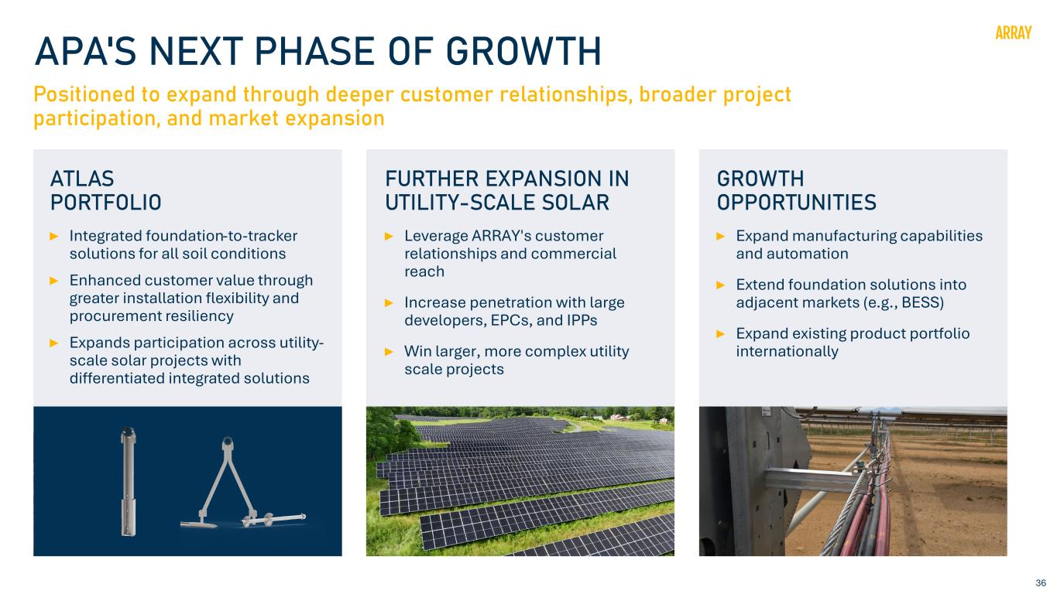
36 APA'S NEXT PHASE OF GROWTH Positioned to expand through deeper customer relationships, broader project participation, and market expansion FURTHER EXPANSION IN UTILITY-SCALE SOLAR Leverage ARRAY's customer relationships and commercial reach Increase penetration with large developers, EPCs, and IPPs Win larger, more complex utility scale projects GROWTH OPPORTUNITIES Expand manufacturing capabilities and automation Extend foundation solutions into adjacent markets (e.g., BESS) Expand existing product portfolio internationally ATLAS PORTFOLIO Integrated foundation-to-tracker solutions for all soil conditions Enhanced customer value through greater installation flexibility and procurement resiliency Expands participation across utility- scale solar projects with differentiated integrated solutions

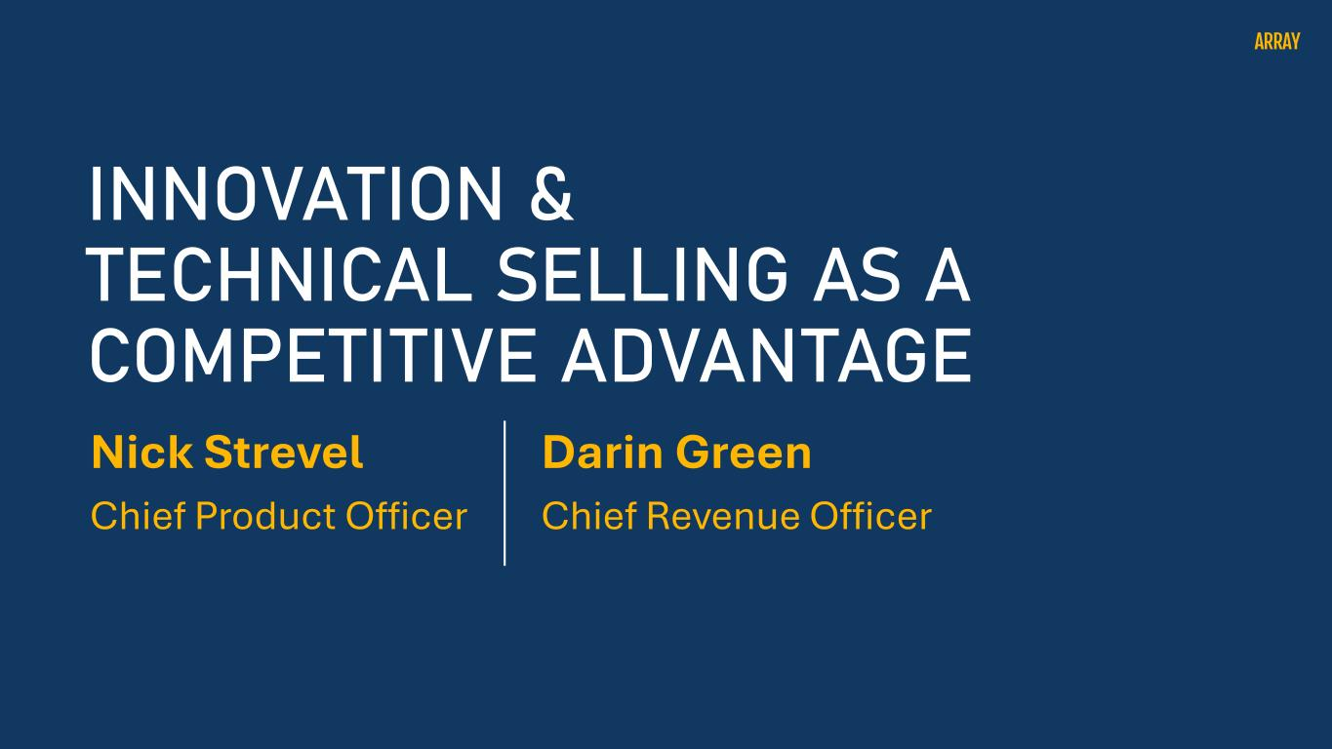
Nick Strevel Chief Product Officer INNOVATION & TECHNICAL SELLING AS A COMPETITIVE ADVANTAGE Darin Green Chief Revenue Officer

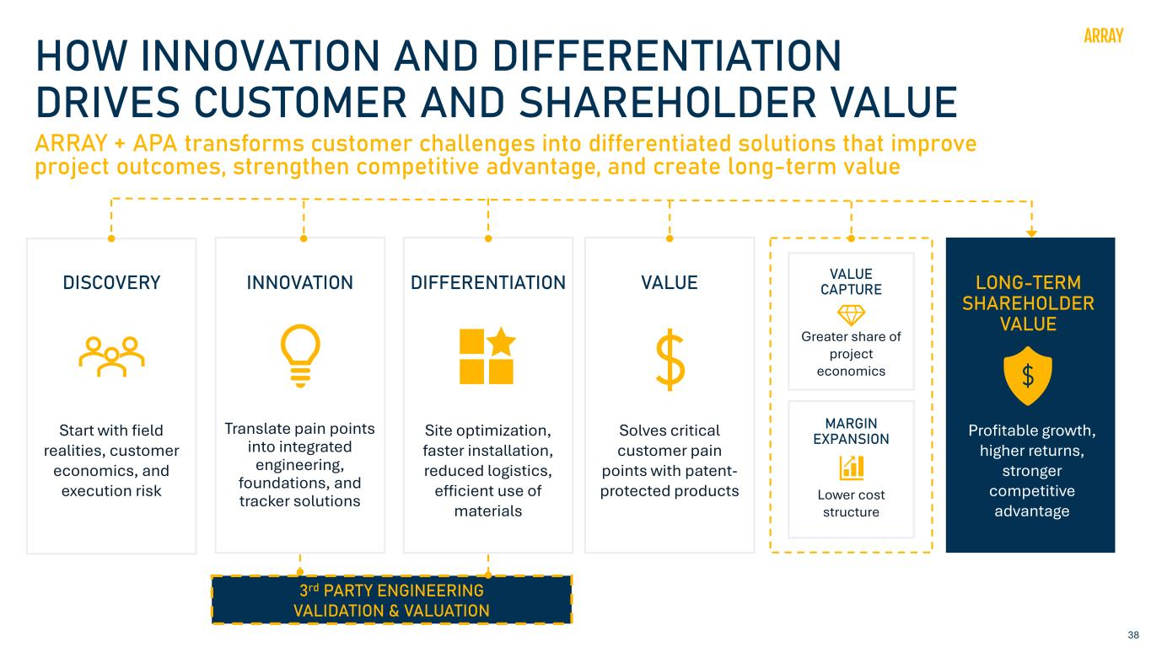
38 3rd PARTY ENGINEERING VALIDATION & VALUATION HOW INNOVATION AND DIFFERENTIATION DRIVES CUSTOMER AND SHAREHOLDER VALUE Greater share of project economics Lower cost structure INNOVATION DIFFERENTIATION VALUE VALUE CAPTURE MARGIN EXPANSION LONG-TERM SHAREHOLDER VALUE Site optimization, faster installation, reduced logistics, efficient use of materials ARRAY + APA transforms customer challenges into differentiated solutions that improve project outcomes, strengthen competitive advantage, and create long-term value DISCOVERY Translate pain points into integrated engineering, foundations, and tracker solutions Start with field realities, customer economics, and execution risk Solves critical customer pain points with patent- protected products Profitable growth, higher returns, stronger competitive advantage

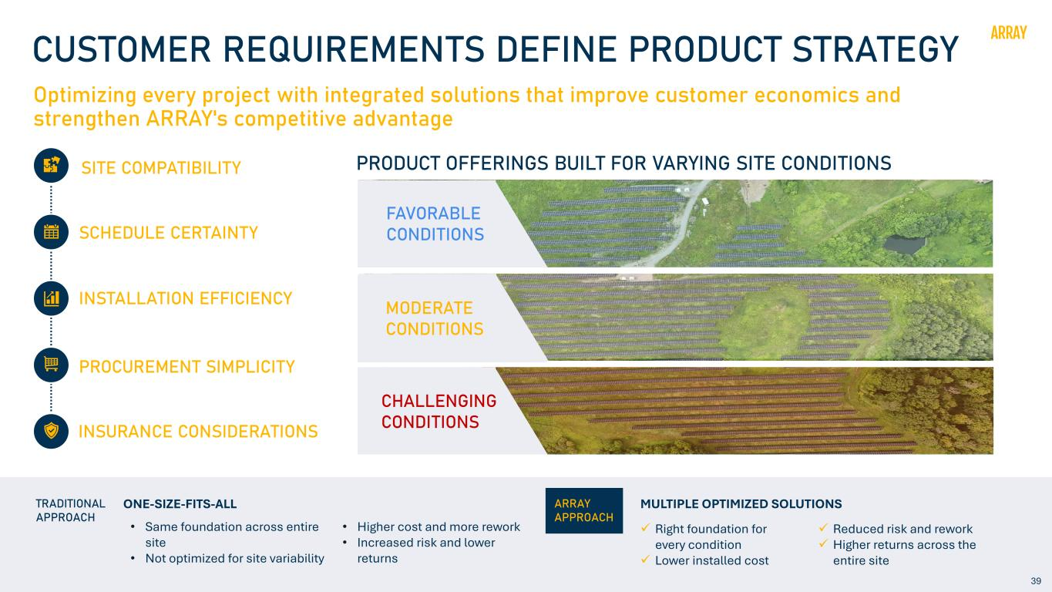
39 CUSTOMER REQUIREMENTS DEFINE PRODUCT STRATEGY Optimizing every project with integrated solutions that improve customer economics and strengthen ARRAY's competitive advantage SITE COMPATIBILITY SCHEDULE CERTAINTY INSTALLATION EFFICIENCY PROCUREMENT SIMPLICITY INSURANCE CONSIDERATIONS PRODUCT OFFERINGS BUILT FOR VARYING SITE CONDITIONS FAVORABLE CONDITIONS MODERATE CONDITIONS CHALLENGING CONDITIONS O E ATE CO ITIO S TRADITIONAL APPROACH ✓ Right foundation for every condition ✓ Lower installed cost ✓ Reduced risk and rework ✓ Higher returns across the entire site MULTIPLE OPTIMIZED SOLUTIONSONE-SIZE-FITS-ALL ARRAY APPROACH • Same foundation across entire site • Not optimized for site variability • Higher cost and more rework • Increased risk and lower returns

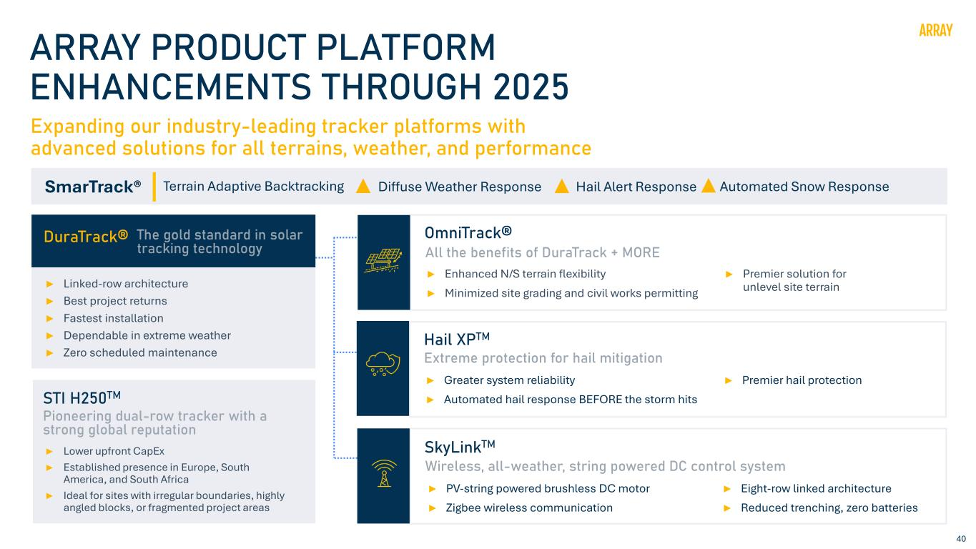
40 ARRAY PRODUCT PLATFORM ENHANCEMENTS THROUGH 2025 Expanding our industry-leading tracker platforms with advanced solutions for all terrains, weather, and performance DuraTrack® ► Linked-row architecture ► Best project returns ► Fastest installation ► Dependable in extreme weather ► Zero scheduled maintenance The gold standard in solar tracking technology SmarTrack® Terrain Adaptive Backtracking Diffuse Weather Response Hail Alert Response Automated Snow Response OmniTrack® ► Enhanced N/S terrain flexibility ► Minimized site grading and civil works permitting ► Premier solution for unlevel site terrain All the benefits of DuraTrack + MORE Hail XPTM Extreme protection for hail mitigation SkyLinkTM ► PV-string powered brushless DC motor ► Zigbee wireless communication ► Eight-row linked architecture ► Reduced trenching, zero batteries Wireless, all-weather, string powered DC control system ► Greater system reliability ► Automated hail response BEFORE the storm hits ► Premier hail protection STI H250TM ► Lower upfront CapEx ► Established presence in Europe, South America, and South Africa ► Ideal for sites with irregular boundaries, highly angled blocks, or fragmented project areas Pioneering dual-row tracker with a strong global reputation

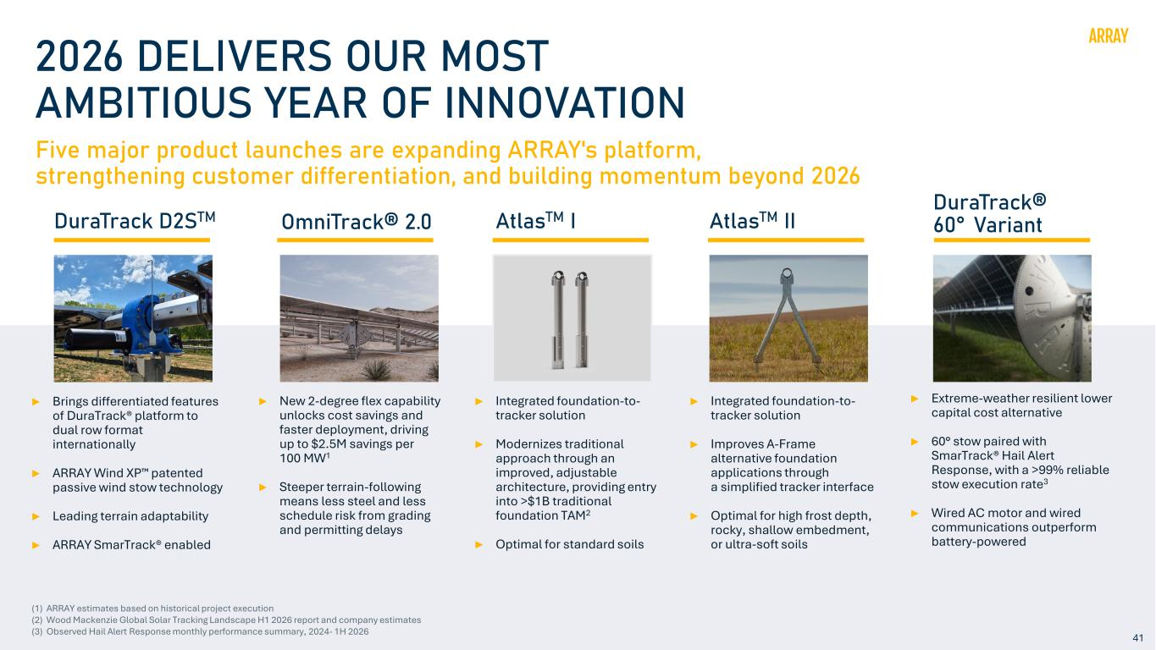
41 2026 DELIVERS OUR MOST AMBITIOUS YEAR OF INNOVATION ► Brings differentiated features of DuraTrack® platform to dual row format internationally ► ARRAY Wind XP patented passive wind stow technology ► Leading terrain adaptability ► ARRAY SmarTrack® enabled DuraTrack D2STM Five major product launches are expanding ARRAY's platform, strengthening customer differentiation, and building momentum beyond 2026 ► New 2-degree flex capability unlocks cost savings and faster deployment, driving up to $2.5M savings per 100 MW1 ► Steeper terrain-following means less steel and less schedule risk from grading and permitting delays OmniTrack® 2.0 ► Integrated foundation-to- tracker solution ► Modernizes traditional approach through an improved, adjustable architecture, providing entry into >$1B traditional foundation TAM2 ► Optimal for standard soils AtlasTM I ► Integrated foundation-to- tracker solution ► Improves A-Frame alternative foundation applications through a simplified tracker interface ► Optimal for high frost depth, rocky, shallow embedment, or ultra-soft soils AtlasTM II DuraTrack® 60° Variant ► Extreme-weather resilient lower capital cost alternative ► 60° stow paired with SmarTrack® Hail Alert Response, with a >99% reliable stow execution rate3 ► Wired AC motor and wired communications outperform battery-powered (1) ARRAY estimates based on historical project execution (2) Wood Mackenzie Global Solar Tracking Landscape H1 2026 report and company estimates (3) Observed Hail Alert Response monthly performance summary, 2024- 1H 2026

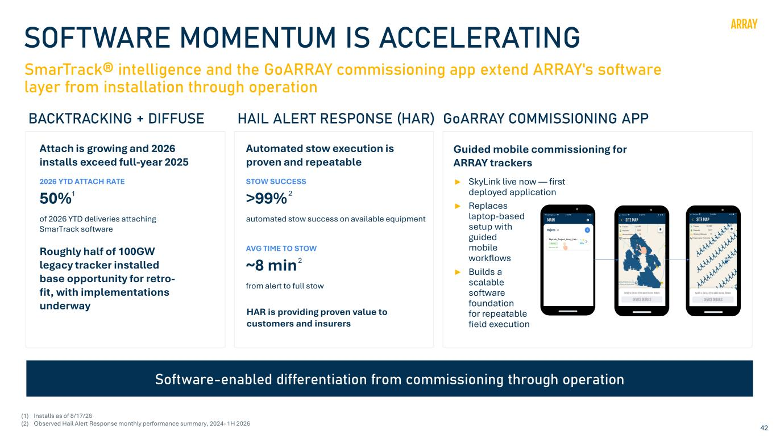
42 SOFTWARE MOMENTUM IS ACCELERATING SmarTrack® intelligence and the GoARRAY commissioning app extend ARRAY's software layer from installation through operation Attach is growing and 2026 installs exceed full-year 2025 2026 YTD ATTACH RATE 50% of 2026 YTD deliveries attaching SmarTrack software Automated stow execution is proven and repeatable STOW SUCCESS >99% automated stow success on available equipment AVG TIME TO STOW ~8 min from alert to full stow Guided mobile commissioning for ARRAY trackers Software-enabled differentiation from commissioning through operation BACKTRACKING + DIFFUSE HAIL ALERT RESPONSE (HAR) GoARRAY COMMISSIONING APP (1) Installs as of 8/17/26 (2) Observed Hail Alert Response monthly performance summary, 2024- 1H 2026 Roughly half of 100GW legacy tracker installed base opportunity for retro- fit, with implementations underway HAR is providing proven value to customers and insurers ► SkyLink live now — first deployed application ► Replaces laptop-based setup with guided mobile workflows ► Builds a scalable software foundation for repeatable field execution 1 2 2

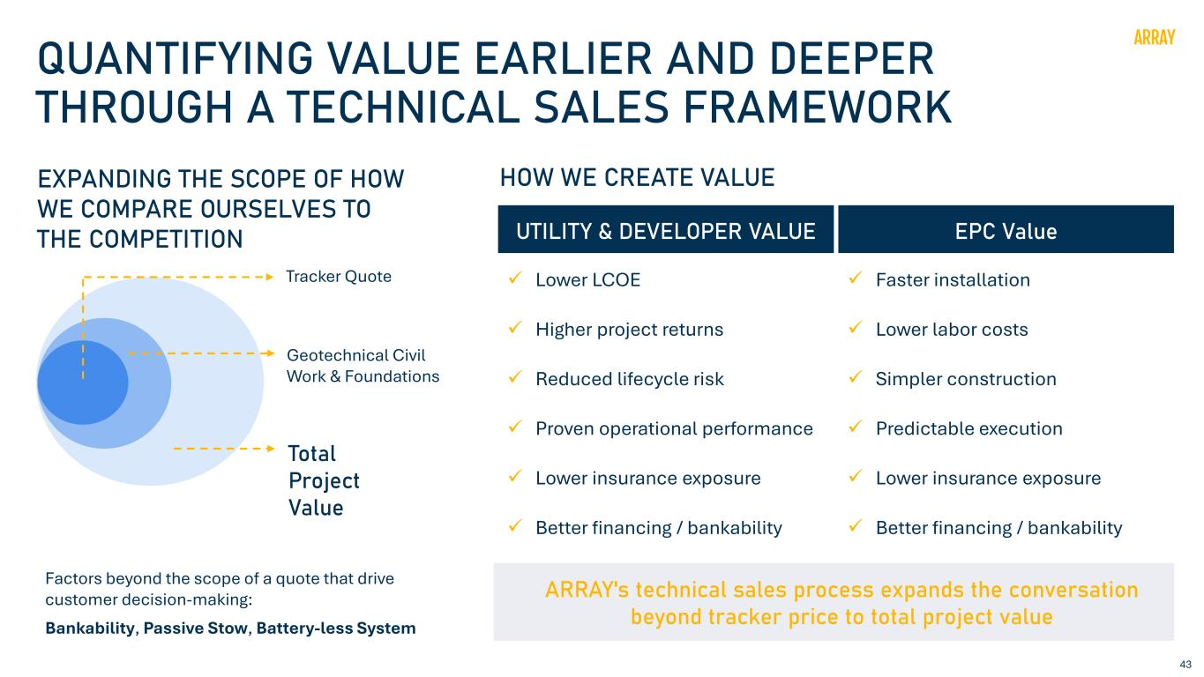
43 QUANTIFYING VALUE EARLIER AND DEEPER THROUGH A TECHNICAL SALES FRAMEWORK EXPANDING THE SCOPE OF HOW WE COMPARE OURSELVES TO THE COMPETITION Factors beyond the scope of a quote that drive customer decision-making: Bankability, Passive Stow, Battery-less System HOW WE CREATE VALUE Geotechnical Civil Work & Foundations Total Project Value ARRAY's technical sales process expands the conversation beyond tracker price to total project value UTILITY & DEVELOPER VALUE ✓ Lower LCOE ✓ Higher project returns ✓ Reduced lifecycle risk ✓ Proven operational performance ✓ Lower insurance exposure ✓ Better financing / bankability Tracker Quote EPC Value ✓ Faster installation ✓ Lower labor costs ✓ Simpler construction ✓ Predictable execution ✓ Lower insurance exposure ✓ Better financing / bankability

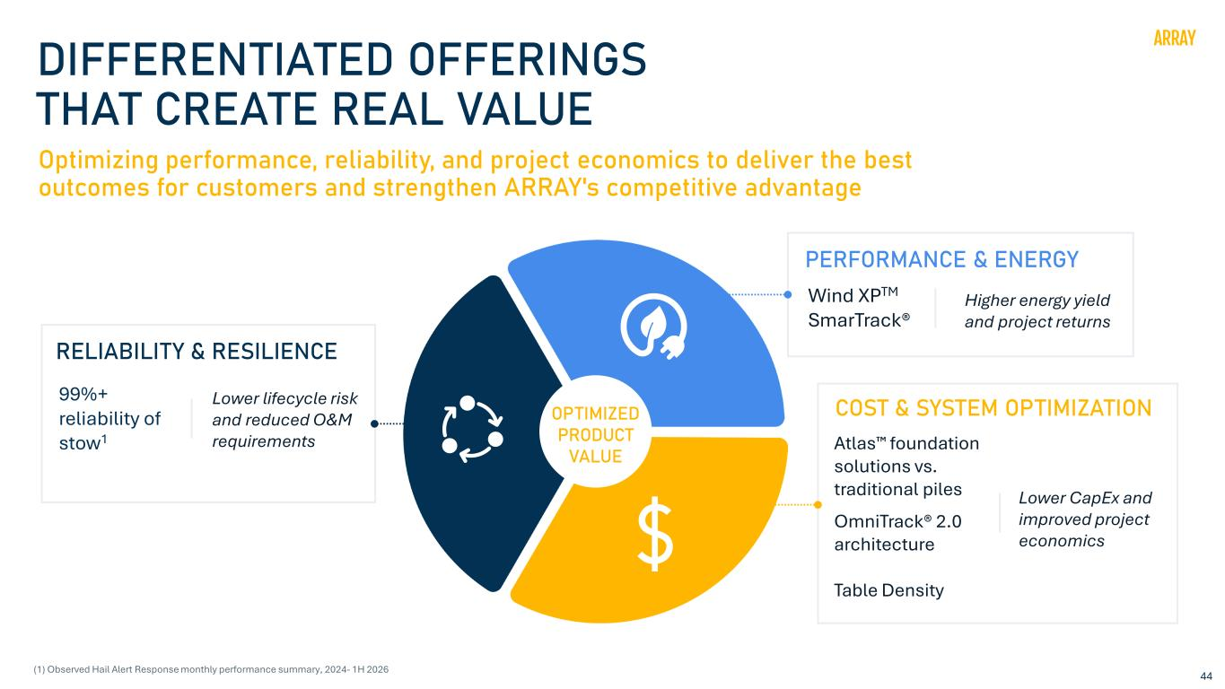
44 OPTIMIZED PRODUCT VALUE DIFFERENTIATED OFFERINGS THAT CREATE REAL VALUE Optimizing performance, reliability, and project economics to deliver the best outcomes for customers and strengthen ARRAY's competitive advantage PERFORMANCE & ENERGY Higher energy yield and project returns COST & SYSTEM OPTIMIZATION Atlas foundation solutions vs. traditional piles OmniTrack® 2.0 architecture Table Density Lower CapEx and improved project economics RELIABILITY & RESILIENCE 99%+ reliability of stow1 Lower lifecycle risk and reduced O&M requirements Wind XPTM SmarTrack® (1) Observed Hail Alert Response monthly performance summary, 2024- 1H 2026

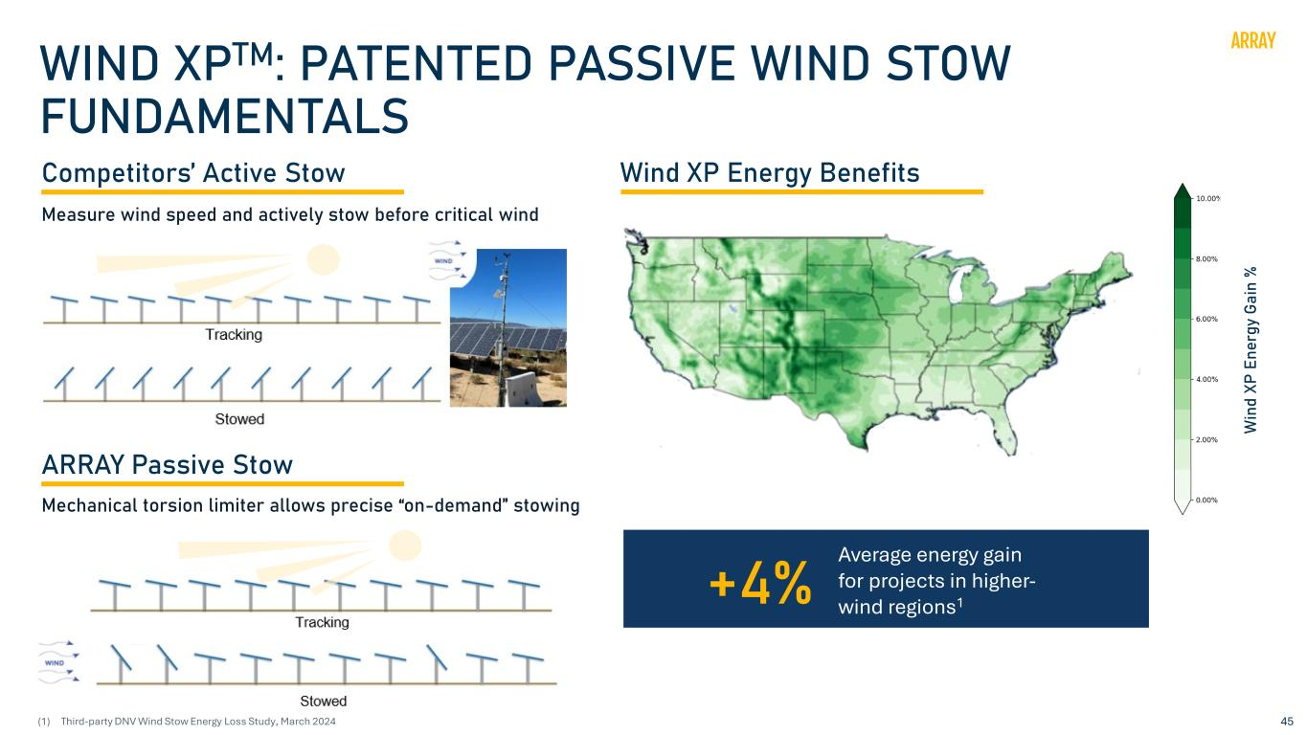
45 WIND XPTM: PATENTED PASSIVE WIND STOW FUNDAMENTALS +4% Average energy gain for projects in higher- wind regions1 Competitors’ Active Stow Wind XP Energy Benefits ARRAY Passive Stow Measure wind speed and actively stow before critical wind W in d XP E ne rg y Ga in % Mechanical torsion limiter allows precise “on-demand” stowing (1) Third-party DNV Wind Stow Energy Loss Study, March 2024

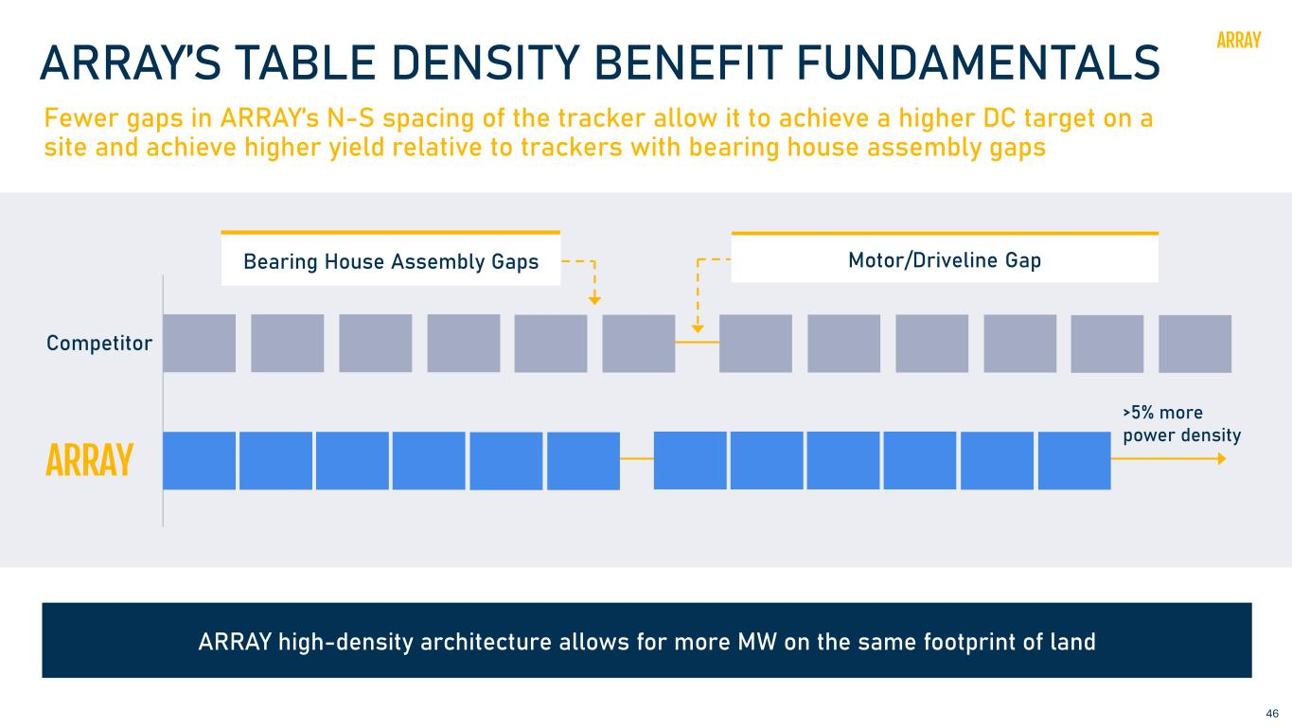
46 ARRAY’S TABLE DENSITY BENEFIT FUNDAMENTALS Fewer gaps in ARRAY’s N-S spacing of the tracker allow it to achieve a higher DC target on a site and achieve higher yield relative to trackers with bearing house assembly gaps Bearing House Assembly Gaps Competitor Motor/Driveline Gap >5% more power density ARRAY high-density architecture allows for more MW on the same footprint of land

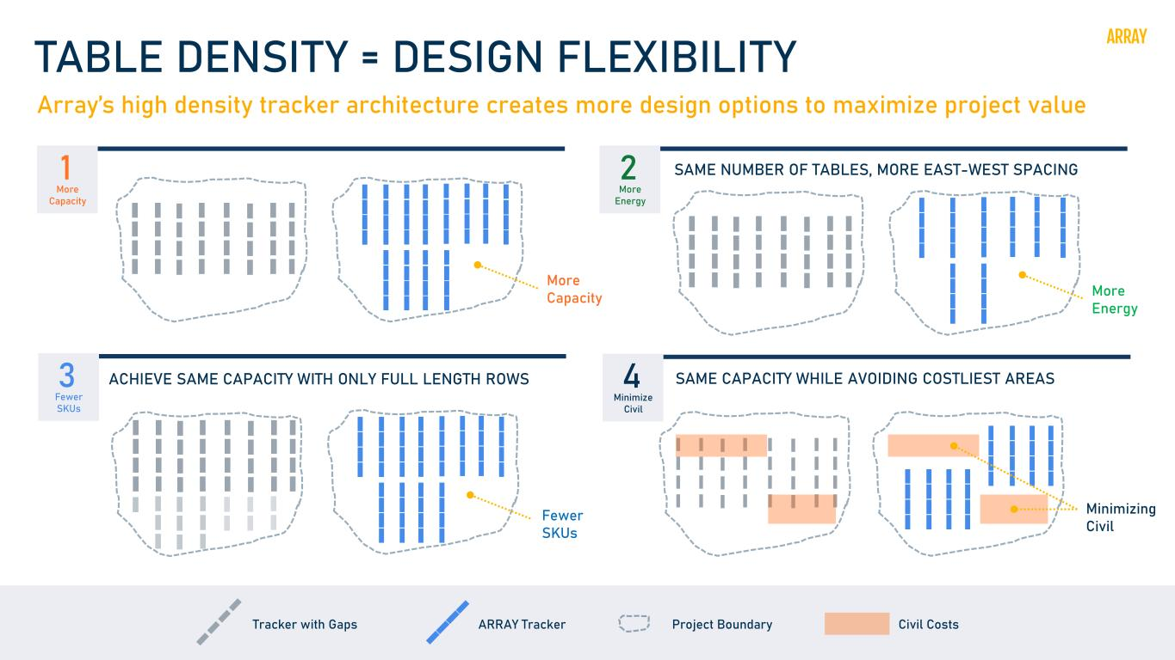
47 TABLE DENSITY = DESIGN FLEXIBILITY Array’s high density tracker architecture creates more design options to maximize project value More Capacity SAME NUMBER OF TABLES, MORE EAST-WEST SPACING SAME CAPACITY WHILE AVOIDING COSTLIEST AREAS Minimizing Civil ACHIEVE SAME CAPACITY WITH ONLY FULL LENGTH ROWS Fewer SKUs More Energy ARRAY TrackerTracker with Gaps Project Boundary Civil Costs 1 More Capacity 3 Fewer SKUs 2 More Energy 4 Minimize Civil

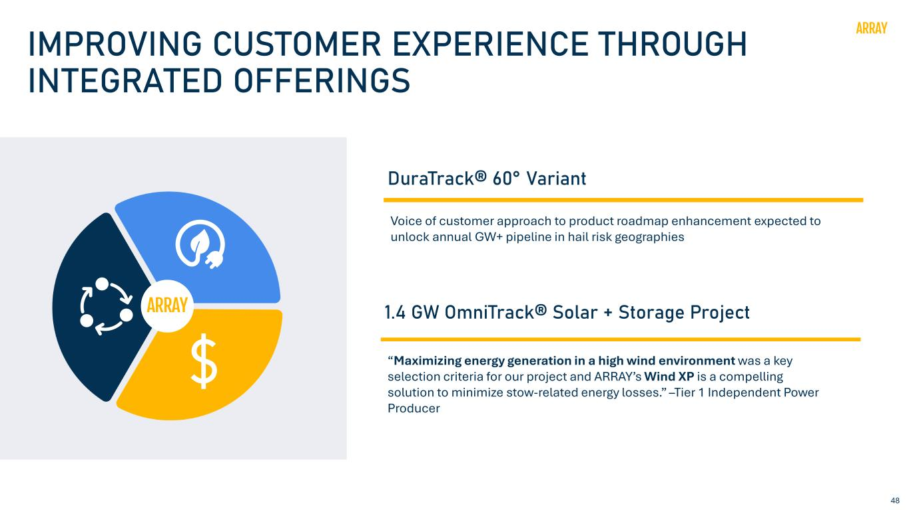
48 IMPROVING CUSTOMER EXPERIENCE THROUGH INTEGRATED OFFERINGS “Maximizing energy generation in a high wind environment was a key selection criteria for our project and ARRAY’s Wind XP is a compelling solution to minimize stow-related energy losses.” –Tier 1 Independent Power Producer 1.4 GW OmniTrack® Solar + Storage Project DuraTrack® 60° Variant Voice of customer approach to product roadmap enhancement expected to unlock annual GW+ pipeline in hail risk geographies

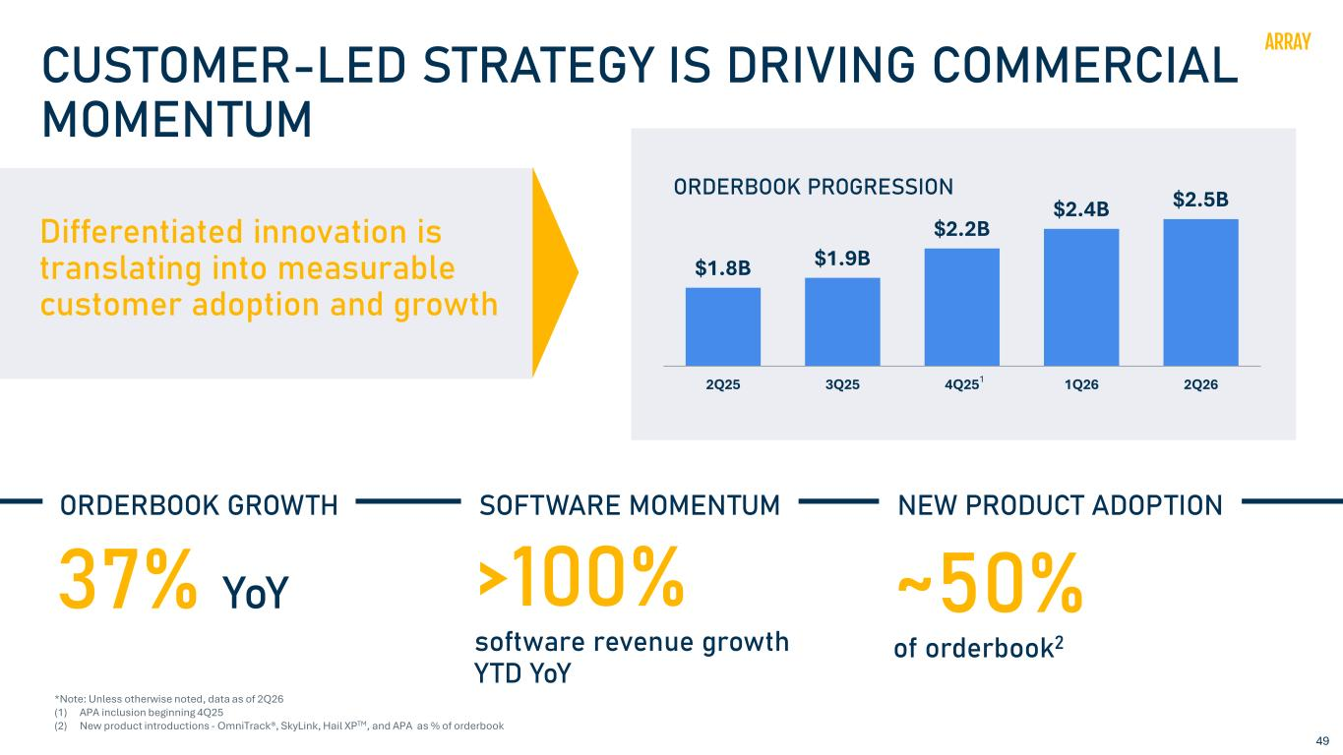
49 CUSTOMER-LED STRATEGY IS DRIVING COMMERCIAL MOMENTUM Differentiated innovation is translating into measurable customer adoption and growth ORDERBOOK GROWTH SOFTWARE MOMENTUM NEW PRODUCT ADOPTION 37% YoY >100% software revenue growth YTD YoY ~50% of orderbook2 $1.8B $1.9B $2.2B $2.4B $2.5B 2Q25 3Q25 4Q25 1Q26 2Q26 ORDERBOOK PROGRESSION *Note: Unless otherwise noted, data as of 2Q26 (1) APA inclusion beginning 4Q25 (2) New product introductions - OmniTrack®, SkyLink, Hail XPTM, and APA as % of orderbook 1

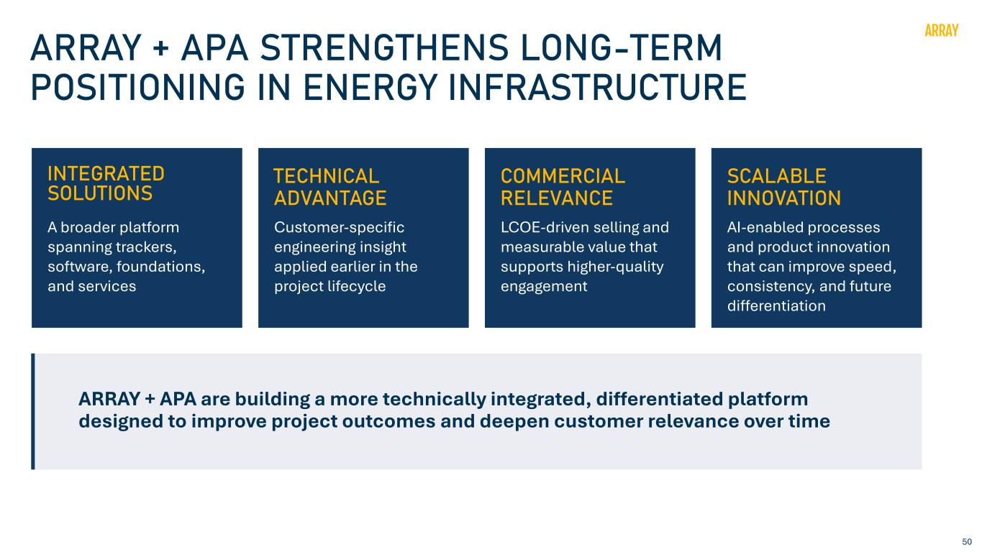
50 ARRAY + APA STRENGTHENS LONG-TERM POSITIONING IN ENERGY INFRASTRUCTURE INTEGRATED SOLUTIONS A broader platform spanning trackers, software, foundations, and services ARRAY + APA are building a more technically integrated, differentiated platform designed to improve project outcomes and deepen customer relevance over time TECHNICAL ADVANTAGE Customer-specific engineering insight applied earlier in the project lifecycle COMMERCIAL RELEVANCE LCOE-driven selling and measurable value that supports higher-quality engagement SCALABLE INNOVATION AI-enabled processes and product innovation that can improve speed, consistency, and future differentiation

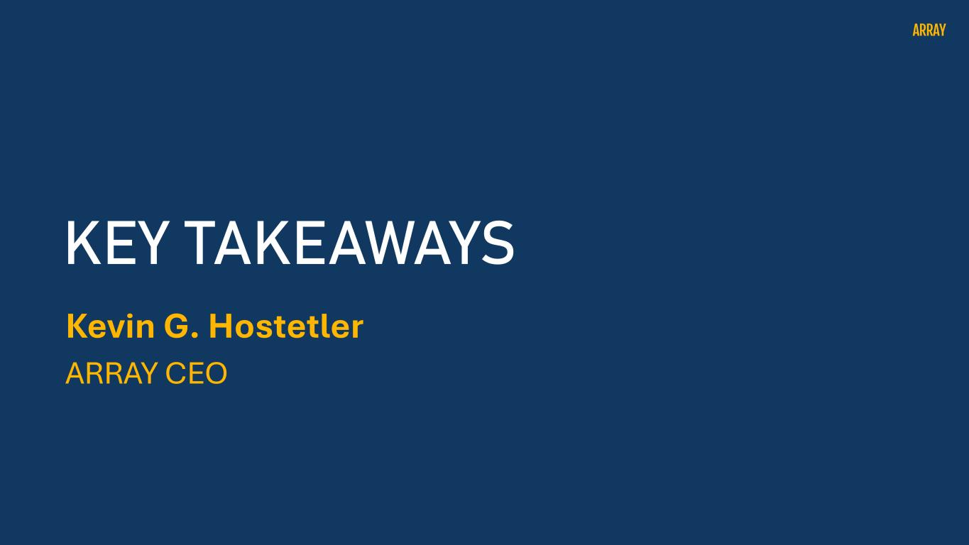
Kevin G. Hostetler ARRAY CEO KEY TAKEAWAYS

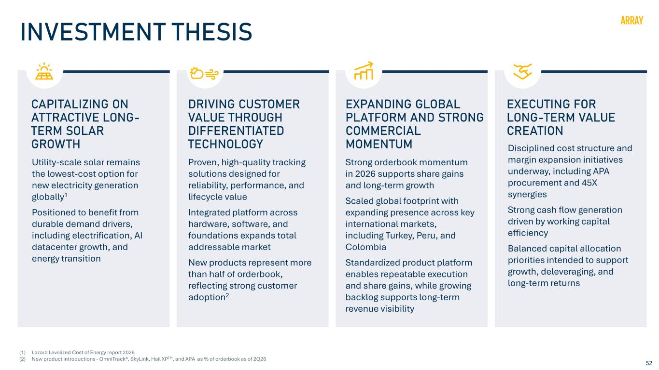
52 INVESTMENT THESIS CAPITALIZING ON ATTRACTIVE LONG- TERM SOLAR GROWTH Utility-scale solar remains the lowest-cost option for new electricity generation globally1 Positioned to benefit from durable demand drivers, including electrification, AI datacenter growth, and energy transition DRIVING CUSTOMER VALUE THROUGH DIFFERENTIATED TECHNOLOGY Proven, high-quality tracking solutions designed for reliability, performance, and lifecycle value Integrated platform across hardware, software, and foundations expands total addressable market New products represent more than half of orderbook, reflecting strong customer adoption2 EXPANDING GLOBAL PLATFORM AND STRONG COMMERCIAL MOMENTUM Strong orderbook momentum in 2026 supports share gains and long-term growth Scaled global footprint with expanding presence across key international markets, including Turkey, Peru, and Colombia Standardized product platform enables repeatable execution and share gains, while growing backlog supports long-term revenue visibility EXECUTING FOR LONG-TERM VALUE CREATION Disciplined cost structure and margin expansion initiatives underway, including APA procurement and 45X synergies Strong cash flow generation driven by working capital efficiency Balanced capital allocation priorities intended to support growth, deleveraging, and long-term returns (1) Lazard Levelized Cost of Energy report 2026 (2) New product introductions - OmniTrack®, SkyLink, Hail XPTM, and APA as % of orderbook as of 2Q26

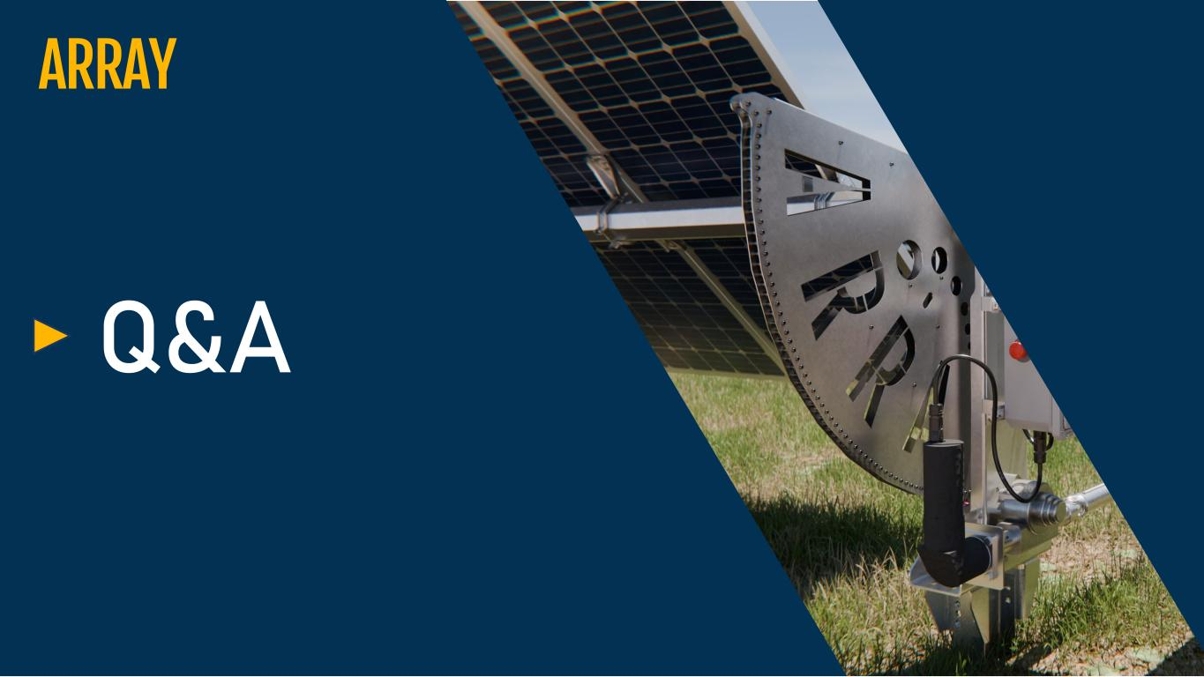
Q&A

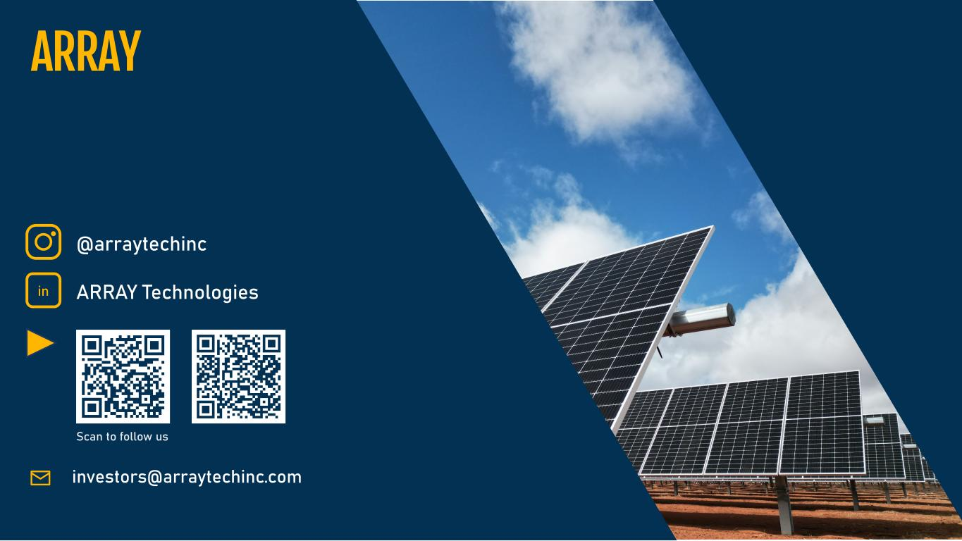
investors@arraytechinc.com @arraytechinc Scan to follow us in ARRAY Technologies

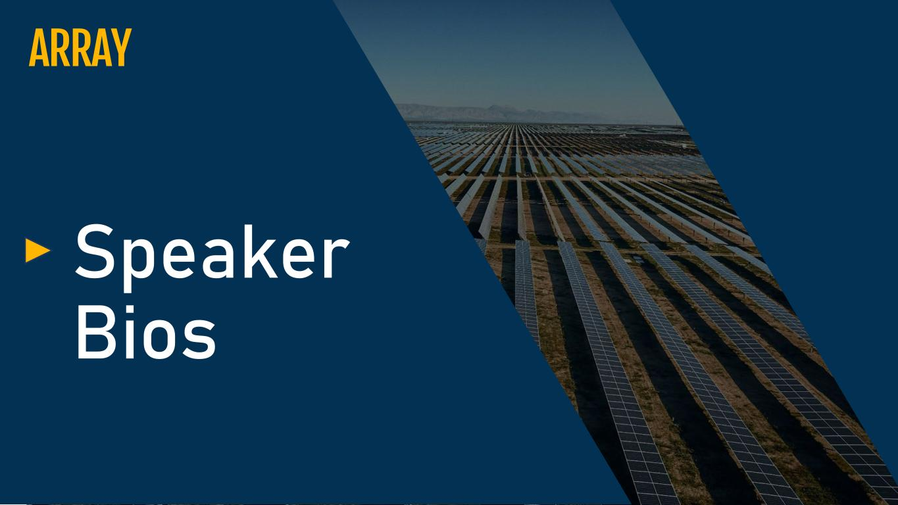
Speaker Bios

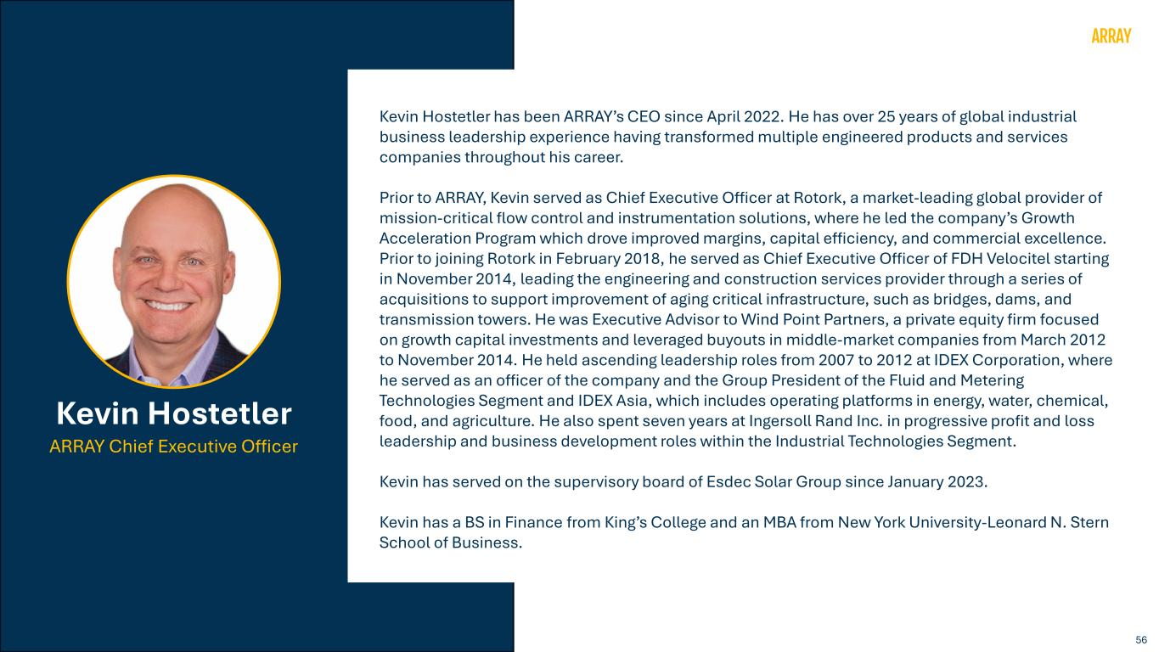
56 Kevin Hostetler has been ARRAY’s CEO since April 2022. He has over 25 years of global industrial business leadership experience having transformed multiple engineered products and services companies throughout his career. Prior to ARRAY, Kevin served as Chief Executive Officer at Rotork, a market-leading global provider of mission-critical flow control and instrumentation solutions, where he led the company’s Growth Acceleration Program which drove improved margins, capital efficiency, and commercial excellence. Prior to joining Rotork in February 2018, he served as Chief Executive Officer of FDH Velocitel starting in November 2014, leading the engineering and construction services provider through a series of acquisitions to support improvement of aging critical infrastructure, such as bridges, dams, and transmission towers. He was Executive Advisor to Wind Point Partners, a private equity firm focused on growth capital investments and leveraged buyouts in middle-market companies from March 2012 to November 2014. He held ascending leadership roles from 2007 to 2012 at IDEX Corporation, where he served as an officer of the company and the Group President of the Fluid and Metering Technologies Segment and IDEX Asia, which includes operating platforms in energy, water, chemical, food, and agriculture. He also spent seven years at Ingersoll Rand Inc. in progressive profit and loss leadership and business development roles within the Industrial Technologies Segment. Kevin has served on the supervisory board of Esdec Solar Group since January 2023. Kevin has a BS in Finance from King’s College and an MBA from New York University-Leonard N. Stern School of Business. Kevin Hostetler ARRAY Chief Executive Officer

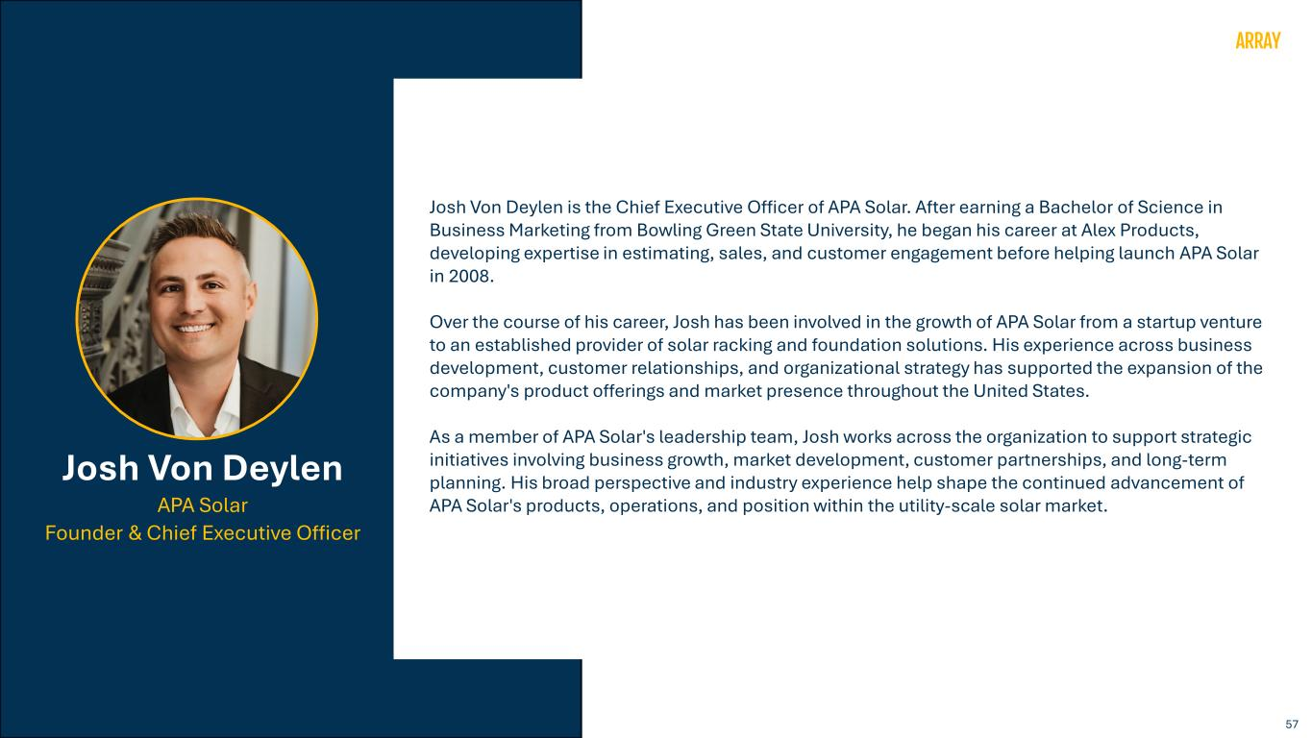
57 Josh Von Deylen is the Chief Executive Officer of APA Solar. After earning a Bachelor of Science in Business Marketing from Bowling Green State University, he began his career at Alex Products, developing expertise in estimating, sales, and customer engagement before helping launch APA Solar in 2008. Over the course of his career, Josh has been involved in the growth of APA Solar from a startup venture to an established provider of solar racking and foundation solutions. His experience across business development, customer relationships, and organizational strategy has supported the expansion of the company's product offerings and market presence throughout the United States. As a member of APA Solar's leadership team, Josh works across the organization to support strategic initiatives involving business growth, market development, customer partnerships, and long-term planning. His broad perspective and industry experience help shape the continued advancement of APA Solar's products, operations, and position within the utility-scale solar market. Josh Von Deylen APA Solar Founder & Chief Executive Officer

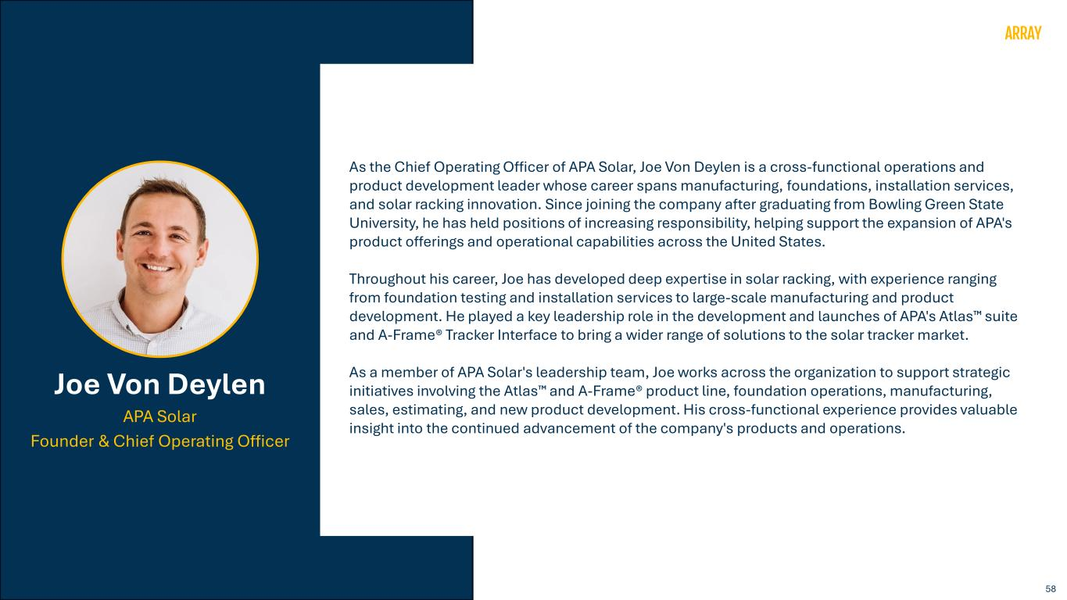
58 As the Chief Operating Officer of APA Solar, Joe Von Deylen is a cross-functional operations and product development leader whose career spans manufacturing, foundations, installation services, and solar racking innovation. Since joining the company after graduating from Bowling Green State University, he has held positions of increasing responsibility, helping support the expansion of APA's product offerings and operational capabilities across the United States. Throughout his career, Joe has developed deep expertise in solar racking, with experience ranging from foundation testing and installation services to large-scale manufacturing and product development. He played a key leadership role in the development and launches of APA's Atlas suite and A-Frame® Tracker Interface to bring a wider range of solutions to the solar tracker market. As a member of APA Solar's leadership team, Joe works across the organization to support strategic initiatives involving the Atlas and A-Frame® product line, foundation operations, manufacturing, sales, estimating, and new product development. His cross-functional experience provides valuable insight into the continued advancement of the company's products and operations. Joe Von Deylen APA Solar Founder & Chief Operating Officer

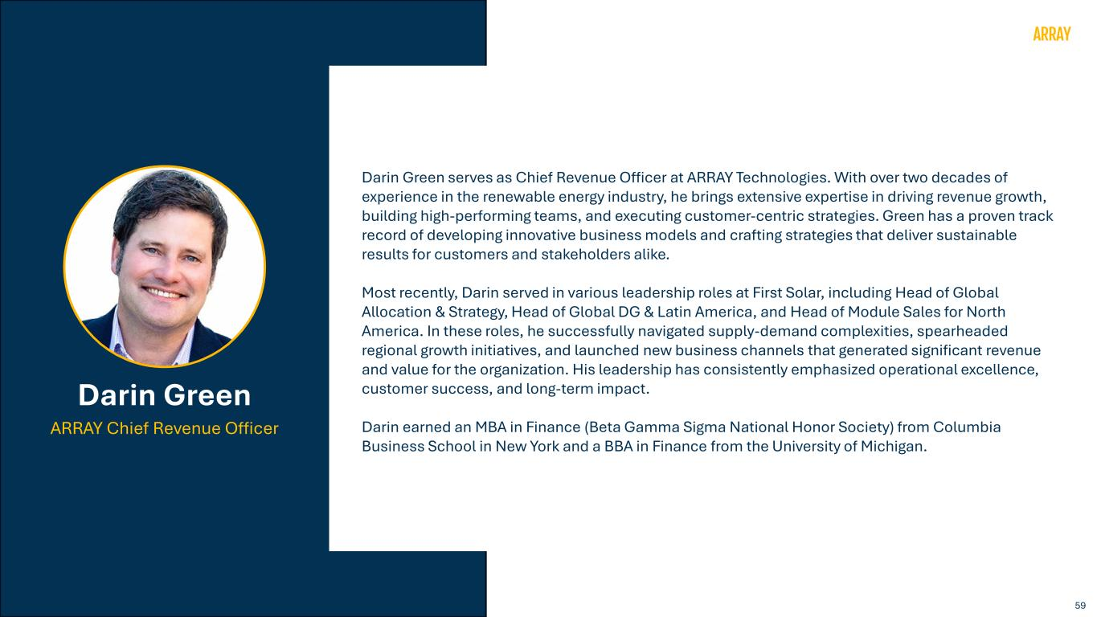
59 Darin Green serves as Chief Revenue Officer at ARRAY Technologies. With over two decades of experience in the renewable energy industry, he brings extensive expertise in driving revenue growth, building high-performing teams, and executing customer-centric strategies. Green has a proven track record of developing innovative business models and crafting strategies that deliver sustainable results for customers and stakeholders alike. Most recently, Darin served in various leadership roles at First Solar, including Head of Global Allocation & Strategy, Head of Global DG & Latin America, and Head of Module Sales for North America. In these roles, he successfully navigated supply-demand complexities, spearheaded regional growth initiatives, and launched new business channels that generated significant revenue and value for the organization. His leadership has consistently emphasized operational excellence, customer success, and long-term impact. Darin earned an MBA in Finance (Beta Gamma Sigma National Honor Society) from Columbia Business School in New York and a BBA in Finance from the University of Michigan. Darin Green ARRAY Chief Revenue Officer

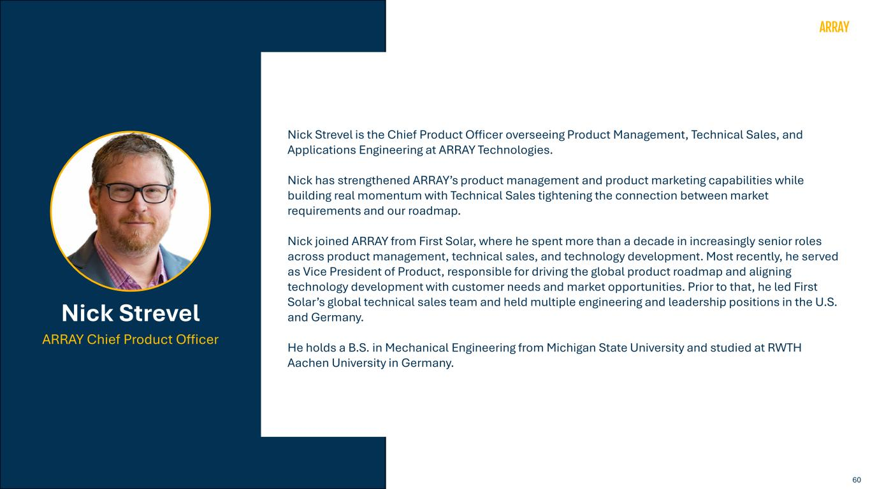
60 Nick Strevel is the Chief Product Officer overseeing Product Management, Technical Sales, and Applications Engineering at ARRAY Technologies. Nick has strengthened ARRAY’s product management and product marketing capabilities while building real momentum with Technical Sales tightening the connection between market requirements and our roadmap. Nick joined ARRAY from First Solar, where he spent more than a decade in increasingly senior roles across product management, technical sales, and technology development. Most recently, he served as Vice President of Product, responsible for driving the global product roadmap and aligning technology development with customer needs and market opportunities. Prior to that, he led First Solar’s global technical sales team and held multiple engineering and leadership positions in the U.S. and Germany. He holds a B.S. in Mechanical Engineering from Michigan State University and studied at RWTH Aachen University in Germany. Nick Strevel ARRAY Chief Product Officer

