UNITED STATES

SECURITIES AND EXCHANGE COMMISSION
WASHINGTON, D.C. 20549

FORM 8-K

CURRENT REPORT

Pursuant to Section 13 or 15(d)

of the Securities Exchange Act of 1934

Date of Report (Date of Earliest Event Reported): November 11, 2021

ARRAY TECHNOLOGIES, INC.

(Exact Name of Registrant as Specified in its Charter)

Delaware | 001-39613 | 83-2747826
(State or Other Jurisdiction | (Commission | (IRS Employer
of Incorporation) | File Number) | Identification No.)

3901 Midway Place NE

Albuquerque, New Mexico 87109
(Address of Principal Executive Offices) (Zip Code)

Registrant’s telephone number, including area code: (505) 881-7567

Check the appropriate box below if the Form 8-K filing is intended to simultaneously satisfy the filing obligation of the registrant under any of the following provisions:

- Written communications pursuant to Rule 425 under the Securities Act (17 CFR 230.425)

- Soliciting material pursuant to Rule 14a-12 under the Exchange Act (17 CFR 240.14a-12)

- Pre-commencement communications pursuant to Rule 14d-2(b) under the Exchange Act (17 CFR 240.14d-2(b))

- Pre-commencement communications pursuant to Rule 13e-4(c) under the Exchange Act (17 CFR 240.13e-4(c))

Securities registered pursuant to Section 12(b) of the Act:

 |  | Trading |  | Name of each exchange
Title of each class |  | Symbol(s) |  | on which registered
Common Stock, $0.001 Par Value |  | ARRY |  | Nasdaq Global Market

Indicate by check mark whether the registrant is an emerging growth company as defined in Rule 405 of the Securities Act of 1933 (§230.405 of this chapter) or Rule 12b-2 of the Securities Exchange Act of 1934 (§240.12b-2 of this chapter).

Emerging growth company ☒

If an emerging growth company, indicate by check mark if the registrant has elected not to use the extended transition period for complying with any new or revised financial accounting standards provided pursuant to Section 13(a) of the Exchange Act. ☐

Item 1.01 Entry Into a Material Definitive Agreement.

Purchase Agreement

On November 10, 2021, Array Tech, Inc. (“Buyer”), a wholly-owned subsidiary of Array Technologies, Inc., a Delaware corporation (the “Company,” “we,” “us” or “our”) entered into a definitive agreement (the “Purchase Agreement”) with Amixa Capital, S.L. and Aurica Trackers, S.L., each a company duly organized under the laws of the Kingdom of Spain (together, the “Sellers”) and Mr. Javier Reclusa Etayo for the specified purposes thereunder, pursuant to which the Company agreed to acquire 100% of the share capital of Soluciones Técnicas Integrales Norland, S.L., a Spanish private limited liability company, and its subsidiaries (collectively, “STI”) (the “Transaction”).

The board of directors of the Company has approved the Purchase Agreement and the Transaction.

Pursuant to the terms of the Purchase Agreement, the consideration to be paid by the Company in the Transaction consists of €342 million (approximately $396 million) in cash (the “Cash Consideration”) and 13,894,800 shares of the Company’s common stock (the “Equity Consideration”), based on the volume-weighted average closing price of the Company’s common stock, par value $0.001 per share (“Common Stock”) for the sixty (60) trading days period immediately preceding the date of the Purchase Agreement, converted into Euros at the Agreed USD/Euro Exchange Rate (as defined in the Purchase Agreement) and subject to a collar price between $19 and $22, subject to certain purchase price adjustments to be calculated as of the closing date (with all post-effective date purchase price adjustments netted against the Cash Consideration). The Purchase Agreement contains customary representations and warranties, covenants and indemnification provisions for cross-border transactions.

The Purchase Agreement also provides customary termination rights for both the Buyer and Sellers for a cross-border transaction.

In connection with the entry into the Purchase Agreement, the Company entered into a debt commitment letter dated November 10, 2021 pursuant to which third party financial institutions have committed, subject to the satisfaction of standard conditions, to provide the Company with a bridge loan facility in aggregate principal amount of up to $300 million. The Company currently intends to finance the transaction and related fees and expenses with cash on hand, borrowings under its senior credit facilities, proceeds from our option to require the holders of our Series A Perpetual Preferred Stock (the “Preferred Shares”) to purchase additional Preferred Shares, and through one or more debt capital markets transactions, subject to market conditions and other factors, and, only to the extent necessary, borrowings under the bridge loan facility.

In connection with the closing of the Transaction, the Company will enter into a registration rights agreement (the “Registration Rights Agreement”) with certain affiliates of STI (the “Holders”) that will receive a portion of the Stock Consideration to be issued at the closing of the Transaction (the “Issuance”). Pursuant to the Registration Rights Agreement, among other things, the Company is required to file with the Securities and Exchange Commission (the “SEC”) a registration statement registering for resale the shares of the Company’s common stock received by the Holders as part of the Issuance. The Registration Rights Agreement also provides, among other things, that each Holder will agree not to sell its portion of the Stock Consideration received in the Issuance for 180 days following the closing of the Transaction (the “Lock-Up Period); provided, however, the Lock-Up (as defined below) shall expire in respect of 20% of each Holder’s Registrable Securities (as defined in the Registration Rights Agreement) if for ten consecutive trading days beginning on the date that is three months after the date of the Registration Rights Agreement and prior to the expiration of the Lock-Up Period, the closing price of the Company’s Common Stock exceeds by 20% or more the price of the Company’s Common Stock at the date of the Registration Rights Agreement (the “Lock-Up”). Additionally, certain members of STI’s management who receive Common Stock in connection with the Transaction have entered into restrictions on the sale or transfer of their shares of the Common Stock for a period of 18 months, subject to certain early release conditions. The foregoing description of the Registration Rights Agreement does not purport to be complete and are subject to, and qualified in their entirety by, the full text of the form of Registration Rights Agreement, which are exhibits to the Purchase Agreement and incorporated herein by reference.

The representations, warranties and covenants contained in the Purchase Agreement have been made solely for the benefit of the parties thereto. In addition, such representations, warranties and covenants

- have been made only for purposes of the Purchase Agreement, (b) are subject to materiality qualifications contained in the Purchase Agreement which may differ from what may be viewed as material by investors, (c) were made only as of the date of the Purchase Agreement or such other date as is specified in the Purchase Agreement and (d) have been included in the Purchase

Agreement for the purpose of allocating risk between the contracting parties rather than establishing matters as fact. Accordingly, the Purchase Agreement is included with this filing only to provide investors with information regarding the terms of the Purchase Agreement, and not to provide investors with any other factual information regarding the parties thereto or their respective businesses. Investors should not rely on the representations, warranties and covenants or any descriptions thereof as characterizations of the actual state of facts or condition of the parties to the Purchase Agreement or any of their respective subsidiaries or affiliates. Moreover, information concerning the subject matter of the representations and warranties may change after the date of the Purchase Agreement, which subsequent information may or may not be fully reflected in the Company’s public disclosures. The Purchase Agreement should not be read alone, but should instead be read in conjunction with the other information regarding the Company that is or will be contained in, or incorporated by reference into, the Company’s Proxy Statement, Annual Reports on Form 10-K, Quarterly Reports on Form 10-Q and other documents that the Company files with the SEC.

The foregoing description of the Purchase Agreement, the Registration Rights Agreement and the transactions contemplated thereby does not purport to be complete and is subject to, and qualified in its entirety by, the full text of the Purchase Agreement and the Registration Rights Agreement attached hereto as Exhibits 2.1 and 10.1, respectively, and are incorporated herein by reference.

Item 2.02 Results of Operations and Financial Condition.

On November 11, 2021, the Company announced its financial results for the quarter ended September 30, 2021, by issuing a press release. A copy of the press release is furnished as Exhibit 99.1 to this Current Report on Form 8-K and incorporated by reference herein. In the press release, the Company also announced that it would be holding a conference call on November 11, 2021, at 5:00 p.m. Eastern Time to discuss its financial results and provide an investor presentation. A copy of the investor presentation will be posted to our website at www.arraytechinc.com. The investor presentation and a preliminary transcript of the earnings call are attached as Exhibit 99.2 and 99.3 to this Current Report on Form 8-K, respectively.

The information included in Item 2.02 of this Current Report on Form 8-K and the exhibits attached hereto are being furnished and shall not be deemed “filed” for purposes of Section 18 of the Securities Exchange Act of 1934, as amended (the “Exchange Act”), or otherwise subject to the liabilities of that section, nor shall it be deemed incorporated by reference into any other filing under the Securities Act of 1933, as amended (the “Securities Act”), or the Exchange Act, regardless of any general incorporation language in any such filing.

Certain non-GAAP measures are set forth in Exhibit 99.1. A non-GAAP financial measure is a numerical measure of a company’s performance that either excludes or includes amounts that are not normally excluded or included in the most directly comparable measure calculated and presented in accordance with GAAP. However, non-GAAP measures are not in accordance with, nor are they a substitute for, GAAP measures. The disclosure in Exhibit 99.1 allows investors to reconcile the non-GAAP measures to GAAP.

Item 3.02 Unregistered Sale of Equity Securities.

The information set forth in Item 1.01 of this Current Report on Form 8-K is incorporated by reference in response to this Item 3.02. The Issuance will be completed in reliance upon the exemption from the registration requirements the Securities Act, provided by Section 4(a)(2) thereof as a transaction by an issuer not involving any public offering.

Item 7.01 Regulation FD Disclosures.

On November 11, 2021, the Company issued a press release announcing among other things, the execution of the Purchase Agreement. A copy of the press release is furnished as Exhibit 99.4 to this Current Report on Form 8-K and incorporated herein by reference.
The information included in Item 7.01 of this Current Report on Form 8-K and the exhibit attached hereto are being furnished and shall not be deemed “filed” for purposes of Section 18 of the Exchange Act, or otherwise subject to the liabilities of that section, nor shall it be deemed incorporated by reference into any other filing under the Securities Act, or the Exchange Act, regardless of any general incorporation language in any such filing.

Forward-Looking Statements

This Current Report on Form 8-K contains forward-looking statements that are based on our management’s beliefs and assumptions and on information currently available to our management. Forward-looking statements include information concerning our projected future results of operations, business strategies, and industry and regulatory environment. Forward-looking statements include statements that are not historical facts and can be identified by terms such as “anticipate,” “believe,” “could,” “estimate,” “expect,” “intend,” “may,” “plan,” “potential,” “predict,” “project,” “seek,” “should,” “will,” “would” or similar expressions and the negatives of those terms.

Our actual results and the timing of events could materially differ from those anticipated in such forward-looking statements as a result of certain risks and uncertainties including those described in more detail in the Company’s most recent Annual Report on Form 10-K and other documents on file with the SEC, each of which can be found on our website www.arraytechinc.com.

Except as required by law, we assume no obligation to update these forward-looking statements, or to update the reasons actual results could differ materially from those anticipated in these forward-looking statements, even if new information becomes available in the future.

Item 9.01 Financial Statements and Exhibits.

(d) Exhibits.

Exhibit |  |  | Exhibit Title or Description
No.
2.1* |  |  | Purchase Agreement, dated November 10, 2021, by and among Array Technologies, Inc., a Delaware corporation, Amixa Capital, S.L. a Spanish private limited liability company
 |  |  | and Aurica Trackers, S.L., a Spanish private limited liability company.
10.1 |  |  | Form of Registration Rights Agreement.
99.1 |  |  | Press Release of Array Technologies, Inc., dated November 11, 2021.
99.2 |  |  | Investor Presentation of Array Technologies, Inc., dated November 11, 2021.
99.3 |  |  | Preliminary Transcript of the Array Technologies, Inc. Earnings Call.
99.4 |  |  | Press Release of Array Technologies, Inc., dated November 11, 2021.

* Exhibits and schedules have been omitted pursuant to Regulation S-K Item 601(a)(5) and will be furnished on a supplemental basis to the Securities and Exchange Commission upon request.

SIGNATURE

Pursuant to the requirements of the Securities Exchange Act of 1934, the registrant has duly caused this report to be signed on its behalf by the undersigned hereunto duly authorized.

Array Technologies, Inc.

By:

Name:

Title:

/s/ Tyson Hottinger

Tyson Hottinger

Chief Legal Officer and General Counsel

Date: November 12, 2021

Exhibit 10.1

REGISTRATION RIGHTS AGREEMENT

This REGISTRATION RIGHTS AGREEMENT, dated as of [ ], 2021 (this “Agreement”), is entered into by and among Array Technologies, Inc., a Delaware corporation (the “Corporation”) and the Holders listed on Schedule A hereto (“Holders”).

RECITALS

WHEREAS, this Agreement is made in connection with the closing of the transactions contemplated by that certain Purchase Agreement dated as of November 9, 2021, by and among the Corporation, Amixa Capital, S.L. and Aurica Trackers, S.L. (the “Purchase Agreement”); and

WHEREAS, the Corporation has agreed to provide the registration rights set forth in this Agreement for the benefit of the Holders pursuant to the Purchase Agreement.

NOW THEREFORE, in consideration of the mutual covenants and agreements set forth herein and for good and valuable consideration, the receipt and sufficiency of which is hereby acknowledged, the parties hereby agree as follows:

Article I

DEFINITIONS

Section I.01 Definitions. As used in this Agreement, the following terms have the meanings in this Section 1.01:

“Affiliate” means, with respect to any Person, any other Person that directly or indirectly, through one or more intermediaries, controls, is controlled by, or is under common control with, the Person in question. As used herein, the term “control” (including, with correlative meanings, “controlled by” and “under common control with”) means the possession, direct or indirect, of the power to direct or cause the direction of the management and policies of a Person, whether through ownership of voting securities, by contract, or otherwise.

“Agreement” has the meaning set forth in the introductory paragraph of this Agreement.

“Automatic Shelf Registration Statement” means an “Automatic Shelf Registration Statement,” as defined in Rule 405 under the Securities Act.

“Business Day” means any day other than a Saturday, Sunday, any federal legal holiday, or any day on which banking institutions in the State of New York are authorized or required by law or other governmental action to close.

“Commission” means the United States Securities and Exchange Commission.

“Common Stock” means the Corporation’s shares of common stock, par value $0.001 per share.

“Corporation” has the meaning set forth in the Recitals of this Agreement.

“Effective Date” means the date of effectiveness of the Registration Statement.

“Effectiveness Period” has the meaning set forth in Section 2.01(a)(ii).

“Exchange Act” means the Securities Exchange Act of 1934, as amended from time to time, and the rules and regulations of the Commission promulgated thereunder.

“Holder” has the meaning set forth in the Recitals of this Agreement.

“Losses” has the meaning set forth in Section 2.06(a).

“National Securities Exchange” means an exchange registered with the Commission under Section 6(a) of the Exchange Act (or any successor to such Section) and any other securities exchange (whether or not registered with the Commission under Section 6(a) (or successor to such Section) of the Exchange Act) that the Corporation shall designate as a National Securities Exchange for purposes of this Agreement.

“Person” means any individual, corporation, company, voluntary association, joint venture, trust, limited liability company, unincorporated organization, government (or any agency, instrumentality or political subdivision thereof), or any other form of entity.

“Purchase Agreement” has the meaning set forth in the Recitals of this Agreement.

“Registrable Securities” means, at any time, the Common Stock issued pursuant to the Purchase Agreement, including any securities issued or issuable with respect to the Company Stock by way of conversion, split, recapitalization, reclassification or similar transaction; provided, however, that Registrable Securities shall cease to be Registrable Securities when (i) they have been distributed to the public pursuant to an offering registered under the Securities Act, (ii) they have been distributed, or may legally be distributed in one transaction, to the public pursuant to Rule 144 (or any successor provision) under the Securities Act or (iii) they have been transferred or sold to any Person to whom the rights under this Agreement are not assigned in accordance with this Agreement.

“Registration” means a registration pursuant to the Registration Statement.

“Registration Expenses” means (other than Selling Expenses) all expenses incurred by the Corporation incident to the Corporation’s performance of its obligations under Section 2.01 and Section 2.02 hereof, including all registration, filing, securities exchange listing and National Securities Exchange fees, all registration, filing, qualification and other fees and expenses of complying with securities or blue sky laws, fees of the Financial Industry Regulatory Authority, fees of transfer agents and registrars, all word processing, duplicating, and printing expenses, and the fees and disbursements of counsel for the Corporation and independent public accountants for the Corporation, including the expenses of “comfort” letters or any special audits required by or incident to such performance and compliance.

“Registration Statement” means the registration statement filed with the Commission by the Corporation registering Registrable Securities pursuant to the terms of this Agreement.

2

“Securities Act” means the Securities Act of 1933, as amended from time to time, and the rules and regulations of the Commission promulgated thereunder.

“Selling Expenses” means the underwriting fees, discounts and commissions, placement fees of underwriters, broker commissions and any transfer taxes, in each case, applicable to all Registrable Securities registered by the Holders and the fees and expenses of counsel engaged by any Holder (other than expenses for counsel that are the Corporation’s expense under the definition of Registration Expenses).

“Selling Holder” means a Holder who is selling Registrable Securities pursuant to the Registration Statement.

“Selling Holder Indemnified Persons” has the meaning set forth in Section 2.06(a).

“Trading Day” means a day on which the principal National Securities Exchange on which the Common Stock is listed or admitted to trading is open for the transaction of business or, if such Common Stock is not listed or admitted to trading on any National Securities Exchange, a day on which banking institutions in New York City generally are open.

“Well-Known Seasoned Issuer” means a “well-known seasoned issuer” as defined in Rule 405 promulgated under the Securities Act (or any successor rule then in effect) and which (i) is a “well-known seasoned issuer” under paragraph (1)(i)(A) of such definition or (ii) is a “well-known seasoned issuer” under paragraph (1)(i)(B) of such definition and is also eligible to register a primary offering of its securities relying on General Instruction I.B.1 of Form S-3 or Form F-3 under the Securities Act.

Article II

REGISTRATION RIGHTS

Section II.01 Shelf Registration.

- Shelf Registration Statement

  - The Corporation shall (A) if it is a Well-Known Seasoned Issuer, prepare and file an Automatic Shelf Registration Statement on or as soon as reasonably practicable (but no more than two business days) following the expiration of the Lock-Up Period (as defined herein) with respect to any Registrable Securities, or (B) if it is not a Well-Known Seasoned Issuer, prepare and file a Registration Statement on or before the 45th day following the date of this Agreement, and shall use its commercially reasonable efforts to make such Registration Statement effective as soon as reasonably practicable thereafter, and in any event no later than the date that is three months after the date hereof. In no event may the resales by the Selling Holders take the form of an underwritten offering of Registrable Securities without the prior written agreement of the Corporation.

3

  - If a Registration Statement is required to be filed pursuant to Section 2.01(a)(i), the Corporation will use its commercially reasonable efforts to cause the Registration Statement filed pursuant to Section 2.01(a)(i) to be continuously effective under the Securities Act, with respect to any Holder, until the the date on which there are no longer any Registrable Securities outstanding (the “Effectiveness Period”). The Registration Statement when declared effective (including the documents incorporated therein by reference) shall comply as to form in all material respects with the applicable requirements of the Securities Act and the Exchange Act and shall not contain an untrue statement of a material fact or omit to state a material fact required to be stated therein or necessary to make the statements therein not misleading (and, in the case of any prospectus contained in such Registration Statement, in the light of the circumstances under which a statement is made). As soon as practicable following the date that the Registration Statement becomes effective, the Corporation shall provide the Holders with written notice of the effectiveness of the Registration Statement.

- Delay Rights. Notwithstanding anything to the contrary contained herein, the Corporation may, upon written notice to any Selling Holder whose Registrable Securities are included in the Registration Statement, suspend such Selling Holder’s use of any prospectus that is a part of such Registration Statement (in which event the Selling Holder shall suspend sales of the Registrable Securities pursuant to such Registration Statement) if (i) the Corporation is pursuing an acquisition, merger, reorganization, disposition, or other similar transaction and the Corporation determines in good faith that the Corporation’s ability to pursue or consummate such a transaction would be materially and adversely affected by any required disclosure of such transaction in such Registration Statement, (ii) the Corporation determines it must amend or supplement the Registration Statement or the related prospectus so that such Registration Statement or prospectus does not include an untrue statement of a material fact or omit to state a material fact required to be stated therein or necessary to make the statements therein (in the case of the prospectus, in light of the circumstances under which they were made) not misleading, (iii) the Corporation would be required to disclose material information or the Corporation has experienced some other material non-public event, in each case the disclosure of which at such time, in the good faith determination of the Corporation, would materially and adversely affect the Corporation; provided, however, that in no event shall the Selling Holders be suspended from selling Registrable Securities pursuant to such Registration Statement for a period that exceeds an aggregate of sixty (60) days in any 180-day period or ninety (90) days in any 365-day period. The Corporation shall use its reasonable best efforts to limit any delay pursuant to the foregoing to as short a period as is practicable, and upon disclosure of such information or the termination of the condition described above, the Corporation shall provide prompt notice to the Selling Holders whose Registrable Securities are included in such Registration Statement, shall promptly terminate any suspension of the use of any prospectus that is a part of such Registration Statement it has put into effect, and shall take such other actions necessary or appropriate to permit registered sales of Registrable Securities as contemplated in this Agreement.

4

Section II.02 Further Obligations. In connection with its obligations under this Article II, the Corporation will:

- promptly prepare and file with the Commission the Registration Statement and such amendments and supplements to such Registration Statement and the prospectus used in connection therewith as may be necessary to keep such Registration Statement effective for the Effectiveness Period and as may be necessary to comply with the provisions of the Securities Act with respect to the disposition of all Registrable Securities covered by such Registration Statement;

- furnish to each Selling Holder (i) as soon as reasonably practicable before filing the Registration Statement or any supplement or amendment thereto, upon request, copies of reasonably complete drafts of all such documents proposed to be filed (including exhibits and each document incorporated by reference therein to the extent then required by the rules and regulations of the Commission), and provide each Selling Holder the opportunity to object to and comment on any information pertaining to such Selling Holder and the plan of distribution that is contained therein and make the corrections reasonably requested with respect to such information prior to filing such Registration Statement and the prospectus included therein or any supplement or amendment thereto, and (ii) such number of copies of such Registration Statement and the prospectus included therein and any supplements and amendments thereto as such Selling Holder may reasonably request in order to facilitate the resale or other disposition of the Registrable Securities covered by such Registration Statement;

- if applicable, use its commercially reasonable efforts to promptly register or qualify the Registrable Securities covered by the Registration Statement under the securities or blue sky laws of such jurisdictions as the Selling Holders shall reasonably request; provided, however, that the Corporation will not be required to qualify generally to transact business in any jurisdiction in which it is not then required to so qualify or to take any action that would subject it to general service of process in any such jurisdiction in which it is not then so subject;

- promptly notify each Selling Holder, at any time when a prospectus relating thereto is required to be delivered by any such Selling Holder under the Securities Act, of (i) the filing of the Registration Statement or any prospectus or prospectus supplement to be used in connection therewith, or any amendment or supplement thereto, and, with respect to such Registration Statement or any post-effective amendment thereto, when the same has become effective; and (ii) the receipt of any written comments from the Commission with respect to any filing referred to in clause (i) and any written request by the Commission for amendments or supplements to such Registration Statement or any prospectus or prospectus supplement thereto;

- promptly notify each Selling Holder, at any time when a prospectus relating thereto is required to be delivered by any such Selling Holder under the Securities Act, of (i) the happening of any event as a result of which the prospectus or prospectus supplement contained in the Registration Statement, as then in effect, includes an untrue statement of a material fact or omits to state any material fact required to be

5

stated therein or necessary to make the statements therein not misleading (in the case of any prospectus contained therein, in the light of the circumstances under which a statement is made); (ii) the issuance or express threat of issuance by the Commission of any stop order suspending the effectiveness of the Registration Statement or the initiation of any proceedings for that purpose; or (iii) the receipt by the Corporation of any notification with respect to the suspension of the qualification of any Registrable Securities for sale under the applicable securities or blue sky laws of any jurisdiction. Following the provision of such notice, the Corporation agrees to, as promptly as practicable, amend or supplement the prospectus or prospectus supplement or take other appropriate action so that the prospectus or prospectus supplement does not include an untrue statement of a material fact or omit to state a material fact required to be stated therein or necessary to make the statements therein not misleading in the light of the circumstances then existing and to take such other action as is reasonably necessary to remove a stop order, suspension, threat thereof, or proceedings related thereto;

- upon request and subject to appropriate confidentiality obligations, furnish to each Selling Holder copies of any and all transmittal letters or other correspondence with the Commission or any other governmental agency or self-regulatory body or other body having jurisdiction (including any domestic or foreign securities exchange) relating to such offering of Registrable Securities;

- otherwise use its commercially reasonable efforts to comply with all applicable rules and regulations of the Commission;

- use its commercially reasonable efforts to cause all Registrable Securities registered pursuant to this Agreement to be listed on each securities exchange or nationally recognized quotation system on which similar securities issued by the Corporation are then listed;

- use its commercially reasonable efforts to cause Registrable Securities to be registered with or approved by such other governmental agencies or authorities as may be necessary by virtue of the business and operations of the Corporation to enable the Selling Holders to consummate the disposition of such Registrable Securities;

- provide a transfer agent and registrar for all Registrable Securities covered by the Registration Statement not later than the Effective Date of such Registration Statement;

- if reasonably requested by any Selling Holder, (i) incorporate in a prospectus supplement or post-effective amendment such information as such Selling Holder reasonably requests to be included therein relating to the sale and distribution of Registrable Securities, including information with respect to the number of Registrable Securities being offered or sold, the purchase price being paid therefor and any other terms of the offering of the Registrable Securities to be sold in such offering; and (ii) make all required filings of such prospectus supplement or post-effective amendment after being notified of the matters to be incorporated in such prospectus supplement or post-effective amendment;

6

- if reasonably required by the Corporation’s transfer agent, the Corporation shall promptly deliver any authorizations, certificates, and directions required by the transfer agent, including the release of any stop transfer orders, to authorize and direct the transfer agent to transfer Registrable Securities without legend upon sale by the Holder of such Registrable Securities under the Registration Statement.

Each Selling Holder, upon receipt of notice from the Corporation of the happening of any event of the kind described in Section 2.02(e), shall forthwith discontinue offers and sales of the Registrable Securities by means of a prospectus or prospectus supplement until such Selling Holder’s receipt of the copies of the supplemented or amended prospectus contemplated by Section 2.02(e) or until it is advised in writing by the Corporation that the use of the prospectus may be resumed and has received copies of any additional or supplemental filings incorporated by reference in the prospectus, and, if so directed by the Corporation, such Selling Holder will deliver to the Corporation (at the Corporation’s expense) all copies in its possession or control, other than permanent file copies then in such Selling Holder’s possession, of the prospectus covering such Registrable Securities current at the time of receipt of such notice.

Section II.03 Cooperation by Holders. The Corporation shall have no obligation to include Registrable Securities of a Holder in the Registration Statement if such Holder has failed to timely furnish such information that the Corporation reasonably determines, after consultation with its counsel, is required in order for the Registration Statement or prospectus supplement, as applicable, to comply with the Securities Act.

Section II.04 Lock-Up Period. Each Holder agrees that, during the period beginning on the date of this Agreement and ending 180 days thereafter (the “Lock-Up Period”), such Holder will not offer, sell, contract to sell, pledge, grant any option to purchase, lend or otherwise dispose of the Registrable Securities issued to such Holder pursuant to the Purchase Agreement; provided, however, that the Lock-Up (as defined below) shall expire in respect of 20% of the Holder’s Registrable Securities if for ten consecutive trading days beginning on the date that is three months after the date of this Agreement and prior to the expiration of the Lock-Up Period, the closing price of the Corporation’s Common Stock exceeds by 20% or more the price of the Corporation’s Common Stock at the date of this Agreement (“Lock-Up”); provided further, that nothing herein shall prohibit or otherwise prevent or restrict any transfer during the Lock-Up Period from one Holder to another Holder or from any Holder to one or more of its Affiliates.

Section II.05 Expenses.

All Registration Expenses shall be borne by the Corporation. In addition, for the avoidance of doubt, the Corporation shall pay its internal expenses in connection with the performance of or compliance with this Agreement (including all salaries and expenses of its officers and employees performing legal or accounting duties), the expense of any annual audit or quarterly review, the expense of any liability insurance and the expenses and fees for listing the securities to be registered on each securities exchange on which they are to be listed. All Selling Expenses relating to Registrable Securities registered shall be borne by the Holders of such Registrable Securities.

Section II.06 Indemnification

7

- By the Corporation. In the event of the Registration of any Registrable Securities under the Securities Act pursuant to this Agreement, the Corporation will indemnify and hold harmless each Selling Holder thereunder and each Person who participates as an underwriter in the offering or sale of Registrable Securities (if customarily required), and their respective directors, officers, managers, partners, employees and agents and each Person, if any, who controls such Selling Holder or underwriter within the meaning of the Securities Act and the Exchange Act, and its directors, officers, managers, partners, employees or agents (collectively, the “Selling Holder Indemnified Persons”), against any losses, claims, damages, expenses, or liabilities (including reasonable attorneys’ fees and expenses) (collectively, “Losses”), joint or several, to which such Selling Holder Indemnified Person may become subject under the Securities Act, the Exchange Act, or otherwise, insofar as such Losses (or actions or proceedings, whether commenced or threatened, in respect thereof) arise out of or are based upon (i) any untrue statement or alleged untrue statement of any material fact (in the case of any prospectus, in light of the circumstances under which such statement is made) contained in (which, for the avoidance of doubt, includes documents incorporated by reference in) the Registration Statement, any preliminary prospectus, prospectus supplement, or final prospectus contained therein, or any amendment or supplement thereof, or any free writing prospectus relating thereto, (ii) the omission or alleged omission to state therein a material fact required to be stated therein or necessary to make the statements therein (in the case of a prospectus, in light of the circumstances under which they were made) not misleading or (iii) any violation by the Corporation of any federal, state or common law rule or regulation applicable to the Corporation and relating to action or inaction by the Corporation in connection with any such Registration of Registrable Securities, and in each case will reimburse each such Selling Holder Indemnified Person for any reasonable, documented legal or other expenses incurred by such Selling Holder Indemnified Person in connection with investigating, defending, or resolving any such Loss or actions or proceedings; provided, however, that the Corporation will not be liable in any such case if and to the extent that any such Loss arises out of or is based upon an untrue statement or alleged untrue statement or omission or alleged omission so made in conformity with information furnished to it by such Selling Holder Indemnified Person in writing specifically for use in the Registration Statement or prospectus supplement, as applicable. Such indemnity shall remain in full force and effect regardless of any investigation made by or on behalf of such Selling Holder Indemnified Person, and shall survive the transfer of such securities by such Selling Holder.

- By Each Selling Holder. Each Selling Holder severally and not jointly agrees to indemnify and hold harmless the Corporation and its directors, officers, employees, and agents and each Person who, directly or indirectly, controls the Corporation within the meaning of the Securities Act or of the Exchange Act to the same extent as the foregoing indemnity from the Corporation to the Selling Holders, but only with respect to information regarding such Selling Holder furnished in writing by or on behalf of such Selling Holder expressly for inclusion in the Registration Statement, any preliminary prospectus, prospectus supplement, or final prospectus contained therein, or any amendment or supplement thereto or any free writing prospectus relating thereto; provided, however, that the liability of each Selling Holder shall not be greater in amount

8

than the dollar amount of the proceeds received by such Selling Holders from the sale of the Registrable Securities giving rise to such indemnification.

- Notice. Promptly after receipt by an indemnified party hereunder of notice of the commencement of any action, such indemnified party shall, if a claim in respect thereof is to be made against the indemnifying party hereunder, notify the indemnifying party in writing thereof, but the omission to so notify the indemnifying party shall not relieve it from any liability that it may have to any indemnified party other than under this Section 2.06(c), except to the extent that the indemnifying party is materially prejudiced by such failure. In any action brought against any indemnified party, it shall notify the indemnifying party of the commencement thereof. The indemnifying party shall be entitled to participate in and, to the extent it shall wish, to assume and undertake the defense thereof with counsel reasonably satisfactory to such indemnified party and, after notice from the indemnifying party to such indemnified party of its election so to assume and undertake the defense thereof, the indemnifying party shall not be liable to such indemnified party under this Section 2.06 for any legal expenses subsequently incurred by such indemnified party in connection with the defense thereof, other than reasonable costs of investigation and of liaison with counsel so selected; provided, however, that, (i) if the indemnifying party has failed to assume the defense or employ counsel reasonably satisfactory to the indemnified party or (ii) if the defendants in any such action include both the indemnified party and the indemnifying party and counsel to the indemnified party shall have concluded that there may be reasonable defenses available to the indemnified party that are different from or additional to those available to the indemnifying party, or if the interests of the indemnified party reasonably may be deemed to conflict with the interests of the indemnifying party, then the indemnified party shall have the right to select a separate counsel and to assume such legal defense and otherwise to participate in the defense of such action, with the reasonable expenses and fees of such separate counsel and other reasonable expenses related to such participation to be reimbursed by the indemnifying party as incurred. Notwithstanding any other provision of this Agreement, no indemnifying party shall settle any action brought against any indemnified party with respect to which such indemnified party may be entitled to indemnification hereunder without the consent of the indemnified party, unless the settlement thereof imposes no liability or obligation on, includes a complete and unconditional release from liability of, and does not contain any admission of wrongdoing by, the indemnified party.

- Contribution. If the indemnification provided for in this Section 2.06 is held by a court or government agency of competent jurisdiction to be unavailable to any indemnified party or is insufficient to hold such indemnified party harmless in respect of any Losses, then each such indemnifying party, in lieu of indemnifying such indemnified party, shall contribute to the amount paid or payable by such indemnified party as a result of such Losses in such proportion as is appropriate to reflect the relative fault of the indemnifying party, on the one hand, and of the indemnified party, on the other hand, in connection with the statements or omissions that resulted in such Losses, as well as any other relevant equitable considerations; provided, however, that the liability of each Selling Holder shall not be greater than the maximum amount for which such Selling Holder could have been liable under the proviso contained in Section 2.06(b). The

9

relative fault of the indemnifying party, on the one hand, and the indemnified party, on the other, shall be determined by reference to, among other things, whether the untrue or alleged untrue statement of a material fact or the omission or alleged omission to state a material fact has been made by, or relates to, information supplied by such party, and the parties’ relative intent, knowledge, access to information, and opportunity to correct or prevent such statement or omission. The parties hereto agree that it would not be just and equitable if contributions pursuant to this paragraph were to be determined by pro rata allocation or by any other method of allocation that does not take account of the equitable considerations referred to herein. The amount paid by an indemnified party as a result of the Losses referred to in the first sentence of this paragraph shall be deemed to include any legal and other expenses reasonably incurred by such indemnified party in connection with investigating, defending, or resolving any Loss that is the subject of this paragraph. No Person guilty of fraudulent misrepresentation (within the meaning of Section 11(f) of the Securities Act) shall be entitled to contribution from any Person who is not guilty of such fraudulent misrepresentation.

- Other Indemnification. The provisions of this Section 2.06 shall be in addition to any other rights to indemnification or contribution that an indemnified party may have pursuant to law, equity, contract, or otherwise and shall remain operative and in full force and effect regardless of any investigation made by or on behalf of any indemnified party and shall survive the delivery of and the payment for any Registrable Securities sold by any Holder.

Section II.07 No Required Sale. Nothing in this Agreement shall be deemed to create an independent obligation on the part of any Holder to sell any Registrable Securities pursuant to any effective registration statement.

Section II.08 Exchange Act Compliance. If the Corporation is subject to the requirements of Section 13 or 15(d) of the Exchange Act, then the Corporation shall timely file all reports required to be filed by it under the Exchange Act and it will take such further action as any Holder may reasonably request so as to enable each such Holder to sell the shares of Common Stock of the Corporation that it holds without registration under the Securities Act pursuant to Rule 144 under the Securities Act, as such rule may be in effect from time-to-time, or any similar or successor rule or regulation hereafter promulgated by the SEC.

Article III

MISCELLANEOUS

Section III.01 Communications. All notices and other communications provided for hereunder shall be in writing and shall be given by registered or certified mail, return receipt requested, telecopy or facsimile, air courier guaranteeing overnight delivery, personal delivery, or (in the case of any notice or communication given by the Corporation to the Holders) email to the following addresses:

- If to the Holders, to the addresses set forth on Schedule A.

- If to the Corporation:

10

Array Technologies, Inc.

3901 Midway Place NE

Albuquerque, New Mexico 87109

Attn: Tyson Hottinger

Christopher J. Fox

Facsimile: with a copy to:

Kirkland & Ellis LLP

609 Main St., Suite 4700

Houston, Texas 77002

Attn: Rhett Van Syoc, P.C.,

Michael Kim, P.C.

Michael W. Rigdon

Facsimile: (713) 836-3601

or to such other address as the Corporation or the Holders may designate to each other in writing from time to time. All notices and communications shall be deemed to have been duly given: at the time delivered by hand, if personally delivered; upon actual receipt if sent by certified or registered mail, return receipt requested, or regular mail, if mailed; upon actual receipt of the facsimile or email copy, if sent via facsimile or email; and upon actual receipt when delivered to an air courier guaranteeing overnight delivery.

Section III.02 Binding Effect. This Agreement shall be binding upon the Corporation, the Holders, and their respective successors and permitted assigns, including subsequent Holders of Registrable Securities to the extent permitted herein. Except as expressly provided in this Agreement, this Agreement shall not be construed so as to confer any right or benefit upon any Person other than the parties to this Agreement and their respective successors and permitted assigns.

Section III.03 Assignment of Rights. The Holders may not assign or transfer this Agreement or any of the rights, benefits, or obligations hereunder without the prior written consent of the Corporation; provided that if any Holder transfers any or all of its Registrable Securities to another Holder or to an Affiliate (each, a “Transferee”), then the transferring Holder may assign its rights, benefits, or obligations hereunder with respect to such transferred Registrable Securities to the applicable Transferee without the prior written consent of the Corporation.

Section III.04 Specific Performance. Damages in the event of breach of this Agreement by a party hereto may be difficult, if not impossible, to ascertain, and it is therefore agreed that each such Person, in addition to and without limiting any other remedy or right it may have, will have the right to seek an injunction or other equitable relief in any court of competent jurisdiction, enjoining any such breach, and enforcing specifically the terms and provisions hereof, and each of the parties hereto hereby waives any and all defenses it may have on the ground of lack of jurisdiction or competence of the court to grant such an injunction or other equitable relief. The existence of this right will not preclude any such Person from pursuing any other rights and remedies at law or in equity that such Person may have.

11

Section III.05 Counterparts. This Agreement may be executed in any number of counterparts and by different parties hereto in separate counterparts, each of which counterparts, when so executed and delivered, shall be deemed to be an original and all of which counterparts, taken together, shall constitute but one and the same agreement.

Section III.06 Governing Law, Submission to Jurisdiction. The corporate law of the State of Delaware will govern all issues and questions concerning the relative rights of the Corporation and its equityholders. All other issues and questions concerning the construction, validity, interpretation and enforcement of this Agreement and the exhibits and schedules hereto will be governed by, and construed in accordance with, the laws of the State of Delaware, without giving effect to any choice of law or conflict of law rules or provisions (whether of the State of Delaware or any other jurisdiction) that would cause the application of the laws of any jurisdiction other than the State of Delaware.

Section III.07 Waiver of Jury Trial. AS A SPECIFICALLY BARGAINED FOR INDUCEMENT FOR EACH OF THE PARTIES HERETO TO ENTER INTO THIS AGREEMENT (AFTER HAVING THE OPPORTUNITY TO CONSULT WITH COUNSEL), EACH PARTY HERETO EXPRESSLY WAIVES THE RIGHT TO TRIAL BY JURY IN ANY LAWSUIT OR PROCEEDING RELATING TO OR ARISING IN ANY WAY FROM THIS AGREEMENT OR THE MATTERS CONTEMPLATED HEREBY.

Section III.08 Entire Agreement. This Agreement is intended by the parties as the final expression of their agreement and is intended to be a complete and exclusive statement of the agreement and understanding of the parties hereto in respect of the subject matter contained herein. There are no restrictions, promises, warranties, or undertakings, other than those set forth or referred to herein, with respect to the rights granted by the Corporation, the Holders, or any of their respective Affiliates set forth herein or therein. This Agreement supersedes all prior agreements and understandings between the parties with respect to such subject matter.

Section III.09 Amendment. This Agreement may be amended only by means of a written amendment signed by the Corporation and each Holder that has Registrable Securities then outstanding. Any amendment, supplement, or modification of or to any provision of this Agreement, any waiver of any provision of this Agreement, and any consent to any departure from the terms of any provision of this Agreement shall be effective only in the specific instance and for the specific purpose for which such amendment, supplement, modification, waiver, or consent has been made or given.

Section III.10 No Presumption. This Agreement has been reviewed and negotiated by sophisticated parties with access to legal counsel and shall not be construed against the drafter.

Section III.11 Obligations Limited to Parties to Agreement. Each of the parties hereto covenants, agrees, and acknowledges that, other than as set forth herein, no Person other than the Holders, their respective permitted assignees, and the Corporation shall have any obligation hereunder and that, notwithstanding that one or more of such Persons may be a corporation or limited liability company, no recourse under this Agreement or under any documents or instruments delivered in connection herewith shall be had against any former, current, or future director, officer, employee, agent, general or limited partner, manager, member, stockholder, or

12

Affiliate of any of such Persons or their respective permitted assignees, or any former, current, or future director, officer, employee, agent, general or limited partner, manager, member, stockholder, or Affiliate of any of the foregoing, whether by the enforcement of any assessment or by any legal or equitable proceeding, or by virtue of any applicable law, it being expressly agreed and acknowledged that no personal liability whatsoever shall attach to, be imposed on, or otherwise be incurred by any former, current, or future director, officer, employee, agent, general or limited partner, manager, member, stockholder, or Affiliate of any of such Persons or any of their respective assignees, or any former, current, or future director, officer, employee, agent, general or limited partner, manager, member, stockholder, or Affiliate of any of the foregoing, as such, for any obligations of such Persons or their respective permitted assignees under this Agreement or any documents or instruments delivered in connection herewith or for any claim based on, in respect of or by reason of such obligation or its creation, except, in each case, for any assignee of the Holders or any other Holder hereunder.

Section III.12 Interpretation. Article, Section, and Schedule references in this Agreement are references to the corresponding Article, Section, or Schedule to this Agreement, unless otherwise specified. All Schedules to this Agreement are hereby incorporated and made a part hereof as if set forth in full herein and are an integral part of this Agreement. All references to instruments, documents, contracts, and agreements are references to such instruments, documents, contracts and agreements as the same may be amended, supplemented, or otherwise modified from time to time, unless otherwise specified. The word “including” shall mean “including but not limited to” and shall not be construed to limit any general statement that it follows to the specific or similar items or matters immediately following it. Whenever the Corporation has an obligation under this Agreement, the expense of complying with that obligation shall be an expense of the Corporation, unless otherwise specified. Any reference in this Agreement to “$” shall mean U.S. dollars. Whenever any determination, consent, or approval is to be made or given by the Holders or any other Holder, such action shall be in such Person’s sole discretion, unless otherwise specified in this Agreement. If any provision in this Agreement is held to be illegal, invalid, not binding, or unenforceable, (a) such provision shall be fully severable and this Agreement shall be construed and enforced as if such illegal, invalid, not binding, or unenforceable provision had never comprised a part of this Agreement, and the remaining provisions shall remain in full force and effect, and (b) the parties hereto shall negotiate in good faith to modify this Agreement so as to effect the original intent of the parties as closely as possible in an acceptable manner in order that the transactions contemplated hereby are consummated as originally contemplated to the greatest extent possible. When calculating the period of time before which, within which, or following which any act is to be done or step taken pursuant to this Agreement, the date that is the reference date in calculating such period shall be excluded. If the last day of such period is a non-Business Day, the period in question shall end on the next succeeding Business Day. The words such as “herein,” “hereinafter,” “hereof,” and “hereunder” refer to this Agreement as a whole and not merely to a subdivision in which such words appear unless the context otherwise requires. The provision of a Table of Contents, the division of this Agreement into Articles, Sections, and other subdivisions, and the insertion of headings are for convenience of reference only and shall not affect or be utilized in construing or interpreting this Agreement.

[Remainder of page left intentionally blank.]

13

IN WITNESS WHEREOF, the parties hereto execute this Agreement, effective as of the date first above written.

ARRAY TECHNOLOGIES, INC.

By: ____________________________

Name:

Title:

[Signature Page to Registration Rights Agreement]

HOLDERS:

Amixa Capital, S.L.

By: ____________________________

Name:

Title:

Aurica Trackers, S.L.

By: ____________________________

Name:

Title:

Javier Reclusa Etayo

By: ____________________________

[Signature Page to Registration Rights Agreement]

SCHEDULE A

Holder Name and Contact Information; Address for Notices to Holders

Exhibit 2.1

SALE AND PURCHASE OF SHARES

10 NOVEMBER 2021

between

Amixa Capital, S.L.

and

Aurica Trackers, S.L.

(as Sellers)

Array Tech, Inc.

(as Buyer)

Array Technologies, Inc.

(as Buyer’s Guarantor)

and

Mr Javier Reclusa Etayo

regarding

Soluciones Técnicas Integrales Norland, S.L.

Allen & Overy

 | CONTENTS
Clause Page
1. | Interpretation | 4
2. | Sale and purchase of the Shares | 4
3. | Condition Precedent | 5
4. | Purchase Price and certainty of funds | 7
5. | Contingent Price | 8
6. | Leakage | 10
7. | Pre-Completion Undertakings | 11
8. | Completion | 15
9. | Termination Rights | 15
10. | Certain Affiliate arrangements | 16
11. | Sellers' Warranties | 16
12. | Limitations | 17
13. | Buyer’s Warranties | 21
14. Buyer's Obligation to Indemnify |  | 21
15. First demand Buyer’s Guarantee and Warranties by the Buyer's Guarantor |  | 22
16. | Payments | 22
17. Cooperation in respect of Debt Financing |  | 22
18. | Miscellaneous | 24
Schedule
The Group Companies |  | 32
Completion actions |  | 43
Permitted Leakage |  | 47
Principles and methodology to calculate the Company’s FY2021 Audited EBITDA |  | 48
Sellers’ bank accounts |  | 50
Completion Buyer’s cash payments and Stock Consideration Shares and Stock Shares to be delivered by Buyer |  | 51
Credit Support Arrangements |  | 52
Sellers’ Warranties |  | 53
Buyer’s Warranties |  | 56
STI Spain SPA |  | 58
STI Brazil SPA |  | 59
Agreed Form Document |  | 60
Interpretation |  | 63

THIS AGREEMENT is made on 10 November 2021 (the Agreement)

BETWEEN

- Amixa Capital, S.L., a company duly incorporated and existing in accordance with the laws of the Kingdom of Spain, whose registered address is at Calle Rio Urbi 155, Valle de Egües, Egües, 31620 Navarra, Spain, registered with the Commercial Registry of Navarra under volume (tomo) 1406, page (folio) 1, and corporate sheet (hoja) NA-27935 and holder of Spanish tax identification number B-31966146 (Amixa), duly represented by Mr Xavier Blanco Platero, of legal age, of Spanish nationality, with domicile at Calle Rio Urbi 155, Valle de Egües, Egües, 31620 Navarra, Spain, and with Spanish ID number 44615759-Z, in force, as sole director of Amixa.

- Aurica Trackers, S.L., a company duly incorporated and existing in accordance with the laws of the Kingdom of Spain, whose registered address is at Avenida Diagonal 598, piso 4, puerta 2, Barcelona, Spain, registered with the Commercial Registry of Barcelona under volume (tomo) 47964, page (folio) 191, and corporate sheet (hoja) B-545564 and holder of Spanish tax identification number B-67587964 (Aurica), duly represented by Mr Iván Plaza Ferriz, of legal age, of Spanish nationality, with domicile at Avenida Diagonal 598, piso 4, puerta 2, Barcelona, Spain, and with Spanish ID number 43546043-M, in force, as representative (representante persona física) of Aurica Capital Desarrollo SGEIC SA, sole director of Aurica.

Amixa and Aurica shall be hereinafter jointly referred to as the Sellers and individually as one Seller.

- Array Tech, Inc., a corporation organized and existing under State of New Mexico, United States of America, whose registered address is at MC-CSC1, 726 E. Michigan Dr., Ste. 101, Hobbs, New Mexico, USA 88240, registered with the Secretary of State of New Mexico (the Buyer), duly represented by Mr. Jim Fusaro, of legal age, of USA nationality and with domicile for these purposes at 3901 Midway Place NE, Albuquerque, NM, USA 87109, in the capacity of duly authorised officer of the Buyer.

- Array Technologies, Inc., a corporation organized and existing under the General Corporation Law of the Estate of Delaware and listed in the Nasdaq, whose registered address is at 251 Little Falls Drive, in the City of Wilmington, County of New Castle, Delaware 19808, USA, registered with the State of Delaware (the Buyer's Guarantor), duly represented by Mr Jim Fusaro, of legal age, of USA nationality and with domicile for these purposes at 3901 Midway Place NE, Albuquerque, NM, USA 87109, in the capacity of duly authorised officer of the Buyer's Guarantor.

The Sellers, the Buyer, and the Buyer’s Guarantor will be hereinafter jointly referred to as the Parties and individually as one Party.

- Mr Javier Reclusa Etayo, of legal age, of Spanish nationality, with address at Alameda Itu 78, Apartamento 2207, Jardim Paulista, CEP 01421-000, Sao Paulo, and holder of Spanish identity card number 72683736-X (Mr Javier Reclusa), in his own name and representation. Mr Javier Reclusa signs this agreement only for the purposes set out in Clause 18.11.

WHEREAS

- Soluciones Técnicas Integrales Norland, S.L. is a Spanish limited liability company, whose registered address is at Avenida Sancho el Fuerte 26, Oficina 1, Pamplona, Spain, registered with the Commercial Registry of Navarra under volume (tomo) 490, page (folio) 1 and corporate sheet (hoja) NA-10,473 and holder of Spanish tax identification number B-31565518 (STI or the Company). More information about STI is included in Schedule 1.

3

- The share capital of STI amounts to EUR 275,000, fully subscribed and paid up, divided into 2,750 shares (participaciones sociales) numbered from 1 to 2,750, both inclusive, of EUR 100 of nominal value each (the Shares), which are legally and beneficially fully held by Amixa and Aurica in the following proportions (the Sellers’ Proportions):

Shareholders | Number of shares | Sellers’ Proportions
Amixa | 1,609 | 58.51%
Aurica | 1,141 | 41.49%
Total | 2,750 | 100.000%

- STI in turn is the legal and beneficial owner of the shares of the share capital of the following companies (the Subsidiaries):

  - STI Solar SpA, a Chilean stock company (sociedad por acciones), whose registered address is at Padre Mariano 82, oficina 1102, Providencia, Santiago, registered with the Commercial Registry of Santiago under number 14627, page 19183 (STI Chile). STI owns 100% of the share capital of STI Chile.

  - STINorland Israel Ltd., an Israeli limited liability company, whose registered address is at Rothschild Bv. 78, 6578605 Tel-Aviv, Israel, registered with the Companies and Associations Registry under number 514820414 (STI Israel). STI owns 100% of the share capital of STI Israel. STI Israel is in the process of being liquidated.

  - STINorland USA Inc., a US limited liability company, whose registered address is at 2804 Gateway Oaks Dr #100, Sacramento, CA 95833, California, USA, registered in California in the Commercial Registry under number 3544402 (STI USA). STI owns 100% of the share capital of STI USA.

  - STINorland South Africa (PTY) Ltd., a South African limited liability company, whose registered address is at 48 Main Road, Walmer, 6065 Port Elizabeth (Gqeberha), South Africa, registered in South Africa in the Commercial Registry under number 2013/042002/07 (STI SA). STI owns 100% of the share capital of STI SA.

  - STINorland Brasil Ltda., a Brazilian limited liability company, whose registered address is at City of Camaçari, State of Bahia, Rodovia BA 535, Via Parafuso, SN, Km. 13.5 - Morro da Manteiga, 42802-041, Brazil, registered under number CNPJ 22.314.723/0001-06 (STI Brazil). STI owns 79.9% of the share capital of STI Brazil. The remaining share capital of STI Brazil is held by Mr Javier Reclusa (20%) and Amixa (0.1%), and will be held by STI on Completion Date pursuant to the STI Brazil SPA.

  - STINorland Mexico S.A. de C.V., a Mexican stock company (sociedad anónima de capital variable), whose registered address is at Calle Darwin 74, Interior 301, Colonia Anzures, Delegación Miguel Hidalgo, Ciudad de México, 11590, Mexico, registered in Mexico in the Contributors Federal Registry under number SME160114658 (STI Mexico). STI owns 99% of the share capital of STI Mexico and Amixa owns the remaining 1%.

  - STINorland India Private Limited, an Indian limited liability company, whose registered address is at No. 39, 02nd Floor, NGEF Lane, Indiranagar First Stage, Bangalore- 560038, India, registered in the Companies Registry under number U40100KA2019FTC125800 (STI India). STI owns 100% of the share capital of STI India.

  - KTRSolar Tech, S.L., a Spanish limited liability company, whose registered address is at Plaza Mayor 17, piso 1º A – Sarriguren, Valle de Egüés, 31621, Navarra, Spain, registered with the

4

Commercial Registry of Navarra under volume (tomo) 1,884, page (folio) 11 and corporate sheet (hoja) NA-37,426 and holder of Spanish tax identification number B71335442 (STI Spain). STI owns 80% of the share capital of STI Spain on the date of this Agreement and expects to own 100% of such share capital on Completion Date pursuant to the STI Spain SPA.

- STINorland Australia Pty Ltd., an Australian limited liability company, whose registered address is at Level 13, 664 Collins Street, Docklands Vic 3008, Australia registered with the Commercial Registry of Victoria with Australian Company Number 645 773 422 (STI Australia). STI owns 100% of the share capital of STI Australia.

More information about the Subsidiaries is included in Schedule 1.

- The Group Companies are engaged in the business of the manufacturing of solar trackers and fixed structures for solar PV panels (the Business).

- On 11 October 2021, the Parties and the Company executed a letter of intent regulating the main terms and conditions under which the Buyer intended to acquire the Company from the Sellers (the Letter of Intent).

- The Buyer, one of the world’s largest manufacturers of utility scale solar technology, supported by its professional advisers, has (i) carried out an analysis of the Group Companies and the Business (the Due Diligence Investigation) including legal, tax, employment, financial, technical, accounting and insurance matters; accessed the information and documentation made available by the Sellers or requested by the Buyer about the Group Companies and the Business between 13 April 2021 and 23:59 CET of 8 November 2021, in the virtual data room hosted by Intralinks named "Project Swift" (Data Room); (ii) had access to the management teams of the Group Companies, through the Meetings and Calls; and (iii) asked the questions that the Buyer considered appropriate during the process through a “questions & answers process” (the written information provided pursuant to (i) and (iii) above, together with the information provided pursuant to (ii) above and the Additional AML USB, the Disclosed Information). The Disclosed Information made available to the Buyer through the Data Room up to 8 November 2021 is in the process of being saved and issued by Intralinks in five identical certified USBs (each, a USB). Within the following three Business Days, one copy of the USB will be delivered to the Buyer’s advisors in Madrid, another one to each Seller, one to Mr Javier Reclusa and the fifth one will be kept in escrow by the Sellers’ legal counsel for its deposit with the Notary Public on Completion by means of the Deposit Deed as indicated in Schedule 2.

- On or before the date hereof:

  - a share purchase agreement has been executed by Alkrao Ventures, S.L. and Mr. Andrés Jimenez de la Cruz, as sellers, and the Company, as buyer, by virtue of which the Company expects to acquire no later than or on Completion Date 10,000 shares of STI Spain owned by Alkrao Ventures, S.L. and 10,000 shares of STI Spain owned by Mr. Andrés Jimenez de la Cruz (the STI Spain SPA, a copy of which is attached as Schedule 10) for the purchase price agreed therein (the STI Spain Purchase Price);

  - a share purchase agreement shall be executed by Mr Javier Reclusa and Amixa, as sellers, and the Company, as purchaser, by virtue of which the Company shall acquire on Completion Date 50 quotas of STI Brazil owned by Amixa and 10,000 quotas of STI Brazil owned by Mr Javier Reclusa (the STI Brazil SPA, an agreed form of which is attached as Schedule 11) for the purchase price agreed therein (the STI Brazil Final Purchase Price); and

  - a warranty deed shall be executed pursuant to which the Sellers and Mr Javier Reclusa have agreed to grant certain representations and warranties concerning the Business activities and

5

the Group Companies in favour of the Buyer for the purpose of allowing the Buyer to subscribe an insurance warranty policy as sole recourse for indemnification coverage in relation with damages arising out of such representations and warranties, all in the terms described therein (the Warranty Deed).

- The Sellers wish to transfer the Shares, and subject to the satisfaction or waiver, as appropriate, of the Condition (as this term is defined in Clause 3), the Buyer wishes to acquire the Shares upon the terms and conditions set out in this Agreement (the Transaction).

- The Buyer’s Guarantor is the ultimate holding company of the Buyer and has agreed to guarantee the performance by the Buyer of its obligations under this Agreement in accordance with the terms and conditions of Clause 15.

And, by virtue of the foregoing, the Sellers, the Buyer and the Buyer’s Guarantor enter into this Agreement which shall be governed by the following.

CLAUSES

- INTERPRETATION

1.1 In addition to terms defined elsewhere in this Agreement, the definitions and other provisions in Schedule 13 apply throughout this Agreement, unless the contrary intention appears.

1.2 In this Agreement, unless the contrary intention appears, a reference to a Clause or Schedule is a reference to a Clause or Schedule to this Agreement.

- SALE AND PURCHASE OF THE SHARES

2.1 Subject to the Condition being satisfied or, where permitted, waived, the Sellers hereby agree to sell and transfer to the Buyer and the Buyer agrees to purchase and acquire from the Sellers, full title (propiedad de pleno dominio) to the Shares, together with all inherent ancillary rights or obligations attaching thereto, free of Encumbrances, on the Completion Date, and consequently the Business of the Company and its Subsidiaries.

2.2 In accordance with articles 1,258 and 1,450 of the Spanish Civil Code (Código Civil), this Agreement is entered into (perfeccionado) by means of its signature by the Parties hereto, hence becoming binding and enforceable upon them from the date hereof; provided, however, that the obligation to proceed to Completion of the Transaction will not arise until the Condition is satisfied or waived pursuant to the terms set out in Clause 3 and subject to the time limit set out in Clause 8.1.

2.3 Subject in any event to the Condition being satisfied or, where permitted, waived, in accordance with Clause 3, the time limit set out in Clause 8.1 and the termination rights regulated in Clause 9, the Transaction shall complete (se consumará) once all of the Completion actions set out in Schedule 2 take place. In this respect, the Parties acknowledge and agree that the transfer of the Shares shall be completed on the basis of the Notarial Deed of Transfer of Shares in the same act (en unidad de acto) with the other Completion actions.

2.4 It is acknowledged and agreed that the obligation of the Parties to complete the sale and purchase of the Shares on Completion pursuant to the terms and conditions of this Agreement shall in no event be affected by any change of circumstances that may take place in the economic and financial markets, by the evolution of the Business after the date of this Agreement or by any other fact or circumstance, even if any such change of circumstances was unforeseeable or unavoidable.

2.5 For purposes of transferring the Shares to the Buyer, each of the Sellers expressly waive its respective pre-emptive acquisition rights concerning the Shares, as applicable.

6

- CONDITION PRECEDENT

3.1 Completion shall be conditional on either (i) the approval by the Spanish Council of Ministers (Consejo de Ministros) of the transfer of the Shares in the terms set out in this Agreement pursuant to Article 7 bis of Act 19/2003, 4 July, on the legal framework of capital movements and foreign economic transactions and on certain measures to prevent money laundering; or (ii) confirmation from the relevant authority that no prior authorization is required (the Condition).

3.2 The Buyer acknowledges that the Sellers have already delivered via e-emails dated 23 September 2021 and 15 and 29 October 2021 a written consultation to the authorities and answers to additional requests of information in order to confirm whether prior authorisation is required (the Sellers’ Consultation). Furthermore, the Parties have agreed that promptly after signing this Agreement, the Sellers shall extend the Sellers’ Consultation by informing the authorities of the identity and details of the Buyer as the potential acquirer of the Shares, in the terms already agreed between the Parties’ legal advisors and copying the Buyer’s legal advisors in the relevant correspondence. In this regard, if the authorities require additional information in order to make the relevant assessment, the Parties shall deliver the relevant information or documentation to the authorities within five (5) Business Days following the receipt of the request by the authorities.

3.3 If the authorities (x) reply to the Sellers’ Consultation or to any further correspondence stating that a formal filing is needed for the purposes of obtaining clearance (the Authorities Reply), or (y) do not reply to the Sellers Consultation by 30 January 2022 in the terms of Clause 3.1 (the Authorities Reply Deadline, as may be extended by written agreement of the Parties), the Buyer shall:

- file and submit all necessary notifications, filings, draft filings or other documentation required in connection with the satisfaction of the Condition (the FDI Filing) immediately following either the receipt of the Authorities Reply or the Authorities Reply Deadline; and

- allow the Sellers to review the relevant notifications, filings or other submissions and make such amendments as they reasonably request.

3.4 The Parties agree that the Condition shall be deemed satisfied upon any of the following events:

- if the authorities reply to the Sellers’ Consultation or to any further correspondence stating that no formal filing or no prior authorisation are required; or

- if the FDI Filing is made:

  - express approval of the Transaction by the Council of Ministers or by any relevant competent body at that time; or

  - upon confirmation by the Foreign Investment Authority (including via email), that the Transaction is not subject to approval for the purposes of the foreign investment regime under article 7.bis Law 19/2003, of 4 July, as enacted by Royal Decree-law 8/2020 of 17 March and amended by Royal Decree-law 11/2020 of 31 March and Royal Decree-law 34/2020 of 17 November; or

  - upon approval of any regulatory amendment that renders article 7 bis of the Act 19/2003 without effect and thereby makes the Transaction not subject to prior approval pursuant to such article 7 bis of Act 19/2003.

3.5 Furthermore, in case of FDI Filing, the Buyer undertakes to:

- notify the Sellers and provide them with a copy of any notice or decision from any government, supervisory regulatory or any other type of body redacting any confidential,

7

privileged or sensitive information considered by the Buyer in relation to obtaining any authorisation or approval (except when such notice or decision has been delivered at the same time to the Sellers);

- provide the Sellers (or their legal advisers) with (i) the drafts of all applications and communications addressed to the government, supervisory or regulatory bodies or any Third Party in relation to obtaining any authorisation or approval, so that the Sellers have a reasonable opportunity to make observations regarding the applications and communications before they are submitted or sent, observations that shall be accepted and included by the Buyer (unless they are unreasonable at Buyer’s sole discretion), provided that the Sellers send any observations at least 2 Business Days prior to the date that the Buyer plans to submit the relevant application or communication, giving the Sellers at least 2 Business Days to provide their comments; and (ii) copies of the applications and communications as they were finally submitted or sent (save that, in relation to all disclosures under this Clause 3.5(b), business secrets, privileged information and other confidential material may be redacted so long as the Buyer acts reasonably in identifying such material for redaction, provided that such confidential material is provided to the other Parties' advisers on an attorney-only basis);

- at the reasonable request of the Sellers and when permitted by the government and any relevant supervisory or regulatory body or Third Party, the representatives of the Sellers will be permitted to attend meetings, conference calls and video conferences that may be held with said government or supervisory; or, if the Sellers are not present or not allowed to attend, if so requested by the Sellers, provide a written summary of any material information arising out of or any material communication made in connection with such meetings or telephone calls as soon as possible thereafter;

- if it becomes apparent that the competent authority or third party will only authorise the Transaction subject to any condition, undertaking, obligation or modification, the Buyer shall offer, accept and agree to any such commitment to the extent its effects are limited solely to the Group Companies (which shall not, without the prior written approval of the Sellers, include any amendment, variation or modification of the terms of this Agreement in such a way as to adversely affect the value to the Sellers of the Transaction contemplated by this Agreement and shall not, in any case, involve a commitment that has an adverse impact on the Buyer, any entities of the Buyer’s Group, or its shareholders other than with respect to the Group Companies) as may be necessary in order to obtain approval for and complete the Transaction as rapidly as possible; and

- immediately notify the Sellers in writing of the satisfaction of the Condition and, in any case, within two (2) Business Days following the satisfaction of the Condition. For purposes of this section, if the Condition is satisfied due to the express approval of the Transaction by the Council of Ministers or by any relevant competent body at that time, the Condition shall be deemed to have been satisfied upon receipt by the Buyer of the notification in writing of the approval issued by the relevant competent body.

3.6 In relation to the fulfilment of the Condition, the Sellers undertake to reasonably assist, and cause the Company or the relevant Subsidiary to reasonably assist, the Buyer in preparing any applications and communications addressed to the competent government, supervisory or regulatory bodies, cooperating, or causing the Company or the relevant Subsidiary to reasonably cooperate, in the administrative procedure leading to the satisfaction of the Condition and providing, or causing the Company or the relevant Subsidiary to provide, the necessary documents and information that the Buyer might request reasonably for the fulfilment of the Condition.

8

3.7 Where the Condition is capable of being waived (in whole or in part), it may only be waived with the agreement of both the Seller and the Purchaser, in which case the Condition (or, where applicable, that part of it) will be deemed to have been satisfied by such waiver.

3.8 The Condition must be fulfilled (or, where permitted, waived by all Parties) no later than 15 August 2022 or such other date as may be applicable in accordance with the following provisions (the Longstop Date).

3.9 Subject to this Clause 3, the Parties will act jointly and will cooperate in good faith so that the Condition can be fulfilled as soon as possible before the Longstop Date.

3.10 If, at any time, a Party becomes aware of an event or circumstance that may prevent the fulfilment of the Condition, it must inform the other Parties of this. Furthermore, the Parties undertake to keep each other informed of the progress made towards fulfilment the Condition and in any event, as abovementioned, the Buyer shall notify to the Sellers the fulfilment of the Condition within two (2) Business Days following the date in which the Buyer becomes aware of such fulfilment.

3.11 If the Condition is not fulfilled or waived on or before the Longstop Date, Clause 9 shall apply.

3.12 All costs and fees generated, if any, in relation to the application and fulfilment of the Condition shall be fully borne by the Buyer, including, for the avoidance of doubt, all costs and consequences arising from any commitment as per Clause 3.5(d), and implementation thereof, but excluding any Sellers’ advisors or internal costs.

- PURCHASE PRICE AND CERTAINTY OF FUNDS

4.1 Initial Purchase Price

The initial purchase price for the transfer of the Shares amounts to EUR 582,645,000 (the Initial Purchase Price).

4.2 Final Purchase Price

The final purchase price for the transfer of the Shares on Completion will be the Initial Purchase Price:

- plus the interest accrued over the Initial Purchase Price from, and including, the Accounts Date, up to, but excluding, the Completion Date at an annual rate of interest equal to 3% until, but excluding, 9 February 2022, to 4% from 9 February 2022 and including such date, until, but excluding, 9 April 2022 and to 5% from 9 April 2022, and including, such date (the Equity Ticker);

- minus the Transaction Expenses;

- minus the Management Transaction Bonus;

- minus the Known Leakage Amount (if any);

- minus the STI Brazil Stake Debt;

- minus the STI Spain Purchase Price of EUR 2,720,000; and

- minus the Mexico Minority Stake Purchase Price;

(the Final Purchase Price).

9

4.3 Method of payment and allocation of the Final Purchase Price

The Final Purchase Price shall be paid by the Buyer on the Completion Date as follows:

- EUR 186,754,805.25 of the Final Purchase Price (the Stock Consideration Amount) shall be paid by the Buyer to the Sellers by issuance in book entry form to the Sellers on the Completion Date of the Stock Consideration Shares, free of Encumbrances, which shall be allocated to each of the Sellers in accordance with the below:

  - Amixa shall receive 6,659,055 Stock Consideration Shares; and

  - Aurica shall receive 4,722,176 Stock Consideration Shares.

- the remaining part of the Final Purchase Price (the Cash Consideration Amount) shall be paid to the Sellers in cash on the Completion Date, and shall be allocated to each of the Sellers in the Sellers’ Proportion.

For the avoidance of doubt, the payments set out in this Clause 4.3(a) may be made directly by Buyer, the Buyer’s Guarantor or by any Third Party acting as agent of the same on its name and on its behalf.

Separately from the Stock Consideration Amount, the Parties acknowledge that on the Completion Date, Amixa and Mr. Javier Reclusa shall receive 12,505 Stock Shares and 2,501,064 Stock Shares, respectively, as part of the payment of the STI Brazil Final Purchase Price under the STI Brazil SPA.

4.4 However, if the Stock Shares are no longer listed or traded on the Nasdaq Stock Market at any time between the date of this Agreement and Completion, the Sellers may at their sole discretion request the Buyer to settle the Stock Consideration Amount in cash (the Cash Alternative).

If the Stock Shares are no longer listed or traded on the Nasdaq Stock Market at any time between the date of this Agreement and Completion the Sellers shall communicate to the Buyer the Sellers’ election to receive the Cash Alternative in the Pre-Completion Certificate and the Buyer shall make payment of the Cash Alternative to the Sellers on the Completion Date, absent which Clause 9.1(c) shall apply. For the avoidance of doubt, the Buyer shall not be entitled to elect the Cash Alternative.

4.5 The Buyer delivers to the Sellers, simultaneously with the execution of this Agreement, the debt commitment letter entered into on or before the date of this Agreement by and among Array Tech, Inc., JP Morgan Chase Bank N.A. and Guggenheim Securities, LLC, setting out the terms and conditions on which, among other things, JP Morgan Chase Bank N.A. and Guggenheim Securities, LLC have undertaken that the Buyer shall receive, on or before the Completion Date, the necessary financing to be applied towards payment of the Final Purchase Price, (the Debt Commitment Letter).

- CONTINGENT PRICE

5.1 The Final Purchase Price may be increased by an amount resulting from the provisions of this Clause (the Contingent Price), payable by the Buyer to the Sellers in the Sellers’ Proportion. In case the Final Purchase Price is increased by the Contingent Price in accordance with the below provisions, the references to Final Purchase Price in this Agreement shall be referred to such increased amount of the Final Purchase Price.

5.2 The Contingent Price shall be calculated as follows:

Contingent Price = (4 x (Company’s FY2021 Audited EBITDA - EUR 47,000,000)) – STI Brazil Contingent Price

10

For clarification purposes, the Company’s FY2021 Audited EBITDA shall be adjusted once calculated to exclude the effect of the Transaction Expenses and the Management Transaction Bonus.

Provided that if the result of applying the above formula results in an amount equal to or above EUR 45,050,500, the Contingent Price shall be subject to a cap of EUR 45,050,500. If such amount is zero or negative, the Contingent Price shall be EUR 0.

5.3 As soon as practicable and in any case on or before the date which is 180 days after 31 December 2021, the Sellers, in case Completion has not occurred by that moment, or the Buyer, in case completion has already occurred (with the cooperation of the other Parties, if necessary) shall have procured that the Company has (i) prepared the Consolidated Accounts, which shall be audited by the Auditor before such 180-day term; and (ii) obtained from the Auditor a certificate indicating the Company’s FY2021 Audited EBITDA (the Auditor Certificate).

5.4 In case the Auditor issues the Auditor Certificate prior to Completion, the Sellers shall include it, together with the Contingent Price, in the Pre-Completion Certificate and the Buyer shall pay the Sellers the Contingent Price, in the Sellers’ Proportion and in cash to the Sellers’ Bank Accounts, on Completion Date.

5.5 In case the Auditor issues the Auditor Certificate after Completion, within ten (10) Business Days following the issuance of the Auditor Certificate, the Buyer shall deliver to the Sellers a certificate (the Contingent Price Certificate) detailing the calculation of the Contingent Price and including a copy of the Auditor Certificate and the Consolidated Accounts. The Contingent Price shall be paid in cash to the Sellers’ Bank Accounts in the Sellers Proportion within five (5) Business Days as from the date when the Contingent Price Certificate is delivered by the Buyer to the Sellers, and in any event no later than fifteen (15) Business Days after the Consolidated Accounts have been audited by the Auditor.

5.6 The Parties undertake to cooperate fully with the Company's management team and to take all such reasonable steps and ensure that the Group Companies provide their full cooperation to enable (i) the Consolidated Accounts to be drawn-up and audited within 180 days from the closing of the 2021 financial year, and (ii) the Auditor Certificate to be issued, as soon as possible thereafter.

5.7 Following Completion, the Buyer shall not take any actions directed to avoid or reduce the Contingent Price.

5.8 In relation with the STI Brazil Contingent Price Debt:

- in case the Auditor issues the Auditor Certificate prior to Completion, the Sellers shall include the STI Brazil Contingent Price Debt in the Pre-Completion Certificate and such amount shall be paid by the Buyer on behalf of the Company on Completion to the JR Bank Account and to the Amixa Bank Account, following the same procedure regulated under section 2.j of Schedule 2 for the purposes of the payment of the STI Brazil Purchase Price;

- in case the Auditor issues the Auditor Certificate after Completion, within ten (10) Business Days following the issuance of the Auditor Certificate, the Buyer shall also deliver to Mr Javier Reclusa the Contingent Price Certificate detailing the calculation of the Contingent Price and the STI Brazil Contingent Price Debt (and including a copy of the Auditor Certificate and the Consolidated Accounts). The Buyer shall pay on behalf of the Company, or shall procure that the Company pays, the STI Brazil Contingent Price Debt in cash to the JR Bank Account and to the Amixa Bank Account, in accordance with the terms of the STI Brazil SPA, within five (5) Business Days as from the date when the Contingent Price Certificate is delivered by the Buyer to the Sellers and Mr Javier Reclusa, and in any event

11

no later than fifteen (15) Business Days after the Consolidated Accounts have been audited by the Auditor.

- LEAKAGE

6.1 Other than the Permitted Leakages, each of the Sellers warrants and undertakes to the Buyer that in the period from the Accounts Date (excluded) to the date hereof (included):

- there has been no Leakage; and

- no arrangement or agreement has been made that will result in any Leakage.

6.2Each of the Sellers undertakes to the Buyer that:

- from the date hereof to the Completion Date, other than Permitted Leakages, there will be no Leakages;

- from the date hereof to the Completion Date, no arrangement or agreement will be made that will result in any Leakage;

- if there is a breach by it of any of the undertakings set out in Clause 6.1 or 6.2 (a) or (b) above, it shall, following Completion, pay in cash to the Buyer on a Euro for Euro basis a sum equal in Euros to the Leakage incurred by the relevant Seller, provided that any claim to be made by the Buyer pursuant to this Clause 6.2 must:

  - be made in writing within six (6) months following Completion; and

  - set out the Buyer's calculation of the amount and all relevant details of the Leakage; and

- it will notify the Buyer in writing after becoming aware of anything which would constitute a breach by it of any of the undertakings set out in Clause 6.1 or 6.2 (a) or (b) above.

6.3 The Buyer acknowledges that the only remedy available to it for breach of the undertakings set out in Clauses 6.1 and 6.2 is provided in this Clause 6. The liability of each of the Sellers for any claim notified under this Clause 6.2, shall (if it has not been previously satisfied, settled or withdrawn) cease six (6) months after (i) Completion Date, if no such claim has been notified, or (ii) the date on which such claim was notified unless court proceedings have been started within four (4) months since that date in respect of the subject matter of the claim and the proceedings have not been withdrawn or terminated. For the purposes of this Clause 6.3, arbitration proceedings shall not be deemed to have been started unless a statement of claim is both properly issued and validly served on the relevant Seller. The Parties agree that the financial limits set out in Clause 12 shall not apply to this Clause 6.

6.4 If any Seller becomes aware of any Leakage prior to Completion and notifies the Buyer of the amount of such Leakage (the Known Leakage Amount), the Final Purchase Price shall, so far as legally possible, be reduced proportionally by an amount equal to such Known Leakage Amount. To the extent the Final Purchase Price is adjusted by the Known Leakage Amount in accordance with Clause 4.2, the relevant Seller shall be discharged from the obligation to make payment of the Known Leakage Amount pursuant to Clause 6.2(c).

6.5 For the purposes of this Clause 6, the amount of any Leakage shall not include any amount in respect of VAT that is recoverable by repayment or credit by a Group Company or by a representative member of any group for VAT purposes of which the relevant Group Company is a member.

12

6.6 The Parties declare that, to the extent legally possible, any payment made by any Seller to the Buyer in respect of any Leakages shall entail a reduction in the Final Purchase Price in the Sellers' Proportions (to the extent the Leakage affects all Sellers proportionally) by the amount of such payments. Each Seller which is responsible for the Leakage shall be individually liable to the Buyer for the relevant Leakage and each non-responsible Seller shall not be joint and severally (solidariamente) liable.

- PRE-COMPLETION UNDERTAKINGS

7.1 Conduct of Business

During the interim period that runs between the date of execution of this Agreement and the Completion Date (the Interim Period), the Sellers shall, whether directly exercising the voting rights that they, directly or indirectly, hold in the Group Companies or providing instructions to the Group Companies’ management bodies, maintain the management and administration of the Group Companies and the Business, and will adopt the decisions necessary for the ordinary development of their day-to-day business.

7.2 Pre-Completion undertakings in relation to the Group Companies

- Unless as otherwise permitted under this Agreement or with prior written consent of the Buyer, the Sellers shall ensure that each of the Group Companies:

  - carry on the Business as an ongoing concern, in the usual manner, in the normal course of business carried on until the date of this Agreement;

  - do not amend the Group Companies’ by-laws, or approve any statutory merger (fusion), spin-off (escisión), global transfer of assets and liabilities (cesión global de activos y pasivos), conversion (transformación) or any other structural reorganisation of the Group Companies;

  - do not declare, make or pay any dividend or distribute profits, reserves or other distribution to Sellers or Third Parties, or perform any act or omission that might directly or indirectly result any Leakage;

  - do not modify, initiate or cease the Group Companies’ activities or lines of business;

  - do not dispose of assets from the Group Companies other than in the ordinary course of normal daily operations;

  - do not terminate without cause, assign or amend in a less favourable way the agreements with suppliers, customers, creditors, agents, lessors, and Third Parties that given their value or strategic importance, are material to the business of the Group Companies,

  - do not transfer, issue, allot, repay or redeem any share capital or other securities or grant any person any option or right to call for the issue of any such shares or securities (in each case except to another Group Company);

  - do not acquire or agree to acquire any share, shares or other interest in any company, partnership or other venture, other than the ones foreseen in this Agreement;

  - do not enter into, or exercise an option in relation to, any agreement or incur any commitment involving any capital expenditure in excess of €500,000 per item and

13

€2,500,000 in aggregate, in each case exclusive of VAT, other than in the ordinary and usual course of business;

- do not incur in any debt in excess of the existing debt for any Group Company without prejudice to the possibility of drawing down funds under current financing agreements up to its current limit, or become a guarantor of any obligation of other person (other than another Group Company);

- do not make any changes to its accounting practices or policies, unless required by law;

  - in relation to any property or real estate assets owned by or occupied by the Company or any Group Company:

    - do not terminate or serve any notice to terminate, surrender or accept any surrender of or waive the terms of any lease, nor amend any of its term (including regarding the rent or fee payable), which is material in the context of the relevant Group Company;

    - not sell, convey, transfer, assign or charge any property or grant any rights or easements over any property or enter into any covenants or other Encumbrance affecting any property or agree to do any of the foregoing; and

- procure that each Group Company allows the Buyer and its representatives, upon reasonable notice and during working hours, access to its Books and Records, other than materials subject to any confidentiality restrictions in favour of Third Parties, and to the properties and the Group Companies’ management, where such access is reasonably required by the Buyer for the purpose of following up on the status of material matters of the Group Companies during the period prior to Completion, always provided that such representatives observe the confidentiality provisions set out at Clause 18.7 of this Agreement and applicable regulation and that the Sellers receive a notice from the Buyer for such purposes at least 5 Business Days in advance. The Buyer shall only be entitled to access the Group Companies premises up to five (5) times during the Interim Period provided that the Completion takes place on January 11, 2021. Thereafter, the Buyer shall be entitled to access the Group Companies premises up to two (2) times every month.

Additionally, the Sellers shall devote reasonable efforts to ensure that each Group Company timely pay Taxes in the manner prescribed under the applicable Tax Laws and do not make any material change to its methods, policies, principles or practices in connection with Tax filings and Tax accounting.

For the avoidance of doubt, the Parties agree that the Sellers will not be liable under a claim for breach of the undertakings set out in Clause 7.2.(a)(iii) if it has pursued a claim for Leakage under Clauses 6.1 and 6.2 above, as provided in Clause 6.

- The Sellers shall procure that none of them nor their Affiliates take any action (other than action arising in the ordinary course of business) over any of the material assets of the Group Companies which is inconsistent with the provisions of this Agreement or the implementation of the Transaction contemplated hereunder.

- The Sellers shall devote reasonable efforts to ensure that the Group Companies operate their business and conduct transactions in compliance with all Applicable Laws as of the date of this Agreement. In the event that the Sellers become aware of any circumstance which could

14

result in a potential violation, by the Group Companies or by any Person acting on their behalf, of Applicable Laws, the Company shall promptly notify the Buyer.

- The Parties acknowledge and agree that nothing in this Clause 7 shall prohibit or restrict the Sellers or any of the Group Companies from taking any action (or omitting to take any action):

  - which constitutes, or is necessary to implement, a Permitted Leakage or a Leakage resulting in a Known Leakage Amount;

  - in the event of an emergency or disaster situation which has the intention of minimising any adverse effect on the Business;

  - which is required to fulfil the Condition;

  - which is considered in good faith to be mandatory for the Sellers, the applicable Group Company or their directors or managers under any contract entered into prior to the date of this Agreement (including any financing agreement or document) or any other source of obligations (including under any Applicable Law, authorisations, permits or licences of any type), provided that the contractual obligation had been previously Fairly Disclosed to the Buyer;

  - in order to comply with the terms and conditions of this Agreement and/or any financing arrangements (including, for the avoidance of doubt, and without limitation, making any required payments under the same), provided that the financial arrangement had been previously Fairly Disclosed to the Buyer;

  - which is referenced in any Transaction Document or was Fairly Disclosed to the Buyer;

  - in order to carry out any investment committed or foreseen in the business plan of the Group Companies as Fairly Disclosed to the Buyer;

  - which can be necessary or advisable in order to implement or otherwise address any conditions or commitments imposed by the relevant authorities in any licences, permits and administrative authorisations held by any of the Group Companies;

  - which can be necessary or advisable for the Group Companies to conduct their respective Business in the ordinary course of business, including, inter alia, requesting any new licenses, permits and administrative authorisations and making any payment or taking any action necessary for the maintenance of premises; and/or

  - which has been consented to by the Buyer following a written request from the Sellers to the Buyer (such approval not to be unreasonably withheld or delayed). If the Buyer does not respond within ten Business Days, such consent shall be deemed to have been given.

7.3 Information

If at any time prior to or at Completion the Sellers become aware that any of the matters set out in Clause 7.2 has occurred, including, for the avoidance of doubt, any action (or omission) described in section (d) of Clause 7.2 above, the Sellers shall as soon as reasonably practicable, and subject to confidentiality obligations, notify the Buyer in good faith of the situation and providing all such information as the Buyer may reasonably request (and, for the avoidance of doubt, the delivery of such notice shall not limit or otherwise affect the remedies available to the Buyer).

15

7.4 Financing waivers and notifications

The Parties shall devote reasonable best efforts to ensure that (i) the Group Companies make their best efforts to prior to Completion obtain from the Existing Lenders with CoC under the Existing Financing with CoC a waiver in writing authorising the change of control that will occur as a result of the completion of this Transaction (and the indirect change of control over the Subsidiaries); and (ii) keep each other reasonably updated about the actions taken for obtaining the waiver and about any notifications received from the Existing Lenders with CoC.

In addition, the Sellers shall procure that the Group Companies submit to the Existing Lenders with Information Obligations a notification to disclose the Transaction under the Existing Financing with Information Obligations.

7.5 Auditor

In case the Buyer requests the Sellers to do so, the Sellers shall procure that the Group Companies put the Buyer in contact with the Auditor in case the Buyer wishes to discuss with the Auditor its resignation with effects after 1 January 2022. If the Buyer so requests in reasonable and good faith terms, the Sellers shall reasonably cooperate with the Buyer in contacting with the Auditor for the purposes of obtaining its resignation as auditor of financial year 2022 and going forward. In any event, any such request shall not affect in any manner the Auditor’s role with respect to the Contingent Price.

7.6 Pre-Completion Certificate

At least eight (8) Business Days before the Completion Date, the Sellers shall deliver to the Buyer a certificate (the Pre-Completion Certificate) including:

- the Equity Ticker;

- the Transaction Expenses, including details of amounts and relevant bank accounts for the payments’ beneficiaries;

- the Management Transaction Bonus, including details of amounts and relevant bank accounts for the payments’ beneficiaries;

- the Known Leakage Amount (if any) pursuant to Clause 6.4;

- the Final Purchase Price payable by the Buyer to the Sellers in accordance with Clause 4.3;

- where appropriate, the election of the Cash Alternative;

- the detailed distribution of the Stock Consideration Shares and the Cash Consideration Amount between the Sellers in accordance with the terms of this Agreement;

- the details of each of the Sellers’ securities accounts where the Buyer shall deliver the Stock Consideration Shares;

- the details of the bank accounts into which the Buyer shall make the wire transfer(s) for due payment of the Cash Consideration Amount;

- the relevant details of the STI Brazil Stake Debt;

- the Mexico Minority Stake Purchase Price;

16

  - confirmation of completion or not of the STI Spain SPA and details of the STI Spain Purchase Price;

  - if applicable, the relevant details of the Contingent Price, including details of its distribution between the Sellers in accordance with the term of this Agreement, and of the STI Brazil Contingent Price Debt and a copy of the Consolidated Accounts and of the Auditor Certificate, if applicable; and

  - summary of the cash payments to be made by Buyer and the Stock Consideration Shares and the Stock Shares to be delivered by Buyer to Sellers (and to Mr Javier Reclusa, on behalf of the Company) on Completion in accordance with the terms of this Agreement, in the terms described in Schedule 6.

- COMPLETION

8.1 Completion shall take place on a Business Day at the offices of the Notary Public:

- in case the Condition is satisfied on or prior to 24 December 2021; on 11 January 2022 (or the first Business Day after such date); and

- in case the Condition is satisfied after 24 December 2021, within ten (10) Business Days after (but never prior to 11 January 2022) (i) confirmation by the authorities that the FDI Filing is not required, if this is the case; or (ii) written notice by a Party to the other Parties confirming that the Condition has been satisfied or, where permitted, waived, or at such other time and in such other place as the Sellers and the Buyer may agree in writing (the Completion Date).

8.2 On the Completion Date, all Parties shall appear before the Notary Public in order to notarize this Agreement as a public deed (elevación a público) and comply with all the obligations and undertakings set out in Schedule 2.

8.3 The obligations and undertakings set out in Schedule 2 shall be carried out on the Completion Date simultaneously (en unidad de acto), and each and every one of them shall be executed, with no possibility of partial execution, and unless each and every one of the documents and acts provided in Schedule 2 have been signed, executed and/or performed as set out herein, this Agreement (and any of the actions contained in Schedule 2) shall not be considered fully completed.

8.4 For the purposes of the above, the Parties shall take any relevant measures to ensure that each of the undertakings set out in Schedule 2 to be done by each of the Parties will occur on Completion Date.

- TERMINATION RIGHTS

9.1 This Agreement may only be terminated by the Parties as set out below and in the following events:

- Mutual agreement. This Agreement may be terminated by mutual written agreement of the Parties.

- Non fulfilment of the Condition. This Agreement may be terminated by any Party in the event that the Condition has not been fulfilled, or, where applicable, waived by the Parties on or before the Longstop Date in accordance with Clause 3.

- Material breach of certain obligations undertaken by the Buyer in this Agreement. If on or before Completion there is a material breach of (i) the obligations undertaken by the Buyer in this Agreement (other than the Completion actions contained in Schedule 2) that cannot be remedied or that can be remedied but are not remedied within the ten (10) days following

17

delivery of a written notification to the Buyer in breach of the Agreement; or (ii) the obligations undertaken by the Buyer in Schedule 2 of this Agreement, the Sellers may either terminate this Agreement or demand its specific performance. In all cases the Sellers may claim against the Buyer for Damages.

- Material breach of certain obligations undertaken by the Sellers in this Agreement. If on or before Completion there is a material breach of the obligations undertaken by the Sellers in Schedule 2 of this Agreement, the Buyer may either terminate this Agreement or demand its specific performance. In all cases the Buyer may claim against the Sellers for Damages.

For the avoidance of any doubt, (i) the existence of a Leakage; (ii) any breach of any obligations of the Sellers other than those provided in Schedule 2; and/or (iii) any breach of the Sellers' Warranties shall not be considered a material breach of the Sellers' obligations under this Agreement for the purposes of this Clause 9.1(d).

9.2 The Parties shall be entitled to terminate this Agreement, as appropriate, if any of the events under Clauses 9.1(b) to 9.1(d) occurs, by serving a notification on the other Parties on or after the Longstop Date, or on or before Completion, as applicable. If so, this Agreement will be terminated except for this Clause 9 and Clause 17, which shall continue in force. Such termination shall not affect the respective rights and obligations of the Parties according to Spanish law.

- CERTAIN AFFILIATE ARRANGEMENTS

10.1 The Sellers, Mr Javier Reclusa, the Buyer and the Company shall, and the Sellers shall cause each Group Company to, use commercially reasonable efforts to cooperate with one another and to, prior to Completion Date, either (i) substitute the Sellers or Mr Javier Reclusa with a Group Company as the obligor under the credit support instruments granted by Sellers or Mr Javier Reclusa or their Affiliates to guarantee obligations of any Group Company listed in Schedule 7 (the Credit Support Arrangements) or (ii) if such substitution is not possible, replace it with substantially similar credit support instruments under which a Group Company or the Buyer is the obligor, in each case of clauses (i) and (ii), pursuant to documentation reasonably satisfactory to the Sellers and/or Mr Javier Reclusa, as applicable.

10.2 In case the Credit Support Arrangements are not substituted by Completion Date, the Buyer undertakes to substitute those pending Credit Support Arrangements as soon as reasonably possible, all in accordance with the above Clause, and the Sellers and/or Mr Javier Reclusa, as applicable, shall cooperate with the Buyer for such purposes.

10.3 The Buyer shall hold the Sellers, Mr Javier Reclusa or any Affiliate of the Sellers or Mr Javier Reclusa, as applicable, harmless of any Damages arising out of the Credit Support Arrangements after Completion.

- SELLERS' WARRANTIES

11.1 Each Seller hereby represents and warrants to the Buyer that, subject to the provisions of this Agreement, each of the Sellers’ Warranties set out in Schedule 8 is true and accurate at the date of this Agreement and as of the Completion Date.

The Sellers acknowledge that the Purchaser is entering into this Agreement on the basis of and in express reliance on the Seller’s Warranties and after a satisfactory Due Diligence Investigation.

11.2 The Sellers’ Warranties are deemed to be repeated on the Completion Date by reference to the facts and circumstances then existing and any reference made to the date of this Agreement (whether express or implied) in relation to any Warranty shall be construed, in relation to such repetition, as a reference to the Completion Date.

18

11.3 Subject to limitations set out in this Agreement, as applicable, the Sellers shall indemnify the Buyer for all Damages incurred as a result of or in connection with (a) any misrepresentation untruthfulness, or breach of the Sellers’ Warranties; or (b) any breach of covenant, undertaking or obligation assumed by the Sellers under this Agreement; in which case, nothing shall limit the Buyer’s right to claim Damages or specific performance pursuant to Article 1,124 of the Spanish Civil Code, save for otherwise provided for in this Agreement. For clarification purposes, only a breach of Sellers’ material undertakings under Schedule 2 shall entitle the Buyer to terminate this Agreement, as provided in clause 9.1 above.

11.4 For the avoidance of doubt, the Sellers’ Warranties are made individually by each Seller in respect of its own capacity and status and only in respect of its own Shares. None of the Sellers shall have any responsibility over the breach of any other Sellers’ Warranties.

11.5 The Buyer further acknowledges and agrees that no statement, promise or forecast made by or on behalf of the Sellers or any member of the Sellers' Group or the Group Companies themselves may form the basis of any claim by the Buyer or any other member of the Buyer's Group under or in connection with this Agreement or the Transaction. In particular, the Sellers do not give or make any warranty or representation as to the accuracy of the forecasts, projections, estimates, statements of intent or statements of opinion or other forward-looking information, including in any information memoranda or similar marketing materials, provided to the Buyer, its Affiliates, or any of its directors, officers, employees, agents or advisers on or prior to the Completion Date in the Due Diligence Investigation.

- LIMITATIONS

12.1 General

The obligations assumed by the Sellers under this Agreement are assumed severally (mancomunadamente) by each of them (and not joint and severally (solidariamente)), pro-rata to the number of Shares transferred by each Seller on the Completion Date. As a result, (i) each Seller shall be liable to the Buyer only in respect to its own obligations assumed under this Agreement and for any breach solely attributable to that Seller under this Agreement, and (ii) in the case of indemnifications resulting from other breaches from which liability of the Sellers is accrued under the terms of this Agreement, if any, the Sellers shall be liable severally (mancomunadamente) in the Sellers’ Proportion.

The Buyer acknowledges that it will have no claim against the non-breaching Seller in the event of breach by one Seller of its own obligations under this Agreement.

12.2 Sole remedy

- The Parties agree that the arrangements for liability provided for in this Agreement shall be the only remedy that the Buyer shall be entitled to claim in relation to the Transaction and/or the Group Companies, and that they replace and exclude the general arrangements for liability of the Sellers under Spanish law. Particularly, the Buyer waives any other remedy provided for in the Spanish Civil Code, Companies Act (Ley de Sociedades de Capital) and Commercial Code (Código de Comercio) with an express revocation and waiver on the part of the Buyer of: (i) the arrangements for remedy due to hidden defects (which are substituted by the regime of this Agreement); (ii) the right of termination on the part of the Buyer due to breach of this Agreement after Completion; (iii) the legal regime applicable to indemnification regarding legal title (saneamiento por evicción) or hidden defects (vicios ocultos); (iv) the extra-contractual liability provided for in article 1,902 of the Spanish Civil Code provided that it has a direct or indirect relation with this Agreement; or (v) any action against the resigning directors of the Group Companies under the Spanish Companies Act.

19

- Likewise, each Party agrees to waive any rights to make any claim in connection with this Agreement and the other Transaction Documents against the Affiliates, the current or former directors, officers, employees, agents, representatives, attorneys or advisers of the other Party, from time to time.

12.3 Exclusions

The Sellers shall not be liable in respect of any Claim to the extent that the matter or circumstance giving rise to the Claim:

- was Fairly Disclosed to the Buyer or its advisers as part of the Disclosed Information; or

- is disclosed in this Agreement including its Schedules; or

- was known to the Buyer on the basis of their knowledge of the Business conducted by the Group Companies and the market(s) in which the Group Companies operate; or

- specifically and identifiable reflected in the Accounts and only to the amount that has been accounted or recorded as an accounting provision, or was taken into account in calculating the Final Purchase Price, as expressly indicated by the Sellers in the Pre-Completion Certificate, or in the Initial Purchase Price; or

- has been or is compensated for without cost to the Buyer or the Group Companies; or

- would not have arisen (or would have been reduced) but for a change in legislation or a change in the interpretation of legislation on the basis of case law made after the date of this Agreement, or any amendment to or the withdrawal of any practice previously published by any relevant authority, in either case occurring after the date of this Agreement, whether or not that change, amendment or withdrawal purports to be effective retrospectively in whole or in part; or

- would not have arisen (or would have been reduced) but for any change after Completion of (i) the date to which the Group Companies makes up its accounts or (ii) in the bases, methods, principles or policies of accounting of the Group Companies except where any such act or omission was necessary in order to comply with any mandatory legal or regulatory requirement; or

- would not have arisen (or would have been reduced) but for any act or omission of the Group Companies on or before Completion, carried out at the written request of the Buyer or any act or omission of the Buyer, or the Group Companies after Completion; except where any such act or omission was necessary in order to comply with any mandatory legal or regulatory requirement.

As an exception, these exclusions will not apply to Warranty Claims arising from the Sellers’ Warranties set out in section 1 to 7 of Schedule 8, and, for the avoidance of doubt, such Sellers’ Warranties are not qualified by the matters, facts or circumstances Fairly Disclosed in the Disclosed Information.

12.4 Acknowledgement

The Buyer acknowledges and agrees that it is not aware of any matter or circumstance makes any of the Sellers’ Warranties untrue or inaccurate.

20

12.5 Financial limits

The maximum aggregate liability of the Sellers arising out of or in connection any Claims shall not exceed the portion of the Final Purchase Price and the Contingent Price (if any) received by each Seller.

12.6 Time limits

The liability of the Sellers in respect of all Claims shall terminate:

- on the date of termination of the statutory period of limitation in respect of the Sellers’ Warranties; and

- eighteen (18) months after Completion in respect of all other Claims,

except in respect of any Claim of which notice is given to the Sellers in accordance with the provisions of Clause 12.9 before the relevant date in paragraphs (a) and (b) above. The liability of the Sellers in respect of any Claim shall in any event terminate if proceedings in respect of it have not been commenced within six months after the giving of notice of that Claim in accordance with the provisions of Clause 12.9.

12.7 Wilful misconduct

In accordance with article 1,102 of the Spanish Civil Code (Código Civil), (i) any and all liability limitations regulated in this agreement shall not apply in case of fraud or wilful misconduct (dolo); and (ii) the Party claiming fraud or wilful misconduct (dolo) shall have the burden of proving it.

12.8 Reduction in Final Purchase Price

Any payment made by the Sellers in respect of a Claim shall, to the maximum extent possible, and in the Sellers’ Proportion (to the extent it affects the Sellers proportionally) be deemed to be a reduction in the Final Purchase Price.

12.9 Notices

- If the Buyer and/or the Group Companies, after Completion, become aware of a matter or circumstance which is likely to give rise to a Claim, the Buyer shall give written notice to the Sellers (or the relevant Seller) specifying the relevant facts (including, without limitation, the Buyer's estimate, to the extent known, on a without prejudice basis, of the amount of such Claim) as soon as reasonably practicable but no later than 20 Business Days after either the Buyer or the Group Company become aware of that matter or circumstance.

- The Sellers shall not be liable for any Damages in respect of any Claim in relation to which the Buyer fails to give notice as contemplated by Clause 12.9(a) to the extent that they are increased, or are not reduced, as a result of such failure.

12.10 Duty to mitigate

Nothing in this Agreement shall relieve the Buyer from its duty under Applicable Law to mitigate any Damages incurred by it as a result of any matter or circumstances giving rise to a Claim.

12.11 Subsequent recovery

If:

21

- any Seller makes a payment in respect of a Warranty Claim regarding any Sellers’ Warranty (the Damages Payment);

- at any time after the making of such Damages Payment the Group Companies or the Buyer receives any compensation other than from the relevant Seller due to the matter or circumstance giving rise to that Warranty Claim net of any costs (including recovery costs) and applicable Taxes (the Third Party Sum);

- the receipt of the Third Party Sum was not taken into account in calculating the Damages Payment; and

- the aggregate of the Third Party Sum and the Damages Payment exceeds the amount required to compensate the Buyer in full for the Damage which gave rise to the Warranty Claim in question (such excess being the Excess Recovery),

the Buyer shall, promptly and no later than ten (10) Business Days following receipt of the Third Party Sum by it or the Group Companies, repay to the relevant Seller an amount equal to the lower of (i) the Excess Recovery and (ii) the Damages Payment.

12.12 Insurance

Without prejudice to the Buyer's duty under applicable law to mitigate any Damages as provided for under Applicable Laws, if in respect of any matter which would otherwise give rise to a Warranty Claim, the Group Companies are entitled to claim under any policy of insurance, the amount of insurance monies which the Group Companies effectively receive from the insurer, or would have been entitled to receive had the relevant insurance policies existing as of Completion not been terminated, shall reduce pro tanto or extinguish that Warranty Claim and the provisions of Clause 12.11 shall apply.

12.13 Voluntary actions

The Buyer shall, and shall devote reasonable best efforts to ensure that the Group Companies shall, refrain from doing, any act or thing (other than in the ordinary course of business of the Group Companies or to comply with any Applicable Law, regulatory requirements or those of any competent authority) which may give rise to a Claim which would not otherwise arise.

12.14 Taxation

- In calculating the liability for any Claim, it shall be taken into account the amount by which any Taxation for which the Buyer or any member of the Buyer’s Group is now or may in the future be accountable or liable to be assessed is reduced or extinguished as a result of the matter giving rise to such liability and any repayment of Taxation which would not have arisen but for the matter giving rise to such liability.

- Compensation paid for each of the Damages must also include Taxes accrued by the Buyer or by any Group Company because of the compensation.

12.15 Net benefit

No liability in respect of any Warranty Claim shall arise for any losses suffered by the Buyer to the extent that there are any corresponding savings by or net benefit to the Buyer or any member of the Buyer’s Group.

22

12.16 Set-off

The Buyer shall be entitled to withhold, set off, counterclaim, deduct or retain any amounts owed to the Sellers against any of the Sellers’ payment obligations under this Agreement which are due and payable (i.e. have been either (i) agreed between the parties or (ii) been the subject matter of a final award) or any of the other Transaction Documents.

The Buyer shall also be entitled to withhold payments of amounts due to the Sellers in case a provisionally enforceable award or an arbitration procedure against the Sellers is ongoing, up to the relevant claimed amount and while such procedure is outstanding, provided that in such case the amounts withheld shall accrue interest at an annual rate of 12% from the date in which the relevant amount was withheld until, and including, the date of final payment to the Sellers.

12.17 No liability for contingent liabilities

If any Warranty Claim is based upon a liability which is contingent only, the Sellers shall have no obligation to make a payment in respect thereof; provided that the Buyer shall be entitled to give notice of a Warranty Claim relating to Damages which are contingent and have not yet crystallized, in which case, the relevant time period shall be extended until the underlying subject matter of the Warranty Claim crystallizes.

12.18 Remedy of breaches

If the matter or circumstance giving rise to a Claim is capable of remedy, the Sellers shall have no liability in respect of that Claim unless the relevant matter or circumstance is not remedied within 60 days at the Sellers’ expense after the date on which the relevant Seller is given notice as contemplated by Clause 12.9 in relation to that matter or circumstance. The Buyer shall procure that the relevant Seller is given the opportunity in that 60-day period to remedy the relevant matter or circumstance and shall provide, and shall procure that the Group Companies provide, all reasonable assistance to such Seller to remedy the relevant matter or circumstance.

12.19 Preservation of information

The Buyer shall ensure that the Company and the Subsidiaries will preserve all documents, records, correspondence, accounts and other information whatsoever relevant to a matter which may give rise to a Claim as required under Applicable Law.

12.20 Force majeure

No liability for any Claim shall arise under this Agreement originated by natural disasters or occurrences which constitute force majeure (fuerza mayor).

12.21 AML Completion Letter

In relation with the Sellers’ Warranties in Section 8 of Schedule 8, the Sellers shall deliver to the Buyer three (3) Business Days before the Completion Date in a USB a letter (Additional AML USB) stating any breach or material variation of the Sellers’ Warranties therein which may have occurred after the date of this Agreement and prior to Completion (the AML Completion Letter) together with any relevant documents and/or information. On the Completion Date, the Parties shall execute a customary public deed of escrow of the Additional AML USB containing the AML Completion Letter before the Notary by means of which such Additional USB will be put in escrow with the Notary Public together with the USB and the Additional USB.

23

The Sellers shall have no liability for any breach of Sellers’ Warranties in Section 8 of Schedule 8, as expressly set out and Fairly Disclosed in the Completion Letter, provided that the Completion Letter complies with the requirements set out above.

- BUYER’S WARRANTIES

The Buyer hereby represents and warrants to the Sellers that each of the Buyer’s Warranties set out in Schedule 9 is true and accurate as of the date of this Agreement and as of Completion Date.

- BUYER'S OBLIGATION TO INDEMNIFY

14.1 The Buyer shall indemnify the Sellers, on a Euro-by-Euro basis, for breaches of this Agreement or for any Damages arising from any breach, untruthfulness or misrepresentation of any Buyer's Warranties.

14.2 With respect to any indemnification claim by the Sellers under this Clause 14, the rules and procedures of Clause 12 will apply (where applicable), mutatis mutandis.

- FIRST DEMAND BUYER’S GUARANTEE AND WARRANTIES BY THE BUYER'S GUARANTOR

15.1 As an essential element for the Sellers to enter into this Agreement with the Buyer and accept the assignment of provisions in Clause 18.3, the Buyer's Guarantor hereby expressly, irrevocably, jointly and severally, absolutely and unconditionally guarantees to the Sellers the due and punctual performance by the Buyer of all of its obligations under this Agreement.

15.2 The guarantee granted by the Buyer's Guarantor pursuant to this Clause 15 is joint and several (solidaria) guarantee. The Buyer’s Guarantor expressly waives the benefits of prior foreclosure against the principal debtor (beneficio de excusión), shared foreclosure (beneficio de división) and ordered foreclosure (beneficio de orden) in respect of its payment obligations under this Agreement and agrees to be treated as joint and several debtor with the Buyer for all purposes.

15.3 The Sellers shall be entitled to make, at their sole and entire discretion, a claim against the Buyer or the Buyer’s Guarantor or against both of them simultaneously, without first proceeding against, claiming payment from, or pursuing any other remedy whatsoever against either of them. For the avoidance of doubt, a claim against the Buyer’s Guarantor shall not prevent or limit in any manner whatsoever the possibility of the Buyer to comply with its obligations, at which point the claim against the Buyer’s Guarantor shall automatically render ineffective.

15.4 The Buyer's Guarantor acknowledges that this first demand joint and several guarantee shall remain in force, without having to seek the Buyer's Guarantor's consent irrespective of any amendment to the terms of this Agreement that may be agreed by the Buyer, and irrespective of any acknowledgement of liability that may be made by the Buyer.

15.5 The guarantee granted by the Buyer’s Guarantor pursuant to this Clause 15 will terminate upon full payment of the Purchase Price and the Contingent Price pursuant to Clause 4 and Clause 5 above.

15.6 The Buyer’s Guarantor warrants to the Sellers that in respect of itself, mutatis mutandis, the Buyer’s Warranties are also true and accurate in all material respects.

- PAYMENTS

Unless otherwise expressly stated all payments to be made under this Agreement shall be made in Euro to the relevant Party, in immediately available funds to the bank account of the relevant Party

24

has specified by giving notice to the other Parties for the purpose of that payment in accordance with Clause 18.2 not less than five (5) Business Days before the date that payment is due.

- COOPERATION IN RESPECT OF DEBT FINANCING

17.1 Prior to the Completion Date, the Sellers shall use their commercially reasonable best efforts to provide and to cause the Group Companies and their representatives to provide, to the Buyer, in each case at the Buyer’s sole cost and expense, such reasonable cooperation as is customary for financings of the type contemplated by the Buyer, which may include a 144A bond offering and/or bank financing (the Debt Financing) and as reasonably requested by the Buyer in connection with the arrangement of the Debt Financing (taking into account the timing of the Marketing Period, provided that such requested cooperation does not unreasonably interfere with the ongoing operations of the Sellers and the Group Companies), which cooperation shall consist of using such commercially reasonable best efforts to:

- furnish the Buyer and its financing sources the applicable Required Information (provided, that such information shall not include financial statements or other information (including segment reporting and consolidating and other financial statements and data) required by Rules 3-05, 3-09, 3-10 and 3-16 of Regulation S-X or Item 402 of Regulation S-K, information regarding executive compensation related to SEC Release Nos. 33-8732A, 34-54302A and IC-27444A (other than customary disclosure with respect to material related party transactions) or any other information customarily excluded for an offering memorandum for private placements of non-convertible high yield bonds pursuant to Rule 144A promulgated under the Securities Act); provided that, in no event shall the Required Information be deemed to include or shall the Sellers otherwise be required to provide pro forma financial statements or pro forma adjustments related to the Debt Financing; provided further that Seller shall furnish to the Buyer and its financing sources, to the extent requested prior to the commencement of the Marketing Period, other customary pertinent financial information of the Group Companies, reasonably requested by the Buyer to permit the Buyer to prepare the pro forma financial statements necessary for the Debt Financing, provided that the information referred to in (iii) and (iv) of the definition of Required Information and other requested information pursuant to the immediately above proviso is already available or is not burdensome to compile;

- provide customary authorization letters to the Buyer’s financing sources authorizing the distribution of information to prospective lenders or investors (to the extent necessary for financing of the type contemplated by the Debt Financing) and facilitate and assist in the preparation, execution and delivery of any definitive financing documents as may be reasonably requested by the Buyer; provided that the foregoing documentation shall be subject to the occurrence of the Completion Date and become effective no earlier than the Completion Date, and to promptly furnish the Buyer and its financing sources with all documentation and information about the Group Companies as is reasonably requested by the Buyer or its financing sources pursuant to applicable “know your customer” and anti-money laundering rules and regulations; and

- make reasonable best efforts to cause the Auditor to provide, consistent with customary practice, consent to the use of their reports in any materials relating to the Debt Financing and to deliver customary comfort letters (including customary “negative assurance” with respect to any “change period” and with respect to the pro forma financial statements included in any such materials) to the Buyer’s financing sources in connection with any offering of high yield debt securities as part of the Debt Financing, and to provide drafts thereof reasonably in advance of “pricing” and “closing” upon reasonable request of the Buyer.

25

Notwithstanding the foregoing, (1) neither the Sellers nor any of the other Group Companies shall be required to pay any commitment or other similar fee or incur prior to the Completion Date any other liability or obligation in connection with the Debt Financing, (2) the Group Companies shall not be required to provide a restatement of any historical financial statements of the Group Companies that would not have been required other than for the purposes of the Debt Financing, (3) none of the Sellers, the other Group Companies or their respective officers, directors or employees shall be required to execute or enter into or perform any agreement with respect to the Debt Financing that is not contingent upon the Completion Date occurring or that would be effective prior to the Completion Date, (4) none of the Sellers, or the Group Companies or their respective officers, directors or employees shall be required to take any action (excluding, for the avoidance of doubt, the provision of the Required Information) that would subject any such person to actual or potential liability, and (5) nothing shall obligate the Sellers or any of the Group Companies to provide, or cause to be provided, any legal opinion by its counsel, or to provide, or cause to be provided, any information or take, or cause to be taken, any action to the extent it would reasonably be expected, in the reasonable judgment of the Sellers, to result in a violation of Applicable Law or loss of any privilege.

In no event shall the Seller or any of the Group Companies be required to bear any cost or expense, pay any commitment or other fee, enter into any definitive agreement, incur any other liability or obligation (including the imposition of any lien on any of their respective assets), make any other payment or agree to provide any indemnity in connection with the Debt Financing or any of the foregoing effective prior to the Completion Date. Buyer shall, promptly upon written request by the Sellers, reimburse the Sellers for all reasonable and documented out-of-pocket costs and expenses (including reasonable attorneys’ fees) incurred by the Sellers or any of the Group Companies in satisfying their obligations under this Clause, provided that if Completion occurs the foregoing shall not apply to any costs or expenses incurred in connection with the preparation and delivery of the Required Information that are incurred and assumed by a Group Company. Buyer shall indemnify and hold harmless the Sellers and the Group Companies and their respective representatives from and against any and all losses, claims, damages, liabilities, costs, reasonable attorneys’ fees, judgments, fines, penalties and amounts paid in settlement (including all interest, assessments and other charges paid or payable in connection with or in respect of any thereof) suffered or incurred in connection with any action taken by the Sellers, any of the Group Companies or any of their respective representatives pursuant to this Clause, except in the event such losses, claims, damages, liabilities, costs, reasonable attorneys’ fees, judgments, fines, penalties and amounts paid in settlement are determined by a final non-appealable judgment of a court of competent jurisdiction to have arisen out of, or resulted from, bad faith, gross negligence or wilful misconduct of, or material breach of this agreement by, the Sellers, any of the Group Companies or any of their respective representatives.

For the avoidance of doubt, the parties hereto acknowledge and agree that the provisions contained in this Clause represent the sole obligation of the Sellers and the Group Companies and their respective representatives with respect to cooperation in connection with the arrangement of the Debt Financing and no other provision of this Agreement (including the Exhibits and Schedules hereto) shall be deemed to expand or modify such obligations.

17.2 All material non-public information provided by the Sellers or any of the Group Companies or any of their representatives shall be permitted to be disclosed to the financing sources, other potential sources of capital, rating agencies and prospective lenders during syndication and marketing of the Debt Financing or any permitted replacement, amended, modified or alternative financing subject to the potential sources of capital, ratings agencies and prospective lenders and investors entering into customary confidentiality undertakings with respect to such information (including through a notice and undertaking in a form customarily used in confidential information memoranda for senior credit facilities).

26

17.3 The Parties agree that (a) obtaining the Debt Financing is not a condition precedent or requirement for the completion of the transfer of shares regulated under this Agreement and irrespective of whether obtained or not by the Buyer, it will not delay Completion Date; (b) the cooperation required from the Sellers, shall be assessed always by reasonability and good faith standards; and (c) the undertaking assumed by the Sellers under this Clause is construed as an obligation of means (“obligación de medios”) and not as an obligations to obtain a result (“obligación de resultado”) in relation to the Debt Financing.

- MISCELLANEOUS

18.1 Interest

If a Party defaults on the payment of any sum due and payable under this Agreement, it shall pay interest on that sum from the date on which payment is due until the date of actual payment (after as well as before judgment) at an annual rate of 8%, which interest shall accrue from day to day and be compounded monthly.

18.2 Notices

Any communications or notices which one Party has to make to the other shall be served by e-mail, letter or telegram with acknowledgement of receipt or by any other written process providing a record of receipt by the addressees at the addresses which, until such time as any different addresses have been notified, shall be as follows:

- To Amixa at:

Amixa Capital, S.L.

Address: Calle Rio Urbi 155, Valle de Egües, Egües, 31620 Navarra, Spain

Marked for the attention of: Mr Xabier Blanco Platero E-mail:

with a copy to:

Allen & Overy LLP

Address: Serrano 73, 28006 Madrid, Spain

Marked for the attention of: Mr Ignacio Hornedo and Ms Patricia Figueroa E-mail:

- To Aurica at:

Aurica Capital Desarrollo S.G.E.I.C. S.A. and Aurica Trackers, S.L. Address: Avenida Diagonal 598, piso 4, puerta 2, Barcelona, Spain Marked for the attention of: Mr Iván Plaza Ferriz, Mr Borja Casanovas E-mail:

with a copy to:

Allen & Overy LLP

Address: Serrano 73, 28006 Madrid, Spain

Marked for the attention of: Mr Ignacio Hornedo and Ms Patricia Figueroa E-mail:

- To Javier Reclusa at:

Address: Alameda Itu 78, Apartamento 2207, Jardim Paulista, CEP 01421-000, Sao Paulo

27

Email:

with a copy to:

Allen & Overy LLP

Address: Serrano 73, 28006 Madrid, Spain

Marked for the attention of: Mr Ignacio Hornedo and Ms Patricia Figueroa

E-mail:

- To the Buyer at:

Array Tech, Inc.

Address: 3901 Midway Place NE, Albuquerque, NM, 87109 (USA)

Marked for the attention of: Mr Tyson Hottinger, Chief Legal Officer E-mail:

with a copy to:

Kirkland & Ellis LLP

Address: 609 Main St., Houston, TX 77002 (USA)

Marked for the attention of: Mr Rhett A. Van Syoc, P.C. E-mail:

and with a copy to:

Cuatrecasas, Gonçalves Pereira SLP

Address: Calle Almagro 9, 28010 Madrid, Spain

Marked for the attention of: Mr Javier Martí-Fluxá and Mr Marcos García E-mail:

- To the Buyer’s Guarantor at:

Array Technologies, Inc.

Address: 3901 Midway Place NE, Albuquerque, NM, 87109 (USA)

Marked for the attention of: Mr Tyson Hottinger, Chief Legal Officer E-mail:

with a copy to:

Kirkland & Ellis LLP

Address: 609 Main St., Houston, TX 77002 (USA)

Marked for the attention of: Mr Rhett A. Van Syoc, P.C. E-mail:

and with a copy to:

Cuatrecasas, Gonçalves Pereira SLP

Address: Calle Almagro 9, 28010 Madrid, Spain

Marked for the attention of: Mr Javier Martí-Fluxá and Mr Marcos García E-mail:

Any change of address or e-mail shall only be effective once it has been notified to the other Party.

28

18.3 Assignment

The Parties cannot assign the rights and obligations arising from this Agreement without the prior written consent of the other Party. In case of assignment and/or subrogation considered under this Clause 18.3, all references made to the Parties in this Agreement will be understood to be made for all purposes to the Person that replaces the respective Party.

As an exception to Clause 18.3, the Buyer may assign:

- the buyer position under this Agreement and any rights and obligations under this Agreement to one or more of Array Technologies, Inc. fully owned Affiliates (except if the relevant Affiliate has its domicile in a Sanctioned Country), and provided that (i) the assignment is covered by the Debt Commitment Letter; (ii) if such assignee ceases to be an Affiliate of the Buyer, all benefits relating to this Agreement assigned to such assignee shall be deemed automatically by that fact to be re-assigned to the Buyer immediately before such cessation; and that (ii) Array Technologies Inc. shall remain as guarantor of all obligations assumed by the relevant assignee in the terms agreed herein in respect of the Buyer; or

- its rights under this Agreement to secure any financing arrangement entered into in connection with the Transaction;

provided that, in both cases, the Buyer serves a written notice to the Sellers of any such assignment at least five (5) Business Days in advance.

18.4 Expenses and Taxes

Except as otherwise expressly provided in this Agreement, each Party shall pay the costs and expenses incurred by it in connection with the entering into and completion of this Agreement. The Buyer shall pay any notarial fees and costs and any transfer Taxes payable in connection with this Agreement, with its execution, or with the transfer of the Shares.

18.5 Amendments

Any amendment to this Agreement (including to any of its Schedules) must be made in writing and signed by each Party.

18.6 Invalidity

- If any provision of this Agreement is or becomes invalid, illegal, inapplicable or unenforceable, the validity, legality, applicability and enforceability of this Agreement shall not be affected or impaired in any way.

- In such an event, the Parties will negotiate in good faith and promptly in order to substitute, if possible, the relevant invalid, illegal, inappropriate or unenforceable provision with a valid, legal, applicable and enforceable provision corresponding to the original provision.

18.7 Announcements and confidentiality

- Other than the Transaction Press Release and subject to Clauses 18.7(c), the Sellers shall (and shall procure that each member of the Sellers’ Group, and, in respect of the period up to Completion, the Group Companies, and each such Person’s advisers and Related Persons, shall) and the Buyer shall (and shall procure that each member of the Buyer's Group, and, in respect of the period from Completion, the Group Companies, and each such Person's advisers and Related Persons, shall):

29

  - not make any announcement concerning the sale and purchase of the Shares or any related or ancillary matter; and

  - keep confidential the provisions and subject matter of, and the negotiations relating to, each Transaction Document.

- The Buyer:

  - must, and must procure that each other member of the Buyer's Group for the time being shall, keep confidential all information provided to it by or on behalf of the Sellers or otherwise obtained by it in connection with this Agreement which relates to the Sellers or any other member of the Sellers’ Group; and

  - must procure that, if after Completion the Group Companies holds confidential information relating to the Sellers or any other member of the Sellers’ Group, the Group Companies shall after Completion destroy, to the extent possible, that information, without retaining copies.

- The Sellers must and must procure that each other member of the Sellers' Group for the time being shall, keep confidential all information provided to it by or on behalf of the Buyer or otherwise obtained by it in connection with this Agreement which relates to the Buyer or any other member of the Buyer’s Group

- Except to the extent specified in such Clauses, the provisions of Clauses 18.7(a) and 18.7(b) shall apply before, on and after Completion.

- Nothing in Clause 18.7(a) or 18.7(b) prevents any announcement being made or any confidential information being disclosed:

  - where such announcement is in an agreed form between the Sellers and the Buyer or the confidential information disclosed comprises only information set out in an announcement in such an agreed form;

  - with the written approval of the other Party, which in the case of any announcement shall not be unreasonably withheld, delayed or conditioned;

  - to the extent required by law, rule, regulation or any judicial, governmental or competent supervisory or regulatory body (including, without limitation, any securities exchange) but, if a Person is so required to make any announcement or to disclose any confidential information, the relevant Party shall promptly notify the other Party, where practicable and permitted by such law, rule, regulation or judicial, governmental or competent supervisory or regulatory body, before the announcement is made or disclosure occurs (as the case may be) and shall cooperate with the other Party regarding the timing and content of such announcement or disclosure (as the case may be) or any action which the other Party may reasonably elect to take to challenge the validity of such requirement.

  - if required to enable any Person to enforce its rights under this Agreement or any Transaction Document or for the purpose of any judicial or arbitration proceedings;

  - if that the information is disclosed on a strictly confidential basis by a Person to its professional advisers, auditors or bankers;

  - where the information is disclosed by the Sellers on a strictly confidential and need-to-know basis to another member of the Sellers’ Group or to any Fund, general

30

partner or management entity related to the Sellers and their investors, or by the Buyer on a strictly confidential and need-to-know basis to another member of the Buyer's Group, to the Buyer’s shareholders or to any Fund, general partner or management entity related to the Buyer and its investors; or

- if the information is in or otherwise comes into the public domain.

For the purposes of this Clause 18.7(c), a compilation of publicly available information in a form not publicly known or easily assessable shall not be regarded as in the public domain.

18.8 Counterparts. Electronic execution

This Agreement may be executed in any number of counterparts, and by each Party on separate counterparts. Each counterpart is an original, but all counterparts shall together constitute one and the same instrument. Delivery of a counterpart of this Agreement by e-mail attachment shall be an effective way of delivery.

The Parties expressly acknowledge and accept that this Agreement may be signed in different places by electronic means, for which purpose signed copies may be delivered in PDF or any other electronic format by sending them to the relevant e-mail addresses provided by the Parties for this purpose; execution of this Agreement being considered complete at the time of receipt by the Parties of all such electronic copies.

The words “execution,” “execute”, “signed”, “signature” and words of like import in or related to any document to be signed in connection with this Agreement and the Transaction contemplated hereby (including without limitation assignments, waivers and consents) shall be deemed to include electronic signatures, the electronic matching of assignment terms and contract formations on electronic platforms, each of which shall be of the same legal effect, validity or enforceability as a manually executed signature or the use of a paper-based recordkeeping system, as the case may be, to the extent and as provided for or not prohibited in any Applicable Law.

18.9 Whole agreement

- This Agreement and the other Transaction Documents contain the whole agreement between the Parties relating to the transactions contemplated by this Agreement and the Transaction Documents and supersede all previous agreements, whether oral or in writing, between the Parties relating to these transactions, including, without limitation, the Letter of Intent and any and all non-disclosure agreements signed between the Parties and/or the Company in relation with the Transaction.

- Each Party acknowledges that in agreeing to enter into this Agreement and the other Transaction Documents it has not relied on any representation, warranty, collateral contract or other assurance made by or on behalf of any other Party before the entering into this Agreement. Each Party waives all rights and remedies which, but for this Clause 18.9, might otherwise be available to it in respect of any such representation, warranty, collateral contract or other assurance.

18.10 Applicable law and jurisdiction

- The law applicable to the Agreement shall be the general law (derecho común) of the Kingdom of Spain.

- Any dispute arising out of or in connection with this Agreement, including any question regarding its existence, validity or termination, shall be referred to and finally resolved by arbitration under the LCIA Rules, which Rules are deemed to be incorporated by reference

31

into this clause. The number of arbitrators shall be three. The seat, or legal place, of arbitration shall be London and the language to be used in the arbitral proceedings shall be English.

18.11 Mr Javier Reclusa

Mr Javier Reclusa signs this Agreement for the purposes of (i) acknowledging the obligations assumed by the Buyer in his favour under Clauses 5.8 and 10 and Schedule 2 of this Agreement in accordance with article 1,257 of the Spanish Civil Code, and (ii) committing to duly execute the Completion actions set out in Schedule 2.

AS WITNESS, this Agreement has been signed in counterparts by the Parties as of the date first above written.

32

SIGNATORIES

THE SELLERS

Amixa Capital, S.L.

/s/ Xabier Blanco Platero

Mr Xabier Blanco Platero

Aurica Trackers, S.L.

/s/ Iván Plaza Ferriz

Aurica Capital Desarrollo SGEIC SA,

represented by Mr Iván Plaza Ferriz

THE BUYER

Array Tech, Inc.

/s/ Jim Fusaro
Mr Jim Fusaro

BUYER’S GUARANTOR

Array Technologies, Inc.

/s/ Jim Fusaro
Mr. Jim Fusaro

33

For the purposes of Clause 18.11 of this Agreement,

/s/ Javier Reclusa Etayo
Mr Javier Reclusa Etayo

34

Exhibit 99.1

November 11, 2021

Array Technologies, Inc. Reports Financial Results for the Third Quarter 2021

Third Quarter 2021 Financial Highlights

  - Revenue of $192.1 million

  - Net loss to common stockholders of $31.0 million

  - Adjusted EBITDA loss of $0.5 million⁽¹⁾

  - Adjusted basic and diluted net loss per share of $0.07⁽¹⁾

  - Executed contracts and awarded orders at September 30, 2021 totaling $1 billion, a new record

- A reconciliation of the GAAP to the most comparable Non-GAAP results is included below.

ALBUQUERQUE, NM — (GLOBE NEWSWIRE) — Array Technologies, Inc. (Nasdaq: ARRY), one of the world’s largest providers of utility-scale solar tracking technology, today announced financial results for its third quarter ended September 30, 2021.

“In the third quarter, we grew revenues 38%, generated over $315 million of new orders - the second highest level of quarterly bookings in our history - and ended the quarter with more than $1 billion in executed contracts and awarded orders, which is a new record for our company. Our results in the quarter demonstrate that the changes we made to our quoting and procurement processes have not impacted demand for our products or inhibited our ability to deliver for our customers. More importantly, we believe the third quarter represents the trough for our margins as it was the last quarter where the majority of our shipments were priced using our historical quoting and procurement processes. We expect that our gross margins should improve steadily over the next several quarters as new, higher margin orders constitute a larger and larger proportion of our shipments and legacy, lower price orders constitute a smaller and smaller proportion of our shipments.” said Jim Fusaro, Chief Executive Officer of Array Technologies.

Mr. Fusaro continued, “We have worked diligently to adapt our business to the inflation, supply chain and logistics challenges facing our industry. We saw, and continue to see, the current environment as an opportunity to gain market share. We are seizing on that opportunity in two ways. First, we are leveraging the strength of the supply chain we have built over the past several months to win customers away from our competitors. Customers are coming to us because, in some cases, we are the only supplier that can reliably deliver product on time and at the promised price as well as source up to 90% of our bill of materials from U.S.-based suppliers—a capability that could give us a tremendous competitive advantage if the proposed domestic content requirements of the current Build Back Better Act are enacted into law. Second, we are aggressively pursuing opportunities for strategic acquisitions, the first of which we announced today — our acquisition of STI Norland. STI accelerates our international expansion and will be significantly be accretive to our margins and earnings per share,” added Mr. Fusaro.

Mr. Fusaro concluded, “I am incredibly excited about the road ahead for Array. We have successfully adapted our business model to the current environment and demonstrated that we can generate bookings in-line with our historical gross margins. The domestic supply chain we have built is helping us to take market share and positions us to be an even bigger winner as U.S. content evolves into a competitive differentiator and with our acquisition of STI Norland we now are equally well positioned to accelerate our international growth. We are building a great company and I am more confident than ever that we will emerge from the current environment even stronger than we were before.”

Third Quarter 2021 Financial Results

Revenues increased 38% to $192.1 million compared to $139.5 million for the prior-year period, primarily driven by continued strong demand for our products as well as favorable comparisons to the third quarter of last year which had lower shipments as a result of the pull forward of orders into the first quarter of 2020 related to the ITC step down.

Gross profit decreased 65% to $9.3 million compared to $26.7 million in the prior year period, driven primarily by higher raw material input and logistics costs. Gross margin decreased to 4.8% from 19.2% driven by higher raw material and freight costs, partially offset by greater absorption of fixed costs as a result of higher sales volumes compared to the prior year period.

Operating expenses decreased to $25.4 million compared to $31.8 million during the same period in the prior year, primarily due to lower contingent consideration expense of $12.7 million. This decrease was partially offset by higher costs associated with being a public company and increased payroll related costs due to higher headcount.

Net loss to common stockholders was $31.0 million compared to a net loss of $7.2 million during the same period in the prior year, and basic and diluted loss per share were $0.24 compared to basic and diluted loss per share of $0.06 during the same period in the prior year.

Adjusted EBITDA decreased to a loss of $0.5 million, compared to $16.6 million for the prior-year period.

Adjusted net loss was $9.8 million compared to adjusted net income of $12.4 million during the same period in the prior year, and adjusted basic and diluted adjusted net loss per share was $0.07 compared to adjusted net income per share of $0.10 during the same period in the prior year.

Executed Contracts and Awarded Orders

Total executed contracts and awarded orders at September 30, 2021 were $1,005 million, representing an increase of 35% from the same date last year and represents a new record for the company.

Third Quarter 2021 Highlights and Recent Developments

- Awarded more than $315 million in new projects during the third quarter, the second highest quarterly bookings in the company’s history

- Entered into a multi-year supply agreement with POSCO for steel, further diversifying our supply chain

- Appointed Ken Stacherski, who previously served as our SVP of Operations, as our Chief Operations Officer

- Entered into an agreement to acquire STI Norland, a leading provider of PV mounting systems in Europe and Latin America, significantly expanding our international footprint and adding a lower-priced product offering ideally suited for emerging markets

Full Year 2021 Outlook

“We are making good progress working off our legacy, lower priced backlog and we believe the ‘hangover’ effect on our margins from those orders will dissipate by the first quarter of 2022. We believe our full year 2021 results will be within the range of the guidance we have provided, but likely at the lower end given continued constraints on freight availability

which could impact our ability to ship product in the fourth quarter. Any shipments that are delayed from the fourth quarter will result in higher revenues in the first quarter of 2022” said Nipul Patel, Chief Financial Officer of Array Technologies.

Conference Call Information

Array management will host a conference call today at 5:00 p.m. Eastern Time, to discuss the Company’s financial results. The conference call can be accessed live over the phone by dialing (877) 451-6152 (domestic) or (201) 389-0879 (international). A telephonic replay will be available approximately two hours after the call by dialing (844) 512-2921, or for international callers, (412) 317-6671. The passcode for

the live call and the replay is 13721670. The replay will be available until 11:59 p.m. (ET) on November 25, 2021.

Interested investors and other parties can listen to a webcast of the live conference call by logging onto the Investor Relations section of the Company's website at http://ir.arraytechinc.com. The online replay will be available for 30 days on the same website immediately following the call.

To learn more about Array Technologies, please visit the company's website at http://ir.arraytechinc.com.

About Array Technologies, Inc.

Array Technologies (NASDAQ: ARRY) is a leading American company and global provider of utility-scale solar tracker technology. Engineered to withstand the harshest conditions on the planet, Array’s high-quality solar trackers and sophisticated software maximize energy production, accelerating the adoption of cost-effective and sustainable energy. Founded and headquartered in the United States, Array relies on its diversified global supply chain and customer-centric approach to deliver, commission and support solar energy developments around the world, lighting the way to a brighter, smarter future for clean energy. For more news and information on Array, please visit arraytechinc.com.

Investor Relations Contact:

Array Technologies, Inc.
Investor Relations
505-437-0010
investors@arraytechinc.com

Forward-Looking Statements

This press release contains forward-looking statements that are based on our management’s beliefs and assumptions and on information currently available to our management. Forward-looking statements include information concerning our projected future results of operations, business strategies, our planned acquisition of STI Norland and industry and regulatory environment. Forward-looking statements include statements that are not historical facts and can be identified by terms such as “anticipate,” “believe,” “could,” “estimate,” “expect,” “intend,” “may,” “plan,” “potential,” “predict,” “project,” "seek," “should,” “will,” “would” or similar expressions and the negatives of those terms.

Array’s actual results and the timing of events could materially differ from those anticipated in such forward-looking statements as a result of certain risks and uncertainties including those described in more detail in the Company’s most recent Annual Report on Form 10-K and other documents on file with the SEC, each of which can be found on our website www.arraytechinc.com.

Except as required by law, we assume no obligation to update these forward-looking statements, or to update the reasons actual results could differ materially from those anticipated in these forward-looking statements, even if new information becomes available in the future.

Non-GAAP Financial Information

This presentation includes certain financial measures that are not presented in accordance with U.S. generally accepted accounting principles (“GAAP”), including Adjusted EBITDA, Adjusted Net Income and Adjusted Net Income per share. We define Adjusted EBITDA as net income (loss) plus (i) interest expense, (ii) other (income) expense, (iii) income tax expense (benefit), (iv) depreciation expense, (v) amortization of intangibles, (vi) equity-based compensation, (vii) remeasurement of the fair value of contingent consideration, (viii) ERP implementation costs, (ix) certain legal expense, and (x) other costs. We define Adjusted Net Income as net income (loss) plus (i) amortization of intangibles, (ii) amortization of debt discount and issuance costs (iii) equity-based compensation, (iv) remeasurement of the fair value of contingent consideration, (v) ERP implementation costs, (vi) certain legal expense, (vii) other costs, and (viii) income tax (expense) benefit of adjustments. A detailed reconciliation between GAAP results and results excluding special items (“non-GAAP”) is included within this presentation. We define Adjusted Net Income per share as Adjusted Net Income divided by the diluted weighted average number of shares outstanding for the applicable period.

We believe that these non-GAAP financial measures are provided to enhance the reader’s understanding of our past financial performance and our prospects for the future. Our management team uses these non-GAAP financial measures in assessing the Company’s performance, as well as in planning and forecasting future periods. The non-GAAP financial information is presented for supplemental informational purposes only and should not be considered a substitute for financial information presented in accordance with GAAP, and may be different from similarly titled non-GAAP measures used by other companies. Among other limitations, Adjusted EBITDA and Adjusted Net Income do not reflect our cash expenditures, or future requirements, for capital expenditures or contractual commitments; do not reflect the impact of certain cash charges resulting from matters we consider not to be indicative of our ongoing operations; do not reflect income tax expense or benefit; and other companies in our industry may calculate Adjusted EBITDA and Adjusted Net Income differently than we do, which limits their usefulness as comparative measures. Because of these limitations, Adjusted EBITDA and Adjusted Net Income should not be considered in isolation or as substitutes for performance measures calculated in accordance with GAAP. We compensate for these limitations by relying primarily on our GAAP results and using Adjusted EBITDA and Adjusted Net Income on a supplemental basis. You should review the reconciliation of net income (loss) to Adjusted EBITDA and Adjusted Net Income below and not rely on any single financial measure to evaluate our business.

Array Technologies, Inc. and Subsidiaries

Consolidated Balance Sheets (unaudited)

(in thousands except share and per share amounts)

 |  | September 30, |  |  | December 31,
 |  | 2021 |  |  | 2020
ASSETS
Current assets
Cash and cash equivalents | $ | 116,391 |  | $ | 108,441
Accounts receivable, net |  | 177,462 |  |  | 118,694
Inventories, net |  | 173,126 |  |  | 118,459
Income tax receivables |  | 6,453 |  |  | 17,158
Prepaid expenses and other |  | 18,193 |  |  | 12,423
Total current assets |  | 491,625 |  |  | 375,175
Property, plant and equipment, net |  | 10,202 |  |  | 9,774
Goodwill |  | 69,727 |  |  | 69,727
Other intangible assets, net |  | 180,630 |  |  | 198,260
Other assets |  | 24,405 |  |  | 3,088
Total assets | $ | 776,589 |  | $ | 656,024
LIABILITIES AND STOCKHOLDERS' EQUITY/(DEFICIT)
Current Liabilities
Accounts payable | $ | 84,703 |  | $ | 82,755
Accounts payable - related party |  | 610 |  |  | 2,232
Accrued expenses and other |  | 31,256 |  |  | 29,164
Accrued warranty reserve |  | 3,025 |  |  | 3,049
Income tax payable |  | 629 |  |  | 8,814
Deferred revenue |  | 81,347 |  |  | 149,821
Current portion of contingent consideration |  | 2,168 |  |  | 8,955
Current portion of term loan |  | 4,300 |  |  | 4,313
Other current liabilities |  | 6,457 |  |  | —
Total current liabilities |  | 214,495 |  |  | 289,103
Long-term liabilities
Deferred tax liability |  | 6,583 |  |  | 13,114
Contingent consideration, net of current portion |  | 10,784 |  |  | 10,736
Other long-term liabilities |  | 2,953 |  |  | —
Long-term debt, net of current portion, debt discount and issuance costs |  | 299,212 |  |  | 423,970
Total long-term liabilities |  | 319,532 |  |  | 447,820
Total liabilities |  | 534,027 |  |  | 736,923
Commitments and contingencies
Series A Redeemable Perpetual Preferred Stock of $0.001 par value - 500,000 authorized; 350,000 at $350.0 million par value and
none issued as of September 30, 2021 and December 31, 2020 |  | 235,278 |  |  | —

Stockholders’ equity/(deficit)

Array Technologies, Inc. and Subsidiaries

Consolidated Balance Sheets (unaudited)

(in thousands except share and per share amounts)

 |  | September 30, |  |  | December 31,
 |  | 2021 |  |  | 2020
Preferred stock of $0.001 par value - 4,500,000 shares authorized; zero issued as of September 30, 2021 and December 31, 2020 |  | — |  |  | —
Common stock of $0.001 par value - 1,000,000,000 shares authorized; 134,869,467 and 126,994,467 shares issued as of
September 30, 2021 and December 31, 2020 |  | 135 |  |  | 127
Additional paid-in capital |  | 251,330 |  |  | 140,473
Accumulated deficit |  | (244,181) |  |  | (221,499)
Total stockholders’ equity/(deficit) |  | 7,284 |  |  | (80,899)
Total liabilities, redeemable perpetual preferred stock and stockholders’ equity/(deficit) | $ | 776,589 |  | $ | 656,024

Array Technologies, Inc. and Subsidiaries

Consolidated Statements of Operations (unaudited)

(in thousands, except share amounts)

 | Three Months Ended September 30, |  |  |  |  |  |  | Nine Months Ended September 30,
 | 2021 |  |  |  | 2020 |  |  | 2021 |  |  | 2020
Revenue | $ | 192,068 |  | $ | 139,462 |  | $ | 640,796 |  | $ | 692,096
Cost of revenue |  | 182,789 |  |  | 112,731 |  |  | 560,872 |  |  | 524,747
Gross profit |  | 9,279 |  |  | 26,731 |  |  | 79,924 |  |  | 167,349
Operating expenses
General and administrative |  | 18,493 |  |  | 11,873 |  |  | 58,279 |  |  | 34,772
Contingent consideration |  | 936 |  |  | 13,591 |  |  | 1,071 |  |  | 16,008
Depreciation and amortization |  | 5,984 |  |  | 6,374 |  |  | 17,949 |  |  | 19,117
Total operating expenses |  | 25,413 |  |  | 31,838 |  |  | 77,299 |  |  | 69,897
Income (loss) from operations |  | (16,134) |  |  | (5,107) |  |  | 2,625 |  |  | 97,452
Other expense
Other expense, net |  | (297) |  |  | (29) |  |  | (497) |  |  | (2,163)
Interest expense |  | (13,109) |  |  | (673) |  |  | (28,769) |  |  | (8,313)
Total other expense |  | (13,406) |  |  | (702) |  |  | (29,266) |  |  | (10,476)
Income (loss) before income tax expense (benefit) |  | (29,540) |  |  | (5,809) |  |  | (26,641) |  |  | 86,976
Income tax expense (benefit) |  | (3,988) |  |  | 1,423 |  |  | (3,959) |  |  | 18,131
Net income (loss) | $ | (25,552) |  | $ | (7,232) |  | $ | (22,682) |  | $ | 68,845
Preferred dividends and accretion |  | (5,479) |  |  | — |  |  | (5,479) |  |  | —
Net income (loss) to common shareholders |  | (31,031) |  |  | (7,232) |  |  | (28,161) |  |  | 68,845
Earnings (loss) per share
Basic | $ | (0.24) |  | $ | (0.06) |  | $ | (0.22) |  | $ | 0.57
Diluted | $ | (0.24) |  | $ | (0.06) |  | $ | (0.22) |  | $ | 0.57
Weighted average number of shares
Basic |  | 130,955 |  |  | 119,994 |  |  | 128,315 |  |  | 119,994
Diluted |  | 130,955 |  |  | 119,994 |  |  | 128,315 |  |  | 119,994

Array Technologies, Inc. and Subsidiaries

Consolidated Statements of Cash Flows (unaudited)

(in thousands)

 |  | Three Months Ended September 30, |  |  |  |  |  | Nine Months Ended September 30,
 |  | 2021 |  |  | 2020 |  |  | 2021 |  |  | 2020
Cash flows used in operating activities
Net income (loss) | $ | (25,552) |  | $ | (7,232) |  | $ | (22,682) |  | $ | 68,845
Adjustments to reconcile net income to net cash used in operating activities:
Provision for (recovery of) bad debts |  | (23) |  |  | 270 |  |  | (574) |  |  | 493
Deferred tax benefit |  | (7,889) |  |  | (2,290) |  |  | (6,531) |  |  | (3,666)
Depreciation and amortization |  | 6,490 |  |  | 6,863 |  |  | 19,454 |  |  | 20,587
Amortization of debt discount and issuance costs |  | 8,535 |  |  | — |  |  | 13,653 |  |  | 2,160
Interest paid-in-kind |  | — |  |  | 348 |  |  | — |  |  | 3,421
Equity-based compensation |  | 2,239 |  |  | 853 |  |  | 11,706 |  |  | 3,264
Contingent consideration |  | 936 |  |  | 13,591 |  |  | 1,071 |  |  | 16,008
Warranty provision |  | (120) |  |  | 36 |  |  | 305 |  |  | 633
Provision for inventory obsolescence |  | (582) |  |  | 2,296 |  |  | 654 |  |  | 2,517
Changes in operating assets and liabilities
Accounts receivable |  | (23,829) |  |  | (19,750) |  |  | (58,194) |  |  | (22,340)
Inventories |  | (34,878) |  |  | 6,469 |  |  | (55,321) |  |  | 48,992
Income tax receivables |  | 3,204 |  |  | 2,799 |  |  | 10,705 |  |  | (15,890)
Prepaid expenses and other |  | (6,596) |  |  | 39 |  |  | (5,770) |  |  | 7,222
Accounts payable |  | 3,326 |  |  | 17,112 |  |  | 1,948 |  |  | (82,284)
Accounts payable - related party |  | — |  |  | (3,690) |  |  | (1,622) |  |  | (3,690)
Accrued expenses and other |  | 12,224 |  |  | 9,009 |  |  | 1,683 |  |  | 4,644
Income tax payable |  | 629 |  |  | (29,240) |  |  | (8,185) |  |  | 6,584
Lease liabilities |  | 269 |  |  | — |  |  | 337 |  |  | —
Contingent consideration |  | — |  |  | — |  |  | — |  |  | —
Deferred revenue |  | 29,889 |  |  | 23,917 |  |  | (68,474) |  |  | (284,000)
Net cash used in operating activities |  | (31,728) |  |  | 21,400 |  |  | (165,837) |  |  | (226,500)
Cash flows used in investing activities
Purchase of property, plant and equipment |  | (1,052) |  |  | (345) |  |  | (2,252) |  |  | (610)
Investment in equity security |  | — |  |  | — |  |  | (11,975)
Net cash used in investing activities |  | (1,052) |  |  | (345) |  |  | (14,227) |  |  | (610)
Cash flows from financing activities
Proceeds from revolving credit facility |  | — |  |  | (4,298) |  |  | 102,000 |  |  | 32
Principal payments on term loan facility |  | (101,075) |  |  | — |  |  | (132,150) |  |  | (57,702)
Proceeds from (Payments on) revolving loan |  | (102,000) |  |  | — |  |  | (102,000) |  |  | —
Payments on related party loans |  | — |  |  | (23,822) |  |  | — |  |  | (45,558)
Proceeds from issuance of Series A Preferred |  | 224,987 |  |  | — |  |  | 224,987 |  |  | —
Proceeds from issuance of common stock |  | 120,645 |  |  | — |  |  | 120,645

Issuance costs of Series A Preferred Issuance costs of common stock Contingent consideration

Debt issuance costs

Array Technologies, Inc. and Subsidiaries

Consolidated Statements of Cash Flows (unaudited)

(in thousands)

Three Months Ended September 30, |  |  |  | Nine Months Ended September 30,
2021 |  | 2020 |  | 2021 |  | 2020
(7,195) |  | — |  | (7,195) |  | —
(3,873) |  | — |  | (3,873) |  | —
— |  | — |  | (7,810) |  | —
— |  | (3,775) |  | (6,590) |  | (3,775)

Net cash provided by (used in) financing activities |  | 131,489 |  |  | (31,895) |  |  | 188,014 |  |  | (107,003)
Net change in cash and cash equivalents |  | 98,709 |  |  | (10,840) |  |  | 7,950 |  |  | (334,113)
Cash and cash equivalents, beginning of period |  | 17,682 |  |  | 37,984 |  |  | 108,441 |  |  | 361,257
Cash and cash equivalents, end of period | $ | 116,391 |  | $ | 27,144 |  | $ | 116,391 |  | $ | 27,144

Array Technologies, Inc. and Subsidiaries

Adjusted EBITDA Reconciliation (unaudited)

(in thousands)

The following table reconciles net income (loss) to Adjusted EBITDA:
 | Three Months Ended September 30, |  |  |  |  |  |  | Nine Months Ended September 30,
 | 2021 |  |  |  | 2020 |  |  | 2021 |  |  | 2020
Net income (loss) | $ | (31,031) |  | $ | (7,232) |  | $ | (28,161) |  | $ | 68,845
Preferred dividends and accretion |  | 5,479 |  |  | — |  |  | 5,479 |  |  | —
Interest expense, net |  | 13,109 |  |  | 673 |  |  | 28,769 |  |  | 8,313
Other expense, net |  | 297 |  |  | 29 |  |  | 497 |  |  | 2,163
Income tax expense (benefit) |  | (3,988) |  |  | 1,423 |  |  | (3,959) |  |  | 18,131
Depreciation expense |  | 613 |  |  | 550 |  |  | 1,825 |  |  | 1,650
Amortization of intangibles |  | 5,878 |  |  | 6,313 |  |  | 17,630 |  |  | 18,937
Equity-based compensation |  | 2,240 |  |  | 852 |  |  | 14,271 |  |  | 3,264
Contingent consideration |  | 936 |  |  | 13,591 |  |  | 1,071 |  |  | 16,008
ERP implementation costs^{(a)} |  | — |  |  | 375 |  |  | — |  |  | 1,946
Legal expense^{(b)} |  | 882 |  |  | 64 |  |  | 1,025 |  |  | 899
Other costs^{(c)} |  | 5,081 |  |  | — |  |  | 11,672 |  |  | 334
Adjusted EBITDA | $ | (504) |  | $ | 16,638 |  | $ | 50,119 |  | $ | 140,490

- Represents consulting costs associated with our enterprise resource planning system implementation.

- Represents certain legal fees and other related costs associated with (i) a patent infringement action against a competitor for which a judgement has been entered in our favor and successful defense of a related matter and (ii) a pending action against a competitor in connection with violation of a non-competition agreement and misappropriation of trade secrets. We consider these costs not representative of legal costs that we will incur from time to time in the ordinary course of our business.

^{(c}) For the three months ended September 30, 2021, other costs represent (i) $3.6 million of certain logistics and other costs incurred primarily due to supplier constraints and port issues which we do not expect to
occur on an ongoing basis (ii) $1.0 million certain costs related to M&A activities (iii) recovery of certain professional fees & payroll related costs we do not expect to incur in the future of $0.5 million. For the three months ended September 30, 2020, other costs were not incurred. For the nine months ended September 30, 2021, other costs represent (i) $6.7 million of one-time logistics charges incurred primarily due to supplier constraints and port issues (ii) Certain costs associated with our IPO and Follow-on Offering of $1.9 million, (iii) $1.7 million of certain costs related to M&A activities (iv) Certain professional fees & payroll related costs we do not expect to incur in the future of $1.3 million. For the nine months ended September 30, 2020, other costs represent (i) Certain professional fees & payroll related costs we do not expect to incur in the future of $0.3 million.

Array Technologies, Inc. and Subsidiaries

Adjusted Net Income Reconciliation (Unaudited)

(In thousands)

The following table reconciles net income (loss) to Adjusted Net Income:
 |  | Three Months Ended September 30, |  |  |  |  |  | Nine Months Ended September 30,
 |  | 2021 |  |  | 2020 |  |  | 2021 |  |  | 2020
Net income (loss) | $ | (31,031) |  | $ | (7,232) |  | $ | (28,161) |  | $ | 68,845
Accretion of Series A Preferred |  | 2,684 |  |  | — |  |  | 2,684 |  |  | —
Amortization of intangibles |  | 5,878 |  |  | 6,313 |  |  | 17,630 |  |  | 18,937
Amortization of debt discount and issuance costs |  | 8,879 |  |  | — |  |  | 13,997 |  |  | 2,160
Equity-based compensation |  | 2,240 |  |  | 852 |  |  | 14,271 |  |  | 3,264
Contingent consideration |  | 936 |  |  | 13,591 |  |  | 1,071 |  |  | 16,008
ERP implementation costs^{(a)} |  | — |  |  | 375 |  |  | — |  |  | 1,946
Legal expense^{(b)} |  | 882 |  |  | 64 |  |  | 1,025 |  |  | 899
Other costs^{(c)} |  | 5,081 |  |  | — |  |  | 11,672 |  |  | 2,566
Income tax expense of adjustments^{(d)} |  | (5,334) |  |  | (1,586) |  |  | (11,804) |  |  | (6,227)
Non-recurring income tax adjustments related to the IRS settlement and CARES
Act |  | — |  |  | — |  |  | — |  |  | (6,608)
Adjusted Net Income (loss) | $ | (9,785) |  | $ | 12,377 |  | $ | 22,385 |  | $ | 101,790
2684042.77

- Represents consulting costs associated with our enterprise resource planning system implementation.

- Represents certain legal fees and other related costs associated with (i) a patent infringement action against a competitor for which a judgement has been entered in our favor and successful defense of a related matter and (ii) a pending action against a competitor in connection with violation of a non-competition agreement and misappropriation of trade secrets. We consider these costs not representative of legal costs that we will incur from time to time in the ordinary course of our business.

- For the three months ended September 30, 2021, other costs represent (i) $3.6 million of certain logistics and other costs incurred primarily due to supplier constraints and port issues which we do not expect to occur on an ongoing basis (ii) $1.0 million certain costs related to M&A activities (iii) recovery of certain professional fees & payroll related costs we do not expect to incur in the future of $0.5 million. For the three months ended September 30, 2020, other costs were not incurred. For the nine months ended September 30, 2021, other costs represent (i) $6.7 million of one-time logistics charges incurred primarily due to supplier constraints and port issues (ii) Certain costs associated with our IPO and Follow-on Offering of $1.9 million, (iii) $1.7 million in certain costs related to M&A activities (iv) Certain professional fees & payroll related costs we do not expect to incur in the future of $1.3 million. For the nine months ended September 30, 2020, other costs represent (i) $2.2 million to the former majority shareholder in connection with tax benefits received as part of the CARES act and (ii) Certain professional fees & payroll related costs we do not expect to incur in the future of $0.3 million.

- Represents the estimated tax impact of all Adjusted Net Income add-backs, excluding those which represent permanent differences between book versus tax.

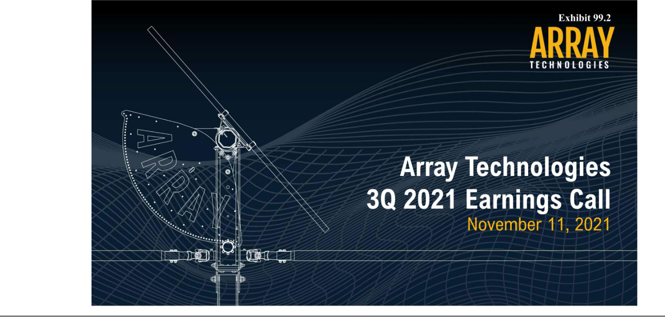

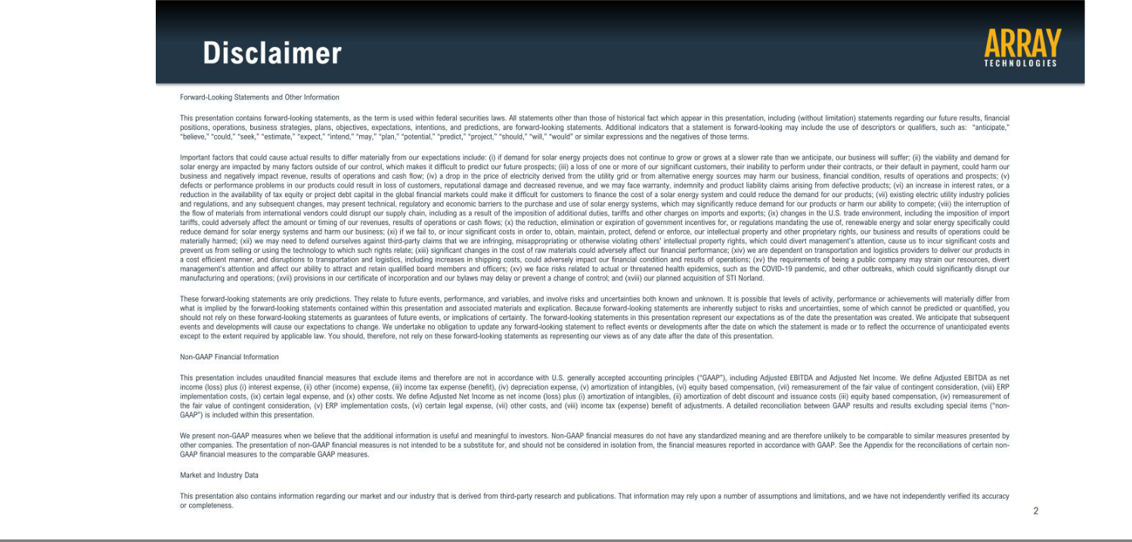

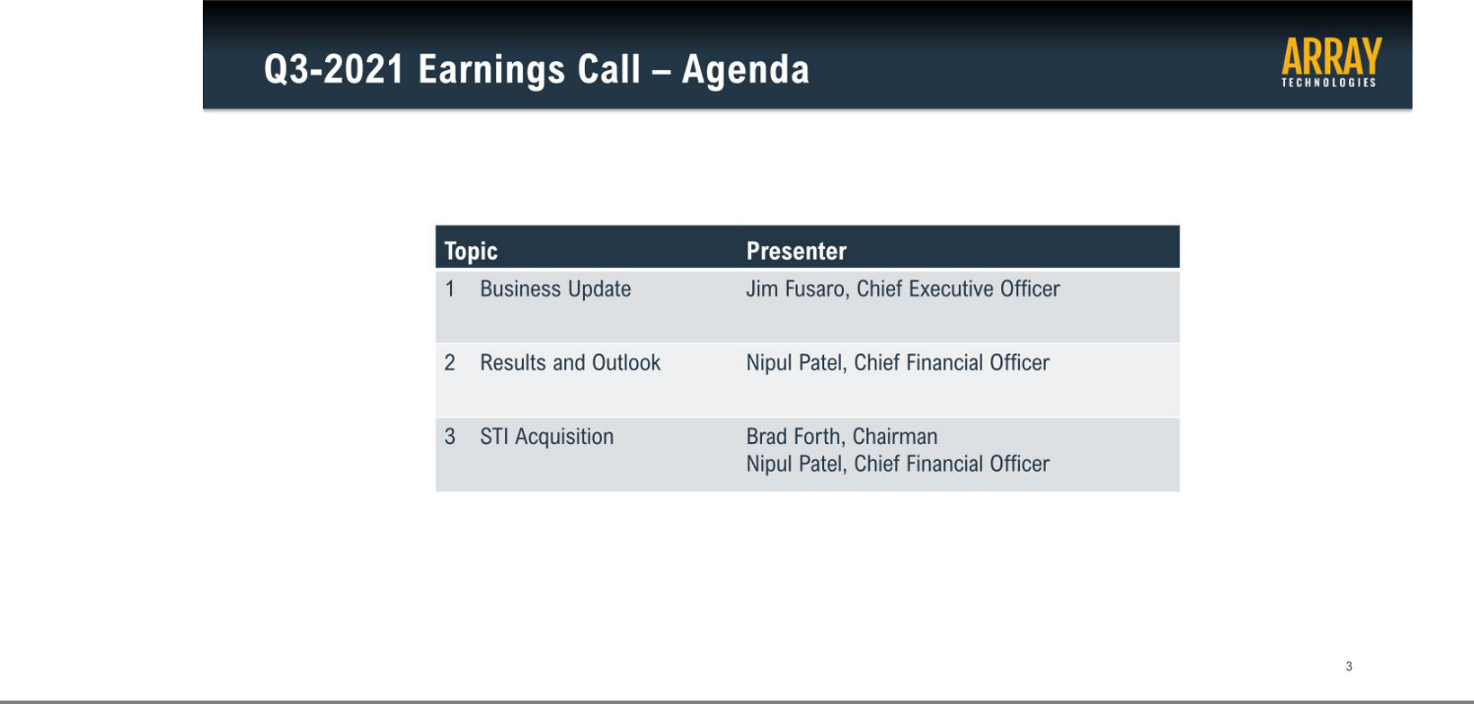

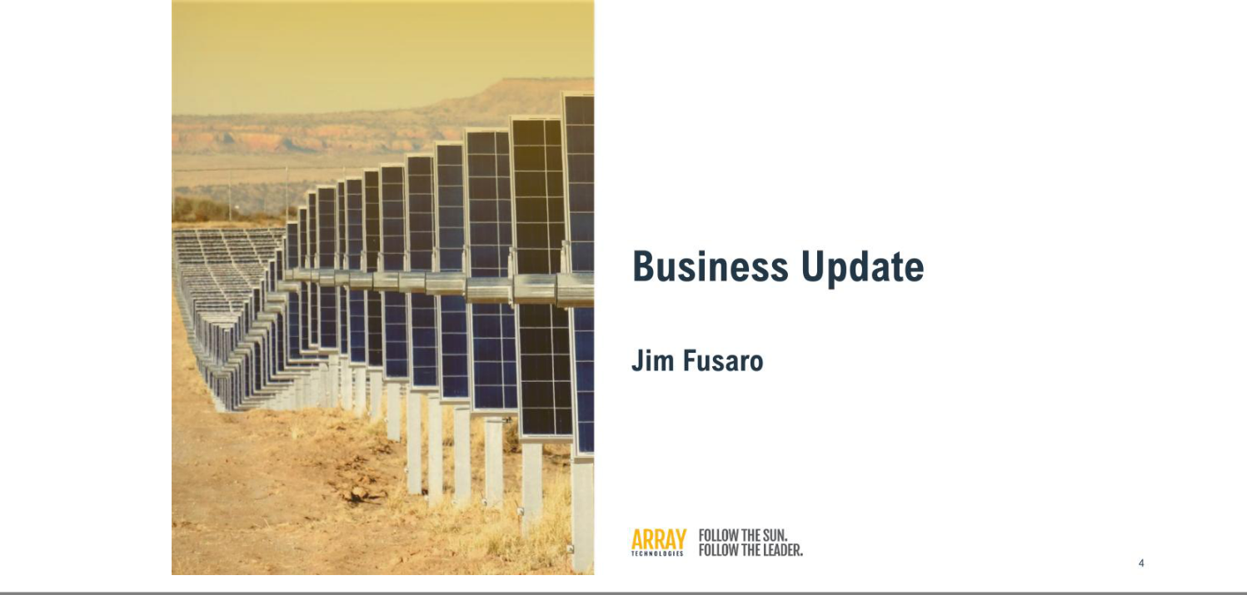

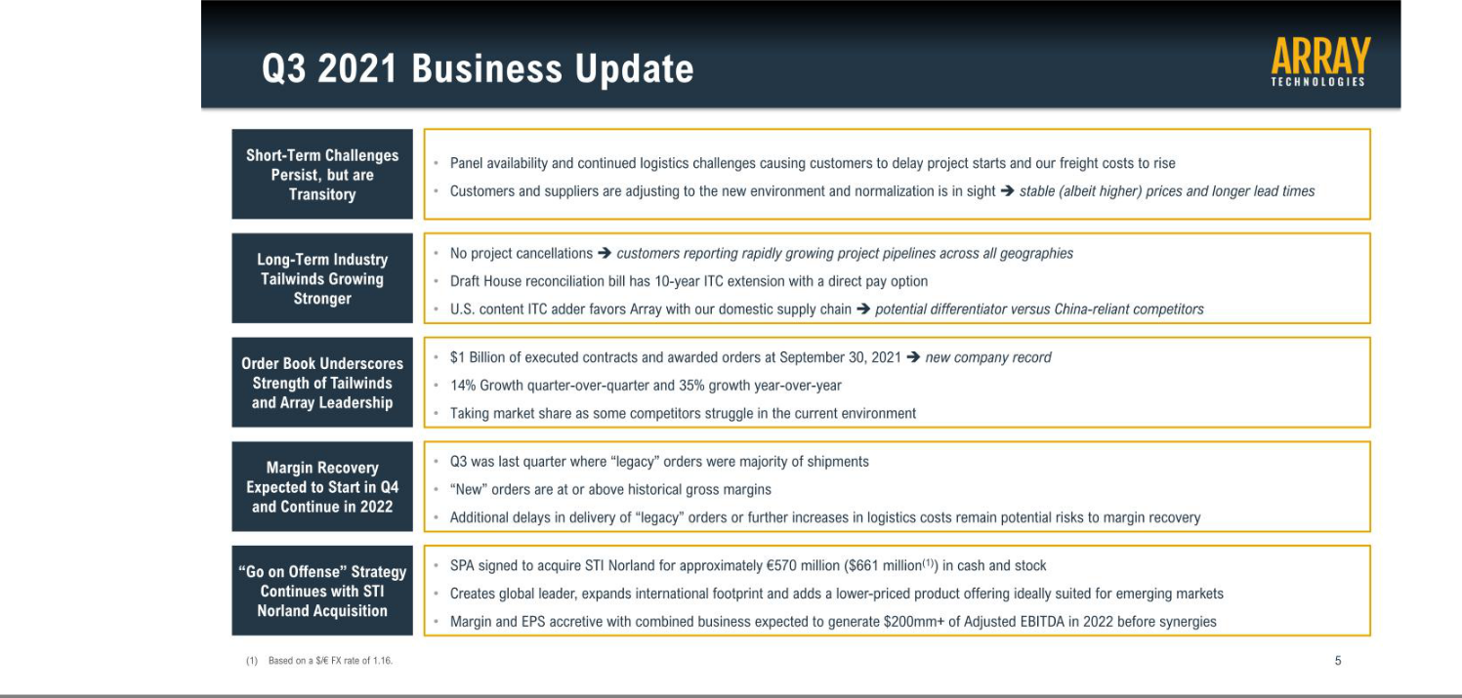

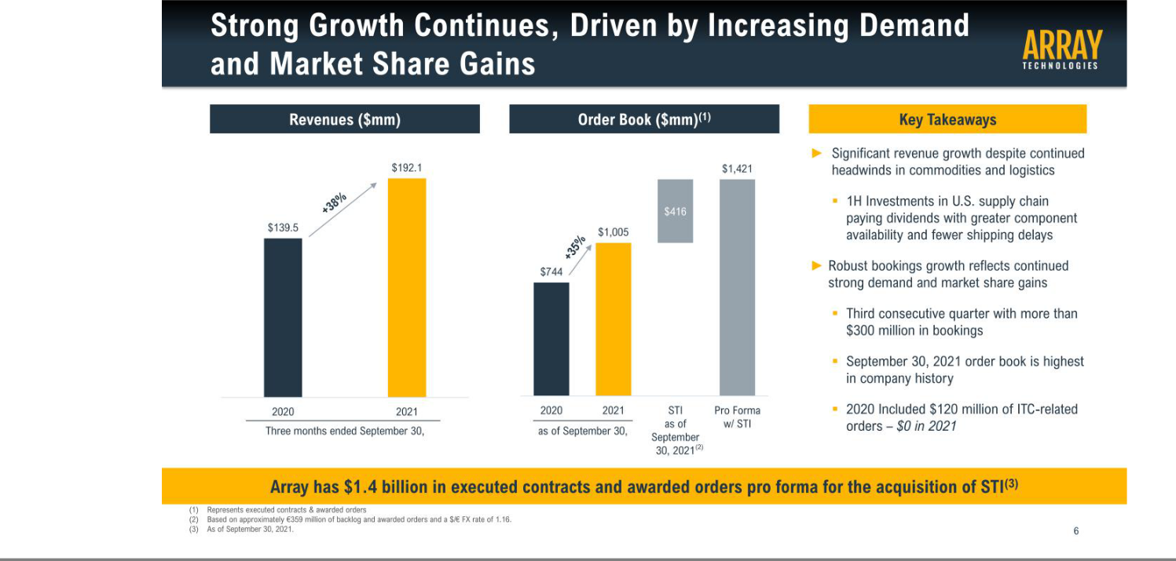

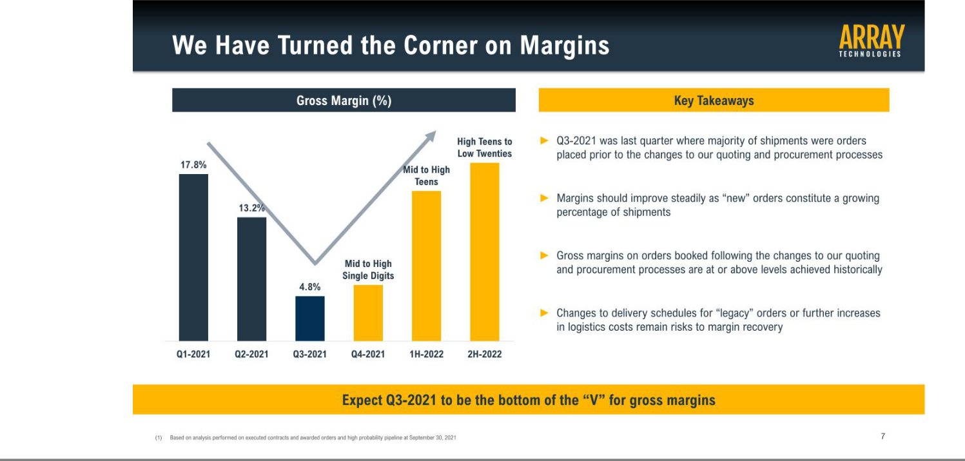

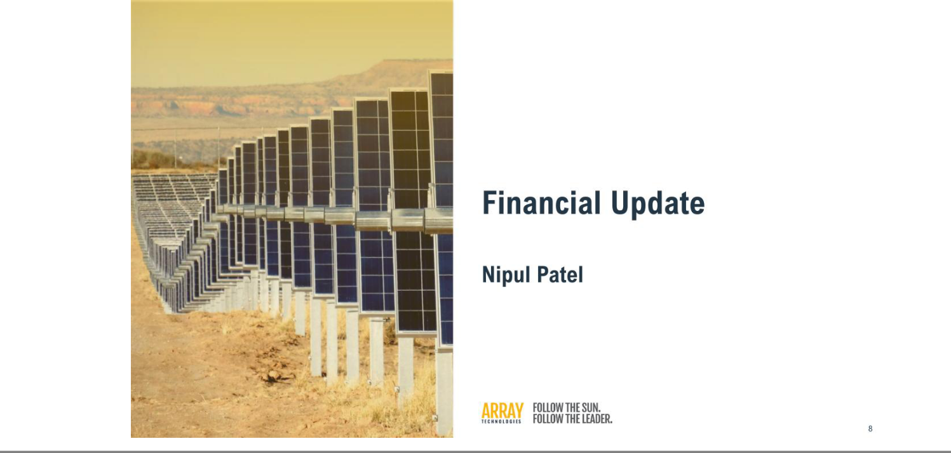

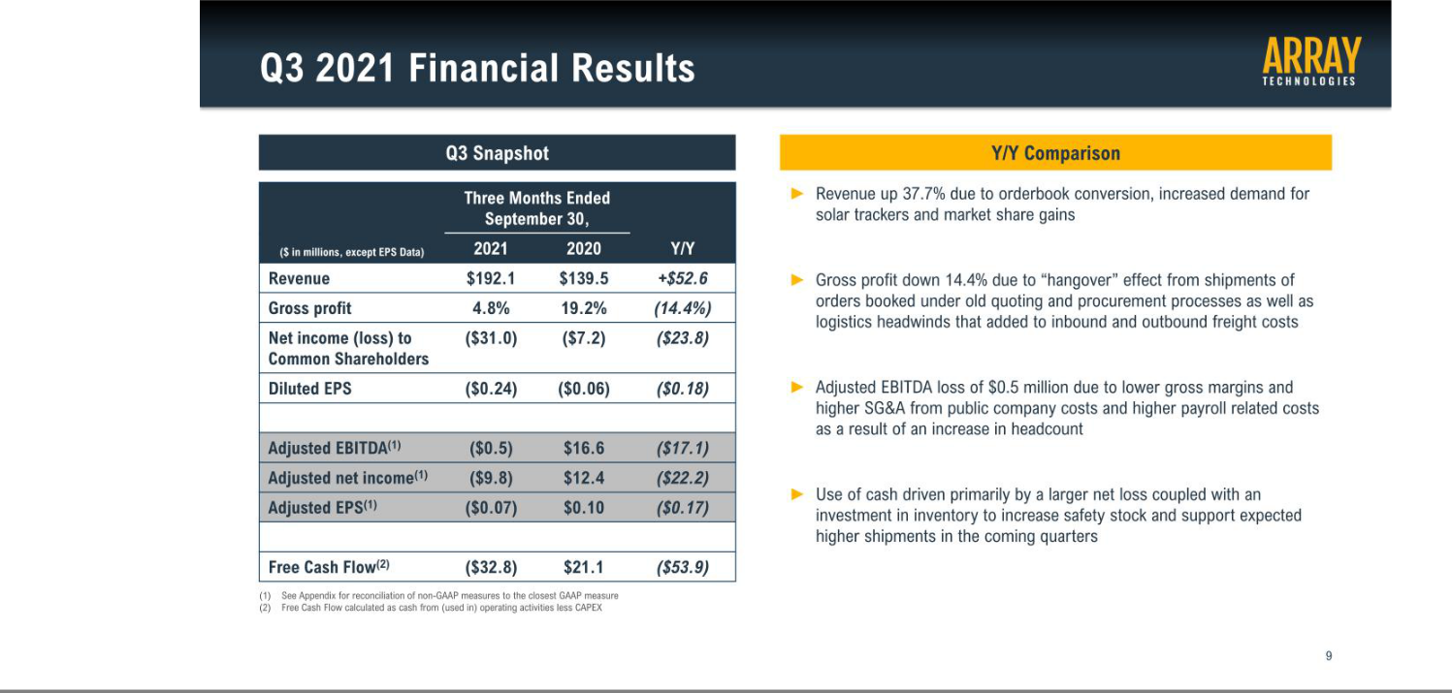

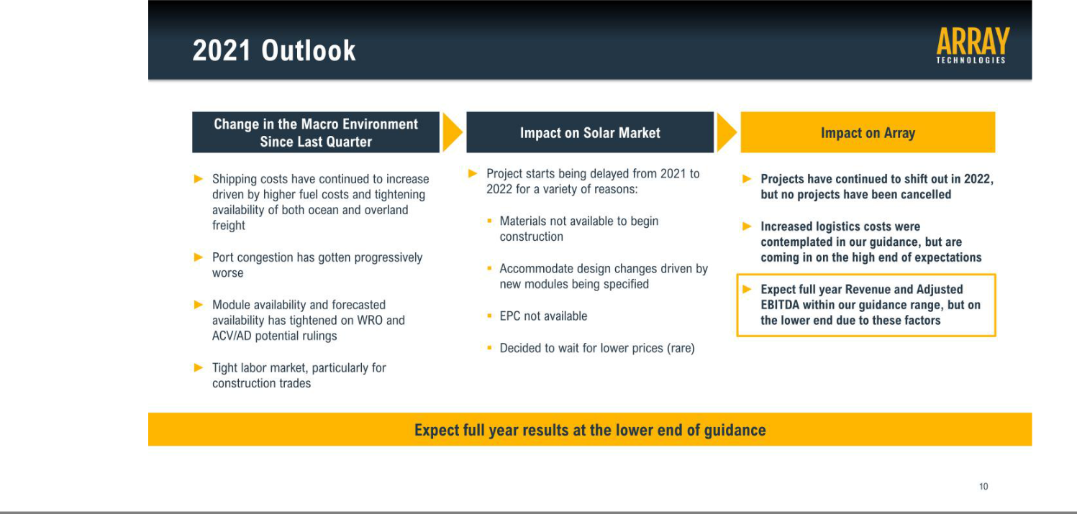

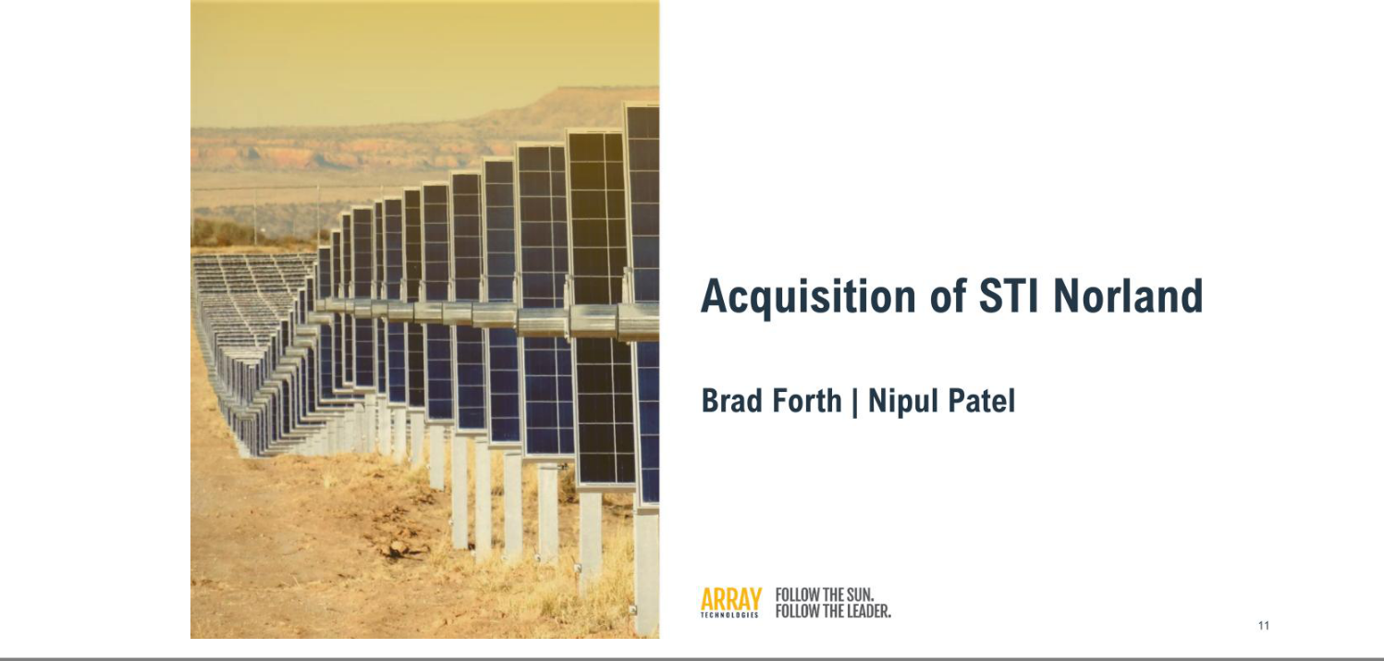

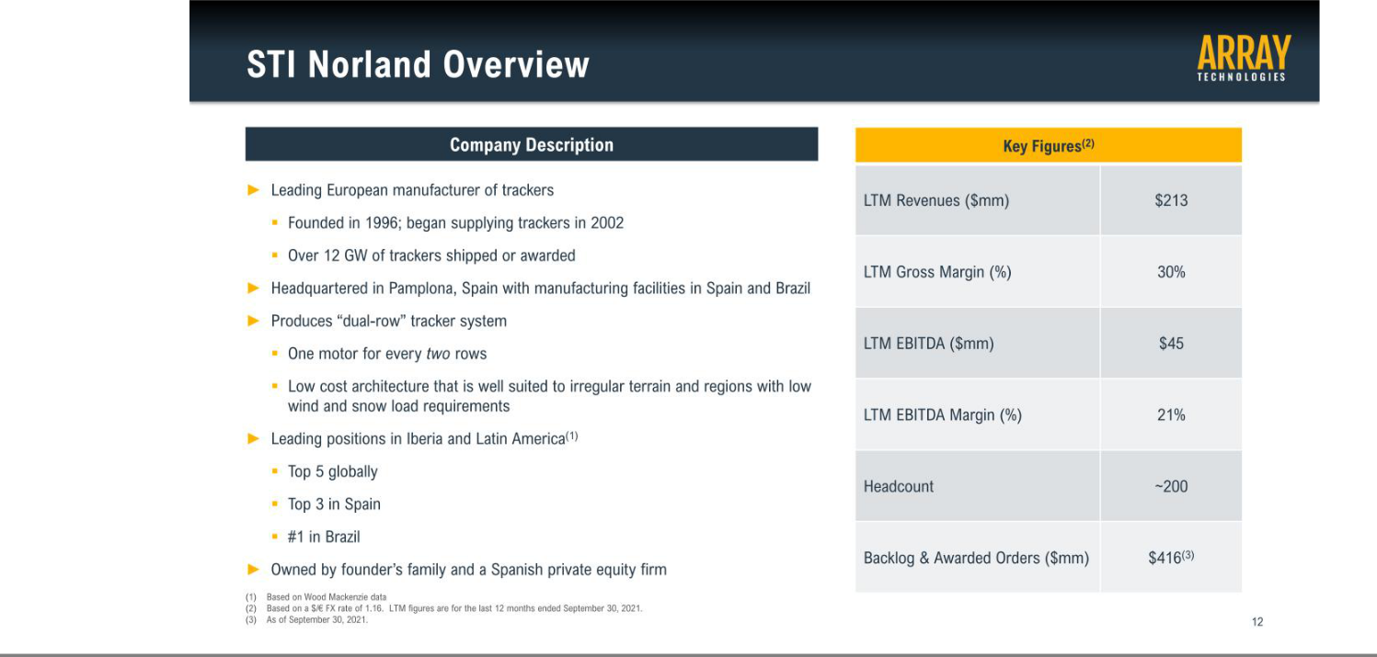

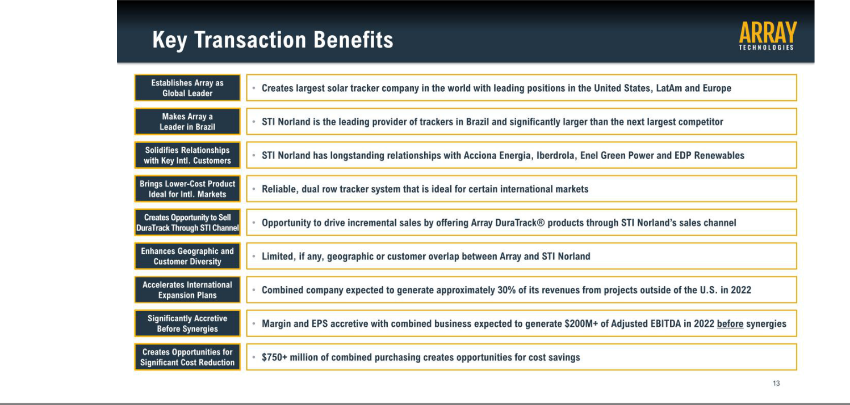

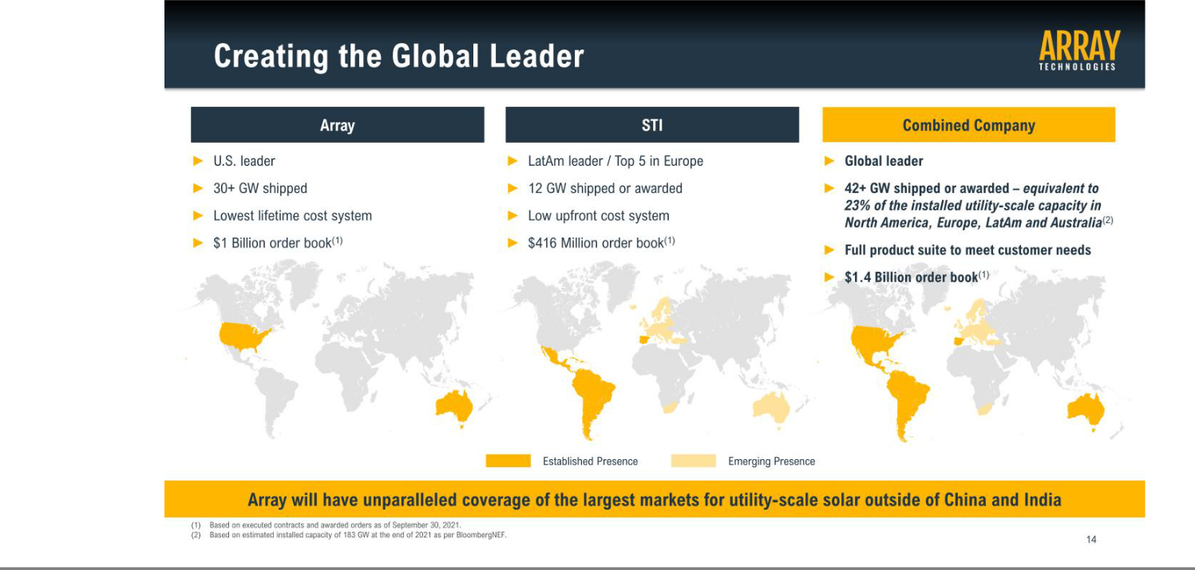

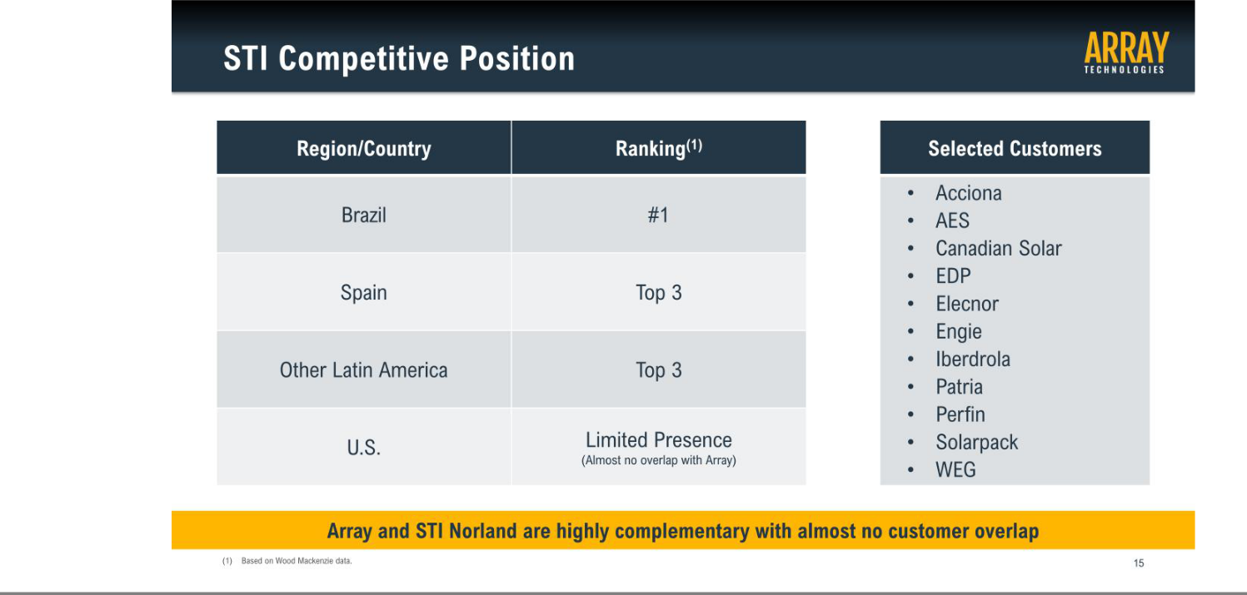

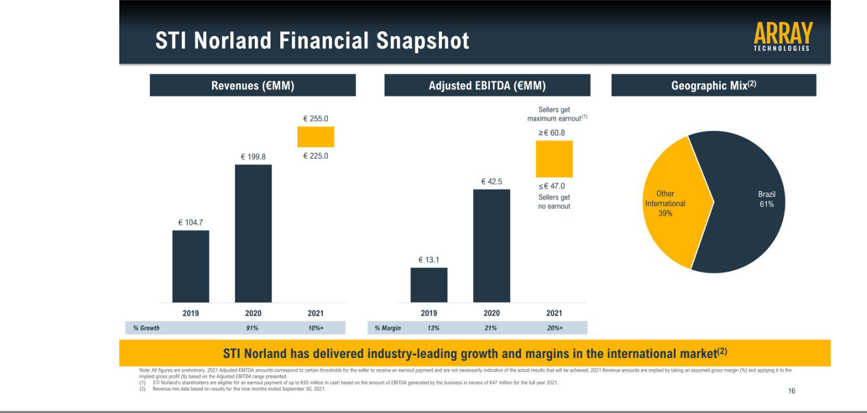

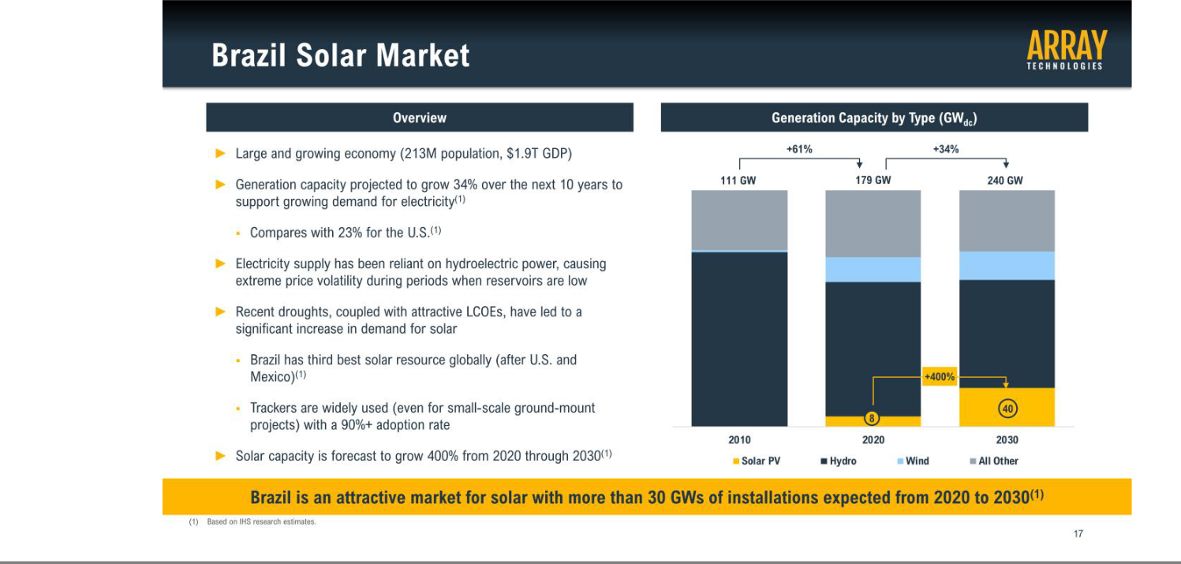

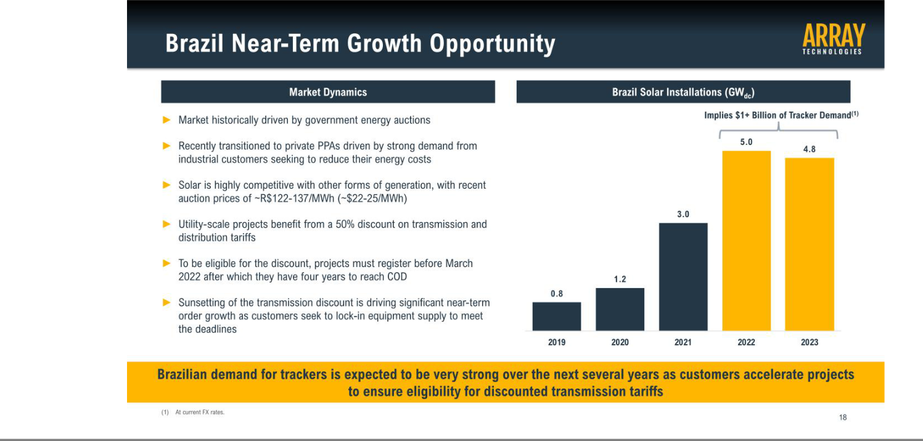

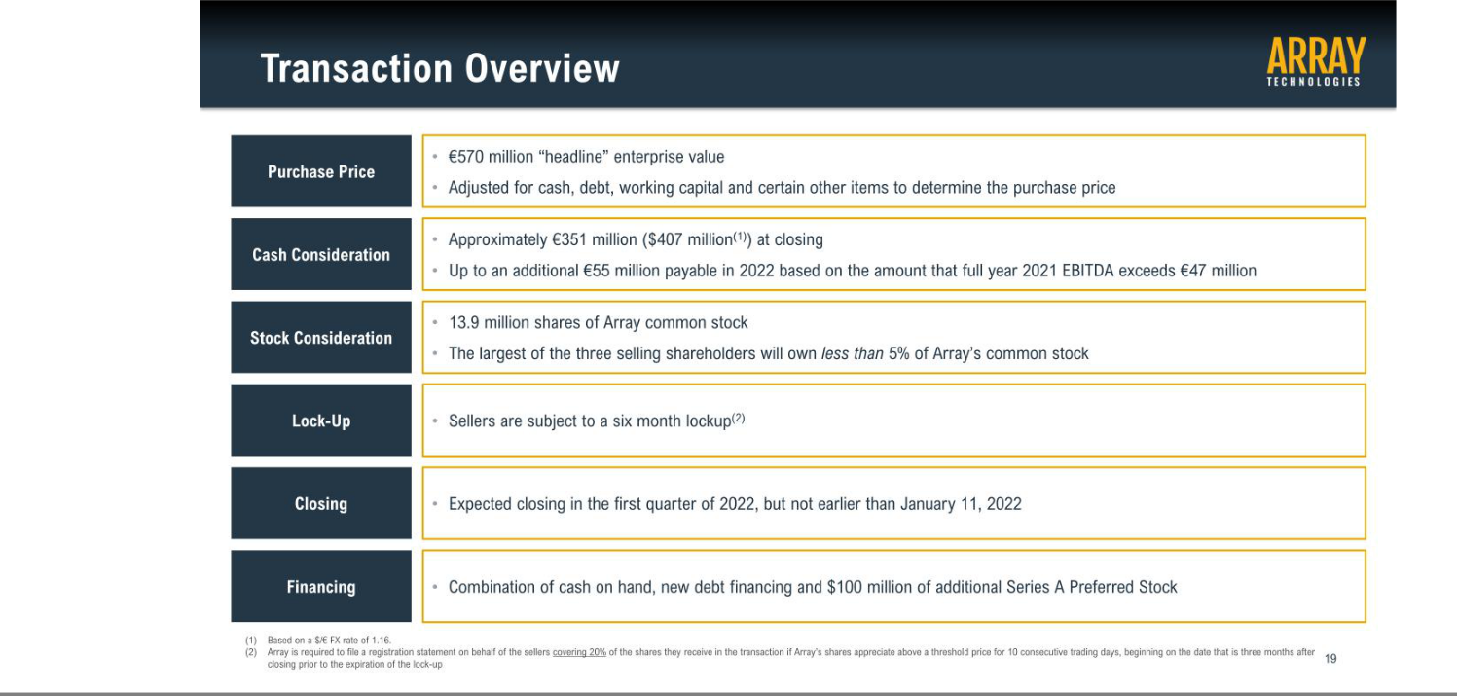

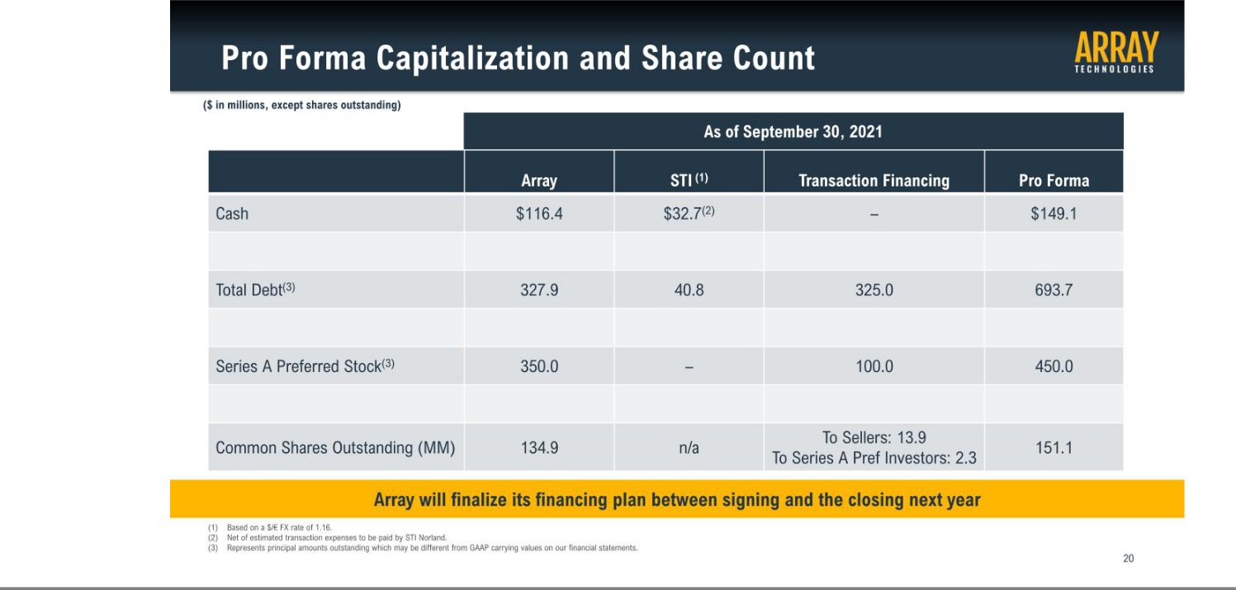

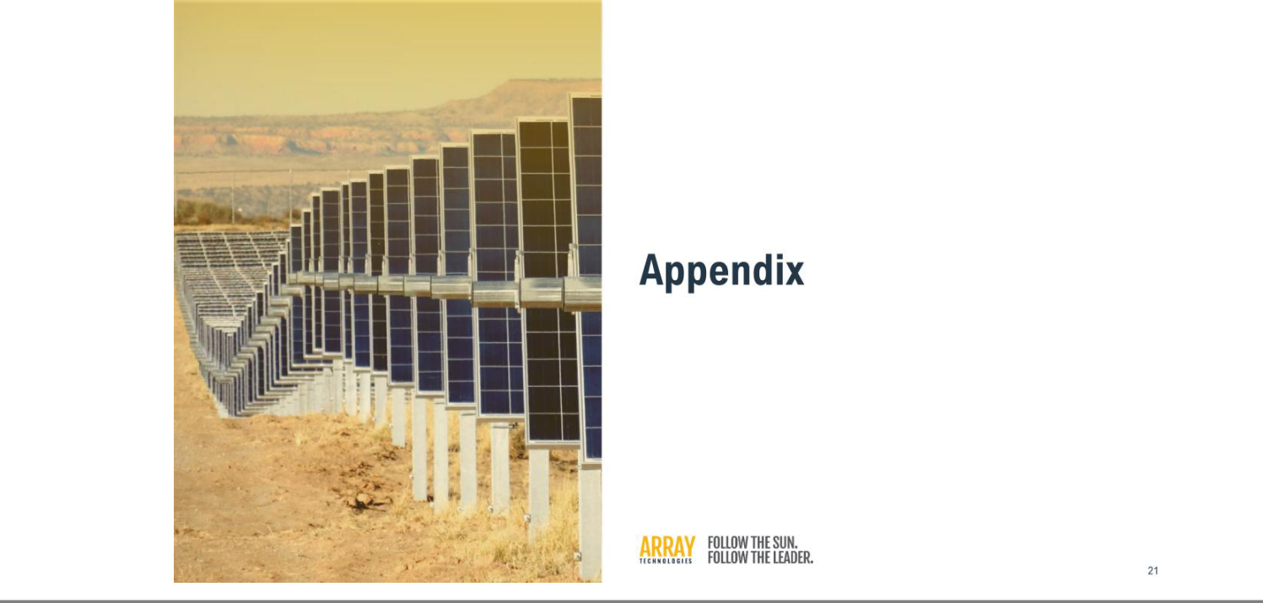

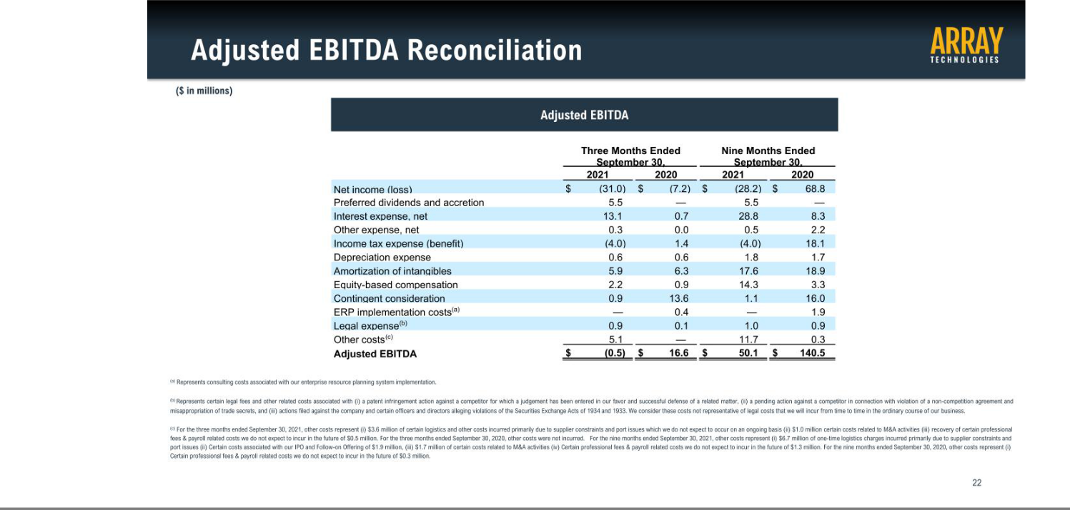

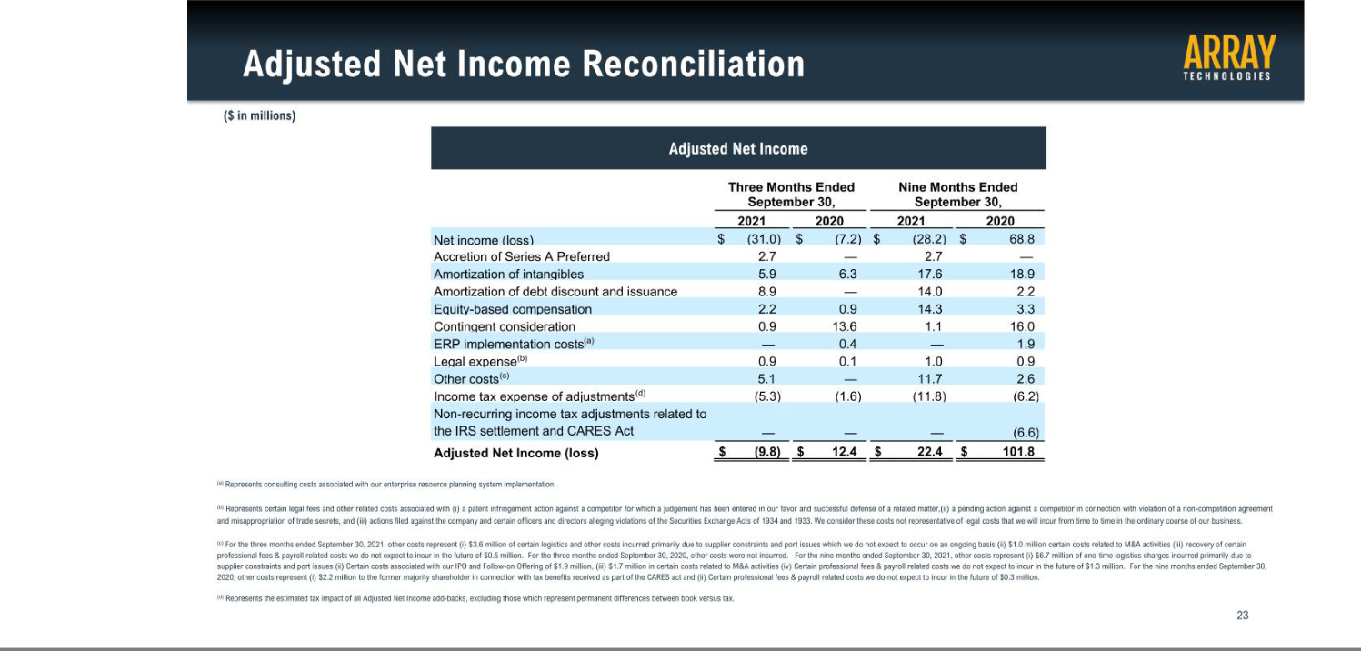

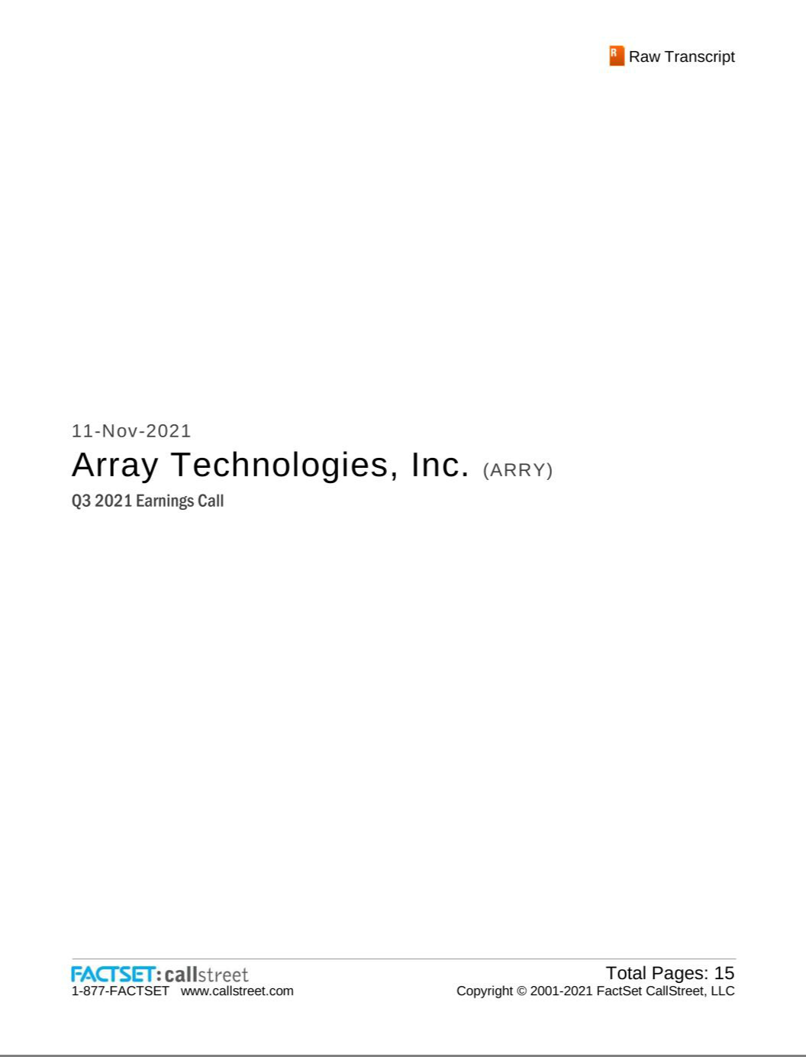

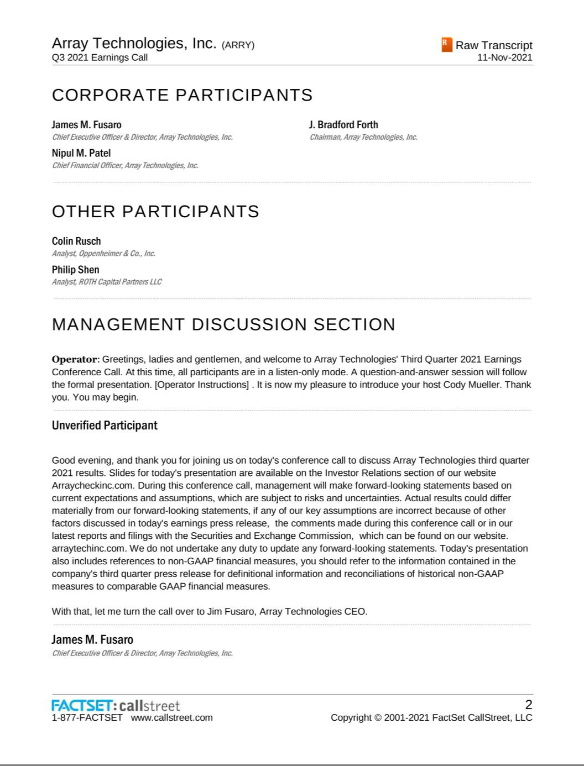

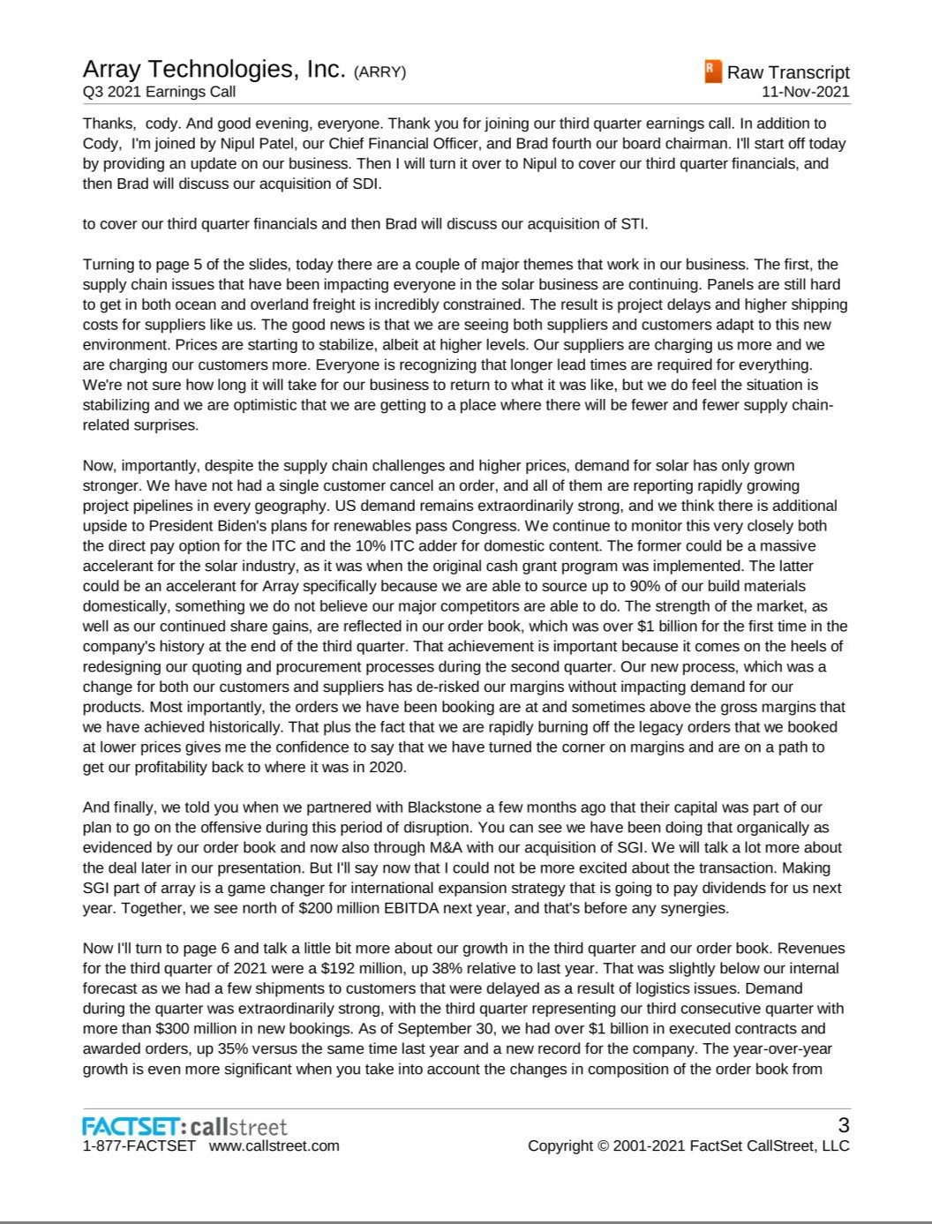

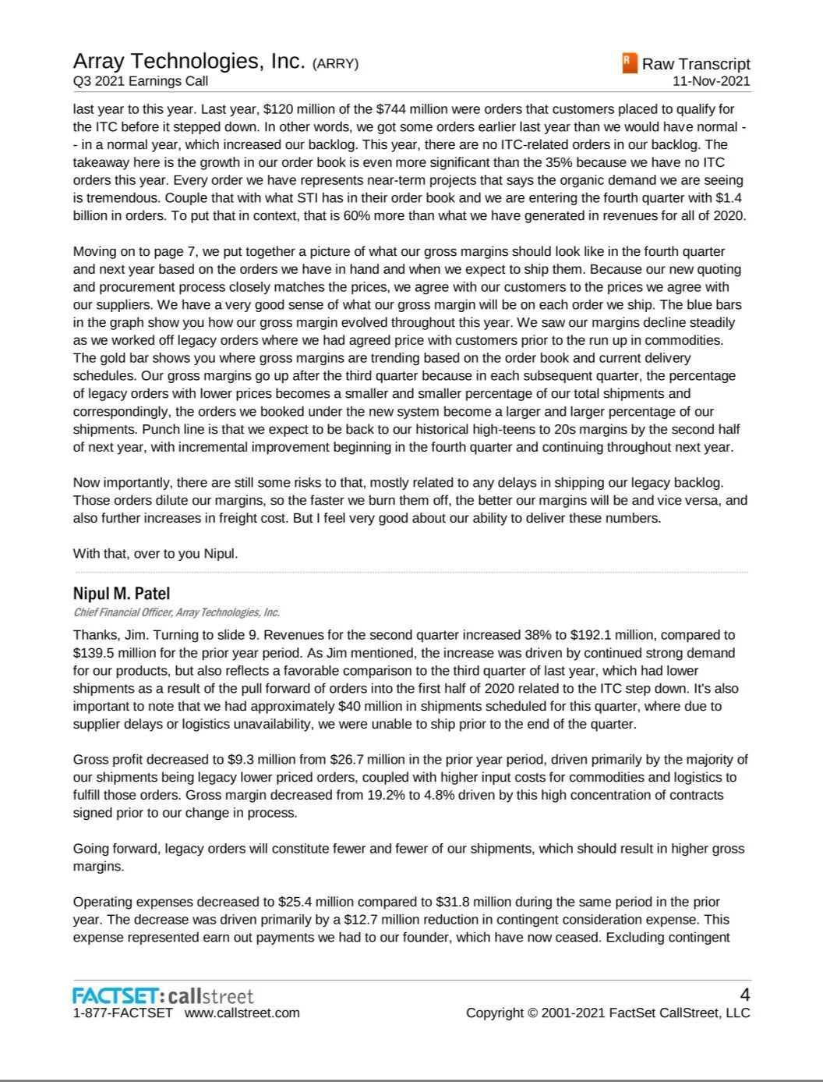

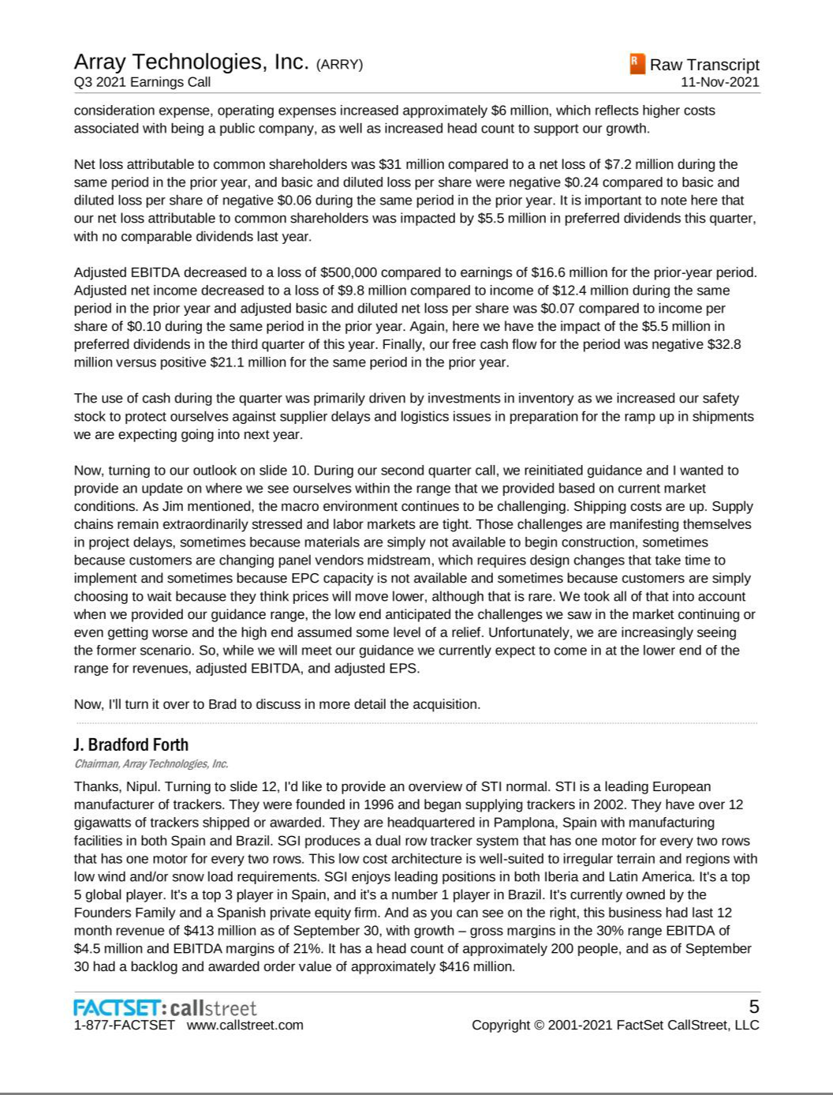

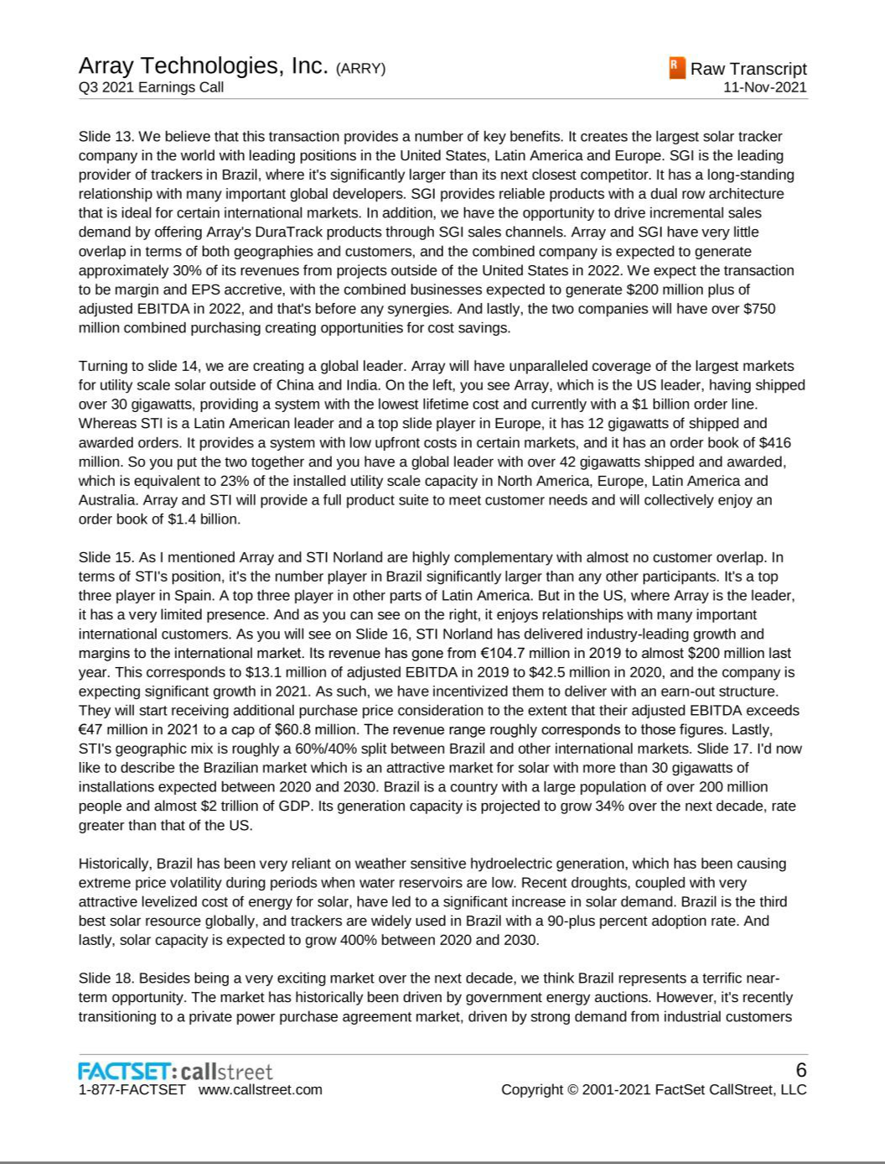

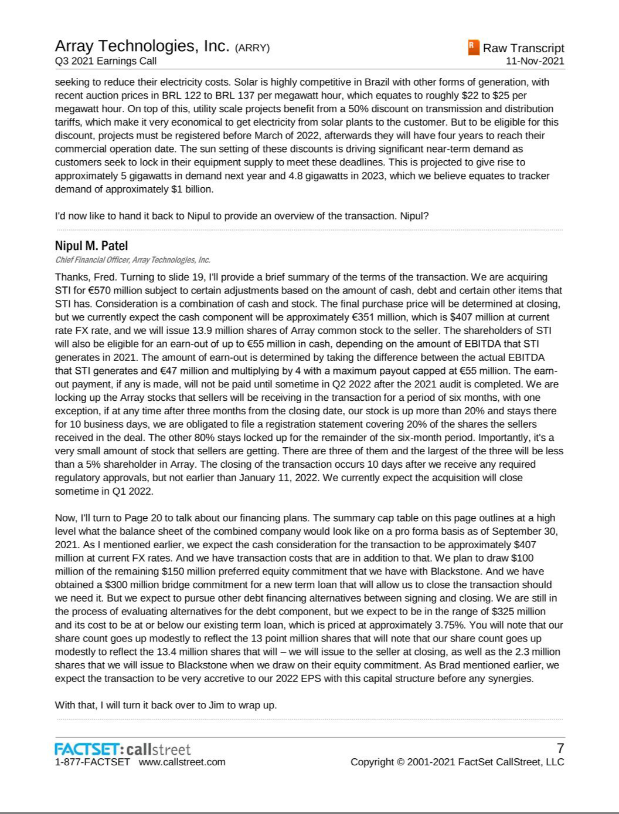

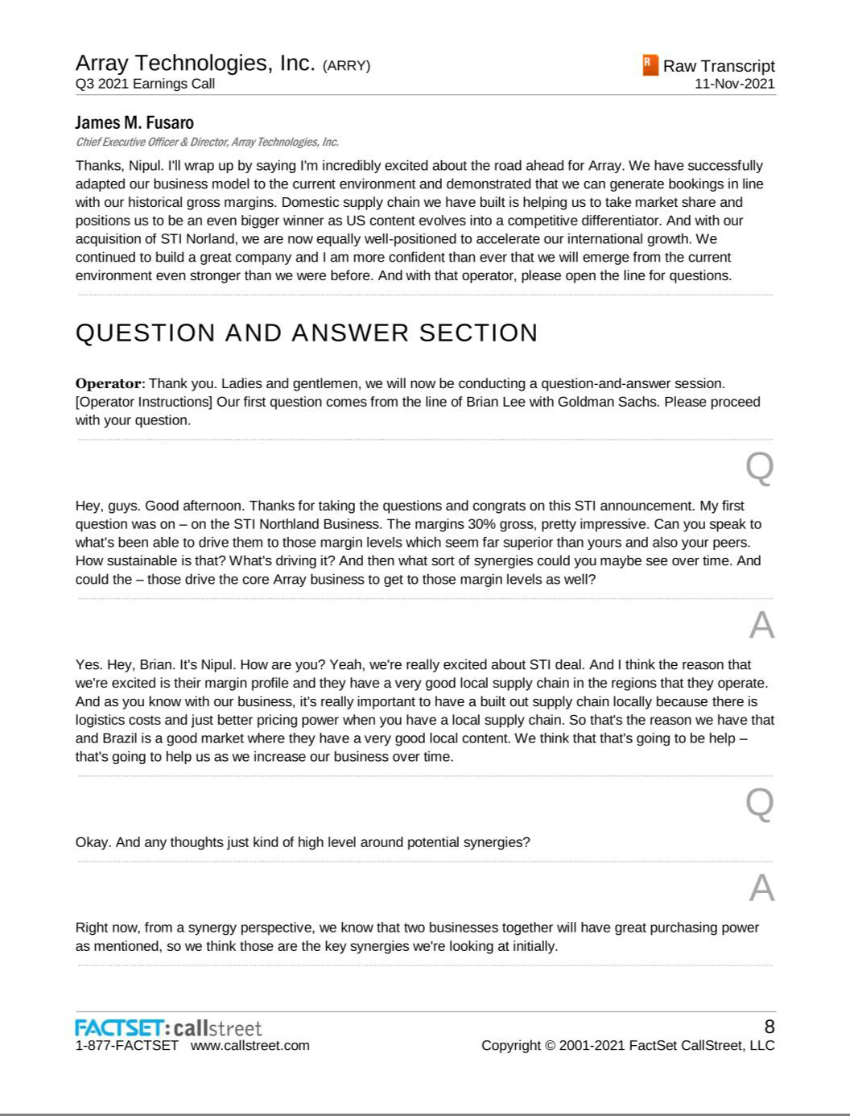

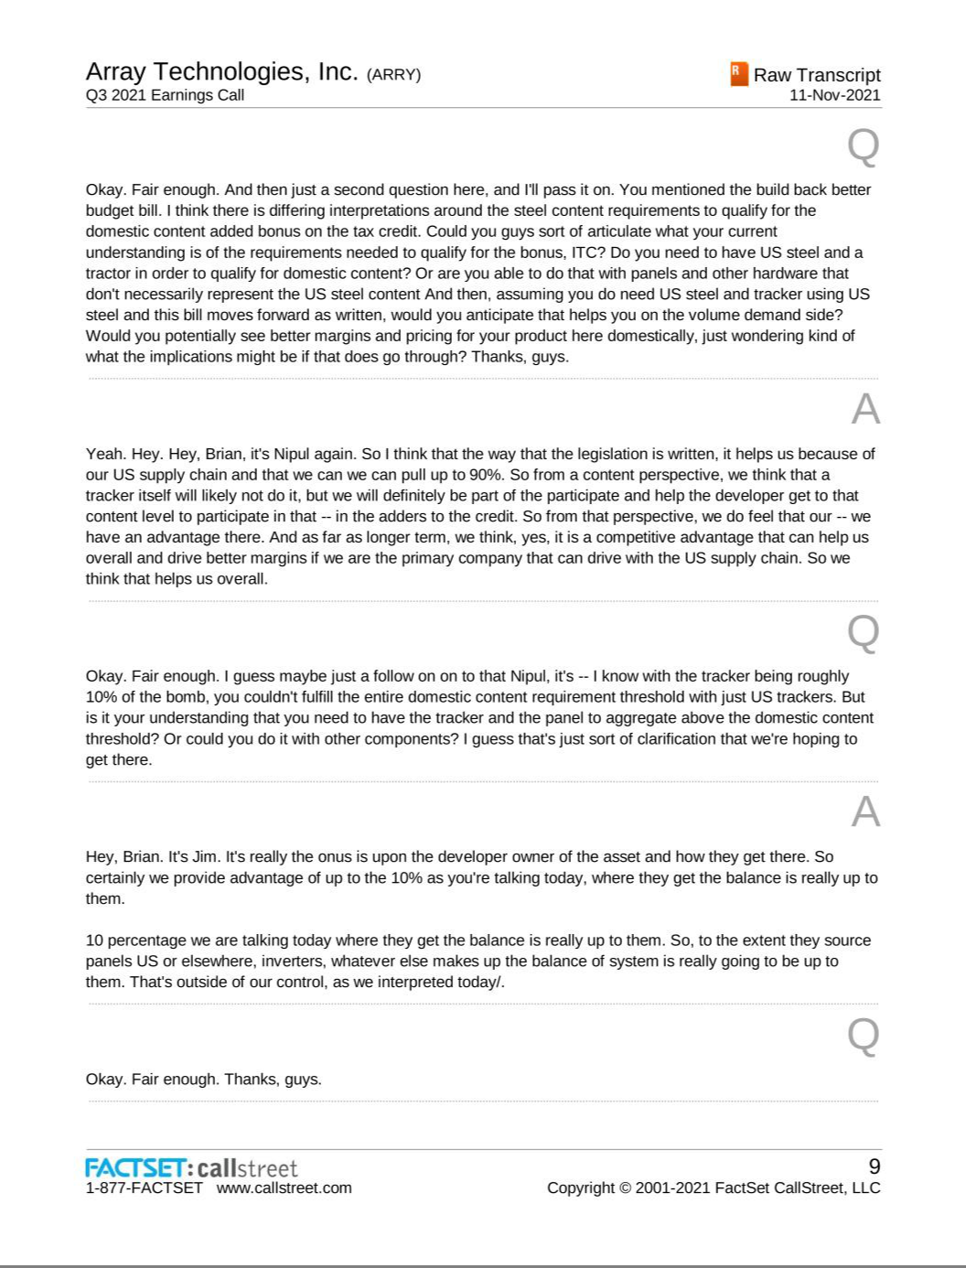

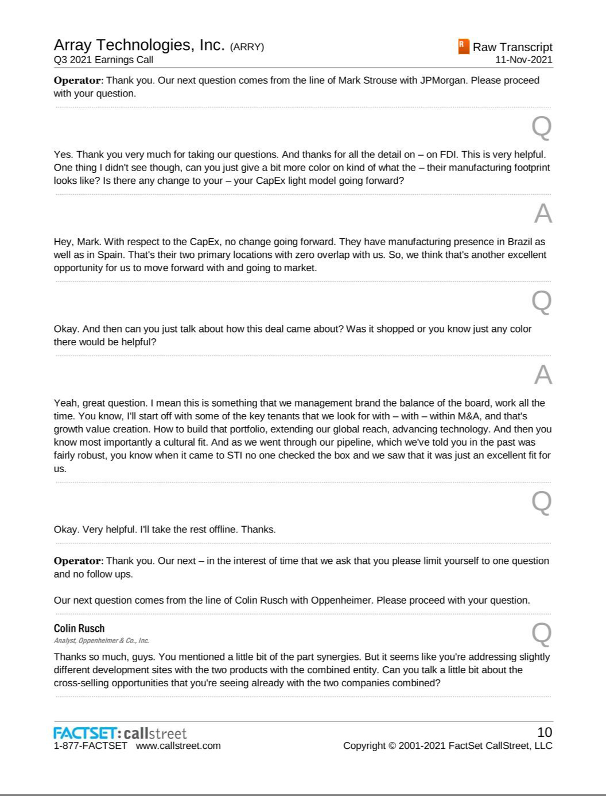

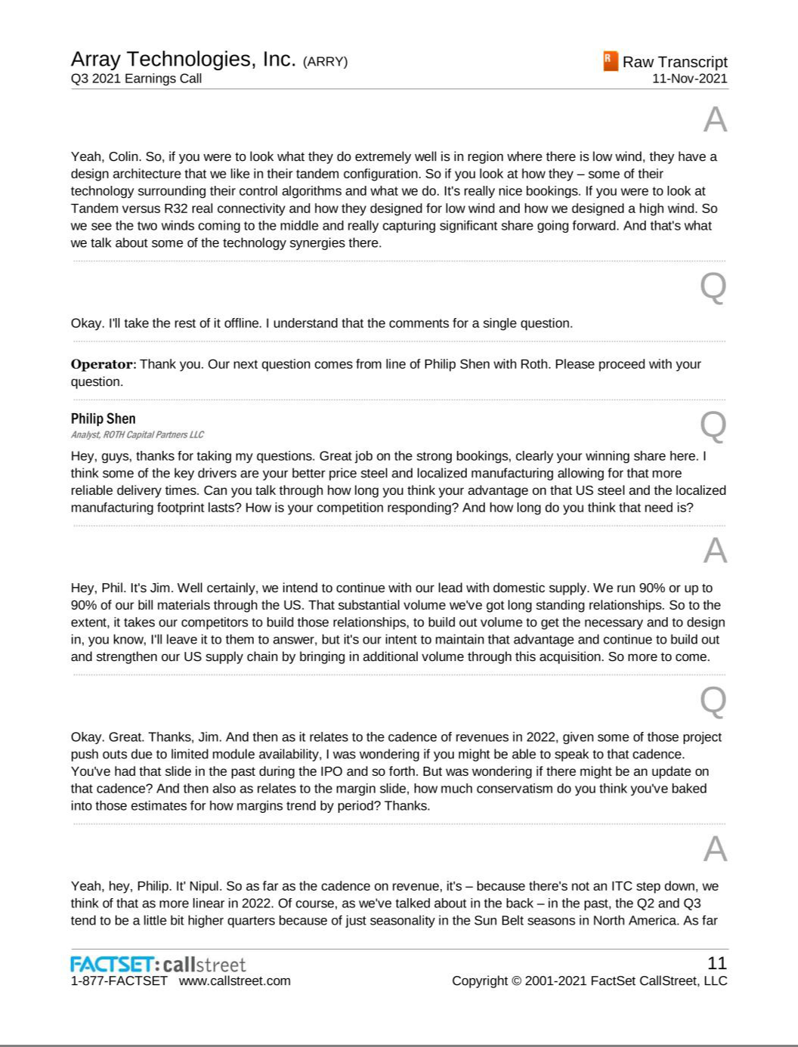

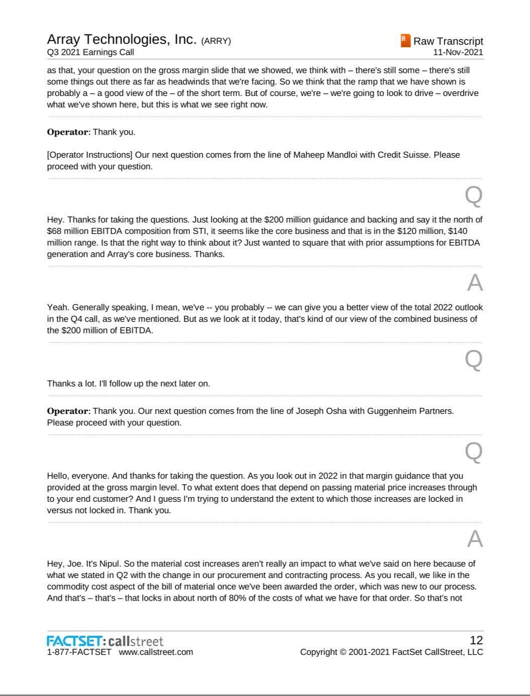

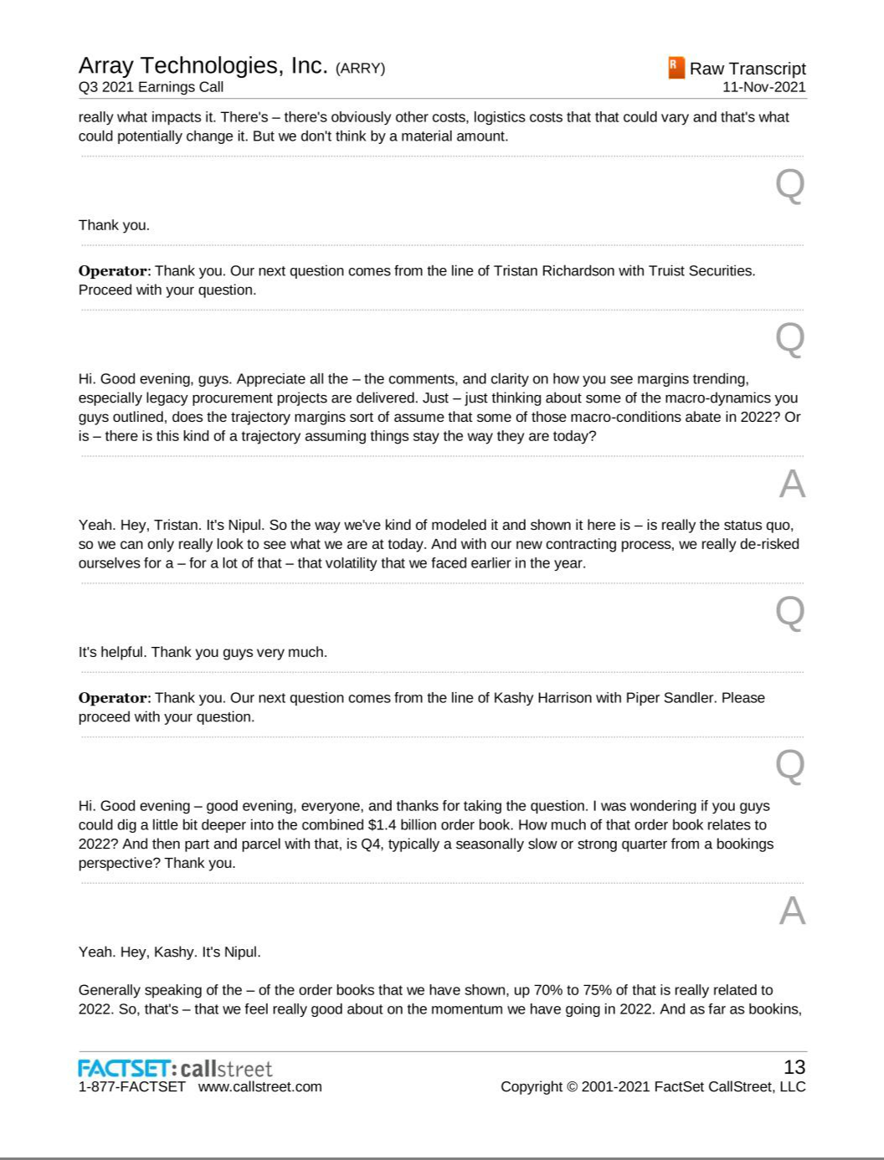

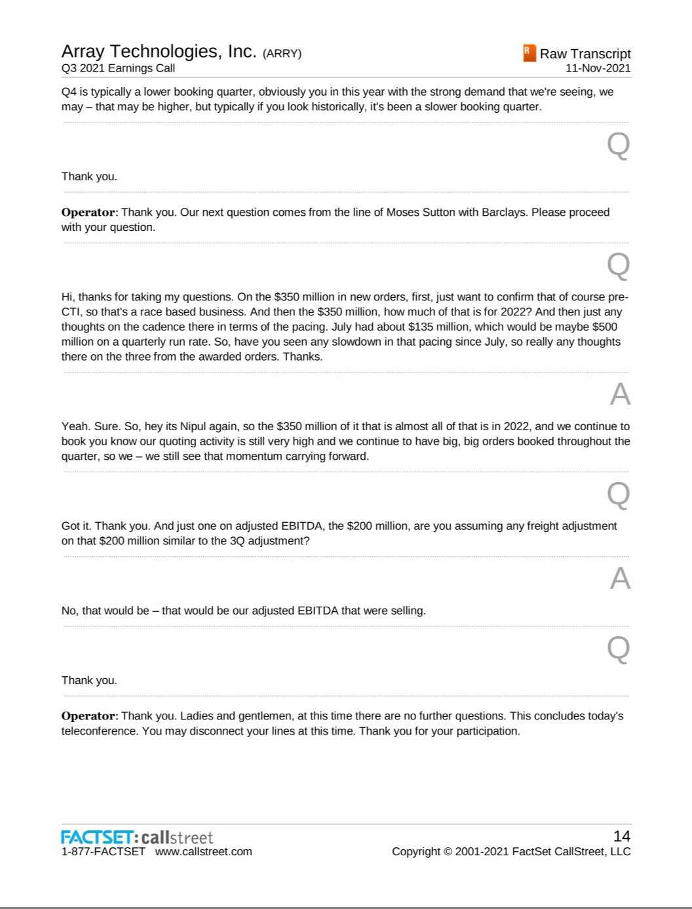

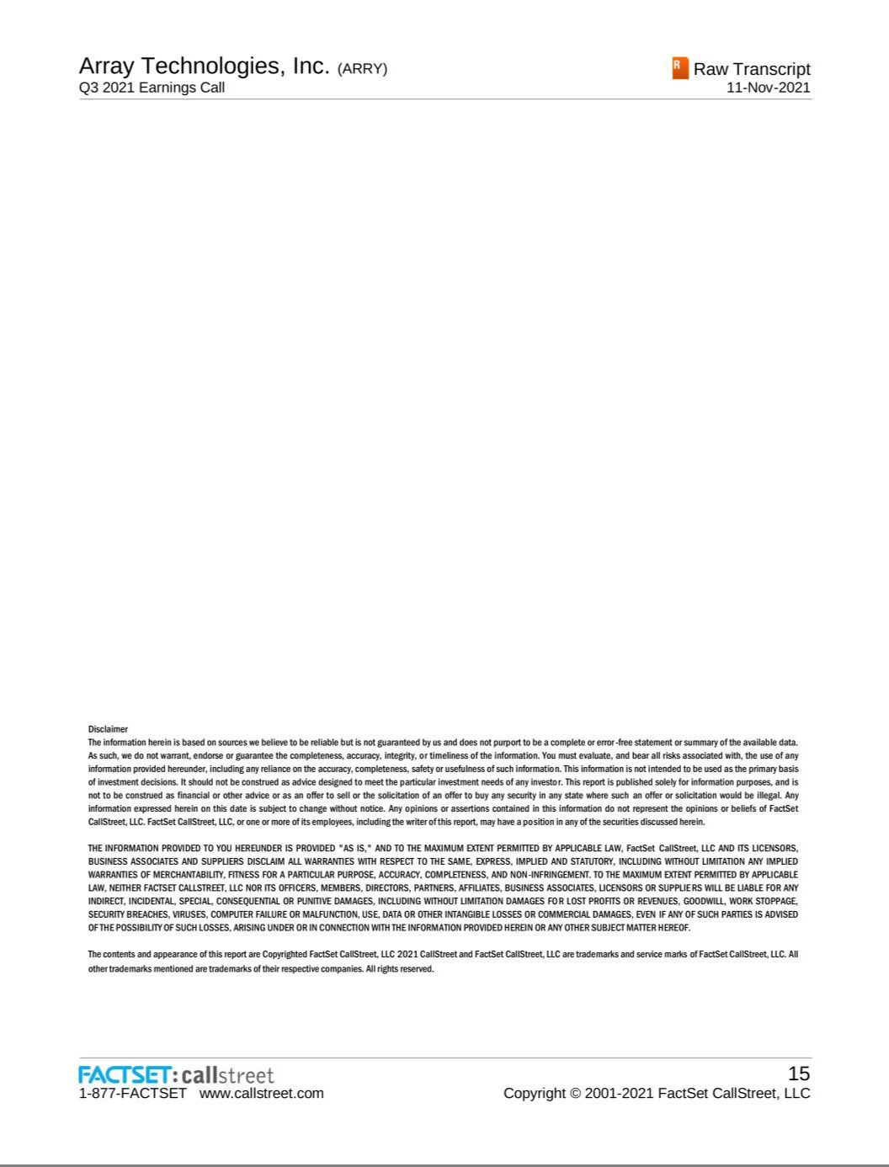

Exhibit 99.4


Array Technologies to Acquire STI Norland

Establishes Array as global leader in solar trackers

Increases exposure to international markets, including the large and rapidly growing Brazilian market

Expected to be significantly accretive to margins and earnings per share before synergies

Combined company expected to generate in excess of $200 million of Adjusted EBITDA in 2022

ALBUQUERQUE, NM — (GLOBE NEWSWIRE) — Array Technologies (NASDAQ: ARRY) (“Array”), one of the world’s largest providers of utility-scale solar tracker technology, today announced that it has entered into a definitive agreement to acquire Soluciones Técnicas Integrales Norland, S.L. (“STI Norland”), one of Europe’s leading manufacturers of solar trackers. Headquartered in Pamplona, Spain, STI Norland has leading positions in Iberia and Latin America, including the rapidly growing Brazilian solar market. STI Norland has completed or been awarded tracker systems for more than 400 projects globally, representing over 12 GW of generation capacity. Over the past several years, the company has achieved high double-digit percentage revenue and EBITDA growth by leveraging the strength of its products and sales teams which are well-suited to the needs of certain international customers. STI Norland generated revenues and EBITDA of approximately €200 million and € 43 million, respectively, in 2020. Under the terms of the agreement, Array will acquire STI Norland for approximately €570 million in cash and stock. The transaction is expected to close in the first quarter of 2022. Javier Reclusa, the Chief Executive Officer of STI Norland, as well as the rest of the company’s senior management team will remain with Array following the closing of the transaction and continue to lead STI Norland.

“This transaction is an important first step in the expansion strategy that we articulated when we announced our preferred equity investment from Blackstone in August. The combination of Array and STI Norland creates the global leader in trackers with leading positions in every major market for solar outside of China and India. STI Norland brings to Array a proven product line that is ideally suited for complementary markets which will help to accelerate our international expansion plans. The increased scale of the combined enterprise also provides opportunities for significant cost reduction as we drive greater volumes with our suppliers and achieve increased leverage on our fixed costs” said Brad Forth, Chairman of Array.

“We look forward to welcoming STI Norland’s employees to Array. Both STI Norland and Array are rooted in entrepreneurial, founder-operated businesses that are focused on innovation. Together, I believe we have the technology, culture and capabilities to build a truly global business that can create tremendous value for our customers, employees and shareholders” said Jim Fusaro, Chief Executive Officer of Array.

Javier Reclusa, Chief Executive Officer of STI Norland, added “The entire STI Norland team is excited about joining Array and the opportunities that the combination of the two companies will unlock. We have a tremendous amount of respect for Array, its technology and management and I look forward to working closely with Brad and Jim to support their ambitious expansion plans.”

Transaction Highlights

- Establishes Array as Global Leader in Solar Trackers – The combination of Array and STI creates the largest solar tracker company in the world. The combined business will have leading positions in North America, Latin America and Europe, the three largest markets for solar outside of China. With manufacturing capacity and design and engineering resources on three continents, the combined organization’s ability to support customers on a global basis will be unparalleled.

- Makes Array a Leader in the Rapidly Growing Brazilian Solar Market – STI Norland is the leading provider of solar trackers in Brazil. STI Norland’s strong position is reinforced by its local manufacturing presence and supply chain. Brazil has the third highest solar resource of any country. Annual utility-scale solar installations in Brazil have more than tripled over the past three years as the LCOE for solar has fallen below conventional generation.

Exhibit 99.4

Nearly 10 GWs of utility-scale solar is forecast to be installed in Brazil in 2022 and 2023 according to industry analysts with over 90% of those projects using trackers.

- Accelerates International Expansion Plans – STI Norland has an established sales presence in Europe, Latin America, Australia and South Africa. By leveraging STI Norland’s existing sales infrastructure and relationships, Array will be able to accelerate its expansion plans for international markets. The combined company is expected to derive approximately 30% of its revenues from international projects in 2022.

- Solidifies Array’s Relationships with Key International Customers – STI Norland has longstanding relationships with major international customers including Acciona Energia, Iberdrola and EDP Renewables that are not currently significant volume customers for Array. Array expects that the strength of STI Norland’s relationships will help to drive increased sales to these customers both in the U.S. and internationally.

- Creates Access to a Lower Cost, Proven Product for International Markets – STI Norland manufactures a reliable, dual row tracker system that is ideal for projects in markets where the cost of installation labor is lower than in the U.S. and wind and snow load factors are significantly lower. Access to STI Norland’s product gives Array a broader product portfolio that will allow the company to provide global customers with the product that best meets their goals given site conditions, local content requirements, labor costs and objectives for upfront cost and total lifetime cost.

- Creates Opportunity to Sell Array Products through STI Norland’s Sales Channel – Array will offer STI Norland’s sales organization the opportunity to sell Array’s industry-leading DuraTrack® products, which have the lowest lifetime cost of any tracker system and exceptional wind and snow load performance, to their customers.

- Enhances Geographic and Customer Diversity – STI Norland generates approximately 95% of its revenues outside of the U.S. and there is virtually no overlap between the company’s major customers and Array’s major customers.

- Significant Margin and Earnings Accretion Before Synergies – Array expects STI Norland to be significantly accretive to Array’s margins and earnings per share in 2022 before any synergies. Based on current market conditions and the backlog, awarded orders and sales pipeline for both companies, Array expects that the combined business can generate in excess of $200 million of Adjusted EBITDA in 2022 before synergies. Array plans to provide detailed guidance for 2022 in connection with the company’s fourth quarter earnings release in March 2022.

- Creates Opportunities for Significant Cost Reduction – Following the closing of the transaction, Array intends to initiate several cost reduction plans across the combined company which will include evaluating additional supplier discounts that may be available from combining purchasing volumes, identifying common components where either company has advantaged pricing, and implementing mutual manufacturing best practices across both companies’ facilities to reduce cost.

Transaction Consideration and Financing

Under the terms of the agreement, Array will acquire STI Norland for € 351 million in cash (approximately $407 million at current exchange rates) and 13.9 million shares of Array common stock. STI Norland shareholders will be eligible for an additional payment of up to €55 million in cash based on the amount of EBITDA in excess of € 47 million that STI Norland generates in 2021. If earned, the additional payment will be made in 2022 following the completion of an audit of STI Norland’s results for 2021. The acquisition is subject to the receipt of any required regulatory approvals and is expected to close in the first quarter of 2022. Array has obtained commitments from J.P. Morgan Securities, LLC and Guggenheim Securities, LLC as joint lead arrangers, for bridge financing, should it be needed, to complete the transaction. However, the company expects to pursue certain other debt financing alternatives to finance the cash portion of the purchase price as well as issue additional preferred stock pursuant to the Series A Preferred Stock commitment it entered into with Blackstone in August 2021.

Exhibit 99.4

Transaction Approvals and Closing Conditions

The transaction is expected to close in the first quarter of 2022, subject to receiving any required regulatory approvals and the satisfaction of other customary closing conditions. Guggenheim Securities, LLC acted as Array’s exclusive financial advisor and Kirkland & Ellis acted as Array’s legal advisor in connection with the transaction. Lazard acted as exclusive financial advisor and Allen & Overy as legal advisor to STI Norland.

Additional information regarding the transaction will be included in a Current Report on Form 8-K to be filed by Array with the Securities and Exchange Commission.

About Array Technologies, Inc.

Array Technologies (NASDAQ: ARRY) is a leading American company and global provider of utility-scale solar tracker technology. Engineered to withstand the harshest conditions on the planet, Array’s high-quality solar trackers and sophisticated software maximize energy production, accelerating the adoption of cost-effective and sustainable energy. Founded and headquartered in the United States, Array relies on its diversified global supply chain and customer-centric approach to deliver, commission and support solar energy developments around the world, lighting the way to a brighter, smarter future for clean energy. For more news and information on Array, please visit arraytechinc.com.

About STI Norland

Founded in 1996 in Pamplona, Spain, STI Norland is a pioneer in Europe in both the development of fixed-tilt structures and trackers for utility-scale PV plants. The company’s system was used in the world’s first PV plant to deploy trackers in 2002. Since then, STI Norland’s trackers have been used in more than 400 solar projects globally representing approximately 12 GW of generation capacity.

Forward Looking Statements

This press release contains forward looking statements including statements about the proposed transaction with STI Norland, the timing thereof and our ability to achieve the intended operational, financial and strategic benefits from such transaction. These statements are not historical facts but rather are based on the Company's current expectations and projections regarding its business, operations and other factors relating thereto. Words such as "may," "will," "could," "would," "should," "anticipate," "predict," "potential," "continue," "expects," "intends," "plans," "projects," "believes," "estimates" and similar expressions are used to identify these forward looking statements. These statements are only predictions and as such are not guarantees of future performance and involve risks, uncertainties and assumptions that are difficult to predict, including but are not limited to, changes in domestic and foreign business, market, financial, political and legal conditions; the inability of the Company to successfully or timely consummate the proposed transaction with STI Norland, including the risk that any required regulatory approvals are not obtained, are delayed or are subject to unanticipated conditions that could adversely affect the combined company or the expected benefits of the proposed transaction; risks relating to the uncertainty of the projected financial information with respect to STI Norland; risks related to the timing and achievement of expected business milestones; the risk that the proposed transactions disrupts current plans and operations of Array and STI Norland as a result of the announcement and consummation of the proposed transaction; the ability to recognize the anticipated benefits of the proposed transaction, which may be affected by, among other things, competition, the ability of the combined company to grow and manage growth profitably, maintain relationships with customers and retain its management and key employees; and risks relating to STI Norland’s intellectual property portfolio. Actual results may differ materially from those in the forward looking statements as a result of a number of factors. There may be additional risks that the Company does not presently know or that the Company currently believes are immaterial that could also cause actual results to differ from those contained in the forward-looking statements. In addition, forward-looking statements reflect the Company’s expectations, plans or forecasts of future events and views only as of the date of this press release. The Company anticipates that subsequent events and developments will cause its assessments to change. However, while the Company may elect to update these forward-looking statements at some point in the future, the Company specifically disclaims any obligation to do so. These forward-looking statements should not be relied upon as representing the Company’s assessments as of any date subsequent to the date of this press release. Accordingly, undue reliance should not be placed upon the forward-looking statements.

Exhibit 99.4

Media Contact:

Laurie Steinberg
845-558-6370
lsteinberg@soleburytrout.com

Investor Relations Contact:

505-437-0010
investors@arraytechinc.com

