UNITED STATES SECURITIES AND EXCHANGE COMMISSION
Washington, D.C. 20549

FORM 10-K

☒ ANNUAL REPORT PURSUANT TO SECTION 13 OR 15(d) OF THE SECURITIES EXCHANGE ACT OF 1934
For the fiscal year ended December 31, 2023

or

☐ TRANSITION REPORT PURSUANT TO SECTION 13 OR 15(d) OF THE SECURITIES EXCHANGE ACT OF 1934
For the transition period from _________ to _________

Commission File Number: 001-39613



ARRAY TECHNOLOGIES, INC.
(Exact name of registrant as specified in its charter)

Delaware |  |  |  |  |  |  |  |  |  |  |  |  |  |  | 83-2747826
(State or other jurisdiction of  incorporation or organization) |  |  |  |  |  |  |  |  | (I.R.S. Employer Identification No.)
3901 Midway Place NE |  |  | Albuquerque |  |  |  |  |  | New Mexico |  |  |  |  |  | 87109
(Address of principal executive offices) |  |  |  |  |  |  |  |  |  |  |  |  |  |  | (Zip Code)

(Registrant’s telephone number, including area code) |  |  | (505) |  |  | 881-7567

Securities registered pursuant to Section 12(b) of the Act:
Title of each class |  |  |  |  |  | Trading Symbol(s) |  |  |  |  |  | Name of each exchange on which registered
Common stock, $0.001 par value |  |  |  |  |  | ARRY |  |  |  |  |  | Nasdaq Global Market

Indicate by check mark if the registrant is a well-known seasoned issuer, as defined in Rule 405 of the Securities Act. ☐ Yes ☒ No

Indicate by check mark if the registrant is not required to file reports pursuant to Section 13 or Section 15(d) of the Act. ☐ Yes ☒ No

Indicate by check mark whether the registrant (1) has filed all reports required to be filed by Section 13 or 15(d) of the Securities Exchange Act of 1934 during the preceding 12 months (or for such shorter period that the registrant was required to file such reports), and (2) has been subject to such filing requirements for the past 90 days. ☒ Yes ☐ No

Indicate by check mark whether the registrant has submitted electronically every Interactive Data File required to be submitted pursuant to Rule 405 of Regulation S-T (§232.405 of this chapter) during the preceding 12 months (or for such shorter period that the registrant was required to submit such files). ☒ Yes ☐ No

Indicate by check mark whether the registrant is a large accelerated filer, an accelerated filer, a non-accelerated filer, a smaller reporting company, or an emerging growth company. See the definitions of “large accelerated filer,” “accelerated filer,” “smaller reporting company,” and "emerging growth company" in Rule 12b-2 of the Exchange Act.
Large accelerated filer |  |  | ☒ |  |  | Accelerated filer |  |  | ☐
Non-accelerated filer |  |  | ☐ |  |  | Smaller reporting company |  |  | ☐
 |  |  |  |  |  | Emerging growth company |  |  | ☐

If an emerging growth company, indicate by check mark if the registrant has elected not to use the extended transition period for complying with any new or revised financial accounting standards provided pursuant to Section 13(a) of the Exchange Act. ☐

Indicate by check mark whether the registrant has filed a report on and attestation to its management’s assessment of the effectiveness of its internal control over financial reporting under Section 404(b) of the Sarbanes-Oxley Act (15 U.S.C. 7262(b)) by the registered public accounting firm that prepared or issued its audit report. ☒

If securities are registered pursuant to Section 12(b) of the Act, indicate by check mark whether the financial statements of the registrant included in the filing reflect the correction of an error to previously issued financial statements. ☐

Indicate by check mark whether any of those error corrections are restatements that required a recovery analysis of incentive-based compensation received by any of the registrant’s executive officers during the relevant recovery period pursuant to § 240.10D-1(b). ☐

Indicate by check mark whether the registrant is a shell company (as defined in Rule 12b-2 of the Exchange Act). ☐ Yes ☒ No

The aggregate market value of the registrant’s common stock held by non-affiliates computed based on the closing sales price of such stock on June 30, 2023 was approximately $2,898,371,623.

Number of Shares of Common Stock outstanding as of February 23, 2024, — 151,288,159.

DOCUMENTS INCORPORATED BY REFERENCE

Portions of the registrant’s definitive proxy statement to be filed with the Securities and Exchange Commission (“SEC”) subsequent to the date hereof pursuant to Regulation 14A in connection with the registrant’s 2024 Annual Meeting of Stockholders, are incorporated by reference into Part III of this Annual Report on Form 10-K. We intend to file such proxy statement with the SEC not later than 120 days after the conclusion of the registrant’s fiscal year ended December 31, 2023.

ii

FORWARD-LOOKING STATEMENTS
This report contains forward-looking statements that are based on our management’s beliefs and assumptions and on information currently available to our management. Forward-looking statements include information concerning our possible or assumed future results of operations, business strategies, technology developments, financing and investment plans, dividend policy, competitive position, industry and regulatory environment, potential growth opportunities and the effects of competition. Forward-looking statements include statements that are not historical facts and can be identified by terms such as “anticipate,” “believe,” “could,” “estimate,” “expect,” “intend,” “may,” “plan,” “potential,” “predict,” “project,” "seek," “should,” “will,” “would” or similar expressions and the negatives of those terms.

Forward-looking statements involve known and unknown risks, uncertainties and other factors that may cause our actual results, performance or achievements to be materially different from any future results, performance or achievements expressed or implied by the forward-looking statements. Given these uncertainties, you should not place undue reliance on forward-looking statements. Also, forward-looking statements represent our management’s beliefs and assumptions only as of the date of this report. You should read this report with the understanding that our actual future results may be materially different from what we expect.

Important factors that could cause actual results to differ materially from our expectations include factors in the “Summary Risk Factors” and “Risk Factors” sections of this Annual Report on Form 10-K. Except as required by law, we assume no obligation to update these forward-looking statements, or to update the reasons actual results could differ materially from those anticipated in these forward-looking statements, even if new information becomes available in the future.

Summary Risk Factors
Our business is subject to a number of risks that if realized could materially and adversely affect our business, financial conditions, results of operations, cash flows, and access to liquidity. These risks are discussed more fully in the “Risk Factors” section of this Annual Report on Form 10-K. Our principal risks include the following:

•if demand for solar energy projects does not continue to grow or grows at a slower rate than we anticipate, our business will suffer;
•the viability and demand for solar energy are impacted by many factors outside of our control, including but not limited to, the retail price of electricity, availability of in-demand components like high voltage breakers, various policies related to the permitting and interconnection costs of solar plants, and the availability of incentives for solar energy and products, which makes it difficult to predict our future prospects;
•competitive pressures within our industry may harm our business, revenues, growth rates, and market share;
•a loss of one or more of our significant customers, their inability to perform under their contracts, or their default in payment, could harm our business and negatively impact revenue, results of operations and cash flow;
•a drop in the price of electricity derived from the utility grid or from alternative energy sources may harm our business, financial condition, results of operations, and prospects;
•a failure to maintain effective internal controls over financial reporting may negatively affect our ability to timely report our financial condition or results of operations, which may adversely affect our business;
•a further increase in interest rates, or a reduction in the availability of tax equity or project debt capital in the global financial markets, could make it difficult for customers to finance the cost of a solar energy system and could reduce the demand for our products;
•electric utility industry policies and regulations, and any subsequent changes, may present technical, regulatory and economic barriers to the purchase and use of solar energy systems, which may significantly reduce demand for our products or harm our ability to compete;
iii

•the interruption of the flow of materials from international vendors could disrupt our supply chain, including as a result of the imposition of additional duties, tariffs and other charges or restrictions on imports and exports;
•geopolitical, macroeconomic and other market conditions unrelated to our operating performance including the COVID-19 pandemic, the military conflict in Ukraine and Russia, the Israel-Hamas war, attacks on shipping in the Red Sea and rising inflation and interest rates;
•changes in the global trade environment, including the imposition of import tariffs or other import restrictions, could adversely affect the amount or timing of our revenues, results of operations or cash flows;
•we may not be able to convert our orders in backlog into revenue;
•our results of operations fluctuate from quarter to quarter, which could make our future performance difficult to predict and could cause our results of operations for a particular period to fall below expectations;
•the reduction, elimination or expiration, or our failure to optimize the benefits of government incentives for, or regulations mandating the use of, renewable energy and solar energy, particularly in relation to our competitors, could reduce demand for solar energy systems and harm our business;
•if we fail to, or incur significant costs in order to, obtain, maintain, protect, defend or enforce, our intellectual property and other proprietary rights, our business and results of operations could be materially harmed;
•significant changes in the cost of raw materials could adversely affect our financial performance;
•defects or performance problems in our products could result in loss of customers, reputational damage and decreased revenue, and we may experience delays, disruptions or quality control problems in our product development operations;
•if we fail to retain our key personnel or if we fail to attract additional qualified personnel, we may not be able to achieve our anticipated level of growth and our business could suffer;
•our continued planned expansion into new markets could subject us to additional business, financial, regulatory and competitive risks;
•cybersecurity or other data incidents, including unauthorized disclosure of personal or sensitive data or theft of confidential information could harm our business;
•internal control deficiencies have been identified that constituted material weaknesses in our internal control over financial reporting. If we fail to implement and maintain effective internal controls over financial reporting, we may be unable to accurately or timely report our financial condition or results of operations, which may adversely affect our business
•our substantial indebtedness could adversely affect our financial condition;
•we face risks related to actual or threatened public health epidemics, pandemics, outbreaks or crises, such as the COVID-19 pandemic, which could have a material and adverse effect on our business, results of operations and financial condition; and
•changes to tax laws and regulations that are applied adversely to us or our customers could materially adversely affect our business, financial condition, results of operations and prospects, including our ability to optimize those changes brought about by the passage of the Inflation Reduction Act.

iv

TABLE OF CONTENTS

ITEM |  |  |  |  |  | PAGE
PART I
Item 1. |  |  | Business |  |  | 1
Item 1A. |  |  | Risk Factors |  |  | 8
Item 1B. |  |  | Unresolved Staff Comments |  |  | 35
Item 1C. |  |  | Cybersecurity |  |  | 36
Item 2. |  |  | Properties |  |  | 38
Item 3. |  |  | Legal Proceedings |  |  | 38
Item 4. |  |  | Mine Safety Disclosures |  |  | 38
PART II
Item 5. |  |  | Market for Registrant’s Common Equity, Related Stockholder Matters and Issuer Purchases of Equity Securities |  |  | 38
Item 6. |  |  | Selected Financial Data |  |  | 41
Item 7. |  |  | Management’s Discussion and Analysis of Financial Condition and Results of Operations |  |  | 42
Item 7A. |  |  | Quantitative and Qualitative Disclosures About Market Risk |  |  | 55
Item 8. |  |  | Financial Statements and Supplementary Data |  |  | 56
Item 9. |  |  | Changes in and Disagreements With Accountants on Accounting and Financial Disclosure |  |  | 56
Item 9A. |  |  | Controls and Procedures |  |  | 56
Item 9B. |  |  | Other Information |  |  | 59
Item 9C. |  |  | Disclosure Regarding Foreign Jurisdictions That Prevent Inspections |  |  | 65
PART III
Item 10. |  |  | Directors, Executive Officers and Corporate Governance |  |  | 65
Item 11. |  |  | Executive Compensation |  |  | 66
Item 12. |  |  | Security Ownership of Certain Beneficial Owners and Management and Related Stockholder Matters |  |  | 66
Item 13. |  |  | Certain Relationships and Related Transactions, and Director Independence |  |  | 66
Item 14. |  |  | Principal Accountant Fees and Services |  |  | 66
PART IV
Item 15. |  |  | Exhibit and Financial Statement Schedules |  |  | 66
Item 16. |  |  | Form 10–K Summary |  |  | 68
 |  |  | SIGNATURES |  |  | 69
 |  |  | INDEX TO FINANCIAL STATEMENTS |  |  | F-1

v

PART I

Item 1. Business

Overview
We are one of the world’s largest manufacturers of ground-mounting tracking systems used in utility and distributed generation solar energy projects worldwide. Our principal products are a portfolio of integrated solar tracking systems comprised of software and hardware, that include, for example, components parts such as steel tubing, steel supports, drivelines, center structures, electric motors, motor controller assemblies, bearing assemblies, gearboxes and electronic controllers commonly referred to as a single-axis “tracker”. Trackers move solar panels throughout the day to maintain an optimal orientation to the sun, which significantly increases their energy production. Solar energy projects that use trackers typically generate more energy and deliver a lower Levelized Cost of Energy (“LCOE”) than projects that use “fixed tilt” mounting systems, which do not move. The vast majority of ground mounted solar systems in the U.S. use trackers.

Our flagship tracker uses a patented design that allows one motor to drive multiple rows of solar panels through articulated driveline joints, which typically leads to a lower assembly costs and lower ongoing operating and maintenance costs. To avoid infringing on our U.S. patent, our competitors must use designs that we believe are inherently less efficient and reliable. For example, some of our competitors’ designs require one motor for each row of solar panels. As a result, we believe our products have greater reliability, lower installation costs, reduced maintenance requirements and competitive manufacturing costs. Our core U.S. patent on a linked-row, rotating gear drive system does not expire until February 5, 2030.

With our acquisition of Soluciones Técnicas Integrales Norland, S.L.U., a Spanish private limited liability Company, and its subsidiaries (collectively, “STI”) in January 2022, we added a dual-row tracker design to our product portfolio. The Array STI H250 tracker uses one motor to drive two connected rows and is ideally suited for sites with irregular and highly angled boundaries or fragmented project areas. To offer a comprehensive set of solutions to the growing market, in September 2022, we also introduced a third tracker product, OmniTrack, requiring significantly less grading and civil works permitting prior to installation in addition to accommodating uneven terrain. This suite of products extends our target applications and ability to deliver the best utility-scale solar tracker solutions to the market.

Sales
Our Customers
We sell our products to engineering, procurement and construction firms (“EPCs”) that build solar energy projects and to large solar developers, independent power producers, and utilities, often under master supply agreements or multi-year procurement contracts. Although sales to a single customer may occasionally be greater than 10%, they generally represent multiple projects, each independently financed, for many different end customers who often directly influence or make the decision to use our solar tracking systems. In 2023, our sales to EPCs represented approximately 69% of our revenue.

During the year ended December 31, 2023, we derived 74% and 26% of our revenues from customers in the U.S. and the rest of the world, respectively. As of December 31, 2023, we had shipped more than 73 gigawatts of trackers to customers worldwide.

1

Our Products and Services
Our Tracker Systems
Large-scale solar energy projects are typically laid out in successive “rows” that form a “block.” An array can have dozens of rows with more than 100 solar panels in each row. With a single-axis tracker system, motors and gears cause each row of solar panels to rotate along their north-south axis to continually align the row with the sun throughout the day. Different tracker manufacturers use different approaches to rotate the panels in a row. We have three tracker systems that, depending on the project site characteristics, offer customers a differentiated set of benefits.

DuraTrack® HZ v3
Our flagship product is the DuraTrack® HZ v3 tracker system, which we launched in May 2015. DuraTrack® HZ v3 is our third-generation single-axis tracker and includes unique patented features such as a patented single-bolt per module mounting system that reduces installation time, a passive wind load mitigation system and a low number of motors and controls per MW.

Array STI H250
The Array STI H250 is designed to deliver a favorable LCOE with a robust, dual-row tracker system. The design enables one motor to move up to 120 photovoltaic modules making this an efficient utility-scale solar tracking system ideally suited for sites with irregular boundaries, highly angled blocks, or fragmented project areas.

Array OmniTrack
The Array OmniTrack delivers all the benefits of our flagship product DuraTrack® — high reliability, durability and performance — with the added benefits of enhanced North/South terrain flexibility and minimized grading. OmniTrack’s flexible design allows for installation on unlevel site terrain, accommodating a greater slope. Requiring significantly less grading and civil works permitting, OmniTrack reduces project costs and time to construct.

SmarTrack Software
SmarTrack is Array’s range of software and control-based products designed for utility-scale solar sites. The software uses site-specific historical weather and energy production data, in combination with machine learning algorithms, to identify the optimal position for a solar array in real time to increase its energy production. Equipped with the SmarTrack Controller, the system is designed to adapt to unique site terrain and weather conditions, improving project yield and reducing risks in extreme weather, while simplifying operations and maintenance (“O&M”) practices. We are particularly excited about our patented severe weather response system that pulls in real time localized weather data and utilizes this data to determine the appropriate stow strategy. Weather events tend to happen concurrently, such as wind, rain, hail, etc., which makes it essential to determine the likelihood and strength of each of these relative to each other when determining our stow strategy.

Services
Array’s Field Services and Customer Training programs are engineered to meet the unique needs of EPCs, utility-scale solar, operation and maintenance (O&M) partners, and solar site developers. They unlock new levels of productivity with our bespoke service and training packages that include a variety of features that focus on optimizing installation practices. Additionally, they can help reduce operational downtime and increase productivity and quality in the field, resulting in effective and efficient solar site installation and operation.
2

Markets
Product Roadmap
Our products reflect the innovation focus and engineering capabilities of our people. Our global product roadmap is rooted in delivering value to the customer, differentiated products and services and creating new market offerings.

We have introduced several platforms of a tracker system and each new version has delivered significant cost and performance improvements over the prior version. We continue to develop and innovate to further develop the next generation of tracker technology, which is focused on delivering value to our customers by improving performance, reliability, and cost of ownership. This is evident in our current tracker portfolio and will continue to be at the forefront of tracker design and development.

We continually introduce improvements and additional functionality to our SmarTrack software, including unique positioning algorithms designed to maximize energy production from blocks that use bi-facial panels, pre-positioning instructions based on weather forecasts and enhanced site specific machine learning capabilities, while making cybersecurity enhancements.

Sales and Marketing Strategy
Our sales and marketing strategy is to educate all influencers and stakeholders involved in building, owning and maintaining a solar energy project on the merits of our products generally and their low lifetime cost of ownership specifically. With the objective of making our products the preferred tracker systems globally, we educate customers and influencers through a combination of direct sales efforts; commissioning independent, third-party studies; hosting training seminars; and sponsoring industry conferences and events.

We take a “360-degree” approach to selling, working with developers, independent power producers, EPCs, utilities, independent engineering firms, insurers and mechanical subcontractors in each of the countries where we operate. In the United States, Europe, the Middle East and Africa (“EMEA”), Latin America and Australia our products are actively sold by employees in seven different countries.

Training and Customer Support
We offer our customers engineering expertise to design and deliver the optimal solution for each unique project, installation training services and dedicated project management to provide comprehensive technical support.

We offer a wide variety of training and support designed to ensure an efficient build process for our tracker system, including hands-on and video-supported instruction and documentation. We support all of our customers with design consulting throughout the sales process. Our technical support organization includes applications, geotechnical, and civil engineering expertise in each region where we operate. To support projects around the globe, we have resources available to work on solutions 24/7. We manage open issues via our customer relationship management system in order to monitor service, track closure of all customer issues and further improve our customer service in every region in which we sell our products.

Customer service and satisfaction are a key focus for us and contribute to our success. We have field service engineers located in geographies where we are active, to support our customers with the commissioning of large projects, introduction of new technologies and features, and on-the-job training for new installers.

3

Competition
Trackers are highly specialized products that are specific to the solar industry. The unique expertise required to design trackers, and customers’ reluctance to try unproven products, have confined the number of firms that produce trackers to a relatively small number. Our principal tracker competitors include Nextracker Inc., PV Hardware, and GameChange Solar. We also compete indirectly with manufacturers of fixed tilt mounting systems, including UNIRAC, Inc., and RBI Solar Inc., a subsidiary of Gibraltar Industries, Inc. We compete based on product performance and features, total cost of ownership (usually measured by LCOE), reliability and duration of product warranty, sales and distribution capabilities, and training and customer support.

Resources
Manufacturing
In the U.S., we operate an approximately 57,900 square foot manufacturing facility in Albuquerque, New Mexico. Our manufacturing process is designed to meet four objectives: limit capital intensive and low value-added activities that can be outsourced to other companies; minimize labor content where possible; minimize the amount of assembly our customers will be required to do at the site; and minimize material movement both from vendors to us and inside our factory. With the acquisition of STI, we gained approximately 54,000 and 632,000 square feet of manufacturing and warehouse facilities in Spain and Brazil, respectively, where we manufacture and assemble component parts for local and international markets.

We produce and/or assemble module clamps, center structures, and motor controller assemblies at our Albuquerque facility. We have entered outsourcing contracts for steel tubing, steel supports, drivelines, bearing assemblies, gearboxes, electric motors and electronic controllers that ship directly from our suppliers to job sites or designated warehouses. By using vendors, we are able to drop ship products directly to our customers’ sites, which improves working capital turnover, quality and inventory management.

While we have historically maintained certain levels of supplies and inventories manufactured by outside vendors, we have the capability to manufacture internally some of these products at our principal manufacturing facility. Additionally, we have identified alternative vendors for contingency purposes, where we depend upon a small number of vendors to manufacture certain components used in our tracking systems.

We believe our Array Legacy operating segment’s (“Array Legacy Operations”) U.S. Operations status as a U.S.-based company with products manufactured in the U.S. reduces the potential impact of U.S. government tariffs placed on, or other U.S. government regulatory actions taken against, products manufactured in foreign countries and imported into the U.S.

Research and Development
We continually devote resources to research and development (“R&D”) with the objective of developing innovative new products and services that enhance system performance, improve product reliability, reduce product cost and simplify installation. Our development strategy is to identify features that bring value to our customers and differentiate us from our competitors. We ensure we address customer pain points and needs. We measure the effectiveness of our R&D using a number of metrics, beginning with a market requirements definition, which includes a program budget, financial payback, resource requirements, and time required to launch the new product, system, or service into the market. We employ a stringent engineering phase gate review process that ensures all R&D programs are meeting their stated objectives from inception to deployment.

We have a strong R&D team with significant experience in solar energy as well as expertise in mechanical engineering, software engineering, civil engineering, and systems/control engineering. As needed, we
4

collaborate with academia, national laboratories and consultants, to further enhance our capabilities and confirm results independently.

Intellectual Property
The success of our business depends, in part, on our ability to maintain and protect our proprietary technologies, information, processes and know-how. We rely primarily on patent, trademark, copyright and trade secret laws in the U.S. and similar laws in other countries, confidentiality agreements and procedures and other contractual arrangements to protect our technology. As of December 31, 2023, we had 34 issued U.S. patents, 245 issued non-U.S. patents and 121 U.S. and non-U.S. patent applications pending. Similarly, we have 77 registered U.S. and foreign trademarks and 103 U.S. and foreign pending trademark applications. Our U.S. issued patents are scheduled to expire between 2030 and 2042.

We rely on trade secret protection and confidentiality agreements to safeguard our interests with respect to proprietary know-how that is not patentable and processes for which patents are difficult to enforce. We believe that many elements of our manufacturing processes involve proprietary know-how, technology or data that are not covered by patents or patent applications, including technical processes, test equipment designs, algorithms, and procedures.

Our R&D employees are subject to confidentiality and proprietary information agreements with us, to address intellectual property protection issues and to require our employees to assign all the inventions, designs, and technologies they develop during the course of employment with us, to Array. However, we might not have entered into such agreements with all applicable personnel, and such agreements might not be self-executing. Moreover, such individuals could breach the terms of such agreements.

We also require our customers and business partners to enter into confidentiality agreements before we disclose any sensitive aspects of our technology or business plans.

Government Contracts
None.

Seasonality
Project construction activity in North America and Europe tends to be lower in colder months. The installation of a solar tracker requires setting foundations in the ground which is more costly when the ground is frozen. Accordingly, we typically expect to see higher revenues in the second and third quarters when the weather is warmer in the northern hemisphere and lower in the first and fourth quarters when the weather is colder absent other factors. While we expect this seasonality will continue to impact us in the near term as a large portion of our business is in North America and Europe, we expect to see less pronounced seasonal variations as we grow our business in Brazil and further expand into new markets in the southern hemisphere.

Our revenue has been impacted by seasonality related to the Federal Investment Tax Credit (“ITC”) step-downs for solar energy projects and seasonal construction activity.

ITC Step-Downs
While solar power is cost-competitive with conventional forms of generation in many U.S. states even without the ITC, we believe step-downs in the ITC have influenced the timing and quantity of some customers’ orders. During the fourth quarter of 2019, we received orders of $400 million that were structured to maintain our customers’ eligibility for the 30% ITC available for projects that began construction before 2020. Of those orders, we shipped and recorded the associated revenues of $100 and $300 million in the fourth quarter of
5

2019 and the first half of 2020, respectively. During the fourth quarter of 2020, we received approximately $80 million of orders that were structured to maintain our customers’ eligibility for the 26% ITC that was available for projects that began construction before 2021. Of those orders, we shipped and recorded the associated revenues on $40 million during the fourth quarter of 2021 and $40 million during the first half of 2022.

With the passage of the Inflation Reduction Act (“IRA”) in August 2022, the ITC was raised to 30% with no step-downs before 2032. Accordingly, we do not anticipate the ITC rate to impact our seasonality during that timeframe.

Government Regulation
Environmental Laws and Regulations
We are subject to a variety of environmental, health and safety, and pollution-control laws and regulations in the jurisdictions in which we operate. We do not believe the costs of compliance with these laws and regulations will be material to the business or our operations. We use, handle, generate, store, discharge and dispose of hazardous substances, chemicals and wastes at some of our facilities in connection with our product development, testing and manufacturing activities. Any failure by us to control the use of, to remediate the presence of or to restrict adequately the discharge of such substances, chemicals or wastes could subject us to potentially significant liabilities, clean-up costs, monetary damages and fines or suspensions in our business operations. In addition, some of our facilities are located on properties with a history of use involving hazardous substances, chemicals and wastes and may be contaminated. Although we have not incurred, and do not currently anticipate, any material liabilities in connection with such contamination, we may be required to make expenditures for environmental remediation in the future.

Government Incentives
Federal, state, local and foreign government bodies provide incentives to owners, end users, distributors and manufacturers of solar energy systems to promote solar electricity in the form of rebates, tax credits and other financial incentives such as system performance payments, payments for renewable energy credits associated with renewable energy generation, and an exclusion of solar energy systems from property tax assessments. The range and duration of these incentives varies widely by geographic market. The market for grid-connected applications, where solar power is sold into organized electric markets or pursuant to power purchase agreements, often depends in large part on the availability and size of these government subsidies and economic incentives.

The recently enacted IRA in the U.S. makes significant changes to the tax credit regime that applies to solar facilities. As a result of changes made by the IRA, U.S. taxpayers generally will be entitled to a 30% ITC for projects placed in service after 2021, increased to 40% if certain “domestic content” requirements are satisfied, subject, in each case, to an 80% reduction if certain wage and apprenticeship requirements are not satisfied or deemed satisfied in accordance with the requirements of the IRA (either because the project has a net output of less than 1 megawatt or because construction begins before January 29, 2023, the date that is 60 days after the IRS released guidance relating to the prevailing wage and apprenticeship requirements). In order to meet the domestic content requirements a qualified facility must generally show that structural items are made from U.S. steel or iron and that manufactured products contain a certain overall percentage of domestic content. In addition, certain other incremental credits are potentially available for facilities located in “energy communities” or “low-income communities” or that are part of “low-income benefit projects” or “low-income residential building projects.”

As a result of changes made by the IRA, U.S. taxpayers will generally also be allowed to elect to receive a production tax credit (“PTC”) in lieu of the ITC for qualified solar facilities if the construction begins before
6

January 1, 2025, and is placed in service after 2021. The PTC is available for electricity produced and sold to unrelated persons in the ten years following a project’s placement in service and is equal to an inflation-adjusted amount (currently 2.75 cents per kilowatt hour, assuming the prevailing wage requirements described above are satisfied or deemed satisfied, reduced by 80% if those requirements are not satisfied) for every kilowatt-hour of electricity produced by a facility. The available credit amount is increased by 10% if the domestic content requirements described above are satisfied. Certain additional incremental PTCs are also available similar to the incremental ITCs described above.

In the case of projects placed in service after 2024, each of the ITC and PTC will be replaced by similar “technology neutral” tax credit incentives that mimic the ITC and PTC but also require that projects satisfy a “zero greenhouse gas emissions” standard (which solar does) in order to qualify for the credits. This new credit regime will continue to apply to projects that begin construction prior to the end of 2033 (and possibly later), at which point the credits will become subject to a phase-out schedule.

Human Capital
We believe our success depends on our ability to attract and retain outstanding employees at all levels of our business. As of December 31, 2023, we had 1,028 full-time employees, of which 50% are located in the U.S., while the other 50% are located throughout the world in Europe, Latin America, Africa, Australia, and Asia. We have not experienced any employment-related work stoppages, and we consider relations with our employees to be good.

We have a team-oriented culture, which we believe helps us to succeed and drive operational excellence. As a rapidly growing business, we rely on the success of our recruitment efforts to attract and retain technically skilled people who can support our ongoing innovation and expansion. We aim to be inclusive in our hiring practices focusing on the best talent for the role, welcoming all genders, nationalities, ethnicities, abilities and other dimensions of diversity. We drive high levels of performance and improvement by prioritizing training and development to ensure our team members are equipped with the knowledge, skills, and tools to succeed. We motivate and develop our employees by providing them with opportunities for advancement, and we invest in both on-the-job and online training and development tools because we believe our people are the ultimate drivers of our success. These initiatives include multiple compliance trainings as well as various leadership development courses. In addition, we support external development and verification programs as well as offer education reimbursement.

We aim to provide our employees with competitive salary and benefits that enable them to achieve a good quality of life and plan for the future. Our benefits differ according to local norms and market preferences but typically include all salary and social benefits required by local law (including retirement saving programs, paid vacation and sick leave) and many additional benefits that go beyond legal requirements in local markets.

We aim to hire individuals who share our passion, commitment and entrepreneurial spirit. We are also committed to diversity and inclusion because we believe that it leads to better outcomes for our business and enables us to better meet the needs of our customers. We recognize the importance of diversity in leadership roles within our company. As of December 31, 2023, approximately 29% of our employees were women and approximately 60% of our employees (who self-identified as a race or ethnicity) are racially or ethnically diverse.

Our employees’ health and safety is important to us. During the COVID-19 pandemic, we implemented procedures to reduce the risk of spreading the virus. In addition, we believe that all accidents and injuries at work are preventable and we aim to ensure a zero-injury culture across our offices and operations. We comply with applicable occupational health and safety regulations and are certified to Quality Management System
7

Standard ISO 9001 and Occupational Health and Safety Management System Standard ISO 45001. Our injury rates are low.

Available Information
Our website address is https://arraytechinc.com, and our investor relations website is located at https://ir.arraytechinc.com. Information on our website is not incorporated by reference herein. We will make available on our website, free of charge, our Annual Report on Form 10-K, Quarterly Reports on Form 10-Q, Current Reports on Form 8-K and any amendments to those reports filed or furnished pursuant to Section 13(a) or 15(d) of the Securities Exchange Act of 1934, as amended (the “Exchange Act”), as soon as reasonably practicable after we electronically file such material with, or furnish it to, the SEC. The SEC maintains an Internet site (http://www.sec.gov) containing reports, proxy and information statements, and other information regarding issuers that file electronically with the SEC.

Item 1A. Risk Factors

In evaluating the Company, you should consider carefully the risks and uncertainties described below, as well as the other information in this Annual Report on Form 10-K, including our consolidated financial statements and related notes appearing at the end of this Annual Report on Form 10-K. The occurrence of any of the following risks could harm our business, financial condition, results of operations and/or growth prospects or cause our actual results to differ materially from those contained in forward-looking statements we have made in this report and those we may make from time to time. The risks and uncertainties described below are not the only ones facing us. Other events that we do not currently anticipate or that we currently deem immaterial also may adversely affect our business, financial condition, results of operations, stockholders’ equity, and cash flows.

Risks Related to Demand for our Products
If demand for solar energy projects does not continue to grow or grows at a slower rate than we anticipate, our business will suffer.
Our solution is utilized in large-scale ground-mounted solar energy projects. As a result, our future success depends on continued demand for solar energy solutions and the ability of solar equipment vendors to meet this demand. The solar industry is an evolving industry that has experienced substantial changes in recent years, and we cannot be certain that consumers and businesses will adopt solar energy as an alternative energy source at levels sufficient to grow our business. If demand for solar energy fails to develop sufficiently, demand for our products will decrease, which would have an adverse impact on our ability to increase our revenue and grow our business.
The viability and demand for solar energy and the demand for our products are impacted by many factors outside of our control, including but not limited to, the retail price of electricity, availability of in-demand components like high voltage breakers, various policies related to the permitting and interconnection costs of solar plants, and the availability of incentives for solar energy and products, which makes it difficult to predict our future prospects.
The viability and demand for solar energy, and in turn, our products, may be affected by many factors outside of our control. While we have been in existence since 1989, we have recently grown and expanded significantly. Our recent significant growth and expansion, combined with the rapidly evolving and competitive nature of our industry, makes it difficult to predict our future prospects. We have limited insight into emerging trends that may adversely affect our business, financial condition, results of operations and prospects. We have encountered and will continue to encounter risks and difficulties frequently experienced by growing companies in rapidly changing industries, including unpredictable and volatile revenues and increased
8

expenses as we continue to grow our business. Some of the factors outside of our control which may impact the viability and demand for solar energy include:
•availability and scale and scope of government subsidies and incentives to support the development and deployment of solar energy solutions;
•levels of investment by end-users of solar energy products, which tend to decrease when economic growth slows;
•policies and backlog related to the permitting and interconnection costs of solar plants to which we supply our products;
•the emergence, continuance or success of, or increased government support for, other alternative energy generation technologies and products;
•the cost and availability of raw materials necessary to produce solar energy, including steel and polysilicon, and in-demand components like high voltage breakers; and
•regional, national or global macroeconomic trends, which could affect the demand for new energy resources.
If we are not able to mitigate these risks and overcome these difficulties successfully, our business and prospects will be materially and adversely affected.
Competitive pressures within our industry may harm our business, result of operations, financial condition and prospects.
The solar tracker industry is currently fragmented and we face intense competition in nearly all of the markets in which we compete. This may result in price competition being greater than expected, which could affect our margins.
Some of our competitors are developing or are currently manufacturing products based on different solar power technologies that may ultimately have costs similar to or lower than our projected costs. Any failure by us to adopt new or enhanced technologies or processes, or to react to changes in existing technologies, could result in product obsolescence, the loss of competitiveness of our products, decreased revenue and a loss of market share to competitors. In addition, some of our competitors have longer operating histories, lower costs of goods sold, lower operating costs, greater name and brand recognition in specific markets in which we compete or intend to sell our products, greater market shares, access to larger customer bases, greater resources and significantly greater economies of scale than we do. Additionally, new competitors may decide to enter our market as a result of, among other factors, lower barriers to entry and lower R&D costs in comparison with the average costs in R&D in other energy industries. We may also face adverse effects from increased competition in the solar EPC market by EPCs subjecting their subcontractors, such as us, to flow-down contractual clauses which provide that a subcontractor’s obligations to an EPC are identical to the obligations the EPC has to the EPC’s end customer. This may result in higher contractual risk to us, such as “pay if paid” clauses that require EPCs to pay us only when the end customer pays the EPC, higher liquidated damages amounts, increased contractual liabilities above 100% of the contract value and more limited force majeure clauses, among others. As the solar energy market continues to grow, EPCs are also expected to increasingly seek second sources for their suppliers. Any of these factors may materially and adversely affect our business, result of operations, financial condition and prospects.
We face competition from conventional and renewable energy sources.
We face significant competition from providers of conventional and renewable energy alternatives such as coal, nuclear, natural gas and wind. We compete with conventional energy sources primarily based on price, predictability of price and energy availability and the ease with which customers can use electricity generated
9

by solar energy projects. If solar energy systems cannot offer a compelling value to customers based on these factors, then our business growth may be impaired.
Conventional energy sources generally have substantially greater financial, technical, operational, and other resources than solar energy sources, and as a result may be able to devote more resources to the research, development, promotion, and product sales or respond more quickly to evolving industry standards and changes in market conditions than solar energy systems. Conventional and other renewable energy sources may be better suited than solar for certain locations or customer requirements and may also offer other value-added products or services that could help them compete with solar energy sources. In addition, the source of a majority of conventional energy electricity is non-renewable, which may in certain markets allow them to sell electricity more cheaply than electricity generated by solar generation facilities. Non-renewable generation is typically available for dispatch at any time, as it is not dependent on the availability of intermittent resources such as sunlight.
A loss of one or more of our significant customers, their inability to perform under their contracts, or their default in payment, could harm our business and negatively impact revenue, results of operations, and cash flow.
We are dependent on a relatively small number of customers for our sales, and a small number of customers have historically accounted for a material portion of our revenue. The loss of any one of the Company’s significant customers, their inability to perform under their contracts, or their default in payment, could have a materially adverse effect on the revenues and profits of the Company. Further, the Company’s trade accounts receivable are from companies within the solar industry, and, as such, the Company is exposed to normal industry credit risks. For the near future, we may continue to derive a significant portion of our net sales from a small number of customers. Accordingly, loss of a significant customer or a significant reduction in pricing or order volume from a significant customer could materially reduce net sales and operating results in any reporting period.
A drop in the price of electricity sold may harm our business, financial condition, results of operations and prospects.
Decreases in the price of electricity, whether in organized electric markets or with contract counterparties, may negatively impact the owners of the solar energy projects or make the purchase of solar energy systems less economically attractive and would likely lower sales of our products. The price of electricity could decrease as a result of:
•construction of a significant number of new, lower-cost power generation plants, including plants utilizing natural gas, renewable energy or other generation technologies;
•relief of transmission constraints that enable distant, lower-cost generation to transmit energy less expensively or in greater quantities;
•reductions in the price of natural gas or other fuels;
•utility rate adjustment and customer class cost reallocation;
•decreased electricity demand, including from energy conservation technologies and public initiatives to reduce electricity consumption;
•development of smart-grid technologies that lower the peak energy requirements;
•development of new or lower-cost customer-sited energy storage technologies that have the ability to reduce a customer’s average cost of electricity by shifting load to off-peak times; and
•development of new energy generation technologies that provide less expensive energy.
10

If the cost of electricity generated by solar energy installations incorporating our systems is high relative to the cost of electricity from other sources, then our business, financial condition and results of operations may be harmed.
Our results of operations may fluctuate across fiscal periods, which could make our future performance difficult to predict and could cause our results of operations for a particular period to fall below expectations, resulting in a decline in the price of our common stock.
Our quarterly results of operations are difficult to predict and fluctuate significantly. Because we recognize revenue on projects as legal title to equipment is transferred from us to the customer, any delays in large projects from one quarter to another for any reason may cause our results of operations for a particular period to fall below expectations.
We have experienced seasonal and quarterly fluctuations in the past as a result of seasonal fluctuations in our customers’ business. Our end-users’ ability to install solar energy systems is affected by weather, as for example during the winter months in Europe and the northeastern U.S. Such installation delays can impact the timing of orders for our products. Inclement weather may also affect our logistics and operations by causing delays in the shipping and delivery of our materials, components and products which may, in turn, cause delays in our customers’ solar projects.
In addition, we have had customers experience project delays for reasons as varied as changes in government regulations, supply chain challenges, tax incentives and the interest rate environment. Any unexpected delay in a material project could materially adversely affect our financial performance in a fiscal period. Our financial performance, sales, working capital requirements and cash flow may fluctuate, and our past results of operations may not be good indicators of future performance. Any substantial decrease in revenues would have an adverse effect on our financial condition, results of operations, cash flows and stock price for any given period.
A further increase in interest rates, or a reduction in the availability of tax equity or project debt capital in the global financial markets could make it difficult for end customers to finance the cost of a solar energy system and could reduce the demand for our products.
Many end-users depend on financing to fund the initial capital expenditure required to construct a solar energy project. As a result, a further increase in interest rates, or a reduction in the supply of project debt or tax equity financing, could reduce the number of solar projects that receive financing or otherwise make it difficult for our customers or their customers to secure the financing necessary to construct a solar energy project on favorable terms, or at all, and thus lower demand for our products which could limit our growth or reduce our net sales. In addition, we believe that a significant percentage of end-users construct solar energy projects as an investment, funding a significant portion of the initial capital expenditure with financing from third parties. A further increase in interest rates could lower an investor’s return on investment on a solar energy project, increase equity requirements or make alternative investments more attractive relative to solar energy projects, and, in each case, could cause these end-users to seek alternative investments.

Risk Related to the Regulatory Environment
Existing electric utility industry policies and regulations, and any subsequent changes, may present technical, regulatory and economic barriers to the purchase and use of solar energy systems that may significantly reduce or delay demand for our products or harm our ability to compete.
Federal, state, local and foreign government regulations and policies concerning the broader electric utility industry, as well as internal policies and regulations promulgated by electric utilities and organized electric markets with respect to fees, practices, and rate design, heavily influence the market for electricity generation products and services. These regulations and policies often affect electricity pricing and the interconnection of generation facilities, and can be subject to frequent modifications by governments, regulatory bodies, utilities and market operators. For example, changes in fee structures, electricity pricing structures, and system
11

permitting, interconnection and operating requirements can deter purchases of renewable energy products, including solar energy systems, by reducing anticipated revenues or increasing costs or regulatory burdens for would-be system purchasers. The resulting reductions in demand for solar energy systems could harm our business, prospects, financial condition and results of operations.
A significant recent development in renewable-energy pricing policies in the U.S. occurred when the Federal Energy Regulatory Commission (“FERC”) issued a final rule amending regulations that implement the Public Utility Regulatory Policies Act (“PURPA”) on July 16, 2020, which FERC upheld on rehearing on November 19, 2020. Among other requirements, PURPA mandates that electric utilities buy the output of certain renewable generators, including qualifying solar energy facilities, below established capacity thresholds. PURPA also requires that such sales occur at a utility’s “avoided cost” rate. FERC’s PURPA reforms include modifications (1) to how regulators and electric utilities may establish avoided cost rates for new contracts, (2) that reduce from 20 MW to 5 MW the capacity threshold above which a renewable-energy qualifying facility is rebuttably presumed to have non-discriminatory market access, thereby removing the requirement for utilities to purchase its output, (3) that require regulators to establish criteria for determining when an electric utility incurs a legally enforceable obligation to purchase from a PURPA qualifying facility, and (4) that reduce barriers for third parties to challenge PURPA eligibility. These new regulations took effect on February 16, 2021, but the net effect of these changes is uncertain, as they have only been effective for a short time, and some changes will not become fully effective until states and other jurisdictions implement the new authorities provided by FERC. In general, however, FERC’s PURPA reforms have the potential to reduce prices for the output from certain new renewable generation projects while also narrowing the scope of PURPA eligibility for new projects. These effects could reduce demand for PURPA-eligible solar energy systems and could harm our business, prospects, financial condition and results of operations.
FERC is also taking steps to encourage the integration of new forms of generation into the electric grid and remove barriers to grid access, which could have positive impacts on the solar energy industry. Specifically, in June 2022, FERC initiated a Notice of Proposed Rulemaking on Improvements to Generator Interconnection Procedures and Agreements, which would require every public utility transmission provider to revise their standard small generator interconnection procedures and agreements contained in their open access transmission tariffs. The outcome of these proposals and their timing for implementation remain uncertain.
Changes in other current laws or regulations applicable to us or the imposition of new laws, regulations or policies in the U.S., Europe or other jurisdictions in which we do business could have a material adverse effect on our business, financial condition and results of operations. Any changes to government, utility or electric market regulations or policies that favor electric utilities, non-solar generation, or other market participants, or that make construction or operation of new solar generation facilities more expensive or difficult, could reduce the competitiveness of solar energy systems and cause a significant reduction in demand for our products and services and adversely impact our growth. In addition, changes in our products or changes in export and import laws and implementing regulations may create delays in the introduction of new products in international markets, prevent our customers from deploying our products internationally or, in some cases, prevent the export or import of our products to certain countries altogether. Any such event could have a material adverse effect on our business, financial condition and results of operations.
The interruption of the flow of components and materials from international vendors could disrupt our supply chain, including as a result of the imposition of additional duties, tariffs and other charges on imports and exports.
We purchase our components through arrangements with various suppliers located across the globe. We depend on our suppliers to source materials and manufacture critical components for our products. Our reliance on these suppliers makes us vulnerable to possible capacity constraints and reduced control over component availability, delivery schedules and costs which could disrupt our ability to procure these components in a timely and cost-efficient manner. The suppliers rely on other suppliers to provide them with
12

raw materials and sub-components that are critical to manufacturing the components of our tracker products. Any shortages of components and materials would affect our ability to timely deliver our products to our customers consistent with our contractual obligations, which may result in liquidated damages or contractual disputes with our customers, harm our reputation and lead to a decrease in demand for our products.
Our ability to deliver our products in a cost-efficient manner have in recent years and could continue to be adversely impacted by other factors not within our control, including, but not limited to, shortages in available cargo capacity, changes by carriers and transportation companies in policies and practices such as scheduling, pricing, payment terms and frequency of service, increases in the cost of fuel, sanctions and labor availability and cost.
Further, our products are manufactured from steel and, as a result, our business is significantly affected by the price of steel. At times, pricing and availability of steel can be volatile due to numerous factors beyond our control, including general domestic and international economic conditions, global capacity, import levels, fluctuations in the costs of raw materials necessary to produce steel, sales levels, competition, consolidation of steel producers, labor costs, import duties and tariffs and foreign currency exchange rates. When steel prices are higher, the prices that we charge customers for our products may increase, which may decrease demand for our products. If we do not increase our prices due to an increase in the price of steel, we will experience lower profitability on our products. Conversely, if steel prices decline, customers may demand lower prices and our and our competitors’ responses to those demands could result in lower sale prices, lower volume, and consequently, negatively affect our profitability.
In addition, as noted above, the IRA provides incremental tax credits for U.S. solar projects satisfying domestic content requirements. While the impact of these requirements on us will remain unclear pending the release of implementing regulations, if we are unable to provide our tracker products in a manner that satisfies applicable domestic content requirements and our competitors are able to do so, we might experience a decline in sales for U.S. projects. In addition, compliance with these requirements may increase our production costs. In light of the foregoing, our U.S. sales, profitability and results of operations in the U.S. may be adversely affected by the applicable domestic content requirements which must be satisfied in order for solar projects to be eligible for these incremental credits.
Other events that could also cause disruptions to our supply chain include:
•the imposition of additional trade law provisions or regulations;
•the imposition of additional duties, tariffs and other charges or quotas on imports and exports, or other trade law provisions or regulations, such as anti-dumping and countervailing duties, and our ability to pass along such charges to our customers;
•continued or renewed instability in the global supply of semiconductors, which has and could continue to impact the timely receipt of our self-powered controller;
•foreign currency fluctuations;
•inflationary pressure and its impact on labor, commodities and fuel prices;
•natural disasters, severe weather, political instability, war, such as the Russia-Ukraine conflict or the Israel-Hamas war, terrorist attacks, social unrest and economic instability in the regions in which our suppliers are located, or through which our components and materials travel;
•shipping and transport disruptions;
•public health issues and epidemic diseases, such as the COVID-19 pandemic, and their effects (including measures taken by governmental authorities in response to their effects);
•theft or other loss;
13

•restrictions on the transfer of funds;
•the financial instability or bankruptcy of vendors; and
•significant labor disputes, strikes, work stoppages or boycotts.
Any significant disruption to our ability to procure our products, and our suppliers’ ability to procure materials to manufacture our products and components for our products could increase the cost or reduce or delay the supply of components and materials available to us and adversely affect our business, financial condition, results of operations and profitability. Further, if any of our suppliers were unable or unwilling to manufacture the components that we require for our products in sufficient volumes and at high quality levels or renew existing terms under supply agreements, we would need to identify, qualify and select acceptable alternative suppliers. An alternative supplier may not be available to us when needed or may not be in a position to satisfy our quality or production requirements on commercially reasonable terms, including price. Any significant interruption in manufacturing by our suppliers would require us to reduce our supply of products to our customers or increase our shipping costs to make up for such delays, which in turn could reduce our revenues and margins, harm our relationships with our customers, damage our reputation with other stakeholders involved with solar projects and cause us to forego potential revenue opportunities.
Changes in the global trade environment, including the imposition of import tariffs, could adversely affect the amount or timing of our revenues, results of operations or cash flows.
Escalating trade tensions, particularly between the U.S. and China, have led to increased tariffs and trade restrictions, including tariffs applicable to certain materials and components for our products or for products used in solar energy projects more broadly, such as module supply and availability. More specifically, in March 2018, the U.S. imposed a 25% tariff on steel imports and a 10% tariff on aluminum imports pursuant to Section 301 of the Trade Act of 1974 and has imposed additional tariffs on steel and aluminum imports pursuant to Section 232 of the Trade Expansion Act of 1962. To the extent we continue to use overseas suppliers of steel and aluminum, these tariffs could result in interruptions in the supply chain and impact costs and our gross margins. Additionally, in January 2018, the U.S. adopted a tariff on imported solar modules and cells pursuant to Section 201 of the Trade Act of 1974. The tariff was initially set at 30%, with a gradual reduction over four years to 15%. While this tariff does not apply directly to the components we import, it may indirectly affect us by impacting the financial viability of solar energy projects, which could in turn reduce demand for our products. On February 4, 2022, President Biden extended the safeguard tariff for an additional four years, starting at a rate of 14.75% and reducing that rate each year to 14% in 2026, and directed the U.S. Trade Representative to conclude agreements with Canada and Mexico on trade in solar products. On July 7, 2022, the U.S. and Canada entered into a non-binding memorandum of understanding in which the U.S. agreed to suspend application of the safeguard tariff to Canadian crystalline silicon photovoltaic cells imported as of February 1, 2022. While this tariff does not apply directly to the components we import, it may indirectly affect us by impacting the financial viability of solar energy projects, which could in turn reduce demand for our products. Furthermore, in July 2018, the U.S. adopted a 10% tariff on a long list of products imported from China under Section 301 of the Trade Act of 1974, including, inverters and power optimizers, which became effective on September 24, 2018. In June 2019, the U.S. Trade Representative increased the rate of such tariffs from 10% to 25%. While these tariffs are not directly applicable to our products, they could impact the solar energy projects in which our products are used, which could lead to decreased demand for our products.
In June 2022, the U.S. President authorized the U.S. Secretary of Commerce to provide a 24-month antidumping and countervailing duty (“AD/CVD”) tariff exemption for imported solar panels from certain Southeast Asian countries. The U.S. Department of Commerce (“USDOC”) previously issued regulations implementing the AD/CVD moratorium in the event that it found circumvention with respect to such Southeast Asian countries. In August 2023, the USDOC issued final affirmative circumvention rulings, finding that solar panels completed in Cambodia, Malaysia, Thailand, and Vietnam using parts and components produced in China circumvent pre-existing AD/CVD orders on China. At this time, it is expected that duties will apply to such
14

solar panels unless they are imported, used, and installed by certain dates in June 2024. While we do not sell solar modules, the degree of our exposure is dependent on, among other things, the impact of the investigation on the projects that are also intended to use our products, with such impact being largely out of our control. We have seen a number of projects in our order book delayed as a result of the USDOC investigation. The repeal of the 24-month exemption, and any affirmative determinations made once the exemption expires in any event, would have an adverse effect on our business, financial condition, and results of operations. More broadly, legislation has been proposed that would make it easier for domestic companies to obtain affirmative determinations in antidumping and countervailing duties investigations. The proposed USICA/America COMPETES Act, if enacted, could result in future successful petitions that limit imports from Asia and other regions.
Additionally, in October 2023, a coalition of U.S. aluminum extruders and a labor union filed AD/CVD cases on aluminum extrusions from fifteen countries. The USDOC has initiated investigations based on the petitions. Certain components in our trackers, including certain clamps, U-joints, and bearing housings are made using extruded aluminum. Our operating results could be adversely impacted if the USDOC imposes duties on such imports. We continue to monitor developments in the investigation and work to mitigate its impact on our supply chain, but if we are unable to do so, these antidumping and countervailing duties could negatively impact our business, financial condition, and results of operations.
Tariffs and the possibility of additional tariffs in the future like those described above have created uncertainty in the industry. If the price of solar systems in the U.S. increases, the use of solar systems could become less economically feasible and could reduce our gross margins or reduce the demand of solar systems manufactured and sold, which in turn may decrease demand for our products. Additionally, existing or future tariffs may negatively affect key customers, suppliers, and manufacturing partners. Such outcomes could adversely affect the amount or timing of our revenues, results of operations or cash flows, and continuing uncertainty could cause sales volatility, price fluctuations or supply shortages or cause our customers to advance or delay their purchase of our products. It is difficult to predict what further trade-related actions governments may take, which may include additional or increased tariffs and trade restrictions, and we may be unable to quickly and effectively react to such actions.
We may not be able to convert our orders in backlog into revenue.
Backlog can be subject to large variations from quarter to quarter and comparisons of backlog from period to period are not necessarily indicative of future revenue. The contracts comprising our backlog may not result in actual revenue in any particular period or at all, and the actual revenue from such contracts may differ from our backlog estimates. The timing of receipt of revenue, if any, on projects included in backlog could change because many factors affect the scheduling of projects. Cancellation of or adjustments to contracts may occur.
The failure to realize all amounts in our backlog could adversely affect our future revenue and gross margins. As a result, our backlog as of any particular date may not be an accurate indicator of our future financial performance.
Our results of operations may ﬂuctuate from quarter to quarter, which could make our future performance difficult to predict and could cause our results of operations for a particular period to fall below expectations.
Our quarterly results of operations are diﬃcult to predict and may ﬂuctuate signiﬁcantly in the future. Because we recognize revenue on projects as legal title to equipment is transferred from us to the customer, any delays in large projects from one quarter to another may cause our results of operations for a particular period to fall below expectations. We have experienced seasonal and quarterly ﬂuctuations in the past as a result of ﬂuctuations in our customers’ businesses, changes in local and global market trends, seasonal weather-related disruptions, permitting and interconnection delays and equipment shortages. For example, our customers’ ability to install solar energy systems is aﬀected by weather, such as during the winter months. Inclement
15

weather may also aﬀect our logistics and operations by causing delays in the shipping and delivery of our materials, components and products which may, in turn, cause delays in our customers’ solar projects.
Further, given that we operate in a rapidly growing industry, the true extent of these fluctuations may have been masked by our recent growth rates and consequently may not be readily apparent from our historical results of operations and may be difficult to predict. Our financial performance, sales, working capital requirements and cash flows may fluctuate, and our past quarterly results of operations may not be good indicators of future performance or prospects. Any substantial fluctuation in revenues could have an adverse effect on our financial condition, results of operations, cash flows and stock price for any given period. In addition, revenue, and other operating results in future fiscal quarters may fall short of the expectations of investors and financial analysts, which could have an adverse effect on the price of our common stock.
Actions addressing determinations of forced labor practices in China and legislation and policies adopted to address such practices may disrupt the global supply of solar panels and have an adverse material effect on our business, financial condition and results of operations.
Solar panel imports to the United States have also been, and may continue to be, impacted by the Uyghur Forced Labor Prevention Act (“UFLPA”) that was signed into law by President Biden on December 23, 2021. According to U.S. Customs and Border Protection, “it establishes a rebuttable presumption that the importation of any goods, wares, articles, and merchandise mined, produced, or manufactured wholly or in part in the Xinjiang Uyghur Autonomous Region of the People’s Republic of China, or produced by certain entities, is prohibited by Section 307 of the Tariff Act of 1930 and that such goods, wares, articles, and merchandise are not entitled to entry to the United States. The presumption applies unless the Commissioner of U.S. Customs and Border Protection determines that the importer of record has complied with specified conditions and, by clear and convincing evidence, that the goods, wares, articles, or merchandise were not produced using forced labor.” There continues to be uncertainty in the market around achieving full compliance with UFLPA, whether related to sufficient traceability of materials or other factors. This has created a significant compliance burden and constrained solar panel imports. We cannot currently predict what, if any, impact the UFLPA will have on the overall future supply of solar panels into the United States and the related timing and cost of our clients’ solar project, development and construction activities. While we do not import or sell solar panels, project delays caused by solar panel constraints may negatively impact our product delivery schedules and future sales, and therefore our business, financial condition, and results of operations.
Since 2016, U.S. Customs and Border Protection has issued a number of withhold release orders (“WROs”) directed at forced labor in China, including WROs directed specifically at activity in the Xinjiang Uyghur Autonomous Region. As a result of these orders, certain products, including solar panels manufactured with polysilicon from Xinjiang, are effectively barred from entering the United States. We cannot determine with certainty whether our suppliers may become subject to a WRO, which could subject us to legal, reputational, and other risks. If this were to occur, we might have to find alternative suppliers on short notice, resulting in construction delays and disruption and higher costs. Additionally, WROs have and could continue to impact the importation of solar panels. While we are not directly involved in the importation of solar panels, such WROs can negatively impact the global solar market and the timing and viability of solar projects to which we sell our products, which could have a material adverse effect on our business, financial condition and results of operations.
The reduction, elimination, expiration, or our failure to optimize the benefits of government incentives for, or regulations mandating the use of, renewable energy and solar energy, particularly in relation to our competitors, could reduce demand for solar energy systems and harm our business.
Federal, state, local and foreign government bodies provide incentives to owners, end users, distributors, system integrators and manufacturers of solar energy systems to promote solar electricity in the form of rebates, tax credits and other financial incentives. The range and duration of these incentives varies widely by jurisdiction. Our customers typically use our systems for grid-connected applications wherein solar power is
16

sold under a power purchase agreement or into an organized electric market. This segment of the solar industry has historically depended in large part on the availability and size of government incentives supporting the use of renewable energy. Consequently, the reduction, elimination or expiration of government incentives for grid-connected solar electricity may negatively affect the competitiveness of solar electricity relative to conventional and non-solar renewable sources of electricity and could harm or halt the growth of the solar electricity industry and our business. These reductions, eliminations or expirations could occur without warning. Any changes to the existing framework of these incentives could cause fluctuation in our results of operations.
The IRA makes significant changes to the tax credit regime that applies to solar facilities. As a result of changes made by the IRA, U.S. taxpayers generally will be entitled to a 30% ITC for projects placed in service after 2021, increased to 40% if certain “domestic content” requirements are satisfied, subject, in each case, to an 80% reduction if certain wage and apprenticeship requirements are not satisfied or deemed satisfied (either because the project has a net output of less than 1 megawatt or because construction begins before January 29, 2023, the date that is 60 days after the IRS released guidance relating to the prevailing wage and apprenticeship requirements).
As a result of changes made by the IRA, U.S. taxpayers will generally also be allowed to elect to receive a PTC in lieu of the ITC for qualified solar facilities the construction of which begins before January 1, 2025 that are placed in service after 2021. The PTC is available for electricity produced and sold to unrelated persons in the ten years following a project’s placement in service and is equal to an inflation-adjusted amount (currently 2.75 cents per kilowatt hour, assuming the prevailing wage requirements described above are satisfied or deemed satisfied, reduced by 80% if those requirements are not satisfied) for every kilowatt-hour of electricity produced by a facility. The available credit amount is increased by 10% if the domestic content requirements described above are satisfied. Certain additional incremental PTCs are also available similar to the incremental ITCs described above.
In the case of projects placed in service after 2024, each of the ITC and PTC will be replaced by similar “technology neutral” tax credit incentives that mimic the ITC and PTC but also require that projects satisfy a “zero greenhouse gas emissions” standard (which solar does) in order to qualify for the credits. This new credit regime will continue to apply to projects that begin construction prior to the end of 2033 (and possibly later), at which point the credits will become subject to a phase-out schedule.
While these changes are intended to encourage investments in new solar projects, the impact these changes will have on our results of operations is unclear. In particular, the tax credit regime in place prior to the IRA’s enactment provided annual reductions in the applicable credit amount at the beginning of 2023 and 2024 and therefore encouraged customers to acquire our products prior to calendar year-end dates in order to qualify for a higher tax credit available for projects that commenced construction (within the meaning of IRS guidance) prior to those dates. As a result of the changes made by the IRA, while there may continue to be an incentive for taxpayers to commence construction on facilities before certain dates, the tax credits will not experience annual reductions similar to those that would have occurred at the end of 2022 and 2023 for at least ten years and therefore customer sales may not be as high as they otherwise would have been through 2023 with the prior ITC step-down schedule. This change could have an adverse impact on our results of operations in the near term, as we anticipated an increase in demand for our products in calendar years 2022 and 2023 (and our fiscal years 2023 and 2024) related to the prior ITC step-down schedule.
In addition, if we are unable to meet the domestic content requirements necessary for customers using our tracker products to qualify for the incremental domestic content bonus credit and our competitors are able to do so, we might experience a decline in sales for U.S. projects. The timing and nature of implementing regulations clarifying the domestic content requirements as applied to our products remain uncertain. Depending on the criteria set forth in those regulations, we may not have an adequate supply of tracker products satisfying the requirements, which could put us at a competitive disadvantage relative to suppliers who are able to maintain a more robust domestic supply chain. In addition, compliance with this requirement may increase our production
17

costs. As a result of these risks, the domestic content requirement may have a material adverse impact on our U.S. sales, business and results of operations.
The international markets in which we operate or may operate in the future may have or may put in place policies to promote renewable energy, including solar. These incentives and mechanisms vary from country to country. In seeking to achieve growth internationally, we may make investments that, to some extent, rely on governmental incentives and support in a new market. We may not be able to optimize the benefits offered by these incentives or realize the growth that we expect from investments in the incentives, particularly in relation to competitors whose products might benefit disproportionately from these incentives.
There is no assurance that these governments will continue to provide sufficient incentives and support to the solar industry and that the industry in any particular country will not suffer significant downturns in the future as the result of changes in public policies or government interest in renewable energy, any of which would adversely affect demand for our solar products.
We may incur obligations, liabilities or costs under environmental, health and safety laws, which could have an adverse impact on our business, financial condition and results of operations.
Our operations involve the use, handling, generation, storage, discharge and disposal of hazardous substances, chemicals and wastes. As a result, we are required to comply with national, state, local, and foreign laws and regulations regarding the protection of the environment and health and safety. Adoption of more stringent laws and regulations in the future could require us to incur substantial costs to come into compliance with these laws and regulations. In addition, violations of, or liabilities under, these laws and regulations may result in restrictions being imposed on our operating activities or in our being subject to adverse publicity, substantial fines, penalties, criminal proceedings, third-party property damage or personal injury claims, cleanup costs, or other costs.

Risks Related to Intellectual Property
If we fail to, or incur significant costs in order to, obtain, maintain, protect, defend or enforce, our intellectual property and other proprietary rights, our business and results of operations could be materially harmed.
Our success depends to a significant degree on our ability to protect our intellectual property and other proprietary rights. We rely on a combination of patent, trademark, copyright, trade secret and unfair competition laws, as well as confidentiality and license agreements and other contractual provisions, to establish and protect our intellectual property and other proprietary rights. Such means may afford only limited protection of our intellectual property and may not (i) prevent our competitors from duplicating our processes or technology; (ii) prevent our competitors from gaining access to our proprietary information and technology; or (iii) permit us to gain or maintain a competitive advantage.
We have applied for patents in numerous countries across the world, including in the U.S., Europe, and China, some of which have been issued. We cannot guarantee that any of our pending patent applications or other applications for intellectual property registrations will be issued or granted or that our existing and future intellectual property rights will be sufficiently broad to protect our proprietary technology. While a presumption of validity exists with respect to U.S. patents issued to us, there can be no assurance that any of our patents, patent applications, or other intellectual property rights will not be, in whole or in part, opposed, contested, challenged, invalidated, circumvented, designed around, or rendered unenforceable. If we fail to obtain issuance of patents or registration of other intellectual property, or our patent claims or other intellectual property rights are rendered invalid or unenforceable, or narrowed in scope, the coverage of patents and other intellectual property rights afforded our products could be impaired. Even if we are to obtain issuance of further patents or registration of other intellectual property, such intellectual property could be subjected to attacks on ownership, validity, enforceability, or other legal attacks. Any such impairment or other failure to obtain sufficient intellectual property protection could impede our ability to market our products, negatively affect our
18

competitive position and harm our business and operating results, including forcing us to, among other things, rebrand or re-design our affected products.
In countries where we have not applied for patent protection or trademark or other intellectual property registration or where effective patent, trademark, trade secret, and other intellectual property laws and judicial systems may not be available to the same extent as in the U.S., we may be at greater risk that our proprietary rights will be circumvented, misappropriated, infringed, or otherwise violated. Filing, prosecuting, maintaining, and defending our intellectual property in all countries throughout the world may be prohibitively expensive, and we may choose to forego such activities in some applicable jurisdictions. The lack of adequate legal protections of intellectual property or failure of legal remedies or related actions in jurisdictions outside of the U.S. could have a material adverse effect on our business, financial condition, results of operations, and prospects.
If we are unable to protect the confidentiality of our trade secrets, our business and competitive position would be harmed.
We rely heavily on nondisclosure agreements to protect the unpatented know-how, technology, and other proprietary information on which we rely to maintain our competitive position. However, trade secrets and know-how can be difficult to protect. We cannot guarantee that we have entered into such agreements with each party that has or may have had access to our proprietary information, know-how, technology and trade secrets, including third-party manufacturers, other suppliers, customers, other stakeholders involved in solar projects, or other business partners or prospective partners. Moreover, no assurance can be given that these agreements will be effective in controlling access to, distribution, use, misuse, misappropriation or disclosure of our proprietary information, know-how and trade secrets.
We may need to defend ourselves against third-party claims that we are infringing, misappropriating or otherwise violating others’ intellectual property rights, which could divert management’s attention, cause us to incur significant costs, and prevent us from selling or using the technology to which such rights relate.
Our competitors and other third parties hold numerous patents related to technology used in our industry, and may hold or obtain patents, copyrights, trademarks or other intellectual property rights that could prevent, limit, or interfere with our ability to make, use, develop, sell or market our products and services, which could make it more difficult for us to operate our business. From time to time, we may be subject to claims of infringement, misappropriation, or other violation of patents or other intellectual property rights and related litigation, and, if we gain greater recognition in the market, we face a higher risk of being the subject of these types of claims. Regardless of their merit, responding to such claims can be time consuming, can divert management’s attention and resources, and may cause us to incur significant expenses in litigation or settlement, and we cannot be certain that we would be successful in defending against any such claims in litigation or other proceedings. If we do not successfully defend or settle an intellectual property claim, we could be liable for significant monetary damages and could be prohibited from continuing to use certain technology, business methods, content, or brands, and from making, selling or incorporating certain components or intellectual property into the products and services we offer. As a result, we could be forced to redesign our products and services, and/or to establish and maintain alternative branding for our products and services. To avoid litigation or being prohibited from marketing or selling the relevant products or services, we could seek a license from the applicable third-party, which could require us to pay significant royalties, licensing fees, or other payments, increasing our operating expenses. If a license is not available at all or not available on reasonable terms, we may be required to develop or license a non-violating alternative, either of which could be infeasible or require significant effort and expense. If we cannot license or develop a non-violating alternative, we would be forced to limit or stop sales of our offerings and may be unable to effectively compete. Finally, any litigation or claims, whether or not valid, could result in substantial costs, negative publicity and diversion of resources and
19

management attention, any of which could have a material adverse effect on our business, financial condition, results of operations and prospects.
We may be subject to claims that our employees, consultants, or advisors have wrongfully used or disclosed alleged trade secrets of their current or former employers or claims asserting ownership of what we regard as our own intellectual property.
Many of our employees and consultants are currently or were previously employed at other companies in our field, including our competitors or potential competitors. Although we try to ensure that our employees and consultants do not use the proprietary information or know-how of others in their work for us, we may be subject to claims that we or these individuals have used or disclosed intellectual property, including trade secrets or other proprietary information, of any such individual’s current or former employer. Litigation may be necessary to defend against these claims. If we fail to successfully defend any such claims, in addition to paying monetary damages, we may lose valuable intellectual property rights or personnel. Even if we are successful in defending against such claims, litigation would result in substantial costs and be a distraction to management.
In addition, while it is our policy to require our employees and contractors who may be involved in the conception or development of intellectual property to execute agreements assigning such intellectual property to us, we may be unsuccessful in executing such an agreement with each party who, in fact, conceives or develops intellectual property that we regard as our own. Any of the foregoing could have a material adverse effect on our business, financial condition, results of operations and prospects.

Risks Related to Our Operations
We depend upon a number of outside vendors. Our operations could be disrupted if we encounter problems with these vendors.
We depend upon a number of vendors to manufacture certain components used in our products. Our reliance on these vendors makes us vulnerable to possible capacity constraints and reduced control over component availability, delivery schedules, manufacturing yields and costs.
If any of our vendors were unable or unwilling to manufacture the components that we require for our products in sufficient volumes and at high quality levels or renew existing terms under supply agreements, we would have to manufacture at our principal manufacturing facility the components manufactured by our vendors or identify, qualify and select acceptable alternative vendors, if not already multi-sourced. Manufacturing at our principal manufacturing facility the components manufactured by our vendors may lower our cost efficiency, and an alternative vendor may not be available to us when needed or may not be in a position to satisfy our quality or production requirements on commercially reasonable terms, including price. Any significant interruption in manufacturing would require us to reduce our supply of products to our customers or increase our shipping costs to make up for delays in manufacturing, which in turn could reduce our revenues, harm our relationships with our customers and damage our reputation with local installers and potential end-users and cause us to forego potential revenue opportunities.
Significant changes in the cost of raw materials could adversely affect our financial performance.
We are subject to risk from fluctuating market prices of certain commodity raw materials, including steel and aluminum, that are used in our products. Prices of these raw materials may be affected by supply restrictions or other market factors from time to time, and we do not enter into hedging arrangements to mitigate commodity risk. Significant price changes for these raw materials could reduce our operating margins if we are unable to recover such increases from our customers, and could harm our business, financial condition and results of operations.
20

We are dependent on transportation and logistics providers to deliver our products in a cost-efficient manner. Disruptions to transportation and logistics, including increases in shipping costs, could adversely impact our financial condition and results of operations.
We rely on transportation and logistics providers for the delivery of our products. We may also incur additional shipping costs when we need to accelerate delivery times. Our ability to deliver our products in a cost-efficient manner could be adversely impacted by shortages in available cargo capacity, changes by carriers and transportation companies in policies and practices, such as scheduling, pricing, payment terms and frequency of service or increases in the cost of fuel, taxes and labor, disruptions to shipping facilities as a result of the COVID-19 or other epidemics, and other factors not within our control. Disruptions to transportation and logistics, including increases in shipping costs, could adversely impact our financial condition and results of operations.
Attacks on shipping vessels in the Red Sea could result in material delays in our supply chain.
Houthi rebels in Yemen have significantly stepped-up attacks against commercial vessels in the Bab-el-Mandeb strait between the Arabian Peninsula and the Horn of Africa since late November 2023, which has led many shipping companies are pause shipments through the Suez Canal and the Red Sea. Many of these shipments are being redirected around the Cape of Good Hope in South Africa, adding between 3,000 to 3,500 nautical miles to routes connecting Europe with Asia. As an additional result of the reroute, certain ports could see crowding and delays in unloading shipments. We do not yet know the duration of these disruptions or the severity of their impact on our operations, but we continue to monitor the situation and evaluate our procurement strategy and supply chain as to reduce any negative impact on our business, financial condition and results of operations.
Defects or performance problems in our products could result in loss of customers, reputational damage and decreased revenue, and we may experience delays, disruptions or quality control problems in our manufacturing operations.
Our products may contain undetected errors or defects, especially when first introduced or when new generations are released. Errors, defects or poor performance can arise due to design flaws, defects in raw materials or components or manufacturing difficulties, which can affect both the quality and the yield of the product. Any actual or perceived errors, defects or poor performance in our products could result in the replacement or recall of our products, temporary suspension or delay in our production line until the errors or defects can be investigated and addressed, shipment delays, rejection of our products, damage to our reputation, lost revenue, diversion of our engineering personnel from our product development efforts and increases in customer service and support costs, all of which could have a material adverse effect on our business, financial condition and results of operations.
Defective components may give rise to warranty, indemnity or product liability claims against us that exceed any revenue or profit we receive from the affected products. Our limited warranties cover defects in materials and workmanship of our products under normal use and service conditions. As a result, we bear the risk of warranty claims long after we have sold products and recognized revenue. While we have accrued reserves for warranty claims, our estimated warranty costs for previously sold products may change to the extent the warranty claims profile of future products is not comparable with that of earlier generation products under warranty. Our warranty accruals are based on our assumptions and we do not have a long history of making such assumptions. As a result, these assumptions could prove to be materially different from the actual performance of our systems, causing us to incur substantial unanticipated expense to repair or replace defective products in the future or to compensate customers for defective products. Our failure to accurately predict future claims could result in unexpected volatility in, and have a material adverse effect on, our financial condition, all of which could have a material effect on our business financial condition and results of operations.
21

Failure by our vendors or our component or raw material suppliers to use ethical business practices and comply with applicable laws and regulations may adversely affect our business.
We do not control our vendors or suppliers or their business practices. Accordingly, we cannot guarantee that they follow ethical business practices such as fair wage practices and compliance with environmental, safety and other local laws. A lack of demonstrated compliance could lead us to seek alternative manufacturers or suppliers, which could increase our costs and result in delayed delivery of our products, product shortages or other disruptions of our operations. Violation of labor or other laws by our manufacturers or suppliers or the divergence of a supplier’s labor or other practices from those generally accepted as ethical in the U.S. or other markets in which we do business could also attract negative publicity for us and harm our business.
If we fail to retain our key personnel or if we fail to attract additional qualified personnel, we may not be able to maintain key relationships with customers and suppliers or achieve our anticipated level of growth, which could cause our business could suffer
Our future success and ability to implement our business strategy depends, in part, on our ability to attract and retain key personnel, and on the continued contributions of members of our senior management team and key technical personnel, each of whom would be difficult to replace. All of our employees, including our senior management, are free to terminate their employment relationships with us at any time. Competition for highly skilled individuals with technical expertise is extremely intense, and we face challenges identifying, hiring and retaining qualified personnel in many areas of our business. Integrating new employees into our team could prove disruptive to our operations, require substantial resources and management attention and ultimately prove unsuccessful. An inability to retain our senior management and other key personnel or to attract additional qualified personnel could limit or delay our strategic efforts, which could have a material adverse effect on our business, financial condition, results of operations and prospects. An inability to retain our senior management and other key personnel or to attract additional qualified personnel could limit or delay our strategic efforts, which could have a material adverse effect on our business, financial condition, results of operations and prospects.
In addition, our reputation and our relationship with our customers is paramount to us, and we have invested heavily in building a brand and solutions associated with high quality and strong customer service. We believe that maintaining the quality of our workforce is critical to our existing customer relationships and our ability to win new customers. As a result, the loss of key personnel and the relationships they have built with our customers and suppliers could reduce demand for our products, undermine the loyalty of our customers or reduce our ability to attract new customers and adversely impact our ability to increase our market share and revenue.
Our continued planned expansion into new markets could subject us to additional business, financial, regulatory and competitive risks.
Part of our strategy is to continue to grow our revenues from international markets, including entering new geographic markets to expand our current international presence, entering into joint-venture or licensing arrangements with companies in certain markets, expanding our relationships with value-added resellers of our products in some countries, and utilizing locally sourced components in our products in jurisdictions where locally sourced components are a regulatory or customer requirement.
Our strategy continues to be to grow revenues outside of the U.S., including broader North America, as well as South America, Europe, Africa and Southeast Asia, but currently excludes China and India. The products and services we intend to offer in these regions may differ from our current products and services in several ways, such as the consumption and utilization of local raw materials, components and logistics, the re-engineering of select components to reduce costs, and region-specific customer training, site commissioning, warranty remediation and other technical services.
22

These markets have different characteristics from the markets in which we currently sell products, and our success will depend on our ability to adapt properly to these differences. These differences include differing regulatory requirements, including tax laws, trade laws, labor regulations, tariffs, export quotas, customs duties or other trade restrictions, limited or unfavorable intellectual property protection, local content requirements, international political or economic conditions, restrictions on the repatriation of earnings, longer sales cycles, warranty expectations, product return policies and cost, performance and compatibility requirements. In addition, expanding into new geographic markets will increase our exposure to presently existing risks, such as fluctuations in the value of foreign currencies and difficulties and increased expenses in complying with U.S. and foreign laws, regulations and trade standards, including the FCPA.
Failure to develop these new products successfully or to otherwise manage the risks and challenges associated with our potential expansion into new geographic markets could adversely affect our revenues and our ability to achieve or sustain profitability.
We have been and will in the future continue to be exposed to risks from currency exchange rate fluctuations between the U.S. dollar and foreign currencies that could adversely affect our financial results and comparability of our results between financial periods.
Changes in exchange rates may affect our financial condition and results of operations. Appreciation of the U.S. dollar against the euro, the Brazilian real or other currencies in which our net sales are denominated may generally have the effect of decreasing our net sales figures. Movements in the exchange rate of the U.S. dollar to the euro, the Brazilian real or other currencies, could increase the amount of cash that must be generated in foreign currencies in order to pay the principal and interest on our Convertible Notes and our other U.S. dollar denominated indebtedness. We are unable to predict with any precision future movements of the exchange rate of the U.S. dollar against foreign currencies or their effect on our business or results of operations.
Inadequacy of our insurance coverage could have a material and adverse effect on our business, financial condition and results of operations.
We maintain third party insurance coverage against various liability risks and risks of loss, including general liability, auto liability, property, cargo, errors and omissions, data security breach, crime and directors’ and officers’ liability. Potential liabilities or other loss associated with these risks or other events could exceed the coverage provided by such arrangements resulting in significant uninsured liabilities or other loss, which could have a material adverse effect on our business, financial condition and results of operations.

Risks Related to Information Technology
Failure to effectively utilize information technology systems or implement new technologies could disrupt our business or reduce our sales or profitability.
We rely extensively on various information technology systems, including data centers, hardware, software and applications to manage many aspects of our business, including to operate and provide our products and services, to process and record transactions, to enable effective communication systems, to track inventory flow, to manage logistics and to generate performance and financial reports. We are dependent on the integrity, security and consistent operations of these systems and related back-up systems. Our computer and information technology systems and the third-party systems we rely upon are also subject to damage or interruption from a number of causes, including power outages; computer and telecommunications failures; ransomware, computer viruses, malware, phishing or distributed denial-of-service attacks; security breaches; cyber-attacks; catastrophic events such as fires, floods, earthquakes, tornadoes, hurricanes; acts of war or terrorism and design or usage errors by our employees or contractors.
Compromises, interruptions or shutdowns of our systems, including those managed by third parties, whether intentional or inadvertent, could lead to delays in our business operations and, if significant or extreme, affect our results of operations, potentially materially.
23

The failure of our information technology systems and the third-party systems we rely on to perform as designed, or our failure to implement and operate them effectively, could disrupt our business or subject us to liability and thereby have a material adverse effect on our business, financial condition, results of operations and prospects.
Cybersecurity or other data incidents, including unauthorized disclosure of personal or sensitive data or theft of confidential information could harm our business.
Our or our third-party vendors’ computer systems are vulnerable to cyber incidents and attacks, including malicious intrusion, ransomware attacks, and other system disruptions caused by unauthorized third parties. Attempts by computer hackers or other unauthorized third parties to penetrate or otherwise gain access to our computer systems or the systems of third parties with which we do business through fraud or other means of deceit, have in the past, and may in the future, if successful, result in the misappropriation of personal information, data, check information or confidential business information. Hardware, software or applications we utilize may contain defects in design or manufacture or other problems that could unexpectedly compromise information security. In addition, our employees, contractors or third parties with which we do business or to which we outsource business operations may attempt to circumvent our security measures in order to misappropriate such information and data and may purposefully or inadvertently cause a breach or other compromise involving such information and data. We increasingly rely on commercially available systems, software, tools (including encryption technology) and monitoring to provide security and oversight for processing, transmission, storage and protection of confidential information and personal data, and we are not able to ensure that each of these systems is free from malicious code. Despite advances in security hardware, software, and encryption technologies, and our own information security program and safeguards, there is no guarantee that our defenses and program will be adequate to safeguard against all data security breaches, cybersecurity attacks, misappropriation of confidential information or misuses of personal data and they have been breached in the past. We may also experience security breaches and other incidents that may remain undetected for an extended period and therefore may have a greater impact on our products and the networks and systems used in our business.
We regularly defend against and respond to data security incidents. We incur significant costs in our efforts to detect and prevent security breaches and other security-related incidents, and we may face increased costs in the event of an actual or perceived security breach or other security-related incident. Despite our precautions, our facilities and systems, and those of third parties with which we do business, may be vulnerable to security breaches, acts of vandalism and theft, computer viruses, misplaced or lost data, programming and/or human errors, or other similar events, and there is no guarantee that inadvertent or unauthorized use or disclosure will not occur or that third parties will not gain unauthorized access to this type of confidential information and personal data.
In addition, as the regulatory environment relating to retailers and other companies’ obligation to protect such sensitive data becomes increasingly rigorous, with new and constantly changing requirements applicable to our business, compliance with those requirements could result in additional costs, and a material failure on our part to comply could potentially subject us to fines or other regulatory sanctions and lawsuits. Any of the foregoing could have a material adverse effect on our business, financial condition, results of operations and prospects.
Failure to comply with current or future federal, state and foreign laws and regulations and industry standards relating to privacy, data protection, cybersecurity and advertising could adversely affect our business, financial condition, results of operations and prospects.
Laws, regulations and industry standards relating to privacy, data protection, cybersecurity and advertising are evolving and subject to potentially differing interpretations. These requirements may be interpreted and applied in a manner that is inconsistent from one jurisdiction to another or may conflict with other rules or our practices. As a result, our practices may not have complied or may not comply in the future with all such laws, regulations, standards, requirements and obligations. Any failure, or perceived failure, by us to comply with our
24

posted privacy policies or with any federal or state privacy or consumer protection-related laws, regulations, industry self-regulatory principles, industry standards or codes of conduct, regulatory guidance, orders to which we may be subject or other legal obligations relating to privacy or information security could adversely affect our reputation, brand and business, and may result in claims, fines, penalties, investigations, proceedings or actions against us by governmental entities, customers, suppliers or others or other liabilities or may require us to change our operations and/or cease using certain data.
Any such claims, proceedings, investigations or actions could harm our reputation, brand and business, force us to incur significant expenses in defense of such claims, proceedings, investigations or actions, distract our management, increase our costs of doing business, erode investor or customer confidence, result in a loss of customers or suppliers and result in the imposition of monetary penalties. We may also be contractually required to indemnify and hold harmless third parties from the costs and consequences of non-compliance with any laws, regulations or other legal obligations relating to privacy or consumer protection or any inadvertent or unauthorized use or disclosure of data that we store or handle as part of operating our business.
Federal, state and foreign governmental authorities continue to evaluate the privacy implications inherent in the use of third-party cookies, pixels, and other methods of online tracking for behavioral advertising and other purposes. The EU has also proposed the draft ePrivacy Regulation, which will replace both the ePrivacy Directive and all the national laws implementing this Directive. The ePrivacy Regulation, as proposed, would impose strict opt-in marketing rules, change rules about cookies, web beacons and related technologies and significantly increase penalties for violations. It would also retain the additional requirements under the EU General Data Protection Regulation (2016/679) (“EU GDPR”). The regulation of the use of these cookies and other current online tracking and advertising practices or a loss in our ability to make effective use of services that employ such technologies could increase our costs of operations and limit our ability to acquire new customers on cost-effective terms and, consequently, materially and adversely affect our business, financial condition and results of operations.
We are subject to a variety of laws and regulations in the U.S., the UK and the EEA that involve matters central to our business, including privacy and data protection. California, and more than a dozen other states, have passed comprehensive privacy laws similar to the EU GDPR. The SEC has similarly enacted detailed cybersecurity rules that require the public disclosure of material cybersecurity incidents within four business days after we determine that an incident is material. Existing and proposed laws and regulations can be costly to comply with and can delay or impede the development of new products and services, significantly increase our operating costs, require significant time and attention of management and technical personnel and subject us to inquiries or investigations, claims or other remedies, including fines or demands that we modify or cease existing business practices. For example, administrative fines of up to the greater of €20 million and 4% of our global turnover can be imposed for breaches of the EU GDPR.
Each of these privacy, security and data protection laws and regulations, and any other such changes or new laws or regulations, could impose significant limitations, require changes to our business, or restrict our use or storage of certain data, which may increase our compliance expenses and make our business more costly or less efficient to conduct. In addition, any such changes could compromise our ability to develop an adequate marketing strategy and pursue our growth strategy effectively.
Any failure to comply with applicable laws or other obligations or any security incident or breach, whether by us, one of our third-party service providers or vendors or another third party, could have adverse effects. We cannot assure you that our vendors or other third-party service providers with access to our or our customers’ or employees’ personally identifiable and other sensitive or confidential information will not breach contractual obligations imposed by us, or that they will not experience data security breaches, which could have a corresponding effect on our business, including putting us in breach of our obligations under privacy laws and regulations and/or which could in turn adversely affect our business, results of operations and financial condition. We also cannot assure you that our contractual measures and our own privacy, data protection, and
25

security-related safeguards will protect us from the risks associated with the third-party processing, use, storage and transmission of such information. Any of the foregoing could have a material adverse effect on our business, financial condition, results of operations and prospects.

Risks Related to Internal Controls over Financial Reporting
Internal control deficiencies have been identified that constituted material weaknesses in our internal control over financial reporting.
We have concluded that the following material weaknesses in our internal control over financial reporting that were previously disclosed in our Annual Report on Form 10-K for the year ended December 31, 2022, have not been remediated as of December 31, 2023:
•We have identified a material weakness due to a deficiency in one of the principles associated with the Control Environment component of the COSO framework, specifically relating to a lack of a sufficient complement of qualified personnel at the appropriate levels to perform control activities in support of preparing the financial statements in accordance with U.S. GAAP.
•Control Activities – STI. We did not design, implement, and monitor general information technology controls in the areas of program change management, user access, and segregation of duties for systems supporting substantially all of STI’s internal control processes and we did not design and implement formal accounting policies, procedures, and controls across substantially all of the STI’s business processes to achieve timely, complete, accurate financial accounting, reporting, and disclosures.
Remediation Plan for Existing Material Weaknesses
Management has been actively engaged in remediation efforts to address the material weaknesses throughout 2023, and these efforts will continue into 2024. We have made enhancements to our control environment by improving guidance, communication of expectations and importance of internal controls. We made progress towards addressing our material weakness in our lack of qualified personnel by hiring additional qualified accounting and finance personnel during 2023, which has helped to provide additional capacity and expertise to enhance our accounting and reporting review procedures. Specifically, in the fourth quarter of 2023, the Company hired a new Chief Financial Officer and additional qualified accounting resources, who are currently assessing if additional personnel should be hired at STI in connection with the planned system implementation, and elsewhere in the organization, in order to perform control activities in support of preparation of the financial statements in accordance with U.S. GAAP. We expect that this assessment will be completed during the first quarter of 2024, with appropriate action taken during 2024, to ensure that the Company has a sufficient complement of qualified personnel at the right levels, based on any identified gaps in personnel requirements.
Due to accounting system limitations at STI, management is limited in its ability to effectively design and implement general information technology controls at STI, which support the underlying business cycle controls. The accounting system was in place when the Company acquired STI, and management is planning on implementing a new accounting system in the first half of 2024. The new system will allow management to effectively design and implement appropriate general information technology controls including system enforced segregation of duties. Management is currently assessing the process level risks at STI, designing controls based upon the planned accounting system. In addition, with the assistance of an outside consulting firm, we are in the process of formalizing our STI accounting and business operation policies and procedures, in advance of this system implementation.
If our estimates or judgments relating to our critical accounting policies are based on assumptions that change or prove to be incorrect, our operating results could fall below the expectations of securities analysts and investors, resulting in a decline in the market price of our common stock.
26

The preparation of financial statements in conformity with U.S. generally accepted accounting principles (“U.S. GAAP”) requires management to make estimates and assumptions that affect the amounts reported in our financial statements and accompanying notes. We base our estimates on historical experience and on various other assumptions that we believe to be reasonable under the circumstances, the results of which form the basis for making judgments about the carrying values of assets, liabilities, equity, revenue and expenses that are not readily apparent from other sources. It is possible that interpretation, industry practice and guidance may evolve over time. If our assumptions change or if actual circumstances differ from our assumptions, our operating results may be adversely affected and could fall below the expectations of securities analysts and investors, resulting in a decline in the market price of our common stock.
We have experienced material weaknesses in our internal control over financial reporting. If we fail to maintain an effective system of integrated internal controls, we may not be able to report our financial results accurately, which could have a material adverse effect on our business, financial condition and results of operations.
Ensuring that we have adequate internal financial and accounting controls and procedures in place so that we can produce accurate financial statements on a timely basis is a costly and time-consuming effort that will need to be evaluated frequently. Section 404 of the Sarbanes-Oxley Act requires public companies to conduct an annual review and evaluation of their internal controls and requires attestations of the effectiveness of internal controls by independent auditors. Evaluation of our internal controls over financial reporting may identify material weaknesses that may cause us to be unable to report our financial information on a timely basis and thereby subject us to adverse regulatory consequences, including sanctions by the SEC or violations of Nasdaq rules. There also could be a negative reaction in the financial markets due to a loss of investor confidence in us and the reliability of our financial statements. Confidence in the reliability of our financial statements also could suffer if we or our independent registered public accounting firm were to report a material weakness in our internal controls over financial reporting. This could have a material adverse effect on our business, financial condition and results of operations and could also lead to a decline in the price of our common stock.

Risks Related to Indebtedness and Financing
Our indebtedness could adversely affect our financial flexibility and our competitive position.
As of December 31, 2023, we owe $238.2 million under our Senior Secured Credit Facility (as defined below) and $425.0 million on our Convertible Notes. Our level of indebtedness increases the risk that we may be unable to generate cash sufficient to pay amounts due in respect of our indebtedness. Our indebtedness could have other important consequences to you and significant effects on our business. For example, it could:
•increase our vulnerability to adverse changes in general economic, industry and competitive conditions;
•require us to dedicate a substantial portion of our cash flow from operations to make payments on our indebtedness, thereby reducing the availability of our cash flow to fund working capital, capital expenditures and other general corporate purposes;
•limit our flexibility in planning for, or reacting to, changes in our business and the industry in which we operate;
•restrict us from exploiting business opportunities;
•make it more difficult to satisfy our financial obligations, including payments on our indebtedness;
•place us at a disadvantage compared to our competitors that have less debt; and
•limit our ability to borrow additional funds for working capital, capital expenditures, acquisitions, debt service requirements, execution of our business strategy or other general corporate purposes.
27

In addition, the agreement governing the Senior Secured Credit Facility contains, and the agreements evidencing or governing any other future indebtedness may contain, restrictive covenants that will limit our ability to engage in activities that may be in our long-term best interests. Our failure to comply with those covenants could result in an event of default which, if not cured or waived, could result in the acceleration of all of our indebtedness. In addition, a default by us under the agreement governing the Senior Secured Credit Facility or an agreement governing any other future indebtedness may trigger cross-defaults under any other future agreements governing our indebtedness. Upon the occurrence of an event of default or cross-default under any of the present or future agreements governing our indebtedness, the lenders could elect to declare all amounts outstanding to be due and payable and exercise other remedies as set forth in the agreements. If any of our indebtedness were to be accelerated, there can be no assurance that our assets would be sufficient to repay this indebtedness in full, which could have a material adverse effect on our ability to continue to operate as a going concern.
The agreement governing the Senior Secured Credit Facility contains, and the agreements evidencing or governing any other future indebtedness may contain, financial restrictions on us and our restricted subsidiaries, including restrictions on our or our restricted subsidiaries’ ability to, among other things:
•place liens on our or our restricted subsidiaries’ assets;
•make investments other than permitted investments;
•incur additional indebtedness;
•prepay or redeem certain indebtedness;
•merge, consolidate or dissolve;
•sell assets;
•engage in transactions with affiliates;
•change the nature of our business;
•change our or our subsidiaries’ fiscal year or organizational documents; and
•make restricted payments (including certain equity issuances).
In addition, the Revolving Credit Facility (as defined below) also includes a springing financial maintenance covenant that is tested on the last day of each fiscal quarter if the outstanding loans and certain other credit extensions under the Revolving Credit Facility exceed 35% of the aggregate amount of commitments thereunder, subject to customary exclusions and conditions.
Our substantial indebtedness could adversely affect our financial condition.
We currently have, and we will continue to have, a significant amount of indebtedness, including the Convertible Notes. This significant amount of indebtedness could limit our ability to obtain additional financing for working capital, capital expenditures, acquisitions, debt service requirements, stock repurchases or other purposes. It may also increase our vulnerability to adverse economic, market and industry conditions, limit our flexibility in planning for, or reacting to, changes in our business operations or to our industry overall, and place us at a disadvantage in relation to our competitors that have lower debt levels. Any or all of the above events and/or factors could have an adverse effect on our results of operations and financial condition.
Further, the interest rates applicable to the Senior Secured Credit Facility are based on, and the interest rates applicable to certain debt obligations we may incur in the future may be based on, a fluctuating rate of interest determined by reference to the Secured Overnight Financing Rate (“Term SOFR”). Term SOFR is a relatively new index rate that is administered by the Federal Reserve Bank of New York (the “New York Fed”). There can be no assurance that the New York Fed will not discontinue the publication of Term SOFR, in which case interest payments on our Senior Secured Credit Facility would need to be calculated using a different index
28

rate, or alter the manner in which Term SOFR is calculated. As a result, our interest expense could increase, in which event we may have difficulties making interest payments and our available cash flow for general corporate requirements may be adversely affected. Our interest expense could also be increased by rising interest rates.
Servicing our debt requires a significant amount of cash, and we may not have sufficient cash flow from our business to pay our substantial debt.
Our ability to make scheduled payments of the principal of, to pay interest on or to refinance our indebtedness, including the Convertible Notes, depends on our future performance, which is subject to economic, financial, competitive and other factors beyond our control. Our business may not continue to generate cash flow from operations in the future sufficient to service our debt and make necessary capital expenditures. If we are unable to generate such cash flow, we may be required to adopt one or more alternatives, such as selling assets, restructuring debt or obtaining additional equity capital on terms that may be onerous or highly dilutive. Our ability to refinance our indebtedness will depend on the capital markets and our financial condition at such time. We may not be able to engage in any of these activities or engage in these activities on desirable terms, which could result in a default on our debt obligations.
We may not be able to raise additional capital to execute our current or future business strategies on favorable terms, if at all, or without dilution to our stockholders.
We expect that we may need to raise additional capital to execute our current or future business strategies. However, we do not know what forms of financing, if any, will be available to us. Some financing activities in which we may engage could cause your equity interest in the Company to be diluted, which could cause the value of your stock to decrease. There can be no assurance that further deterioration in credit and financial markets and confidence in economic conditions will not occur, including as a result of recent increases in interest rates. A severe or prolonged economic downturn could result in a variety of risks to our business, including weakened demand for our products and harm our ability to raise additional capital when needed on acceptable terms, if at all. If the equity and credit markets continue to deteriorate, it may make any necessary debt or equity financing more difficult, more costly, and more dilutive. If financing is not available on acceptable terms, if and when needed, our ability to fund our operations, expand our R&D and sales and marketing functions, develop and enhance our products, respond to unanticipated events, including unanticipated opportunities, or otherwise respond to competitive pressures would be significantly limited. In any such event, our business, financial condition and results of operations could be materially harmed, and we may be unable to continue our operations.
Despite our current debt levels, we may still incur substantially more debt or take other actions which would intensify the risks discussed above.
Despite our current consolidated debt levels, we and our subsidiaries may be able to incur substantial additional debt in the future, subject to the restrictions contained in our debt instruments, some of which may be secured debt. We will not be restricted under the terms of the indenture governing the Convertible Notes from incurring additional debt, securing existing or future debt, recapitalizing our debt or taking a number of other actions that are not limited by the terms of the indenture governing the Convertible Notes that could have the effect of diminishing our ability to make payments on the Convertible Notes when due. Our Senior Secured Credit Facility restricts our ability to incur additional indebtedness, including secured indebtedness, but if the facility matures or is repaid, we may not be subject to such restrictions under the terms of any subsequent indebtedness.
The conditional conversion feature of the Convertible Notes, if triggered, may adversely affect our financial condition and operating results.
In the event the conditional conversion feature of the Convertible Notes is triggered, holders of Convertible Notes will be entitled to convert the Convertible Notes at any time during specified periods at their option. If one
29

or more holders elect to convert their Convertible Notes, we would be required to settle in cash up to the converted aggregate principal amount of such Convertible Notes converted and may at our election pay the excess of any conversion obligation in cash, which could adversely affect our liquidity. In addition, even if holders do not elect to convert their Convertible Notes, we could be required under applicable accounting rules to reclassify all or a portion of the outstanding principal of the Convertible Notes as a current rather than long-term liability, which would result in a material reduction of our net working capital.
The fundamental change repurchase feature of the Convertible Notes may delay or prevent an otherwise beneficial attempt to acquire us.
Certain provisions in the indenture governing the Convertible Notes may make it more difficult or expensive for a third-party to acquire us. For example, the indenture governing the Convertible Notes requires us, in certain circumstances, to repurchase the Convertible Notes for cash upon the occurrence of a fundamental change and, in certain circumstances, to increase the conversion rate for a holder that converts its Convertible Notes in connection with a make-whole fundamental change. A takeover of us may trigger the requirement that we repurchase the Convertible Notes and/or increase the conversion rate, which could make it more costly for a potential acquirer to engage in such takeover. Such additional costs may have the effect of delaying or preventing a takeover of us that would otherwise be beneficial to investors.
The capped call transactions may affect the market price of our common stock.
In connection with the pricing of the Convertible Notes, we entered into capped call transactions with several affiliates of the initial purchasers (the “Option Counterparties”). The capped call transactions are expected generally to reduce potential dilution to our common stock upon conversion of any Notes and/or offset any cash payments we are required to make in excess of the principal amount of converted Notes, as the case may be, with such reduction and/or offset subject to a cap.
In addition, the Option Counterparties and/or their respective affiliates may modify their hedge positions by entering into or unwinding various derivatives with respect to our common stock and/or purchasing or selling our common stock or other securities of ours in secondary market transactions and prior to the maturity of the Convertible Notes (and are likely to do so on each exercise date for the capped call transactions or following any termination of any portion of the capped call transactions in connection with any repurchase, redemption or early conversion of the Convertible Notes). This activity could cause or avoid an increase or decrease in the market price of our common stock.
We are subject to counterparty risk with respect to the capped call transactions.
The option counterparties are financial institutions, and we are subject to the risk that any or all of them might default under the capped call transactions. Our exposure to the credit risk of the option counterparties is not secured by any collateral. Past global economic conditions have resulted in the actual or perceived failure or financial difficulties of many financial institutions. If an option counterparty becomes subject to insolvency proceedings, we will become an unsecured creditor in those proceedings with a claim equal to our exposure at that time under the capped call transactions with such option counterparty. Our exposure will depend on many factors but, generally, an increase in our exposure will be correlated to an increase in the market price and in the volatility of our common stock. In addition, upon a default by an option counterparty, we may suffer more dilution than we currently anticipate with respect to our common stock. We can provide no assurance as to the financial stability or viability of the option counterparties.

Risks Related to Ownership of Our Common Stock
Sales of substantial amounts of our common stock in the public markets, or the perception that such sales could occur, could reduce the market price of our common stock.
30

Sales of a substantial number of shares of our common stock in the public market, or the perception that such sales could occur, could adversely affect the market price of our common stock. We are unable to predict the effect that such sales may have on the prevailing market price of our common stock.
We may issue common stock or equity securities senior to our common stock in the future for a number of reasons, including to finance our operations and growth plans, to adjust our ratio of debt-to-equity, to satisfy our obligations upon the exercise of options or for other reasons. Future sales or issuances of shares of our common stock or other equity securities, or the availability of shares of common stock or such other equity securities for future sale or issuance may negatively affect the trading price of our common stock. No prediction can be made as to the effect, if any, that future sales or issuance of shares of our common stock or other equity or equity-linked securities will have on the trading price of our common stock and, in turn, the Convertible Notes.
The market price for our common stock could be volatile, which could result in substantial losses for purchasers of our common stock and subject us to securities class action litigation.
The market price of our common stock could be subject to significant fluctuations. The price of our stock may change in response to fluctuations in our results of operations in future periods and also may change in response to other factors, including factors specific to companies in our industry, many of which are beyond our control. As a result, our share price may experience significant volatility and may not necessarily reflect the value of our expected performance. Among other factors that could affect our stock price are:
•changes in laws or regulations applicable to our industry or offerings;
•speculation about our business in the press or the investment community;
•price and volume fluctuations in the overall stock market;
•volatility in the market price and trading volume of companies in our industry or companies that investors consider comparable;
•share price and volume fluctuations attributable to inconsistent trading levels of our shares;
•our ability to protect our intellectual property and other proprietary rights and to operate our business without infringing, misappropriating or otherwise violating the intellectual property and other proprietary rights of others;
•sales of our common stock by us or our significant stockholders, officers and directors;
•success of competitive products or services;
•the public’s response to press releases or other public announcements by us or others, including our filings with SEC, announcements relating to litigation or significant changes to our key personnel;
•the effectiveness of our internal controls over financial reporting;
•changes in our capital structure or dividend policy, including as a result of future issuances of securities, sales of large blocks of common stock by our stockholders, potential resales of a substantial number of additional shares of common stock received upon conversion of the Convertible Notes, or our incurrence of debt;
•our entry into new markets;
•tax developments in the U.S., Europe or other markets;
•strategic actions by us or our competitors, such as acquisitions or restructurings;
•changes in accounting principles;
31

•geopolitical, macroeconomic and other market conditions unrelated to our operating performance or the operating performance of our competitors, including the COVID-19 pandemic, the military conflict in Ukraine and Russia, the Israel-Hamas war, attacks on a shipping in the Red Sea and rising inflation and interest rates; and
•the other factors described in this “Risk Factors” section.
Further, in recent years the U.S. securities markets have experienced significant price and volume fluctuations that have affected and continue to affect the market prices of equity securities of many companies. These fluctuations often have been unrelated or disproportionate to the operating performance of those companies. In addition, the stock prices of many renewable energy companies have experienced wide fluctuations that have often been unrelated to the operating performance of those companies. These broad market and industry fluctuations, as well as general economic, political and market conditions such as recessions, interest rate changes or international currency fluctuations, may cause the market price of our common stock to decline.
In addition, in the past, class action litigation has often been instituted against companies whose securities have experienced periods of volatility in market price. Securities litigation brought against us following volatility in our stock price, regardless of the merit or ultimate results of such litigation, could result in substantial costs, which would harm our financial condition and operating results and divert management’s attention and resources from our business.
We have issued and may in the future issue preferred stock whose terms could adversely affect the voting power or value of our common stock.
The certificate of incorporation governing our Series A Preferred Shares (as defined below) authorizes us to issue, without the approval of our stockholders, one or more classes or series of preferred stock having such designations, preferences, limitations and relative rights, including preferences over our common stock respecting dividends and distributions, as our board of directors may determine. The terms of one or more classes or series of preferred stock could adversely impact the voting power or value of our common stock. For example, we might grant holders of preferred stock the right to elect some number of our directors in all events or on the happening of specified events or the right to veto specified transactions. Similarly, the repurchase or redemption rights or liquidation preferences we might assign to holders of preferred stock could affect the residual value of our common stock.
Provisions in our certificate of incorporation and bylaws, may have the effect of delaying or preventing a change of control or changes in our management.
Our certificate of incorporation and bylaws contain provisions that could depress the trading price of our common stock by discouraging, delaying or preventing a change of control of our Company or changes in our management that the stockholders of our Company may believe advantageous. These provisions include:
•authorizing “blank check” preferred stock that our board of directors could issue to increase the number of outstanding shares to discourage a takeover attempt;
•providing for a classified board of directors with staggered, three-year terms, which could delay the ability of stockholders to change the membership of a majority of our board of directors;
•not providing for cumulative voting in the election of directors, which limits the ability of minority stockholders to elect director candidates;
•limiting the ability of stockholders to call a special stockholder meeting;
•prohibiting stockholders from acting by written consent;
•establishing advance notice requirements for nominations for election to our board of directors or for proposing matters that can be acted upon by stockholders at stockholder meetings;
32

•the removal of directors only for cause and only upon the affirmative vote of the holders of at least 66 2/3% in voting power of all the then-outstanding shares of common stock of the Company entitled to vote thereon;
•providing that our board of directors is expressly authorized to amend, alter, rescind or repeal our bylaws; and
•requiring the affirmative vote of holders of at least 66 2/3% of the voting power of all of the then outstanding shares of common stock to amend provisions of our certificate of incorporation relating to the management of our business, our board of directors, stockholder action by written consent, calling special meetings of stockholders, competition and corporate opportunities, Section 203 of the Delaware General Corporation Law (the “DGCL”), forum selection and the liability of our directors, or to amend, alter, rescind or repeal our bylaws.
In addition, we are not governed by the provisions of Section 203 of the DGCL, which generally prohibits a Delaware corporation from engaging in a broad range of business combinations with any “interested” stockholder for a period of three years following the date on which the stockholder becomes an “interested” stockholder.
Furthermore, our certificate of incorporation provides that the federal district courts of the U.S. is the exclusive forum for resolving any complaint asserting a cause of action arising under the Securities Act of 1933, as amended (the “Securities Act”), but that the forum selection provision will not apply to claims brought to enforce a duty or liability created by the Exchange Act.
Our certificate of incorporation provides that the Court of Chancery of the State of Delaware is the exclusive forum for substantially all disputes between us and our stockholders, which could limit our stockholders’ ability to obtain a favorable judicial forum for disputes with us or our directors, officers or employees.
Our certificate of incorporation provides that the Court of Chancery of the State of Delaware is the exclusive forum for any derivative action or proceeding brought on our behalf; any action asserting a breach of fiduciary duty; any action asserting a claim against us arising pursuant to the DGCL, our certificate of incorporation or our bylaws; any action to interpret, apply, enforce or determine the validity of our certificate of incorporation or our bylaws; any action asserting a claim against us that is governed by the internal affairs doctrine; or any action asserting an “internal corporate claim” as defined in Section 115 of the DGCL. The choice of forum provision may limit a stockholder’s ability to bring a claim in a judicial forum that it finds favorable for disputes with us or our directors, officers or other employees, which may discourage such lawsuits against us and our directors, officers and other employees. Alternatively, if a court were to find the choice of forum provision contained in our certificate of incorporation to be inapplicable or unenforceable in an action, we may incur additional costs associated with resolving such action in other jurisdictions, which could materially and adversely affect our business, financial condition, and results of operations.
We do not intend to pay any cash distributions or dividends on our common stock in the foreseeable future.
We have never declared or paid any distributions or dividends on our common stock, except the Special Distribution (as defined below). We currently intend to retain any future earnings and do not expect to pay any cash distributions or dividends in the foreseeable future. Any future determination to declare cash distributions or dividends will be made at the discretion of our board of directors, subject to applicable laws and provisions of our debt instruments and organizational documents, after taking into account our financial condition, results of operations, capital requirements, general business conditions and other factors that our board of directors may deem relevant. As a result, capital appreciation in the price of our common stock, if any, may be your only source of gain on an investment in our common stock.

33

General Risk Factors
We face risks related to actual or threatened public health epidemics, pandemics, outbreaks or crises, such as the COVID-19 pandemic, which could have a material and adverse effect on our business, results of operations and financial condition.
Our business has been and could continue to be adversely impacted by the effects of a widespread outbreak of contagious disease, including the COVID-19 pandemic. The COVID-19 pandemic and the response to the pandemic materially impacted our workforce and operations, the operations of our customers, and those of our respective vendors and suppliers. We experienced disruptions due to illness and the effect of governmental mandates and recommendations, as well as measures we took to mitigate the impact of COVID-19 at our offices around the world. Should COVID-19 become more virulent, or should another pandemic arise, this could further negatively affect our operations and financial results. The impact of the pandemic on our business has included and the impact of any similar public health crisis could in the future include:
•disruptions to our suppliers’ manufacturing facilities;
•disruptions to ports and other shipping infrastructure;
•other disruptions to our supply chain generally;
•disruptions caused by our supplier, subcontractor and labor availability, worker absenteeism and quarantines;
•shortages of medical equipment (such as COVID-19 test kits and personal protection equipment for employees);
•other disruptions to our ground operations at project sites;
•office, factory, warehouse and other location closures; and
•other travel or health-related restrictions disrupting our ability to conduct our business or market our products.
The extent to which the post-COVID-19 environment will continue to impact our business and financial results going forward will be dependent on future developments such as the length and severity of the crisis, the potential resurgence of COVID-19 in the future including variants of the virus, the availability and distribution of effective treatments, vaccines and boosters, and public health measures and actions taken throughout the world to contain COVID-19, and the overall impact of the COVID-19 pandemic on the global economy and capital markets, among many other factors, all of which remain highly uncertain and unpredictable.
Our business is subject to the risks of severe weather events, natural disasters and other catastrophic events.
Our customers and suppliers are located in the U.S. and around the world. A severe weather event or other catastrophe could significantly impact our supply chain by causing delays in the shipping and delivery of our materials, components and products which may, in turn, cause delays in our customers’ solar projects. Our customers’ ability to install solar energy systems is also affected by weather, such as during the winter months.
Any damage and disruption in any locations in which our customers have solar projects which are caused by severe weather events (such as extreme cold weather, hail, hurricanes, tornadoes and heavy snowfall), seismic activity, fires, floods and other natural disasters or catastrophic events could result in a delay or even a complete cessation of our worldwide or regional operations and could cause severe damage to our products and equipment used in our solar projects. Even if our tracker products are not damaged, severe weather, natural disasters and catastrophic events may cause damage to the solar panels that are mounted to our tracker products, which could result in decreased demand for our products, loss of customers and the
34

withdrawal of coverage for solar panels and solar tracking systems by insurance companies. Any of these events would negatively impact our ability to deliver our products and services to our customers and could result in reduced demand for our products and services, and any damage to our products and equipment used for our solar projects could result in large warranty claims which could, individually or in the aggregate, exceed the amount of insurance available to us, all of which would have a material adverse effect on our financial condition and results of operations. These events may increase in frequency and severity due to the effects of climate change.
Economic, political and market conditions could adversely effect on our business, results of operations and financial condition, including our revenue growth and profitability, which in turn could adversely affect our stock price.
Macroeconomic developments such as the global or regional economic effects resulting from the current Russia-Ukraine conflict and current Middle East instability (including the Israel-Hamas conflict and disruptions in the transportation of goods through the Suez canal and to shipping in the Red Sea), continued inflation and related economic curtailment initiatives, evolving trade policies between the U.S. and international trade partners, or the occurrence of similar events in other countries that lead to uncertainty or instability in economic, political or market conditions could negatively affect our business, operating results, financial condition and outlook, which, in turn, could adversely affect our stock price. Political issues and conflicts could have a material adverse effect on our results of operations and financial condition if they escalate into geographies in which we do business or obtain our components. A local conflict, such as the Ukraine-Russian War or the Middle East conflict, could also have a significant adverse impact on regional or global macroeconomic conditions, give rise to regional instability or result in heightened economic tariffs, sanctions and import export restrictions in a manner that adversely affects us, including to the extent that any such actions cause material business interruptions or restrict our ability to conduct business with certain suppliers. Additionally, such conflict or sanctions may significantly devalue various global currencies and have a negative impact on economies in geographies in which we do business. Any general weakening of, and related declining corporate confidence in, the global economy could cause current or potential customers to reduce or eliminate their budgets and spending, which could cause customers to delay, decrease or cancel projects with us which would have a negative effect on our business, operating results and financial condition.
Changes in tax laws or regulations that are applied adversely to us or our customers could materially adversely affect our business, financial condition, results of operations and prospects.
Tax laws continually change as new laws are passed and new interpretations of the law are issued or applied. Changes to tax laws, such as changes in corporate tax rates, tax incentives for renewable energy projects, the realization of net deferred tax assets relating to our U.S. operations, the taxation of foreign earnings, and the deductibility of expenses under future tax reform legislation could have a material impact on the value of our deferred tax assets, could result in significant one-time charges in the current or future taxable years, and could increase our future U.S. tax expense, which could have a material adverse effect on our business, financial condition, results of operations, and prospects.
The European Union member states enacted the OECD Pillar Two Directive that generally provides for a 15% minimum tax rate. The first European Directive effective date for certain aspects of Pillar Two is January 1, 2024 and the Undertaxed Profits Rule aspect of Pillar Two will be effective on January 1, 2025. It is uncertain whether the U.S. will enact legislation to adopt Pillar Two, however, certain countries in which we operate have adopted legislation which could have a negative impact on future income tax expense.

Item 1B. Unresolved Staff Comments

None.

35

Item 1C. Cybersecurity

Risk Management and Strategy
Our commercial success depends on developing, implementing, and maintaining robust cybersecurity measures to safeguard our information systems and protect the confidentiality, integrity and availability of our data.

Managing Material Risks & Integrated Enterprise Risk Management
We are working to strategically integrate cybersecurity risk management into our broader enterprise risk management program to promote a company-wide culture of cybersecurity risk management. Our enterprise risk management project team is working closely with our IT department to evaluate and address cybersecurity risks in alignment with our business objectives and operational needs while building out a framework to monitor those risks and integrate objectives into our broader strategic plan.

Engaging Third Parties on Risk Management
Given the complexity and evolving nature of cybersecurity threats, we have engaged a range of external experts, including cybersecurity assessors, consultants, and auditors in evaluating, testing, and improving our risk management systems. These partnerships enable us to leverage specialized knowledge and insights and includes regular audits, threat assessments, and consultation on security enhancements.

Overseeing Third Party Risk
The need to govern third party service providers and vendors poses significant challenges, and as a result we have implemented processes to oversee and manage these risks. Our procedures contemplate conducting security assessments of all third-party providers that are proportional to the risks present, ideally before or soon after engagement, and periodically thereafter, in order to mitigate risks related to data breaches or other security incidents originating from third parties.

Risks from Cybersecurity Threats
We have not encountered cybersecurity threats that have materially affected or are reasonably likely to materially affect our business strategy, results of operations, or financial condition, although we cannot rule out that a cyber attack in the future could materially affect our ability to operate.

Governance
Our Board of Directors (the “Board”) is aware of the critical nature of managing risks associated with cybersecurity threats. In recognition of the significance of these threats to our operational integrity and shareholder confidence, the Board has established oversight mechanisms to ensure effective governance in managing risks associated with cybersecurity threats.

Board of Directors Oversight
The Nominating and Corporate Governance Committee of the Board bears primary responsibility for oversight of cybersecurity risks. The Nominating and Corporate Governance Committee is briefed on cybersecurity risks at least once each year and any material cybersecurity incidents by the Chief Information Officer (“CIO”) and the Chief Legal Officer (“CLO”), as further described below. The Nominating and Corporate Governance Committee is composed of directors equipped with diverse skills needed to oversee the difference facets of cybersecurity risks effectively, including risk management, public company leadership, innovation and technology, corporate governance and finance.
36

Management’s Role Managing Risk
The CIO and the CLO are responsible for updating the Nominating and Corporate Governance Committee on cybersecurity risks and the Company’s mitigation strategies. They provide quarterly updates to the Nominating and Corporate Governance Committee, as well as comprehensive briefings at least once per year and appropriate briefings during any potentially material cybersecurity incident. These briefings encompass a broad range of topics, including:
•results of internal assessments and audits by third parties;
•the current cybersecurity landscape and emerging threats;
•the status of ongoing cybersecurity initiatives and strategies;
•incident reports and lessons learned from any cybersecurity events; and
•compliance with regulatory requirements and industry standards.
In addition to regular scheduled meetings, the Nominating and Corporate Governance Committee, CIO and Chief Executive Officer (“CEO”) maintain an ongoing dialogue regarding emerging or potential cybersecurity risks. Together, they receive periodic updates on significant developments in the cybersecurity landscape to support proactive and responsive Board oversight. The Nominating and Corporate Governance Committee actively participates in strategic decisions related to cybersecurity, reviewing and offering guidance on major initiatives and any potentially material cybersecurity incident. This involvement ensures that cybersecurity considerations are integrated into the Company’s broader strategic objectives.

Risk Management Personnel
Primary responsibility for assessing, monitoring and managing our cybersecurity risks rests with the CIO, Jovan Kangrga. Mr. Kangrga has managed cybersecurity and information security at Array for the past four years and has over 13 years of total experience as an information technology executive for publicly listed companies. Mr. Kangrga holds B.S. degrees in finance and computer science from Arizona State University as well as a M.B.A. from Western International University. He manages a team with over 40 years of combined experience in cybersecurity. Our CIO reports to our CLO, and both our CIO and CLO are responsible for updating the CEO, the Nominating & Corporate Governance Committee, and the Board on cybersecurity issues.

Ongoing Education and Monitoring
The CIO leads our cybersecurity team, which remains current with the latest developments in cybersecurity, including potential threats and innovative risk management techniques. This ongoing education is crucial for the effective prevention, detection, mitigation and remediation of cybersecurity threats and incidents. The CIO implements and oversees processes for the regular monitoring of our information systems. This includes the deployment of advanced security measures and regular system audits, including penetration testing, to identify potential vulnerabilities. In the event of a cybersecurity incident, we are equipped with a well-defined incident response plan. This plan includes immediate actions to mitigate the impact and long-term strategies for remediation and prevention of future incidents.

Reporting to the Board of Directors
The CIO regularly informs the CLO and CEO of all significant aspects related to cybersecurity risks and incidents. This ensures that the highest levels of management are kept abreast of the cybersecurity posture and potential significant risks facing the Company. Furthermore, significant cybersecurity matters, and strategic risk management decisions are escalated to the Nominating and Corporate Governance Committee of the
37

Board and, in certain cases, the Board itself, ensuring that they have comprehensive oversight and can provide guidance on any potentially material cybersecurity incident.

Item 2. Properties

To support our global operations, we occupy approximately 3.8 million square feet of office, manufacturing and warehouse space - primarily located in the U.S., Spain and Brazil.
Our corporate headquarters are located in Albuquerque, New Mexico and consists of approximately 11,600 square feet of office space and approximately 58,000 square feet of manufacturing, warehousing and shipping facilities - all of which we own. We also lease approximately 74,000 square feet of office space in Chandler, Arizona for our corporate staff. To conduct our U.S. domestic warehousing operations, we lease approximately 20,000, 1,400,000, 514,000, 337,000, 465,000, 35,000 and 64,000 square feet of space in AZ, KS, NV, OH, TN, TX and NM, respectively.
To support our international operations, in Spain, we own approximately 2,000 square feet office space and lease approximately 13,000 square feet for our STI corporate staff. In Brazil we lease approximately 11,000 square feet of office space. To conduct our international manufacturing and warehouse operations, in Spain, we own approximately 27,000 square feet and lease approximately 27,000 square feet and in Brazil we lease approximately 579,000 square feet of space. In the rest of the world, we lease office space for sales and technical support employees as well as approximately 80,000 square feet square feet for warehousing and storage locations to support operations.

We believe our existing facilities are in good condition and are sufficient and suitable for the conduct of our business for the foreseeable future. To the extent our needs change as our business grows, we expect that additional space and facilities will be available.

Item 3. Legal Proceedings

Refer to Note 16 – Commitments and Contingencies in the accompanying notes to the consolidated financial statements for information regarding legal proceedings in which we are involved. In addition to the lawsuits described in Note 16 to our consolidated financial statements, from time to time we may be involved in claims arising in the ordinary course of business. To our knowledge, other than the cases described in Note 16 to our consolidated financial statements, no material legal proceedings, governmental actions, investigations or claims are currently pending against us or involve us that, in the opinion of our management, could reasonably be expected to have a material adverse effect on our business and financial condition.

Item 4. Mine Safety Disclosures

Not applicable.

PART II

Item 5. Market for Registrant’s Common Equity, Related Stockholder Matters and Issuer Purchases of Equity Securities

Market Information
Our common stock is traded on the Nasdaq Global Market under the symbol “ARRY.”

38

Holders of Record
As of February 23, 2024, there were approximately five stockholders of record of our common stock, which does not include shares held in street name.

Dividend Policy
We have never declared or paid any distributions or dividends on our common stock, except the special distribution paid to ATI Investment Parent, LLC (“Former Parent”) upon the closing of our initial public offering (“IPO”). We currently intend to retain any future earnings and do not expect to pay any cash distributions or dividends in the foreseeable future. Any future determination to declare cash distributions or dividends will be made at the discretion of our board of directors, subject to applicable laws and provisions of our debt agreements and organizational documents, after taking into account our financial condition, results of operations, capital requirements, general business conditions and other factors that our board of directors may deem relevant.

We also have a series of preferred stock, the Series A Shares (as defined below), that accrues dividends in kind until the fifth anniversary of the initial closing of the Series A Shares issuance, August 11, 2026. Following August 11, 2026, dividends are payable only in cash. For more information regarding Series A Shares dividends, see Note 12 – Redeemable Perpetual Preferred Stock.

Securities Authorized for Issuance Under Our Equity Compensation Plans
Information regarding securities authorized for issuance under our equity compensation plans is incorporated herein by reference to Item 12., “Security Ownership of Certain Beneficial Owners and Management and Related Stockholder Matters” of Part III of this Annual Report on Form 10-K.

Stock Performance Graph
The following graph compares the cumulative total return on our common stock since the date of our IPO, in October 2020, with (i) the cumulative total returns of the Russel 2000 Index and (ii) a customized peer group of four companies (Enphase Energy, Solaredge Technologies, Shoals Technologies Group and FTC Solar). The graph assumes an investment of $100 (including reinvestment of dividends) is made in Array’s common stock, the Russel 2000 Index and the peer group on October 15, 2020, and tracks the results through December 31, 2023. Past stock performance as shown in the graph is not necessarily indicative of future stock price performance.
39

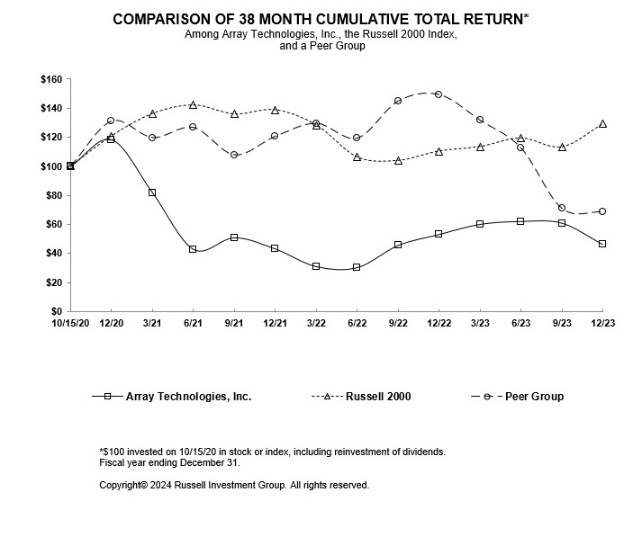
Recent Sales of Unregistered Equity Securities
Series A Redeemable Perpetual Preferred
On August 10, 2021, the Company entered into a Securities Purchase Agreement (the “Securities Purchase Agreement”) pursuant to which on August 11, 2021, the Company issued and sold to BCP Helios Aggregator L.P., an investment vehicle of funds affiliated with Blackstone Inc. (the “Purchaser”), 350,000 shares of its newly designated Series A Redeemable Perpetual Preferred Stock of the Company, par value $0.001 per share (the “Series A Shares”), and 7,098,765 shares of the Company’s common stock for an aggregate purchase price of $346.0 million (the “Initial Closing”). Further, pursuant to the Securities Purchase Agreement, on September 27, 2021, the Company issued and sold to the Purchaser 776,235 shares of common stock for an aggregate purchase price of $776 (the “Prepaid Forward Contract”).

On January 7, 2022, pursuant to the Put Option, the Company issued and sold to the Purchaser 50,000 shares of Series A Shares and 1,125,000 shares of the Company’s common stock in an additional closing for an aggregate purchase price of $49.4 million (the “Additional Closing”). The securities issued pursuant to the
40

Securities Purchase Agreement were offered, issued, and sold in reliance upon the exemption from the registration requirements of the Securities Act set forth under Section 4(a)(2) of the Securities Act.

For more information regarding the Series A Shares and our unregistered sales of equity securities, see Note 12 – Redeemable Perpetual Preferred Stock to the accompanying notes to the consolidated financial statements.

Purchases of Equity Securities by the Issuer and Affiliated Purchasers
None.

Item 6. Reserved

41

Item 7. Management’s Discussion and Analysis of Financial Condition and Results of Operations

Management’s Discussion and Analysis of Financial Condition and Results of Operations
This Management’s Discussion and Analysis of Financial Condition and Results of Operations should be read in conjunction with our financial statements and the related notes and other financial information included in this Annual Report on Form 10-K. In addition to historical financial information, the following discussion and analysis contains forward-looking statements that involve risks, uncertainties and assumptions. Our actual results and timing of selected events may differ materially from those anticipated in these forward-looking statements as a result of many factors, including those discussed under the sections of this Form 10-K captioned “Forward-Looking Statements” and “Risk Factors.”

Overview
We are one of the world’s largest manufacturers of ground-mounting tracking systems used in solar energy projects at utility scale. Our principal products are a portfolio of integrated solar tracking systems comprised of steel supports, electric motors, gearboxes and electronic controllers commonly referred to as a single-axis “tracker.” Trackers move solar panels throughout the day to maintain an optimal orientation to the sun, which significantly increases their energy production. Solar energy projects that use trackers generate more energy and deliver a lower LCOE than projects that use “fixed tilt” mounting systems, which do not move. The vast majority of ground mounted solar systems in the U.S. use trackers.

Our flagship tracker uses a patented design that allows one motor to drive multiple rows of solar panels through articulated driveline joints. To avoid infringing on our U.S. patent, our competitors must use designs that we believe are inherently less efficient and reliable. For example, our largest competitor’s design requires one motor for each row of solar panels. As a result, we believe our products have greater reliability, lower installation costs, reduced maintenance requirements and competitive manufacturing costs. Our core U.S. patent is on a linked-row, single-driving apparatus that rotates a plurality of tracker rows connected by an articulating drive shaft. This patent does not expire until February 5, 2030.

With our acquisition of STI in January 2022, we added a dual-row tracker design to our product portfolio. This tracker uses one motor to drive two connected rows and is ideally suited for sites with irregular and highly angled boundaries or fragmented project areas. To offer a comprehensive set of solutions to the growing market, in September of 2022, we also introduced a third tracker product requiring significantly less grading and civil works permitting prior to installation in addition to accommodating uneven terrain. This suite of products extends our target applications and ability to deliver the best utility-scale solar tracker solutions to the market.

We sell our products to EPCs that build solar energy projects and to large solar developers, independent power producers and utilities, often under master supply agreements or multi-year procurement contracts. During the year ended December 31, 2023, we derived 74% and 26% of our revenues from customers in the U.S. and the rest of the world, respectively. As of December 31, 2023, we had shipped more than 73 gigawatts of trackers to customers worldwide.

Acquisition of STI Norland
On January 11, 2022, we completed our acquisition of STI for purchase consideration of $410.5 million in cash and 13,894,800 shares of our common stock. The fair value of the purchase consideration was $610.8 million and resulted in the Company owning 100% of the equity interests in STI.

42

STI generates revenue through the design, manufacture and sale of its utility-scale solar tracker systems to customers in global markets that include Spain, Brazil, U.S. and South Africa. The integration of STI provides us the opportunity to accelerate our international expansion and better address rising global demand for utility-scale solar projects, particularly in developing countries in Latin America and Africa.

Reversal of Out-of-Period Adjustment Recorded during the three months ended March 31, 2023
Capped Calls and Put Option
During the three months ended December 31, 2023, the Company consulted with the staff of the Office of the Chief Accountant of the SEC, and after consultation with the staff, the Company concluded that the change from its historical accounting treatment for its Capped Calls and its Put Option that were made during the three months ended March 31, 2023, was not required. As a result, the Company has chosen to revert to its historical accounting and reverse the initial cumulative catch-up recorded during the three months ended March 31, 2023, as well as any subsequent fair value adjusting entries recorded during the interim periods in 2023. See Note 11 – Debt and Item 9B. Other Information.

Factors Affecting Results Of Operations
Project Timing
Because we recognize revenue on projects as legal title to equipment is transferred from us to the customer, any delays in large projects from one quarter to another for any reason may cause our results of operations for a particular period to fall below expectations. Our end-users’ ability to install solar energy systems has been affected by a number of factors including:

•Weather. Inclement weather can affect our customers’ ability to install their systems, particularly in the northeastern United States and in Europe. In addition, weather delays can adversely affect our logistics and operations by causing delays in the shipping and delivery of our materials.
•The interest rate environment. As interest rates have risen, we have seen customers looking to renegotiate power purchase agreements to improve project returns. Any unexpected or protracted negotiation can cause installation delays and delay our ability to recognize revenue relating to the relevant projects. In addition, we have had customers delay planned installations in anticipation of interest reductions and more favorable project financing conditions later in 2024.
•Availability of necessary equipment. We have a broad portfolio of customer relationships including presence with every Tier 1 utility in the United States. Each utility has unique specifications for access to its grid, which is generally not consistent across the industry. As the supply of renewables projects has increased, severe shortages and long lead-times in the supply of switches, transformers and HV breakers used in the interconnection of utility scale solar power plants to the grid, has affected the timing and completion of these projects, including for some of our customers.
•Local Permitting. If our customers cannot receive permitting for their projects, they are unable to begin and ultimately complete them in a timely manner. A dramatic increase in solar and battery storage sites has increased the average permitting time in many geographies in which our customers operate.

Impact of IRA
While solar power is cost-competitive with conventional forms of generation in many U.S. states even without the ITC, we believe step-downs in the ITC have influenced the timing and quantity of some customers’ orders. With the passage of the Inflation Reduction Act (“IRA”) in August 2022, the ITC was raised to 30% with no step downs before 2032. Accordingly, we do not anticipate the ITC rate to impact our seasonality during that timeframe.
43

After a period of uncertainty, in December the IRS published proposed regulations on 45X manufacturing credit benefits that largely confirmed our previous understanding around the eligibility of our torque tube. In late 2023 and early 2024, we successfully negotiated agreements with key suppliers around 45X benefits associated with the torque tube. This resulted in the accumulation of $49.9 million of 45X benefit in the fourth quarter, from volume delivered throughout 2023. We recognized $9.3 million of that benefit as a reduction to cost of revenue during the year ended December 31, 2023, and the remaining $40.6 million is expected to be recognized during 2024.

The 45X proposed regulations published in December did not further clarify what would be considered a structural fastener; however, we do continue to expect that there will be additional credits we can monetize for a number of our components under the existing law and proposed regulations. We are actively working on multiple initiatives to obtain additional clarity regarding the eligibility and in parallel are negotiating the split of the 45X benefits with our suppliers for parts we do not manufacture internally.

Structured Cost Management
We actively manage the risk from certain types of customer contracts, including, for example, multi-year contracts that require fixed pricing or pricing tied to certain commodity indices. Depending on the totality of the circumstances and our ability to mitigate risk, we may or may not pursue such contractual arrangements. Where we decline, this may have the effect of driving certain customers or projects to our competitors. We believe this is the right way to manage a high quality portfolio and drive consistent margins over time.

Impact of Attacks on Shipping in the Red Sea
Houthi rebels in Yemen have significantly stepped-up attacks against commercial vessels in the Bab-el-Mandeb strait between the Arabian peninsula and the Horn of Africa since late November 2023, which has led many shipping companies are pause shipments through the Suez Canal and the Red Sea. Many of these shipments are being redirected around the Cape of Good Hope in South Africa, adding between 3,000 to 3,500 nautical miles to routes connecting Europe with Asia. As an additional result of the reroute, certain ports could see crowding and delays in unloading shipments. We do not yet know the duration of these disruptions or the severity of their impact on our operations, but we continue to monitor the situation and evaluate our procurement strategy and supply chain as to reduce any negative impact on our business, financial condition and results of operations.

Inflation
Inflationary pressures may continue to impact, at least in the near-term, and may continue to negatively impact our results of operations. To mitigate the inflationary pressures on our business, we have implemented selective price increases in certain markets, accelerated productivity initiatives and expanded our supplier base, while continuing to execute on overhead cost containment practices.

Regulatory Impacts
In June 2022, the U.S. President authorized the U.S. Secretary of Commerce to provide a 24-month AD/CVD tariff exemption for imported solar panels from certain Southeast Asian countries. The USDOC previously issued regulations implementing the AD/CVD moratorium in the event that it found circumvention with respect to such Southeast Asian countries. In August 2023, the USDOC issued final affirmative circumvention rulings, finding that solar panels completed in Cambodia, Malaysia, Thailand, and Vietnam using parts and components produced in China circumvent pre-existing AD/CVD orders on China. At this time, it is expected that duties will apply to such solar panels unless they are imported, used, and installed by certain dates in June 2024. While we do not sell solar modules, the degree of our exposure is dependent on, among other things,
44

the impact of the investigation on the projects that are also intended to use our products, with such impact being largely out of our control. We have seen a number of projects in our order book delayed as a result of the USDOC investigation. The repeal of the 24-month exemption, and any affirmative determinations made once the exemption expires in any event, would have an adverse effect on our business, financial condition, and results of operations. More broadly, legislation has been proposed that would make it easier for domestic companies to obtain affirmative determinations in antidumping and countervailing duties investigations. The proposed USICA/America COMPETES Act, if enacted, could result in future successful petitions that limit imports from Asia and other regions.

Additionally, in October 2023, a coalition of U.S. aluminum extruders and a labor union filed AD/CVD cases on aluminum extrusions from fifteen countries. The USDOC has initiated investigations based on the petitions. Certain components in our trackers, including certain clamps, U-joints, and bearing housings are made using extruded aluminum. Our operating results could be adversely impacted if the USDOC imposes duties on such imports. We continue to monitor developments in the investigation and work to mitigate its impact on our supply chain, but if we are unable to do so, these antidumping and countervailing duties could negatively impact our business, financial condition, and results of operations.

Foreign Currency Translation
For non-U.S. subsidiaries that operate in a local currency environment, assets and liabilities are translated into U.S. dollars at period end exchange rates. Income, expense and cash flow items are translated at average exchange rates prevailing during the period. For non-U.S. subsidiaries that operate in a U.S. dollar functional currency, local currency inventories and property, plant and equipment are translated into U.S. dollars at rates prevailing when acquired, and all other assets and liabilities are translated at period-end exchange rates. Income and expense items are translated at average exchange rates prevailing during the period. Gains and losses which result from remeasurement are included in earnings.

Performance Measures
In managing our business and assessing financial performance, we supplement the information provided by the financial statements with other operating metrics. These operating metrics are utilized by our management to evaluate our business, measure our performance, identify trends affecting our business and formulate projections. The primary operating metric we use to evaluate our sales performance and to track market acceptance of our products from year to year is megawatts (“MWs”) shipped generally and the change in MWs shipped from period to period specifically. MWs is measured for each individual project and is calculated based on the projects expected megawatt output once installed and fully operational.

We also utilize metrics related to price and cost of goods sold per MW, including average selling price (“ASP”) and cost per watt (“CPW”). ASP is calculated by dividing total applicable revenues by total applicable MWs, whereas CPW is calculated by dividing total applicable costs of goods sold by total applicable MWs. These metrics enable us to evaluate trends in pricing, manufacturing cost and customer profitability.

Key Components of Our Results of Operations
The following discussion describes certain line items in our consolidated statements of operations.

Revenue
We generate revenue from the sale of solar tracking systems and parts. Our customers include EPCs, utilities, solar developers and independent power producers. For each individual solar project, we enter into a contract with our customers covering the price, specifications, delivery dates and warranty for the products being purchased, among other things. Our contractual delivery period for the tracker system and parts can vary from days to several months. Contracts can range in value from hundreds of thousands to tens of millions of dollars.
45

Our revenue is affected by changes in the volume and ASPs of solar tracking systems purchased by our customers. The quarterly volume and ASP of our systems is driven by the supply of, and demand for, our products, changes in project mix between module type and wattage, geographic mix of our customers, strength of competitors’ product offerings, and availability of government incentives to the end-users of our products.

Our revenue growth is dependent on continued growth in the size and number of solar energy projects installed each year as well as our ability to maintain our market share in each of the geographies where we compete, expand our global footprint to new and evolving markets, grow our production capabilities to meet demand and to continue to develop and introduce new and innovative products that address the changing technology and performance requirements of our customers.

Cost of Revenue and Gross Profit
Cost of revenue consists primarily of product costs, including raw materials, purchased components, salaries, wages and benefits of manufacturing personnel, freight, tariffs, customer support, product warranty, amortization of developed technology, and depreciation of manufacturing and testing equipment. Our product costs are affected by (i) the underlying cost of raw materials, including steel and aluminum, (ii) component costs, including electric motors and gearboxes, (iii) technological innovation, and (iv) economies of scale and improvements in production processes and automation. We may experience disruptions to our supply chain and increased material and freight costs like those experienced in 2021 and 2022 during the COVID-19 pandemic. When possible, we modify our production schedules and processes to mitigate the impact of these disruptions and cost increases on our margins. We do not currently hedge against changes in the price of our raw materials.

Gross profit may vary from quarter to quarter and is primarily affected by our volume, ASPs, product costs, project mix, customer mix, geographical mix, commodity prices, logistics rates, warranty costs, and seasonality.

Inflation Reduction Act Vendor Rebates
On August 16, 2022, the Inflation Reduction Act of 2022 (“IRA”) was enacted into law, which includes numerous green energy credits. The 45X Advanced Manufacturing Production Tax Credit (“45X Credit”) was established as part of the IRA. The 45X Credit is a per-unit tax credit that is earned over time for each clean energy component domestically produced and sold by a manufacturer. We have, and will continue to, enter into arrangements with torque tube and structural fastener manufacturing vendors that produce 45X Credit eligible parts, in which the vendors agree to share a portion of the benefit received related to our purchases, in the form of “Vendor Rebates”.

We account for these Vendor Rebates as a reduction of the purchase prices of the vendors’ products and therefore a reduction of inventory until the inventory is sold, at which time we recognize such rebates as a reduction of cost of revenues on the consolidated statements of operations. Rebates related to purchases that were made prior to the execution of the agreements are deferred and recognized as a reduction of the prices of future purchases. In the fourth quarter of 2023, we had accumulated a total of $49.9 million in Vendor Rebates from current year activity, of which $48.4 million were outstanding and included in Prepaid expenses and other, and $40.6 million of deferred consideration was included in Other current liabilities, on our consolidated balance sheet dated December 31, 2023. Additionally, we recognized $9.3 million of Vendor Rebate benefit as a reduction of cost of revenue, during the fourth quarter of 2023.

In December 2023, the internal revenue service (“IRS”) issued proposed regulations on the 45X Credits. While these proposed regulations did not provide additional clarity on what would be considered a structural fastener as it relates to 45X Credit eligibility, we continue to actively negotiate potential benefit sharing arrangements
46

with manufacturing vendors of structural fasteners, as well as manufacturers of other of our components, that could potentially be declared eligible at a future date.

Operating Expenses
General and administrative expense consist primarily of salaries, benefits, and equity-based compensation related to our executive, sales, engineering, finance, human resources, information technology, and legal personnel, as well as travel, facility costs, marketing, bad debt provision, and professional fees. The majority of our sales in 2023, 2022, and 2021, were in the U.S.; however, in January 2022, we expanded our international operations with the STI Acquisition. We currently have a sales presence in the U.S., Spain, Brazil, South Africa, Australia, and the U.K. We intend to continue to expand our sales presence and marketing efforts to additional countries.

Contingent consideration consists of the changes in fair value of the tax receivable agreement (“TRA”) entered into with a former indirect stockholder, concurrent with the acquisition of Patent LLC by Former Parent. The TRA liability was recorded at fair value as of July 8, 2016 (the “Patent Acquisition Date”) and subsequent changes in the fair value are recognized in earnings. For discussion and analysis of the TRA see Note 16 – Commitments and Contingencies.
Depreciation expense consists of costs associated with property, plant and equipment not used in manufacturing of our products. We expect that as we continue to grow both our revenue and our general and administrative personnel we may require some additional property, plant and equipment to support this growth resulting in additional depreciation expense.

Amortization of intangibles consists of customer relationships, contractual backlog and the STI trade name expensed over their expected period of use.

Non-Operating Expenses
Interest expense consists of interest and other charges paid in connection with our Senior Secured Credit Facility, the Convertible Notes, and Other Debt held by our STI Operations.

We are subject to U.S. federal, state and non-U.S. income taxes. As we expand into additional foreign markets, we may be subject to additional foreign tax.

Reportable Segments
Subsequent to the acquisition of STI, the Company began reporting its results of operations in two segments; the Array Legacy operating segment and the newly acquired STI Legacy operating segment (“STI Legacy Operations”) pertaining to legacy STI operations. The segment amounts included in this Item 7. Management’s Discussion and Analysis are presented on a basis consistent with our internal management reporting. Additional information on our reportable segments is contained in Note 20 – Segment and Geographic Information in the accompanying notes to the consolidated financial statements.

47

Results of Operations

The following table sets forth our consolidated statement of operations (in thousands):
 |  |  | Year Ended December 31, |  |  |  |  |  |  |  |  |  |  |  | Increase (Decrease)
 |  |  | 2023 |  |  |  |  |  | 2022 |  |  |  |  |  | $ |  |  |  |  |  | %
Revenue |  |  | $ | 1,576,551 |  |  |  |  | $ | 1,637,546 |  |  |  |  | $ | (60,995) |  |  |  |  | (4) |  | %
Cost of revenue:
Cost of product and service revenue |  |  | 1,146,442 |  |  |  |  |  | 1,410,270 |  |  |  |  |  | (263,828) |  |  |  |  |  | (19) |  | %
Amortization of developed technology |  |  | 14,558 |  |  |  |  |  | 14,558 |  |  |  |  |  | — |  |  |  |  |  | — |  | %
Total cost of revenue |  |  | 1,161,000 |  |  |  |  |  | 1,424,828 |  |  |  |  |  | (263,828) |  |  |  |  |  | (19) |  | %
Gross profit |  |  | 415,551 |  |  |  |  |  | 212,718 |  |  |  |  |  | 202,833 |  |  |  |  |  | 95 |  | %
Operating expenses:
General and administrative |  |  | 159,535 |  |  |  |  |  | 150,777 |  |  |  |  |  | 8,758 |  |  |  |  |  | 6 |  | %
Change in fair value of contingent consideration |  |  | 2,964 |  |  |  |  |  | (4,507) |  |  |  |  |  | (7,471) |  |  |  |  |  | (166) |  | %
Depreciation and amortization |  |  | 38,928 |  |  |  |  |  | 84,581 |  |  |  |  |  | (45,653) |  |  |  |  |  | (54) |  | %
Total operating expenses |  |  | 201,427 |  |  |  |  |  | 230,851 |  |  |  |  |  | (29,424) |  |  |  |  |  | (13) |  | %
Income (loss) from operations |  |  | 214,124 |  |  |  |  |  | (18,133) |  |  |  |  |  | 232,257 |  |  |  |  |  | 1281 |  | %
Other (expense) income, net |  |  | (1,015) |  |  |  |  |  | 2,789 |  |  |  |  |  | (3,804) |  |  |  |  |  | (136) |  | %
Interest income |  |  | 8,330 |  |  |  |  |  | 3,181 |  |  |  |  |  | 5,149 |  |  |  |  |  | 162 |  | %
Legal settlement |  |  | — |  |  |  |  |  | 42,750 |  |  |  |  |  | (42,750) |  |  |  |  |  | (100) |  | %
Foreign currency transaction (loss) gain, net |  |  | (53) |  |  |  |  |  | 1,155 |  |  |  |  |  | (1,208) |  |  |  |  |  | (105) |  | %
Interest expense |  |  | (44,229) |  |  |  |  |  | (36,694) |  |  |  |  |  | 7,535 |  |  |  |  |  | 21 |  | %
Total other (expense) income |  |  | (36,967) |  |  |  |  |  | 13,181 |  |  |  |  |  | (35,078) |  |  |  |  |  | 266 |  | %
Income (loss) before income tax expense (benefit) |  |  | 177,157 |  |  |  |  |  | (4,952) |  |  |  |  |  | 182,109 |  |  |  |  |  | 3677 |  | %
Income tax expense (benefit) |  |  | 39,917 |  |  |  |  |  | (9,384) |  |  |  |  |  | 49,301 |  |  |  |  |  | 525 |  | %
Net income |  |  | $ | 137,240 |  |  |  |  | $ | 4,432 |  |  |  |  | $ | 132,808 |  |  |  |  | 2997 |  | %

The following table provides details on our operating results by reportable segment for the respective periods (in thousands):
 |  |  | Year Ended December 31, |  |  |  |  |  |  |  |  |  |  |  | Increase/Decrease
Revenue: |  |  | 2023 |  |  |  |  |  | 2022 |  |  |  |  |  | $ |  |  |  |  |  | %
Array Legacy Operations |  |  | $ | 1,172,827 |  |  |  |  | $ | 1,267,883 |  |  |  |  | $ | (95,056) |  |  |  |  | (7) |  | %
STI Operations |  |  | 403,724 |  |  |  |  |  | 369,663 |  |  |  |  |  | 34,061 |  |  |  |  |  | 9 |  | %
Total |  |  | $ | 1,576,551 |  |  |  |  | $ | 1,637,546 |  |  |  |  | $ | (60,995) |  |  |  |  | (4) |  | %
Gross Profit:
Array Legacy Operations |  |  | $ | 317,605 |  |  |  |  | $ | 153,612 |  |  |  |  | $ | 163,993 |  |  |  |  | 107 |  | %
STI Operations |  |  | 97,946 |  |  |  |  |  | 59,106 |  |  |  |  |  | 38,840 |  |  |  |  |  | 66 |  | %
Total |  |  | $ | 415,551 |  |  |  |  | $ | 212,718 |  |  |  |  | $ | 202,833 |  |  |  |  | 95 |  | %

48

Year Ended December 31, 2023 Compared to Year Ended December 31, 2022
Revenue
Consolidated revenue decreased $61.0 million, or 4%, driven by a decrease in Array Legacy Operations of $95.1 million, offset by an increase in STI Operations of $34.1 million.

The $95.1 million, or 7%, revenue decrease in Array Legacy Operations was driven by a decrease in the number of megawatts shipped, due primarily to project delays from our customers.

The $34.1 million, or 9%, revenue increase in STI Operations was driven by an increase in the number of megawatts shipped, most notably in the Brazil region, which offset lower ASP, due to a smaller percentage of construction services being offered.

Cost of Revenue and Gross Profit
Consolidated cost of revenue decreased $263.8 million, or 19%, driven primarily by a reduction in revenue combined with a decrease in input costs.
As a percentage of revenue, consolidated gross profit increased to 26% for the year ended December 31, 2023, as compared to 13% during the same period in the prior year. The increase in gross profit dollars was driven by an improvement in the gross margin percentage in both our Array Legacy Operations and our STI Operations.

As a percentage of revenue, gross profit for Array Legacy Operations increased to 27% from 12% for the year ended December 31, 2023 and 2022, respectively. The increase in gross profit as a percent of revenue was driven by the improved pass through of commodity volatility to customers, in addition to cost savings opportunities in logistics and raw materials, as well as a higher proportion of higher margin non-tracker revenue.

As a percentage of revenue, gross profit for STI Operations increased to 24% from 16% for the year ended December 31, 2023 and 2022, respectively, driven primarily by improved pass through of commodity volatility to customers, cost saving opportunities in raw materials, and a reduced impact of lower margin construction-related services provided.

Operating Expenses
Consolidated general and administrative expense increased $8.8 million, or 6%. The increase was primarily due to higher payroll and other personnel-related expenses, driven by an increase in headcount. These increases were partially offset by no acquisition related expenses in 2023 compared to expenses related to the STI Acquisition in 2022.

Change in the fair value of contingent consideration resulted in a loss of $3.0 million for the year ended December 31, 2023, due to the fair value remeasurement of the TRA liability, primarily driven by a decrease in the discount rates used in the valuation.

Consolidated depreciation and amortization expense decreased $45.7 million, or 54%, due to the decrease in the amortization of intangibles, as the backlog purchased as part of the STI Acquisition had a one-year life and was fully amortized as of the first quarter of 2023.

49

Legal Settlement
Legal settlement income in 2022 resulted from the settlement of litigation related to trade secret misappropriation, for which the Company received a $42.8 million settlement. The settlement is related to Nextracker’s acknowledgment that an Array employee was hired in violation of his non-compete agreement, certain Array confidential information was improperly obtained, and Nextracker’s behavior was wrongful. The parties concluded the matter and plan to continue their shared missions of mainstreaming clean energy worldwide. As part of the settlement, the parties agreed to treat the settlement terms as confidential except to the extent required or necessitated by law, regulation, or the corporate parties’ shareholder disclosure standards. There were no settlements in 2023.

Foreign Currency Gain
Consolidated foreign currency gain decreased $1.2 million, or 105%, as compared with the prior year due to the weakening of the U.S. Dollar compared to the Euro and compared to the Brazilian Real during 2023.

Interest Income
Consolidated interest income increased by $5.1 million, or 162%, as compared to the prior year, due to higher cash on hand in 2023 coupled with higher interest rates.

Interest Expense
Consolidated interest expense increased by $7.5 million, or 21%, primarily due to increased variable interest rates charged on our Term Loan Facility as well as the acceleration of $4.2 million of non-cash interest expense related to unscheduled principal payments made against the outstanding Term Loan balance.

Income Tax Expense (Benefit)
Consolidated Income tax expense (benefit) decreased by $49.3 million, or 525%, We recorded income tax expense of $39.9 million and a benefit of $9.4 million for the years ended December 31, 2023 and 2022, respectively. The income tax expense for the year ended December 31, 2023, was unfavorably impacted by higher income in non-U.S. jurisdictions, partially offset by benefits related to excess equity-based compensation deductions. The tax expense for the year ended December 31, 2022, was favorably impacted by losses in non-U.S. jurisdictions which have higher tax rates than the U.S., partially offset by non-deductible expenses.

Year Ended December 31, 2022 Compared to Year Ended December 31, 2021
A discussion and analysis covering the comparison of the year ended December 31, 2022, to the year ended December 31, 2021, is included in our annual report on Form 10-K filed with the Securities and Exchange Commission on March 22, 2023.

50

Liquidity and Capital Resources
Financing Transactions
Series A Shares
For more information related to the 2022 and 2021 Series A Share issuances, see Note 12 – Redeemable Perpetual Preferred Stock, to the accompanying consolidated financial statements.

Debt Obligations
For a discussion of our debt obligations see Note 11 – Debt, in the accompanying notes to the consolidated financial statements.

Surety Bonds
The Company is required to provide surety bonds to various parties as required for certain transactions initiated during the ordinary course of business to guarantee the Company’s performance in accordance with contractual or legal obligations. These off-balance sheet arrangements do not adversely impact our liquidity or capital resources. As of December 31, 2023, we posted surety bonds totaling approximately $172.9 million.

Cash Flows (in thousands)
 |  |  | Year Ended December 31,
 |  |  | 2023 |  |  |  |  |  | 2022
Net cash provided by operating activities |  |  | $ | 231,955 |  |  |  |  | $ | 141,493
Net cash used in investing activities |  |  | (16,821) |  |  |  |  |  | (384,437)
Net cash (used in) provided by financing activities |  |  | (101,761) |  |  |  |  |  | 8,440
Effect of exchange rate changes on cash and cash equivalent balances |  |  | 1,806 |  |  |  |  |  | 735
Net change in cash and cash equivalents |  |  | $ | 115,179 |  |  |  |  | $ | (233,769)

Historically, we have financed our operations with the proceeds from operating cash flows, capital contributions and short and long-term borrowings. Our ability to generate positive cash flow from operations is dependent on the strength of our gross margins as well as our ability to quickly turn our working capital.

High volatility and uncertainty in the capital markets resulting from macroeconomic conditions, including fluctuating inflation data and heightened interest rates, has had, and could continue to have, a negative impact on the price of our common stock and could adversely impact our ability to raise additional funds. In response to the recent challenging environment, we continuously evaluate our ability to meet our obligations over the next 12 months. We believe we have sufficient liquidity as well as financing options available to fund current and future commitments.

As of December 31, 2023, our cash balance was $249.1 million, of which $66.8 million was held outside the U.S., and net working capital was $496.6 million. We had outstanding borrowings of $238.2 million under our $575 million Term Loan Facility and $175.2 million available to us under our $200.0 million Revolving Credit Facility.

The Company continually monitors and reviews its liquidity position and funding needs. Management believes that the Company’s ability to generate operating cash flows in the future and available borrowing capacity under its Senior Secured Credit Facility will be sufficient to meet its future liquidity needs.

51

Cash Flows from Operating Activities
The Company generated $232.0 million in cash from operating activities during the year ended December 31, 2023, of which, $224.4 million was generated from net income as adjusted for the impact of non-cash expenses, primarily consisting of depreciation and amortization and equity-based compensation.

For the year ended December 31, 2022, the Company generated $141.5 million in cash from operating activities, of which, $97.2 million was generated from net income as adjusted for the impact of non-cash expenses, primarily consisting of depreciation and amortization and equity-based compensation. The remaining $44.3 million was generated by changes in net working capital, including a $59.0 million increase in deferred revenue from deposits received from customers in 2022 for projects due in the first half of 2023, a $13.7 million increase in accounts payable and accrued expenses resulting from improved payables management, and a $20.9 million decrease in inventory levels as we burned down historically high raw material quantities from prior year, all of which were partially offset by a $77.0 million increase in accounts receivable driven primarily by a year-over-year increase in revenue.

Cash Flows from Investing Activities
For the year ended December 31, 2023, cash used in investing activities was $16.8 million, all of which was related to the purchase of property, plant and equipment.

For the year ended December 31, 2022, cash used in investing activities was $384.4 million primarily related to the STI Acquisition; net of cash acquired, the Company paid $373.8 million in cash as part of the purchase price consideration. Additionally, the Company utilized $10.6 million for the purchase of property, plant and equipment.

Cash Flows from Financing Activities
For the year ended December 31, 2023, net cash used in financing activities was $101.8 million, driven primarily by $74.3 million in payments on our Term Loan and a $24.8 million reduction of Other debt.

For the year ended December 31, 2022, net cash provided by financing activities was $8.4 million, which included $49.0 million related to proceeds from the sale of Series A Shares and common shares in January 2022 offset by a dividend payment of $18.7 million on the Series A Shares.

Discussion of Historical Cash Flows for Year Ended December 31, 2022 and 2021
A discussion and analysis covering historical cash flows for the year ended December 31, 2022 and 2021, is included in our annual report on Form 10-K filed with the Securities and Exchange Commission on March 22, 2023.

Critical Accounting Estimates
Our consolidated financial statements are prepared in accordance with U.S. GAAP. In connection with the preparation of our consolidated financial statements, we are required to make assumptions and estimates about future events and apply judgments that affect the reported amounts of assets, liabilities, revenue, expenses and related disclosures. We base our assumptions, estimates and judgments on historical experience, current trends and other factors that management believes to be relevant at the time our consolidated financial statements are prepared. On a regular basis, we review the accounting policies, assumptions, estimates and judgments to ensure that our consolidated financial statements are presented fairly and in accordance with U.S. GAAP. However, because future events and their effects cannot be determined with certainty, actual results could differ from our assumptions and estimates. To the extent that
52

there are material differences between these estimates and actual results, our future financial statement presentation, financial condition, results of operations and cash flows will be affected.

We consider an accounting policy to be critical if it requires an accounting estimate to be made based on assumptions about matters that are highly uncertain at the time the estimate is made, and if different estimates that reasonably could have been used, or changes in the accounting estimates that are reasonably likely to occur periodically, could materially impact the consolidated financial statements.

Revenue Recognition
The Company’s revenue recognition policy is described in Note 14 – Revenue, in the accompanying notes to our consolidated financial statements,

Accounting for contracts utilizing the cost-to-cost measure of progress is based on various assumptions to project the outcome of future events. These assumptions include the cost and availability of materials. The cost estimation process for recognizing revenues over time under the cost-to-cost method is based on the professional knowledge and experience of the Company’s project managers, engineers and finance professionals. The Company reviews and updates its contract-related estimates on an ongoing basis and recognizes adjustments for any project specific facts and circumstances that could impact the measurement of the extent of progress, such as the total costs to complete the contracts, under the cumulative catch-up method. Under this method, the impact of the adjustment on profit recorded to date is recognized in the period the adjustment is identified. Revenue and profit in future periods of contract performance is recognized using the adjusted estimate. As a result, if the actual costs to be incurred are different than the assumptions used to estimate those costs, there could be cumulative adjustments recorded to revenues as a result.

Business Combinations
The Company completed one business combination for an aggregate purchase price of $610.8 million during the year ended December 31, 2022. In accordance with Topic 805 Business Combinations, total consideration was first allocated to the fair value of assets acquired and liabilities assumed, with the excess being recorded as Goodwill. The fair value of the identifiable intangible assets has been estimated using the Excess Earnings Method (customer relationships and backlog) and Relief from Royalty Method (trade name). Significant inputs using the Excess Earnings Method and Level 3 inputs in the fair value hierarchy include estimated revenue, expenses based on actuals and forecast. The Company uses its best estimates and assumptions to assign fair value to the tangible and intangible assets acquired and liabilities assumed at the acquisition date. Intangible assets have been recognized apart from goodwill whenever an acquired intangible asset arises from contractual or other legal rights, or whenever it is capable of being separated or divided from the acquired entity. Determining these fair values required us to make significant estimates and assumptions, particularly with respect to acquired intangible assets. The determination of fair value required considerable judgment and were sensitive to changes in underlying assumptions, estimates and market factors. There were no business combinations during the year ended December 31, 2023.

Goodwill
Our goodwill represents the excess of the purchase price of business combinations over the fair value of the net assets acquired. Goodwill impairment testing requires significant judgment and management estimates, including, but not limited to, the determination of (i) the number of reporting units, (ii) the goodwill and other assets and liabilities to be allocated to the reporting units and (iii) the fair values of the reporting units. The estimates and assumptions described above, along with other factors such as discount rates, will significantly affect the outcome of the impairment tests and the amounts of any resulting impairment losses. We may use either a qualitative or quantitative approach when testing a reporting unit’s goodwill for impairment on an
53

annual basis during the fourth quarter of each year, and between annual tests whenever events or changes in circumstances indicate that the carrying amount may not be recoverable. If we use a qualitative approach and determine that it is more likely than not that the fair value of a reporting unit is less than its carrying value, we would then perform the first step of the goodwill impairment test, which would consist primarily of a discounted cash flow (“DCF”) analysis compared to a guideline publicly-traded companies (“GPC”) analysis to determine the fair value of the reporting unit.

During the fourth quarter of 2023, we used a qualitative approach to assess if it is more likely than not that that the fair value of the Array Legacy Operations reporting unit is less than its carrying value.

During the fourth quarter of 2023, with the assistance of a third-party specialist, we performed a quantitative assessment of the fair value of our STI reporting unit using the DCF and GPC methods described in Note 7 – Goodwill and Other Intangible Assets of the consolidated financial statements. The significant assumptions used in determining the fair values of the STI reporting unit primarily relate to the selection of EBITDA multiples used in the GPC analysis, and the revenue growth rate, the forecasted EBITDA margin, and the selected discount rate used in the DCF model. To the extent that GPC multiples in the future decrease, the discount rate used in determining the present value of our cash flows increases, or if we do not meet its cash flow projections for the reporting unit, an impairment charge may be recorded in the future.

Product Warranty
The Company offers an assurance type warranty for its products against manufacturer defects and does not contain a service element. For these assurance type warranties, a provision for estimated future costs related to warranty expense is recorded when they are probable and reasonably estimable, which is typically when products are delivered. This provision is based on historical information on the nature, frequency and average cost of claims for each product line. When little or no experience exists for an immature product line, the estimate is based on comparable product lines. These estimates are re-evaluated on an ongoing basis using best-available information and revisions to estimates are made as necessary.

Tax Receivable Agreement
Concurrent with the Former Parent’s acquisition of Patent LLC, Array Tech, Inc. entered into the TRA with a former indirect stockholder. The TRA is valued based on the future expected payments under the agreement and is accounted for as contingent consideration and subsequent changes in fair value of the contingent liability are recognized in earnings within the Company’s consolidated statement of operations. Estimating the amount of payments that may be made under the TRA is by nature imprecise. The significant fair value inputs used to estimate the future expected TRA payments include the timing of tax payments, a discount rate, book income projections, timing of expected adjustments to calculate taxable income and the projected rate of use for attributes defined in the TRA. For discussion and analysis of the TRA see Note 16 – Commitments and Contingencies.

Equity-Based Compensation
The Company granted restricted stock units (“RSUs”) to employees and Performance Stock Units (“PSUs”) to certain executives. The PSUs contain performance and market conditions. The PSU grants were valued using the Monte Carlo simulation method and the assigned fair value on grant date will be recognized on a straight-line basis over the vesting term of the awards. The probability of the awards meeting the performance related vested conditions is not included in the grant date fair value, but rather will be estimated quarterly and the Company will true-up the expense recognition accordingly upon any probability to vest revision. The Company accounts for forfeitures as they occur.

54

Recent Accounting Pronouncements
Refer to Note 2 – Summary of Significant Accounting Policies in the accompanying notes to our consolidated financial statements included in this Annual Report on Form 10-K for a discussion of recent accounting pronouncements.

Item 7A. Quantitative and Qualitative Disclosures About Market Risk

We are exposed to market risk in the ordinary course of our business. Market risk represents the risk of loss that may impact our financial position due to adverse changes in financial market prices and rates. Our market risk exposure is primarily a result of fluctuations in steel and aluminum prices and customer concentrations. We do not hold or issue financial instruments for trading purposes.

Concentrations of Major Customers
Our customer base consists primarily of large solar developers, independent power producers, utilities and EPCs. We do not require collateral on our accounts receivable.

At December 31, 2023, the Company’s largest customer and five largest customers accounted for 2.7% and 29.6%, respectively, of total accounts receivable. At December 31, 2022, the Company’s largest and five largest customers constituted 7.9% and 23.4% of trade accounts receivable, respectively.

During the year ended December 31, 2023, one customers accounted for 13.4% of total revenue. During the year ended December 31, 2022, two customers accounted for 11.8% and 10.6%, respectively, of total revenue. During the year ended December 31, 2021, two customers accounted for 12.6% and 10.2%, respectively, of total revenue.

Further, our accounts receivable are from companies within the solar industry and, as such, we are exposed to normal industry credit risk. We continually evaluate our reserves for potential credit losses and establish reserves for such losses.

Commodity Price Risk
We are subject to risk from fluctuating market prices of certain commodity raw materials, including steel and aluminum, that are used in our products. Prices of these raw materials may be affected by supply restrictions or other market factors from time to time, and we do not enter into hedging arrangements to mitigate commodity risk. Significant price changes for these raw materials could reduce our operating margins if we are unable to recover such increases from our customers, and could harm our business, financial condition and results of operations.

In addition, we are subject to risk from fluctuating logistics costs. As a result of sheltering-in-place and other disruptions during the COVID-19 pandemic, consumer and commercial demand for shipped goods increased across multiple industries, which in turn reduced the availability and capacity of shipping containers and available ships worldwide. In the event of a resurgence of COVID-19 or a similar pandemic and the resulting disruptions, we may experience increased logistics costs and shipment delays affecting the timing of our project deliveries, the timing of our recognition of revenue and our profitability.

Interest Rate Risk
As of December 31, 2023, or long-term debt, net of discounts and issuance costs, was $660.9 million, of which, $261.0 million is subject to variable-rate interest agreements and is therefore subject to future changes in
55

interest rates. Accordingly, a 50 basis point increase in interest rates would impact our expected annual interest expense for the next 12 months by approximately $1.2 million.

Customer Financing Exposure
We are also indirectly exposed to interest rate risk because many of our customers depend on debt financing to purchase our product. An increase in interest rates could make it challenging for our customers to obtain the capital necessary to make such purchases on favorable terms, or at all. Such factors could reduce demand or lower the price we can charge for our product, thereby reducing our net sales and gross profit.

Foreign Currency Exchange Risk
We do business in various foreign countries where the functional currency used to transact differs from our reporting currency. As a result, we are subject to the risk of foreign currency exchange rate fluctuations.

Item 8. Financial Statements and Supplementary Data

The financial statements and supplementary data required by this item are included after the Signature page of this Annual Report on Form 10-K beginning on page F-1.

Item 9. Changes in and Disagreements with Accountants on Accounting and Financial Disclosure

None.

Item 9A. Controls and Procedures

Evaluation of Disclosure Controls and Procedures
We maintain “disclosure controls and procedures,” as defined in Rules 13a-15(e) and 15d-15(e) under the Securities Exchange Act of 1934, as amended (the “Exchange Act”), that are designed to ensure that information required to be disclosed in the reports that we file or submit under the Exchange Act is (1) recorded, processed, summarized and reported, within the time periods specified in the SEC’s rules and forms and (2) accumulated and communicated to our management, including our principal executive officer and principal financial officer, to allow timely decisions regarding required disclosure. Management recognizes that any controls and procedures, no matter how well designed and operated, can provide only reasonable assurance of achieving their objectives and management necessarily applies its judgment in evaluating the cost-benefit relationship of possible controls and procedures.

Our management, with the participation of our Chief Executive Officer and Chief Financial Officer, evaluated the effectiveness of our disclosure controls and procedures as of December 31, 2023. Based upon the evaluation, our Chief Executive Officer and Chief Financial Officer concluded that, as of such date, our disclosure controls and procedures were not effective at a reasonable assurance level, due to the material weaknesses identified below.

However, after giving full consideration to the material weaknesses described below, and the additional analyses and other procedures we performed to ensure that our consolidated financial statements included in this Annual Report on Form 10-K were prepared in accordance with U.S. GAAP, our management has concluded that our consolidated financial statements present fairly, in all material respects, our financial position, results of operations and cash flows for the periods disclosed in conformity with U.S. GAAP.

56

Management’s Report on Internal Control Over Financial Reporting.
The Company’s management is responsible for establishing and maintaining adequate internal control over financial reporting, as defined in the Exchange Act Rules 13a-15(f) and 15d-15(f). The Company’s management, including the Chief Executive Officer and Chief Financial Officer, conducted an evaluation of the effectiveness of the Company’s internal control over financial reporting based on the Internal Control – Integrated Framework (2013) issued by the Committee of Sponsoring Organizations of the Treadway Commission (COSO). Based on the results of this evaluation, the Company’s management concluded that internal control over financial reporting was not effective as of December 31, 2023, due to the material weaknesses listed below. A material weakness is a deficiency, or combination of deficiencies, in internal control over financial reporting such that there is a reasonable possibility that a material misstatement of the Company’s annual or interim financial statements will not be prevented or detected on a timely basis. Our independent registered public accounting firm, Deloitte & Touche LLP, has audited the effectiveness of our internal control over financial reporting as of December 31, 2023, as stated in their report, which appears herein.

We have concluded that the following material weaknesses in our internal control over financial reporting that were previously disclosed in our Annual Report on Form 10-K for the year ended December 31, 2022, have not been remediated as of December 31, 2023:
•We have identified a material weakness due to a deficiency in one of the principles associated with the Control Environment component of the COSO framework, specifically relating to a lack of a sufficient complement of qualified personnel at the appropriate levels to perform control activities in support of preparing the financial statements in accordance with U.S. GAAP.
•Control Activities – STI. We did not design, implement, and monitor general information technology controls in the areas of program change management, user access, and segregation of duties for systems supporting substantially all of STI’s internal control processes and we did not design and implement formal accounting policies, procedures, and controls across substantially all of the STI’s business processes to achieve timely, complete, accurate financial accounting, reporting, and disclosures.

Remediation Plan for Existing Material Weaknesses
Management has been actively engaged in remediation efforts to address the material weaknesses throughout 2023, and these efforts will continue into 2024. We have made enhancements to our control environment by improving guidance, communication of expectations and importance of internal controls. We made progress towards addressing our material weakness in our lack of qualified personnel by hiring additional qualified accounting and finance personnel during 2023, which has helped to provide additional capacity and expertise to enhance our accounting and reporting review procedures. Specifically, in the fourth quarter of 2023, the Company hired a new Chief Financial Officer and additional qualified accounting resources, who are currently assessing if additional personnel should be hired at STI in connection with the planned system implementation, and elsewhere in the organization, in order to perform control activities in support of preparation of the financial statements in accordance with U.S. GAAP. We expect that this assessment will be completed during the first quarter of 2024, with appropriate action taken during 2024, to ensure that the Company has a sufficient complement of qualified personnel at the right levels, based on any identified gaps in personnel requirements.

Due to accounting system limitations at STI, management is limited in its ability to effectively design and implement general information technology controls at STI, which support the underlying business cycle controls. The accounting system was in place when the Company acquired STI, and management is planning on implementing a new accounting system in the first half of 2024. The new system will allow management to effectively design and implement appropriate general information technology controls including system
57

enforced segregation of duties. Management is currently assessing the process level risks at STI, designing controls based upon the planned accounting system. In addition, with the assistance of an outside consulting firm, we are in the process of formalizing our STI accounting and business operation policies and procedures, in advance of this system implementation.

Remediation of Previously Identified Material Weaknesses
The following entity level material weaknesses were previously disclosed in our Annual Report on Form 10-K for the year ended December 31, 2022:
•Control Environment, Risk Assessment and Monitoring Activities – We did not maintain appropriately designed entity-level controls impacting the control environment and effective monitoring controls to prevent or detect material misstatements to the consolidated financial statements. These deficiencies were attributed to (i) a lack of a sufficient number of qualified resources and inadequate oversight and accountability over the performance of control activities, (ii) ineffective identification and assessment of risks to properly design and implement relevant controls, and (iii) ineffective evaluation and determination as to whether the components of internal control were present and functioning.

We have concluded that with the exception of a lack sufficient number of qualified personnel as discussed above, that these material weaknesses have been remediated. Specifically, management, with the assistance of an outside consulting firm, implemented a process level risk assessment for all material classes of transactions, identified and designed relevant controls to mitigate the identified risks of material misstatement, and tested the design, implementation, and operating effectiveness of those controls.

As previously disclosed in our Annual Report on Form 10-K for the year ended December 31, 2022, we also identified material weaknesses related to Control Activities. With the exception of the STI related material weakness above we have completed our remediation efforts previously identified in Item 9A “Controls and Procedures” of our Annual Report on Form 10-K for the year ended December 31, 2022. Based on our testing of the design and operating effectiveness of the enhanced internal controls, we have concluded that the following material weaknesses related to Control Activities that existed as of December 31, 2022, exclusive of STI, have been remediated:
•Inventory
•Revenue Recognition
•Accounts Receivable
•Financial Reporting, Consolidation and Business Combination
•Foreign Currency.

Changes in Internal Control over Financial Reporting
During the quarter ended December 31, 2023, except for the changes discussed above, there have been no other changes in the Company’s internal control over financial reporting that have materially affected, or are reasonably likely to materially affect, the Company’s internal control over financial reporting.

58

Item 9B. Other Information

Immaterial Correction of Interim Condensed Consolidated Financial Statements
Capped Calls
In connection with the pricing of the Convertible Notes, we entered into capped call transactions with the Option Counterparties. At issuance the Company concluded that the Capped Calls met the criteria for equity classification because they are indexed to the Company’s common stock and the Company has discretion to settle the Capped Calls in shares or cash. As a result, the amount paid for the Capped Calls was recorded as a reduction to additional paid-in capital. When the Company entered into the Capped Calls, the Company executed certain side letters (the “Side Letters”) with the counterparties that replaced some of the terms described in the primary contract including the volatility inputs used to value the Capped Calls under certain circumstances. Upon further evaluation of the accounting during the three months ended March 31, 2023, the Company concluded that the modification to the volatility inputs in the side letters precluded the Capped Calls from being accounted for as an equity instrument indexed to its own stock and should be accounted for as a freestanding derivative instrument asset recognized at fair value, with subsequent changes in fair value recognized in earnings. During the three months ended March 31, 2023, the Company began to account for the Capped Calls as derivative assets, with subsequent changes in fair value being recorded through earnings. During the three months ended December 31, 2023, after consultation with the staff of the Office of the Chief Accountant of the SEC, the Company concluded that the original equity classification accounting treatment was acceptable. As a result, the Company reclassified the derivative asset recognized during the interim periods of 2023 as a reduction to equity and reversed the related mark to market adjustments recognized during the interim periods of 2023.

Redeemable Perpetual Preferred Stock
At issuance, the Company evaluated the accounting for the instruments issued pursuant to the SPA and determined the Series A Shares and common stock issued in the Initial Closing, as well as the Prepaid Forward Contract, and Put Option are freestanding instruments that are classified in equity. During the first quarter of 2023, the Company reconsidered the provisions of the Put Option and concluded that it should be accounted for as a freestanding derivative instrument asset accounted for at fair value with subsequent fair value adjustments recognized in earnings. During the fourth quarter of 2023, after consultation with the staff of the Office of the Chief Accountant of the SEC, the Company concluded that the original equity accounting classification was correct. As a result, the Company reclassified the derivative asset recognized during the interim periods of 2023 as a reduction of equity and also reversed the related fair value adjustments.

Management evaluated the above misstatements and concluded they were not material to the interim periods of 2023, individually or in aggregate. As a result, the Company plans to prospectively correct the relevant prior period condensed consolidated financial statements and related footnotes for these misstatements.

The following tables reflect the effects of the correction on all affected line items of the Company’s previously reported condensed consolidated interim financial statements to be presented as comparative in the Form 10-Q for the nine months ended September 30, 2024:

59

Condensed Consolidated Statements of Operations (unaudited)
 |  |  | Three Months Ended September 30, 2023 |  |  |  |  |  |  |  |  |  |  |  |  |  |  |  |  |  | Nine Months Ended September 30, 2023
(in thousands) |  |  | As Previously Reported |  |  |  |  |  | Adjustments |  |  |  |  |  | As Corrected |  |  |  |  |  | As Previously Reported |  |  |  |  |  | Adjustments |  |  |  |  |  | As Corrected
Change in fair value of derivative assets |  |  | $ | 116 |  |  |  |  | $ | (116) |  |  |  |  | $ | — |  |  |  |  | $ | (1,140) |  |  |  |  | $ | 1,140 |  |  |  |  | $ | —
Total other income (expense) |  |  | (9,762) |  |  |  |  |  | (116) |  |  |  |  |  | (9,878) |  |  |  |  |  | (30,242) |  |  |  |  |  | 1,140 |  |  |  |  |  | (29,102)
Income (loss) before income tax expense |  |  | 30,443 |  |  |  |  |  | (116) |  |  |  |  |  | 30,327 |  |  |  |  |  | 153,662 |  |  |  |  |  | 1,140 |  |  |  |  |  | 154,802
Income tax expense (benefit) |  |  | 7,229 |  |  |  |  |  | — |  |  |  |  |  | 7,229 |  |  |  |  |  | 39,508 |  |  |  |  |  | (2,604) |  |  |  |  |  | 36,904
Net income (loss) |  |  | 23,214 |  |  |  |  |  | (116) |  |  |  |  |  | 23,098 |  |  |  |  |  | 114,154 |  |  |  |  |  | 3,744 |  |  |  |  |  | 117,898
Net income (loss) to common shareholders |  |  | $ | 10,123 |  |  |  |  | $ | (116) |  |  |  |  | $ | 10,007 |  |  |  |  | $ | 75,795 |  |  |  |  | $ | 3,744 |  |  |  |  | $ | 79,539
Income per common share
Basic |  |  | $ | 0.07 |  |  |  |  | $ | — |  |  |  |  | $ | 0.07 |  |  |  |  | $ | 0.50 |  |  |  |  | $ | 0.02 |  |  |  |  | $ | 0.52
Diluted |  |  | $ | 0.07 |  |  |  |  | $ | — |  |  |  |  | $ | 0.07 |  |  |  |  | $ | 0.50 |  |  |  |  | $ | 0.02 |  |  |  |  | $ | 0.52

Condensed Consolidated Statements of Comprehensive Income (Loss) (unaudited)
 |  |  | Three Months Ended September 30, 2023 |  |  |  |  |  |  |  |  |  |  |  |  |  |  |  |  |  | Nine Months Ended September 30, 2023
(in thousands) |  |  | As Previously Reported |  |  |  |  |  | Adjustments |  |  |  |  |  | As Corrected |  |  |  |  |  | As Previously Reported |  |  |  |  |  | Adjustments |  |  |  |  |  | As Corrected
Net income (loss) |  |  | $ | 23,214 |  |  |  |  | $ | (116) |  |  |  |  | $ | 23,098 |  |  |  |  | $ | 114,154 |  |  |  |  | $ | 3,744 |  |  |  |  | $ | 117,898
Comprehensive income (loss) |  |  | $ | 719 |  |  |  |  | $ | (116) |  |  |  |  | $ | 603 |  |  |  |  | $ | 129,443 |  |  |  |  | $ | 3,744 |  |  |  |  | $ | 133,187

60

Condensed Consolidated Statements of Changes in Redeemable Perpetual Preferred Stock and Stockholders’ Equity (unaudited)
 |  |  | Three Months Ended September 30, 2023
(in thousands) |  |  | Additional Paid-In Capital |  |  |  |  |  | Accumulated Deficit |  |  |  |  |  | Total Stockholders’ Equity
As Previously Reported
Balance at June 30, 2023 |  |  | $ | 417,624 |  |  |  |  | $ | (176,530) |  |  |  |  | $ | 287,454
Net income |  |  | — |  |  |  |  |  | 23,214 |  |  |  |  |  | 23,214
Balance at September 30, 2023 |  |  | 407,916 |  |  |  |  |  | (153,316) |  |  |  |  |  | 278,465
Adjustments
Balance at June 30, 2023 |  |  | (52,914) |  |  |  |  |  | 3,860 |  |  |  |  |  | (49,054)
Net loss |  |  | — |  |  |  |  |  | (116) |  |  |  |  |  | (116)
As Corrected
Balance at June 30, 2023 |  |  | 364,710 |  |  |  |  |  | (172,670) |  |  |  |  |  | 238,400
Net income |  |  | — |  |  |  |  |  | 23,098 |  |  |  |  |  | 23,098
Balance at September 30, 2023 |  |  | $ | 355,002 |  |  |  |  | $ | (149,572) |  |  |  |  | $ | 229,295
 |  |  | Nine Months Ended September 30, 2023
(in thousands) |  |  | Additional Paid-In Capital |  |  |  |  |  | Accumulated Deficit |  |  |  |  |  | Total Stockholders’ Equity
As Previously Reported
Balance at December 31, 2022 |  |  | $ | 383,176 |  |  |  |  | $ | (267,470) |  |  |  |  | $ | 124,281
Correction of the Capped Call and Put Option errors |  |  | 52,914 |  |  |  |  |  | — |  |  |  |  |  | 52,914
Net income |  |  | — |  |  |  |  |  | 114,154 |  |  |  |  |  | 114,154
Balance at September 30, 2023 |  |  | 407,916 |  |  |  |  |  | (153,316) |  |  |  |  |  | 278,465
Adjustments
Correction of the Capped Call and Put Option errors |  |  | (52,914) |  |  |  |  |  | — |  |  |  |  |  | (52,914)
Net income |  |  | — |  |  |  |  |  | 3,744 |  |  |  |  |  | 3,744
As Corrected
Balance at December 31, 2022 |  |  | 383,176 |  |  |  |  |  | (267,470) |  |  |  |  |  | 124,281
Correction of the Capped Call and Put Option errors |  |  | — |  |  |  |  |  | — |  |  |  |  |  | —
Net income |  |  | — |  |  |  |  |  | 117,898 |  |  |  |  |  | 117,898
Balance at September 30, 2023 |  |  | $ | 355,002 |  |  |  |  | $ | (149,572) |  |  |  |  | $ | 229,295
Condensed Consolidated Statements of Cash Flows (unaudited)
 |  |  | Nine Months Ended September 30, 2023
(in thousands) |  |  | As Previously Reported |  |  |  |  |  | Adjustments |  |  |  |  |  | As Corrected
Net income |  |  | $ | 114,154 |  |  |  |  | $ | 3,744 |  |  |  |  | $ | 117,898
Deferred tax expense (benefit) |  |  | 284 |  |  |  |  |  | (2,612) |  |  |  |  |  | (2,328)
Change in fair value of derivative assets |  |  | 1,140 |  |  |  |  |  | (1,140) |  |  |  |  |  | —
Income tax payable |  |  | $ | (738) |  |  |  |  | $ | 8 |  |  |  |  | $ | (730)
61

The following tables reflect the effects of the correction on all affected line items of the Company’s previously reported condensed consolidated financial statements to be presented as comparative in the Form 10-Q for six months ended June 30, 2024:
Condensed Consolidated Statements of Operations (unaudited)
 |  |  | Three Months Ended June 30, 2023 |  |  |  |  |  |  |  |  |  |  |  |  |  |  |  |  |  | Six Months Ended June 30, 2023
(in thousands) |  |  | As Previously Reported |  |  |  |  |  | Adjustments |  |  |  |  |  | As Corrected |  |  |  |  |  | As Previously Reported |  |  |  |  |  | Adjustments |  |  |  |  |  | As Corrected
Change in fair value of derivative assets |  |  | $ | 694 |  |  |  |  | $ | (694) |  |  |  |  | $ | — |  |  |  |  | $ | (1,256) |  |  |  |  | $ | 1,256 |  |  |  |  | $ | —
Total other income (expense) |  |  | (9,030) |  |  |  |  |  | (694) |  |  |  |  |  | (9,724) |  |  |  |  |  | (20,480) |  |  |  |  |  | 1,256 |  |  |  |  |  | (19,224)
Income (loss) before income tax expense |  |  | 87,211 |  |  |  |  |  | (694) |  |  |  |  |  | 86,517 |  |  |  |  |  | 123,219 |  |  |  |  |  | 1,256 |  |  |  |  |  | 124,475
Income tax expense (benefit) |  |  | 22,403 |  |  |  |  |  | (1,051) |  |  |  |  |  | 21,352 |  |  |  |  |  | 32,279 |  |  |  |  |  | (2,604) |  |  |  |  |  | 29,675
Net income |  |  | 64,808 |  |  |  |  |  | 357 |  |  |  |  |  | 65,165 |  |  |  |  |  | 90,940 |  |  |  |  |  | 3,860 |  |  |  |  |  | 94,800
Net income to common shareholders |  |  | $ | 52,024 |  |  |  |  | $ | 357 |  |  |  |  | $ | 52,381 |  |  |  |  | $ | 65,672 |  |  |  |  | $ | 3,860 |  |  |  |  | $ | 69,532
Income per common share
Basic |  |  | $ | 0.34 |  |  |  |  | $ | — |  |  |  |  | $ | 0.34 |  |  |  |  | $ | 0.44 |  |  |  |  | $ | 0.03 |  |  |  |  | $ | 0.47
Diluted |  |  | $ | 0.34 |  |  |  |  | $ | — |  |  |  |  | $ | 0.34 |  |  |  |  | $ | 0.43 |  |  |  |  | $ | 0.03 |  |  |  |  | $ | 0.46

Condensed Consolidated Statements of Comprehensive Income (Loss) (unaudited)
 |  |  | Three Months Ended June 30, 2023 |  |  |  |  |  |  |  |  |  |  |  |  |  |  |  |  |  | Six Months Ended June 30, 2023
(in thousands) |  |  | As Previously Reported |  |  |  |  |  | Adjustments |  |  |  |  |  | As Corrected |  |  |  |  |  | As Previously Reported |  |  |  |  |  | Adjustments |  |  |  |  |  | As Corrected
Net income |  |  | $ | 64,808 |  |  |  |  | $ | 357 |  |  |  |  | $ | 65,165 |  |  |  |  | $ | 90,940 |  |  |  |  | $ | 3,860 |  |  |  |  | $ | 94,800
Comprehensive income |  |  | $ | 88,720 |  |  |  |  | $ | 357 |  |  |  |  | $ | 89,077 |  |  |  |  | $ | 128,724 |  |  |  |  | $ | 3,860 |  |  |  |  | $ | 132,584

62

Condensed Consolidated Statements of Changes in Redeemable Perpetual Preferred Stock and Stockholders’ Equity (unaudited)
 |  |  | Three Months Ended June 30, 2023
(in thousands) |  |  | Additional Paid-In Capital |  |  |  |  |  | Accumulated Deficit |  |  |  |  |  | Total Stockholders’ Equity
As Previously Reported
Balance at March 31, 2023 |  |  | $ | 426,221 |  |  |  |  | $ | (241,338) |  |  |  |  | $ | 207,330
Net income |  |  | — |  |  |  |  |  | 64,808 |  |  |  |  |  | 64,808
Balance at June 30, 2023 |  |  | 417,624 |  |  |  |  |  | (176,530) |  |  |  |  |  | 287,454
Adjustments
Balance at March 31, 2023 |  |  | (52,914) |  |  |  |  |  | 3,503 |  |  |  |  |  | (49,411)
Net income |  |  | — |  |  |  |  |  | 357 |  |  |  |  |  | 357
As Corrected
Balance at March 31, 2023 |  |  | 373,307 |  |  |  |  |  | (237,835) |  |  |  |  |  | 157,919
Net income |  |  | — |  |  |  |  |  | 65,165 |  |  |  |  |  | 65,165
Balance at June 30, 2023 |  |  | $ | 364,710 |  |  |  |  | $ | (172,670) |  |  |  |  | $ | 238,400
 |  |  | Six Months Ended June 30, 2023
(in thousands) |  |  | Additional Paid-In Capital |  |  |  |  |  | Accumulated Deficit |  |  |  |  |  | Total Stockholders’ Equity
As Previously Reported
Balance at December 31, 2022 |  |  | $ | 383,176 |  |  |  |  | $ | (267,470) |  |  |  |  | $ | 124,281
Correction of the Capped Call and Put Option errors |  |  | 52,914 |  |  |  |  |  | — |  |  |  |  |  | 52,914
Net income |  |  | — |  |  |  |  |  | 90,940 |  |  |  |  |  | 90,940
Balance at June 30, 2023 |  |  | 417,624 |  |  |  |  |  | (176,530) |  |  |  |  |  | 287,454
Adjustments
Correction of the Capped Call and Put Option errors |  |  | (52,914) |  |  |  |  |  | — |  |  |  |  |  | (52,914)
Net income |  |  | — |  |  |  |  |  | 3,860 |  |  |  |  |  | 3,860
As Corrected
Balance at December 31, 2022 |  |  | 383,176 |  |  |  |  |  | (267,470) |  |  |  |  |  | 124,281
Correction of the Capped Call and Put Option errors |  |  | — |  |  |  |  |  | — |  |  |  |  |  | —
Net income |  |  | — |  |  |  |  |  | 94,800 |  |  |  |  |  | 94,800
Balance at June 30, 2023 |  |  | $ | 364,710 |  |  |  |  | $ | (172,670) |  |  |  |  | $ | 238,400
Condensed Consolidated Statements of Cash Flows (unaudited)
 |  |  | Six Months Ended June 30, 2023
(in thousands) |  |  | As Previously Reported |  |  |  |  |  | Adjustments |  |  |  |  |  | As Corrected
Net income |  |  | $ | 90,940 |  |  |  |  | $ | 3,860 |  |  |  |  | $ | 94,800
Deferred tax expense (benefit) |  |  | 816 |  |  |  |  |  | (2,612) |  |  |  |  |  | (1,796)
Change in fair value of derivative assets |  |  | 1,256 |  |  |  |  |  | (1,256) |  |  |  |  |  | —
Income tax payable |  |  | $ | 9,830 |  |  |  |  | $ | 8 |  |  |  |  | $ | 9,838
63

The following tables reflect the effects of the correction on all affected line items of the Company’s previously reported condensed consolidated financial statements to be presented as comparative in the Form 10-Q for three months ended March 31, 2024:
Condensed Consolidated Statements of Operations (unaudited)
 |  |  | Three Months Ended March 31, 2023
(in thousands) |  |  | As Previously Reported |  |  |  |  |  | Adjustments |  |  |  |  |  | As Corrected
Change in fair value of derivative assets |  |  | $ | (1,950) |  |  |  |  | $ | 1,950 |  |  |  |  | $ | —
Total other income (expense) |  |  | (11,450) |  |  |  |  |  | 1,950 |  |  |  |  |  | (9,500)
Income before income tax benefit |  |  | 36,008 |  |  |  |  |  | 1,950 |  |  |  |  |  | 37,958
Income tax expense (benefit) |  |  | 9,876 |  |  |  |  |  | (1,553) |  |  |  |  |  | 8,323
Net income |  |  | 26,132 |  |  |  |  |  | 3,503 |  |  |  |  |  | 29,635
Net income to common shareholders |  |  | $ | 13,648 |  |  |  |  | $ | 3,503 |  |  |  |  | $ | 17,151
Income per common share
Basic |  |  | $ | 0.09 |  |  |  |  | $ | 0.02 |  |  |  |  | $ | 0.11
Diluted |  |  | $ | 0.09 |  |  |  |  | $ | 0.02 |  |  |  |  | $ | 0.11

Condensed Consolidated Statements of Comprehensive Income (Loss) (unaudited)
 |  |  | Three Months Ended March 31, 2023
(in thousands) |  |  | As Previously Reported |  |  |  |  |  | Adjustments |  |  |  |  |  | As Corrected
Net income |  |  | $ | 26,132 |  |  |  |  | $ | 3,503 |  |  |  |  | $ | 29,635
Comprehensive income |  |  | $ | 40,004 |  |  |  |  | $ | 3,503 |  |  |  |  | $ | 43,507

Condensed Consolidated Statements of Changes in Redeemable Perpetual Preferred Stock and Stockholders’ Equity (unaudited)
 |  |  | Three Months Ended March 31, 2023
(in thousands) |  |  | Additional Paid-In Capital |  |  |  |  |  | Accumulated Deficit |  |  |  |  |  | Total Stockholders’ Equity
As Previously Reported
Balance at December 31, 2022 |  |  | $ | 383,176 |  |  |  |  | $ | (267,470) |  |  |  |  | $ | 124,281
Correction of the Capped Call and Put Option errors |  |  | 52,914 |  |  |  |  |  | — |  |  |  |  |  | 52,914
Net income |  |  | — |  |  |  |  |  | 26,132 |  |  |  |  |  | 26,132
Balance at March 31, 2023 |  |  | 426,221 |  |  |  |  |  | (241,338) |  |  |  |  |  | 207,330
Adjustments
Correction of the Capped Call and Put Option errors |  |  | (52,914) |  |  |  |  |  | — |  |  |  |  |  | (52,914)
Net income |  |  | — |  |  |  |  |  | 3,503 |  |  |  |  |  | 3,503
As Corrected
Balance at December 31, 2022 |  |  | 383,176 |  |  |  |  |  | (267,470) |  |  |  |  |  | 124,281
Correction of the Capped Call and Put Option errors |  |  | — |  |  |  |  |  | — |  |  |  |  |  | —
Net income |  |  | — |  |  |  |  |  | 29,635 |  |  |  |  |  | 29,635
Balance at March 31, 2023 |  |  | $ | 373,307 |  |  |  |  | $ | (237,835) |  |  |  |  | $ | 157,919

64

Condensed Consolidated Statements of Cash Flows (unaudited)
 |  |  | Three Months Ended March 31, 2023
(in thousands) |  |  | As Previously Reported |  |  |  |  |  | Adjustments |  |  |  |  |  | As Corrected
Net income |  |  | $ | 26,132 |  |  |  |  | $ | 3,503 |  |  |  |  | $ | 29,635
Deferred tax expense (benefit) |  |  | 4,555 |  |  |  |  |  | (1,553) |  |  |  |  |  | 3,002
Change in fair value of derivative assets |  |  | $ | 1,950 |  |  |  |  | $ | (1,950) |  |  |  |  | $ | —

Trading Arrangements
During the fiscal quarter ended December 31, 2023, certain of our directors and officers (as defined in Rule 16a-1(f) under the Exchange Act) entered into contracts, instructions or written plans for the purchase or sale of our securities that are intended to satisfy the conditions specified in Rule 10b5-1(c) under the Exchange Act for an affirmative defense against liability for trading in securities on the basis of material nonpublic information. We refer to these contracts, instructions, and written plans as “Trading Plans” and each one as a “Trading Plan.”
Director/Officer |  |  | Action & Date of Action |  |  | Commencement of Trading Period |  |  | Scheduled Termination of Trading Period (1) |  |  | Security Covered |  |  | Maximum Number of Securities to be Purchased or Sold Pursuant to the Rule 10b5-1 Trading Plan (2) |  |  | Covers Purchase or Sale?
Travis Rose, Chief Revenue Officer |  |  | Adoption November 16, 2023 |  |  | February 20, 2024 |  |  | December 31, 2024 |  |  | Common Stock |  |  | 11,500 |  |  | Sale

We maintain a website at www.arraytechinc.com. The contents of our website are not incorporated in, or otherwise to be regarded as part of, this Annual Report on Form 10-K. We make available, free of charge on our website, access to our Annual Report on Form 10-K, our Quarterly Reports on Form 10-Q, our Current Reports on Form 8-K and amendments to those reports filed or furnished pursuant to Section 13(a) or 15(d) of the Exchange Act, as soon as reasonably practicable after we file or furnish them electronically with the SEC.

Item 9C. Disclosure Regarding Foreign Jurisdictions that Prevent Inspections

None.

PART III

Item 10. Directors, Executive Officers and Corporate Governance

The information required by this item and not set forth below will be contained in our definitive proxy statement to be filed with the Securities and Exchange Commission in connection with our 2024 Annual Meeting of Stockholders, or the Proxy Statement, which is expected to be filed not later than 120 days after the end of our fiscal year ended December 31, 2023, and is incorporated herein by reference.

We have adopted a written Code of Business Conduct that applies to all officers, directors and employees, including our principal executive officer, principal financial officer, principal accounting officer or controller, or persons performing similar functions. The Code of Business Conduct is available on our website at
65

www.arraytechinc.com. If we make any substantive amendments to the Code of Business Conduct or grant any waiver from a provision of the Code of Business Conduct to any executive officer or director, we will promptly disclose the nature of the amendment or waiver on our website or in a Current Report on Form 8-K.

Item 11. Executive Compensation

The information required by this item will be set forth in the Proxy Statement and is incorporated herein by reference.

Item 12. Security Ownership of Certain Beneficial Owners and Management and Related Stockholder Matters

The information required by this item will be set forth in the Proxy Statement and is incorporated herein by reference.

Item 13. Certain Relationships and Related Transactions, and Director Independence

The information required by this item will be set forth in the Proxy Statement and is incorporated herein by reference.

Item 14. Principal Accountant Fees and Services

The information required by this item will be set forth in the Proxy Statement and is incorporated herein by reference.

Auditor Firm Id: 34 Auditor Name: Deloitte & Touche LLP Auditor Location: Tempe, AZ, United States

PART IV

Item 15. Exhibit and Financial Statement Schedules

(a)(1) Financial Statements.
The financial statements and supplementary data required by this item are included after the Signature page of this Annual Report on Form 10-K beginning on page F-1.

(a)(2) Financial Statement Schedules.
All schedules have been omitted because they are not required or because the required information is given in the Financial Statements or Notes thereto.

(a)(3) Exhibits.
The exhibits listed in the Exhibit Index below are filed or incorporated by reference as part of this Annual Report.

Exhibit Index

Number |  |  |  |  |  | Description of Document |  |  |  |  |  | Form |  |  |  |  |  | Date |  |  |  |  |  | No.
3.1 |  |  |  |  |  | Amended and Restated Certificate of Incorporation of Array Technologies, Inc., dated October 19, 2020 |  |  |  |  |  | 8-K |  |  |  |  |  | 10/19/2020 |  |  |  |  |  | 3.1
3.2 |  |  |  |  |  | Amended and Restated Bylaws of Array Technologies, Inc., dated October 19, 2020 |  |  |  |  |  | 8-K |  |  |  |  |  | 10/19/2020 |  |  |  |  |  | 3.2
66

Number |  |  |  |  |  | Description of Document |  |  |  |  |  | Form |  |  |  |  |  | Date |  |  |  |  |  | No.
3.3 |  |  |  |  |  | Certificate of Designations of Series A Perpetual Preferred Stock |  |  |  |  |  | 8-K |  |  |  |  |  | 08/11/2021 |  |  |  |  |  | 3.1
4.1 |  |  |  |  |  | Description of securities registered under Section 12 of the Exchange Act |  |  |  |  |  | 10-K |  |  |  |  |  | 03/10/2021 |  |  |  |  |  | 4.1
4.2 |  |  |  |  |  | Indenture, dated December 3, 2021, among Array Technologies, Inc. and U.S. Bank National Association |  |  |  |  |  | 8-K |  |  |  |  |  | 12/07/2021 |  |  |  |  |  | 4.1
4.3 |  |  |  |  |  | Form of 1.00% Convertible Senior Note due 2028 |  |  |  |  |  | 8-K |  |  |  |  |  | 12/07/2021 |  |  |  |  |  | 4.1
10.1 |  |  |  |  |  | Registration Rights Agreement, dated August 10, 2021, by and between Array Technologies, Inc. and BCP Helios Aggregator L.P. |  |  |  |  |  | 8-K |  |  |  |  |  | 08/11/2021 |  |  |  |  |  | 10.2
10.2 |  |  |  |  |  | Registration Rights Agreement, dated January 11, 2022, by and among Array Technologies, Inc. and the holders identified therein |  |  |  |  |  | 8-K |  |  |  |  |  | 01/11/2022 |  |  |  |  |  | 10.1
10.3 |  |  |  |  |  | Credit Agreement, dated October 14, 2020, by and among Array Tech, Inc. (f/k/a Array Technologies, Inc.), as borrower, ATI Investment Sub, Inc., as guarantor, Goldman Sachs Bank USA, as administrative agent and collateral agent, and the Lenders (as defined therein) from time to time party thereto |  |  |  |  |  | 8-K |  |  |  |  |  | 10/19/2020 |  |  |  |  |  | 10.2
10.4 |  |  |  |  |  | Amended and Restated ABL Credit and Guarantee Agreement, dated March 23, 2020, by and among ATI Investment Holdings, Inc., Wells Fargo Bank, National Association, as administrative agent, and the lenders from time to time party thereto |  |  |  |  |  | S-1/A |  |  |  |  |  | 10/14/2020 |  |  |  |  |  | 10.1
10.5 |  |  |  |  |  | Tax Receivable Agreement, dated July 8, 2016, between Array Tech, Inc. (f/k/a Array Technologies, Inc.) and Ron P. Corio |  |  |  |  |  | S-1/A |  |  |  |  |  | 10/14/2020 |  |  |  |  |  | 10.3
10.6 |  |  |  |  |  | Form of Array Technologies, Inc. 2020 Long-Term Incentive Plan |  |  |  |  |  | S-1/A |  |  |  |  |  | 10/7/2020 |  |  |  |  |  | 10.4
10.9 |  |  |  |  |  | Employment Offer Letter, dated April 3, 2022, between Array Tech, Inc. and Kevin Hostetler |  |  |  |  |  | 8-K |  |  |  |  |  | 4/5/2022 |  |  |  |  |  | 10.1
10.10* |  |  |  |  |  | Employment Offer Letter, dated March 7, 2019, between Array Tech, Inc. (f/k/a Array Technologies, Inc. and Nipul Patel
10.11* |  |  |  |  |  | Employment Offer Letter, dated July 25, 2022, between Array Tech, Inc. and Terrance Collins
10.12* |  |  |  |  |  | Employment Offer Letter, dated April 7, 2022, between Array Tech, Inc. and Tyson Hottinger
10.13* |  |  |  |  |  | Employment Offer Letter, dated November 28, 2022, between Array Tech, Inc. and Neil Manning
10.14 |  |  |  |  |  | Employment Offer Letter, dated November 3, 2023, between Array Tech, Inc. and Kurt Wood |  |  |  |  |  | 8-K |  |  |  |  |  | 11/07/2023 |  |  |  |  |  | 10.1
10.15 |  |  |  |  |  | Array Technologies, Inc. Executive Severance and Change in Control Plan |  |  |  |  |  | 8-K |  |  |  |  |  | 04/05/2022 |  |  |  |  |  | 10.2
10.16 |  |  |  |  |  | Transition and Separation Agreement, dated November 3, 2023, by and between Array Technologies, Inc. and Nipul Patel |  |  |  |  |  | 8-K |  |  |  |  |  | 11/07/2023 |  |  |  |  |  | 10.2
10.17 |  |  |  |  |  | Form of Director and Officer Indemnification Agreement |  |  |  |  |  | S-1/A |  |  |  |  |  | 10/14/2020 |  |  |  |  |  | 10.11
10.18 |  |  |  |  |  | Employment Agreement Terms |  |  |  |  |  | 10-K |  |  |  |  |  | 03/10/2021 |  |  |  |  |  | 10.13
67

Number |  |  |  |  |  | Description of Document |  |  |  |  |  | Form |  |  |  |  |  | Date |  |  |  |  |  | No.
10.19 |  |  |  |  |  | Amendment No. 1, dated February 23, 2021, to the credit agreement by and among Array Tech, Inc. (f/k/a Array Technologies, Inc.), as borrower, ATI Investment Sub, Inc., as guarantor, Goldman Sachs Bank USA, as administrative agent and collateral agent, and the lenders from time to time party thereto |  |  |  |  |  | 10-K |  |  |  |  |  | 03/10/2021 |  |  |  |  |  | 10.14
10.20 |  |  |  |  |  | Amendment No. 2, dated February 26, 2021, to the credit agreement by and among Array Tech, Inc. (f/k/a Array Technologies, Inc.), as borrower, ATI Investment Sub, Inc., as guarantor, Goldman Sachs Bank USA, as administrative agent and collateral agent, and the lenders from time to time party thereto |  |  |  |  |  | 8-K |  |  |  |  |  | 03/02/2021 |  |  |  |  |  | 10.1
10.21 |  |  |  |  |  | Form of Capped Call Confirmation |  |  |  |  |  | 8-K |  |  |  |  |  | 12/07/21 |  |  |  |  |  | 10.1
10.22* |  |  |  |  |  | Form of Capped Call Side Letter
21.1* |  |  |  |  |  | List of Subsidiaries of the Registrant
23.1* |  |  |  |  |  | Consent of Independent Registered Public Accounting Firm
23.2* |  |  |  |  |  | Consent of Independent Registered Public Accounting Firm
31.1* |  |  |  |  |  | Certification of the Chief Executive Officer, as required by Section 302 of the Sarbanes- Oxley Act of 2002 (18 U.S.C. 1350)
31.2* |  |  |  |  |  | Certification of the Chief Financial Officer, as required by Section 302 of the Sarbanes- Oxley Act of 2002 (18 U.S.C. 1350)
32.1** |  |  |  |  |  | Certification of the Chief Executive Officer, as required by Section 906 of the Sarbanes-Oxley Act of 2002 (18 U.S.C. 1350)
32.2** |  |  |  |  |  | Certification of the Chief Financial Officer, as required by Section 906 of the Sarbanes-Oxley Act of 2002 (18 U.S.C. 1350)
97* |  |  |  |  |  | Array Technologies, Inc. Clawback Policy
101* |  |  |  |  |  | Interactive Data Files
104* |  |  |  |  |  | Cover Page Interactive Data Files
* Filed herewith
** Furnished herewith
+ Exhibits and schedules have been omitted pursuant to Regulation S-K Item 601(a)(5) and will be furnished on a supplemental basis to the Securities and Exchange Commission upon request.

Item 16. Form 10–K Summary

None.

68

SIGNATURES

Pursuant to the requirements of Section 13 or 15(d) of the Securities Exchange Act of 1934, as amended, the Registrant has duly caused this report to be signed on its behalf by the undersigned, thereunto duly authorized on February 27, 2024.

Array Technologies, Inc.
By: |  |  | /s/ Kevin Hostetler
 |  |  | Kevin Hostetler
 |  |  | Chief Executive Officer
 |  |  | (Principal Executive Officer)

Pursuant to the requirements of the Securities Exchange Act of 1934, this report has been signed below by the following persons on behalf of the Registrant and in the capacity and on the dates indicated.

Signature |  |  |  |  |  | Title |  |  |  |  |  | Date
/s/ Kevin Hostetler |  |  |  |  |  | Chief Executive Officer |  |  |  |  |  | February 27, 2024
Kevin Hostetler |  |  |  |  |  | (Principal Executive Officer)
/s/ Kurt Wood |  |  |  |  |  | Chief Financial Officer |  |  |  |  |  | February 27, 2024
Kurt Wood |  |  |  |  |  | (Principal Financial and Accounting Officer)
/s/ Brad Forth |  |  |  |  |  | Chairman of the Board of Directors |  |  |  |  |  | February 27, 2024
Brad Forth
/s/ Paulo Almirante |  |  |  |  |  | Member of the Board of Directors |  |  |  |  |  | February 27, 2024
Paulo Almirante
/s/ Troy Alstead |  |  |  |  |  | Member of the Board of Directors |  |  |  |  |  | February 27, 2024
Troy Alstead
/s/ Orlando D. Ashford |  |  |  |  |  | Member of the Board of Directors |  |  |  |  |  | February 27, 2024
Orlando D. Ashford
/s/ Jayanthi Iyengar |  |  |  |  |  | Member of the Board of Directors |  |  |  |  |  | February 27, 2024
Jayanthi Iyengar
/s/ Bilal Khan |  |  |  |  |  | Member of the Board of Directors |  |  |  |  |  | February 27, 2024
Bilal Khan
/s/ Tracy Jokinen |  |  |  |  |  | Member of the Board of Directors |  |  |  |  |  | February 27, 2024
Tracy Jokinen
69

Signature |  |  |  |  |  | Title |  |  |  |  |  | Date
/s/ Gerrard Schmid |  |  |  |  |  | Member of the Board of Directors |  |  |  |  |  | February 27, 2024
Gerrard Schmid

70

INDEX TO FINANCIAL STATEMENTS
Array Technologies, Inc. and Subsidiaries

Reports of Independent Registered Public Accounting Firms |  |  | F-2
Consolidated Balance Sheets |  |  | F-8
Consolidated Statements of Operations |  |  | F-10
Consolidated Statements of Changes in Redeemable Perpetual Preferred Stock and Stockholders' Equity (Deficit) |  |  | F-12
Consolidated Statements of Cash Flows |  |  | F-14
Notes to Consolidated Financial Statements |  |  | F-16

F-1

REPORT OF INDEPENDENT REGISTERED PUBLIC ACCOUNTING FIRM
To the shareholders and the Board of Directors of Array Technologies, Inc.
Opinion on the Financial Statements
We have audited the accompanying consolidated balance sheet of Array Technologies, Inc. (the "Company") as of December 31, 2023, the related consolidated statements of operations, comprehensive income (loss), changes in redeemable perpetual preferred stock and stockholders’ equity (deficit), and cash flows, for the year then ended, and the related notes (collectively referred to as the "financial statements"). In our opinion, the financial statements present fairly, in all material respects, the financial position of the Company as of December 31, 2023, and the results of its operations and its cash flows for the year then ended, in conformity with accounting principles generally accepted in the United States of America.
We have also audited, in accordance with the standards of the Public Company Accounting Oversight Board (United States) (PCAOB), the Company's internal control over financial reporting as of December 31, 2023, based on criteria established in Internal Control — Integrated Framework (2013) issued by the Committee of Sponsoring Organizations of the Treadway Commission and our report dated February 27, 2024, expressed an adverse opinion on the Company’s internal control over financial reporting because of material weaknesses.
Basis for Opinion
These financial statements are the responsibility of the Company's management. Our responsibility is to express an opinion on the Company's financial statements based on our audit. We are a public accounting firm registered with the PCAOB and are required to be independent with respect to the Company in accordance with the U.S. federal securities laws and the applicable rules and regulations of the Securities and Exchange Commission and the PCAOB.
We conducted our audit in accordance with the standards of the PCAOB. Those standards require that we plan and perform the audit to obtain reasonable assurance about whether the financial statements are free of material misstatement, whether due to error or fraud. Our audit included performing procedures to assess the risks of material misstatement of the financial statements, whether due to error or fraud, and performing procedures that respond to those risks. Such procedures included examining, on a test basis, evidence regarding the amounts and disclosures in the financial statements. Our audit also included evaluating the accounting principles used and significant estimates made by management, as well as evaluating the overall presentation of the financial statements. We believe that our audit provides a reasonable basis for our opinion.
Critical Audit Matters
The critical audit matters communicated below are matters arising from the current-period audit of the financial statements that were communicated or required to be communicated to the audit committee and that (1) relate to accounts or disclosures that are material to the financial statements and (2) involved our especially challenging, subjective, or complex judgments. The communication of critical audit matters does not alter in any way our opinion on the financial statements, taken as a whole, and we are not, by communicating the critical audit matters below, providing separate opinions on the critical audit matters or on the accounts or disclosures to which they relate.
F-2

Goodwill – STI Operations Reporting Unit – Refer to Note 2 and 7 to the financial statements
Critical Audit Matter Description
The Company’s goodwill for its STI Operations reporting unit (“STI”) is tested annually for impairment during the fourth quarter of each year, and more frequently if events and circumstances indicate that the assets might be impaired. The Company’s evaluation of its STI goodwill for impairment involves the comparison of the fair value of the reporting unit to its carrying value.
The Company used a quantitative approach to determine the fair value of STI based upon the discounted cash flow method, which was compared to an indication of value using the guideline publicly-traded companies method. The fair value determination using the discounted cash flow method requires management to make significant estimates and assumptions related to forecasts of future revenues and earnings before interest, taxes, depreciation, and amortization (EBITDA) margins and the discount rate. The comparison of the fair value of the reporting unit to the marketplace multiples determined under the public company guideline method requires management to make assumptions related to marketplace EBITDA multiples from within a peer public company group. The goodwill balance was $435.6 million as of December 31, 2023, of which $365.9 million was allocated to STI. The fair value of STI exceeded its carrying value as of the measurement date and, therefore, no impairment was recognized.
Given the significant judgments made by management to estimate the fair value of STI, performing audit procedures to evaluate the reasonableness of management’s estimates and assumptions related to forecasts of future revenues and EBITDA margins, as well as the selection of the discount rate and the comparison of the fair value to marketplace multiples, required a high degree of auditor judgment and an increased extent of effort, including the need to involve our fair value specialists.
How the Critical Audit Matter Was Addressed in the Audit
Our audit procedures related to the forecasts of future revenues and EBITDA margins ("forecasts"), the selection of the discount rate and the comparison of the fair value to marketplace multiples for STI included the following, among others:
•We tested the effectiveness of controls over management's goodwill impairment evaluation over the determination of the fair value of STI, such as controls related to management's forecasts and the selection of the discount rate and market multiples used.
•We evaluated the reasonableness of management's forecasts by comparing the forecasts to (1) historical results, (2) internal communications to management and the Board of Directors, (3) inquiry with non-accounting personnel and (4) forecasted information included in industry reports that STI operates within.
•With the assistance of our fair value specialists, we evaluated (1) the valuation methodologies used, (2) the marketplace multiples used by management to compare to the DCF fair value, and (3) the discount rate used in determining the present value of the expected cash flows by developing independent estimates and comparing those to the rate selected by management.
F-3

•We considered the impact of (1) changes in the industry and (2) current macroeconomic factors on management's forecasts.

Accounting for Capped Calls -- Refer to Note 11 to the financial statements
Critical Audit Matter Description
In December 2021, in connection with the offering of convertible senior notes, the Company entered into capped call agreements (the “Capped Calls”) related to the issuance of the convertible senior notes. At inception, the Company paid $52.9 million for the capped calls which have been classified as equity.
We identified the key judgements around whether the Capped Calls should be equity classified under Accounting Standards Codification Topic 815, Derivatives and Hedging, ("ASC 815”) or accounted for as a derivative asset with subsequent changes in fair value recorded through earnings at the end of each accounting period. When the Company entered into the Capped Calls, the Company executed certain side letters (the “Side Letters”) with the counterparties that modified some of the terms in the primary contract including the volatility inputs used to value the Capped Calls under certain circumstances. The evaluation of the impact of the Side Letters on the volatility inputs requires significant judgement in determining if the Capped Calls can be considered indexed to the Company’s own stock under ASC 815-40-15. This judgement requires a high degree of auditor judgment, and an increased extent of effort, including the need to involve professionals having expertise in accounting for complex financial instruments, when performing audit procedures to evaluate management's judgments and conclusions.
How the Critical Audit Matter Was Addressed in the Audit
Our audit procedures related to determining the accounting for the Capped Calls within the financial statements included the following, among others:
•We tested the effectiveness of internal controls over management's accounting evaluation of the impact of the side letters on the volatility inputs.
•We read the underlying agreements and the related side letters and evaluated the Company's accounting analysis over the accounting of the Capped Calls, including managements conclusions around the impact of the side letters on equity classification.
•With the assistance of professionals in our firm having expertise in capped calls and ASC 815, we evaluated the Company's conclusions regarding the accounting guidance and the impact of the side letters on the equity classification of the Capped Calls.
/s/ Deloitte & Touche LLP
Tempe, Arizona
February 27, 2024
We have served as the Company's auditor since 2023.

F-4

REPORT OF INDEPENDENT REGISTERED PUBLIC ACCOUNTING FIRM
To the shareholders and the Board of Directors of Array Technologies, Inc.
Opinion on Internal Control over Financial Reporting
We have audited the internal control over financial reporting of Array Technologies, Inc. (the “Company”) as of December 31, 2023, based on criteria established in Internal Control — Integrated Framework (2013) issued by the Committee of Sponsoring Organizations of the Treadway Commission (COSO). In our opinion, because of the effect of the material weaknesses identified below on the achievement of the objectives of the control criteria, the Company has not maintained effective internal control over financial reporting as of December 31, 2023, based on criteria established in Internal Control — Integrated Framework (2013) issued by COSO.
We have also audited, in accordance with the standards of the Public Company Accounting Oversight Board (United States) (PCAOB), the consolidated financial statements as of and for the year ended December 31, 2023, of the Company and our report dated February 27, 2024, expressed an unqualified opinion on those consolidated financial statements.
Basis for Opinion
The Company’s management is responsible for maintaining effective internal control over financial reporting and for its assessment of the effectiveness of internal control over financial reporting, included in the accompanying Management’s Report on Internal Control over Financial Reporting. Our responsibility is to express an opinion on the Company’s internal control over financial reporting based on our audit. We are a public accounting firm registered with the PCAOB and are required to be independent with respect to the Company in accordance with the U.S. federal securities laws and the applicable rules and regulations of the Securities and Exchange Commission and the PCAOB.
We conducted our audit in accordance with the standards of the PCAOB. Those standards require that we plan and perform the audit to obtain reasonable assurance about whether effective internal control over financial reporting was maintained in all material respects. Our audit included obtaining an understanding of internal control over financial reporting, assessing the risk that a material weakness exists, testing and evaluating the design and operating effectiveness of internal control based on the assessed risk, and performing such other procedures as we considered necessary in the circumstances. We believe that our audit provides a reasonable basis for our opinion.
Definition and Limitations of Internal Control over Financial Reporting
A company’s internal control over financial reporting is a process designed to provide reasonable assurance regarding the reliability of financial reporting and the preparation of financial statements for external purposes in accordance with generally accepted accounting principles. A company’s internal control over financial reporting includes those policies and procedures that (1) pertain to the maintenance of records that, in reasonable detail, accurately and fairly reflect the transactions and dispositions of the assets of the company; (2) provide reasonable assurance that transactions are recorded as necessary to permit preparation of financial statements in accordance with generally accepted accounting principles, and that receipts and expenditures of the company are being made only in accordance with
F-5

authorizations of management and directors of the company; and (3) provide reasonable assurance regarding prevention or timely detection of unauthorized acquisition, use, or disposition of the company’s assets that could have a material effect on the financial statements.
Because of its inherent limitations, internal control over financial reporting may not prevent or detect misstatements. Also, projections of any evaluation of effectiveness to future periods are subject to the risk that controls may become inadequate because of changes in conditions, or that the degree of compliance with the policies or procedures may deteriorate.
Material Weaknesses
A material weakness is a deficiency, or a combination of deficiencies, in internal control over financial reporting, such that there is a reasonable possibility that a material misstatement of the company’s annual or interim financial statements will not be prevented or detected on a timely basis. The following material weaknesses have been identified and included in management's assessment:
Control Environment - management identified a material weakness due to a deficiency in one of the principles associated with the Control Environment component of the COSO framework, specifically relating to a lack of a sufficient complement of qualified personnel at the appropriate levels to perform control activities in support of preparing the financial statements in accordance with U.S. GAAP.
Control Activities - the Company did not design, implement, and monitor general information technology controls in the areas of program change management, user access, and segregation of duties for systems supporting substantially all of STI’s internal control processes and did not design and implement formal accounting policies, procedures, and controls across substantially all of the STI’s business processes to achieve timely, complete, accurate financial accounting, reporting, and disclosures.
These material weaknesses were considered in determining the nature, timing, and extent of audit tests applied in our audit of the consolidated financial statements as of and for the year ended December 31, 2023, of the Company, and this report does not affect our report on such financial statements.

/s/ Deloitte & Touche LLP
Tempe, Arizona
February 27, 2024

F-6

Report of Independent Registered Public Accounting Firm

Stockholders and Board of Directors
Array Technologies, Inc.
Albuquerque, New Mexico

Opinion on the Consolidated Financial Statements

We have audited the accompanying consolidated balance sheet of Array Technologies, Inc. (the “Company”) as of December 31, 2022, the related consolidated statements of operations, and comprehensive income(loss), changes in redeemable perpetual preferred stock and stockholders’ equity(deficit), and cash flows for each of the two years in the period ended December 31, 2022, and the related notes (collectively referred to as the “consolidated financial statements”). In our opinion, the consolidated financial statements present fairly, in all material respects, the financial position of the Company at December 31, 2022, and the results of its operations and its cash flows for each of the two years in the period ended December 31, 2022, in conformity with accounting principles generally accepted in the United States of America.

Basis for Opinion

These consolidated financial statements are the responsibility of the Company’s management. Our responsibility is to express an opinion on the Company’s consolidated financial statements based on our audits. We are a public accounting firm registered with the Public Company Accounting Oversight Board (United States) (“PCAOB”) and are required to be independent with respect to the Company in accordance with the U.S. federal securities laws and the applicable rules and regulations of the Securities and Exchange Commission and the PCAOB.

We conducted our audits in accordance with the standards of the PCAOB. Those standards require that we plan and perform the audit to obtain reasonable assurance about whether the consolidated financial statements are free of material misstatement, whether due to error or fraud.

Our audits included performing procedures to assess the risks of material misstatement of the consolidated financial statements, whether due to error or fraud, and performing procedures that respond to those risks. Such procedures included examining, on a test basis, evidence regarding the amounts and disclosures in the consolidated financial statements. Our audits also included evaluating the accounting principles used and significant estimates made by management, as well as evaluating the overall presentation of the consolidated financial statements. We believe that our audits provide a reasonable basis for our opinion.

/s/ BDO USA, LLP

We served as the Company's auditor from 2016 to 2023

Austin, Texas

March 22, 2023

F-7
Table of Contents

Array Technologies, Inc.
Consolidated Balance Sheets
(in thousands, except per share and share amounts)
 |  |  | December 31,
 |  |  | 2023 |  |  |  |  |  | 2022
ASSETS
Current assets
Cash and cash equivalents |  |  | $ | 249,080 |  |  |  |  | $ | 133,901
Accounts receivable, net |  |  | 332,152 |  |  |  |  |  | 421,183
Inventories |  |  | 161,964 |  |  |  |  |  | 233,159
Income tax receivables |  |  | — |  |  |  |  |  | 3,532
Prepaid expenses and other |  |  | 89,085 |  |  |  |  |  | 39,434
Total current assets |  |  | 832,281 |  |  |  |  |  | 831,209
Property, plant and equipment, net |  |  | 31,886 |  |  |  |  |  | 23,174
Goodwill |  |  | 435,591 |  |  |  |  |  | 416,184
Other intangible assets, net |  |  | 350,396 |  |  |  |  |  | 386,364
Deferred income tax assets |  |  | 15,870 |  |  |  |  |  | 16,466
Other assets |  |  | 40,717 |  |  |  |  |  | 32,655
Total assets |  |  | $ | 1,706,741 |  |  |  |  | $ | 1,706,052
LIABILITIES, REDEEMABLE PERPETUAL PREFERRED STOCK AND STOCKHOLDERS' EQUITY
Current liabilities
Accounts payable |  |  | $ | 119,498 |  |  |  |  | $ | 170,430
Accrued expenses and other |  |  | 70,211 |  |  |  |  |  | 54,895
Accrued warranty reserve |  |  | 2,790 |  |  |  |  |  | 3,690
Income tax payable |  |  | 5,754 |  |  |  |  |  | 6,881
Deferred revenue |  |  | 66,488 |  |  |  |  |  | 178,922
Current portion of contingent consideration |  |  | 1,427 |  |  |  |  |  | 1,200
Current portion of debt |  |  | 21,472 |  |  |  |  |  | 38,691
Other current liabilities |  |  | 48,051 |  |  |  |  |  | 10,553
Total current liabilities |  |  | 335,691 |  |  |  |  |  | 465,262
Deferred income tax liabilities |  |  | 66,858 |  |  |  |  |  | 72,606
Contingent consideration, net of current portion |  |  | 8,936 |  |  |  |  |  | 7,387
Other long-term liabilities |  |  | 20,428 |  |  |  |  |  | 14,808
Long-term warranty |  |  | 3,372 |  |  |  |  |  | 1,786
Long-term debt, net of current portion |  |  | 660,948 |  |  |  |  |  | 720,352
Total liabilities |  |  | 1,096,233 |  |  |  |  |  | 1,282,201
Commitments and contingencies (Note 16)
Series A Redeemable Perpetual Preferred Stock: $0.001 par value; 500,000 shares authorized; 432,759 and 406,389 issued, respectively; liquidation preference of $493.1 million and $493.1 million, respectively |  |  | 351,260 |  |  |  |  |  | 299,570
F-8
Table of Contents

Array Technologies, Inc.
Consolidated Balance Sheets (continued)
(in thousands, except shares and par value)
 |  |  | December 31,
 |  |  | 2023 |  |  |  |  |  | 2022
Stockholders’ equity
Preferred stock $0.001 par value - 4,500,000 shares authorized; none issued at respective dates |  |  | — |  |  |  |  |  | —
Common stock $0.001 par value - 1,000,000,000 shares authorized; 151,242,120 and 150,513,104 shares issued at respective dates |  |  | 151 |  |  |  |  |  | 150
Additional paid-in capital |  |  | 344,517 |  |  |  |  |  | 383,176
Accumulated deficit |  |  | (130,230) |  |  |  |  |  | (267,470)
Accumulated other comprehensive income |  |  | 44,810 |  |  |  |  |  | 8,425
Total stockholders’ equity |  |  | 259,248 |  |  |  |  |  | 124,281
Total liabilities, redeemable perpetual preferred stock and stockholders’ equity |  |  | $ | 1,706,741 |  |  |  |  | $ | 1,706,052

See accompanying Notes to Consolidated Financial Statements.

F-9
Table of Contents

Array Technologies, Inc.
Consolidated Statements of Operations
(in thousands)
 |  |  | Year Ended December 31,
 |  |  | 2023 |  |  |  |  |  | 2022 |  |  |  |  |  | 2021
Revenue |  |  | $ | 1,576,551 |  |  |  |  | $ | 1,637,546 |  |  |  |  | $ | 853,318
Cost of revenue:
Cost of product and service revenue |  |  | 1,146,442 |  |  |  |  |  | 1,410,270 |  |  |  |  |  | 770,459
Amortization of developed technology |  |  | 14,558 |  |  |  |  |  | 14,558 |  |  |  |  |  | 14,558
Total cost of revenue |  |  | 1,161,000 |  |  |  |  |  | 1,424,828 |  |  |  |  |  | 785,017
Gross profit |  |  | 415,551 |  |  |  |  |  | 212,718 |  |  |  |  |  | 68,301
Operating expenses:
General and administrative |  |  | 159,535 |  |  |  |  |  | 150,777 |  |  |  |  |  | 80,974
Change in fair value of contingent consideration |  |  | 2,964 |  |  |  |  |  | (4,507) |  |  |  |  |  | 2,696
Depreciation and amortization |  |  | 38,928 |  |  |  |  |  | 84,581 |  |  |  |  |  | 9,372
Total operating expenses |  |  | 201,427 |  |  |  |  |  | 230,851 |  |  |  |  |  | 93,042
Income (loss) from operations |  |  | 214,124 |  |  |  |  |  | (18,133) |  |  |  |  |  | (24,741)
Other (expense) income, net |  |  | (1,015) |  |  |  |  |  | 2,789 |  |  |  |  |  | (905)
Interest income |  |  | 8,330 |  |  |  |  |  | 3,181 |  |  |  |  |  | 209
Legal settlement |  |  | — |  |  |  |  |  | 42,750 |  |  |  |  |  | —
Foreign currency transaction (loss) gain, net |  |  | (53) |  |  |  |  |  | 1,155 |  |  |  |  |  | —
Interest expense |  |  | (44,229) |  |  |  |  |  | (36,694) |  |  |  |  |  | (35,684)
Total other (expense) income |  |  | (36,967) |  |  |  |  |  | 13,181 |  |  |  |  |  | (36,380)
Income (loss) before income tax expense (benefit) |  |  | 177,157 |  |  |  |  |  | (4,952) |  |  |  |  |  | (61,121)
Income tax expense (benefit) |  |  | 39,917 |  |  |  |  |  | (9,384) |  |  |  |  |  | (10,718)
Net income (loss) |  |  | 137,240 |  |  |  |  |  | 4,432 |  |  |  |  |  | (50,403)
Preferred dividends and accretion |  |  | 51,691 |  |  |  |  |  | 48,054 |  |  |  |  |  | 15,715
Net income (loss) to common shareholders |  |  | $ | 85,549 |  |  |  |  | $ | (43,622) |  |  |  |  | $ | (66,118)
Income (loss) per common share
Basic |  |  | $ | 0.57 |  |  |  |  | $ | (0.29) |  |  |  |  | $ | (0.51)
Diluted |  |  | $ | 0.56 |  |  |  |  | $ | (0.29) |  |  |  |  | $ | (0.51)
Weighted average common shares outstanding
Basic |  |  | 150,942 |  |  |  |  |  | 149,819 |  |  |  |  |  | 129,984
Diluted |  |  | 152,022 |  |  |  |  |  | 149,819 |  |  |  |  |  | 129,984

See accompanying Notes to Consolidated Financial Statements.

F-10
Table of Contents

Array Technologies, Inc.
Consolidated Statements of Comprehensive Income (Loss)
(in thousands)

 |  |  | Year Ended December 31,
 |  |  | 2023 |  |  |  |  |  | 2022 |  |  |  |  |  | 2021
Net income (loss) |  |  | $ | 137,240 |  |  |  |  | $ | 4,432 |  |  |  |  | $ | (50,403)
Foreign currency(1) |  |  | 36,385 |  |  |  |  |  | 8,425 |  |  |  |  |  | —
Comprehensive income (loss) |  |  | $ | 173,625 |  |  |  |  | $ | 12,857 |  |  |  |  | $ | (50,403)
(1) There are no tax effects on foreign currency adjustments.

See accompanying Notes to Consolidated Financial Statements.

F-11
Table of Contents

Array Technologies, Inc.
Consolidated Statements of Changes in Redeemable Perpetual Preferred Stock and Stockholders’ Equity (Deficit)
(in thousands)

 |  |  | Temporary Equity |  |  |  |  |  |  |  |  |  |  |  |  |  |  | Permanent Equity
 |  |  | Series A Redeemable Perpetual Preferred Stock |  |  |  |  |  |  |  |  |  |  |  |  |  |  | Preferred Stock |  |  |  |  |  |  |  |  |  |  |  | Common Stock
 |  |  | Shares |  |  |  |  |  | Amount |  |  |  |  |  |  |  |  | Shares |  |  |  |  |  | Amount |  |  |  |  |  | Shares |  |  |  |  |  | Amount |  |  |  |  |  | Additional Paid-In Capital |  |  |  |  |  | Accumulated Deficit |  |  |  |  |  | Accumulated Other Comprehensive Loss |  |  |  |  |  | Total Stockholders’ Equity (Deficit)
Balance, December 31, 2020 |  |  | — |  |  |  |  |  | $ | — |  |  |  |  |  |  |  | — |  |  |  |  |  | $ | — |  |  |  |  | 126,994 |  |  |  |  |  | $ | 127 |  |  |  |  | $ | 140,473 |  |  |  |  | $ | (221,499) |  |  |  |  | $ | — |  |  |  |  | $ | (80,899)
Equity-based compensation |  |  | — |  |  |  |  |  | — |  |  |  |  |  |  |  |  | — |  |  |  |  |  | — |  |  |  |  |  | 158 |  |  |  |  |  | — |  |  |  |  |  | 13,562 |  |  |  |  |  | — |  |  |  |  |  | — |  |  |  |  |  | 13,562
Issuance of common stock, net |  |  | — |  |  |  |  |  | — |  |  |  |  |  |  |  |  | — |  |  |  |  |  | — |  |  |  |  |  | 7,875 |  |  |  |  |  | 8 |  |  |  |  |  | 104,756 |  |  |  |  |  | — |  |  |  |  |  | — |  |  |  |  |  | 104,764
Issuance of Series A Preferred, net of fees |  |  | 350 |  |  |  |  |  | 229,799 |  |  |  |  |  |  |  |  | — |  |  |  |  |  | — |  |  |  |  |  | — |  |  |  |  |  | — |  |  |  |  |  | — |  |  |  |  |  | — |  |  |  |  |  | — |  |  |  |  |  | —
Deferred tax impact of capped call |  |  | — |  |  |  |  |  | — |  |  |  |  |  |  |  |  | — |  |  |  |  |  | — |  |  |  |  |  | — |  |  |  |  |  | — |  |  |  |  |  | (40,514) |  |  |  |  |  | — |  |  |  |  |  | — |  |  |  |  |  | (40,514)
Preferred cumulative dividends |  |  | — |  |  |  |  |  | 8,226 |  |  |  |  |  |  |  |  | — |  |  |  |  |  | — |  |  |  |  |  | — |  |  |  |  |  | — |  |  |  |  |  | (8,226) |  |  |  |  |  | — |  |  |  |  |  | — |  |  |  |  |  | (8,226)
Payment of dividends |  |  | — |  |  |  |  |  | (8,052) |  |  |  |  |  |  |  |  | — |  |  |  |  |  | — |  |  |  |  |  | — |  |  |  |  |  | — |  |  |  |  |  | — |  |  |  |  |  | — |  |  |  |  |  | — |  |  |  |  |  | —
Preferred accretion |  |  | — |  |  |  |  |  | 7,489 |  |  |  |  |  |  |  |  | — |  |  |  |  |  | — |  |  |  |  |  | — |  |  |  |  |  | — |  |  |  |  |  | (7,489) |  |  |  |  |  |  |  |  |  |  |  | — |  |  |  |  |  | (7,489)
Net (loss) |  |  | — |  |  |  |  |  | — |  |  |  |  |  |  |  |  | — |  |  |  |  |  | — |  |  |  |  |  | — |  |  |  |  |  | — |  |  |  |  |  | — |  |  |  |  |  | (50,403) |  |  |  |  |  | — |  |  |  |  |  | (50,403)
Balance, December 31, 2021 |  |  | 350 |  |  |  |  |  | 237,462 |  |  |  |  |  |  |  |  | — |  |  | — |  |  | — |  |  | — |  |  | 135,027 |  |  |  |  |  | 135 |  |  |  |  |  | 202,562 |  |  |  |  |  | (271,902) |  |  |  |  |  | — |  |  |  |  |  | (69,205)
Equity-based compensation |  |  | — |  |  |  |  |  | — |  |  |  |  |  |  |  |  | — |  |  |  |  |  | — |  |  |  |  |  | 339 |  |  |  |  |  | — |  |  |  |  |  | 14,543 |  |  |  |  |  | — |  |  |  |  |  | — |  |  |  |  |  | 14,543
Issuance of Series A Redeemable Perpetual Preferred Stock, net of fees |  |  | 50 |  |  |  |  |  | 32,724 |  |  |  |  |  |  |  |  | — |  |  |  |  |  | — |  |  |  |  |  | — |  |  |  |  |  | — |  |  |  |  |  | (1,938) |  |  |  |  |  | — |  |  |  |  |  | — |  |  |  |  |  | (1,938)
Issuance of common stock, net |  |  | — |  |  |  |  |  | — |  |  |  |  |  |  |  |  | — |  |  |  |  |  | — |  |  |  |  |  | 15,147 |  |  |  |  |  | 15 |  |  |  |  |  | 216,063 |  |  |  |  |  | — |  |  |  |  |  | — |  |  |  |  |  | 216,078
Preferred cumulative dividends plus accretion and commitment fees |  |  | 19 |  |  |  |  |  | 48,054 |  |  |  |  |  |  |  |  | — |  |  |  |  |  | — |  |  |  |  |  | — |  |  |  |  |  | — |  |  |  |  |  | (48,054) |  |  |  |  |  | — |  |  |  |  |  | — |  |  |  |  |  | (48,054)
Dividends paid |  |  | (13) |  |  |  |  |  | (18,670) |  |  |  |  |  |  |  |  | — |  |  |  |  |  | — |  |  |  |  |  | — |  |  |  |  |  | — |  |  |  |  |  | — |  |  |  |  |  | — |  |  |  |  |  | — |  |  |  |  |  | —
F-12
Table of Contents

Array Technologies, Inc.
Consolidated Statements of Changes in Redeemable Perpetual Preferred Stock and Stockholders’ Equity (Deficit)
(in thousands)
 |  |  | Temporary Equity |  |  |  |  |  |  |  |  |  |  |  |  |  |  | Permanent Equity
 |  |  | Series A Redeemable Perpetual Preferred Stock |  |  |  |  |  |  |  |  |  |  |  |  |  |  | Preferred Stock |  |  |  |  |  |  |  |  |  |  |  | Common Stock
 |  |  | Shares |  |  |  |  |  | Amount |  |  |  |  |  |  |  |  | Shares |  |  |  |  |  | Amount |  |  |  |  |  | Shares |  |  |  |  |  | Amount |  |  |  |  |  | Additional Paid-In Capital |  |  |  |  |  | Accumulated Deficit |  |  |  |  |  | Accumulated Other Comprehensive Loss |  |  |  |  |  | Total Stockholders’ Equity (Deficit)
Net income |  |  | — |  |  |  |  |  | — |  |  |  |  |  |  |  |  | — |  |  |  |  |  | — |  |  |  |  |  | — |  |  |  |  |  | — |  |  |  |  |  | — |  |  |  |  |  | 4,432 |  |  |  |  |  | — |  |  |  |  |  | 4,432
Foreign currency translation |  |  | — |  |  |  |  |  | — |  |  |  |  |  |  |  |  | — |  |  |  |  |  | — |  |  |  |  |  | — |  |  |  |  |  | — |  |  |  |  |  | — |  |  |  |  |  | — |  |  |  |  |  | 8,425 |  |  |  |  |  | 8,425
Balance, December 31, 2022 |  |  | 406 |  |  |  |  |  | 299,570 |  |  |  |  |  |  |  |  | — |  |  |  |  |  | — |  |  |  |  |  | 150,513 |  |  |  |  |  | 150 |  |  |  |  |  | 383,176 |  |  |  |  |  | (267,470) |  |  |  |  |  | 8,425 |  |  |  |  |  | 124,281
Equity-based compensation |  |  | — |  |  |  |  |  | — |  |  |  |  |  |  |  |  | — |  |  |  |  |  | — |  |  |  |  |  | 729 |  |  |  |  |  | 1 |  |  |  |  |  | 14,540 |  |  |  |  |  | — |  |  |  |  |  | — |  |  |  |  |  | 14,541
Preferred cumulative dividends plus accretion and commitment fees |  |  | 26 |  |  |  |  |  | 51,690 |  |  |  |  |  |  |  |  | — |  |  |  |  |  | — |  |  |  |  |  | — |  |  |  |  |  | — |  |  |  |  |  | (53,199) |  |  |  |  |  | — |  |  |  |  |  | — |  |  |  |  |  | (53,199)
Net income |  |  | — |  |  |  |  |  | — |  |  |  |  |  |  |  |  | — |  |  |  |  |  | — |  |  |  |  |  | — |  |  |  |  |  | — |  |  |  |  |  | — |  |  |  |  |  | 137,240 |  |  |  |  |  | — |  |  |  |  |  | 137,240
Foreign currency translation |  |  | — |  |  |  |  |  | — |  |  |  |  |  |  |  |  | — |  |  |  |  |  | — |  |  |  |  |  | — |  |  |  |  |  | — |  |  |  |  |  | — |  |  |  |  |  | — |  |  |  |  |  | 36,385 |  |  |  |  |  | 36,385
Balance, December 31, 2023 |  |  | 432 |  |  |  |  |  | $ | 351,260 |  |  |  |  |  |  |  | — |  |  |  |  |  | $ | — |  |  |  |  | 151,242 |  |  |  |  |  | $ | 151 |  |  |  |  | $ | 344,517 |  |  |  |  | $ | (130,230) |  |  |  |  | $ | 44,810 |  |  |  |  | $ | 259,248

See accompanying Notes to Consolidated Financial Statements.

F-13
Table of Contents

Array Technologies, Inc.
Consolidated Statements of Cash Flows
(in thousands)
 |  |  | Year Ended December 31,
 |  |  | 2023 |  |  |  |  |  | 2022 |  |  |  |  |  | 2021
Operating activities:
Net income (loss) |  |  | $ | 137,240 |  |  |  |  | $ | 4,432 |  |  |  |  | $ | (50,403)
Adjustments to net income (loss):
Provision for (recovery of) bad debts |  |  | 2,527 |  |  |  |  |  | 2,599 |  |  |  |  |  | (467)
Deferred tax benefit |  |  | (8,862) |  |  |  |  |  | (31,565) |  |  |  |  |  | (10,102)
Depreciation and amortization |  |  | 40,268 |  |  |  |  |  | 86,501 |  |  |  |  |  | 11,388
Amortization of developed technology |  |  | 14,558 |  |  |  |  |  | 14,558 |  |  |  |  |  | 14,558
Amortization of debt discount and issuance costs |  |  | 10,570 |  |  |  |  |  | 6,857 |  |  |  |  |  | 15,036
Gain on debt refinancing |  |  | (457) |  |  |  |  |  | — |  |  |  |  |  | —
Equity-based compensation |  |  | 14,540 |  |  |  |  |  | 14,982 |  |  |  |  |  | 13,757
Contingent consideration |  |  | 2,964 |  |  |  |  |  | (4,507) |  |  |  |  |  | 2,696
Warranty provision |  |  | 4,666 |  |  |  |  |  | 4,152 |  |  |  |  |  | 516
Write-down of inventories |  |  | 6,431 |  |  |  |  |  | (859) |  |  |  |  |  | 990
Changes in operating assets and liabilities, net of business acquisition:
Accounts receivable |  |  | 92,800 |  |  |  |  |  | (76,984) |  |  |  |  |  | (116,848)
Inventories |  |  | 66,743 |  |  |  |  |  | 20,870 |  |  |  |  |  | (88,184)
Income tax receivables |  |  | 9 |  |  |  |  |  | 5,611 |  |  |  |  |  | 8,106
Prepaid expenses and other |  |  | (10,840) |  |  |  |  |  | 19,124 |  |  |  |  |  | (21,226)
Accounts payable |  |  | (37,654) |  |  |  |  |  | 12,667 |  |  |  |  |  | 7,015
Accrued expenses and other |  |  | 5,325 |  |  |  |  |  | 1,024 |  |  |  |  |  | 9,133
Income tax payable |  |  | 1,936 |  |  |  |  |  | (755) |  |  |  |  |  | (8,754)
Lease liabilities |  |  | 1,177 |  |  |  |  |  | 3,784 |  |  |  |  |  | 221
Deferred revenue |  |  | (111,986) |  |  |  |  |  | 59,002 |  |  |  |  |  | (50,619)
Net cash provided by (used in) operating activities |  |  | 231,955 |  |  |  |  |  | 141,493 |  |  |  |  |  | (263,187)
Investing activities:
Purchase of property, plant and equipment |  |  | (16,989) |  |  |  |  |  | (10,619) |  |  |  |  |  | (3,357)
Retirement/disposal of PP&E |  |  | 168 |  |  |  |  |  | — |  |  |  |  |  | —
Acquisition of STI, net of cash acquired |  |  | — |  |  |  |  |  | (373,818) |  |  |  |  |  | —
Investment in equity securities |  |  | — |  |  |  |  |  | — |  |  |  |  |  | (11,975)
Net cash used in investing activities |  |  | (16,821) |  |  |  |  |  | (384,437) |  |  |  |  |  | (15,332)
Financing activities:
Proceeds from Series A issuance |  |  | — |  |  |  |  |  | 33,098 |  |  |  |  |  | 224,987
Proceeds from common stock issuance |  |  | — |  |  |  |  |  | 15,885 |  |  |  |  |  | 120,645
Series A equity issuance costs and commitment fees |  |  | (1,509) |  |  |  |  |  | (1,893) |  |  |  |  |  | (7,195)
Common stock issuance costs |  |  | — |  |  |  |  |  | (450) |  |  |  |  |  | (3,873)
F-14
Table of Contents

Array Technologies, Inc.
Consolidated Statements of Cash Flows (continued)
(in thousands)
 |  |  | Year Ended December 31,
 |  |  | 2023 |  |  |  |  |  | 2022 |  |  |  |  |  | 2021
Dividends paid on Series A Preferred |  |  | — |  |  |  |  |  | (18,670) |  |  |  |  |  | (8,051)
Payments on revolving credit facility |  |  | — |  |  |  |  |  | (116,000) |  |  |  |  |  | (126,033)
Proceeds from revolving credit facility |  |  | — |  |  |  |  |  | 116,000 |  |  |  |  |  | 126,033
Proceeds from issuance of other debt |  |  | 63,311 |  |  |  |  |  | 20,188 |  |  |  |  |  | —
Proceeds from issuance of convertible notes |  |  | — |  |  |  |  |  | — |  |  |  |  |  | 413,321
Premium paid on capped call |  |  | — |  |  |  |  |  | — |  |  |  |  |  | (52,870)
Fees paid on issuance of convertible notes |  |  | — |  |  |  |  |  | — |  |  |  |  |  | (1,591)
Principal payments on term loan facility |  |  | (74,300) |  |  |  |  |  | (14,300) |  |  |  |  |  | —
Principal payments on other debt |  |  | (88,063) |  |  |  |  |  | (23,935) |  |  |  |  |  | (133,225)
Contingent consideration payments |  |  | (1,200) |  |  |  |  |  | (1,483) |  |  |  |  |  | (7,810)
Debt issuance costs |  |  | — |  |  |  |  |  | — |  |  |  |  |  | (6,590)
Net cash (used in) provided by financing activities |  |  | (101,761) |  |  |  |  |  | 8,440 |  |  |  |  |  | 537,748
Effect of exchange rate changes on cash and cash equivalent balances |  |  | 1,806 |  |  |  |  |  | 735 |  |  |  |  |  | —
Net change in cash and cash equivalents |  |  | 115,179 |  |  |  |  |  | (233,769) |  |  |  |  |  | 259,229
Cash and cash equivalents, beginning of period |  |  | 133,901 |  |  |  |  |  | 367,670 |  |  |  |  |  | 108,441
Cash and cash equivalents, end of period |  |  | $ | 249,080 |  |  |  |  | $ | 133,901 |  |  |  |  | $ | 367,670
Supplemental Cash Flow Information
Cash paid for interest |  |  | $ | 43,949 |  |  |  |  | $ | 23,118 |  |  |  |  | $ | 24,306
Cash paid for income taxes |  |  | $ | 45,942 |  |  |  |  | $ | 10,739 |  |  |  |  | $ | 13,318
Non-cash Investing and Financing Activities
Dividends accrued on Series A Preferred |  |  | $ | 26,370 |  |  |  |  | $ | 6,389 |  |  |  |  | $ | —
Stock consideration paid for acquisition of STI |  |  | $ | — |  |  |  |  | $ | 200,224 |  |  |  |  | $ | —

See accompanying Notes to Consolidated Financial Statements.

F-15
Table of Contents
Array Technologies, Inc.
Notes to Consolidated Financial Statements

1. Organization, Business and Out-of-Period Adjustments

Array Technologies, Inc. (the “Company”), formerly ATI Intermediate Holdings, LLC, is a Delaware corporation formed in December 2018 as a wholly owned subsidiary of ATI Investment Parent, LLC (“Former Parent”). On October 14, 2020, the Company converted from a Delaware limited liability company to a Delaware corporation and changed the Company’s name to Array Technologies, Inc.

On January 11, 2022, the Company acquired 100% of the share capital of Soluciones Técnicas Integrales Norland, S.L.U., a Spanish private limited liability Company, and its subsidiaries (collectively, “STI”) with cash and common stock of the Company (the “STI Acquisition”). The STI Acquisition was accounted for as a business combination.

Upon completion of the STI Acquisition, the Company began operating as two reportable operating segments: the Array Legacy operating segment (“Array Legacy Operations”) and the newly acquired operations (the “STI Legacy Operations”) operating segment pertaining to STI.

Headquartered in Albuquerque, New Mexico, the Company is a leading global manufacturer and supplier of utility-scale solar tracking systems and technologies.

2. Summary of Significant Accounting Policies

Basis of Accounting and Presentation
The accompanying consolidated financial statements were prepared on the accrual basis of accounting in accordance with U.S. generally accepted accounting principles (“U.S. GAAP”).

Reclassifications
Beginning in the third quarter of 2023, the Company reclassified amounts recorded for amortization of certain acquired intangible assets in prior presentations from Total operating expenses under the caption "Depreciation and amortization" to Total cost of revenue under the caption "Amortization of developed technology" in the consolidated statements of operations. The Company believes this presentation enhances the comparability of the Company’s financial statements to industry peers. This reclassification resulted in $14.6 million recorded to Amortization of developed technology within Total cost of revenue and a $14.6 million decrease to Depreciation and amortization within Total operating expenses during the year ended December 31, 2022. This reclassification did not impact the Company’s operating income (loss), net income (loss) or earnings (loss) per share for any current or historical periods. These reclassifications also did not impact the consolidated balance sheets or consolidated statements of cash flows for the dates and annual periods presented.

Revenue in 2023, excludes a Brazil value-added tax benefit, Imposto sobre Circulação de Mercadorias e Servicos (“ICMS”), that has been reclassified and included in cost of revenues in the current year. For the year ended December 31, 2023, the Brazil ICMS value-added tax benefit was $23.2 million. For the year ended December 31, 2022, an ICMS benefit of $12.3 million was included in revenues.

This reclassification in the current year had no impact on the Company’s gross profit, income (loss) from operations, net income or income (loss) per common share in the current period. These reclassifications also did not impact the consolidated balance sheets or consolidated statements of cash flows.
F-16
Table of Contents
Array Technologies, Inc.
Notes to Consolidated Financial Statements

Principles of Consolidation
The consolidated financial statements include the accounts of Array Technologies, Inc. and its Subsidiaries. All intercompany accounts and transactions have been eliminated upon consolidation.

Use of Estimates
The preparation of financial statements in conformity with U.S. GAAP requires management to make estimates and assumptions that affect the reported amounts of assets and liabilities, the disclosure of contingent assets and liabilities and the reported amounts of revenues and expenses during the reporting period. Although management believes its estimates are reasonable, actual results could differ from those estimates.

Impact of the Ongoing Russian-Ukraine Conflict
The ongoing Russian-Ukraine conflict has reduced the availability of material that can be sourced in Europe and, as a result, increased logistics costs for the procurement of certain inputs and materials used in our products. We do not know the ultimate severity or duration of the conflict, but we continue to monitor the situation and evaluate our procurement strategy and supply chain as to reduce any negative impact on our business, financial condition and results of operations.

Impact of Attacks on Shipping in the Red Sea
Houthi rebels in Yemen have significantly stepped-up attacks against commercial vessels in the Bab-el-Mandeb strait between the Arabian peninsula and the Horn of Africa since late November of 2023, which has led to many shipping companies pausing shipments through the Suez Canal and the Red Sea. Many of these shipments are being redirected around the Cape of Good Hope in South Africa, adding between 3,000 – 3,500 nautical miles to routes connecting Europe with Asia. As an additional result of the reroute, certain ports could see crowding and delays in unloading shipments. We do not yet know the duration of these disruptions or the severity of their impact on our operations, but we continue to monitor the situation and evaluate our procurement strategy and supply chain to reduce any negative impact on our business, financial condition and results of operations.

Inflation
Inflationary pressures are expected to persist, at least in the near-term, and may negatively impact our results of operations. To mitigate the inflationary pressures on our business, we have implemented selective price increases in certain markets, accelerated productivity initiatives and expanded our supplier base, while continuing to execute on overhead cost containment practices.

Vendor Rebates
On August 16, 2022, the Inflation Reduction Act of 2022 (“IRA”) was enacted into law, which includes numerous green energy credits. The 45X Advanced Manufacturing Production Tax Credit (“45X Credit”) was established as part of the IRA. The 45X Credit is a per-unit tax credit that is earned over time for each clean energy component domestically produced and sold by a manufacturer. The Company has, and will continue to, enter into arrangements with torque tube manufacturing vendors that produce 45X Credit eligible parts, in which the vendors agree to share a portion of the benefit received related to Array purchases, in the form of “Vendor Rebates”.

F-17
Table of Contents
Array Technologies, Inc.
Notes to Consolidated Financial Statements
The Company accounts for these Vendor Rebates as a reduction of the purchase prices of the vendors’ products and therefore a reduction of inventory until the inventory is sold, at which time the Company recognizes such rebates as a reduction of cost of revenues on the consolidated statements of operations. Rebates related to purchases that were made prior to the execution of the agreements are deferred and recognized as a reduction of the prices of future purchases. During the three months ended December 31, 2023, the Company had accumulated a total of $49.9 million in Vendor Rebates from current year activity, of which $48.4 million was outstanding and included in Prepaid expenses and other, and $40.6 million of deferred consideration was included in Other current liabilities, on the consolidated balance sheet as of December 31, 2023.

Foreign Currency Translation
Our foreign subsidiaries have functional currencies that are different than our reporting currency. When translating balances from the functional currency to the reporting currency, assets and liabilities are translated into U.S. dollars at period end exchange rates, retained earnings is translated at historical rates, and income, expenses, and cash flow items are translated at average exchange rates prevailing during the period. Translation adjustments for these subsidiaries are accumulated within accumulated other comprehensive income. In situations when a foreign subsidiary has a local currency that is different than the functional currency, monetary assets and liabilities are translated into the functional currency at the period end exchange rates, and non-monetary assets and the related income statement effects are translated into the functional currency using historical rates. Gains and losses that result from remeasurement from a local currency to the functional currency are included in earnings.

Cash and Cash Equivalents
The Company considers all highly liquid investments purchased with an original maturity of three months or less to be cash equivalents. We regularly maintain cash balances that exceed insured amounts, but we have experienced no losses associated with these amounts to date.

Accounts Receivable
The Company’s accounts receivable are due primarily from solar contractors across the U.S. and internationally. Credit is extended in the normal course of business based on evaluation of a customer’s financial condition and, generally, collateral is not required. Trade receivables consist of uncollateralized customer obligations due under normal trade terms requiring payment within 30 to 60 days of the invoice date. Management regularly reviews outstanding accounts receivable and provides for estimated credit losses through an estimate of expected credit losses valuation account. The Company adopted Accounting Standards Updated (“ASU”) No. 2016-13, Financial Instruments - Credit Losses, on January 1, 2021, which revised the methodology for measuring credit losses on financial instruments including trade accounts receivable and the timing of when such losses are recorded. The Company adopted ASU 2016-13 using a modified retrospective approach with a cumulative effect adjustment to the opening balance of retained earnings, which had no impact on the consolidated financial statements. The allowance for credit losses is a valuation account that is deducted from a financial asset’s amortized cost to present the net amount we expect to collect from the asset. We estimate allowances for credit losses using relevant available information from both internal and external sources. We monitor the estimated credit losses associated with our trade accounts receivable and unbilled accounts receivable based primarily on our collection history and the delinquency status of amounts owed to us, which we determine based on the aging of such receivables. In evaluating the level of established reserves, management makes judgments regarding the customers’ ability to make required payments, economic events, and other factors. As the financial conditions of these customers change, circumstances develop, or additional
F-18
Table of Contents
Array Technologies, Inc.
Notes to Consolidated Financial Statements
information becomes available, adjustments to the valuation account may be required. When deemed uncollectible, the receivable is charged against the valuation account for credit losses or directly written off.

Unbilled receivables represent temporary timing differences between shipments made and billing milestones achieved and are recorded in the accounts receivable balances. Such amounts have not been billed due to pending commercial criteria such as billing on a specified date of the month or upon completion of mega-watt deliveries. Unbilled receivables are invoiced once the underlying commercial criteria have been met and we expect payment within 30 to 60 days.

Inventories
Inventories consist of raw materials and finished goods and are stated at the lower of cost or estimated net realizable value using primarily the moving average cost method that approximates the FIFO method. Provisions are made to reduce excess or obsolete inventories to their estimated net realizable values.

Property, Plant and Equipment
Property, plant and equipment are recorded at cost, net of accumulated depreciation and amortization. Improvements, betterments and replacements which extend the life of an asset are capitalized. Depreciation and amortization is computed using the straight-line method over the estimated useful lives of the respective assets. Repair and maintenance costs are expensed as incurred.

A gain or loss on the sale of property, plant and equipment is calculated as the difference between the cost of the asset disposed of, net of depreciation, and the sales proceeds received. A gain or loss on an asset disposal is recognized in the period that the sale occurs.

Leases
Operating lease arrangements are comprised primarily of real estate and equipment agreements. The Company determines if an arrangement contains a lease at inception based on whether it conveys the right to control the use of an identified asset in exchange for consideration. Lease right-of-use assets (“ROU assets”) and associated lease liabilities are recognized at the commencement date of the lease based on the present value of lease payments over the lease term. ROU assets represent our right to use an underlying asset for the lease term and lease liabilities represent our obligation to make lease payments arising from the lease. Certain lease agreements may include one or more options to extend or terminate a lease. Lease terms are inclusive of these options if it is reasonably certain that the Company will exercise such options.

ROU assets also include any initial direct costs and prepayments less lease incentives. As most of our leases do not provide an implicit rate, we generally use our incremental borrowing rate based on the estimated rate of interest for collateralized borrowing over a similar term of the lease payments at commencement date. Lease expense is recognized on a straight-line basis over the lease term.

ROU assets and the corresponding operating lease liabilities are included in other assets and other liabilities in our consolidated balance sheets. Finance leases are included in property and equipment, other current liabilities, and other long-term liabilities in our consolidated balance sheets.

F-19
Table of Contents
Array Technologies, Inc.
Notes to Consolidated Financial Statements
Impairment of Long-Lived Assets
When events, circumstances or operating results indicate that the carrying values of long-lived assets might not be recoverable through future operations, the Company prepares projections of the undiscounted future cash flows expected to result from the use of the assets and their eventual disposition. If the projections indicate that the recorded amounts are not expected to be recoverable, such amounts are reduced to estimated fair value. Management determined there was no impairment for the years ended December 31, 2023, 2022 and 2021.

Goodwill and Indefinite-Lived Intangible Asset
Goodwill reflects the excess of the consideration transferred, including the fair value of any contingent consideration over the assigned fair values of the identifiable net assets acquired. Goodwill is not amortized and is assigned at the reporting unit level and tested for impairment on an annual basis and between annual tests if an event occurs or circumstances change that would more likely than not reduce the fair value of the reporting unit below its carrying value. Goodwill is assessed using either a qualitative assessment or quantitative approach to determine whether it is more likely than not that the fair value of the reporting unit is less than the carrying amount. The qualitative assessment evaluates factors including macroeconomic conditions, industry-specific and company-specific considerations, legal and regulatory environments, and historical performance. If the Company cannot determine if it is more likely than not that the fair value of a reporting unit is greater than its carrying value, a quantitative assessment is performed. The quantitative approach compares the estimated fair value of the reporting unit to its carrying amount, including goodwill. Impairment is indicated if the estimated fair value or the reporting unit is less than the carrying amount of the reporting unit, and an impairment charge is recognized for the differential.

When determining the fair value of a reporting unit using the quantitative approach, we determine the fair value of the reporting unit using both a discounted cash flow (“DCF”) analysis and guideline publicly-traded companies (“GPC”) analysis to determine the fair value of the reporting unit.

The Company has one indefinite-lived intangible asset for a Trade name it acquired as part of a past acquisition. The Company performs an annual impairment test on its Trade name indefinite-lived intangible asset, utilizing a qualitative or quantitative impairment analysis during the fourth quarter of each year.

Investment in Equity Securities
In 2021, the Company invested $12.0 million in the preferred stock of a private company. The investment is accounted for, in accordance with ASC 321 Investments — Equity Securities. Because the securities do not have a readily determined fair value, they are valued at cost, less any impairment. If the Company identifies an observable price change in an orderly transaction, the Company will measure the investment at fair value as of the date the observable transaction occurred. The equity investment is recorded in other assets on the consolidated balance sheets. No impairment has been recognized since the date of investment.

Amortizable and Other Intangible Assets
The Company amortizes identifiable finite lived intangible assets consisting of developed technology, customer relationships, contractual backlog and the STI trade name on a straight-line basis over the assets’ estimated useful lives. The basis of amortization approximates the pattern in which the assets are utilized, over their estimated useful lives.

F-20
Table of Contents
Array Technologies, Inc.
Notes to Consolidated Financial Statements
The Array Technologies trade name has been determined to have an indefinite life and, therefore, is not amortized but is subject to an annual impairment test or at any other time when impairment indicators exist. The Company did not recognize any impairment charges for the years ended December 31, 2023, 2022 and 2021.

Deferred Offering Costs
Deferred offering costs consist primarily of registration fees, filing fees, listing fees, specific legal and accounting costs, and transfer agent fees, which are direct and incremental fees related to the offerings. Deferred offering costs were offset against the proceeds.

Debt Discount and Issuance Costs
Debt discount and issuance costs incurred to issue debt are deferred and amortized using the effective interest method as a component of interest expense over the life of the related debt agreement. Amortization expense of debt discount and deferred issuance costs was $10.6 million, $6.9 million and $15.0 million (including $9.6 million in write-offs in connection with unscheduled principal payoffs that occurred in February and August of 2021), for the years ended December 31, 2023, 2022 and 2021, respectively.

Revenue Recognition
In accordance with ASC 606, the Company recognizes revenues from the sale of solar tracking systems, parts, installation services, extended warranties on solar tracker system components and software licenses along with associated maintenance and support. The Company determines its revenue recognition through the following steps (i) identification of the contract or contracts with a customer, (ii) identification of the performance obligations within the contract, (iii) determination of the transaction price, (iv) allocation of the transaction price to the performance obligations within the contract, and (v) recognition of revenue when, or as the performance obligation has been satisfied.

In assessing the recognition of revenue, the Company also evaluates whether two or more contracts should be combined and accounted for as one contract and if the combined or single contract should be accounted for as multiple performance obligations which could change the amount of revenue and profit (loss) recorded in a period. Further, the Company assesses whether control of the product or services promised under the contract is transferred to the customer at a point in time or over time.

Performance Obligations
The Company’s contracts for specific solar tracker system projects with customers are predominantly accounted for as a single performance obligation, because the Company is integrating the solar tracking system components and related services as part of a single project. The Company’s performance creates and enhances an asset that the customer controls as the Company performs under the contract, which is principally as tracker system components are delivered to the designated project site. The Company sources the component parts from third party manufacturers, it obtains control and receives title of such parts before transferring them to the customer because the Company is responsible for fulfillment to its customer. The Company’s engineering services and professional services are interdependent with the component parts whereby the parts form an input into a combined output for which it is the principal, and the Company could redirect the parts before they are transferred to the customer if needed. The customer owns the work-in-process over the course of the project and the Company’s performance enhances a customer-controlled asset, resulting in the recognition of the performance obligation over time.
F-21
Table of Contents
Array Technologies, Inc.
Notes to Consolidated Financial Statements

In contracts with a single performance obligation, the Company’s obligation is satisfied over-time as control is transferred to the customer by measuring the progress toward complete satisfaction of the performance obligation using an input (i.e., the “cost-to-cost”) method. Under the cost-to-cost measure of progress, the extent of progress towards completion is measured based on the ratio of costs incurred to date to the total estimated costs at completion of the performance obligation. The costs of materials and hardware components are recognized as incurred, which is typically upon delivery to the customer site or upon transfer of control while in transit.

For contracts with customers that result in multiple performance obligations, the Company allocates the contract’s transaction price to each performance obligation using its best estimate of the standalone selling price of each distinct good or service in the contract. These contracts include contracts for the sale of components, contracts with installation services, solar tracker systems sold with an extended warranty, and contracts that include the sale of software and maintenance. For all years presented, the transaction price associated with extended warranties and the sale of software and maintenance was not material. The Company uses the expected cost-plus margin approach to estimate the standalone selling price of each performance obligation.

For contracts related to the sale of components as opposed to contracts to provide an integrated solar tracker project, the Company’s obligation to the customer is to deliver components that are used by the customer to create a tracker system and does not include engineering or other professional services or the obligation to provide such services in the future. Under these arrangements, each component is a distinct performance obligation, and often the components are delivered in batches at different points in time. The Company estimates the standalone selling price (“SSP”) of each performance obligation based on a cost-plus margin approach. Revenue allocated to a component is recognized at the point in time that control of the component transfers to the customer, which is usually upon delivery to the customer’s site.

Contracts are often modified through change orders to account for changes in specifications or design, manner of performance, equipment, materials, scope of work, and/or the period of completion of the project. Although the Company evaluates each change order to determine whether such modification creates a separate performance obligation, the majority of change orders are for goods or services that are not distinct within the context of the original contract and, therefore, not treated as separate performance obligations but rather as a modification of the existing contract and performance obligation.

Bill and Hold Arrangements
In certain situations, the Company recognizes revenue under bill-and-hold arrangements with its customers. In all bill-and-hold arrangements, because the customers lack sufficient storage capacity to accept a large amount of material prior to the start of construction, they request that the Company keep the product in our custody. The material is bundled or palletized in the Company’s warehouses, identified separately as belonging to the respective customer and is ready for immediate transport to the customer project upon customer request. Additionally, title and risk of loss has passed to the customer and the Company does not have the ability to use the product or direct it to another customer.

Contract Estimates
Accounting for contracts utilizing the cost-to-cost measure of progress is based on various assumptions to project the outcome of future events that can exceed a year. These assumptions include the cost and
F-22
Table of Contents
Array Technologies, Inc.
Notes to Consolidated Financial Statements
availability of materials. The Company reviews and updates its contract-related estimates on an ongoing basis and recognizes adjustments for any project specific facts and circumstances that could impact the measurement of the extent of progress, such as the total costs to complete the contracts, under the cumulative catch-up method. Under this method, the impact of the adjustment on profit recorded to date is recognized in the period the adjustment is identified. Revenue and profit in future periods of contract performance is recognized using the adjusted estimate. At contract inception, any variable consideration such as liquidated damages are estimated based on probability of occurrence and then re-evaluated for probability at the end of the quarterly period. If at any time the estimate of contract profitability indicates an anticipated loss on the contract, the Company recognizes the total loss in the period it is identified.

Contract Balances
The timing of revenue recognition, billings and cash collections results in billed accounts receivable, unbilled accounts receivable for goods or services delivered but not invoiced, and deferred revenue (contract liabilities) on the consolidated balance sheets. The majority of the Company’s contract amounts are billed as work progresses in accordance with agreed-upon contractual terms, which generally coincide with the shipment of one or more phases of the project. Billing sometimes occurs subsequent to revenue recognition, resulting in unbilled accounts receivable. The changes in unbilled accounts receivable and the corresponding amounts recorded in revenue relate to fluctuations in the timing and volume of billings for the Company’s revenue recognized over-time.

Practical Expedients and Exemptions
The Company has elected to adopt certain practical expedients and exemptions as allowed under ASC 606, such as (i) recording sales commissions as incurred because the amortization period is less than one year, (ii) not adjusting for the effects of significant financing components when the contract term is less than one year, (iii) excluding collected sales tax amounts from the calculation of revenue and (iv) accounting for the costs of shipping and handling activities that are incurred after the customer obtains control of the product as fulfillment costs rather than a separate service provided to the customer for which consideration would need to be allocated.

Warranty Obligations
The Company offers a multi-year assurance type warranty for its products against manufacturer defects and does not contain service elements. For these assurance type warranties, a provision for estimated future costs related to warranty expense is recorded when they are probable and reasonably estimable, which is typically when products are delivered. This provision is based on historical information on the nature, frequency and average cost of claims for each product line. When little or no experience exists for an immature product line, the estimate is based on comparable product lines. These estimates are re-evaluated on an ongoing basis using best-available information and revisions to estimates are made as necessary. Claims estimated to be payable in the following year are classified as current liabilities and those payable beyond one year are classified as long-term liabilities.

Income Taxes
The Company provides for income taxes based on the provisions of ASC Topic 740 Income Taxes (“ASC 740”), which, among other things, requires that recognition of deferred income taxes be measured by the provisions of enacted tax rates in effect at the date of the consolidated financial statements. A valuation allowance is provided to reduce deferred income tax assets if it is more likely than not that all, or some portion,
F-23
Table of Contents
Array Technologies, Inc.
Notes to Consolidated Financial Statements
of such deferred tax assets will not be recognized. Provision for estimated income taxes is based upon elements of income and expense reported in the consolidated statements of operations. The Company also files certain corporate state income tax returns. Generally, the Company is subject to examination by U.S. federal, state and non-U.S. income tax authorities. The current provision for income taxes represents actual or estimated amounts payable on tax return filings each year. Deferred tax assets and liabilities are recorded for the estimated future tax effects of temporary differences between the tax basis of assets and liabilities and amounts reported in the accompanying consolidated balance sheets, and for operating loss and tax credit carryforwards. The change in deferred tax assets and liabilities for the period measures the deferred tax provision or benefit for the period. Effects of changes in enacted tax laws on deferred tax assets and liabilities are reflected as adjustments to the tax provision or benefit in the period of enactment.

The Company determines whether uncertain tax positions are more likely than not to be sustained upon examination, including resolution of any related appeals or litigation processes, based on the technical merits of the position.

The Company recognizes interest and penalties related to unrecognized tax benefits within interest expense and other expenses, respectively, in the consolidated statements of operations. The Company does not have any uncertain tax positions.

Equity-Based Compensation
The Company recognizes equity-based compensation expense based on the equity award’s grant date fair value. The determination of the fair value of equity awards issued to employees of the Company is based upon the underlying share price and a number of assumptions, including volatility, performance period, risk-free interest rate and expected dividends. The Company values equity awards with a market condition using a Monte Carlo simulation model. The Company accounts for forfeitures as they occur. The grant date fair value of each unit is amortized on a straight-line basis over the requisite service period.

Temporary Equity
Equity instruments that are redeemable for cash or other assets are classified as temporary equity if the instrument is redeemable, at the option of the holder, at a fixed or determinable price on a fixed or determinable date or upon the occurrence of an event that is not solely within the control of the issuer. Redeemable equity instruments are initially carried at the fair value of the equity instrument at the issuance date, which is subsequently adjusted at each balance sheet date if the instrument is currently redeemable, or probable of becoming redeemable. The Series A Redeemable Perpetual Preferred Stock of the Company, par value $0.001 per share (the “Series A Shares”) issued in connection with the SPA as described in Note 12 – Redeemable Perpetual Preferred Stock are classified as temporary equity in the accompanying consolidated financial statements. The Company elected the accreted redemption value method under which it accretes changes in redemption value over the period from the date of issuance of the Series A Shares to the earliest costless redemption date (the fifth anniversary) using the effective interest method. Such adjustments are included in preferred undeclared dividends and accretion on Series A Shares on the Company’s consolidated statements of changes in redeemable perpetual preferred stock and stockholders’ equity (deficit) and treated similarly to a dividend on preferred stock in accordance with U.S. GAAP.

Earnings per Share
Basic earnings per share (“EPS”), is computed by dividing net income available to common shareholders by the weighted average shares outstanding during the period. Diluted EPS takes into account the potential
F-24
Table of Contents
Array Technologies, Inc.
Notes to Consolidated Financial Statements
dilution that could occur if securities or other contracts to issue shares, such as stock options, unvested restricted stock, or convertible debt, were exercised and converted into shares. The convertible debt is not currently convertible. Diluted EPS is computed by dividing net income available to common shareholders by the weighted average shares outstanding during the period, increased by the number of additional shares that would have been outstanding if the potential shares had been issued and were dilutive.

Credit Concentration
Financial instruments that potentially subject the Company to significant concentrations of credit risk consist primarily of cash and accounts receivable. The Company has no significant off balance sheet concentrations of credit risk. The Company maintains its cash with financial institutions that are believed to be of high credit quality and has not experienced any material losses relating to cash balances.

Our customer base consists primarily of large solar developers, independent power producers, utilities and EPCs. We do not require collateral on our accounts receivable.

At December 31, 2023, the Company’s largest customer and five largest customers accounted for 2.7% and 29.6%, respectively, of total accounts receivable. At December 31, 2022, the Company’s largest and five largest customers constituted 7.9% and 23.4% of trade accounts receivable, respectively.

During the year ended December 31, 2023, one customer accounted for 13.4% of total revenue. During the year ended December 31, 2022, two customers accounted for 11.8% and 10.6%, respectively, of total revenue. During the year ended December 31, 2021, two customers accounted for 12.6% and 10.2%, respectively, of total revenue.

Further, our accounts receivable are from companies within the solar industry and, as such, we are exposed to normal industry credit risk. We continually evaluate our reserves for potential credit losses and establish reserves for such losses.

Fair Value
Fair value is defined as the price that would be received to sell an asset or paid to transfer a liability in an orderly transaction between market participants at the measurement date. The Company follows a fair value hierarchy which requires the Company to maximize the use of observable inputs and minimize the use of unobservable inputs when measuring fair value.

Three levels of inputs may be used to measure fair value, as follows:
•Level 1 - Quoted prices in active markets for identical assets or liabilities.
•Level 2 - Observable inputs other than Level 1 prices, such as quoted prices for similar assets or liabilities; quoted prices in markets that are not active; or other inputs that are observable or can be corroborated by observable market data for substantially the full term of the assets or liabilities.
•Level 3 - Unobservable inputs that are supported by little or no market activity that are significant to the fair value of the assets or liabilities.

The fair values of the Company’s cash, accounts receivable, and accounts payable approximate their carrying values due to their short maturities. The carrying value of the Company’s notes payable approximate their fair values, as they are based on current market rates at which the Company could borrow funds with similar terms.
F-25
Table of Contents
Array Technologies, Inc.
Notes to Consolidated Financial Statements

The Company follows the provisions of ASC 820 Fair Value Measurement for nonfinancial assets and liabilities measured at fair value on a non-recurring basis. As it relates to the Company, this applies to certain nonfinancial assets and liabilities acquired in business combinations and measurement of goodwill impairment and non-amortizable intangibles and is thereby measured at fair value, which was determined by the Company with the assistance of third-party valuation specialists.

Recent Accounting Pronouncements
In March 2023, the Company amended an existing debt agreement to replace the London Interbank Offered Rate (“LIBOR”) interest rate provisions with interest rate provisions based on a forward-looking term rate based on the secured overnight funding rate (“SOFR”) (see Note 11 – Debt). There were no other changes to the agreement. There was no significant impact to the Company’s consolidated financial statements.

In November 2023, the Financial Accounting Standards Board (the “FASB”) issued ASU 2023-07, Segment Reporting (Topic 280): Improvements to Reportable Segment Disclosures. The amendments in this ASU will require public entities to disclose significant segment expenses and other segment items and to provide in interim periods all disclosures about a reportable segment’s profit or loss and assets that are currently required annually. Public entities with a single reportable segment will also be required to provide the new disclosures and all the disclosures required under ASC 280. The guidance is effective for fiscal years beginning after December 15, 2023, and for interim periods within fiscal years beginning after December 15, 2024, with early adoption permitted. The amendments in this ASU should be applied retrospectively to all periods presented unless it is impracticable. The Company is currently assessing the impact of the guidance on its financial statements.

In December 2023, the FASB issued ASU 2023-09, Income Taxes (Topic 740): Improvements to Income Tax Disclosures, which requires disclosure of disaggregated income taxes paid, prescribes standard categories for the components of the effective tax rate reconciliation, and modifies other income tax-related disclosures. The standard will become effective for the Company’s fiscal year ended December 31, 2025, with early adoption permitted. The Company is currently assessing the impact of the new guidance on the its consolidated financial statements.

3. Acquisition of STI

On January 11, 2022, the Company completed the STI Acquisition pursuant to the purchase agreement, dated November 10, 2021, by and among Amixa Capital, S.L. and Aurica Trackers, S.L., each a company duly organized under the laws of the Kingdom of Spain (together, the “Sellers”) and Mr. Javier Reclusa Etayo (the “STI Purchase Agreement”). The STI Acquisition was funded primarily with borrowings from the Convertible Notes (as defined below) and the issuance of the Series A Shares. The STI Acquisition provided the Company with an immediate presence in Spain, Western Europe, Brazil and South Africa. Transaction expenses incurred in connection with the acquisition are $5.6 million recorded in the general and administrative line item on the consolidated statement of operations for the year ended December 31, 2022. In accordance with the Purchase Agreement, the Company paid closing consideration to the Sellers consisting of $410.5 million in cash and (13,894,800 shares) of the Company’s common stock with an estimated fair value of $200.2 million based on the closing share price on the date of acquisition. The fair value of the purchase consideration was $610.8 million and resulted in the Company owning 100% of the interests in STI. The Company has performed a valuation of the acquisition assets and liabilities and determined the related accounting impact.
F-26
Table of Contents
Array Technologies, Inc.
Notes to Consolidated Financial Statements

The consideration paid to acquire STI consisted of the following (in thousands):
Cash consideration for STI |  |  |  |  |  | $ | 409,647
Cash consideration for transaction expenses of STI |  |  |  |  |  | 896
Total cash consideration |  |  |  |  |  | 410,543
Non-cash equity consideration |  |  |  |  |  | 200,224
Total consideration transferred |  |  |  |  |  | 610,767
Total purchase price consideration |  |  |  |  |  | $ | 610,767

The STI Acquisition was accounted for as a business combination in accordance with ASC 805 Business Combinations. The equity consideration transferred consisted of the Company’s common stock and was measured at fair value based on the closing stock price on the Acquisition Date. The purchase price was allocated to the assets acquired and liabilities assumed based on management’s estimate of the respective fair values at the Acquisition Date. Goodwill was calculated as the excess of the consideration transferred over the net assets recognized and represents the estimated future economic benefits arising from other assets acquired that could not be individually identified and separately recognized. The factors contributing to the recognition of goodwill were the expected synergies of the combined entities that are expected to be realized from the STI Acquisition. None of the goodwill is expected to be deductible for income tax purposes.

F-27
Table of Contents
Array Technologies, Inc.
Notes to Consolidated Financial Statements
The following table summarizes the fair values of the assets acquired and liabilities assumed as of the Acquisition Date (in thousands):
Fair Value of Net Assets Acquired and Liabilities Assumed: |  |  | Acquisition Date |  |  |  |  |  | Measurement Adjustment |  |  |  |  |  | Remeasured Acquisition Date
Cash and cash equivalents |  |  | $ | 36,725 |  |  |  |  | $ | — |  |  |  |  | $ | 36,725
Accounts receivable |  |  | 110,789 |  |  |  |  |  | — |  |  |  |  |  | 110,789
Inventories |  |  | 47,517 |  |  |  |  |  | — |  |  |  |  |  | 47,517
Prepaid expenses and other |  |  | 23,399 |  |  |  |  |  | — |  |  |  |  |  | 23,399
Property, plant and equipment |  |  | 4,434 |  |  |  |  |  | — |  |  |  |  |  | 4,434
Other intangible assets |  |  | 304,431 |  |  |  |  |  | — |  |  |  |  |  | 304,431
Other assets |  |  | 325 |  |  |  |  |  | 2,655 |  |  |  |  |  | 2,980
Total assets acquired |  |  | $ | 527,620 |  |  |  |  | $ | 2,655 |  |  |  |  | $ | 530,275
Accounts payable |  |  | 65,761 |  |  |  |  |  | — |  |  |  |  |  | 65,761
Deferred revenue |  |  | 20,345 |  |  |  |  |  | — |  |  |  |  |  | 20,345
Short-term debt |  |  | 44,338 |  |  |  |  |  | — |  |  |  |  |  | 44,338
Other liabilities |  |  | 10,115 |  |  |  |  |  | 2,655 |  |  |  |  |  | 12,770
Income tax payable |  |  | 7,576 |  |  |  |  |  | — |  |  |  |  |  | 7,576
Deferred tax liability |  |  | 95,510 |  |  |  |  |  | — |  |  |  |  |  | 95,510
Other long-term liabilities |  |  | 4,524 |  |  |  |  |  | — |  |  |  |  |  | 4,524
Long-term debt |  |  | 12,053 |  |  |  |  |  | — |  |  |  |  |  | 12,053
Total liabilities assumed |  |  | $ | 260,222 |  |  |  |  | $ | 2,655 |  |  |  |  | $ | 262,877
Fair value of net assets acquired |  |  | 267,398 |  |  |  |  |  |  |  |  |  |  |  | 267,398
Allocation to goodwill |  |  | $ | 343,369 |  |  |  |  |  |  |  |  |  |  | $ | 343,369

The purchase price allocation was based upon Management’s estimates with the assistance of a third party valuation specialist. The estimates of the fair values of the assets acquired and liabilities assumed were estimated to approximate carrying values since they are short term in nature, and they are receivable or payable on demand. These assets and liabilities were cash and cash equivalents, accounts receivable, inventories, prepaid expenses and other, accounts payable, other liabilities, and deferred revenue. The deferred tax liability was determined utilizing statutory rates in effect at the time of the acquisition, as applied to the respective intangible assets by jurisdiction. For assets and liabilities excluded from the scope of the intangible assets and property, plant and equipment valuation, the Company considered net book value to be a reasonable proxy as of the Acquisition Date.

F-28
Table of Contents
Array Technologies, Inc.
Notes to Consolidated Financial Statements
The purchase price allocation includes $304.4 million of acquired identifiable intangible assets.
(in thousands, except useful lives) |  |  |  |  |  | Estimated Fair Value |  |  |  |  |  | Estimated Weighted Average Useful Life in Years
Backlog |  |  |  |  |  | $ | 50,000 |  |  |  |  | 1
Customer relationships |  |  |  |  |  | 228,408 |  |  |  |  |  | 10
Trade name |  |  |  |  |  | 26,023 |  |  |  |  |  | 20
Total |  |  |  |  |  | $ | 304,431

The fair value of the identifiable intangible assets has been estimated using the Excess Earnings Method (customer relationships and backlog) and Relief from Royalty Method (trade name). Significant inputs using the Excess Earnings Method and Level 3 inputs in the fair value hierarchy include economic life, estimated revenue, expenses based on historical results and forecasts, and a discount rate based on a weighted average cost of capital for customer relationships of 15% for Spain, 16.5% for Brazil and 14.0% for Spain foreign sourced projects and for order backlog of 8.5% for Spain, 9.5% for Brazil and 7.5% for Spain foreign sourced projects. Significant inputs to the Relief from Royalty method model include estimates of future revenue, economic life, estimated royalty rate of 1.25%, and a discount rate based on a weighted average cost of capital 15.2%. The weighted average cost of capital was determined based on the Company’s capital structure, cost of capital, inherent business risk profile and long-term growth expectations. The intangible assets are being amortized over their estimated useful lives on a straight-line basis that reflects the economic benefit of the asset. The determination of the useful lives is based upon various industry studies, historical acquisition experience, economic factors, and future forecasted cash flows of the Company following the STI Acquisition.

The amounts of revenue and net income of STI included in the Company’s consolidated statement of operations from the Acquisition Date through December 31, 2023 are $773.4 million and $9.9 million, respectively.

Pro Forma Financial Information (Unaudited)
The following unaudited pro forma financial information presents the combined results of operations of the Company and STI as if the acquisition had occurred on January 1, 2021, after giving effect to certain unaudited pro forma adjustments. The unaudited pro forma adjustments reflected herein include only those adjustments that are directly attributable to the STI Acquisition including amortization of intangibles, debt financing expenses and tax benefits. The unaudited pro forma financial information does not reflect any adjustments for anticipated expense savings resulting from the STI Acquisition and is not necessarily indicative of the operating results that would have actually occurred had the STI Acquisition been consummated on January 1, 2021, (in thousands):
 |  |  | Year Ended December 31,
 |  |  | 2022 |  |  |  |  |  | 2021
Revenue |  |  | $ | 1,645,962 |  |  |  |  | $ | 1,118,903
Net income (loss) |  |  | $ | 36,285 |  |  |  |  | $ | (74,215)

F-29
Table of Contents
Array Technologies, Inc.
Notes to Consolidated Financial Statements
4. Accounts Receivable

Accounts receivable consists of the following (in thousands):
 |  |  | December 31,
 |  |  | 2023 |  |  |  |  |  | 2022 |  |  |  |  |  | 2021
Accounts receivable |  |  | $ | 335,976 |  |  |  |  | $ | 423,071 |  |  |  |  | $ | 236,149
Less: allowance for credit losses |  |  | (3,824) |  |  |  |  |  | (1,888) |  |  |  |  |  | (140)
Accounts receivable, net |  |  | $ | 332,152 |  |  |  |  | $ | 421,183 |  |  |  |  | $ | 236,009

Included in accounts receivable are amounts retained by project owners that represent funds withheld by our customers until the products are installed by a third-party, arranged by the customer, and the project is declared operational. Such retention amounts were $24.0 million, $47.4 million, and $13.5 million as of December 31, 2023, 2022, and 2021, respectively. All retention amounts outstanding as of December 31, 2023, are collectible within the next 12 months.

The following is the activity of the allowance for credit losses on accounts receivable which includes trade accounts receivable and unbilled accounts receivable (in thousands):
 |  |  | December 31,
 |  |  | 2023 |  |  |  |  |  | 2022 |  |  |  |  |  | 2021
Beginning balance |  |  | $ | (1,888) |  |  |  |  | $ | (140) |  |  |  |  | $ | (663)
Provision for credit losses |  |  | (2,871) |  |  |  |  |  | (2,599) |  |  |  |  |  | 303
Collected |  |  | 916 |  |  |  |  |  | 731 |  |  |  |  |  | 130
Written-off |  |  | 19 |  |  |  |  |  | 120 |  |  |  |  |  | 90
Ending balance |  |  | $ | (3,824) |  |  |  |  | $ | (1,888) |  |  |  |  | $ | (140)

5. Inventories

Inventories consist of the following (in thousands):
 |  |  | December 31,
 |  |  | 2023 |  |  |  |  |  | 2022
Raw materials |  |  | $ | 86,614 |  |  |  |  | $ | 66,574
Finished goods |  |  | 75,350 |  |  |  |  |  | 166,585
Total |  |  | $ | 161,964 |  |  |  |  | $ | 233,159

The Company values a portion of its inventory using the moving average cost method that approximates the First In, First Out method (“FIFO”). As of December 31, 2023, inventory valued using moving average cost and FIFO was $129.5 million and $32.5 million, respectively. As of December 31, 2022, inventory valued using moving average cost and FIFO, was $209.3 million and $23.8 million, respectively.

F-30
Table of Contents
Array Technologies, Inc.
Notes to Consolidated Financial Statements
6. Property, Plant and Equipment

Property, plant and equipment consisted of the following (in thousands, except for useful lives):
 |  |  |  |  |  |  |  |  | December 31,
 |  |  | Estimated Useful Life (Years) |  |  |  |  |  | 2023 |  |  |  |  |  | 2022
Land |  |  | N/A |  |  |  |  |  | $ | 1,634 |  |  |  |  | $ | 1,583
Buildings and land improvements |  |  | 15-39 |  |  |  |  |  | 9,344 |  |  |  |  |  | 7,411
Manufacturing equipment |  |  | 7 |  |  |  |  |  | 22,962 |  |  |  |  |  | 18,983
Furniture, fixtures and equipment |  |  | 5-7 |  |  |  |  |  | 4,770 |  |  |  |  |  | 3,583
Vehicles |  |  | 5 |  |  |  |  |  | 688 |  |  |  |  |  | 585
Hardware and software |  |  | 3-5 |  |  |  |  |  | 8,055 |  |  |  |  |  | 3,706
Construction in progress |  |  | N/A |  |  |  |  |  | 6,525 |  |  |  |  |  | 5,142
Total |  |  |  |  |  |  |  |  | 53,978 |  |  |  |  |  | 40,993
Less: accumulated depreciation |  |  |  |  |  |  |  |  | (22,092) |  |  |  |  |  | (17,819)
Property, plant and equipment, net |  |  |  |  |  |  |  |  | $ | 31,886 |  |  |  |  | $ | 23,174

Depreciation expense was $3.5 million, $2.6 million and $2.4 million for the years ended December 31, 2023, 2022 and 2021, respectively, of which $1.3 million, $1.6 million and $2.0 million, respectively, was included in cost of revenues and $2.2 million, $1.0 million and $0.4 million, respectively, was included in depreciation and amortization in the accompanying consolidated statements of operations for the years ended December 31, 2023, 2022 and 2021.

7. Goodwill and Other Intangible Assets

Goodwill
At December 31, 2022, goodwill related to the Former Parent’s acquisition of the Company was $69.7 million, net of accumulated impairment of $51.9 million.

As a result of the STI Acquisition, the Company recorded $343.4 million of goodwill and began reporting two segments, Array Legacy Operations and STI Operations (the newly acquired STI Operations). These reportable segments are separate operating segments and reporting units.

Changes in the carrying amount of goodwill by reporting unit during the year ended December 31, 2023, consisted of the following (in thousands):
 |  |  | Array Legacy Operations(1) |  |  |  |  |  | STI Operations |  |  |  |  |  | Total
Beginning balance |  |  | $ | 69,727 |  |  |  |  | $ | 346,457 |  |  |  |  | $ | 416,184
Adjustment to goodwill |  |  | — |  |  |  |  |  | (2,000) |  |  |  |  |  | (2,000)
Foreign currency translation |  |  | — |  |  |  |  |  | 21,407 |  |  |  |  |  | 21,407
Ending balance |  |  | $ | 69,727 |  |  |  |  | $ | 365,864 |  |  |  |  | $ | 435,591
(1) Goodwill attributable to Array Legacy Operations is net of impairment of $51.9 million.

F-31
Table of Contents
Array Technologies, Inc.
Notes to Consolidated Financial Statements
In connection with the acquisition of STI, the Company had understated goodwill by $2.0 million and overstated inventory by the same amount that was sold during 2022. The Company corrected the goodwill balance during the first quarter 2023, resulting in an increase in goodwill and a decrease in cost of revenue.

The Company performs an annual goodwill impairment test, utilizing a qualitative or quantitative impairment analysis during the fourth quarter of each year. The results of this analysis indicated that goodwill was not impaired as of December 31, 2023 and 2022.

Other Intangible Assets
Other intangible assets consisted of the following (in thousands, except for useful lives):
 |  |  |  |  |  |  |  |  | December 31,
 |  |  | Estimated Useful Life (Years) |  |  |  |  |  | 2023 |  |  |  |  |  | 2022
Amortizable:
Developed technology |  |  | 14 |  |  |  |  |  | $ | 203,800 |  |  |  |  | $ | 203,800
Customer relationships |  |  | 10 |  |  |  |  |  | 336,134 |  |  |  |  |  | 321,935
Backlog |  |  | 1 |  |  |  |  |  | 54,438 |  |  |  |  |  | 51,015
Trade name |  |  | 20 |  |  |  |  |  | 27,061 |  |  |  |  |  | 25,682
Total amortizable intangibles |  |  |  |  |  |  |  |  | 621,433 |  |  |  |  |  | 602,432
Accumulated amortization:
Developed technology |  |  |  |  |  |  |  |  | 108,905 |  |  |  |  |  | 94,347
Customer relationships |  |  |  |  |  |  |  |  | 115,444 |  |  |  |  |  | 81,268
Backlog |  |  |  |  |  |  |  |  | 54,322 |  |  |  |  |  | 49,507
Trade name |  |  |  |  |  |  |  |  | 2,666 |  |  |  |  |  | 1,246
Total accumulated amortization |  |  |  |  |  |  |  |  | 281,337 |  |  |  |  |  | 226,368
Total amortizable intangibles, net |  |  |  |  |  |  |  |  | 340,096 |  |  |  |  |  | 376,064
Non-amortizable:
Trade name |  |  |  |  |  |  |  |  | 10,300 |  |  |  |  |  | 10,300
Total other intangible assets, net |  |  |  |  |  |  |  |  | $ | 350,396 |  |  |  |  | $ | 386,364

Amortization expense related to intangible assets was $51.3 million, $98.2 million and $23.5 million for the years ended December 31, 2023, 2022 and 2021, respectively, of which $14.6 million was included in amortization of developed technology, a component of cost of revenue, in all three periods. The remaining amortization expense of $36.7 million, $83.6 million and $8.9 million, respectively, was included in depreciation and amortization, on the accompanying consolidated statements of operations.

F-32
Table of Contents
Array Technologies, Inc.
Notes to Consolidated Financial Statements
The following table presents estimated future annual amortization expense (in thousands):
 |  |  | Amount
2024 |  |  | $ | 49,107
2025 |  |  | 49,107
2026 |  |  | 44,801
2027 |  |  | 40,157
2028 |  |  | 40,157
Thereafter |  |  | 116,767
 |  |  | $ | 340,096

The Company performs an annual impairment test on its Trade name indefinite-lived intangible asset, utilizing a qualitative or quantitative impairment analysis during the fourth quarter of each year. The results of this analysis indicated that its Trade name was not impaired as of December 31, 2023 and 2022.

8. Income Taxes

The components of the Company’s income (loss) before provision for income taxes are as follows (in thousands):
 |  |  | Year Ended December 31,
 |  |  | 2023 |  |  |  |  |  | 2022 |  |  |  |  |  | 2021
U.S. |  |  | $ | 136,498 |  |  |  |  | $ | 34,344 |  |  |  |  | $ | (61,332)
Foreign |  |  | 40,659 |  |  |  |  |  | (39,296) |  |  |  |  |  | 211
Income (loss) before provision for income taxes |  |  | $ | 177,157 |  |  |  |  | $ | (4,952) |  |  |  |  | $ | (61,121)

The provision for income taxes charged to operations consists of the following (in thousands):
 |  |  | Year Ended December 31,
 |  |  | 2023 |  |  |  |  |  | 2022 |  |  |  |  |  | 2021
Current expense (benefit):
Federal |  |  | $ | 26,592 |  |  |  |  | $ | 12,826 |  |  |  |  | $ | (8)
State |  |  | 5,678 |  |  |  |  |  | 1,630 |  |  |  |  |  | (668)
Foreign |  |  | 16,509 |  |  |  |  |  | 7,725 |  |  |  |  |  | 60
 |  |  | 48,779 |  |  |  |  |  | 22,181 |  |  |  |  |  | (616)
Deferred expense (benefit):
Federal |  |  | 942 |  |  |  |  |  | (6,160) |  |  |  |  |  | (9,085)
State |  |  | (327) |  |  |  |  |  | (960) |  |  |  |  |  | (1,017)
Foreign |  |  | (9,477) |  |  |  |  |  | (24,445) |  |  |  |  |  | —
 |  |  | (8,862) |  |  |  |  |  | (31,565) |  |  |  |  |  | (10,102)
Total income tax expense (benefit) |  |  | $ | 39,917 |  |  |  |  | $ | (9,384) |  |  |  |  | $ | (10,718)

F-33
Table of Contents
Array Technologies, Inc.
Notes to Consolidated Financial Statements
Significant components of the Company’s deferred tax assets and liabilities were as follows (in thousands):
 |  |  | December 31,
 |  |  | 2023 |  |  |  |  |  | 2022
Deferred tax assets:
Bad debts |  |  | $ | 164 |  |  |  |  | $ | 234
Inventories |  |  | 3,528 |  |  |  |  |  | 2,780
Accrued warranties |  |  | 4,336 |  |  |  |  |  | 3,575
Accrued compensation |  |  | 569 |  |  |  |  |  | 637
Net operating loss |  |  | 2,181 |  |  |  |  |  | 1,014
Equity-based compensation |  |  | 3,222 |  |  |  |  |  | 2,240
Lease liabilities |  |  | 5,794 |  |  |  |  |  | 4,588
Premium on capped call |  |  | 9,376 |  |  |  |  |  | 10,792
Interest expense carryforward |  |  | 3,411 |  |  |  |  |  | 6,750
Capitalized research and development expenses |  |  | 2,000 |  |  |  |  |  | 1,752
Other |  |  | 4,580 |  |  |  |  |  | 2,435
Deferred tax assets |  |  | 39,161 |  |  |  |  |  | 36,797
Valuation allowance |  |  | (2,360) |  |  |  |  |  | (1,449)
Deferred tax assets, net |  |  | 36,801 |  |  |  |  |  | 35,348
Deferred tax liabilities:
Property, plant, and equipment |  |  | (2,825) |  |  |  |  |  | (1,592)
Intangible assets |  |  | (79,913) |  |  |  |  |  | (85,927)
ROU assets |  |  | (5,051) |  |  |  |  |  | (3,969)
Deferred tax liabilities |  |  | (87,789) |  |  |  |  |  | (91,488)
Deferred tax asset (liability), net |  |  | $ | (50,988) |  |  |  |  | $ | (56,140)

F-34
Table of Contents
Array Technologies, Inc.
Notes to Consolidated Financial Statements
A reconciliation of income tax expense computed at the federal statutory rate of 21% to actual income tax expense at the Company’s effective rate is as follows (in thousands):
 |  |  | Year Ended December 31,
 |  |  | 2023 |  |  |  |  |  | 2022 |  |  |  |  |  | 2021
Income tax rate reconciliation
Income tax expense (benefit) at U.S. statutory rate |  |  | $ | 37,204 |  |  |  |  | $ | (1,040) |  |  |  |  | $ | (12,835)
State income taxes |  |  | 4,150 |  |  |  |  |  | 530 |  |  |  |  |  | (1,545)
Officer’s compensation |  |  | 518 |  |  |  |  |  | 740 |  |  |  |  |  | 435
Equity-based compensation |  |  | (932) |  |  |  |  |  | 712 |  |  |  |  |  | 1,542
Contingent consideration |  |  | 622 |  |  |  |  |  | (947) |  |  |  |  |  | 567
Tax credits |  |  | (407) |  |  |  |  |  | (421) |  |  |  |  |  | (620)
Non-U.S. income taxed at different rate than U.S. statutory rate |  |  | 2,658 |  |  |  |  |  | (4,274) |  |  |  |  |  | —
Non-U.S. indirect tax incentives |  |  | (5,035) |  |  |  |  |  | (4,183) |  |  |  |  |  | —
Foreign derived intangible income benefit |  |  | (403) |  |  |  |  |  | (1,668) |  |  |  |  |  | —
Transaction costs |  |  | — |  |  |  |  |  | 1,628 |  |  |  |  |  | 950
Change in valuation allowance |  |  | 911 |  |  |  |  |  | (534) |  |  |  |  |  | 14
Nondeductible expenses |  |  | 299 |  |  |  |  |  | 10 |  |  |  |  |  | 69
Other |  |  | 332 |  |  |  |  |  | 63 |  |  |  |  |  | 705
Total income tax expense (benefit) |  |  | $ | 39,917 |  |  |  |  | $ | (9,384) |  |  |  |  | $ | (10,718)

The Company receives a non-U.S. indirect tax incentive which is excluded from the local income tax base, resulting in a reduction of the overall effective tax rate of the Company. The income tax benefits from the non-U.S. indirect tax incentive is $5.0 million and 4.2 million for 2023 and 2022, respectively. Due to recent legislation, effective in 2024 these non-U.S. indirect tax incentives will no longer be excluded from the local income tax base.

As of December 31, 2023, the Company has federal income tax net operating loss (“NOL”) carryforwards of approximately $6.8 million that do not expire, state income tax NOL carryforwards of approximately $2.3 million that will expire in future years beginning in 2029, state tax credits of approximately $0.3 million that will expire in future years beginning in 2033, and certain foreign NOLs that are immaterial. As of December 31, 2022, the Company has federal income tax NOL carryforwards of approximately $4.8 million that do not expire, state income tax NOL carryforwards of approximately $4.5 million that will expire in future years beginning in 2029, and certain foreign NOLs that are immaterial.

Realization of deferred tax assets is dependent upon generating sufficient taxable income of the appropriate type and in the appropriate jurisdictions. In assessing the ability to realize a portion of the deferred tax assets, management considers whether it is more likely than not that some portion or all the deferred tax assets will not be realized. It is not more likely than not that deferred tax assets from certain U.S. Federal, state and foreign net operating loss would be realized due to type and location of future earnings. As a result, the Company has a valuation allowance of $2.4 million and $1.4 million for the years ended December 31, 2023 and 2022. A valuation allowance of $1.8 million was established against certain of STI’s acquired deferred income tax assets.

F-35
Table of Contents
Array Technologies, Inc.
Notes to Consolidated Financial Statements
ASC 740 addresses the determination of how tax benefits claimed or expected to be claimed on a tax return should be recorded in the financial statements. In accordance with ASC 740, the Company must recognize the tax benefit from an uncertain tax position only if it is more likely than not that the tax position will be sustained on examination by taxing authorities, based on the technical merits of the position. The Company’s assessments of its tax positions in accordance with ASC 740 did not result in changes that had a material impact on results of operations, financial condition or liquidity. The Company had no unrecognized income tax benefits at either December 31, 2023 or 2022.

The Company files income tax returns in the U.S. federal jurisdiction, in multiple U.S. states, as well as in non-U.S. jurisdictions. Through global expansion and the acquisition of STI, the Company has a significant presence in Spain and Brazil. The Company and its subsidiaries are routinely examined by various U.S. and non-U.S. taxing authorities. The Company is not subject to U.S. federal, state and non-U.S. income tax examinations by tax authorities for years before 2017. There are currently no income tax audits in any material jurisdictions.

The cash held by foreign subsidiaries for permanent reinvestment is generally used to finance the subsidiaries' operational activities and future foreign investments. Repatriation of funds could result in an adjustment to the tax liability for foreign withholding taxes, foreign and/or state income taxes and the impact of foreign currency movements. At December 31, 2023, management believed that sufficient liquidity was available in the U.S. The Company may consider repatriating certain funds from its non-U.S. subsidiaries that are not needed to finance local operations; however, any repatriation activities are not expected to result in a significant incremental tax liability to the Company.

The Organization for Economic Co-operation and Development (OECD) has a framework to implement a global minimum corporate tax of 15% for companies with global revenues and profits above certain thresholds (referred to as Pillar Two), with certain aspects of Pillar Two effective January 1, 2024 and other aspects effective January 1, 2025. While it is uncertain whether the U.S. will enact legislation to adopt Pillar Two, certain countries in which we operate have adopted legislation, and other countries are in the process of introducing legislation to implement Pillar Two. We currently do not expect Pillar Two to have a material impact on our effective tax rate or our consolidated results of operation, financial position, and cash flows.

Additionally, the IRA created a 15% corporate alternative minimum tax on certain large corporations and a 1% excise tax on certain corporate stock repurchases. These provisions, which became effective for Company beginning on January 1, 2023, did not have a material impact on the Company during the year ended December 31, 2023.

F-36
Table of Contents
Array Technologies, Inc.
Notes to Consolidated Financial Statements
9. Accrued Expenses and Other

Accrued expenses and other consisted of the following (in thousands):
 |  |  | December 31,
 |  |  | 2023 |  |  |  |  |  | 2022
Unvouchered payables |  |  | $ | 21,548 |  |  |  |  | $ | 11,562
Accrued payroll expenses |  |  | 15,778 |  |  |  |  |  | 11,488
Accrued interest |  |  | 4,723 |  |  |  |  |  | 3,054
Non-income taxes payable |  |  | 5,560 |  |  |  |  |  | 950
Other |  |  | 22,602 |  |  |  |  |  | 27,840
Accrued expenses and other |  |  | $ | 70,211 |  |  |  |  | $ | 54,895

10. Accrued Warranty Reserve

The following table presents changes in the accrued warranty reserve balances (in thousands):
 |  |  | December 31,
 |  |  | 2023 |  |  |  |  |  | 2022 |  |  |  |  |  | 2021
Beginning balance |  |  | $ | 5,476 |  |  |  |  | $ | 3,192 |  |  |  |  | $ | 3,049
Provision for warranties issued |  |  | 6,328 |  |  |  |  |  | 5,289 |  |  |  |  |  | 1,064
Payments |  |  | (3,980) |  |  |  |  |  | (1,868) |  |  |  |  |  | (373)
Warranty expirations |  |  | (1,662) |  |  |  |  |  | (1,137) |  |  |  |  |  | (548)
Ending balance |  |  | $ | 6,162 |  |  |  |  | $ | 5,476 |  |  |  |  | $ | 3,192

F-37
Table of Contents
Array Technologies, Inc.
Notes to Consolidated Financial Statements
11. Debt

The following table summarizes the Company’s total debt (in thousands):
 |  |  | December 31,
 |  |  | 2023 |  |  |  |  |  | 2022
Senior Secured Credit Facility:
Term loan facility |  |  | $ | 238,175 |  |  |  |  | $ | 312,475
Revolving credit facility |  |  | — |  |  |  |  |  | —
Total secured credit facility |  |  | 238,175 |  |  |  |  |  | 312,475
Convertible notes |  |  | 425,000 |  |  |  |  |  | 425,000
Other debt |  |  | 39,889 |  |  |  |  |  | 51,951
Total principal |  |  | 703,064 |  |  |  |  |  | 789,426
Unamortized discount and issuance costs, total |  |  | (20,644) |  |  |  |  |  | (30,383)
Current portion of debt |  |  | (21,472) |  |  |  |  |  | (38,691)
Total long-term debt, net of current portion |  |  | $ | 660,948 |  |  |  |  | $ | 720,352

Senior Secured Credit Facility
On October 14, 2020, the Company entered into a credit agreement (as amended, the “Credit Agreement”) governing the Company’s senior secured credit facility, consisting of (i) a $575 million senior secured 7-year term loan facility (the “Term Loan Facility”) and (ii) a $200 million senior secured 5-year revolving credit facility (the “Revolving Credit Facility” and, together with the Term Loan Facility, the “Senior Secured Credit Facility”). The Credit Agreement was amended on February 23, 2021 (the “First Amendment”), on February 26, 2021 (the “Second Amendment”) and again on March 2, 2023 (the “Third Amendment”). The First Amendment, in the case of Eurocurrency borrowings, lowered the London interbank offered rate floor to 50 basis points from 100 basis points and lowered the applicable margin to 325 basis points from 400 basis points per annum. The Second Amendment increased the borrowing capacity of the Revolving Credit Facility from $150 million to $200 million. The Third Amendment replaced the former discontinued Senior Secured Credit Facility reference rate of LIBOR, with the comparable active reference rate, SOFR.

The outstanding balance on the Term Loan Facility was $238.2 million and $312.5 million as of December 31, 2023 and 2022, respectively. The Term Loan Facility is presented in the accompanying consolidated balance sheets, net of debt discount and issuance costs of $11.3 million and $19.1 million at December 31, 2023 and 2022, respectively.

The Company had no outstanding balance under the revolving credit facility as of both December 31, 2023 and 2022, $24.8 million and $38.8 million in standby letters of credit as of December 31, 2023 and 2022, respectively, and availability of $175.2 million and $161.2 million as of December 31, 2023 and 2022, respectively.

F-38
Table of Contents
Array Technologies, Inc.
Notes to Consolidated Financial Statements
Terms and Conditions of the Senior Secured Credit Facility
Interest Rates
The interest rates applicable to the loans under the Term Loan Facility equal, at the Company’s election, to either, (x) for SOFR Loans at Adjusted Term SOFR (subject to a floor of 0.50%) plus 3.25% or (y) for Base Rate Loans at the higher of the Prime Rate, one half of 1.00% above the Federal Funds Rate or the Adjusted Term SOFR for one-month interest period, after giving effect to any floor plus 1.00%, plus 2.25%. Applicable interest rate at December 31, 2023 and 2022, were 10.15% and 7.94%, respectively.

For the years ended December 31, 2023 and 2022, interest expense related to the Term Loan Facility was $32.4 million and $21.2 million, respectively, of which, $24.5 million and $17.0 million, respectively, was contractual interest and $7.9 million and $4.2 million, respectively, was amortization of debt discount and issuance costs. The discount and issuance costs are amortized over the life of the debt using the effective interest rate method.

Prepayments and Amortization
The Term Loan Facility amortizes in equal quarterly installments in aggregate annual amounts equal to 1.00% per annum of the original principal amount of the loans funded thereunder. There is no scheduled amortization under the Revolving Credit Facility.

Loans under the Revolving Credit Facility may be voluntarily prepaid in whole, or in part, in each case without premium or penalty. Loans under the Term Loan Facility may be voluntarily prepaid in whole, or in part, in each case without premium or penalty (other than a 1% premium with respect to prepayments on account of certain “repricing events,” subject to exceptions, occurring within 12 months of the closing date of the Senior Secured Credit Facility).

Additionally, the Term Loan Facility requires an annual excess cash flow calculation, for which the prescribed formula did not result in requiring the Company to make an advance principal payment for the year ended December 31, 2023.

Restrictive Covenants and Other Matters
The Revolving Credit Facility includes a springing financial maintenance covenant that is tested on the last day of each fiscal quarter if the outstanding loans and certain other credit extensions under the Revolving Credit Facility exceed 35% of the aggregate amount of commitments thereunder, subject to customary exclusions and conditions. If the financial maintenance covenant is triggered, the first lien net leverage ratio will be tested for compliance not to exceed 7.10 to 1.00. As of December 31, 2023, the Company was in compliance with all the required covenants.

The Senior Secured Credit Facility also contains affirmative and negative covenants customary for financings of this type, including covenants that restrict our incurrence of indebtedness and liens, dispositions, investments, acquisitions, restricted payments, and transactions with affiliates. The Senior Secured Credit Facility also includes customary events of default, including the occurrence of a change of control.

Guarantees and Security
The obligations under the Senior Secured Credit Facility are guaranteed by ATI Investment Sub, Inc., a wholly owned subsidiary of the Company, and its wholly owned domestic subsidiaries other than certain immaterial
F-39
Table of Contents
Array Technologies, Inc.
Notes to Consolidated Financial Statements
subsidiaries and other excluded subsidiaries. The obligations under the Senior Secured Credit Facility are secured by a first priority security interest in substantially all of the future property and assets of the guarantor and the borrower, Array Tech, Inc. (f/k/a Array Technologies, Inc.), including accounts receivable, inventory, equipment, general intangibles, intellectual property, investment property, other personal property, material owned real property, cash and proceeds of the foregoing.

Convertible Debt
On December 3, 2021 and December 9, 2021, the Company completed a $425 million private offering ($375 million and $50 million, respectively), of its 1.00% Convertible Senior Notes due 2028 (the “Convertible Notes”), resulting in proceeds of $413.3 million ($364.7 million and $48.6 million, respectively), after deducting the original issue discount of 2.75%. The Convertible Notes were issued pursuant to an indenture, dated December 3, 2021, between the Company and U.S. Bank National Association, as trustee (the “Indenture”).

For each of the years ended December 31, 2023 and 2022, interest expense related to the Convertible Notes was $6.1 million, of which, $4.2 million was contractual interest and $1.9 million was amortization of debt discount and issuance costs. The discount and issuance costs will be amortized over the life of the debt using the effective interest rate of 1.5%.

The Convertible Notes are senior unsecured obligations of the Company and will mature on December 1, 2028, unless earlier converted, redeemed, or repurchased. The Convertible Notes bear interest at a rate of 1.00% per year, payable semiannually in arrears on June 1 and December 1 of each year, beginning on June 1, 2022. As of December 31, 2023 and 2022, the principal balance of the Convertible Notes was $425.0 million with unamortized discount and issuance costs of $9.4 million and $11.2 million, respectively, for a net carrying amount of $415.6 million and $413.8 million, respectively.

The Convertible Notes were not convertible during the year ended December 31, 2023, and none have been converted to date. As the average market price of the Company’s common stock has not exceeded the exercise price since inception, there was no dilutive impact to earnings per share for the year ended December 31, 2023.

Redemption
At any time prior to the close of business on the business day immediately preceding June 1, 2028, the Convertible Notes are convertible at the option of the holders only under the following circumstances: (1) during any calendar quarter commencing after the calendar quarter ending on March 31, 2022 (and only during such calendar quarter), if the last reported sale price of our common stock for at least 20 trading days (whether or not consecutive) during a period of 30 consecutive trading days ending on, and including, the last trading day of the immediately preceding calendar quarter is greater than or equal to 130% of the conversion price then in effect on each applicable trading day; (2) during the five business day period after any ten consecutive trading day period (the “measurement period”) in which the trading price per $1,000 principal amount of Notes for each trading day of the measurement period was less than 98% of the product of the last reported sale price of the Company’s common stock and the conversion rate for the Convertible Notes on each such trading day; (3) if the Company calls such Convertible Notes for redemption, at any time prior to the close of business on the second scheduled trading day immediately preceding the redemption date, but only with respect to the Convertible Notes called (or deemed called) for redemption; or (4) upon the occurrence of specified corporate events as described in the Indenture. On or after June 1, 2028, until the close of business on the second scheduled trading day immediately preceding the maturity date, holders of the Convertible Notes may convert
F-40
Table of Contents
Array Technologies, Inc.
Notes to Consolidated Financial Statements
all or any portion of their Convertible Notes at any time regardless of the foregoing circumstances. Upon conversion of the Convertible Notes, the Company will pay cash up to the aggregate principal amount of the Convertible Notes to be converted and pay or deliver, as the case may be, cash, shares of the Company’s common stock or a combination of cash and shares of the Company’s common stock, at the Company’s election, in respect of the remainder, if any, of the Company’s conversion obligation in excess of the aggregate principal amount of the Convertible Notes being converted.

The Company may redeem (an “Optional Redemption”) for cash all or any portion of the Convertible Notes, at its option, on or after December 6, 2025, if the last reported sale price of the Company’s common stock has been at least 130% of the conversion price then in effect for at least 20 trading days (whether or not consecutive) during any 30 consecutive trading day period (including the last trading day of such period) ending on, and including, the trading day immediately preceding the date on which the Company provides notice of redemption at a redemption price equal to 100% of the principal amount of the Convertible Notes to be redeemed, plus accrued and unpaid interest to, but excluding, the redemption date. If the Company redeems less than all the outstanding Convertible Notes, at least $100 million aggregate principal amount of Convertible Notes must be outstanding and not subject to redemption as of the date of the relevant notice of redemption. No sinking fund is provided for the Convertible Notes.

The conversion rate for the Convertible Notes was initially, and remains currently, 41.9054 shares of the Company’s common stock per $1,000 principal amount of the Convertible Notes, which is equivalent to a conversion price of approximately $23.86 per share of common stock or 10.1 million shares. The conversion price of the Convertible Notes represents a premium of approximately 32.5% to the last reported sale price of the Company’s common stock on the Nasdaq Global Market on November 30, 2021. The conversion rate for the Convertible Notes is subject to adjustment under certain circumstances in accordance with the terms of the Indenture. In addition, following certain corporate events that occur prior to the maturity date of the Convertible Notes or if the Company delivers a notice of redemption in respect of the Convertible Notes, the Company will, under certain circumstances, increase the conversion rate of the Convertible Notes for a holder who elects to convert its Convertible Notes (or any portion thereof) in connection with such a corporate event or convert its Convertible Notes called (or deemed called) for redemption during the related Redemption Period (as defined in the Indenture), as the case may be.

If the Company undergoes a Fundamental Change (as defined in the Indenture), holders may require, subject to certain conditions and exceptions, the Company to repurchase for cash all or any portion of their Convertible Notes at a Fundamental Change Repurchase Price (as defined in the Indenture) equal to 100% of the principal amount of the Convertible Notes to be repurchased, plus accrued and unpaid interest, to, but excluding, the Fundamental Change Repurchase Date (as defined in the Indenture).

The Indenture includes customary covenants and sets forth certain events of default after which the Convertible Notes may be declared immediately due and payable and sets forth certain types of bankruptcy or insolvency events of default involving the Company or certain of its subsidiaries after which the Convertible Notes become automatically due and payable.

Capped Calls
In connection with the issuances of the Convertible Notes, the Company paid $52.9 million, in aggregate, to enter into capped call option agreements to reduce the potential dilution to holders of the Company’s common stock after a conversion of the Convertible Notes. Specifically, upon the exercise of the capped call instruments
F-41
Table of Contents
Array Technologies, Inc.
Notes to Consolidated Financial Statements
issued pursuant to the agreements (the “Capped Calls”), the Company would receive shares of its common stock equal to approximately 17.8 million shares (a) multiplied by (i) the lower of $36.0200 or the then-current market price of its common stock, less (ii) the applicable exercise price, $23.86, and (b) divided by the then-current market price of its common stock. The results of this formula are that the Company would receive more shares as the market price of its common stock exceeds the exercise price and approaches the cap, which was initially, and remains currently, $36.02 per share.

Consequently, if the Convertible Notes are converted, then the number of shares to be issued by the Company would be effectively partially offset by the shares of common stock received by the Company under the Capped Calls as they are exercised. The formula above would be adjusted in the event of certain specified extraordinary events affecting the Company, including a merger; a tender offer; nationalization, insolvency or delisting of the Company’s common stock; changes in law; failure to deliver; insolvency filing; stock splits, combinations, dividends, repurchases or similar events; or an announcement of certain of the preceding actions.

The Company can also elect to receive the equivalent value of cash in lieu of shares of common stock upon settlement, except in certain circumstances. The Capped Calls expire on December 1, 2028 and terminate upon the occurrence of certain extraordinary events such as a merger, tender offer, nationalization, insolvency, delisting, event of default, a change in law, failure to deliver, an announcement of certain of these events, or an early conversion of the Convertible Notes. Although intended to reduce the net number of shares of common stock issued after a conversion of the Convertible Notes, the Capped Calls were separately negotiated transactions, are not a part of the terms of the Convertible Notes, and do not affect the rights of the holders of the Convertible Notes.

The Company made a tax election to integrate the Convertible Notes and the Capped Calls. The accounting impact of this tax election makes the Capped Calls deductible as original issue discount interest for tax purposes over the term of the note, and as a result, established as deferred income tax asset of $10.8 million at inception, with an offsetting adjustment to additional paid-in capital on the consolidated balance sheets as of December 31, 2022.

At issuance the Company concluded that the Capped Calls met the criteria for equity classification because they are indexed to the Company’s common stock and the Company has discretion to settle the Capped Calls in shares or cash. As a result, the amount paid for the Capped Calls was recorded as a reduction to additional paid-in capital. When the Company entered into the Capped Calls, the Company executed certain side letters (the “Side Letters”) with the counterparties that replaced some of the terms described in the primary contract including the volatility inputs used to value the Capped Calls under certain circumstances. Upon further evaluation of the accounting during the three months ended March 31, 2023, the Company concluded that the modification to the volatility inputs in the side letters precluded the Capped Calls from being accounted for as an equity instrument indexed to its own stock and should be accounted for as a freestanding derivative instrument asset recognized at fair value, with subsequent changes in fair value recognized in earnings. During the three months ended March 31, 2023, the Company began to account for the Capped Calls as derivative assets, with subsequent changes in fair value being recorded through earnings. During the three months ended December 31, 2023, after consultation with the staff of the Office of the Chief Accountant of the SEC, the Company concluded that the original equity classification accounting treatment was acceptable. As a result, the Company reclassified the derivative asset recognized during the interim periods of 2023 as a reduction to equity and reversed the related mark to market adjustments recognized during the interim periods of 2023. The impact of reversing the mark to market adjustments in the interim periods for the Capped Calls and the Put
F-42
Table of Contents
Array Technologies, Inc.
Notes to Consolidated Financial Statements
Option referenced in Note 12 – Redeemable Perpetual Preferred Stock, was not material to the condensed consolidated statements of operations for each of the interim periods for 2023.

Other Debt
Other debt consists of the debt obligations of STI (“Other Debt”). Interest rates on other debt range from 0.55% to 4.50% annually. Of the $39.9 million Other debt balance as of December 31, 2023, $29.5 million is denominated in Euros and $10.4 million is denominated in Brazilian Real.

Aggregate Debt Maturities
Aggregate future debt maturities are as follows (in thousands):
 |  |  | Amount
2024 |  |  | $ | 21,472
2025 |  |  | 19,140
2026 |  |  | 9,828
2027 |  |  | 227,624
2028 |  |  | 425,000
 |  |  | $ | 703,064

12. Redeemable Perpetual Preferred Stock

Series A Redeemable Perpetual Preferred Stock
The Company entered into a Securities Purchase Agreement (the “SPA”) with certain investors (the “Purchasers”) pursuant to which, on August 11, 2021, the Company issued 350,000 shares of its newly designated Series A Shares and 7,098,765 shares of the Company’s common stock for an aggregate purchase price of $346.0 million (the “Initial Closing”). Further, pursuant to the SPA, on September 27, 2021, the Company issued and sold to the Purchasers 776,235 shares of common stock for an aggregate purchase price of $776 (the “Prepaid Forward Contract”). The Company used the net proceeds from the initial Closing to repay the $102.0 million outstanding balance under its existing Revolving Credit Facility and prepay $100.0 million of the Company’s Term Loan Facility. The Series A Shares have no maturity date.

The Put Option included in the SPA required the Purchasers to purchase up to an additional 150,000 shares of Series A Shares and up to 3,375,000 shares of common stock (or up to 6,100,000 shares of common stock in the event of certain price-related adjustments) until June 30, 2023, subject to certain equitable adjustments pursuant to any stock dividend, stock split, stock combination, reclassification or similar transaction, for an aggregate purchase price up to $148.0 million (the “Delayed Draw Commitment” or the “Put Option”). The Put Option expired effective June 30, 2023.

On January 7, 2022, pursuant to the Put Option, the Company issued and sold to the Purchasers 50,000 shares of Series A Shares and 1,125,000 shares of the Company’s common stock in an additional closing for an aggregate purchase price of $49.4 million (the “Additional Closing”).

The Company evaluated the accounting for the instruments issued pursuant to the SPA and determined the Series A Shares and common stock issued in the Initial Closing, as well as the Prepaid Forward Contract, and Delayed Draw Commitment are freestanding instruments accounted for in equity. The Series A Shares are
F-43
Table of Contents
Array Technologies, Inc.
Notes to Consolidated Financial Statements
recorded in temporary equity on the consolidated balance sheets as they have redemption features upon certain triggering events that are outside the Company’s control, such as a fundamental change.

The proceeds of the Series A Shares, net of transaction costs and discount of $334.6 million have been allocated to each instrument based on its relative fair value. At the Initial Closing date, $229.8 million was allocated to the Series A Shares, $105.4 million to common stock, $12.4 million to the Delayed Draw Commitment, which was recorded as a debit to additional paid-in-capital, and $11.7 million to the Prepaid Forward Contract.

Direct costs associated with the issuance of the Securities were $11.1 million, which along with the $4.4 million discount, have been accounted for as a reduction in the proceeds of the Securities. The net proceeds of $334.6 million have been allocated to Series A Shares of $229.8 million, common stock of $105.4 million and additional paid-in capital of $12.4 million for the committed financing put right.

The Additional Closing proceeds, net of transaction costs and discount of $1.3 million, were allocated among the Series A Shares and common stock based on the proceeds of $33.1 million and $15.9 million, respectively.

The Company has classified the Series A Shares as temporary equity and is accreting the carrying amount to its full redemption amount from the date of issuance to the earliest redemption date using the effective interest method. Such accretion totaled $25.3 million and $23.2 million for the years ended December 31, 2023 and 2022, respectively.

At issuance, the Company evaluated the accounting for the instruments issued pursuant to the SPA and determined the Series A Shares and common stock issued in the Initial Closing, as well as the Prepaid Forward Contract, and Put Option are freestanding instruments that are classified in equity. During the first quarter of 2023, the Company reconsidered the provisions of the Put Option and concluded that it should be accounted for as a freestanding derivative instrument asset accounted for at fair value with subsequent fair value adjustments recognized in earnings. During the fourth quarter of 2023, after consultation with the staff of the Office of the Chief Accountant of the SEC, the Company concluded that the original equity accounting classification was correct. As a result, the Company reclassified the derivative asset recognized during the interim periods of 2023 as a reduction of equity and also reversed the related fair value adjustments. The impact of reversing the mark to market adjustments in the interim periods for the Put Option and Capped Calls referenced in Note 11 – Debt, was not material to the condensed consolidated statements of operations for each of the interim periods for 2023.

Dividends
On or prior to the fifth anniversary of the Initial Closing, the Company may pay dividends on the Series A Shares either in (i) cash at the then-applicable Cash Regular Dividend Rate (as defined below), (ii) through accrual to the Liquidation Preference at the Accrued Regular Dividend Rate of 6.25% (the “Permitted Accrued Dividends,”) or (iii) a combination thereof. Following the fifth anniversary of the Initial Closing, dividends are payable only in cash. To the extent the Company does not declare such dividends and pay in cash following the fifth anniversary of the Initial Closing, the dividends accrue to the Liquidation Preference (“Default Accrued Dividends”) at the then-applicable Cash Regular Dividend Rate plus 200 basis points. In the event there are Default Accrued Dividends outstanding for six consecutive quarters, the Company, at the option of the holders of the Series A Shares, will pay 100% of the amount of Default Accrued Dividends by delivering to such holder a number of shares of the Company’s common stock equal to the quotient of (i) the amount of Default Accrued Dividends divided by (ii) 95% of the 30-day VWAP of the Company’s common stock (“Non-Cash Dividend”).
F-44
Table of Contents
Array Technologies, Inc.
Notes to Consolidated Financial Statements

The “Cash Regular Dividend Rate” of the Series A Shares means (i) initially, 5.75% per annum on the Liquidation Preference and (ii) increased by (a) 50 basis points on each of the fifth, sixth and seventh anniversaries of the Initial Closing and (b) 100 basis points on each of the eighth, ninth and tenth anniversaries of the Initial Closing. The “Accrued Regular Dividend Rate” on the Series A Shares means 6.25% per annum on the Liquidation Preference.

As used herein, “Liquidation Preference” means, with respect to the Series A Shares, the initial liquidation preference of $1,000 per share plus any accrued dividends of such share as the time of the determination.

During the year ended December 31, 2023, the Company accrued dividends on the Series A Shares at the Accrued Regular Dividend rate of 6.25% totaling $26.4 million. As of December 31, 2023 total accrued and unpaid dividends were $32.8 million.

The Series A Shares have similar characteristics of an “Increasing Rate Security” as described by SEC Staff Accounting Bulletin Topic 5Q, Increasing Rate Preferred Stock. As a result, the discount on Series A Shares is considered an unstated dividend cost that is amortized over the period preceding commencement of the perpetual dividend using the effective interest method, by charging imputed dividend cost against retained earnings, or additional paid in capital in the absence of retained earnings, and increasing the carrying amount of the Series A Shares by a corresponding amount. Accordingly, the discount is amortized over five years using the effective yield method.

Fees
During the six months ended June 30, 2023, the Company paid the Purchasers a per annum cash commitment fee totaling $1.5 million on the unpurchased portion of the Put Option. The Put Option expired effective June 30, 2023.

Ranking and Liquidation Preference
The Series A Shares rank senior to the Common Stock with respect to dividend rights and rights upon the voluntary or involuntary liquidation, dissolution or winding up of the affairs of the Company (a “Liquidation”). Upon a Liquidation, each of Series A Redeemable Share would be entitled to receive an amount per share (the “Liquidation, Redemption or Repurchase Amount”) equal to the greater of (i) the Liquidation Preference of such share, plus all accrued and unpaid dividends (including any Accrued Dividends) thereon and (ii) an amount in cash equal to the sum of (a) 130.0% of the Initial Liquidation Preference (as defined below) of such share, minus (b) the cumulative amount of cash dividends paid in respect of such share prior to such payment. As used herein, “Liquidation Preference” means, with respect to any of the Series A Shares, the initial liquidation preference of $1,000 per share (the “Initial Liquidation Preference”) plus any Accrued Dividends of such share as of the time of determination.

Redemption Rights
The Company may redeem all or any portion of the Series A Shares (in increments of not less than $200 million, based on the Liquidation Preference of the Series A Shares to be redeemed at such time or such lesser amount to the extent the Company chooses to redeem all of the outstanding shares of Series A Shares) for an amount in cash equal to the Liquidation, Redemption or Repurchase Amount. Upon a “Fundamental Change” (involving a change of control, bankruptcy, insolvency or liquidation of the Company as further described in the Certificate of Designations), each Holder shall have the right to require the Company to
F-45
Table of Contents
Array Technologies, Inc.
Notes to Consolidated Financial Statements
redeem all or any part of the Holder’s Series A Shares for an amount in cash equal to the Liquidation, Redemption or Repurchase Amount.

Voting Rights
Each Holder of Series A Shares will have one vote per share on any matter on which Holders of Series A Shares are entitled to vote separately as a class (as described below), whether at a meeting or by written consent. The Holders of Series A Shares do not otherwise have any voting rights.

13. Common and Preferred Stock

Common Stock
Each holder of Common Stock shall be entitled to one vote for each share of Common Stock held as of the applicable record date on any matter that is submitted to a vote or for the consent of the stockholders of the Company. The holders of Common Stock shall be entitled to share equally, on a per share basis, in such dividends and other distributions of cash, property or shares of stock of the Company as may be declared by the Board of Directors of the Company (the “Board”), subject to the preferences applicable to holders of Preferred Stock. In the event of a voluntary or involuntary liquidation, dissolution, distribution of assets or winding up of the Company, all assets of the Corporation of whatever kind available for distribution to the holders of Common Stock shall be divided among and paid ratably to the holders of Common Stock, subject to the preferences applicable to holders of Preferred Stock.

Preferred Stock
Preferred Stock may be issued from time to time by the Company for such consideration as may be fixed by the Company’s Board of Directors (the “Board”). The Board is authorized to provide for one or more series of Preferred Stock and to fix the designation of such series, the voting rights, preferences and relative, participating, optional and other special rights, and the qualifications, limitations or restrictions thereof, of such series of Preferred Stock and the number of shares of such series, as may be permitted under the General Corporation Law of the State of Delaware. The powers, preferences and relative, participating, optional and other special rights of, and the qualifications, limitations or restrictions thereof, of each series of Preferred Stock, if any, may differ from those of any and all other series at any time outstanding.

14. Revenue

The Company disaggregates its revenue from contracts with customers by sales recorded over time and sales recorded at a point in time. The following table presents the Company’s disaggregated revenues (in thousands):
 |  |  | Year Ended December 31,
 |  |  | 2023 |  |  |  |  |  | 2022 |  |  |  |  |  | 2021
Over-time revenue |  |  | $ | 1,417,217 |  |  |  |  | $ | 1,155,848 |  |  |  |  | $ | 519,003
Point in time revenue |  |  | 159,334 |  |  |  |  |  | 481,698 |  |  |  |  |  | 334,315
Total revenue |  |  | $ | 1,576,551 |  |  |  |  | $ | 1,637,546 |  |  |  |  | $ | 853,318

F-46
Table of Contents
Array Technologies, Inc.
Notes to Consolidated Financial Statements
Contract assets consisting of unbilled receivables are recorded within accounts receivable, net on the consolidated balance sheets on a contract-by-contract basis at the end of the reporting period and consisted of the following (in thousands):
 |  |  | December 31,
 |  |  | 2023 |  |  |  |  |  | 2022 |  |  |  |  |  | 2021
Unbilled receivables |  |  | $ | 102,603 |  |  |  |  | $ | 101,513 |  |  |  |  | $ | 111,224

The Company also receives advances or deposits from its customers, before revenue is recognized, resulting in contract liabilities. The changes in contract liabilities (i.e., deferred revenue) relate to advanced orders and payments received by the Company. Contract liabilities consisting of deferred revenue recorded on a contract-by-contract basis at the end of each reporting period were as follows (in thousands):
 |  |  | December 31,
 |  |  | 2023 |  |  |  |  |  | 2022 |  |  |  |  |  | 2021
Deferred revenue |  |  | $ | 66,488 |  |  |  |  | $ | 178,922 |  |  |  |  | $ | 99,575

During the years ended December 31, 2023 and 2022, the Company converted $161.2 million and $84.7 million deferred revenue to revenue, respectively, which represented 90% and 85% of the prior years’ deferred revenue balance, respectively.

Bill-and-Hold Arrangements
Revenue recognized for the Company’s federal investment tax credit (“ITC”) contracts and standalone system component sales is recorded at a point in time and recognized when obligations under the terms of the contract with the Company’s customer are satisfied. Generally, this occurs with the transfer of control of the asset, which is typically upon delivery to the customer in line with shipping terms.

In certain situations, the Company recognizes revenue under a bill-and-hold arrangement with its customers. An example of such a situation is when customers purchase material prior to the start of construction of a solar project in order to meet the Five Percent Safe Harbor test to qualify for the ITC. Because the customers lack sufficient storage capacity to accept a large amount of material prior to the start of construction, they request that the Company keep the product in its custody. All bill-and-hold inventory is bundled or palletized in the Company’s warehouses, separately identified as not belonging to the Company and ready for immediate transport to the customer project upon request. Additionally, title and risk of loss has passed to the customer and the Company does not have the ability to use the product or direct it to another customer.

During the year ended December 31, 2023, the Company recognized $38.8 million in revenue from three customers for the sale of goods and services that contained bill-and-hold obligations such as storage, handling and other custodial duties. During the year ended December 31, 2022 and 2021, the Company recognized $13.7 million, and $168.9 million, respectively, from one customer that also contained bill-and-hold obligations.

Remaining Performance Obligations
As of December 31, 2023, the Company had $376.9 million of remaining performance obligations. The Company expects to recognize revenue on 100% of these performance obligations in the next twelve months.

F-47
Table of Contents
Array Technologies, Inc.
Notes to Consolidated Financial Statements
15. Earnings per Share

The following table sets forth the computation of basic and diluted income (loss) per share (in thousands, except per share amounts):
 |  |  | Year Ended December 31,
 |  |  | 2023 |  |  |  |  |  | 2022 |  |  |  |  |  | 2021
Net income (loss) |  |  | $ | 137,240 |  |  |  |  | $ | 4,432 |  |  |  |  | $ | (50,403)
Preferred dividends and accretion |  |  | 51,691 |  |  |  |  |  | 48,054 |  |  |  |  |  | 15,715
Net income (loss) to common shareholders |  |  | 85,549 |  |  |  |  |  | (43,622) |  |  |  |  |  | (66,118)
Basic:
Weighted average common shares outstanding |  |  | 150,942 |  |  |  |  |  | 149,819 |  |  |  |  |  | 129,984
Earnings (loss) per share |  |  | $ | 0.57 |  |  |  |  | $ | (0.29) |  |  |  |  | $ | (0.51)
Diluted:
Weighted average common shares outstanding |  |  | 150,942 |  |  |  |  |  | 149,819 |  |  |  |  |  | 129,984
Effect of Restricted Stock and Performance Awards |  |  | 1,080 |  |  |  |  |  | — |  |  |  |  |  | —
Weighted average dilutive shares |  |  | 152,022 |  |  |  |  |  | 149,819 |  |  |  |  |  | 129,984
Income (loss) per share |  |  | $ | 0.56 |  |  |  |  | $ | (0.29) |  |  |  |  | $ | (0.51)

Potentially dilutive common shares issuable pursuant to equity-based awards of 2,362,982 were not included as their effect was anti-dilutive for the year ended December 31, 2023. Potentially dilutive common shares issuable pursuant to equity-based awards of 2,165,217 and 1,078,096 were not included for the years ended December 31, 2022 and 2021, respectively, as their potential effect was anti-dilutive since the Company generated a net loss to common shareholders.

There were no potentially dilutive common shares issuable pursuant to the Convertible Notes for the years ended December 31, 2023, 2022 and 2021, as the average market price of the Company’s common stock has not exceeded the exercise price since their issuance.

16. Commitments and Contingencies

Litigation
The Company, in the normal course of business, is subject to claims and litigation. The Company reviews the status of each matter and assesses its potential financial exposure. If the potential loss from any claim or legal proceeding is considered probable and the amount can be reasonably estimated, the Company would accrue a liability for the estimated loss.

On May 14, 2021, a putative class action was filed in the U.S. District Court for the Southern District of New York (the “Southern District of New York” or the “Court”) against the Company and certain officers and directors alleging violations of Sections 10(b) and 20(a) of the Securities Exchange Act of 1934, and Rule 10b-5, promulgated thereunder, and Sections 11, 12(a)(2) and 15 of the Securities Exchange Act of 1933 (“Plymouth Action”). The Plymouth Action alleges misstatements and/or omissions in the Company’s registration statements and prospectuses related to the Company’s October 2020 initial public offering (“IPO”), the Company’s December 2020 offering (the “2020 Follow-On Offering”), and the Company’s March 2021 offering
F-48
Table of Contents
Array Technologies, Inc.
Notes to Consolidated Financial Statements
(the “2021 Follow-On Offering”) during the putative class period of October 14, 2020 through May 11, 2021. An amended class action complaint was filed on December 7, 2021 containing allegations similar to those in the original complaint, and additional allegations regarding misstatements and/or omissions in: (1) in the Company’s Annual Report on Form 10-K and associated press release announcing results for the fourth quarter and full fiscal year 2020; and (2) in the Company’s November 5, 2020 and March 9, 2021 earnings calls (“Consolidated Amended Complaint”).

On June 30, 2021, a second putative class action was filed in the Southern District of New York against the Company and certain officers and directors alleging violations of Sections 10(b) and 20(a) of the Securities Exchange Act of 1934, and Rule 10b-5, promulgated thereunder, and Sections 11 and 15 of the Securities Exchange Act of 1933 (“Keippel Action”). The Keippel Action similarly alleged misstatements and/or omissions in certain of the Company’s registration statements and prospectuses related to the Company’s IPO, the Company’s 2020 Follow-On Offering, and the Company’s 2021 Follow-On Offering during the putative class period of October 14, 2020 through May 11, 2021. On July 6, 2021, the Court entered an order that the Keippel Action was in all material respects substantially similar to the Plymouth Action that both actions arise out of the same or similar operative facts, and that the parties are substantially the same parties. The Court accordingly consolidated the Keippel Action with the Plymouth Action for all pretrial purposes and, ordered all filings to be made in the Plymouth Action.

On July 16, 2021, a verified derivative complaint was filed in the Southern District of New York against certain officers and directors of the Company (“First SDNY Derivative Action”). The complaint alleges: (1) violations of Section 14(a) of the Securities Exchange Act of 1934 for misleading proxy statements, (2) breach of fiduciary duty, (3) unjust enrichment, (4) abuse of control, (5) gross mismanagement, (6) corporate waste, (7) aiding and abetting breach of fiduciary duty, and (8) contribution under sections 10(b) and 21D of the Securities Exchange Act of 1934.

On July 30, 2021, a second and related verified derivative complaint was filed in the Southern District of New York against certain officers and directors of the Company (“Second SDNY Derivative Action”). The complaint alleges: (1) violations of Section 14(a) of the Securities Exchange Act of 1934 for causing the issuance of a false/misleading proxy statement, (2) breach of fiduciary duty, and (3) aiding and abetting breaches of fiduciary duty. On August 24, 2021, the Second SDNY Derivative Action was consolidated with the First SDNY Derivative Action, the Court appointed co-lead counsel, and the case was temporarily stayed pending the entry of an order on all motions to dismiss directed at the pleadings filed in the Plymouth Action. The stay shall remain in effect until the later of (a) the entry of an order on any motions to dismiss the Plymouth Action or, (b) to the extent the complaint in the Plymouth Action is amended, the entry of an order on any motions to dismiss any such amended complaints in the Plymouth Action.

On August 3, 2022, a verified derivative complaint was filed in the Court of Chancery of the State of Delaware (the “Court of Chancery”) against certain officers and directors of the Company, asserting claims for: (1) breach of fiduciary duty and (2) unjust enrichment (“First Delaware Derivative Action”).

On August 11, 2022, a second verified derivative complaint was filed against certain officers and directors of the Company Court of Chancery, asserting claims for: (1) breach of fiduciary duty; (2) aiding and abetting breaches of fiduciary duty; (3) waste of corporate assets; (4) unjust enrichment; (5) insider selling; and (6) aiding and abetting insider selling (“Second Delaware Derivative Action”).

F-49
Table of Contents
Array Technologies, Inc.
Notes to Consolidated Financial Statements
On September 2, 2022, the Second Delaware Derivative Action was consolidated with the First Delaware Derivative Action, the Court of Chancery appointed co-lead counsel, and the case was temporarily stayed pending the entry of an order on all motions to dismiss directed at the pleadings filed in the Plymouth Action. The stay shall remain in effect until the later of (a) the entry of an order on the pending motion to dismiss the Consolidated Amended Complaint in the Plymouth Action, (b) to the extent the Consolidated Amended Complaint in the Plymouth Action is further amended, the entry of an order on any motions to dismiss any such amended complaints in the Plymouth Action, or (c) the public announcement of a settlement of the Plymouth Action.
On July 5, 2023, the Court granted the Company’s motion to dismiss and dismissed the Plymouth Action with prejudice.

On August 4, 2023, the lead plaintiffs filed a notice of appeal of the Court’s dismissal of the Consolidated Amended Complaint (the “Second Circuit Appeal”). Opening briefs have been filed in the Second Circuit Appeal and appellant may file a reply brief on or before March 8, 2024.

The stays in both the Consolidated SDNY Derivative Action and the Consolidated Delaware Derivative Action remain in place following the dismissal of the Plymouth Action during the pendency of the Second Circuit Appeal.

At this time the Company believes that the likelihood of any material loss related to these matters is remote given the preliminary stage of the claims and strength of the Company’s defenses. The Company has not recorded any material loss contingency in the consolidated balance sheets as of December 31, 2023.

Contingent Consideration
Tax Receivable Agreement
Concurrent with the Former Parent’s acquisition of Array Technologies Patent Holdings Co., LLC on July 8, 2016, Array Tech, Inc. entered into a TRA with the former majority shareholder of the Company. The TRA is valued based on the future expected payments under the agreement. The TRA provides for the payment by Array Tech, Inc. to the former owners for certain federal, state, local and non-U.S. tax benefits deemed realized in post-closing taxable periods by the Company, from the use of certain deductions generated by the increase in the tax value of the developed technology. The TRA is accounted for as contingent consideration and changes in the fair value of the TRA are recognized in earnings. As of December 31, 2023 and 2022, the fair value of the TRA was $10.4 million and $8.6 million, respectively.

The Company considers certain factors to estimate the future expected TRA payments to the former owners include the timing of tax payments, a discount rate, book income projections, timing of expected adjustments to calculate taxable income and the projected rate of use for attributes defined in the TRA. These factors are classified as Level 3 inputs within the fair value hierarchy as discussed in Note 2 – Summary of Significant Accounting Policies.

F-50
Table of Contents
Array Technologies, Inc.
Notes to Consolidated Financial Statements
The following table summarizes the activity related to our estimated TRA obligation (in thousands):
 |  |  | TRA Liability
Balance, December 31, 2021 |  |  | $ | 14,577
IRS Settlement |  |  | (4,507)
Fair value adjustment |  |  | (1,483)
Balance, December 31, 2022 |  |  | 8,587
Payments |  |  | (1,200)
Fair value adjustment |  |  | 2,976
Balance, December 31, 2023 |  |  | $ | 10,363

Payments made under the TRA incorporate tax positions taken by the Company and are due within 125 days following the filing of the Company’s U.S. federal and state income tax returns under procedures described in the TRA. The current portion of the TRA liability is based on expected tax returns. The TRA will continue until 2030, or the Company elects early termination under the terms described in the TRA. The current and noncurrent amounts of the TRA Liability are presented as Current portion of contingent consideration and Contingent consideration, net of current portion, respectively, on the consolidated balance sheets.

The undiscounted future expected payments under the TRA are as follows (in thousands):
 |  |  | Amount
2024 |  |  | $ | 1,427
2025 |  |  | 2,017
2026 |  |  | 1,662
2027 |  |  | 1,654
2028 |  |  | 1,654
Thereafter |  |  | 5,795
 |  |  | $ | 14,209

Surety Bond
The Company is required to provide surety bonds to various parties as required for certain transactions initiated during the ordinary course of business to guarantee the Company’s performance in accordance with contractual or legal obligations. These off-balance sheet arrangements do not adversely impact the Company’s liquidity or capital resources. As of December 31, 2023, the Company had surety bonds outstanding in the amount of $172.9 million.

17. Fair Value of Financial Instruments

The carrying values and the estimated fair values of debt financial instruments were as follows (in thousands):
 |  |  | December 31, 2023 |  |  |  |  |  |  |  |  |  |  |  | December 31, 2022
 |  |  | Carrying Value |  |  |  |  |  | Fair Value |  |  |  |  |  | Carrying Value |  |  |  |  |  | Fair Value
Convertible Notes |  |  | $ | 415,632 |  |  |  |  | $ | 416,500 |  |  |  |  | $ | 413,752 |  |  |  |  | $ | 430,236

The fair value of the Convertible Notes is estimated using Level 2 inputs, as they are not registered securities nor listed on any securities exchange but may be traded by qualified institutional buyers.
F-51
Table of Contents
Array Technologies, Inc.
Notes to Consolidated Financial Statements

The fair value of the Term Loans and Other Debt is estimated using Level 2 inputs. The carrying values of the Term Loans outstanding under the Senior Secured Credit facility recorded in consolidated balance sheets approximate fair value due to the variable interest rate.

Other Debt totaling $39.9 million, consists of variable rate obligations only. The carrying value of the $39.9 million variable rate obligations approximate fair value due to the variable nature of the interest rates.

18. Equity-Based Compensation

2020 Equity Incentive Plan
On October 14, 2020, the Company’s 2020 Equity Incentive Plan (the “2020 Plan”) became effective. The 2020 Plan authorized 6,683,919 new shares, subject to adjustments pursuant to the 2020 Plan.

Restricted Stock Units
Pursuant to the 2020 Plan, the Company grants restricted stock units (“RSUs”) to employees and board of director members. The fair value of the RSUs is determined using the market value of common stock on the grant date.

RSU activity under the 2020 Plan was as follows:
 |  |  | Number of Shares |  |  |  |  |  | Weighted Average Grant Date Fair Value
Outstanding non-vested, December 31, 2020 |  |  | 500,006 |  |  |  |  |  | $ | 22.00
Shares granted |  |  | 661,924 |  |  |  |  |  | $ | 23.17
Shares vested |  |  | (157,473) |  |  |  |  |  | $ | 22.00
Shares forfeited |  |  | (74,048) |  |  |  |  |  | $ | 27.51
Outstanding non-vested, December 31, 2021 |  |  | 930,409 |  |  |  |  |  | $ | 22.39
Shares granted |  |  | 1,484,782 |  |  |  |  |  | $ | 10.93
Shares vested |  |  | (458,849) |  |  |  |  |  | $ | 20.00
Shares forfeited |  |  | (255,518) |  |  |  |  |  | $ | 15.42
Outstanding non-vested, December 31, 2022 |  |  | 1,700,824 |  |  |  |  |  | $ | 13.81
Shares granted |  |  | 904,075 |  |  |  |  |  | $ | 17.89
Shares vested |  |  | (736,774) |  |  |  |  |  | $ | 14.43
Shares forfeited |  |  | (197,616) |  |  |  |  |  | $ | 16.43
Outstanding non-vested, December 31, 2023 |  |  | 1,670,509 |  |  |  |  |  | $ | 15.44

F-52
Table of Contents
Array Technologies, Inc.
Notes to Consolidated Financial Statements
Performance Stock Units
The Company has granted performance stock units (“PSUs”) to certain executives. The PSUs cliff vest after three years and upon meeting certain revenue and adjusted EPS targets. The PSUs also contain a modifier based on the total stock return (“TSR”) compared to a certain index which modifies the number of PSUs that vest. The PSUs were valued using a Monte-Carlo simulation method on the date of grant based on the U.S. Treasury Constant Maturity rates. The following assumptions were used in the Monte Carlo simulation for computing the grant date fair value of the PSUs issued during the years ended December 31, 2023 and 2022:
 |  |  | 2023 |  |  |  |  |  | 2022
Volatility |  |  | 90 |  | % |  |  |  | 60 |  | %
Risk-free interest rate |  |  | 3.74 |  | % |  |  |  | 2.83 |  | %
Dividend yield |  |  | — |  | % |  |  |  | — |  | %

PSU activity under the 2020 Plan during the years ended December 31, 2023, 2022 and 2021, was as follows:
 |  |  | Number of Shares |  |  |  |  |  | Weighted Average Grant Date Fair Value
PSUs
Outstanding non-vested, December 31, 2020 |  |  | — |  |  |  |  |  | $ | —
Shares granted (1) |  |  | 177,472 |  |  |  |  |  | $ | 28.25
Shares vested |  |  | — |  |  |  |  |  | $ | —
Shares forfeited |  |  | (29,785) |  |  |  |  |  | $ | 30.74
Outstanding non-vested, December 31, 2021 |  |  | 147,687 |  |  |  |  |  | $ | 27.75
Shares granted (1) |  |  | 466,916 |  |  |  |  |  | $ | 10.88
Shares vested |  |  | — |  |  |  |  |  | $ | —
Shares forfeited |  |  | (150,210) |  |  |  |  |  | $ | 20.81
Outstanding non-vested, December 31, 2022 |  |  | 464,393 |  |  |  |  |  | $ | 11.96
Shares granted (1) |  |  | 263,594 |  |  |  |  |  | $ | 19.22
Shares vested |  |  | — |  |  |  |  |  | $ | —
Shares forfeited |  |  | (35,514) |  |  |  |  |  | $ | 15.47
Outstanding non-vested, December 31, 2023 |  |  | 692,473 |  |  |  |  |  | $ | 14.54
(1) Number of PSUs granted is based on the attainment level of performance metric(s), by key executive officers and employees of the Company, estimated to be probable at the grant date. The actual number of shares to be issued will depend on the relative attainment of the performance metrics.

For the years ended December 31, 2023, 2022 and 2021, the Company recognized $14.6 million, $14.8 million and $16.3 million, respectively, in equity-based compensation, which is included in General and administrative expense on the consolidated statements of operations. At December 31, 2023, the Company had $19.8 million of unrecognized compensation costs related to RSUs and PSU, which are expected to be recognized over a weighted average of 1.9 years and 2.1 years, respectively.
F-53
Table of Contents
Array Technologies, Inc.
Notes to Consolidated Financial Statements

Class B Units and Class C Units of Former Parent
The Company accounted for equity grants to employees of Class B units and Class C units (collectively, the “Units”) of Former Parent as equity-based compensation under ASC 718 Compensation-Stock Compensation. The Units contain vesting provisions and do not forfeit upon termination. Equity-based compensation cost is measured at the grant date fair value and is recognized on a straight-line basis over the requisite service period, including those Units with graded vesting with a corresponding credit to additional paid-in capital as a capital contribution from Former Parent. The amount of equity-based compensation at any date is equal to the portion of the grant date value of the award that is vested.

The Units issued to employees are measured at fair value on the grant date using an option pricing model. The Company utilizes the estimated weighted average of the Company’s expected fund life dependent on various exit scenarios to estimate the expected term of the awards. Expected volatility is based on the average of historical and implied volatility of a set of comparable companies, adjusted for size and leverage. The risk-free rates are based on the yields of U.S. Treasury instruments with comparable terms. Actual results may vary depending on the assumptions applied within the model.

On November 19, 2019 and May 19, 2020, Former Parent issued 22,326,653 and 4,344,941, respectively, Class B Units to certain employees of the Company. On March 28, 2020, Former Parent issued 1,000 Class C Units to a member of the board of directors of the Company.

On March 23, 2021, in connection with the closing of the 2021 Follow-On Offering, all of the outstanding Class B and Class C Units of Former Parent were immediately vested per the terms of the equity awards, resulting in the Company accelerating the recognition of equity-based compensation expense of $8.9 million for the year ended December 31, 2021.

Employee Stock Purchase Plan
The Company’s Compensation Committee approved the Employee Stock Purchase Plan in December 2021. The Plan allows employees to purchase shares at a 15% discount off the lower of the stock price at the beginning or ending of the six months window through payroll deductions. The plan is considered compensatory in nature and the Company recorded equity-based compensation expense on the plan beginning in 2022. During the years ended December 31, 2023 and 2022, the Company recorded $0.2 million and $0.1 million, respectively, in equity-based compensation related to the Employee Stock Purchase Plan.

401(k) Plan
We have a defined contribution plan (“401(k) Plan”) which allows eligible employees to contribute up to 75% of their compensation up to the Internal Revenue Service maximum. We match each employee’s deferrals (contributions) at 100% for the first 3% and 50% of the fourth and fifth percentages of compensation and may make additional contributions at our discretion. Employees are immediately vested in the contributions made by us. Our contributions to the 401(k) Plan were $1.9 million, $1.5 million, and $1.1 million for the years ended December 31, 2023, 2022 and 2021, respectively, and are recorded in cost of revenue and general and administrative expense. We have made no discretionary contributions to the 401(k) Plan to date.

F-54
Table of Contents
Array Technologies, Inc.
Notes to Consolidated Financial Statements
19. Leases

Effective January 1, 2021, the Company adopted ASC 842 Leases (“ASC 842”) using the modified retrospective approach. The Company elected the use of the package of practical expedients permitted under the transition guidance which allows the Company not to reassess whether a contract contains a lease, carry forward the historical lease classification, and not reassess initial direct lease costs. The Company also elected to apply the short-term measurement and recognition exemption in which the right-of-use (“ROU”) assets and lease liabilities are not recognized for short-term leases. Adoption of this standard resulted in recording of net operating lease ROU assets and corresponding operating lease liabilities of $13.2 million and $13.5 million, respectively. The standard did not materially affect the consolidated statements of income and had no impact on the consolidated statements of cash flows.

The following table summarizes the Company’s ROU assets and lease liabilities (in thousands):
 |  |  |  |  |  |  |  |  | December 31,
 |  |  | Location on the  Consolidated Balance Sheets |  |  |  |  |  | 2023 |  |  |  |  |  | 2022
ROU Assets |  |  | Other assets |  |  |  |  |  | $ | 22,085 |  |  |  |  | $ | 17,770
Lease liabilities, current portion |  |  | Other current liabilities |  |  |  |  |  | 5,744 |  |  |  |  |  | 6,509
Lease liabilities, long-term portion |  |  | Other long-term liabilities |  |  |  |  |  | 19,475 |  |  |  |  |  | 13,897
Total lease liabilities |  |  |  |  |  |  |  |  | $ | 25,219 |  |  |  |  | $ | 20,406

The components of lease cost related to the Company’s operating leases were as follows (in thousands):
 |  |  | Year Ended December 31,
 |  |  | 2023 |  |  |  |  |  | 2022 |  |  |  |  |  | 2021
Operating lease expense |  |  | $ | 8,188 |  |  |  |  | $ | 7,701 |  |  |  |  | $ | 6,635
Variable lease expense |  |  | 1,501 |  |  |  |  |  | 1,089 |  |  |  |  |  | 106
Short-term lease expense |  |  | 86 |  |  |  |  |  | 327 |  |  |  |  |  | —
Total lease expense |  |  | $ | 9,775 |  |  |  |  | $ | 9,117 |  |  |  |  | $ | 6,741

Future minimum operating lease payments as of December 31, 2023, are as follows (in thousands):
 |  |  | Operating Leases
2024 |  |  | $ | 4,855
2025 |  |  | 6,654
2026 |  |  | 3,042
2027 |  |  | 2,969
2028 |  |  | 2,983
Thereafter |  |  | 14,316
Total lease payments |  |  | 34,819
Less: Imputed lease interest |  |  | (9,600)
Total lease liabilities |  |  | $ | 25,219

F-55
Table of Contents
Array Technologies, Inc.
Notes to Consolidated Financial Statements
Other information pertaining to operating leases consists of the following:
 |  |  | Year Ended December 31,
 |  |  | 2023 |  |  |  |  |  | 2022 |  |  |  |  |  | 2021
Weighted average remaining lease-term |  |  | 5.7 years |  |  |  |  |  | 4.2 years |  |  |  |  |  | 3.8 years
Weighted average discount rate |  |  | 7.9 |  | % |  |  |  | 5.4 |  | % |  |  |  | 5.0 |  | %

Supplemental cash flow and other information related to operating leases are as follows (in thousands):
 |  |  | Year Ended December 31,
 |  |  | 2023 |  |  |  |  |  | 2022 |  |  |  |  |  | 2021
Operating cash flows from operating leases |  |  | $ | 7,911 |  |  |  |  | $ | 5,380 |  |  |  |  | $ | 6,644
Non cash investing activities:
Lease liabilities arising from obtaining right-of-use assets |  |  | $ | 10,562 |  |  |  |  | $ | 12,558 |  |  |  |  | $ | 17,363

20. Segment and Geographic Information

ASC 280 Segment Reporting establishes standards for reporting information about operating segments. Operating segments are defined as components of an enterprise about which separate financial information is available that is evaluated regularly by the chief operating decision maker (“CODM”) in deciding how to allocate resources and in assessing performance. The CODM is the Chief Executive Officer of the Company. Based on the way the CODM allocates resources and assess performance, the Company has concluded that it has two operating and reporting segments; Array Legacy Operations and STI Operations.

Segment revenue and gross profit were as follows during the periods presented (in thousands):
 |  |  | Year Ended December 31,
 |  |  | 2023 |  |  |  |  |  | 2022 |  |  |  |  |  | 2021
Revenue:
Array Legacy Operations |  |  | $ | 1,172,827 |  |  |  |  | $ | 1,267,883 |  |  |  |  | $ | 853,318
STI Operations |  |  | 403,724 |  |  |  |  |  | 369,663 |  |  |  |  |  | —
Total |  |  | $ | 1,576,551 |  |  |  |  | $ | 1,637,546 |  |  |  |  | $ | 853,318
Gross Profit:
Array Legacy Operations |  |  | $ | 317,605 |  |  |  |  | $ | 153,612 |  |  |  |  | $ | 68,301
STI Operations |  |  | 97,946 |  |  |  |  |  | 59,106 |  |  |  |  |  | —
Total |  |  | $ | 415,551 |  |  |  |  | $ | 212,718 |  |  |  |  | $ | 68,301

The total assets of the Array Legacy Operations segment are $1,437.6 million or approximately 84% of total consolidated assets. The total assets of the STI Operations segment are $269.1 million or approximately 16% of total consolidated assets.
F-56
Table of Contents
Array Technologies, Inc.
Notes to Consolidated Financial Statements

The following table presents revenues by geographic region, based on the customers project location (in thousands):
 |  |  | Year Ended December 31,
 |  |  | 2023 |  |  |  |  |  | 2022 |  |  |  |  |  | 2021
U.S. |  |  | $ | 1,166,160 |  |  |  |  | $ | 1,286,064 |  |  |  |  | $ | 826,639
Spain |  |  | 99,160 |  |  |  |  |  | 129,292 |  |  |  |  |  | 7,281
Brazil |  |  | 257,872 |  |  |  |  |  | 144,464 |  |  |  |  |  | —
Australia |  |  | 20,842 |  |  |  |  |  | 9,429 |  |  |  |  |  | 5,509
Remainder |  |  | 32,517 |  |  |  |  |  | 68,297 |  |  |  |  |  | 13,889
Total revenue |  |  | $ | 1,576,551 |  |  |  |  | $ | 1,637,546 |  |  |  |  | $ | 853,318

The following table presents property, plant and equipment, net by geographic region at the end of the period (in thousands):
 |  |  | December 31,
 |  |  | 2023 |  |  |  |  |  | 2022
U.S. |  |  | $ | 22,731 |  |  |  |  | $ | 17,789
Spain |  |  | 3,457 |  |  |  |  |  | 2,676
Brazil |  |  | 3,549 |  |  |  |  |  | 1,676
Australia |  |  | 554 |  |  |  |  |  | 1
Remainder |  |  | 1,595 |  |  |  |  |  | 1,032
Total property, plant and equipment, net |  |  | $ | 31,886 |  |  |  |  | $ | 23,174

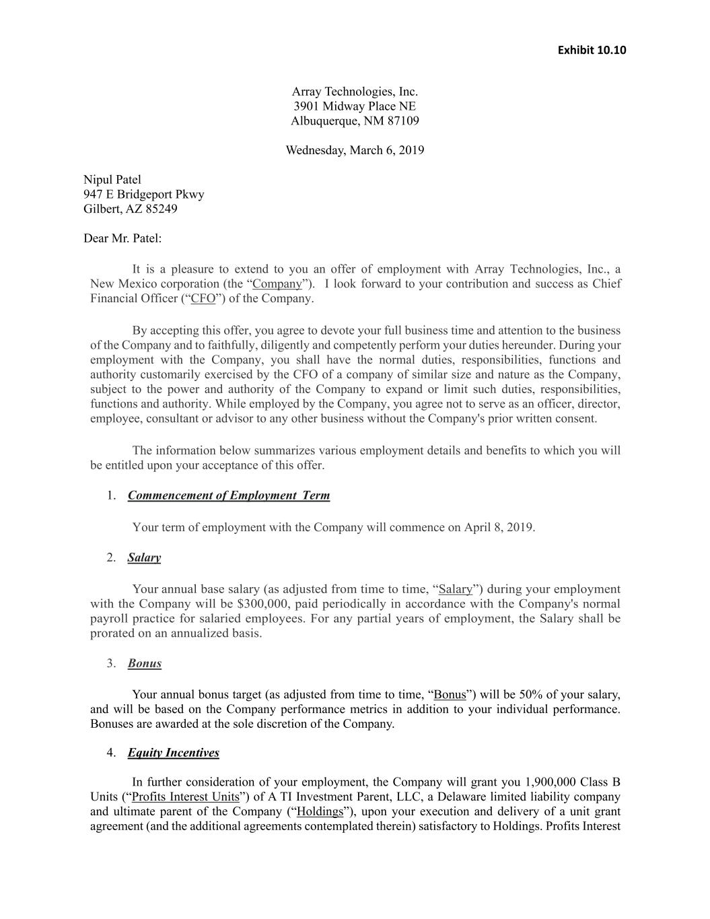
F-57
Exhibit 10.10 Array Technologies, Inc. 3901 Midway Place NE Albuquerque, NM 87109 Wednesday, March 6, 2019 Nipul Patel 947 E Bridgeport Pkwy Gilbert, AZ 85249 Dear Mr. Patel: It is a pleasure to extend to you an offer of employment with Array Technologies, Inc., a New Mexico corporation (the “Company”). I look forward to your contribution and success as Chief Financial Officer (“CFO”) of the Company. By accepting this offer, you agree to devote your full business time and attention to the business of the Company and to faithfully, diligently and competently perform your duties hereunder. During your employment with the Company, you shall have the normal duties, responsibilities, functions and authority customarily exercised by the CFO of a company of similar size and nature as the Company, subject to the power and authority of the Company to expand or limit such duties, responsibilities, functions and authority. While employed by the Company, you agree not to serve as an officer, director, employee, consultant or advisor to any other business without the Company's prior written consent. The information below summarizes various employment details and benefits to which you will be entitled upon your acceptance of this offer. 1. Commencement of Employment Term Your term of employment with the Company will commence on April 8, 2019. 2. Salary Your annual base salary (as adjusted from time to time, “Salary”) during your employment with the Company will be $300,000, paid periodically in accordance with the Company's normal payroll practice for salaried employees. For any partial years of employment, the Salary shall be prorated on an annualized basis. 3. Bonus Your annual bonus target (as adjusted from time to time, “Bonus”) will be 50% of your salary, and will be based on the Company performance metrics in addition to your individual performance. Bonuses are awarded at the sole discretion of the Company. 4. Equity Incentives In further consideration of your employment, the Company will grant you 1,900,000 Class B Units (“Profits Interest Units”) of A TI Investment Parent, LLC, a Delaware limited liability company and ultimate parent of the Company (“Holdings”), upon your execution and delivery of a unit grant agreement (and the additional agreements contemplated therein) satisfactory to Holdings. Profits Interest

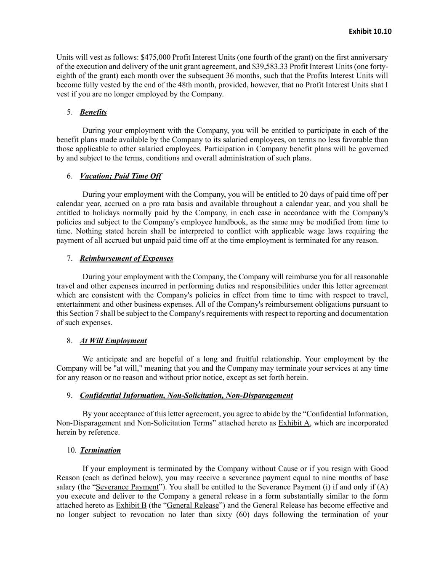
Exhibit 10.10 Units will vest as follows: $475,000 Profit Interest Units (one fourth of the grant) on the first anniversary of the execution and delivery of the unit grant agreement, and $39,583.33 Profit Interest Units (one forty- eighth of the grant) each month over the subsequent 36 months, such that the Profits Interest Units will become fully vested by the end of the 48th month, provided, however, that no Profit Interest Units shat I vest if you are no longer employed by the Company. 5. Benefits During your employment with the Company, you will be entitled to participate in each of the benefit plans made available by the Company to its salaried employees, on terms no less favorable than those applicable to other salaried employees. Participation in Company benefit plans will be governed by and subject to the terms, conditions and overall administration of such plans. 6. Vacation; Paid Time Off During your employment with the Company, you will be entitled to 20 days of paid time off per calendar year, accrued on a pro rata basis and available throughout a calendar year, and you shall be entitled to holidays normally paid by the Company, in each case in accordance with the Company's policies and subject to the Company's employee handbook, as the same may be modified from time to time. Nothing stated herein shall be interpreted to conflict with applicable wage laws requiring the payment of all accrued but unpaid paid time off at the time employment is terminated for any reason. 7. Reimbursement of Expenses During your employment with the Company, the Company will reimburse you for all reasonable travel and other expenses incurred in performing duties and responsibilities under this letter agreement which are consistent with the Company's policies in effect from time to time with respect to travel, entertainment and other business expenses. All of the Company's reimbursement obligations pursuant to this Section 7 shall be subject to the Company's requirements with respect to reporting and documentation of such expenses. 8. At Will Employment We anticipate and are hopeful of a long and fruitful relationship. Your employment by the Company will be "at will," meaning that you and the Company may terminate your services at any time for any reason or no reason and without prior notice, except as set forth herein. 9. Confidential Information, Non-Solicitation, Non-Disparagement By your acceptance of this letter agreement, you agree to abide by the “Confidential Information, Non-Disparagement and Non-Solicitation Terms” attached hereto as Exhibit A, which are incorporated herein by reference. 10. Termination If your employment is terminated by the Company without Cause or if you resign with Good Reason (each as defined below), you may receive a severance payment equal to nine months of base salary (the “Severance Payment”). You shall be entitled to the Severance Payment (i) if and only if (A) you execute and deliver to the Company a general release in a form substantially similar to the form attached hereto as Exhibit B (the “General Release”) and the General Release has become effective and no longer subject to revocation no later than sixty (60) days following the termination of your

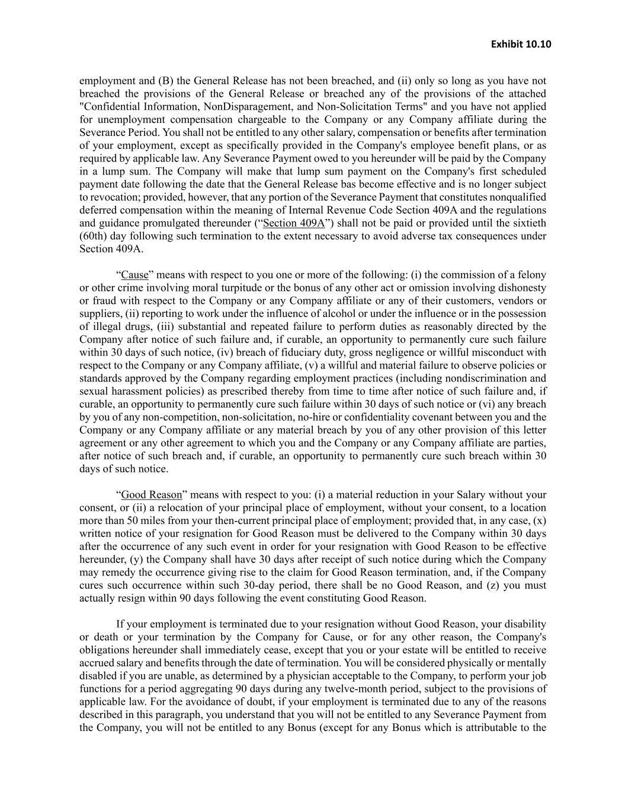
Exhibit 10.10 employment and (B) the General Release has not been breached, and (ii) only so long as you have not breached the provisions of the General Release or breached any of the provisions of the attached "Confidential Information, NonDisparagement, and Non-Solicitation Terms" and you have not applied for unemployment compensation chargeable to the Company or any Company affiliate during the Severance Period. You shall not be entitled to any other salary, compensation or benefits after termination of your employment, except as specifically provided in the Company's employee benefit plans, or as required by applicable law. Any Severance Payment owed to you hereunder will be paid by the Company in a lump sum. The Company will make that lump sum payment on the Company's first scheduled payment date following the date that the General Release bas become effective and is no longer subject to revocation; provided, however, that any portion of the Severance Payment that constitutes nonqualified deferred compensation within the meaning of Internal Revenue Code Section 409A and the regulations and guidance promulgated thereunder (“Section 409A”) shall not be paid or provided until the sixtieth (60th) day following such termination to the extent necessary to avoid adverse tax consequences under Section 409A. “Cause” means with respect to you one or more of the following: (i) the commission of a felony or other crime involving moral turpitude or the bonus of any other act or omission involving dishonesty or fraud with respect to the Company or any Company affiliate or any of their customers, vendors or suppliers, (ii) reporting to work under the influence of alcohol or under the influence or in the possession of illegal drugs, (iii) substantial and repeated failure to perform duties as reasonably directed by the Company after notice of such failure and, if curable, an opportunity to permanently cure such failure within 30 days of such notice, (iv) breach of fiduciary duty, gross negligence or willful misconduct with respect to the Company or any Company affiliate, (v) a willful and material failure to observe policies or standards approved by the Company regarding employment practices (including nondiscrimination and sexual harassment policies) as prescribed thereby from time to time after notice of such failure and, if curable, an opportunity to permanently cure such failure within 30 days of such notice or (vi) any breach by you of any non-competition, non-solicitation, no-hire or confidentiality covenant between you and the Company or any Company affiliate or any material breach by you of any other provision of this letter agreement or any other agreement to which you and the Company or any Company affiliate are parties, after notice of such breach and, if curable, an opportunity to permanently cure such breach within 30 days of such notice. “Good Reason” means with respect to you: (i) a material reduction in your Salary without your consent, or (ii) a relocation of your principal place of employment, without your consent, to a location more than 50 miles from your then-current principal place of employment; provided that, in any case, (x) written notice of your resignation for Good Reason must be delivered to the Company within 30 days after the occurrence of any such event in order for your resignation with Good Reason to be effective hereunder, (y) the Company shall have 30 days after receipt of such notice during which the Company may remedy the occurrence giving rise to the claim for Good Reason termination, and, if the Company cures such occurrence within such 30-day period, there shall be no Good Reason, and (z) you must actually resign within 90 days following the event constituting Good Reason. If your employment is terminated due to your resignation without Good Reason, your disability or death or your termination by the Company for Cause, or for any other reason, the Company's obligations hereunder shall immediately cease, except that you or your estate will be entitled to receive accrued salary and benefits through the date of termination. You will be considered physically or mentally disabled if you are unable, as determined by a physician acceptable to the Company, to perform your job functions for a period aggregating 90 days during any twelve-month period, subject to the provisions of applicable law. For the avoidance of doubt, if your employment is terminated due to any of the reasons described in this paragraph, you understand that you will not be entitled to any Severance Payment from the Company, you will not be entitled to any Bonus (except for any Bonus which is attributable to the

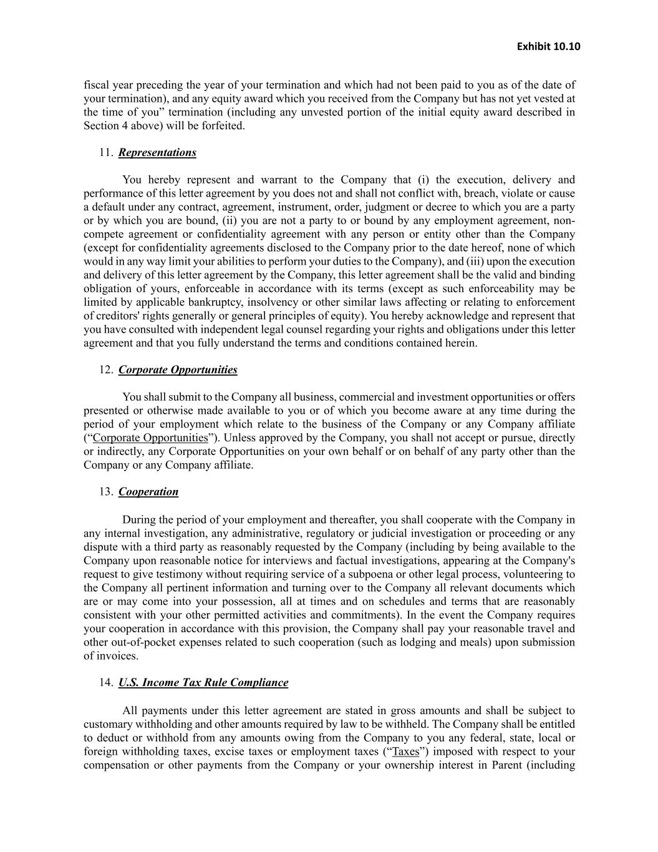
Exhibit 10.10 fiscal year preceding the year of your termination and which had not been paid to you as of the date of your termination), and any equity award which you received from the Company but has not yet vested at the time of you” termination (including any unvested portion of the initial equity award described in Section 4 above) will be forfeited. 11. Representations You hereby represent and warrant to the Company that (i) the execution, delivery and performance of this letter agreement by you does not and shall not conflict with, breach, violate or cause a default under any contract, agreement, instrument, order, judgment or decree to which you are a party or by which you are bound, (ii) you are not a party to or bound by any employment agreement, non- compete agreement or confidentiality agreement with any person or entity other than the Company (except for confidentiality agreements disclosed to the Company prior to the date hereof, none of which would in any way limit your abilities to perform your duties to the Company), and (iii) upon the execution and delivery of this letter agreement by the Company, this letter agreement shall be the valid and binding obligation of yours, enforceable in accordance with its terms (except as such enforceability may be limited by applicable bankruptcy, insolvency or other similar laws affecting or relating to enforcement of creditors' rights generally or general principles of equity). You hereby acknowledge and represent that you have consulted with independent legal counsel regarding your rights and obligations under this letter agreement and that you fully understand the terms and conditions contained herein. 12. Corporate Opportunities You shall submit to the Company all business, commercial and investment opportunities or offers presented or otherwise made available to you or of which you become aware at any time during the period of your employment which relate to the business of the Company or any Company affiliate (“Corporate Opportunities”). Unless approved by the Company, you shall not accept or pursue, directly or indirectly, any Corporate Opportunities on your own behalf or on behalf of any party other than the Company or any Company affiliate. 13. Cooperation During the period of your employment and thereafter, you shall cooperate with the Company in any internal investigation, any administrative, regulatory or judicial investigation or proceeding or any dispute with a third party as reasonably requested by the Company (including by being available to the Company upon reasonable notice for interviews and factual investigations, appearing at the Company's request to give testimony without requiring service of a subpoena or other legal process, volunteering to the Company all pertinent information and turning over to the Company all relevant documents which are or may come into your possession, all at times and on schedules and terms that are reasonably consistent with your other permitted activities and commitments). In the event the Company requires your cooperation in accordance with this provision, the Company shall pay your reasonable travel and other out-of-pocket expenses related to such cooperation (such as lodging and meals) upon submission of invoices. 14. U.S. Income Tax Rule Compliance All payments under this letter agreement are stated in gross amounts and shall be subject to customary withholding and other amounts required by law to be withheld. The Company shall be entitled to deduct or withhold from any amounts owing from the Company to you any federal, state, local or foreign withholding taxes, excise taxes or employment taxes (“Taxes”) imposed with respect to your compensation or other payments from the Company or your ownership interest in Parent (including

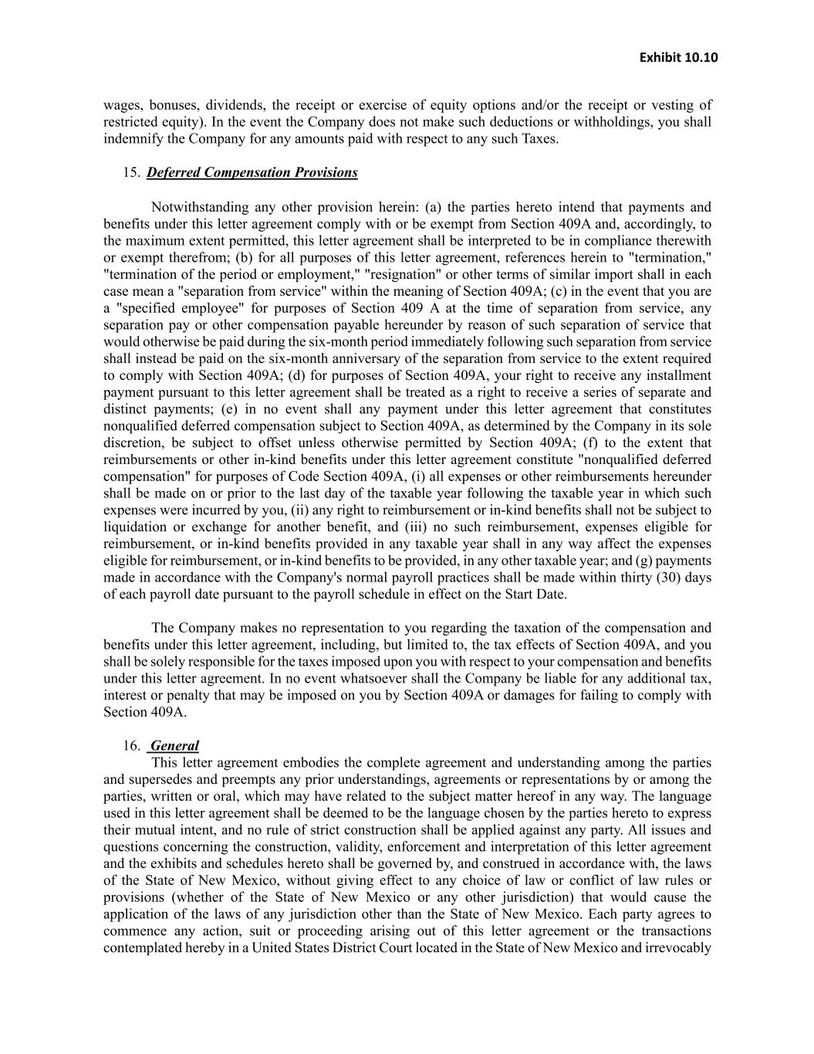
Exhibit 10.10 wages, bonuses, dividends, the receipt or exercise of equity options and/or the receipt or vesting of restricted equity). In the event the Company does not make such deductions or withholdings, you shall indemnify the Company for any amounts paid with respect to any such Taxes. 15. Deferred Compensation Provisions Notwithstanding any other provision herein: (a) the parties hereto intend that payments and benefits under this letter agreement comply with or be exempt from Section 409A and, accordingly, to the maximum extent permitted, this letter agreement shall be interpreted to be in compliance therewith or exempt therefrom; (b) for all purposes of this letter agreement, references herein to "termination," "termination of the period or employment," "resignation" or other terms of similar import shall in each case mean a "separation from service" within the meaning of Section 409A; (c) in the event that you are a "specified employee" for purposes of Section 409 A at the time of separation from service, any separation pay or other compensation payable hereunder by reason of such separation of service that would otherwise be paid during the six-month period immediately following such separation from service shall instead be paid on the six-month anniversary of the separation from service to the extent required to comply with Section 409A; (d) for purposes of Section 409A, your right to receive any installment payment pursuant to this letter agreement shall be treated as a right to receive a series of separate and distinct payments; (e) in no event shall any payment under this letter agreement that constitutes nonqualified deferred compensation subject to Section 409A, as determined by the Company in its sole discretion, be subject to offset unless otherwise permitted by Section 409A; (f) to the extent that reimbursements or other in-kind benefits under this letter agreement constitute "nonqualified deferred compensation" for purposes of Code Section 409A, (i) all expenses or other reimbursements hereunder shall be made on or prior to the last day of the taxable year following the taxable year in which such expenses were incurred by you, (ii) any right to reimbursement or in-kind benefits shall not be subject to liquidation or exchange for another benefit, and (iii) no such reimbursement, expenses eligible for reimbursement, or in-kind benefits provided in any taxable year shall in any way affect the expenses eligible for reimbursement, or in-kind benefits to be provided, in any other taxable year; and (g) payments made in accordance with the Company's normal payroll practices shall be made within thirty (30) days of each payroll date pursuant to the payroll schedule in effect on the Start Date. The Company makes no representation to you regarding the taxation of the compensation and benefits under this letter agreement, including, but limited to, the tax effects of Section 409A, and you shall be solely responsible for the taxes imposed upon you with respect to your compensation and benefits under this letter agreement. In no event whatsoever shall the Company be liable for any additional tax, interest or penalty that may be imposed on you by Section 409A or damages for failing to comply with Section 409A. 16. General This letter agreement embodies the complete agreement and understanding among the parties and supersedes and preempts any prior understandings, agreements or representations by or among the parties, written or oral, which may have related to the subject matter hereof in any way. The language used in this letter agreement shall be deemed to be the language chosen by the parties hereto to express their mutual intent, and no rule of strict construction shall be applied against any party. All issues and questions concerning the construction, validity, enforcement and interpretation of this letter agreement and the exhibits and schedules hereto shall be governed by, and construed in accordance with, the laws of the State of New Mexico, without giving effect to any choice of law or conflict of law rules or provisions (whether of the State of New Mexico or any other jurisdiction) that would cause the application of the laws of any jurisdiction other than the State of New Mexico. Each party agrees to commence any action, suit or proceeding arising out of this letter agreement or the transactions contemplated hereby in a United States District Court located in the State of New Mexico and irrevocably

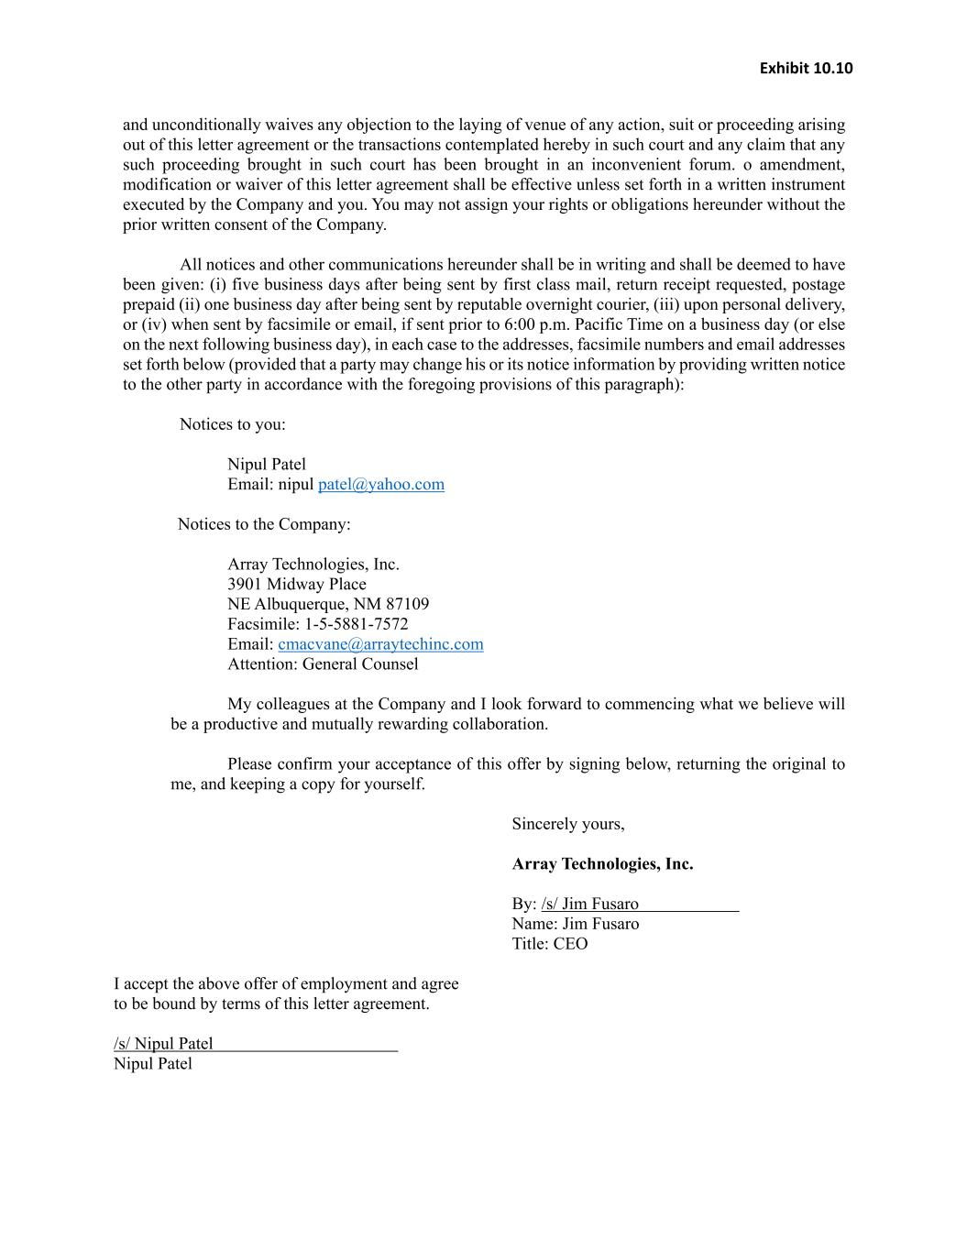
Exhibit 10.10 and unconditionally waives any objection to the laying of venue of any action, suit or proceeding arising out of this letter agreement or the transactions contemplated hereby in such court and any claim that any such proceeding brought in such court has been brought in an inconvenient forum. o amendment, modification or waiver of this letter agreement shall be effective unless set forth in a written instrument executed by the Company and you. You may not assign your rights or obligations hereunder without the prior written consent of the Company. All notices and other communications hereunder shall be in writing and shall be deemed to have been given: (i) five business days after being sent by first class mail, return receipt requested, postage prepaid (ii) one business day after being sent by reputable overnight courier, (iii) upon personal delivery, or (iv) when sent by facsimile or email, if sent prior to 6:00 p.m. Pacific Time on a business day (or else on the next following business day), in each case to the addresses, facsimile numbers and email addresses set forth below (provided that a party may change his or its notice information by providing written notice to the other party in accordance with the foregoing provisions of this paragraph): Notices to you: Nipul Patel Email: nipul patel@yahoo.com Notices to the Company: Array Technologies, Inc. 3901 Midway Place NE Albuquerque, NM 87109 Facsimile: 1-5-5881-7572 Email: cmacvane@arraytechinc.com Attention: General Counsel My colleagues at the Company and I look forward to commencing what we believe will be a productive and mutually rewarding collaboration. Please confirm your acceptance of this offer by signing below, returning the original to me, and keeping a copy for yourself. Sincerely yours, Array Technologies, Inc. By: /s/ Jim Fusaro Name: Jim Fusaro Title: CEO I accept the above offer of employment and agree to be bound by terms of this letter agreement. /s/ Nipul Patel Nipul Patel

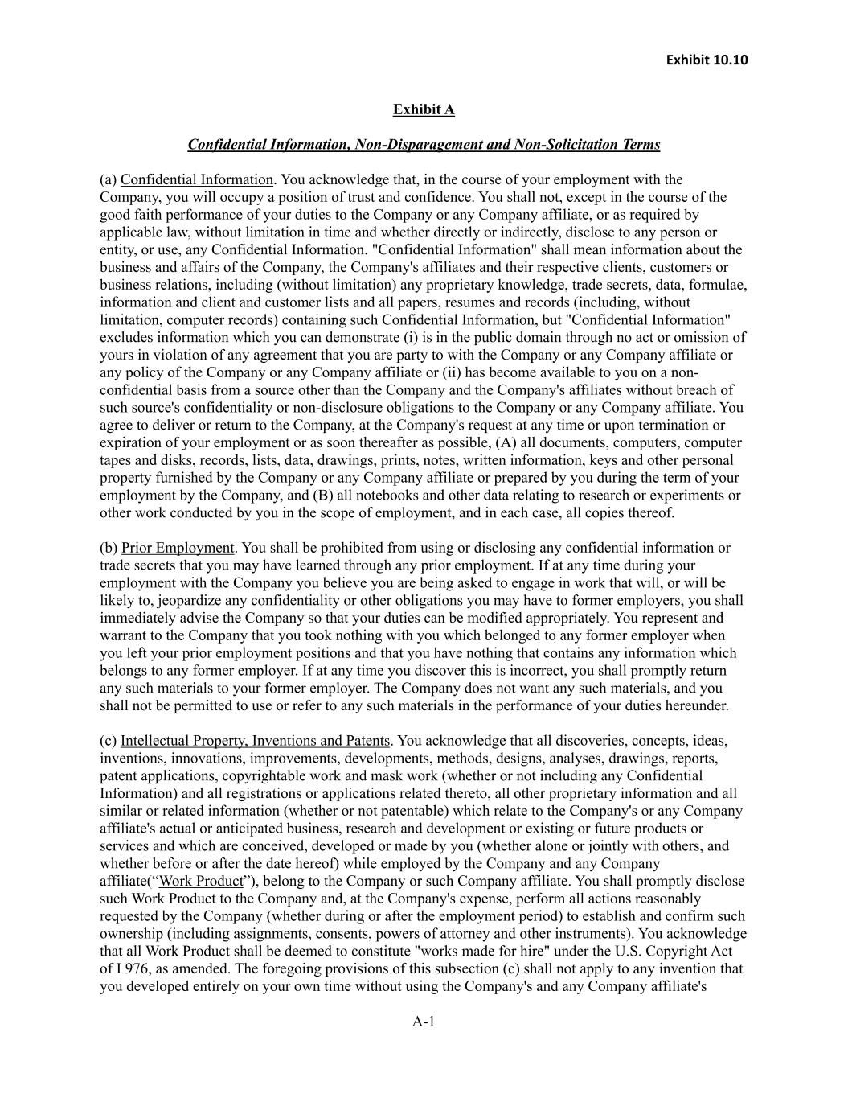
Exhibit 10.10 A-1 Exhibit A Confidential Information, Non-Disparagement and Non-Solicitation Terms (a) Confidential Information. You acknowledge that, in the course of your employment with the Company, you will occupy a position of trust and confidence. You shall not, except in the course of the good faith performance of your duties to the Company or any Company affiliate, or as required by applicable law, without limitation in time and whether directly or indirectly, disclose to any person or entity, or use, any Confidential Information. "Confidential Information" shall mean information about the business and affairs of the Company, the Company's affiliates and their respective clients, customers or business relations, including (without limitation) any proprietary knowledge, trade secrets, data, formulae, information and client and customer lists and all papers, resumes and records (including, without limitation, computer records) containing such Confidential Information, but "Confidential Information" excludes information which you can demonstrate (i) is in the public domain through no act or omission of yours in violation of any agreement that you are party to with the Company or any Company affiliate or any policy of the Company or any Company affiliate or (ii) has become available to you on a non- confidential basis from a source other than the Company and the Company's affiliates without breach of such source's confidentiality or non-disclosure obligations to the Company or any Company affiliate. You agree to deliver or return to the Company, at the Company's request at any time or upon termination or expiration of your employment or as soon thereafter as possible, (A) all documents, computers, computer tapes and disks, records, lists, data, drawings, prints, notes, written information, keys and other personal property furnished by the Company or any Company affiliate or prepared by you during the term of your employment by the Company, and (B) all notebooks and other data relating to research or experiments or other work conducted by you in the scope of employment, and in each case, all copies thereof. (b) Prior Employment. You shall be prohibited from using or disclosing any confidential information or trade secrets that you may have learned through any prior employment. If at any time during your employment with the Company you believe you are being asked to engage in work that will, or will be likely to, jeopardize any confidentiality or other obligations you may have to former employers, you shall immediately advise the Company so that your duties can be modified appropriately. You represent and warrant to the Company that you took nothing with you which belonged to any former employer when you left your prior employment positions and that you have nothing that contains any information which belongs to any former employer. If at any time you discover this is incorrect, you shall promptly return any such materials to your former employer. The Company does not want any such materials, and you shall not be permitted to use or refer to any such materials in the performance of your duties hereunder. (c) Intellectual Property, Inventions and Patents. You acknowledge that all discoveries, concepts, ideas, inventions, innovations, improvements, developments, methods, designs, analyses, drawings, reports, patent applications, copyrightable work and mask work (whether or not including any Confidential Information) and all registrations or applications related thereto, all other proprietary information and all similar or related information (whether or not patentable) which relate to the Company's or any Company affiliate's actual or anticipated business, research and development or existing or future products or services and which are conceived, developed or made by you (whether alone or jointly with others, and whether before or after the date hereof) while employed by the Company and any Company affiliate(“Work Product”), belong to the Company or such Company affiliate. You shall promptly disclose such Work Product to the Company and, at the Company's expense, perform all actions reasonably requested by the Company (whether during or after the employment period) to establish and confirm such ownership (including assignments, consents, powers of attorney and other instruments). You acknowledge that all Work Product shall be deemed to constitute "works made for hire" under the U.S. Copyright Act of I 976, as amended. The foregoing provisions of this subsection (c) shall not apply to any invention that you developed entirely on your own time without using the Company's and any Company affiliate's

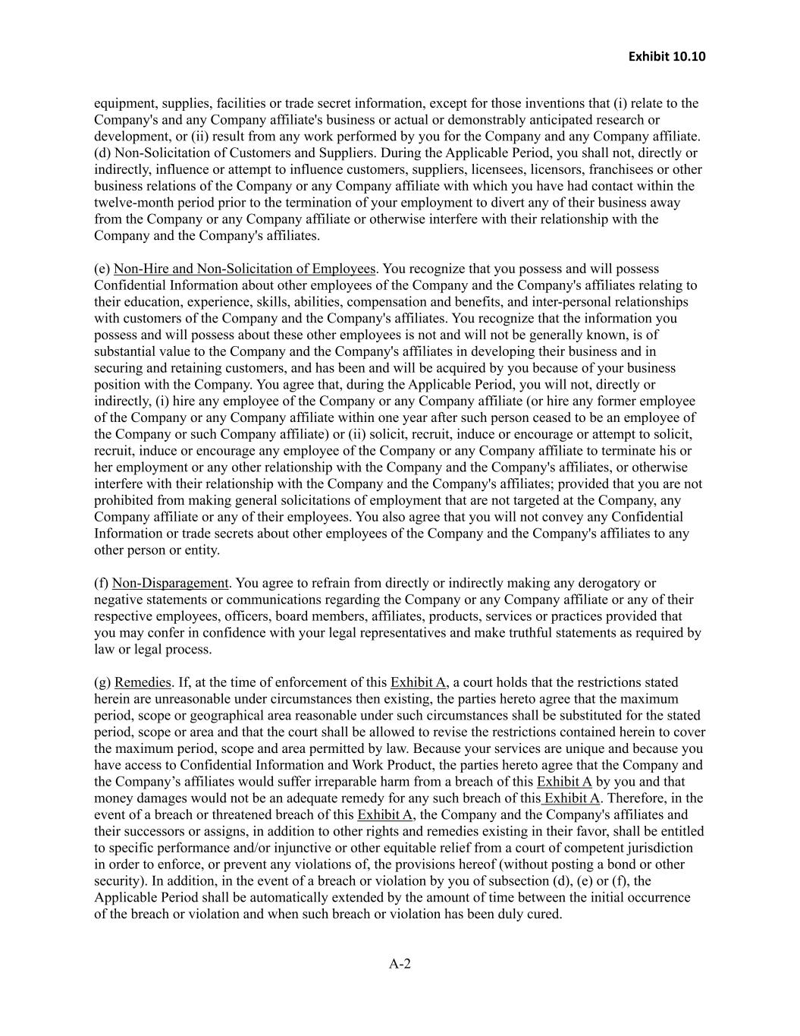
Exhibit 10.10 A-2 equipment, supplies, facilities or trade secret information, except for those inventions that (i) relate to the Company's and any Company affiliate's business or actual or demonstrably anticipated research or development, or (ii) result from any work performed by you for the Company and any Company affiliate. (d) Non-Solicitation of Customers and Suppliers. During the Applicable Period, you shall not, directly or indirectly, influence or attempt to influence customers, suppliers, licensees, licensors, franchisees or other business relations of the Company or any Company affiliate with which you have had contact within the twelve-month period prior to the termination of your employment to divert any of their business away from the Company or any Company affiliate or otherwise interfere with their relationship with the Company and the Company's affiliates. (e) Non-Hire and Non-Solicitation of Employees. You recognize that you possess and will possess Confidential Information about other employees of the Company and the Company's affiliates relating to their education, experience, skills, abilities, compensation and benefits, and inter-personal relationships with customers of the Company and the Company's affiliates. You recognize that the information you possess and will possess about these other employees is not and will not be generally known, is of substantial value to the Company and the Company's affiliates in developing their business and in securing and retaining customers, and has been and will be acquired by you because of your business position with the Company. You agree that, during the Applicable Period, you will not, directly or indirectly, (i) hire any employee of the Company or any Company affiliate (or hire any former employee of the Company or any Company affiliate within one year after such person ceased to be an employee of the Company or such Company affiliate) or (ii) solicit, recruit, induce or encourage or attempt to solicit, recruit, induce or encourage any employee of the Company or any Company affiliate to terminate his or her employment or any other relationship with the Company and the Company's affiliates, or otherwise interfere with their relationship with the Company and the Company's affiliates; provided that you are not prohibited from making general solicitations of employment that are not targeted at the Company, any Company affiliate or any of their employees. You also agree that you will not convey any Confidential Information or trade secrets about other employees of the Company and the Company's affiliates to any other person or entity. (f) Non-Disparagement. You agree to refrain from directly or indirectly making any derogatory or negative statements or communications regarding the Company or any Company affiliate or any of their respective employees, officers, board members, affiliates, products, services or practices provided that you may confer in confidence with your legal representatives and make truthful statements as required by law or legal process. (g) Remedies. If, at the time of enforcement of this Exhibit A, a court holds that the restrictions stated herein are unreasonable under circumstances then existing, the parties hereto agree that the maximum period, scope or geographical area reasonable under such circumstances shall be substituted for the stated period, scope or area and that the court shall be allowed to revise the restrictions contained herein to cover the maximum period, scope and area permitted by law. Because your services are unique and because you have access to Confidential Information and Work Product, the parties hereto agree that the Company and the Company’s affiliates would suffer irreparable harm from a breach of this Exhibit A by you and that money damages would not be an adequate remedy for any such breach of this Exhibit A. Therefore, in the event of a breach or threatened breach of this Exhibit A, the Company and the Company's affiliates and their successors or assigns, in addition to other rights and remedies existing in their favor, shall be entitled to specific performance and/or injunctive or other equitable relief from a court of competent jurisdiction in order to enforce, or prevent any violations of, the provisions hereof (without posting a bond or other security). In addition, in the event of a breach or violation by you of subsection (d), (e) or (f), the Applicable Period shall be automatically extended by the amount of time between the initial occurrence of the breach or violation and when such breach or violation has been duly cured.

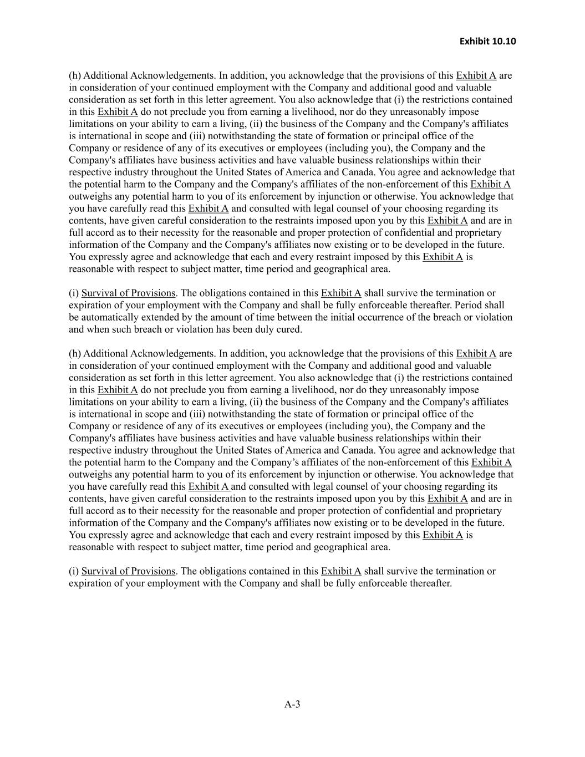
Exhibit 10.10 A-3 (h) Additional Acknowledgements. In addition, you acknowledge that the provisions of this Exhibit A are in consideration of your continued employment with the Company and additional good and valuable consideration as set forth in this letter agreement. You also acknowledge that (i) the restrictions contained in this Exhibit A do not preclude you from earning a livelihood, nor do they unreasonably impose limitations on your ability to earn a living, (ii) the business of the Company and the Company's affiliates is international in scope and (iii) notwithstanding the state of formation or principal office of the Company or residence of any of its executives or employees (including you), the Company and the Company's affiliates have business activities and have valuable business relationships within their respective industry throughout the United States of America and Canada. You agree and acknowledge that the potential harm to the Company and the Company's affiliates of the non-enforcement of this Exhibit A outweighs any potential harm to you of its enforcement by injunction or otherwise. You acknowledge that you have carefully read this Exhibit A and consulted with legal counsel of your choosing regarding its contents, have given careful consideration to the restraints imposed upon you by this Exhibit A and are in full accord as to their necessity for the reasonable and proper protection of confidential and proprietary information of the Company and the Company's affiliates now existing or to be developed in the future. You expressly agree and acknowledge that each and every restraint imposed by this Exhibit A is reasonable with respect to subject matter, time period and geographical area. (i) Survival of Provisions. The obligations contained in this Exhibit A shall survive the termination or expiration of your employment with the Company and shall be fully enforceable thereafter. Period shall be automatically extended by the amount of time between the initial occurrence of the breach or violation and when such breach or violation has been duly cured. (h) Additional Acknowledgements. In addition, you acknowledge that the provisions of this Exhibit A are in consideration of your continued employment with the Company and additional good and valuable consideration as set forth in this letter agreement. You also acknowledge that (i) the restrictions contained in this Exhibit A do not preclude you from earning a livelihood, nor do they unreasonably impose limitations on your ability to earn a living, (ii) the business of the Company and the Company's affiliates is international in scope and (iii) notwithstanding the state of formation or principal office of the Company or residence of any of its executives or employees (including you), the Company and the Company's affiliates have business activities and have valuable business relationships within their respective industry throughout the United States of America and Canada. You agree and acknowledge that the potential harm to the Company and the Company’s affiliates of the non-enforcement of this Exhibit A outweighs any potential harm to you of its enforcement by injunction or otherwise. You acknowledge that you have carefully read this Exhibit A and consulted with legal counsel of your choosing regarding its contents, have given careful consideration to the restraints imposed upon you by this Exhibit A and are in full accord as to their necessity for the reasonable and proper protection of confidential and proprietary information of the Company and the Company's affiliates now existing or to be developed in the future. You expressly agree and acknowledge that each and every restraint imposed by this Exhibit A is reasonable with respect to subject matter, time period and geographical area. (i) Survival of Provisions. The obligations contained in this Exhibit A shall survive the termination or expiration of your employment with the Company and shall be fully enforceable thereafter.

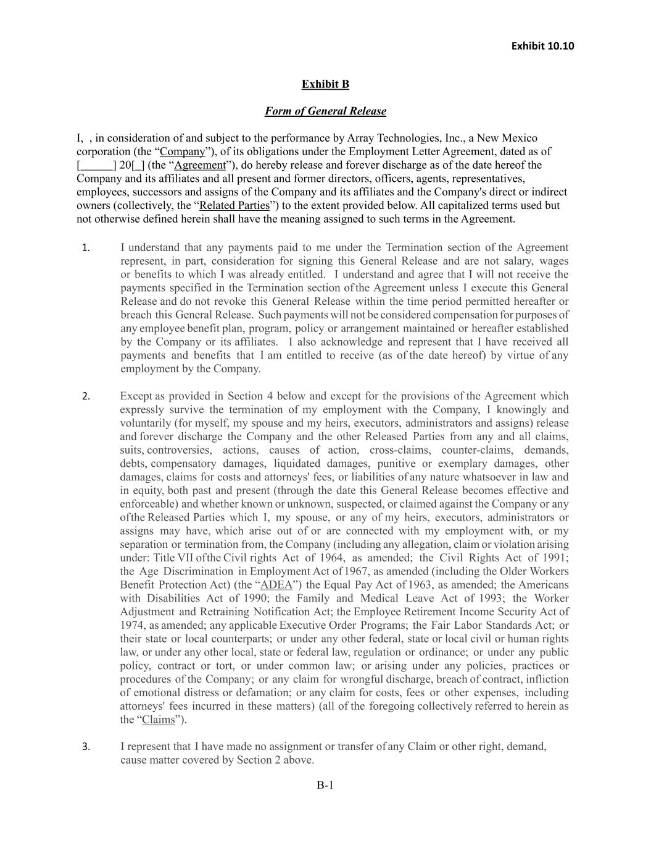
Exhibit 10.10 B-1 Exhibit B Form of General Release I, , in consideration of and subject to the performance by Array Technologies, Inc., a New Mexico corporation (the “Company”), of its obligations under the Employment Letter Agreement, dated as of [ ] 20[ ] (the “Agreement”), do hereby release and forever discharge as of the date hereof the Company and its affiliates and all present and former directors, officers, agents, representatives, employees, successors and assigns of the Company and its affiliates and the Company's direct or indirect owners (collectively, the “Related Parties”) to the extent provided below. All capitalized terms used but not otherwise defined herein shall have the meaning assigned to such terms in the Agreement. 1. I understand that any payments paid to me under the Termination section of the Agreement represent, in part, consideration for signing this General Release and are not salary, wages or benefits to which I was already entitled. I understand and agree that I will not receive the payments specified in the Termination section of the Agreement unless I execute this General Release and do not revoke this General Release within the time period permitted hereafter or breach this General Release. Such payments will not be considered compensation for purposes of any employee benefit plan, program, policy or arrangement maintained or hereafter established by the Company or its affiliates. I also acknowledge and represent that I have received all payments and benefits that I am entitled to receive (as of the date hereof) by virtue of any employment by the Company. 2. Except as provided in Section 4 below and except for the provisions of the Agreement which expressly survive the termination of my employment with the Company, I knowingly and voluntarily (for myself, my spouse and my heirs, executors, administrators and assigns) release and forever discharge the Company and the other Released Parties from any and all claims, suits, controversies, actions, causes of action, cross-claims, counter-claims, demands, debts, compensatory damages, liquidated damages, punitive or exemplary damages, other damages, claims for costs and attorneys' fees, or liabilities of any nature whatsoever in law and in equity, both past and present (through the date this General Release becomes effective and enforceable) and whether known or unknown, suspected, or claimed against the Company or any of the Released Parties which I, my spouse, or any of my heirs, executors, administrators or assigns may have, which arise out of or are connected with my employment with, or my separation or termination from, the Company (including any allegation, claim or violation arising under: Title VII of the Civil rights Act of 1964, as amended; the Civil Rights Act of 1991; the Age Discrimination in Employment Act of 1967, as amended (including the Older Workers Benefit Protection Act) (the “ADEA”) the Equal Pay Act of 1963, as amended; the Americans with Disabilities Act of 1990; the Family and Medical Leave Act of 1993; the Worker Adjustment and Retraining Notification Act; the Employee Retirement Income Security Act of 1974, as amended; any applicable Executive Order Programs; the Fair Labor Standards Act; or their state or local counterparts; or under any other federal, state or local civil or human rights law, or under any other local, state or federal law, regulation or ordinance; or under any public policy, contract or tort, or under common law; or arising under any policies, practices or procedures of the Company; or any claim for wrongful discharge, breach of contract, infliction of emotional distress or defamation; or any claim for costs, fees or other expenses, including attorneys' fees incurred in these matters) (all of the foregoing collectively referred to herein as the “Claims”). 3. I represent that I have made no assignment or transfer of any Claim or other right, demand, cause matter covered by Section 2 above.

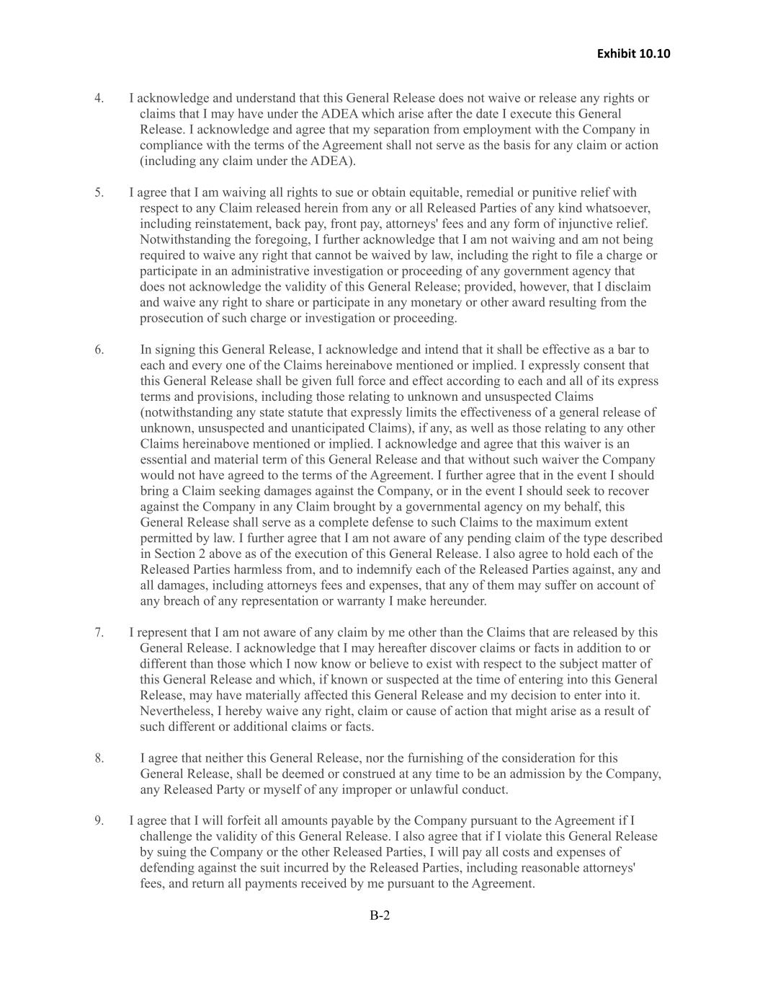
Exhibit 10.10 B-2 4. I acknowledge and understand that this General Release does not waive or release any rights or claims that I may have under the ADEA which arise after the date I execute this General Release. I acknowledge and agree that my separation from employment with the Company in compliance with the terms of the Agreement shall not serve as the basis for any claim or action (including any claim under the ADEA). 5. I agree that I am waiving all rights to sue or obtain equitable, remedial or punitive relief with respect to any Claim released herein from any or all Released Parties of any kind whatsoever, including reinstatement, back pay, front pay, attorneys' fees and any form of injunctive relief. Notwithstanding the foregoing, I further acknowledge that I am not waiving and am not being required to waive any right that cannot be waived by law, including the right to file a charge or participate in an administrative investigation or proceeding of any government agency that does not acknowledge the validity of this General Release; provided, however, that I disclaim and waive any right to share or participate in any monetary or other award resulting from the prosecution of such charge or investigation or proceeding. 6. In signing this General Release, I acknowledge and intend that it shall be effective as a bar to each and every one of the Claims hereinabove mentioned or implied. I expressly consent that this General Release shall be given full force and effect according to each and all of its express terms and provisions, including those relating to unknown and unsuspected Claims (notwithstanding any state statute that expressly limits the effectiveness of a general release of unknown, unsuspected and unanticipated Claims), if any, as well as those relating to any other Claims hereinabove mentioned or implied. I acknowledge and agree that this waiver is an essential and material term of this General Release and that without such waiver the Company would not have agreed to the terms of the Agreement. I further agree that in the event I should bring a Claim seeking damages against the Company, or in the event I should seek to recover against the Company in any Claim brought by a governmental agency on my behalf, this General Release shall serve as a complete defense to such Claims to the maximum extent permitted by law. I further agree that I am not aware of any pending claim of the type described in Section 2 above as of the execution of this General Release. I also agree to hold each of the Released Parties harmless from, and to indemnify each of the Released Parties against, any and all damages, including attorneys fees and expenses, that any of them may suffer on account of any breach of any representation or warranty I make hereunder. 7. I represent that I am not aware of any claim by me other than the Claims that are released by this General Release. I acknowledge that I may hereafter discover claims or facts in addition to or different than those which I now know or believe to exist with respect to the subject matter of this General Release and which, if known or suspected at the time of entering into this General Release, may have materially affected this General Release and my decision to enter into it. Nevertheless, I hereby waive any right, claim or cause of action that might arise as a result of such different or additional claims or facts. 8. I agree that neither this General Release, nor the furnishing of the consideration for this General Release, shall be deemed or construed at any time to be an admission by the Company, any Released Party or myself of any improper or unlawful conduct. 9. I agree that I will forfeit all amounts payable by the Company pursuant to the Agreement if I challenge the validity of this General Release. I also agree that if I violate this General Release by suing the Company or the other Released Parties, I will pay all costs and expenses of defending against the suit incurred by the Released Parties, including reasonable attorneys' fees, and return all payments received by me pursuant to the Agreement.

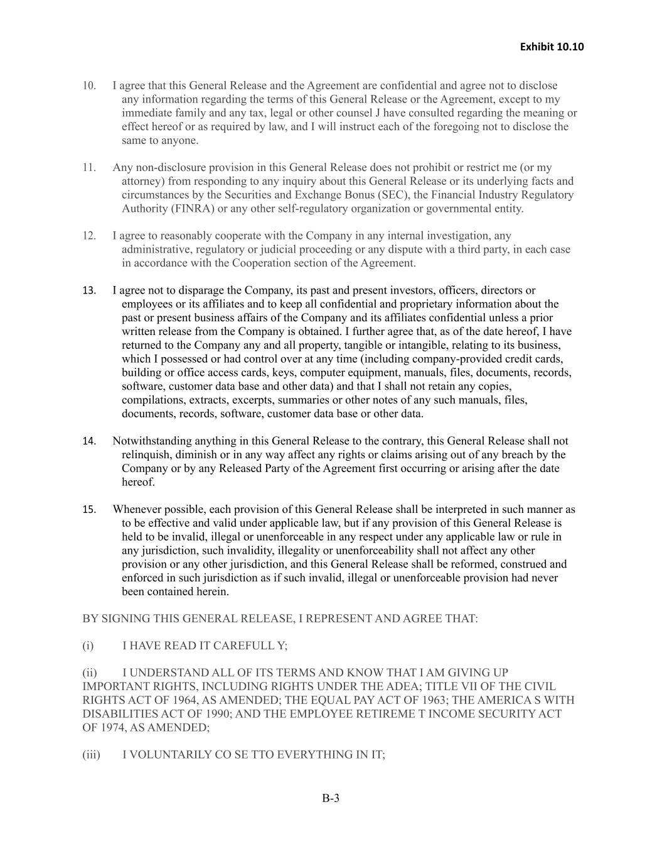
Exhibit 10.10 B-3 10. I agree that this General Release and the Agreement are confidential and agree not to disclose any information regarding the terms of this General Release or the Agreement, except to my immediate family and any tax, legal or other counsel J have consulted regarding the meaning or effect hereof or as required by law, and I will instruct each of the foregoing not to disclose the same to anyone. 11. Any non-disclosure provision in this General Release does not prohibit or restrict me (or my attorney) from responding to any inquiry about this General Release or its underlying facts and circumstances by the Securities and Exchange Bonus (SEC), the Financial Industry Regulatory Authority (FINRA) or any other self-regulatory organization or governmental entity. 12. I agree to reasonably cooperate with the Company in any internal investigation, any administrative, regulatory or judicial proceeding or any dispute with a third party, in each case in accordance with the Cooperation section of the Agreement. 13. I agree not to disparage the Company, its past and present investors, officers, directors or employees or its affiliates and to keep all confidential and proprietary information about the past or present business affairs of the Company and its affiliates confidential unless a prior written release from the Company is obtained. I further agree that, as of the date hereof, I have returned to the Company any and all property, tangible or intangible, relating to its business, which I possessed or had control over at any time (including company-provided credit cards, building or office access cards, keys, computer equipment, manuals, files, documents, records, software, customer data base and other data) and that I shall not retain any copies, compilations, extracts, excerpts, summaries or other notes of any such manuals, files, documents, records, software, customer data base or other data. 14. Notwithstanding anything in this General Release to the contrary, this General Release shall not relinquish, diminish or in any way affect any rights or claims arising out of any breach by the Company or by any Released Party of the Agreement first occurring or arising after the date hereof. 15. Whenever possible, each provision of this General Release shall be interpreted in such manner as to be effective and valid under applicable law, but if any provision of this General Release is held to be invalid, illegal or unenforceable in any respect under any applicable law or rule in any jurisdiction, such invalidity, illegality or unenforceability shall not affect any other provision or any other jurisdiction, and this General Release shall be reformed, construed and enforced in such jurisdiction as if such invalid, illegal or unenforceable provision had never been contained herein. BY SIGNING THIS GENERAL RELEASE, I REPRESENT AND AGREE THAT: (i) I HAVE READ IT CAREFULL Y; (ii) I UNDERSTAND ALL OF ITS TERMS AND KNOW THAT I AM GIVING UP IMPORTANT RIGHTS, INCLUDING RIGHTS UNDER THE ADEA; TITLE VII OF THE CIVIL RIGHTS ACT OF 1964, AS AMENDED; THE EQUAL PAY ACT OF 1963; THE AMERICA S WITH DISABILITIES ACT OF 1990; AND THE EMPLOYEE RETIREME T INCOME SECURITY ACT OF 1974, AS AMENDED; (iii) I VOLUNTARILY CO SE TTO EVERYTHING IN IT;

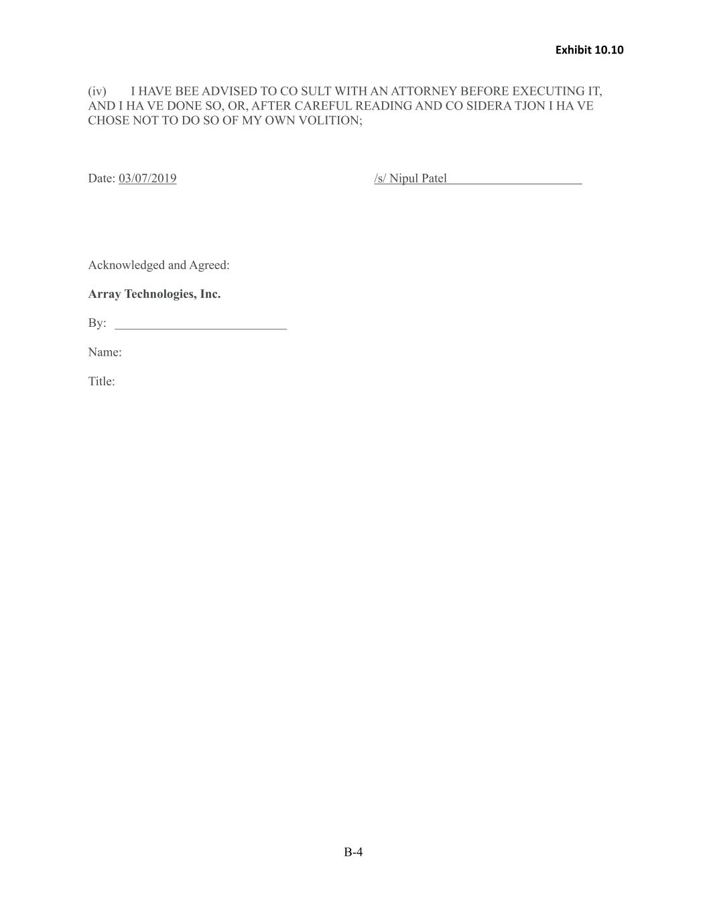
Exhibit 10.10 B-4 (iv) I HAVE BEE ADVISED TO CO SULT WITH AN ATTORNEY BEFORE EXECUTING IT, AND I HA VE DONE SO, OR, AFTER CAREFUL READING AND CO SIDERA TJON I HA VE CHOSE NOT TO DO SO OF MY OWN VOLITION; Date: 03/07/2019 /s/ Nipul Patel Acknowledged and Agreed: Array Technologies, Inc. By: ___________________________ Name: Title:

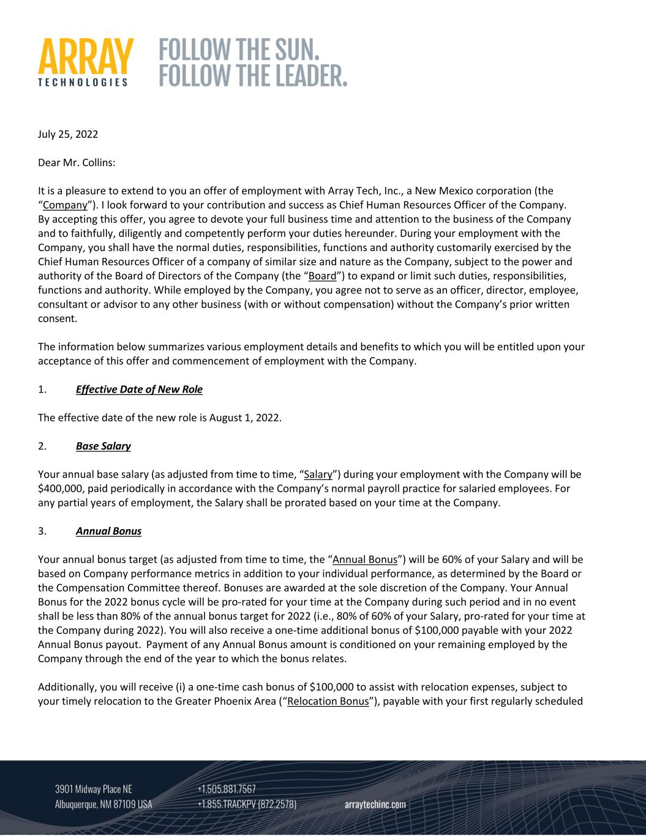
July 25, 2022 Dear Mr. Collins: It is a pleasure to extend to you an offer of employment with Array Tech, Inc., a New Mexico corporation (the “Company”). I look forward to your contribution and success as Chief Human Resources Officer of the Company. By accepting this offer, you agree to devote your full business time and attention to the business of the Company and to faithfully, diligently and competently perform your duties hereunder. During your employment with the Company, you shall have the normal duties, responsibilities, functions and authority customarily exercised by the Chief Human Resources Officer of a company of similar size and nature as the Company, subject to the power and authority of the Board of Directors of the Company (the “Board”) to expand or limit such duties, responsibilities, functions and authority. While employed by the Company, you agree not to serve as an officer, director, employee, consultant or advisor to any other business (with or without compensation) without the Company’s prior written consent. The information below summarizes various employment details and benefits to which you will be entitled upon your acceptance of this offer and commencement of employment with the Company. 1. Effective Date of New Role The effective date of the new role is August 1, 2022. 2. Base Salary Your annual base salary (as adjusted from time to time, “Salary”) during your employment with the Company will be $400,000, paid periodically in accordance with the Company’s normal payroll practice for salaried employees. For any partial years of employment, the Salary shall be prorated based on your time at the Company. 3. Annual Bonus Your annual bonus target (as adjusted from time to time, the “Annual Bonus”) will be 60% of your Salary and will be based on Company performance metrics in addition to your individual performance, as determined by the Board or the Compensation Committee thereof. Bonuses are awarded at the sole discretion of the Company. Your Annual Bonus for the 2022 bonus cycle will be pro‐rated for your time at the Company during such period and in no event shall be less than 80% of the annual bonus target for 2022 (i.e., 80% of 60% of your Salary, pro‐rated for your time at the Company during 2022). You will also receive a one‐time additional bonus of $100,000 payable with your 2022 Annual Bonus payout. Payment of any Annual Bonus amount is conditioned on your remaining employed by the Company through the end of the year to which the bonus relates. Additionally, you will receive (i) a one‐time cash bonus of $100,000 to assist with relocation expenses, subject to your timely relocation to the Greater Phoenix Area (“Relocation Bonus”), payable with your first regularly scheduled

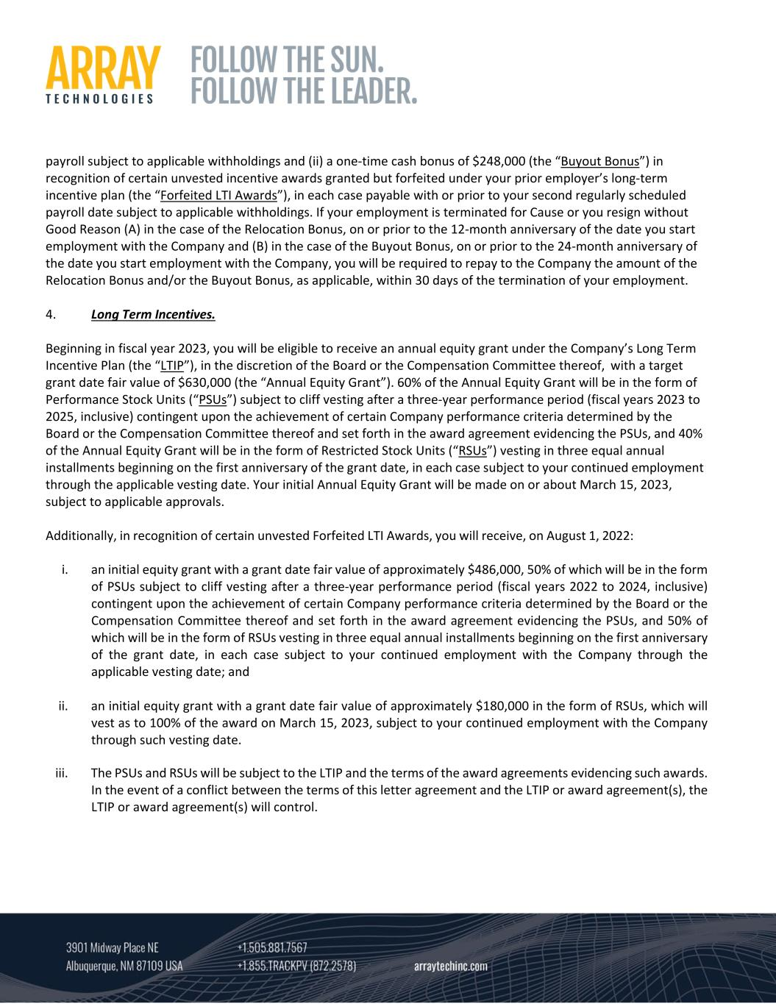
payroll subject to applicable withholdings and (ii) a one‐time cash bonus of $248,000 (the “Buyout Bonus”) in recognition of certain unvested incentive awards granted but forfeited under your prior employer’s long‐term incentive plan (the “Forfeited LTI Awards”), in each case payable with or prior to your second regularly scheduled payroll date subject to applicable withholdings. If your employment is terminated for Cause or you resign without Good Reason (A) in the case of the Relocation Bonus, on or prior to the 12‐month anniversary of the date you start employment with the Company and (B) in the case of the Buyout Bonus, on or prior to the 24‐month anniversary of the date you start employment with the Company, you will be required to repay to the Company the amount of the Relocation Bonus and/or the Buyout Bonus, as applicable, within 30 days of the termination of your employment. 4. Long Term Incentives. Beginning in fiscal year 2023, you will be eligible to receive an annual equity grant under the Company’s Long Term Incentive Plan (the “LTIP”), in the discretion of the Board or the Compensation Committee thereof, with a target grant date fair value of $630,000 (the “Annual Equity Grant”). 60% of the Annual Equity Grant will be in the form of Performance Stock Units (“PSUs”) subject to cliff vesting after a three‐year performance period (fiscal years 2023 to 2025, inclusive) contingent upon the achievement of certain Company performance criteria determined by the Board or the Compensation Committee thereof and set forth in the award agreement evidencing the PSUs, and 40% of the Annual Equity Grant will be in the form of Restricted Stock Units (“RSUs”) vesting in three equal annual installments beginning on the first anniversary of the grant date, in each case subject to your continued employment through the applicable vesting date. Your initial Annual Equity Grant will be made on or about March 15, 2023, subject to applicable approvals. Additionally, in recognition of certain unvested Forfeited LTI Awards, you will receive, on August 1, 2022: i. an initial equity grant with a grant date fair value of approximately $486,000, 50% of which will be in the form of PSUs subject to cliff vesting after a three‐year performance period (fiscal years 2022 to 2024, inclusive) contingent upon the achievement of certain Company performance criteria determined by the Board or the Compensation Committee thereof and set forth in the award agreement evidencing the PSUs, and 50% of which will be in the form of RSUs vesting in three equal annual installments beginning on the first anniversary of the grant date, in each case subject to your continued employment with the Company through the applicable vesting date; and ii. an initial equity grant with a grant date fair value of approximately $180,000 in the form of RSUs, which will vest as to 100% of the award on March 15, 2023, subject to your continued employment with the Company through such vesting date. iii. The PSUs and RSUs will be subject to the LTIP and the terms of the award agreements evidencing such awards. In the event of a conflict between the terms of this letter agreement and the LTIP or award agreement(s), the LTIP or award agreement(s) will control.

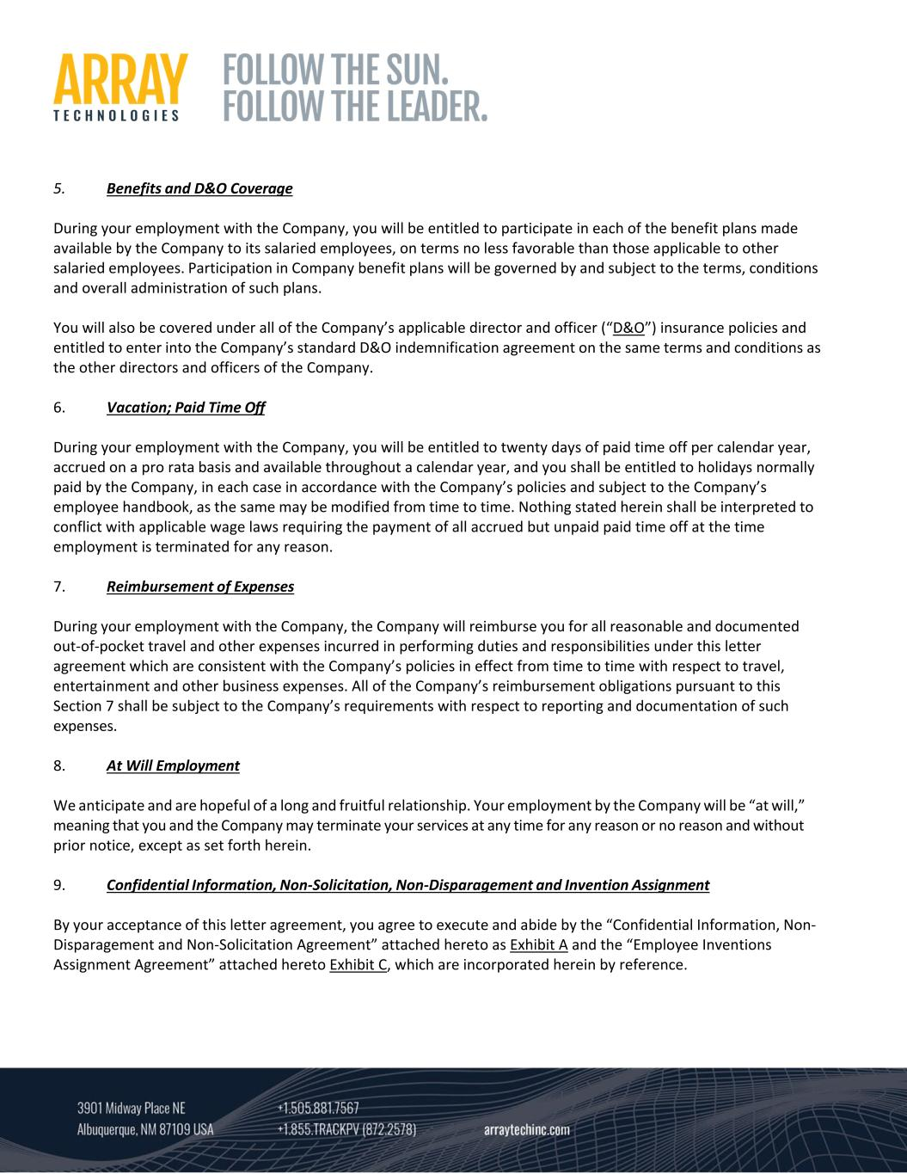
5. Benefits and D&O Coverage During your employment with the Company, you will be entitled to participate in each of the benefit plans made available by the Company to its salaried employees, on terms no less favorable than those applicable to other salaried employees. Participation in Company benefit plans will be governed by and subject to the terms, conditions and overall administration of such plans. You will also be covered under all of the Company’s applicable director and officer (“D&O”) insurance policies and entitled to enter into the Company’s standard D&O indemnification agreement on the same terms and conditions as the other directors and officers of the Company. 6. Vacation; Paid Time Off During your employment with the Company, you will be entitled to twenty days of paid time off per calendar year, accrued on a pro rata basis and available throughout a calendar year, and you shall be entitled to holidays normally paid by the Company, in each case in accordance with the Company’s policies and subject to the Company’s employee handbook, as the same may be modified from time to time. Nothing stated herein shall be interpreted to conflict with applicable wage laws requiring the payment of all accrued but unpaid paid time off at the time employment is terminated for any reason. 7. Reimbursement of Expenses During your employment with the Company, the Company will reimburse you for all reasonable and documented out‐of‐pocket travel and other expenses incurred in performing duties and responsibilities under this letter agreement which are consistent with the Company’s policies in effect from time to time with respect to travel, entertainment and other business expenses. All of the Company’s reimbursement obligations pursuant to this Section 7 shall be subject to the Company’s requirements with respect to reporting and documentation of such expenses. 8. At Will Employment We anticipate and are hopeful of a long and fruitful relationship. Your employment by the Company will be “at will,” meaning that you and the Company may terminate your services at any time for any reason or no reason and without prior notice, except as set forth herein. 9. Confidential Information, Non‐Solicitation, Non‐Disparagement and Invention Assignment By your acceptance of this letter agreement, you agree to execute and abide by the “Confidential Information, Non‐ Disparagement and Non‐Solicitation Agreement” attached hereto as Exhibit A and the “Employee Inventions Assignment Agreement” attached hereto Exhibit C, which are incorporated herein by reference.

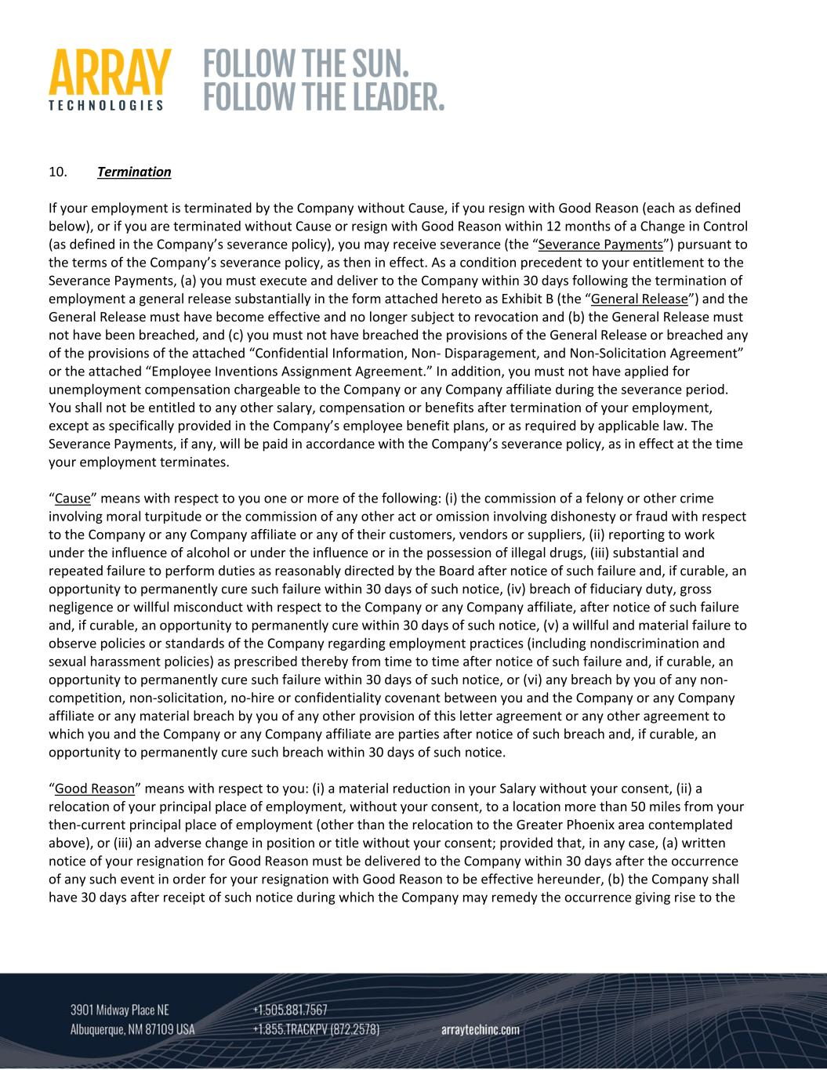
10. Termination If your employment is terminated by the Company without Cause, if you resign with Good Reason (each as defined below), or if you are terminated without Cause or resign with Good Reason within 12 months of a Change in Control (as defined in the Company’s severance policy), you may receive severance (the “Severance Payments”) pursuant to the terms of the Company’s severance policy, as then in effect. As a condition precedent to your entitlement to the Severance Payments, (a) you must execute and deliver to the Company within 30 days following the termination of employment a general release substantially in the form attached hereto as Exhibit B (the “General Release”) and the General Release must have become effective and no longer subject to revocation and (b) the General Release must not have been breached, and (c) you must not have breached the provisions of the General Release or breached any of the provisions of the attached “Confidential Information, Non‐ Disparagement, and Non‐Solicitation Agreement” or the attached “Employee Inventions Assignment Agreement.” In addition, you must not have applied for unemployment compensation chargeable to the Company or any Company affiliate during the severance period. You shall not be entitled to any other salary, compensation or benefits after termination of your employment, except as specifically provided in the Company’s employee benefit plans, or as required by applicable law. The Severance Payments, if any, will be paid in accordance with the Company’s severance policy, as in effect at the time your employment terminates. “Cause” means with respect to you one or more of the following: (i) the commission of a felony or other crime involving moral turpitude or the commission of any other act or omission involving dishonesty or fraud with respect to the Company or any Company affiliate or any of their customers, vendors or suppliers, (ii) reporting to work under the influence of alcohol or under the influence or in the possession of illegal drugs, (iii) substantial and repeated failure to perform duties as reasonably directed by the Board after notice of such failure and, if curable, an opportunity to permanently cure such failure within 30 days of such notice, (iv) breach of fiduciary duty, gross negligence or willful misconduct with respect to the Company or any Company affiliate, after notice of such failure and, if curable, an opportunity to permanently cure within 30 days of such notice, (v) a willful and material failure to observe policies or standards of the Company regarding employment practices (including nondiscrimination and sexual harassment policies) as prescribed thereby from time to time after notice of such failure and, if curable, an opportunity to permanently cure such failure within 30 days of such notice, or (vi) any breach by you of any non‐ competition, non‐solicitation, no‐hire or confidentiality covenant between you and the Company or any Company affiliate or any material breach by you of any other provision of this letter agreement or any other agreement to which you and the Company or any Company affiliate are parties after notice of such breach and, if curable, an opportunity to permanently cure such breach within 30 days of such notice. “Good Reason” means with respect to you: (i) a material reduction in your Salary without your consent, (ii) a relocation of your principal place of employment, without your consent, to a location more than 50 miles from your then‐current principal place of employment (other than the relocation to the Greater Phoenix area contemplated above), or (iii) an adverse change in position or title without your consent; provided that, in any case, (a) written notice of your resignation for Good Reason must be delivered to the Company within 30 days after the occurrence of any such event in order for your resignation with Good Reason to be effective hereunder, (b) the Company shall have 30 days after receipt of such notice during which the Company may remedy the occurrence giving rise to the

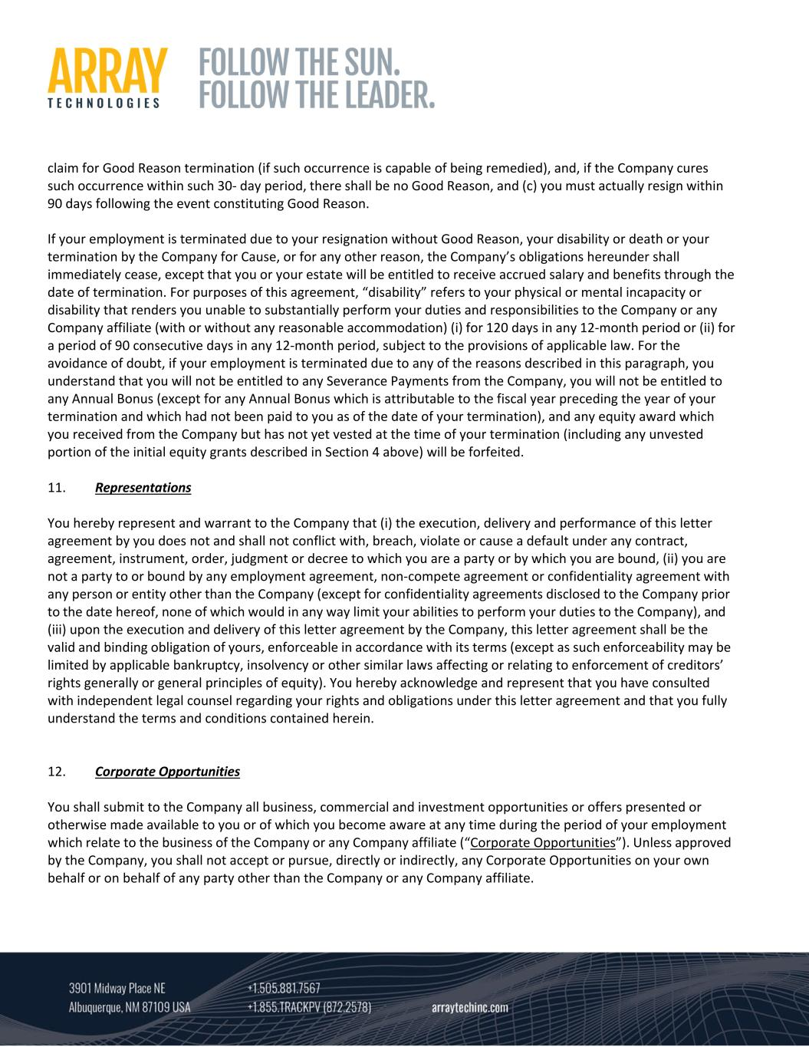
claim for Good Reason termination (if such occurrence is capable of being remedied), and, if the Company cures such occurrence within such 30‐ day period, there shall be no Good Reason, and (c) you must actually resign within 90 days following the event constituting Good Reason. If your employment is terminated due to your resignation without Good Reason, your disability or death or your termination by the Company for Cause, or for any other reason, the Company’s obligations hereunder shall immediately cease, except that you or your estate will be entitled to receive accrued salary and benefits through the date of termination. For purposes of this agreement, “disability” refers to your physical or mental incapacity or disability that renders you unable to substantially perform your duties and responsibilities to the Company or any Company affiliate (with or without any reasonable accommodation) (i) for 120 days in any 12‐month period or (ii) for a period of 90 consecutive days in any 12‐month period, subject to the provisions of applicable law. For the avoidance of doubt, if your employment is terminated due to any of the reasons described in this paragraph, you understand that you will not be entitled to any Severance Payments from the Company, you will not be entitled to any Annual Bonus (except for any Annual Bonus which is attributable to the fiscal year preceding the year of your termination and which had not been paid to you as of the date of your termination), and any equity award which you received from the Company but has not yet vested at the time of your termination (including any unvested portion of the initial equity grants described in Section 4 above) will be forfeited. 11. Representations You hereby represent and warrant to the Company that (i) the execution, delivery and performance of this letter agreement by you does not and shall not conflict with, breach, violate or cause a default under any contract, agreement, instrument, order, judgment or decree to which you are a party or by which you are bound, (ii) you are not a party to or bound by any employment agreement, non‐compete agreement or confidentiality agreement with any person or entity other than the Company (except for confidentiality agreements disclosed to the Company prior to the date hereof, none of which would in any way limit your abilities to perform your duties to the Company), and (iii) upon the execution and delivery of this letter agreement by the Company, this letter agreement shall be the valid and binding obligation of yours, enforceable in accordance with its terms (except as such enforceability may be limited by applicable bankruptcy, insolvency or other similar laws affecting or relating to enforcement of creditors’ rights generally or general principles of equity). You hereby acknowledge and represent that you have consulted with independent legal counsel regarding your rights and obligations under this letter agreement and that you fully understand the terms and conditions contained herein. 12. Corporate Opportunities You shall submit to the Company all business, commercial and investment opportunities or offers presented or otherwise made available to you or of which you become aware at any time during the period of your employment which relate to the business of the Company or any Company affiliate (“Corporate Opportunities”). Unless approved by the Company, you shall not accept or pursue, directly or indirectly, any Corporate Opportunities on your own behalf or on behalf of any party other than the Company or any Company affiliate.

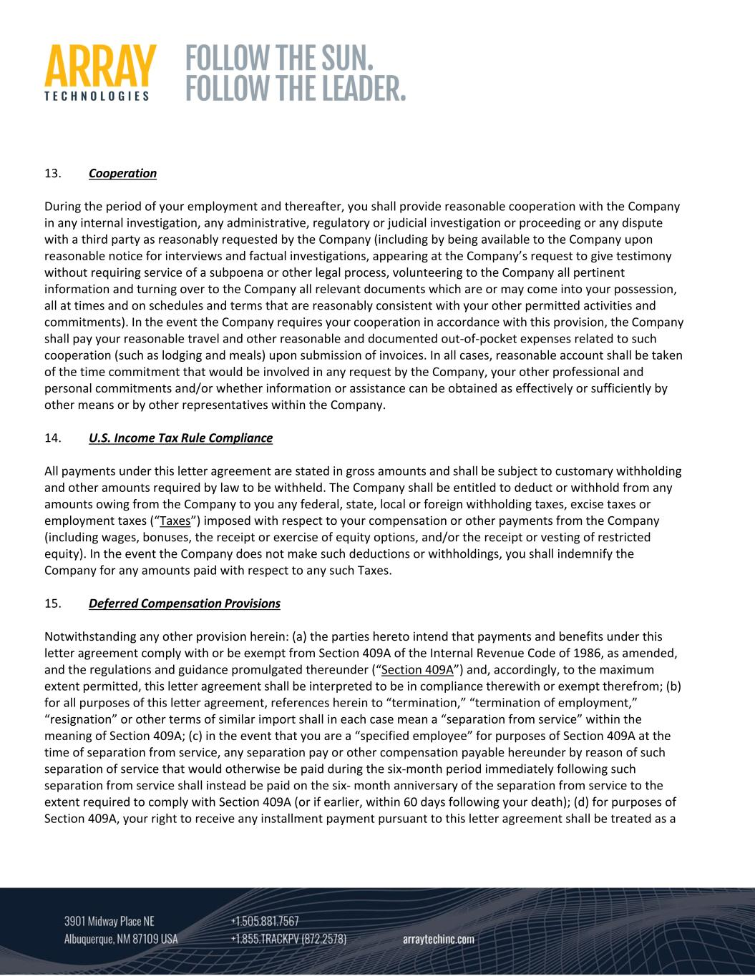
13. Cooperation During the period of your employment and thereafter, you shall provide reasonable cooperation with the Company in any internal investigation, any administrative, regulatory or judicial investigation or proceeding or any dispute with a third party as reasonably requested by the Company (including by being available to the Company upon reasonable notice for interviews and factual investigations, appearing at the Company’s request to give testimony without requiring service of a subpoena or other legal process, volunteering to the Company all pertinent information and turning over to the Company all relevant documents which are or may come into your possession, all at times and on schedules and terms that are reasonably consistent with your other permitted activities and commitments). In the event the Company requires your cooperation in accordance with this provision, the Company shall pay your reasonable travel and other reasonable and documented out‐of‐pocket expenses related to such cooperation (such as lodging and meals) upon submission of invoices. In all cases, reasonable account shall be taken of the time commitment that would be involved in any request by the Company, your other professional and personal commitments and/or whether information or assistance can be obtained as effectively or sufficiently by other means or by other representatives within the Company. 14. U.S. Income Tax Rule Compliance All payments under this letter agreement are stated in gross amounts and shall be subject to customary withholding and other amounts required by law to be withheld. The Company shall be entitled to deduct or withhold from any amounts owing from the Company to you any federal, state, local or foreign withholding taxes, excise taxes or employment taxes (“Taxes”) imposed with respect to your compensation or other payments from the Company (including wages, bonuses, the receipt or exercise of equity options, and/or the receipt or vesting of restricted equity). In the event the Company does not make such deductions or withholdings, you shall indemnify the Company for any amounts paid with respect to any such Taxes. 15. Deferred Compensation Provisions Notwithstanding any other provision herein: (a) the parties hereto intend that payments and benefits under this letter agreement comply with or be exempt from Section 409A of the Internal Revenue Code of 1986, as amended, and the regulations and guidance promulgated thereunder (“Section 409A”) and, accordingly, to the maximum extent permitted, this letter agreement shall be interpreted to be in compliance therewith or exempt therefrom; (b) for all purposes of this letter agreement, references herein to “termination,” “termination of employment,” “resignation” or other terms of similar import shall in each case mean a “separation from service” within the meaning of Section 409A; (c) in the event that you are a “specified employee” for purposes of Section 409A at the time of separation from service, any separation pay or other compensation payable hereunder by reason of such separation of service that would otherwise be paid during the six‐month period immediately following such separation from service shall instead be paid on the six‐ month anniversary of the separation from service to the extent required to comply with Section 409A (or if earlier, within 60 days following your death); (d) for purposes of Section 409A, your right to receive any installment payment pursuant to this letter agreement shall be treated as a

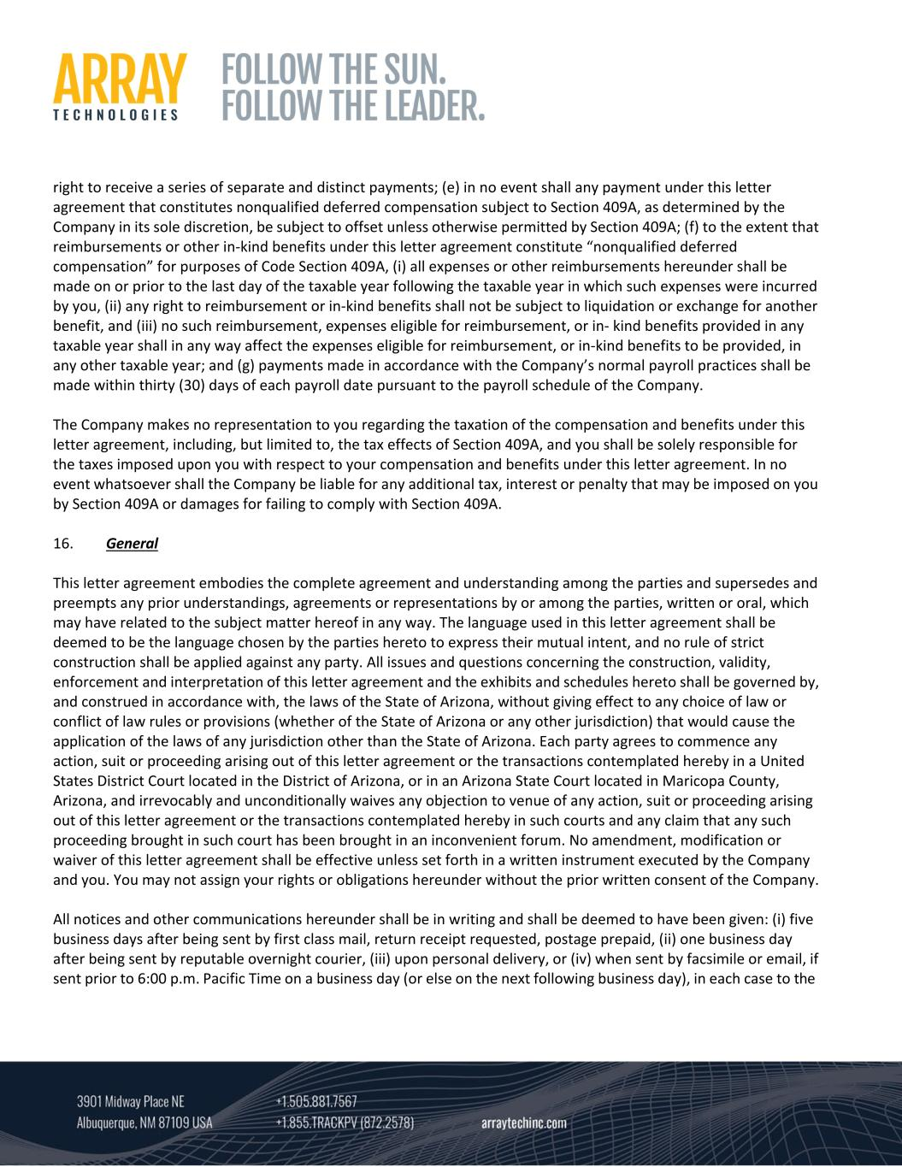
right to receive a series of separate and distinct payments; (e) in no event shall any payment under this letter agreement that constitutes nonqualified deferred compensation subject to Section 409A, as determined by the Company in its sole discretion, be subject to offset unless otherwise permitted by Section 409A; (f) to the extent that reimbursements or other in‐kind benefits under this letter agreement constitute “nonqualified deferred compensation” for purposes of Code Section 409A, (i) all expenses or other reimbursements hereunder shall be made on or prior to the last day of the taxable year following the taxable year in which such expenses were incurred by you, (ii) any right to reimbursement or in‐kind benefits shall not be subject to liquidation or exchange for another benefit, and (iii) no such reimbursement, expenses eligible for reimbursement, or in‐ kind benefits provided in any taxable year shall in any way affect the expenses eligible for reimbursement, or in‐kind benefits to be provided, in any other taxable year; and (g) payments made in accordance with the Company’s normal payroll practices shall be made within thirty (30) days of each payroll date pursuant to the payroll schedule of the Company. The Company makes no representation to you regarding the taxation of the compensation and benefits under this letter agreement, including, but limited to, the tax effects of Section 409A, and you shall be solely responsible for the taxes imposed upon you with respect to your compensation and benefits under this letter agreement. In no event whatsoever shall the Company be liable for any additional tax, interest or penalty that may be imposed on you by Section 409A or damages for failing to comply with Section 409A. 16. General This letter agreement embodies the complete agreement and understanding among the parties and supersedes and preempts any prior understandings, agreements or representations by or among the parties, written or oral, which may have related to the subject matter hereof in any way. The language used in this letter agreement shall be deemed to be the language chosen by the parties hereto to express their mutual intent, and no rule of strict construction shall be applied against any party. All issues and questions concerning the construction, validity, enforcement and interpretation of this letter agreement and the exhibits and schedules hereto shall be governed by, and construed in accordance with, the laws of the State of Arizona, without giving effect to any choice of law or conflict of law rules or provisions (whether of the State of Arizona or any other jurisdiction) that would cause the application of the laws of any jurisdiction other than the State of Arizona. Each party agrees to commence any action, suit or proceeding arising out of this letter agreement or the transactions contemplated hereby in a United States District Court located in the District of Arizona, or in an Arizona State Court located in Maricopa County, Arizona, and irrevocably and unconditionally waives any objection to venue of any action, suit or proceeding arising out of this letter agreement or the transactions contemplated hereby in such courts and any claim that any such proceeding brought in such court has been brought in an inconvenient forum. No amendment, modification or waiver of this letter agreement shall be effective unless set forth in a written instrument executed by the Company and you. You may not assign your rights or obligations hereunder without the prior written consent of the Company. All notices and other communications hereunder shall be in writing and shall be deemed to have been given: (i) five business days after being sent by first class mail, return receipt requested, postage prepaid, (ii) one business day after being sent by reputable overnight courier, (iii) upon personal delivery, or (iv) when sent by facsimile or email, if sent prior to 6:00 p.m. Pacific Time on a business day (or else on the next following business day), in each case to the

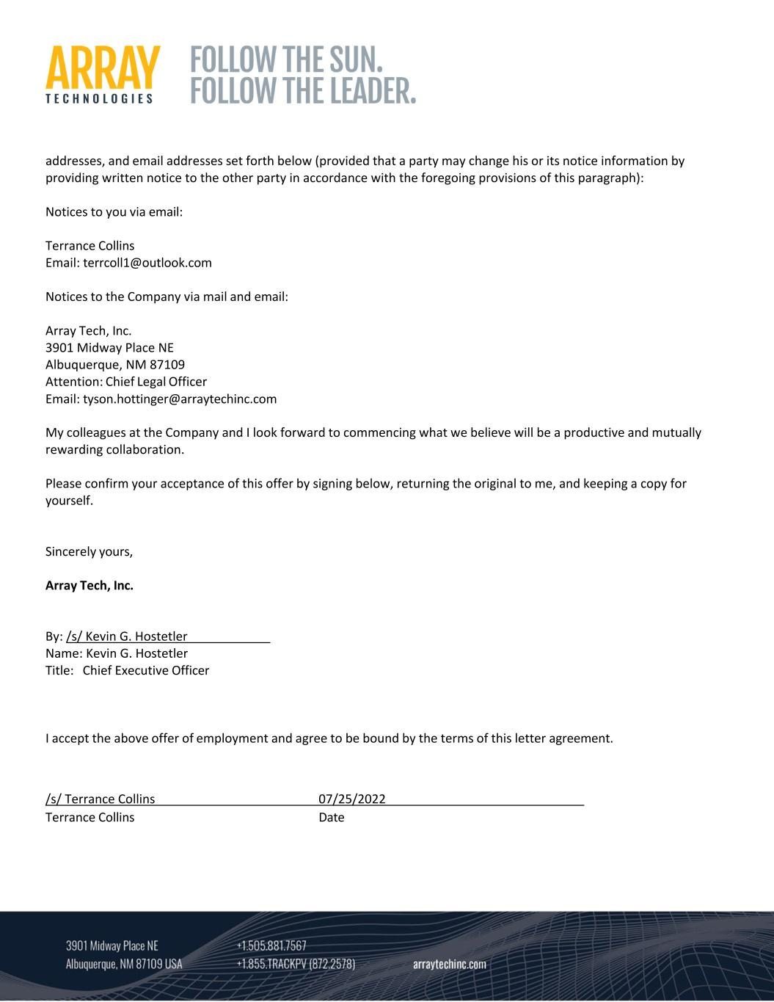
addresses, and email addresses set forth below (provided that a party may change his or its notice information by providing written notice to the other party in accordance with the foregoing provisions of this paragraph): Notices to you via email: Terrance Collins Email: terrcoll1@outlook.com Notices to the Company via mail and email: Array Tech, Inc. 3901 Midway Place NE Albuquerque, NM 87109 Attention: Chief Legal Officer Email: tyson.hottinger@arraytechinc.com My colleagues at the Company and I look forward to commencing what we believe will be a productive and mutually rewarding collaboration. Please confirm your acceptance of this offer by signing below, returning the original to me, and keeping a copy for yourself. Sincerely yours, Array Tech, Inc. By: /s/ Kevin G. Hostetler Name: Kevin G. Hostetler Title: Chief Executive Officer I accept the above offer of employment and agree to be bound by the terms of this letter agreement. /s/ Terrance Collins 07/25/2022 Terrance Collins Date

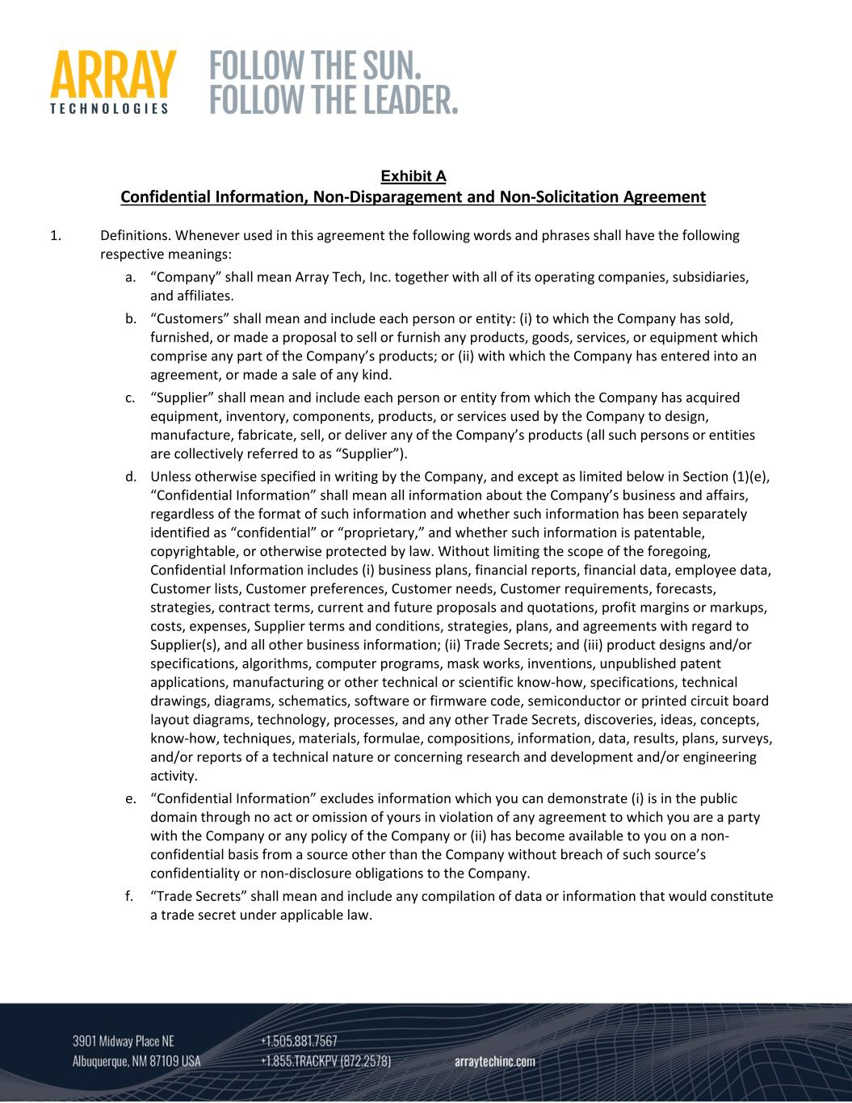
Exhibit A Confidential Information, Non‐Disparagement and Non‐Solicitation Agreement 1. Definitions. Whenever used in this agreement the following words and phrases shall have the following respective meanings: a. “Company” shall mean Array Tech, Inc. together with all of its operating companies, subsidiaries, and affiliates. b. “Customers” shall mean and include each person or entity: (i) to which the Company has sold, furnished, or made a proposal to sell or furnish any products, goods, services, or equipment which comprise any part of the Company’s products; or (ii) with which the Company has entered into an agreement, or made a sale of any kind. c. “Supplier” shall mean and include each person or entity from which the Company has acquired equipment, inventory, components, products, or services used by the Company to design, manufacture, fabricate, sell, or deliver any of the Company’s products (all such persons or entities are collectively referred to as “Supplier”). d. Unless otherwise specified in writing by the Company, and except as limited below in Section (1)(e), “Confidential Information” shall mean all information about the Company’s business and affairs, regardless of the format of such information and whether such information has been separately identified as “confidential” or “proprietary,” and whether such information is patentable, copyrightable, or otherwise protected by law. Without limiting the scope of the foregoing, Confidential Information includes (i) business plans, financial reports, financial data, employee data, Customer lists, Customer preferences, Customer needs, Customer requirements, forecasts, strategies, contract terms, current and future proposals and quotations, profit margins or markups, costs, expenses, Supplier terms and conditions, strategies, plans, and agreements with regard to Supplier(s), and all other business information; (ii) Trade Secrets; and (iii) product designs and/or specifications, algorithms, computer programs, mask works, inventions, unpublished patent applications, manufacturing or other technical or scientific know‐how, specifications, technical drawings, diagrams, schematics, software or firmware code, semiconductor or printed circuit board layout diagrams, technology, processes, and any other Trade Secrets, discoveries, ideas, concepts, know‐how, techniques, materials, formulae, compositions, information, data, results, plans, surveys, and/or reports of a technical nature or concerning research and development and/or engineering activity. e. “Confidential Information” excludes information which you can demonstrate (i) is in the public domain through no act or omission of yours in violation of any agreement to which you are a party with the Company or any policy of the Company or (ii) has become available to you on a non‐ confidential basis from a source other than the Company without breach of such source’s confidentiality or non‐disclosure obligations to the Company. f. “Trade Secrets” shall mean and include any compilation of data or information that would constitute a trade secret under applicable law.

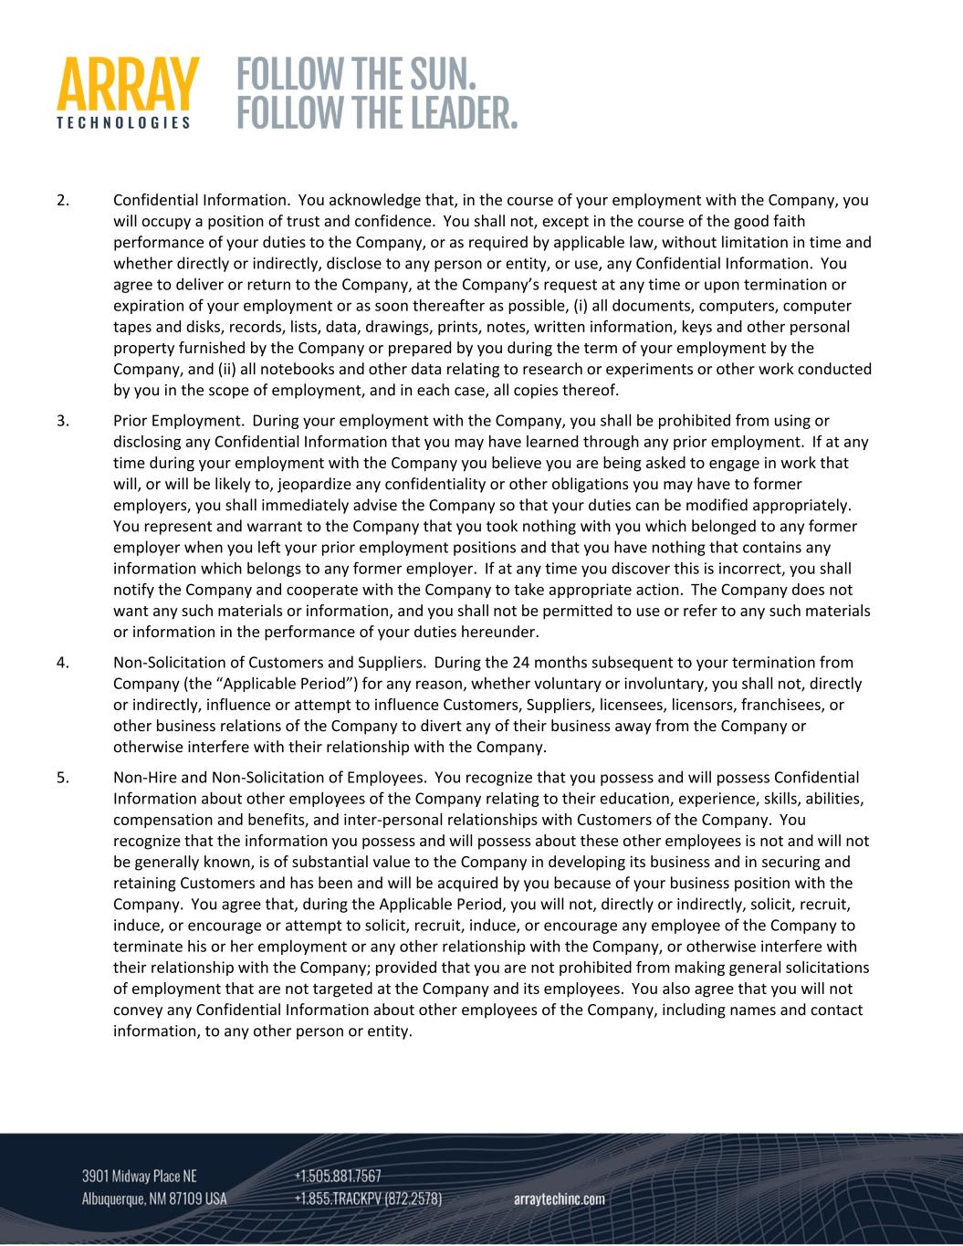
2. Confidential Information. You acknowledge that, in the course of your employment with the Company, you will occupy a position of trust and confidence. You shall not, except in the course of the good faith performance of your duties to the Company, or as required by applicable law, without limitation in time and whether directly or indirectly, disclose to any person or entity, or use, any Confidential Information. You agree to deliver or return to the Company, at the Company’s request at any time or upon termination or expiration of your employment or as soon thereafter as possible, (i) all documents, computers, computer tapes and disks, records, lists, data, drawings, prints, notes, written information, keys and other personal property furnished by the Company or prepared by you during the term of your employment by the Company, and (ii) all notebooks and other data relating to research or experiments or other work conducted by you in the scope of employment, and in each case, all copies thereof. 3. Prior Employment. During your employment with the Company, you shall be prohibited from using or disclosing any Confidential Information that you may have learned through any prior employment. If at any time during your employment with the Company you believe you are being asked to engage in work that will, or will be likely to, jeopardize any confidentiality or other obligations you may have to former employers, you shall immediately advise the Company so that your duties can be modified appropriately. You represent and warrant to the Company that you took nothing with you which belonged to any former employer when you left your prior employment positions and that you have nothing that contains any information which belongs to any former employer. If at any time you discover this is incorrect, you shall notify the Company and cooperate with the Company to take appropriate action. The Company does not want any such materials or information, and you shall not be permitted to use or refer to any such materials or information in the performance of your duties hereunder. 4. Non‐Solicitation of Customers and Suppliers. During the 24 months subsequent to your termination from Company (the “Applicable Period”) for any reason, whether voluntary or involuntary, you shall not, directly or indirectly, influence or attempt to influence Customers, Suppliers, licensees, licensors, franchisees, or other business relations of the Company to divert any of their business away from the Company or otherwise interfere with their relationship with the Company. 5. Non‐Hire and Non‐Solicitation of Employees. You recognize that you possess and will possess Confidential Information about other employees of the Company relating to their education, experience, skills, abilities, compensation and benefits, and inter‐personal relationships with Customers of the Company. You recognize that the information you possess and will possess about these other employees is not and will not be generally known, is of substantial value to the Company in developing its business and in securing and retaining Customers and has been and will be acquired by you because of your business position with the Company. You agree that, during the Applicable Period, you will not, directly or indirectly, solicit, recruit, induce, or encourage or attempt to solicit, recruit, induce, or encourage any employee of the Company to terminate his or her employment or any other relationship with the Company, or otherwise interfere with their relationship with the Company; provided that you are not prohibited from making general solicitations of employment that are not targeted at the Company and its employees. You also agree that you will not convey any Confidential Information about other employees of the Company, including names and contact information, to any other person or entity.

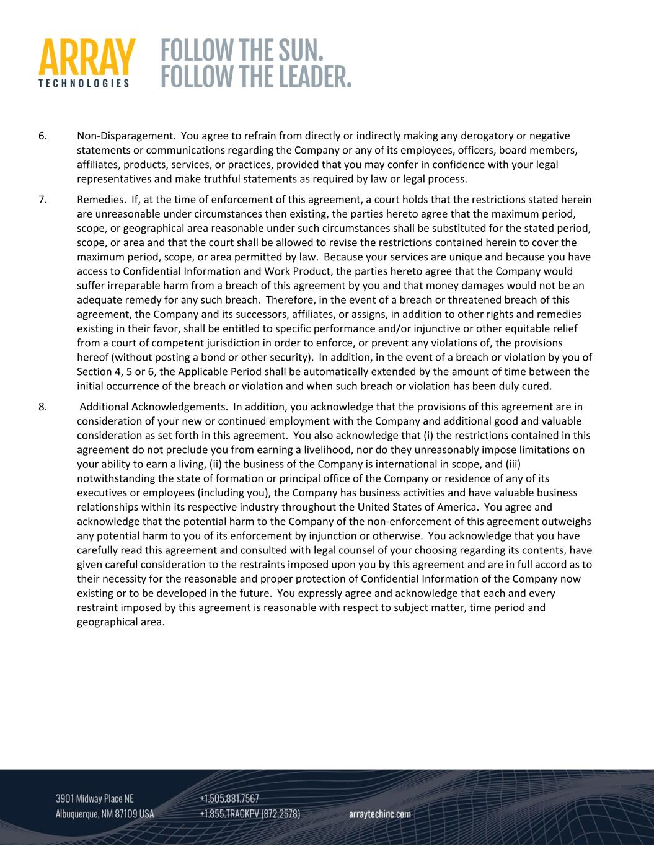
6. Non‐Disparagement. You agree to refrain from directly or indirectly making any derogatory or negative statements or communications regarding the Company or any of its employees, officers, board members, affiliates, products, services, or practices, provided that you may confer in confidence with your legal representatives and make truthful statements as required by law or legal process. 7. Remedies. If, at the time of enforcement of this agreement, a court holds that the restrictions stated herein are unreasonable under circumstances then existing, the parties hereto agree that the maximum period, scope, or geographical area reasonable under such circumstances shall be substituted for the stated period, scope, or area and that the court shall be allowed to revise the restrictions contained herein to cover the maximum period, scope, or area permitted by law. Because your services are unique and because you have access to Confidential Information and Work Product, the parties hereto agree that the Company would suffer irreparable harm from a breach of this agreement by you and that money damages would not be an adequate remedy for any such breach. Therefore, in the event of a breach or threatened breach of this agreement, the Company and its successors, affiliates, or assigns, in addition to other rights and remedies existing in their favor, shall be entitled to specific performance and/or injunctive or other equitable relief from a court of competent jurisdiction in order to enforce, or prevent any violations of, the provisions hereof (without posting a bond or other security). In addition, in the event of a breach or violation by you of Section 4, 5 or 6, the Applicable Period shall be automatically extended by the amount of time between the initial occurrence of the breach or violation and when such breach or violation has been duly cured. 8. Additional Acknowledgements. In addition, you acknowledge that the provisions of this agreement are in consideration of your new or continued employment with the Company and additional good and valuable consideration as set forth in this agreement. You also acknowledge that (i) the restrictions contained in this agreement do not preclude you from earning a livelihood, nor do they unreasonably impose limitations on your ability to earn a living, (ii) the business of the Company is international in scope, and (iii) notwithstanding the state of formation or principal office of the Company or residence of any of its executives or employees (including you), the Company has business activities and have valuable business relationships within its respective industry throughout the United States of America. You agree and acknowledge that the potential harm to the Company of the non‐enforcement of this agreement outweighs any potential harm to you of its enforcement by injunction or otherwise. You acknowledge that you have carefully read this agreement and consulted with legal counsel of your choosing regarding its contents, have given careful consideration to the restraints imposed upon you by this agreement and are in full accord as to their necessity for the reasonable and proper protection of Confidential Information of the Company now existing or to be developed in the future. You expressly agree and acknowledge that each and every restraint imposed by this agreement is reasonable with respect to subject matter, time period and geographical area.

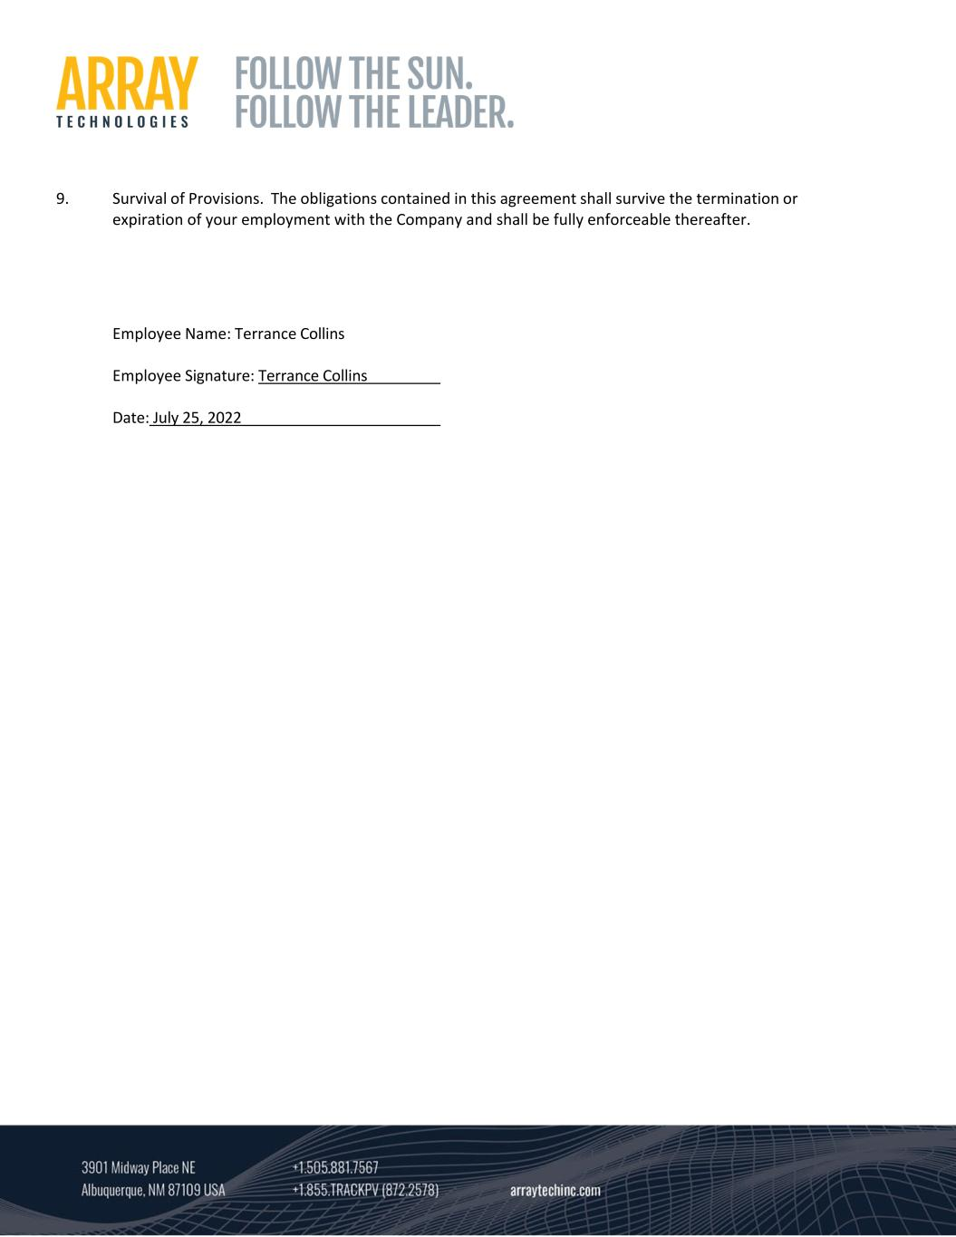
9. Survival of Provisions. The obligations contained in this agreement shall survive the termination or expiration of your employment with the Company and shall be fully enforceable thereafter. Employee Name: Terrance Collins Employee Signature: Terrance Collins Date: July 25, 2022

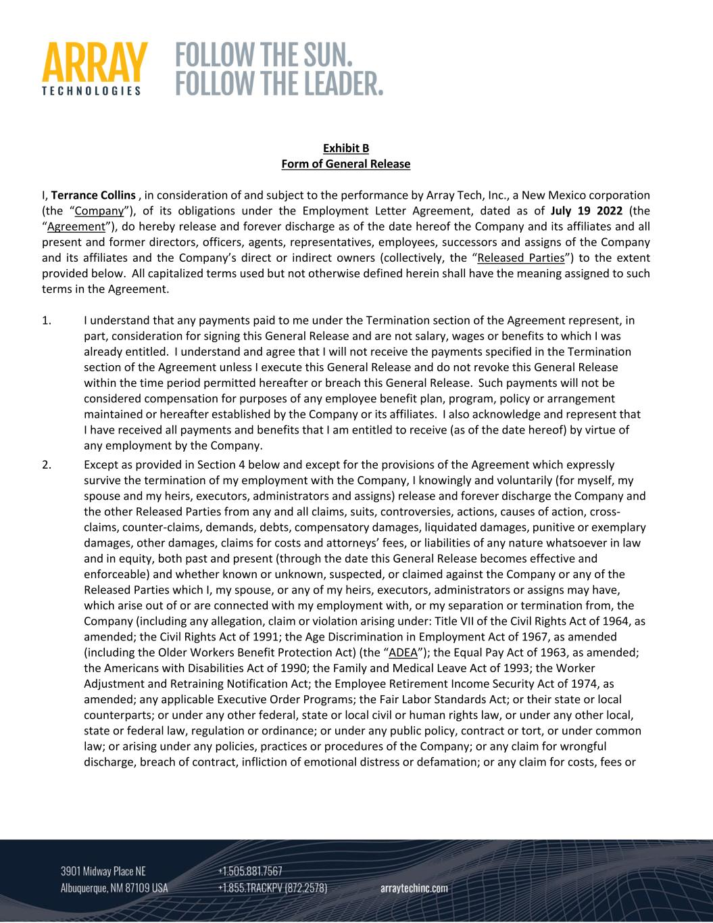
Exhibit B Form of General Release I, Terrance Collins , in consideration of and subject to the performance by Array Tech, Inc., a New Mexico corporation (the “Company”), of its obligations under the Employment Letter Agreement, dated as of July 19 2022 (the “Agreement”), do hereby release and forever discharge as of the date hereof the Company and its affiliates and all present and former directors, officers, agents, representatives, employees, successors and assigns of the Company and its affiliates and the Company’s direct or indirect owners (collectively, the “Released Parties”) to the extent provided below. All capitalized terms used but not otherwise defined herein shall have the meaning assigned to such terms in the Agreement. 1. I understand that any payments paid to me under the Termination section of the Agreement represent, in part, consideration for signing this General Release and are not salary, wages or benefits to which I was already entitled. I understand and agree that I will not receive the payments specified in the Termination section of the Agreement unless I execute this General Release and do not revoke this General Release within the time period permitted hereafter or breach this General Release. Such payments will not be considered compensation for purposes of any employee benefit plan, program, policy or arrangement maintained or hereafter established by the Company or its affiliates. I also acknowledge and represent that I have received all payments and benefits that I am entitled to receive (as of the date hereof) by virtue of any employment by the Company. 2. Except as provided in Section 4 below and except for the provisions of the Agreement which expressly survive the termination of my employment with the Company, I knowingly and voluntarily (for myself, my spouse and my heirs, executors, administrators and assigns) release and forever discharge the Company and the other Released Parties from any and all claims, suits, controversies, actions, causes of action, cross‐ claims, counter‐claims, demands, debts, compensatory damages, liquidated damages, punitive or exemplary damages, other damages, claims for costs and attorneys’ fees, or liabilities of any nature whatsoever in law and in equity, both past and present (through the date this General Release becomes effective and enforceable) and whether known or unknown, suspected, or claimed against the Company or any of the Released Parties which I, my spouse, or any of my heirs, executors, administrators or assigns may have, which arise out of or are connected with my employment with, or my separation or termination from, the Company (including any allegation, claim or violation arising under: Title VII of the Civil Rights Act of 1964, as amended; the Civil Rights Act of 1991; the Age Discrimination in Employment Act of 1967, as amended (including the Older Workers Benefit Protection Act) (the “ADEA”); the Equal Pay Act of 1963, as amended; the Americans with Disabilities Act of 1990; the Family and Medical Leave Act of 1993; the Worker Adjustment and Retraining Notification Act; the Employee Retirement Income Security Act of 1974, as amended; any applicable Executive Order Programs; the Fair Labor Standards Act; or their state or local counterparts; or under any other federal, state or local civil or human rights law, or under any other local, state or federal law, regulation or ordinance; or under any public policy, contract or tort, or under common law; or arising under any policies, practices or procedures of the Company; or any claim for wrongful discharge, breach of contract, infliction of emotional distress or defamation; or any claim for costs, fees or

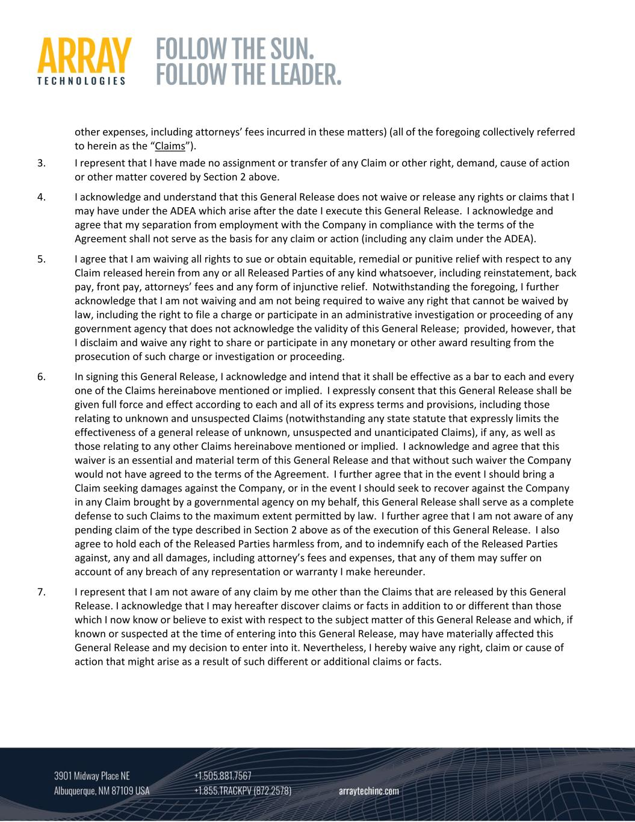
other expenses, including attorneys’ fees incurred in these matters) (all of the foregoing collectively referred to herein as the “Claims”). 3. I represent that I have made no assignment or transfer of any Claim or other right, demand, cause of action or other matter covered by Section 2 above. 4. I acknowledge and understand that this General Release does not waive or release any rights or claims that I may have under the ADEA which arise after the date I execute this General Release. I acknowledge and agree that my separation from employment with the Company in compliance with the terms of the Agreement shall not serve as the basis for any claim or action (including any claim under the ADEA). 5. I agree that I am waiving all rights to sue or obtain equitable, remedial or punitive relief with respect to any Claim released herein from any or all Released Parties of any kind whatsoever, including reinstatement, back pay, front pay, attorneys’ fees and any form of injunctive relief. Notwithstanding the foregoing, I further acknowledge that I am not waiving and am not being required to waive any right that cannot be waived by law, including the right to file a charge or participate in an administrative investigation or proceeding of any government agency that does not acknowledge the validity of this General Release; provided, however, that I disclaim and waive any right to share or participate in any monetary or other award resulting from the prosecution of such charge or investigation or proceeding. 6. In signing this General Release, I acknowledge and intend that it shall be effective as a bar to each and every one of the Claims hereinabove mentioned or implied. I expressly consent that this General Release shall be given full force and effect according to each and all of its express terms and provisions, including those relating to unknown and unsuspected Claims (notwithstanding any state statute that expressly limits the effectiveness of a general release of unknown, unsuspected and unanticipated Claims), if any, as well as those relating to any other Claims hereinabove mentioned or implied. I acknowledge and agree that this waiver is an essential and material term of this General Release and that without such waiver the Company would not have agreed to the terms of the Agreement. I further agree that in the event I should bring a Claim seeking damages against the Company, or in the event I should seek to recover against the Company in any Claim brought by a governmental agency on my behalf, this General Release shall serve as a complete defense to such Claims to the maximum extent permitted by law. I further agree that I am not aware of any pending claim of the type described in Section 2 above as of the execution of this General Release. I also agree to hold each of the Released Parties harmless from, and to indemnify each of the Released Parties against, any and all damages, including attorney’s fees and expenses, that any of them may suffer on account of any breach of any representation or warranty I make hereunder. 7. I represent that I am not aware of any claim by me other than the Claims that are released by this General Release. I acknowledge that I may hereafter discover claims or facts in addition to or different than those which I now know or believe to exist with respect to the subject matter of this General Release and which, if known or suspected at the time of entering into this General Release, may have materially affected this General Release and my decision to enter into it. Nevertheless, I hereby waive any right, claim or cause of action that might arise as a result of such different or additional claims or facts.

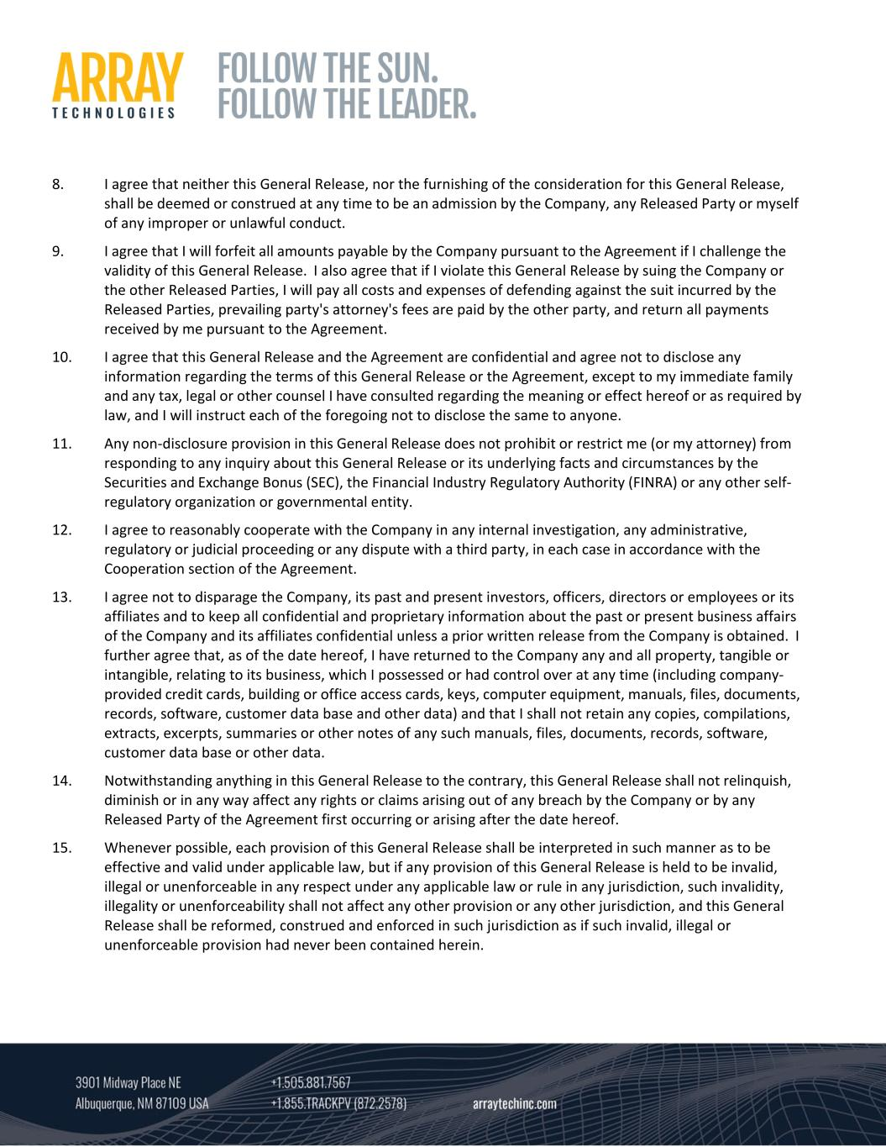
8. I agree that neither this General Release, nor the furnishing of the consideration for this General Release, shall be deemed or construed at any time to be an admission by the Company, any Released Party or myself of any improper or unlawful conduct. 9. I agree that I will forfeit all amounts payable by the Company pursuant to the Agreement if I challenge the validity of this General Release. I also agree that if I violate this General Release by suing the Company or the other Released Parties, I will pay all costs and expenses of defending against the suit incurred by the Released Parties, prevailing party's attorney's fees are paid by the other party, and return all payments received by me pursuant to the Agreement. 10. I agree that this General Release and the Agreement are confidential and agree not to disclose any information regarding the terms of this General Release or the Agreement, except to my immediate family and any tax, legal or other counsel I have consulted regarding the meaning or effect hereof or as required by law, and I will instruct each of the foregoing not to disclose the same to anyone. 11. Any non‐disclosure provision in this General Release does not prohibit or restrict me (or my attorney) from responding to any inquiry about this General Release or its underlying facts and circumstances by the Securities and Exchange Bonus (SEC), the Financial Industry Regulatory Authority (FINRA) or any other self‐ regulatory organization or governmental entity. 12. I agree to reasonably cooperate with the Company in any internal investigation, any administrative, regulatory or judicial proceeding or any dispute with a third party, in each case in accordance with the Cooperation section of the Agreement. 13. I agree not to disparage the Company, its past and present investors, officers, directors or employees or its affiliates and to keep all confidential and proprietary information about the past or present business affairs of the Company and its affiliates confidential unless a prior written release from the Company is obtained. I further agree that, as of the date hereof, I have returned to the Company any and all property, tangible or intangible, relating to its business, which I possessed or had control over at any time (including company‐ provided credit cards, building or office access cards, keys, computer equipment, manuals, files, documents, records, software, customer data base and other data) and that I shall not retain any copies, compilations, extracts, excerpts, summaries or other notes of any such manuals, files, documents, records, software, customer data base or other data. 14. Notwithstanding anything in this General Release to the contrary, this General Release shall not relinquish, diminish or in any way affect any rights or claims arising out of any breach by the Company or by any Released Party of the Agreement first occurring or arising after the date hereof. 15. Whenever possible, each provision of this General Release shall be interpreted in such manner as to be effective and valid under applicable law, but if any provision of this General Release is held to be invalid, illegal or unenforceable in any respect under any applicable law or rule in any jurisdiction, such invalidity, illegality or unenforceability shall not affect any other provision or any other jurisdiction, and this General Release shall be reformed, construed and enforced in such jurisdiction as if such invalid, illegal or unenforceable provision had never been contained herein.

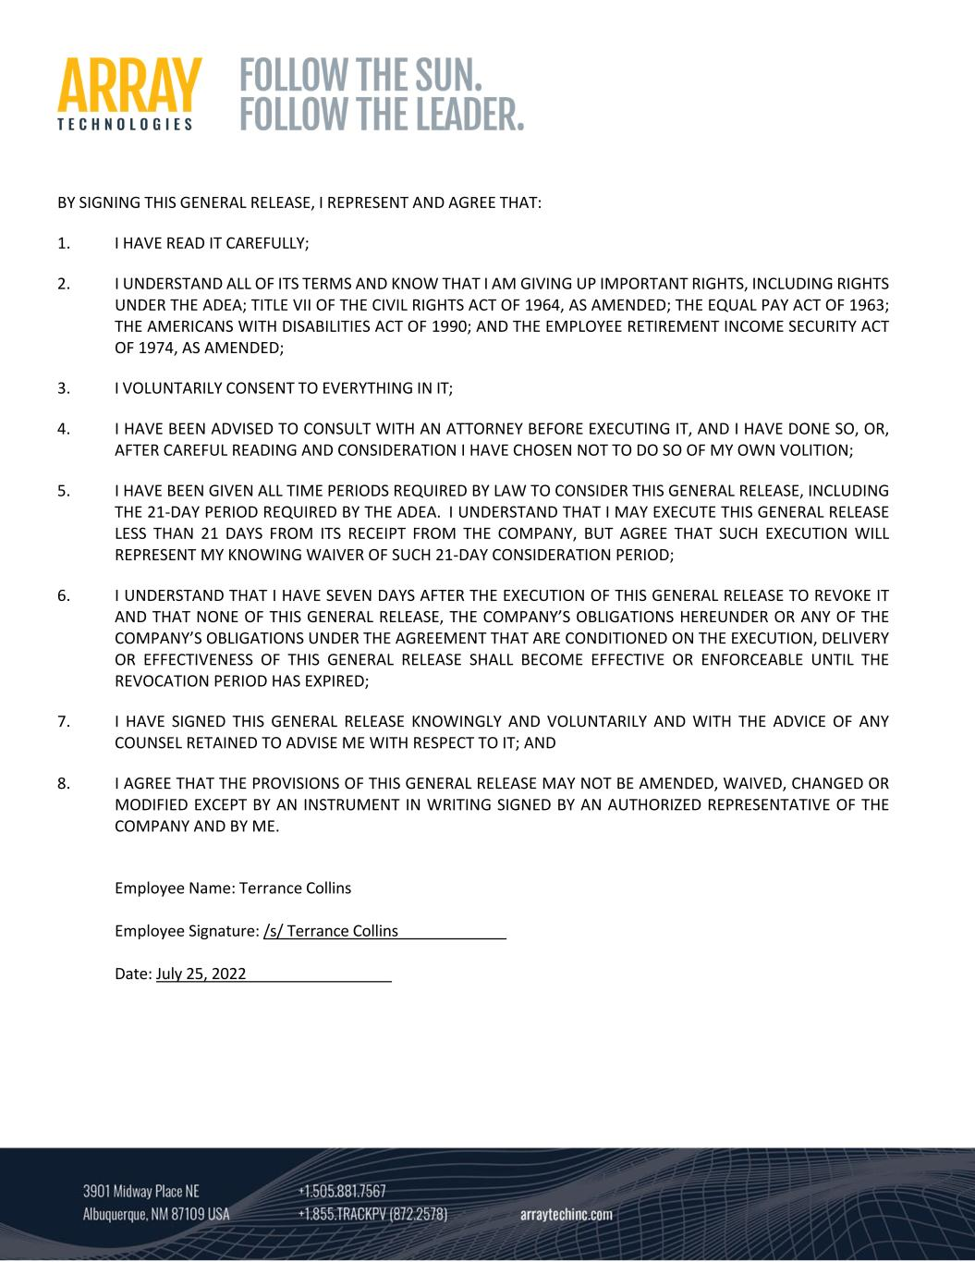
BY SIGNING THIS GENERAL RELEASE, I REPRESENT AND AGREE THAT: 1. I HAVE READ IT CAREFULLY; 2. I UNDERSTAND ALL OF ITS TERMS AND KNOW THAT I AM GIVING UP IMPORTANT RIGHTS, INCLUDING RIGHTS UNDER THE ADEA; TITLE VII OF THE CIVIL RIGHTS ACT OF 1964, AS AMENDED; THE EQUAL PAY ACT OF 1963; THE AMERICANS WITH DISABILITIES ACT OF 1990; AND THE EMPLOYEE RETIREMENT INCOME SECURITY ACT OF 1974, AS AMENDED; 3. I VOLUNTARILY CONSENT TO EVERYTHING IN IT; 4. I HAVE BEEN ADVISED TO CONSULT WITH AN ATTORNEY BEFORE EXECUTING IT, AND I HAVE DONE SO, OR, AFTER CAREFUL READING AND CONSIDERATION I HAVE CHOSEN NOT TO DO SO OF MY OWN VOLITION; 5. I HAVE BEEN GIVEN ALL TIME PERIODS REQUIRED BY LAW TO CONSIDER THIS GENERAL RELEASE, INCLUDING THE 21‐DAY PERIOD REQUIRED BY THE ADEA. I UNDERSTAND THAT I MAY EXECUTE THIS GENERAL RELEASE LESS THAN 21 DAYS FROM ITS RECEIPT FROM THE COMPANY, BUT AGREE THAT SUCH EXECUTION WILL REPRESENT MY KNOWING WAIVER OF SUCH 21‐DAY CONSIDERATION PERIOD; 6. I UNDERSTAND THAT I HAVE SEVEN DAYS AFTER THE EXECUTION OF THIS GENERAL RELEASE TO REVOKE IT AND THAT NONE OF THIS GENERAL RELEASE, THE COMPANY’S OBLIGATIONS HEREUNDER OR ANY OF THE COMPANY’S OBLIGATIONS UNDER THE AGREEMENT THAT ARE CONDITIONED ON THE EXECUTION, DELIVERY OR EFFECTIVENESS OF THIS GENERAL RELEASE SHALL BECOME EFFECTIVE OR ENFORCEABLE UNTIL THE REVOCATION PERIOD HAS EXPIRED; 7. I HAVE SIGNED THIS GENERAL RELEASE KNOWINGLY AND VOLUNTARILY AND WITH THE ADVICE OF ANY COUNSEL RETAINED TO ADVISE ME WITH RESPECT TO IT; AND 8. I AGREE THAT THE PROVISIONS OF THIS GENERAL RELEASE MAY NOT BE AMENDED, WAIVED, CHANGED OR MODIFIED EXCEPT BY AN INSTRUMENT IN WRITING SIGNED BY AN AUTHORIZED REPRESENTATIVE OF THE COMPANY AND BY ME. Employee Name: Terrance Collins Employee Signature: /s/ Terrance Collins Date: July 25, 2022

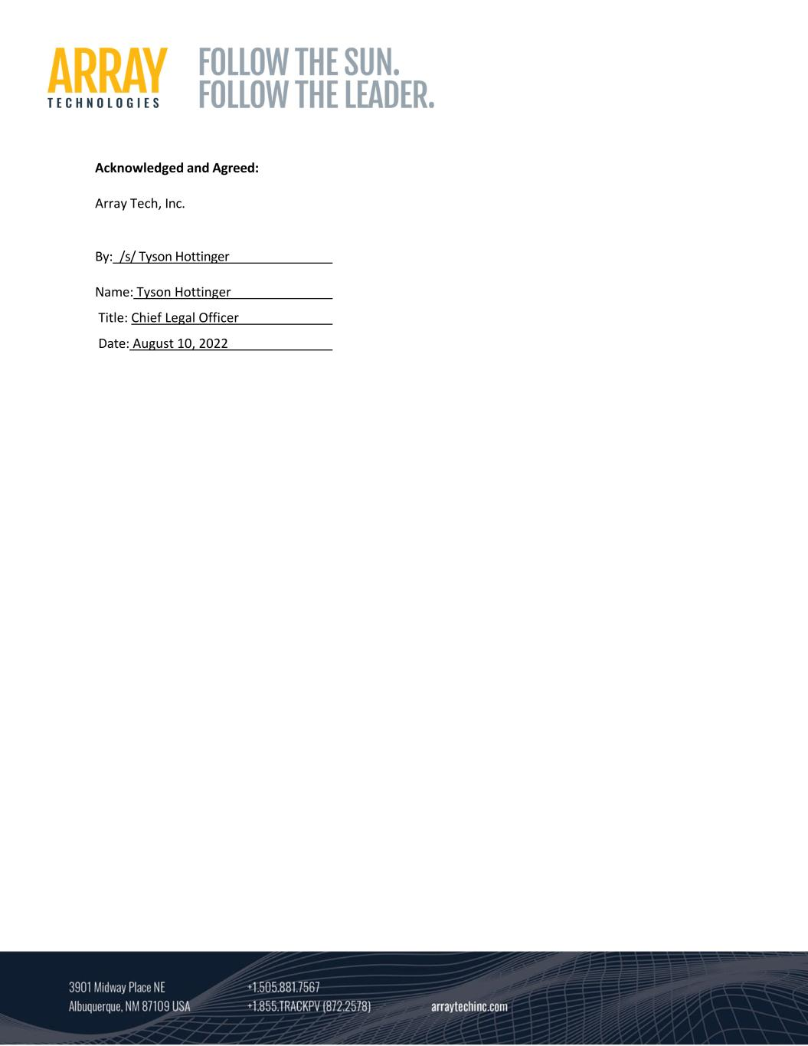
Acknowledged and Agreed: Array Tech, Inc. By:_/s/ Tyson Hottinger Name: Tyson Hottinger Title: Chief Legal Officer Date: August 10, 2022

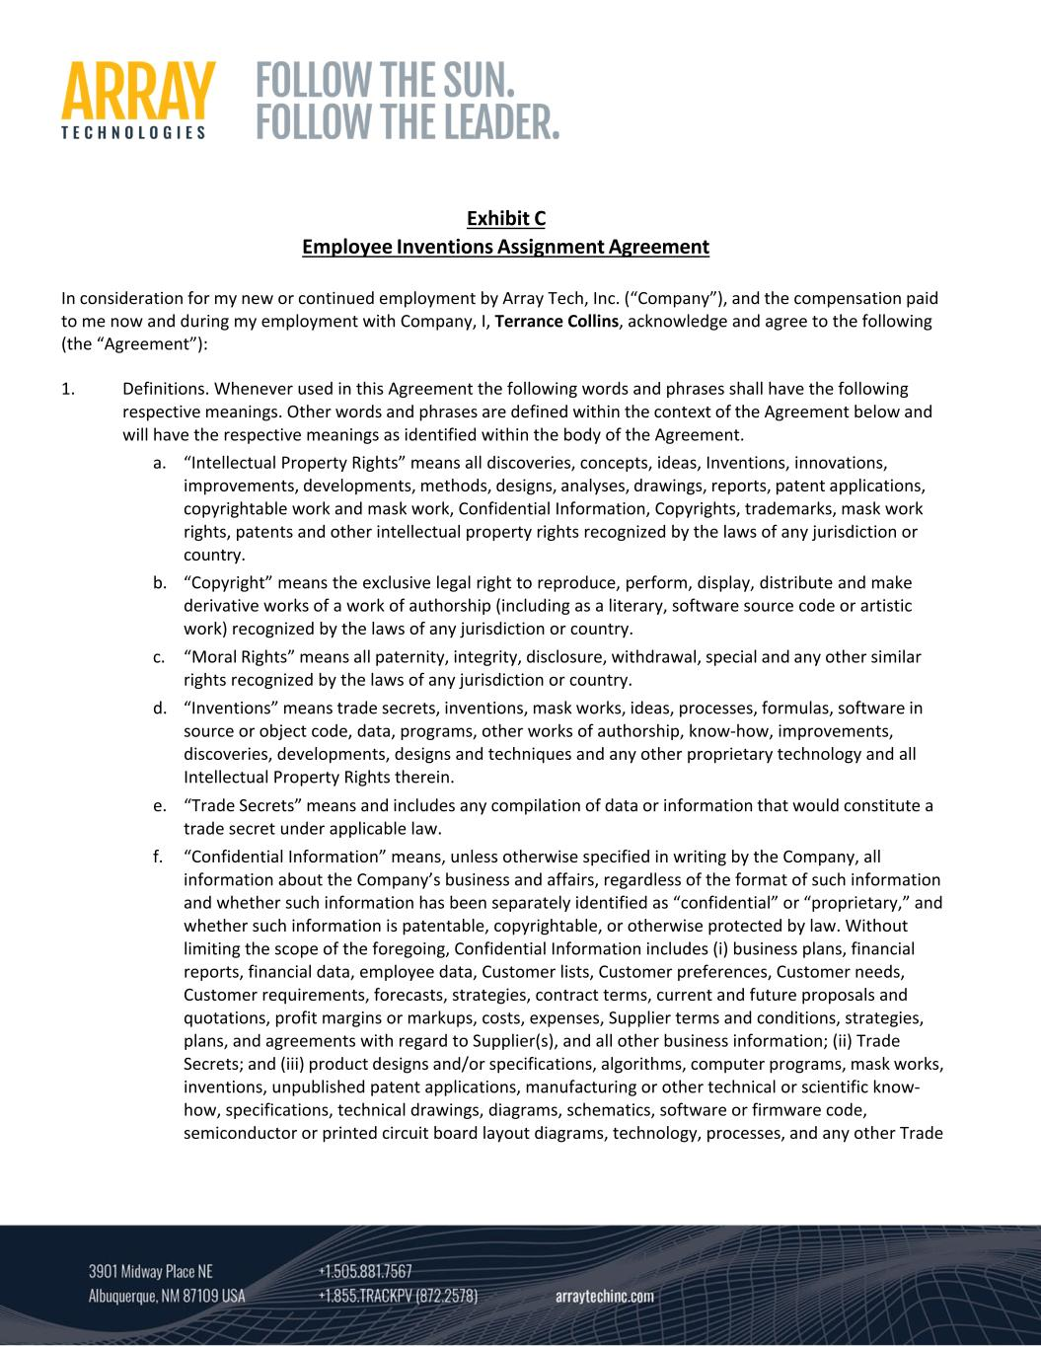
Exhibit C Employee Inventions Assignment Agreement In consideration for my new or continued employment by Array Tech, Inc. (“Company”), and the compensation paid to me now and during my employment with Company, I, Terrance Collins, acknowledge and agree to the following (the “Agreement”): 1. Definitions. Whenever used in this Agreement the following words and phrases shall have the following respective meanings. Other words and phrases are defined within the context of the Agreement below and will have the respective meanings as identified within the body of the Agreement. a. “Intellectual Property Rights” means all discoveries, concepts, ideas, Inventions, innovations, improvements, developments, methods, designs, analyses, drawings, reports, patent applications, copyrightable work and mask work, Confidential Information, Copyrights, trademarks, mask work rights, patents and other intellectual property rights recognized by the laws of any jurisdiction or country. b. “Copyright” means the exclusive legal right to reproduce, perform, display, distribute and make derivative works of a work of authorship (including as a literary, software source code or artistic work) recognized by the laws of any jurisdiction or country. c. “Moral Rights” means all paternity, integrity, disclosure, withdrawal, special and any other similar rights recognized by the laws of any jurisdiction or country. d. “Inventions” means trade secrets, inventions, mask works, ideas, processes, formulas, software in source or object code, data, programs, other works of authorship, know‐how, improvements, discoveries, developments, designs and techniques and any other proprietary technology and all Intellectual Property Rights therein. e. “Trade Secrets” means and includes any compilation of data or information that would constitute a trade secret under applicable law. f. “Confidential Information” means, unless otherwise specified in writing by the Company, all information about the Company’s business and affairs, regardless of the format of such information and whether such information has been separately identified as “confidential” or “proprietary,” and whether such information is patentable, copyrightable, or otherwise protected by law. Without limiting the scope of the foregoing, Confidential Information includes (i) business plans, financial reports, financial data, employee data, Customer lists, Customer preferences, Customer needs, Customer requirements, forecasts, strategies, contract terms, current and future proposals and quotations, profit margins or markups, costs, expenses, Supplier terms and conditions, strategies, plans, and agreements with regard to Supplier(s), and all other business information; (ii) Trade Secrets; and (iii) product designs and/or specifications, algorithms, computer programs, mask works, inventions, unpublished patent applications, manufacturing or other technical or scientific know‐ how, specifications, technical drawings, diagrams, schematics, software or firmware code, semiconductor or printed circuit board layout diagrams, technology, processes, and any other Trade

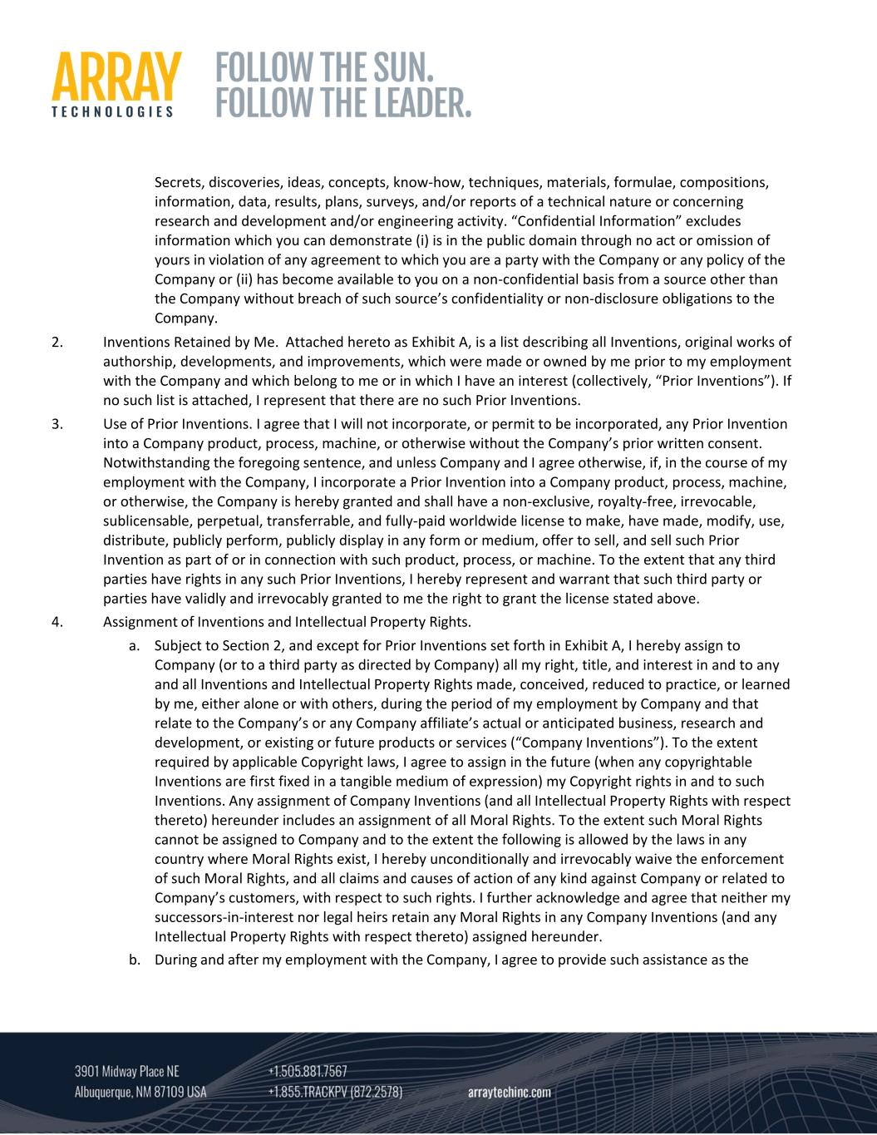
Secrets, discoveries, ideas, concepts, know‐how, techniques, materials, formulae, compositions, information, data, results, plans, surveys, and/or reports of a technical nature or concerning research and development and/or engineering activity. “Confidential Information” excludes information which you can demonstrate (i) is in the public domain through no act or omission of yours in violation of any agreement to which you are a party with the Company or any policy of the Company or (ii) has become available to you on a non‐confidential basis from a source other than the Company without breach of such source’s confidentiality or non‐disclosure obligations to the Company. 2. Inventions Retained by Me. Attached hereto as Exhibit A, is a list describing all Inventions, original works of authorship, developments, and improvements, which were made or owned by me prior to my employment with the Company and which belong to me or in which I have an interest (collectively, “Prior Inventions”). If no such list is attached, I represent that there are no such Prior Inventions. 3. Use of Prior Inventions. I agree that I will not incorporate, or permit to be incorporated, any Prior Invention into a Company product, process, machine, or otherwise without the Company’s prior written consent. Notwithstanding the foregoing sentence, and unless Company and I agree otherwise, if, in the course of my employment with the Company, I incorporate a Prior Invention into a Company product, process, machine, or otherwise, the Company is hereby granted and shall have a non‐exclusive, royalty‐free, irrevocable, sublicensable, perpetual, transferrable, and fully‐paid worldwide license to make, have made, modify, use, distribute, publicly perform, publicly display in any form or medium, offer to sell, and sell such Prior Invention as part of or in connection with such product, process, or machine. To the extent that any third parties have rights in any such Prior Inventions, I hereby represent and warrant that such third party or parties have validly and irrevocably granted to me the right to grant the license stated above. 4. Assignment of Inventions and Intellectual Property Rights. a. Subject to Section 2, and except for Prior Inventions set forth in Exhibit A, I hereby assign to Company (or to a third party as directed by Company) all my right, title, and interest in and to any and all Inventions and Intellectual Property Rights made, conceived, reduced to practice, or learned by me, either alone or with others, during the period of my employment by Company and that relate to the Company’s or any Company affiliate’s actual or anticipated business, research and development, or existing or future products or services (“Company Inventions”). To the extent required by applicable Copyright laws, I agree to assign in the future (when any copyrightable Inventions are first fixed in a tangible medium of expression) my Copyright rights in and to such Inventions. Any assignment of Company Inventions (and all Intellectual Property Rights with respect thereto) hereunder includes an assignment of all Moral Rights. To the extent such Moral Rights cannot be assigned to Company and to the extent the following is allowed by the laws in any country where Moral Rights exist, I hereby unconditionally and irrevocably waive the enforcement of such Moral Rights, and all claims and causes of action of any kind against Company or related to Company’s customers, with respect to such rights. I further acknowledge and agree that neither my successors‐in‐interest nor legal heirs retain any Moral Rights in any Company Inventions (and any Intellectual Property Rights with respect thereto) assigned hereunder. b. During and after my employment with the Company, I agree to provide such assistance as the

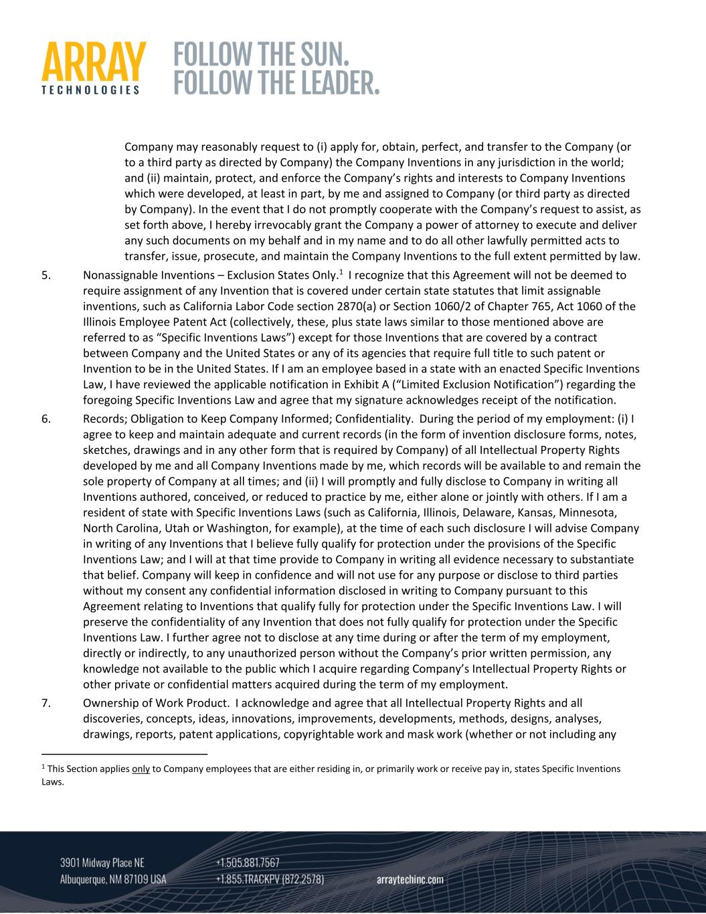
Company may reasonably request to (i) apply for, obtain, perfect, and transfer to the Company (or to a third party as directed by Company) the Company Inventions in any jurisdiction in the world; and (ii) maintain, protect, and enforce the Company’s rights and interests to Company Inventions which were developed, at least in part, by me and assigned to Company (or third party as directed by Company). In the event that I do not promptly cooperate with the Company’s request to assist, as set forth above, I hereby irrevocably grant the Company a power of attorney to execute and deliver any such documents on my behalf and in my name and to do all other lawfully permitted acts to transfer, issue, prosecute, and maintain the Company Inventions to the full extent permitted by law. 5. Nonassignable Inventions – Exclusion States Only.1 I recognize that this Agreement will not be deemed to require assignment of any Invention that is covered under certain state statutes that limit assignable inventions, such as California Labor Code section 2870(a) or Section 1060/2 of Chapter 765, Act 1060 of the Illinois Employee Patent Act (collectively, these, plus state laws similar to those mentioned above are referred to as “Specific Inventions Laws”) except for those Inventions that are covered by a contract between Company and the United States or any of its agencies that require full title to such patent or Invention to be in the United States. If I am an employee based in a state with an enacted Specific Inventions Law, I have reviewed the applicable notification in Exhibit A (“Limited Exclusion Notification”) regarding the foregoing Specific Inventions Law and agree that my signature acknowledges receipt of the notification. 6. Records; Obligation to Keep Company Informed; Confidentiality. During the period of my employment: (i) I agree to keep and maintain adequate and current records (in the form of invention disclosure forms, notes, sketches, drawings and in any other form that is required by Company) of all Intellectual Property Rights developed by me and all Company Inventions made by me, which records will be available to and remain the sole property of Company at all times; and (ii) I will promptly and fully disclose to Company in writing all Inventions authored, conceived, or reduced to practice by me, either alone or jointly with others. If I am a resident of state with Specific Inventions Laws (such as California, Illinois, Delaware, Kansas, Minnesota, North Carolina, Utah or Washington, for example), at the time of each such disclosure I will advise Company in writing of any Inventions that I believe fully qualify for protection under the provisions of the Specific Inventions Law; and I will at that time provide to Company in writing all evidence necessary to substantiate that belief. Company will keep in confidence and will not use for any purpose or disclose to third parties without my consent any confidential information disclosed in writing to Company pursuant to this Agreement relating to Inventions that qualify fully for protection under the Specific Inventions Law. I will preserve the confidentiality of any Invention that does not fully qualify for protection under the Specific Inventions Law. I further agree not to disclose at any time during or after the term of my employment, directly or indirectly, to any unauthorized person without the Company’s prior written permission, any knowledge not available to the public which I acquire regarding Company’s Intellectual Property Rights or other private or confidential matters acquired during the term of my employment. 7. Ownership of Work Product. I acknowledge and agree that all Intellectual Property Rights and all discoveries, concepts, ideas, innovations, improvements, developments, methods, designs, analyses, drawings, reports, patent applications, copyrightable work and mask work (whether or not including any 1 This Section applies only to Company employees that are either residing in, or primarily work or receive pay in, states Specific Inventions Laws.

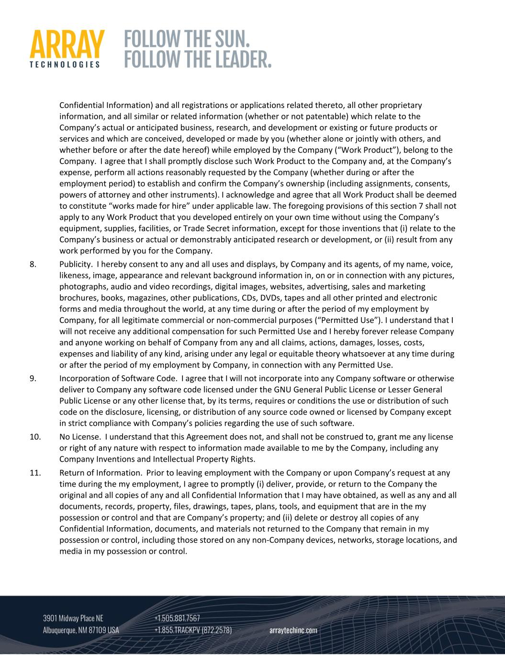
Confidential Information) and all registrations or applications related thereto, all other proprietary information, and all similar or related information (whether or not patentable) which relate to the Company’s actual or anticipated business, research, and development or existing or future products or services and which are conceived, developed or made by you (whether alone or jointly with others, and whether before or after the date hereof) while employed by the Company (“Work Product”), belong to the Company. I agree that I shall promptly disclose such Work Product to the Company and, at the Company’s expense, perform all actions reasonably requested by the Company (whether during or after the employment period) to establish and confirm the Company’s ownership (including assignments, consents, powers of attorney and other instruments). I acknowledge and agree that all Work Product shall be deemed to constitute “works made for hire” under applicable law. The foregoing provisions of this section 7 shall not apply to any Work Product that you developed entirely on your own time without using the Company’s equipment, supplies, facilities, or Trade Secret information, except for those inventions that (i) relate to the Company’s business or actual or demonstrably anticipated research or development, or (ii) result from any work performed by you for the Company. 8. Publicity. I hereby consent to any and all uses and displays, by Company and its agents, of my name, voice, likeness, image, appearance and relevant background information in, on or in connection with any pictures, photographs, audio and video recordings, digital images, websites, advertising, sales and marketing brochures, books, magazines, other publications, CDs, DVDs, tapes and all other printed and electronic forms and media throughout the world, at any time during or after the period of my employment by Company, for all legitimate commercial or non‐commercial purposes (“Permitted Use”). I understand that I will not receive any additional compensation for such Permitted Use and I hereby forever release Company and anyone working on behalf of Company from any and all claims, actions, damages, losses, costs, expenses and liability of any kind, arising under any legal or equitable theory whatsoever at any time during or after the period of my employment by Company, in connection with any Permitted Use. 9. Incorporation of Software Code. I agree that I will not incorporate into any Company software or otherwise deliver to Company any software code licensed under the GNU General Public License or Lesser General Public License or any other license that, by its terms, requires or conditions the use or distribution of such code on the disclosure, licensing, or distribution of any source code owned or licensed by Company except in strict compliance with Company’s policies regarding the use of such software. 10. No License. I understand that this Agreement does not, and shall not be construed to, grant me any license or right of any nature with respect to information made available to me by the Company, including any Company Inventions and Intellectual Property Rights. 11. Return of Information. Prior to leaving employment with the Company or upon Company’s request at any time during the my employment, I agree to promptly (i) deliver, provide, or return to the Company the original and all copies of any and all Confidential Information that I may have obtained, as well as any and all documents, records, property, files, drawings, tapes, plans, tools, and equipment that are in the my possession or control and that are Company’s property; and (ii) delete or destroy all copies of any Confidential Information, documents, and materials not returned to the Company that remain in my possession or control, including those stored on any non‐Company devices, networks, storage locations, and media in my possession or control.

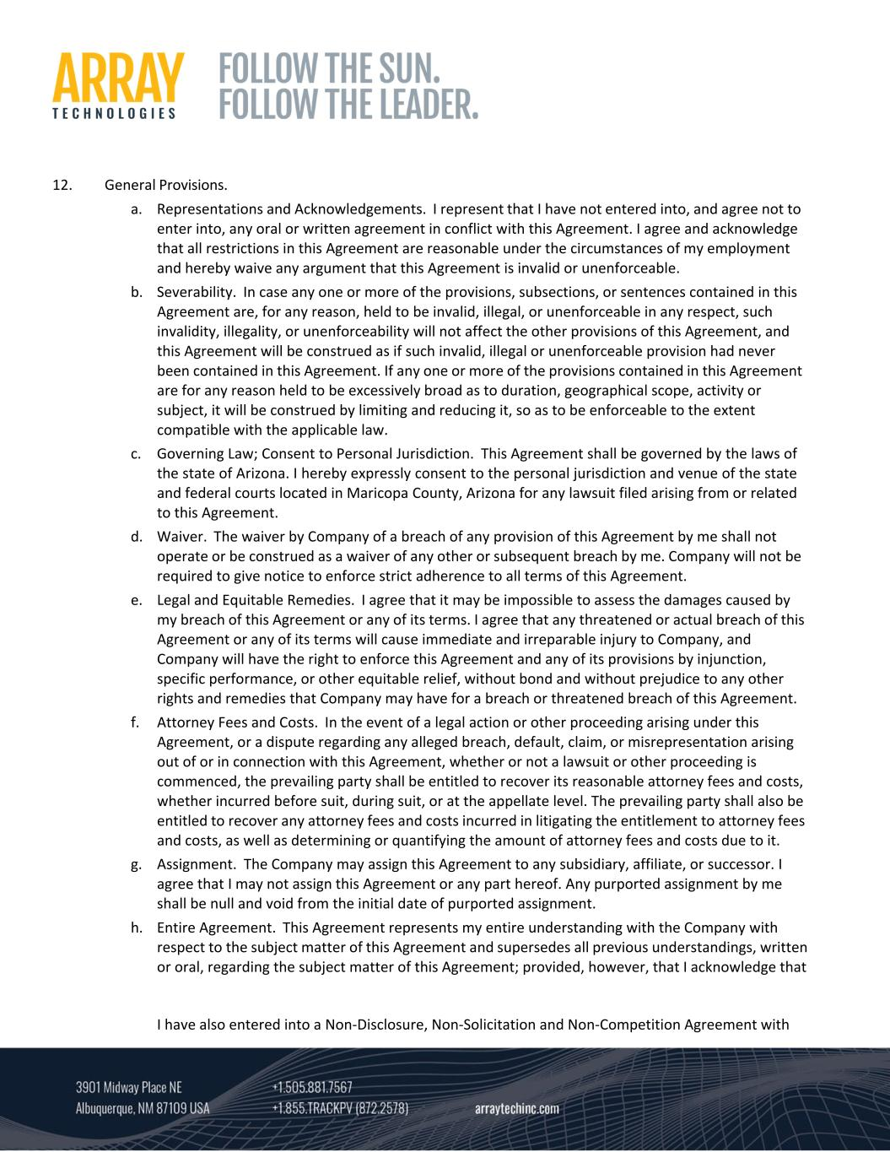
12. General Provisions. a. Representations and Acknowledgements. I represent that I have not entered into, and agree not to enter into, any oral or written agreement in conflict with this Agreement. I agree and acknowledge that all restrictions in this Agreement are reasonable under the circumstances of my employment and hereby waive any argument that this Agreement is invalid or unenforceable. b. Severability. In case any one or more of the provisions, subsections, or sentences contained in this Agreement are, for any reason, held to be invalid, illegal, or unenforceable in any respect, such invalidity, illegality, or unenforceability will not affect the other provisions of this Agreement, and this Agreement will be construed as if such invalid, illegal or unenforceable provision had never been contained in this Agreement. If any one or more of the provisions contained in this Agreement are for any reason held to be excessively broad as to duration, geographical scope, activity or subject, it will be construed by limiting and reducing it, so as to be enforceable to the extent compatible with the applicable law. c. Governing Law; Consent to Personal Jurisdiction. This Agreement shall be governed by the laws of the state of Arizona. I hereby expressly consent to the personal jurisdiction and venue of the state and federal courts located in Maricopa County, Arizona for any lawsuit filed arising from or related to this Agreement. d. Waiver. The waiver by Company of a breach of any provision of this Agreement by me shall not operate or be construed as a waiver of any other or subsequent breach by me. Company will not be required to give notice to enforce strict adherence to all terms of this Agreement. e. Legal and Equitable Remedies. I agree that it may be impossible to assess the damages caused by my breach of this Agreement or any of its terms. I agree that any threatened or actual breach of this Agreement or any of its terms will cause immediate and irreparable injury to Company, and Company will have the right to enforce this Agreement and any of its provisions by injunction, specific performance, or other equitable relief, without bond and without prejudice to any other rights and remedies that Company may have for a breach or threatened breach of this Agreement. f. Attorney Fees and Costs. In the event of a legal action or other proceeding arising under this Agreement, or a dispute regarding any alleged breach, default, claim, or misrepresentation arising out of or in connection with this Agreement, whether or not a lawsuit or other proceeding is commenced, the prevailing party shall be entitled to recover its reasonable attorney fees and costs, whether incurred before suit, during suit, or at the appellate level. The prevailing party shall also be entitled to recover any attorney fees and costs incurred in litigating the entitlement to attorney fees and costs, as well as determining or quantifying the amount of attorney fees and costs due to it. g. Assignment. The Company may assign this Agreement to any subsidiary, affiliate, or successor. I agree that I may not assign this Agreement or any part hereof. Any purported assignment by me shall be null and void from the initial date of purported assignment. h. Entire Agreement. This Agreement represents my entire understanding with the Company with respect to the subject matter of this Agreement and supersedes all previous understandings, written or oral, regarding the subject matter of this Agreement; provided, however, that I acknowledge that I have also entered into a Non‐Disclosure, Non‐Solicitation and Non‐Competition Agreement with

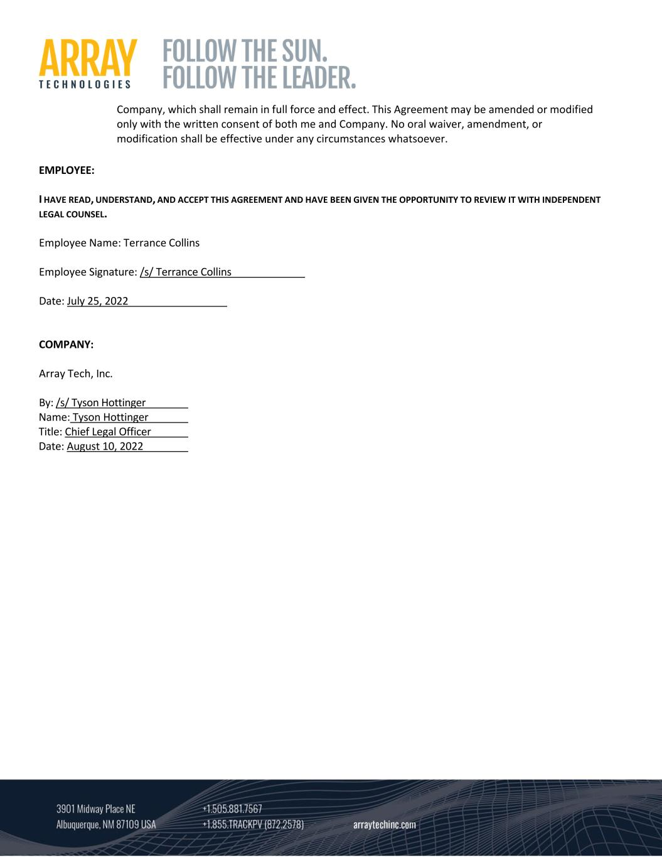
Company, which shall remain in full force and effect. This Agreement may be amended or modified only with the written consent of both me and Company. No oral waiver, amendment, or modification shall be effective under any circumstances whatsoever. EMPLOYEE: I HAVE READ, UNDERSTAND, AND ACCEPT THIS AGREEMENT AND HAVE BEEN GIVEN THE OPPORTUNITY TO REVIEW IT WITH INDEPENDENT LEGAL COUNSEL. Employee Name: Terrance Collins Employee Signature: /s/ Terrance Collins Date: July 25, 2022 COMPANY: Array Tech, Inc. By: /s/ Tyson Hottinger Name: Tyson Hottinger Title: Chief Legal Officer Date: August 10, 2022

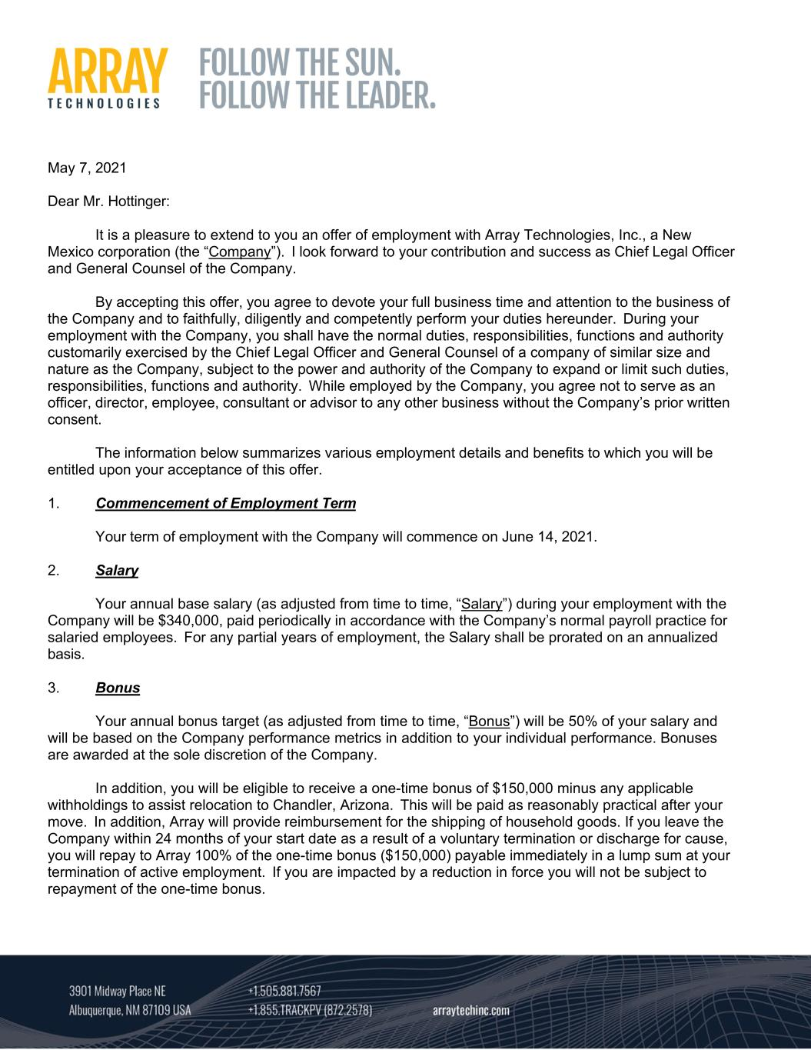
May 7, 2021 Dear Mr. Hottinger: It is a pleasure to extend to you an offer of employment with Array Technologies, Inc., a New Mexico corporation (the “Company”). I look forward to your contribution and success as Chief Legal Officer and General Counsel of the Company. By accepting this offer, you agree to devote your full business time and attention to the business of the Company and to faithfully, diligently and competently perform your duties hereunder. During your employment with the Company, you shall have the normal duties, responsibilities, functions and authority customarily exercised by the Chief Legal Officer and General Counsel of a company of similar size and nature as the Company, subject to the power and authority of the Company to expand or limit such duties, responsibilities, functions and authority. While employed by the Company, you agree not to serve as an officer, director, employee, consultant or advisor to any other business without the Company’s prior written consent. The information below summarizes various employment details and benefits to which you will be entitled upon your acceptance of this offer. 1. Commencement of Employment Term Your term of employment with the Company will commence on June 14, 2021. 2. Salary Your annual base salary (as adjusted from time to time, “Salary”) during your employment with the Company will be $340,000, paid periodically in accordance with the Company’s normal payroll practice for salaried employees. For any partial years of employment, the Salary shall be prorated on an annualized basis. 3. Bonus Your annual bonus target (as adjusted from time to time, “Bonus”) will be 50% of your salary and will be based on the Company performance metrics in addition to your individual performance. Bonuses are awarded at the sole discretion of the Company. In addition, you will be eligible to receive a one-time bonus of $150,000 minus any applicable withholdings to assist relocation to Chandler, Arizona. This will be paid as reasonably practical after your move. In addition, Array will provide reimbursement for the shipping of household goods. If you leave the Company within 24 months of your start date as a result of a voluntary termination or discharge for cause, you will repay to Array 100% of the one-time bonus ($150,000) payable immediately in a lump sum at your termination of active employment. If you are impacted by a reduction in force you will not be subject to repayment of the one-time bonus.

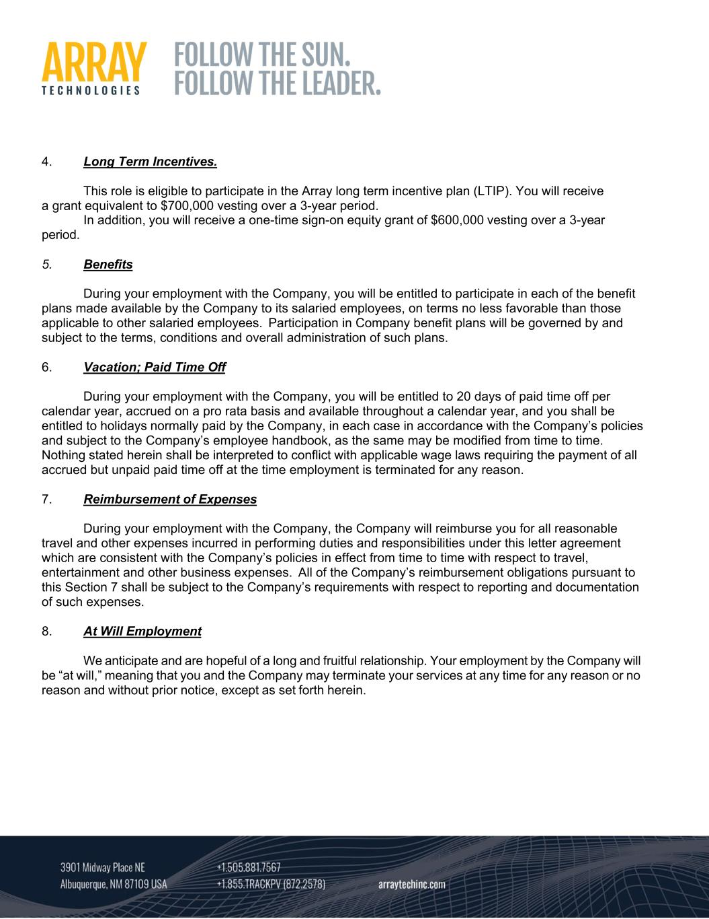
4. Long Term Incentives. This role is eligible to participate in the Array long term incentive plan (LTIP). You will receive a grant equivalent to $700,000 vesting over a 3-year period. In addition, you will receive a one-time sign-on equity grant of $600,000 vesting over a 3-year period. 5. Benefits During your employment with the Company, you will be entitled to participate in each of the benefit plans made available by the Company to its salaried employees, on terms no less favorable than those applicable to other salaried employees. Participation in Company benefit plans will be governed by and subject to the terms, conditions and overall administration of such plans. 6. Vacation; Paid Time Off During your employment with the Company, you will be entitled to 20 days of paid time off per calendar year, accrued on a pro rata basis and available throughout a calendar year, and you shall be entitled to holidays normally paid by the Company, in each case in accordance with the Company’s policies and subject to the Company’s employee handbook, as the same may be modified from time to time. Nothing stated herein shall be interpreted to conflict with applicable wage laws requiring the payment of all accrued but unpaid paid time off at the time employment is terminated for any reason. 7. Reimbursement of Expenses During your employment with the Company, the Company will reimburse you for all reasonable travel and other expenses incurred in performing duties and responsibilities under this letter agreement which are consistent with the Company’s policies in effect from time to time with respect to travel, entertainment and other business expenses. All of the Company’s reimbursement obligations pursuant to this Section 7 shall be subject to the Company’s requirements with respect to reporting and documentation of such expenses. 8. At Will Employment We anticipate and are hopeful of a long and fruitful relationship. Your employment by the Company will be “at will,” meaning that you and the Company may terminate your services at any time for any reason or no reason and without prior notice, except as set forth herein.

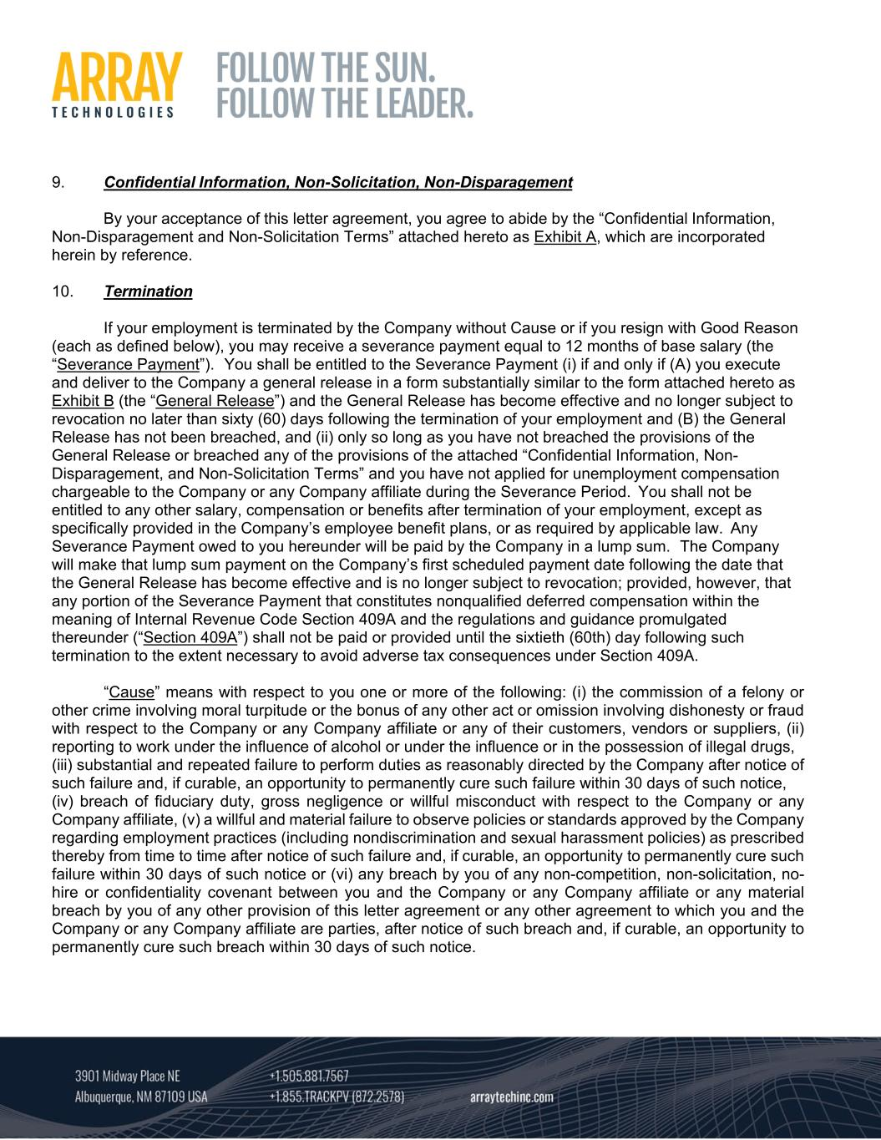
9. Confidential Information, Non-Solicitation, Non-Disparagement By your acceptance of this letter agreement, you agree to abide by the “Confidential Information, Non-Disparagement and Non-Solicitation Terms” attached hereto as Exhibit A, which are incorporated herein by reference. 10. Termination If your employment is terminated by the Company without Cause or if you resign with Good Reason (each as defined below), you may receive a severance payment equal to 12 months of base salary (the “Severance Payment”). You shall be entitled to the Severance Payment (i) if and only if (A) you execute and deliver to the Company a general release in a form substantially similar to the form attached hereto as Exhibit B (the “General Release”) and the General Release has become effective and no longer subject to revocation no later than sixty (60) days following the termination of your employment and (B) the General Release has not been breached, and (ii) only so long as you have not breached the provisions of the General Release or breached any of the provisions of the attached “Confidential Information, Non- Disparagement, and Non-Solicitation Terms” and you have not applied for unemployment compensation chargeable to the Company or any Company affiliate during the Severance Period. You shall not be entitled to any other salary, compensation or benefits after termination of your employment, except as specifically provided in the Company’s employee benefit plans, or as required by applicable law. Any Severance Payment owed to you hereunder will be paid by the Company in a lump sum. The Company will make that lump sum payment on the Company’s first scheduled payment date following the date that the General Release has become effective and is no longer subject to revocation; provided, however, that any portion of the Severance Payment that constitutes nonqualified deferred compensation within the meaning of Internal Revenue Code Section 409A and the regulations and guidance promulgated thereunder (“Section 409A”) shall not be paid or provided until the sixtieth (60th) day following such termination to the extent necessary to avoid adverse tax consequences under Section 409A. “Cause” means with respect to you one or more of the following: (i) the commission of a felony or other crime involving moral turpitude or the bonus of any other act or omission involving dishonesty or fraud with respect to the Company or any Company affiliate or any of their customers, vendors or suppliers, (ii) reporting to work under the influence of alcohol or under the influence or in the possession of illegal drugs, (iii) substantial and repeated failure to perform duties as reasonably directed by the Company after notice of such failure and, if curable, an opportunity to permanently cure such failure within 30 days of such notice, (iv) breach of fiduciary duty, gross negligence or willful misconduct with respect to the Company or any Company affiliate, (v) a willful and material failure to observe policies or standards approved by the Company regarding employment practices (including nondiscrimination and sexual harassment policies) as prescribed thereby from time to time after notice of such failure and, if curable, an opportunity to permanently cure such failure within 30 days of such notice or (vi) any breach by you of any non-competition, non-solicitation, no- hire or confidentiality covenant between you and the Company or any Company affiliate or any material breach by you of any other provision of this letter agreement or any other agreement to which you and the Company or any Company affiliate are parties, after notice of such breach and, if curable, an opportunity to permanently cure such breach within 30 days of such notice.

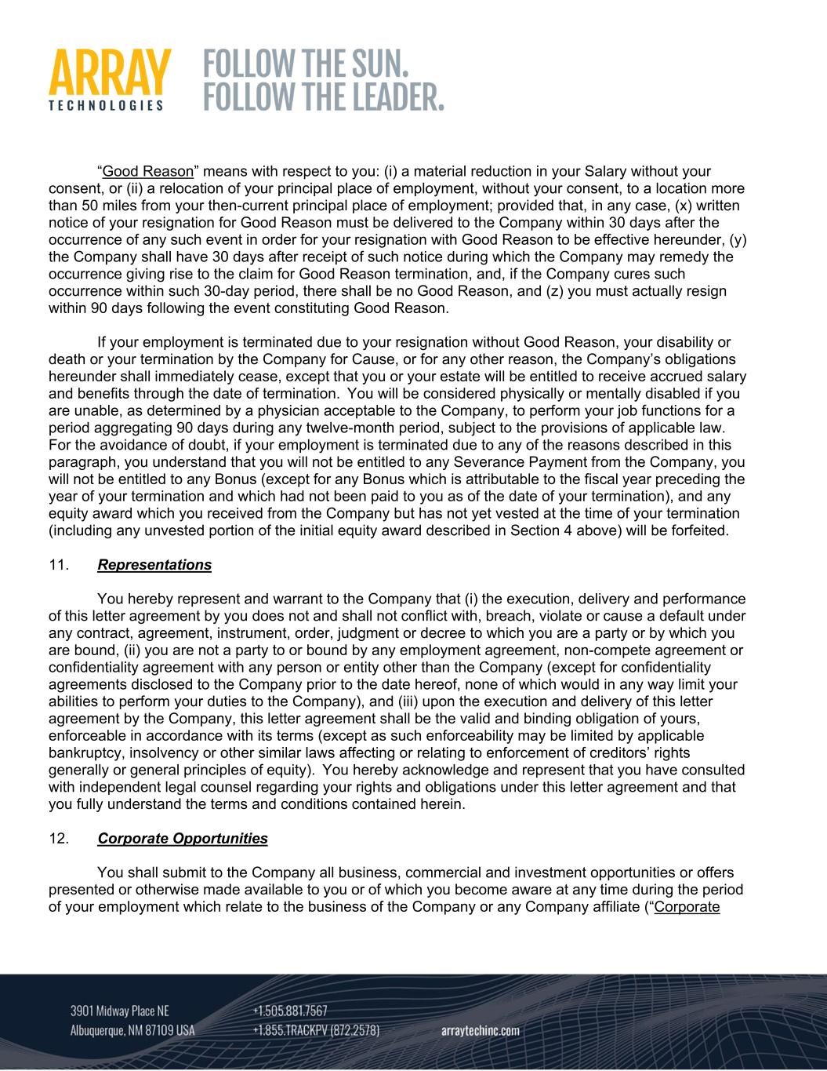
“Good Reason” means with respect to you: (i) a material reduction in your Salary without your consent, or (ii) a relocation of your principal place of employment, without your consent, to a location more than 50 miles from your then-current principal place of employment; provided that, in any case, (x) written notice of your resignation for Good Reason must be delivered to the Company within 30 days after the occurrence of any such event in order for your resignation with Good Reason to be effective hereunder, (y) the Company shall have 30 days after receipt of such notice during which the Company may remedy the occurrence giving rise to the claim for Good Reason termination, and, if the Company cures such occurrence within such 30-day period, there shall be no Good Reason, and (z) you must actually resign within 90 days following the event constituting Good Reason. If your employment is terminated due to your resignation without Good Reason, your disability or death or your termination by the Company for Cause, or for any other reason, the Company’s obligations hereunder shall immediately cease, except that you or your estate will be entitled to receive accrued salary and benefits through the date of termination. You will be considered physically or mentally disabled if you are unable, as determined by a physician acceptable to the Company, to perform your job functions for a period aggregating 90 days during any twelve-month period, subject to the provisions of applicable law. For the avoidance of doubt, if your employment is terminated due to any of the reasons described in this paragraph, you understand that you will not be entitled to any Severance Payment from the Company, you will not be entitled to any Bonus (except for any Bonus which is attributable to the fiscal year preceding the year of your termination and which had not been paid to you as of the date of your termination), and any equity award which you received from the Company but has not yet vested at the time of your termination (including any unvested portion of the initial equity award described in Section 4 above) will be forfeited. 11. Representations You hereby represent and warrant to the Company that (i) the execution, delivery and performance of this letter agreement by you does not and shall not conflict with, breach, violate or cause a default under any contract, agreement, instrument, order, judgment or decree to which you are a party or by which you are bound, (ii) you are not a party to or bound by any employment agreement, non-compete agreement or confidentiality agreement with any person or entity other than the Company (except for confidentiality agreements disclosed to the Company prior to the date hereof, none of which would in any way limit your abilities to perform your duties to the Company), and (iii) upon the execution and delivery of this letter agreement by the Company, this letter agreement shall be the valid and binding obligation of yours, enforceable in accordance with its terms (except as such enforceability may be limited by applicable bankruptcy, insolvency or other similar laws affecting or relating to enforcement of creditors’ rights generally or general principles of equity). You hereby acknowledge and represent that you have consulted with independent legal counsel regarding your rights and obligations under this letter agreement and that you fully understand the terms and conditions contained herein. 12. Corporate Opportunities You shall submit to the Company all business, commercial and investment opportunities or offers presented or otherwise made available to you or of which you become aware at any time during the period of your employment which relate to the business of the Company or any Company affiliate (“Corporate

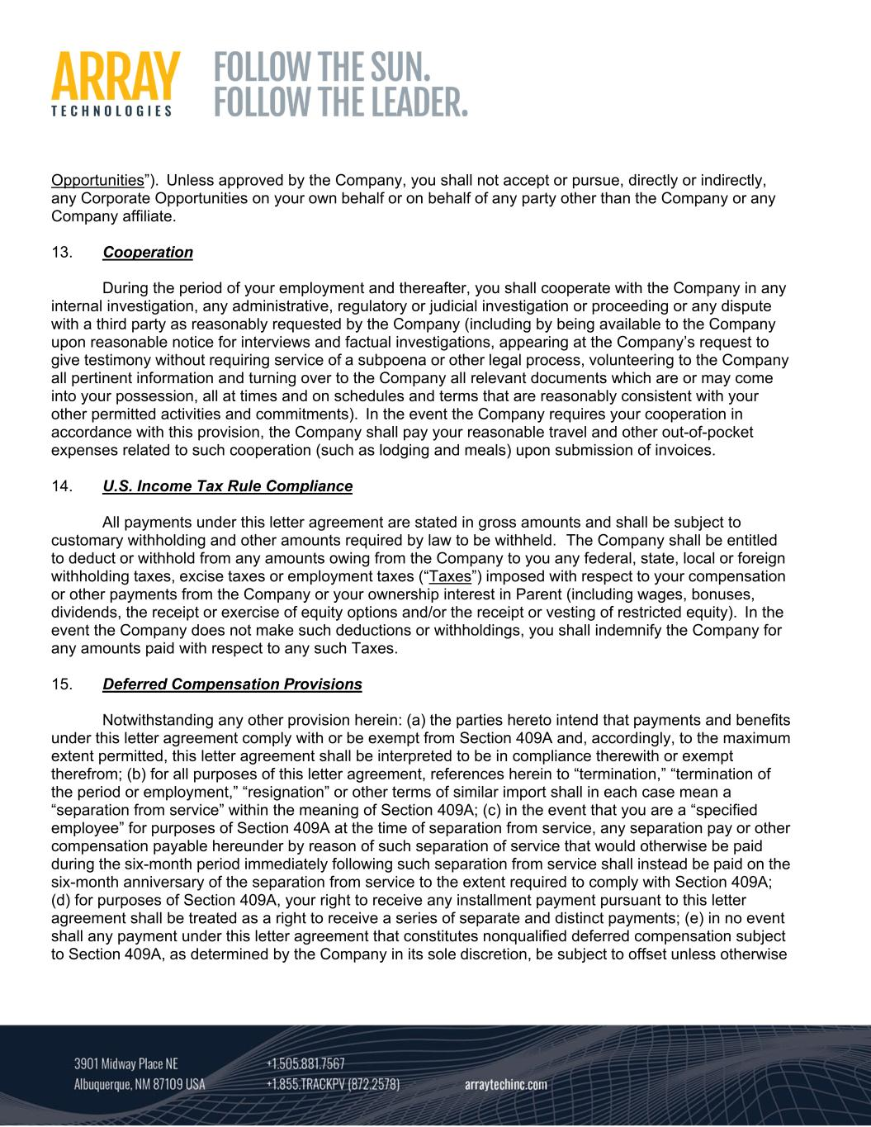
Opportunities”). Unless approved by the Company, you shall not accept or pursue, directly or indirectly, any Corporate Opportunities on your own behalf or on behalf of any party other than the Company or any Company affiliate. 13. Cooperation During the period of your employment and thereafter, you shall cooperate with the Company in any internal investigation, any administrative, regulatory or judicial investigation or proceeding or any dispute with a third party as reasonably requested by the Company (including by being available to the Company upon reasonable notice for interviews and factual investigations, appearing at the Company’s request to give testimony without requiring service of a subpoena or other legal process, volunteering to the Company all pertinent information and turning over to the Company all relevant documents which are or may come into your possession, all at times and on schedules and terms that are reasonably consistent with your other permitted activities and commitments). In the event the Company requires your cooperation in accordance with this provision, the Company shall pay your reasonable travel and other out-of-pocket expenses related to such cooperation (such as lodging and meals) upon submission of invoices. 14. U.S. Income Tax Rule Compliance All payments under this letter agreement are stated in gross amounts and shall be subject to customary withholding and other amounts required by law to be withheld. The Company shall be entitled to deduct or withhold from any amounts owing from the Company to you any federal, state, local or foreign withholding taxes, excise taxes or employment taxes (“Taxes”) imposed with respect to your compensation or other payments from the Company or your ownership interest in Parent (including wages, bonuses, dividends, the receipt or exercise of equity options and/or the receipt or vesting of restricted equity). In the event the Company does not make such deductions or withholdings, you shall indemnify the Company for any amounts paid with respect to any such Taxes. 15. Deferred Compensation Provisions Notwithstanding any other provision herein: (a) the parties hereto intend that payments and benefits under this letter agreement comply with or be exempt from Section 409A and, accordingly, to the maximum extent permitted, this letter agreement shall be interpreted to be in compliance therewith or exempt therefrom; (b) for all purposes of this letter agreement, references herein to “termination,” “termination of the period or employment,” “resignation” or other terms of similar import shall in each case mean a “separation from service” within the meaning of Section 409A; (c) in the event that you are a “specified employee” for purposes of Section 409A at the time of separation from service, any separation pay or other compensation payable hereunder by reason of such separation of service that would otherwise be paid during the six-month period immediately following such separation from service shall instead be paid on the six-month anniversary of the separation from service to the extent required to comply with Section 409A; (d) for purposes of Section 409A, your right to receive any installment payment pursuant to this letter agreement shall be treated as a right to receive a series of separate and distinct payments; (e) in no event shall any payment under this letter agreement that constitutes nonqualified deferred compensation subject to Section 409A, as determined by the Company in its sole discretion, be subject to offset unless otherwise

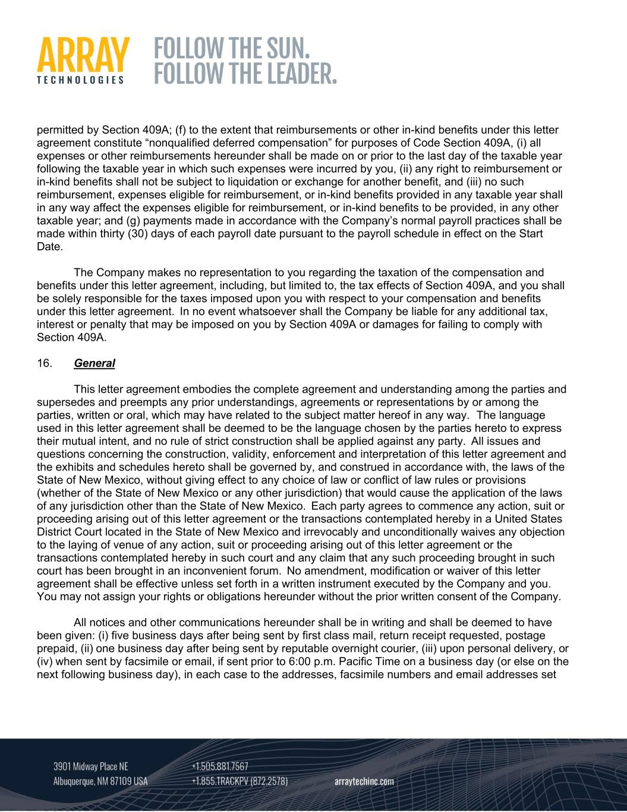
permitted by Section 409A; (f) to the extent that reimbursements or other in-kind benefits under this letter agreement constitute “nonqualified deferred compensation” for purposes of Code Section 409A, (i) all expenses or other reimbursements hereunder shall be made on or prior to the last day of the taxable year following the taxable year in which such expenses were incurred by you, (ii) any right to reimbursement or in-kind benefits shall not be subject to liquidation or exchange for another benefit, and (iii) no such reimbursement, expenses eligible for reimbursement, or in-kind benefits provided in any taxable year shall in any way affect the expenses eligible for reimbursement, or in-kind benefits to be provided, in any other taxable year; and (g) payments made in accordance with the Company’s normal payroll practices shall be made within thirty (30) days of each payroll date pursuant to the payroll schedule in effect on the Start Date. The Company makes no representation to you regarding the taxation of the compensation and benefits under this letter agreement, including, but limited to, the tax effects of Section 409A, and you shall be solely responsible for the taxes imposed upon you with respect to your compensation and benefits under this letter agreement. In no event whatsoever shall the Company be liable for any additional tax, interest or penalty that may be imposed on you by Section 409A or damages for failing to comply with Section 409A. 16. General This letter agreement embodies the complete agreement and understanding among the parties and supersedes and preempts any prior understandings, agreements or representations by or among the parties, written or oral, which may have related to the subject matter hereof in any way. The language used in this letter agreement shall be deemed to be the language chosen by the parties hereto to express their mutual intent, and no rule of strict construction shall be applied against any party. All issues and questions concerning the construction, validity, enforcement and interpretation of this letter agreement and the exhibits and schedules hereto shall be governed by, and construed in accordance with, the laws of the State of New Mexico, without giving effect to any choice of law or conflict of law rules or provisions (whether of the State of New Mexico or any other jurisdiction) that would cause the application of the laws of any jurisdiction other than the State of New Mexico. Each party agrees to commence any action, suit or proceeding arising out of this letter agreement or the transactions contemplated hereby in a United States District Court located in the State of New Mexico and irrevocably and unconditionally waives any objection to the laying of venue of any action, suit or proceeding arising out of this letter agreement or the transactions contemplated hereby in such court and any claim that any such proceeding brought in such court has been brought in an inconvenient forum. No amendment, modification or waiver of this letter agreement shall be effective unless set forth in a written instrument executed by the Company and you. You may not assign your rights or obligations hereunder without the prior written consent of the Company. All notices and other communications hereunder shall be in writing and shall be deemed to have been given: (i) five business days after being sent by first class mail, return receipt requested, postage prepaid, (ii) one business day after being sent by reputable overnight courier, (iii) upon personal delivery, or (iv) when sent by facsimile or email, if sent prior to 6:00 p.m. Pacific Time on a business day (or else on the next following business day), in each case to the addresses, facsimile numbers and email addresses set

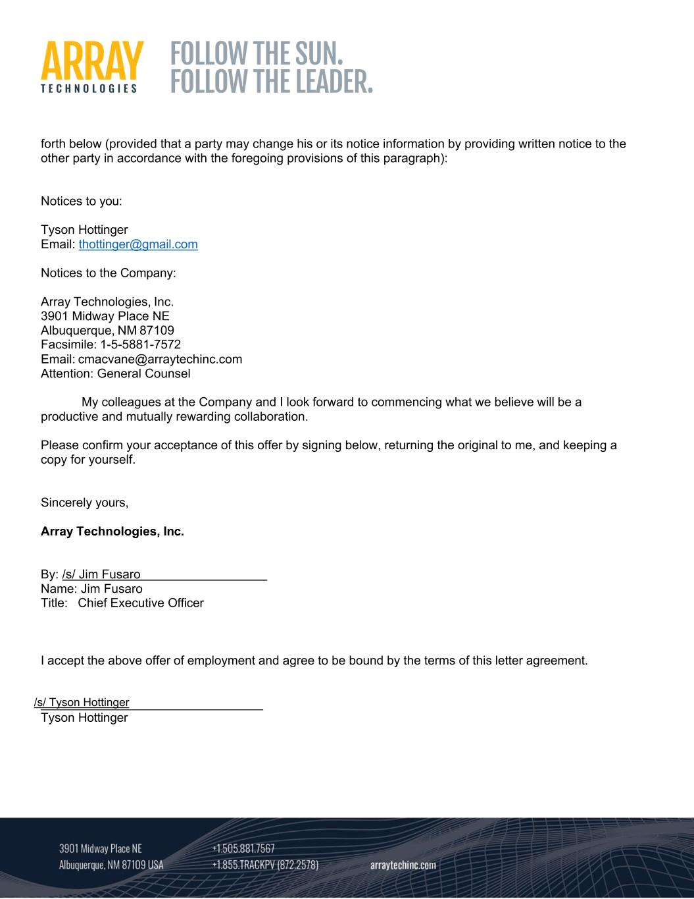
forth below (provided that a party may change his or its notice information by providing written notice to the other party in accordance with the foregoing provisions of this paragraph): Notices to you: Tyson Hottinger Email: thottinger@gmail.com Notices to the Company: Array Technologies, Inc. 3901 Midway Place NE Albuquerque, NM 87109 Facsimile: 1-5-5881-7572 Email: cmacvane@arraytechinc.com Attention: General Counsel My colleagues at the Company and I look forward to commencing what we believe will be a productive and mutually rewarding collaboration. Please confirm your acceptance of this offer by signing below, returning the original to me, and keeping a copy for yourself. Sincerely yours, Array Technologies, Inc. By: /s/ Jim Fusaro Name: Jim Fusaro Title: Chief Executive Officer I accept the above offer of employment and agree to be bound by the terms of this letter agreement. /s/ Tyson Hottinger Tyson Hottinger

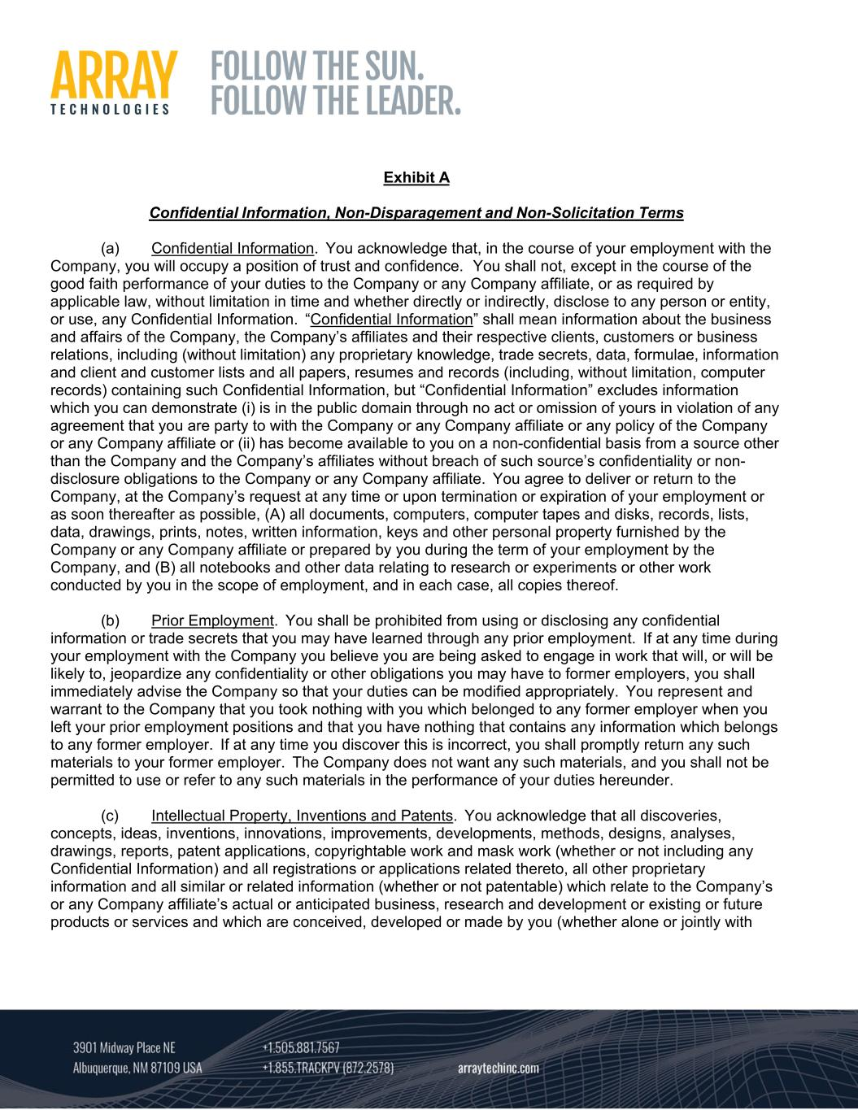
Exhibit A Confidential Information, Non-Disparagement and Non-Solicitation Terms (a) Confidential Information. You acknowledge that, in the course of your employment with the Company, you will occupy a position of trust and confidence. You shall not, except in the course of the good faith performance of your duties to the Company or any Company affiliate, or as required by applicable law, without limitation in time and whether directly or indirectly, disclose to any person or entity, or use, any Confidential Information. “Confidential Information” shall mean information about the business and affairs of the Company, the Company’s affiliates and their respective clients, customers or business relations, including (without limitation) any proprietary knowledge, trade secrets, data, formulae, information and client and customer lists and all papers, resumes and records (including, without limitation, computer records) containing such Confidential Information, but “Confidential Information” excludes information which you can demonstrate (i) is in the public domain through no act or omission of yours in violation of any agreement that you are party to with the Company or any Company affiliate or any policy of the Company or any Company affiliate or (ii) has become available to you on a non-confidential basis from a source other than the Company and the Company’s affiliates without breach of such source’s confidentiality or non- disclosure obligations to the Company or any Company affiliate. You agree to deliver or return to the Company, at the Company’s request at any time or upon termination or expiration of your employment or as soon thereafter as possible, (A) all documents, computers, computer tapes and disks, records, lists, data, drawings, prints, notes, written information, keys and other personal property furnished by the Company or any Company affiliate or prepared by you during the term of your employment by the Company, and (B) all notebooks and other data relating to research or experiments or other work conducted by you in the scope of employment, and in each case, all copies thereof. (b) Prior Employment. You shall be prohibited from using or disclosing any confidential information or trade secrets that you may have learned through any prior employment. If at any time during your employment with the Company you believe you are being asked to engage in work that will, or will be likely to, jeopardize any confidentiality or other obligations you may have to former employers, you shall immediately advise the Company so that your duties can be modified appropriately. You represent and warrant to the Company that you took nothing with you which belonged to any former employer when you left your prior employment positions and that you have nothing that contains any information which belongs to any former employer. If at any time you discover this is incorrect, you shall promptly return any such materials to your former employer. The Company does not want any such materials, and you shall not be permitted to use or refer to any such materials in the performance of your duties hereunder. (c) Intellectual Property, Inventions and Patents. You acknowledge that all discoveries, concepts, ideas, inventions, innovations, improvements, developments, methods, designs, analyses, drawings, reports, patent applications, copyrightable work and mask work (whether or not including any Confidential Information) and all registrations or applications related thereto, all other proprietary information and all similar or related information (whether or not patentable) which relate to the Company’s or any Company affiliate’s actual or anticipated business, research and development or existing or future products or services and which are conceived, developed or made by you (whether alone or jointly with

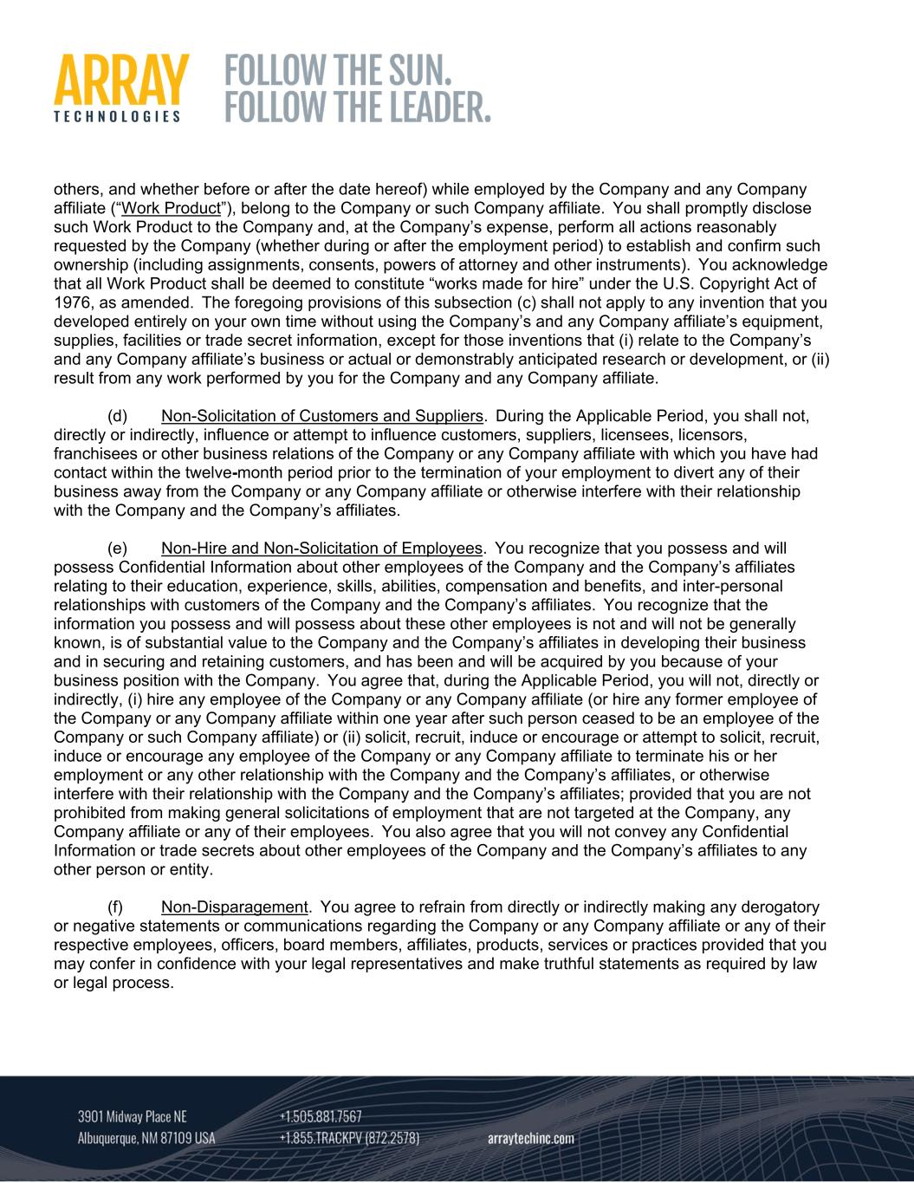
others, and whether before or after the date hereof) while employed by the Company and any Company affiliate (“Work Product”), belong to the Company or such Company affiliate. You shall promptly disclose such Work Product to the Company and, at the Company’s expense, perform all actions reasonably requested by the Company (whether during or after the employment period) to establish and confirm such ownership (including assignments, consents, powers of attorney and other instruments). You acknowledge that all Work Product shall be deemed to constitute “works made for hire” under the U.S. Copyright Act of 1976, as amended. The foregoing provisions of this subsection (c) shall not apply to any invention that you developed entirely on your own time without using the Company’s and any Company affiliate’s equipment, supplies, facilities or trade secret information, except for those inventions that (i) relate to the Company’s and any Company affiliate’s business or actual or demonstrably anticipated research or development, or (ii) result from any work performed by you for the Company and any Company affiliate. (d) Non-Solicitation of Customers and Suppliers. During the Applicable Period, you shall not, directly or indirectly, influence or attempt to influence customers, suppliers, licensees, licensors, franchisees or other business relations of the Company or any Company affiliate with which you have had contact within the twelve-month period prior to the termination of your employment to divert any of their business away from the Company or any Company affiliate or otherwise interfere with their relationship with the Company and the Company’s affiliates. (e) Non-Hire and Non-Solicitation of Employees. You recognize that you possess and will possess Confidential Information about other employees of the Company and the Company’s affiliates relating to their education, experience, skills, abilities, compensation and benefits, and inter-personal relationships with customers of the Company and the Company’s affiliates. You recognize that the information you possess and will possess about these other employees is not and will not be generally known, is of substantial value to the Company and the Company’s affiliates in developing their business and in securing and retaining customers, and has been and will be acquired by you because of your business position with the Company. You agree that, during the Applicable Period, you will not, directly or indirectly, (i) hire any employee of the Company or any Company affiliate (or hire any former employee of the Company or any Company affiliate within one year after such person ceased to be an employee of the Company or such Company affiliate) or (ii) solicit, recruit, induce or encourage or attempt to solicit, recruit, induce or encourage any employee of the Company or any Company affiliate to terminate his or her employment or any other relationship with the Company and the Company’s affiliates, or otherwise interfere with their relationship with the Company and the Company’s affiliates; provided that you are not prohibited from making general solicitations of employment that are not targeted at the Company, any Company affiliate or any of their employees. You also agree that you will not convey any Confidential Information or trade secrets about other employees of the Company and the Company’s affiliates to any other person or entity. (f) Non-Disparagement. You agree to refrain from directly or indirectly making any derogatory or negative statements or communications regarding the Company or any Company affiliate or any of their respective employees, officers, board members, affiliates, products, services or practices provided that you may confer in confidence with your legal representatives and make truthful statements as required by law or legal process.

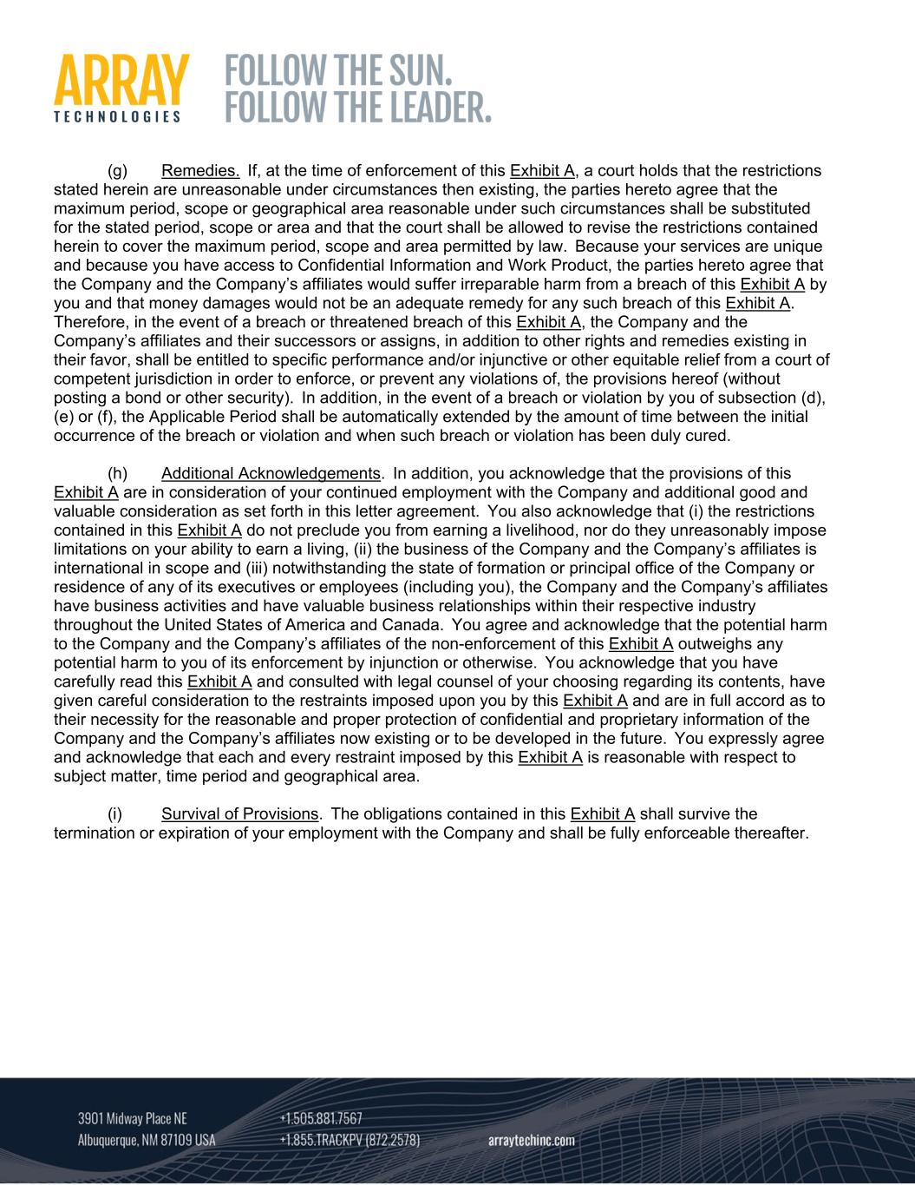
(g) Remedies. If, at the time of enforcement of this Exhibit A, a court holds that the restrictions stated herein are unreasonable under circumstances then existing, the parties hereto agree that the maximum period, scope or geographical area reasonable under such circumstances shall be substituted for the stated period, scope or area and that the court shall be allowed to revise the restrictions contained herein to cover the maximum period, scope and area permitted by law. Because your services are unique and because you have access to Confidential Information and Work Product, the parties hereto agree that the Company and the Company’s affiliates would suffer irreparable harm from a breach of this Exhibit A by you and that money damages would not be an adequate remedy for any such breach of this Exhibit A. Therefore, in the event of a breach or threatened breach of this Exhibit A, the Company and the Company’s affiliates and their successors or assigns, in addition to other rights and remedies existing in their favor, shall be entitled to specific performance and/or injunctive or other equitable relief from a court of competent jurisdiction in order to enforce, or prevent any violations of, the provisions hereof (without posting a bond or other security). In addition, in the event of a breach or violation by you of subsection (d), (e) or (f), the Applicable Period shall be automatically extended by the amount of time between the initial occurrence of the breach or violation and when such breach or violation has been duly cured. (h) Additional Acknowledgements. In addition, you acknowledge that the provisions of this Exhibit A are in consideration of your continued employment with the Company and additional good and valuable consideration as set forth in this letter agreement. You also acknowledge that (i) the restrictions contained in this Exhibit A do not preclude you from earning a livelihood, nor do they unreasonably impose limitations on your ability to earn a living, (ii) the business of the Company and the Company’s affiliates is international in scope and (iii) notwithstanding the state of formation or principal office of the Company or residence of any of its executives or employees (including you), the Company and the Company’s affiliates have business activities and have valuable business relationships within their respective industry throughout the United States of America and Canada. You agree and acknowledge that the potential harm to the Company and the Company’s affiliates of the non-enforcement of this Exhibit A outweighs any potential harm to you of its enforcement by injunction or otherwise. You acknowledge that you have carefully read this Exhibit A and consulted with legal counsel of your choosing regarding its contents, have given careful consideration to the restraints imposed upon you by this Exhibit A and are in full accord as to their necessity for the reasonable and proper protection of confidential and proprietary information of the Company and the Company’s affiliates now existing or to be developed in the future. You expressly agree and acknowledge that each and every restraint imposed by this Exhibit A is reasonable with respect to subject matter, time period and geographical area. (i) Survival of Provisions. The obligations contained in this Exhibit A shall survive the termination or expiration of your employment with the Company and shall be fully enforceable thereafter.

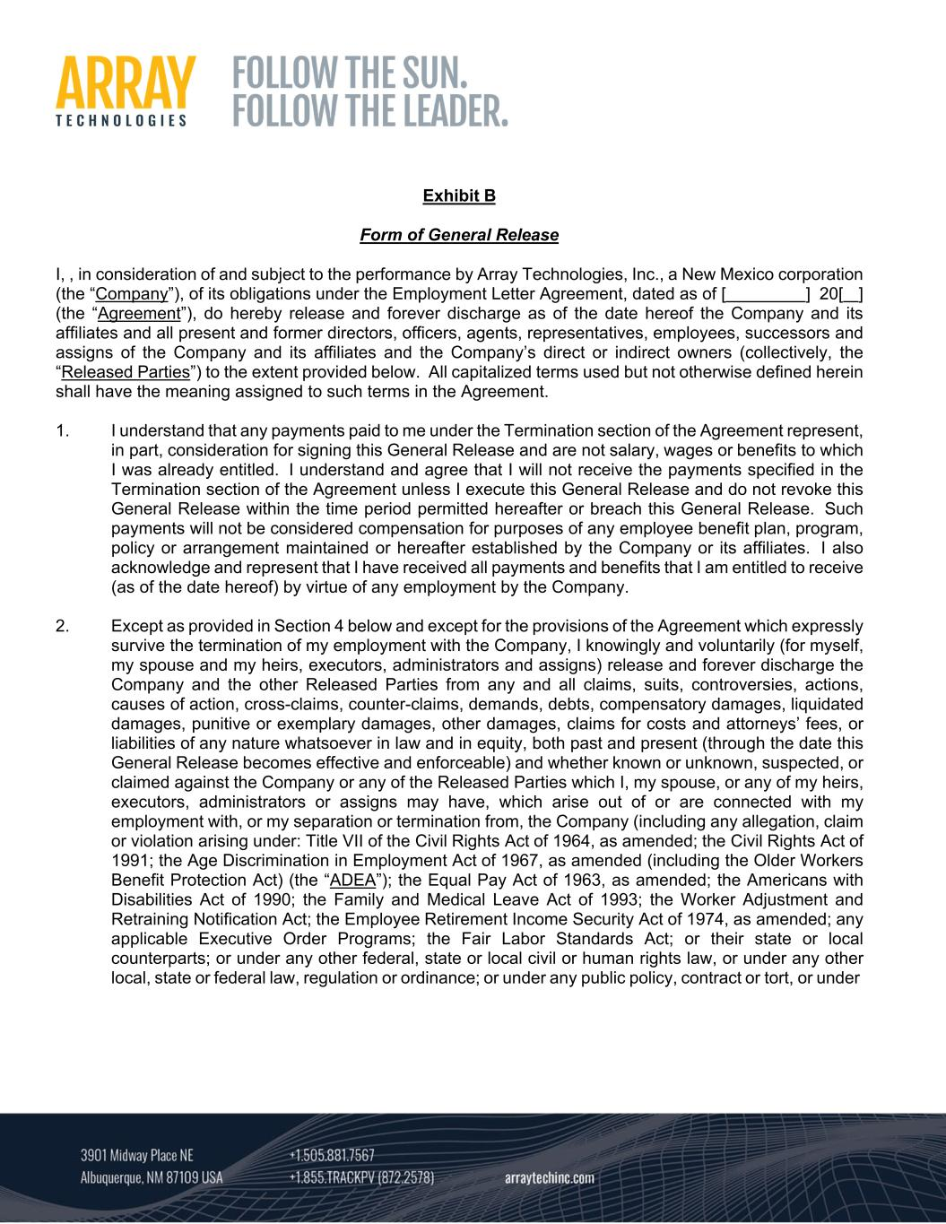
Exhibit B Form of General Release I, , in consideration of and subject to the performance by Array Technologies, Inc., a New Mexico corporation (the “Company”), of its obligations under the Employment Letter Agreement, dated as of [ ] 20[ ] (the “Agreement”), do hereby release and forever discharge as of the date hereof the Company and its affiliates and all present and former directors, officers, agents, representatives, employees, successors and assigns of the Company and its affiliates and the Company’s direct or indirect owners (collectively, the “Released Parties”) to the extent provided below. All capitalized terms used but not otherwise defined herein shall have the meaning assigned to such terms in the Agreement. 1. I understand that any payments paid to me under the Termination section of the Agreement represent, in part, consideration for signing this General Release and are not salary, wages or benefits to which I was already entitled. I understand and agree that I will not receive the payments specified in the Termination section of the Agreement unless I execute this General Release and do not revoke this General Release within the time period permitted hereafter or breach this General Release. Such payments will not be considered compensation for purposes of any employee benefit plan, program, policy or arrangement maintained or hereafter established by the Company or its affiliates. I also acknowledge and represent that I have received all payments and benefits that I am entitled to receive (as of the date hereof) by virtue of any employment by the Company. 2. Except as provided in Section 4 below and except for the provisions of the Agreement which expressly survive the termination of my employment with the Company, I knowingly and voluntarily (for myself, my spouse and my heirs, executors, administrators and assigns) release and forever discharge the Company and the other Released Parties from any and all claims, suits, controversies, actions, causes of action, cross-claims, counter-claims, demands, debts, compensatory damages, liquidated damages, punitive or exemplary damages, other damages, claims for costs and attorneys’ fees, or liabilities of any nature whatsoever in law and in equity, both past and present (through the date this General Release becomes effective and enforceable) and whether known or unknown, suspected, or claimed against the Company or any of the Released Parties which I, my spouse, or any of my heirs, executors, administrators or assigns may have, which arise out of or are connected with my employment with, or my separation or termination from, the Company (including any allegation, claim or violation arising under: Title VII of the Civil Rights Act of 1964, as amended; the Civil Rights Act of 1991; the Age Discrimination in Employment Act of 1967, as amended (including the Older Workers Benefit Protection Act) (the “ADEA”); the Equal Pay Act of 1963, as amended; the Americans with Disabilities Act of 1990; the Family and Medical Leave Act of 1993; the Worker Adjustment and Retraining Notification Act; the Employee Retirement Income Security Act of 1974, as amended; any applicable Executive Order Programs; the Fair Labor Standards Act; or their state or local counterparts; or under any other federal, state or local civil or human rights law, or under any other local, state or federal law, regulation or ordinance; or under any public policy, contract or tort, or under

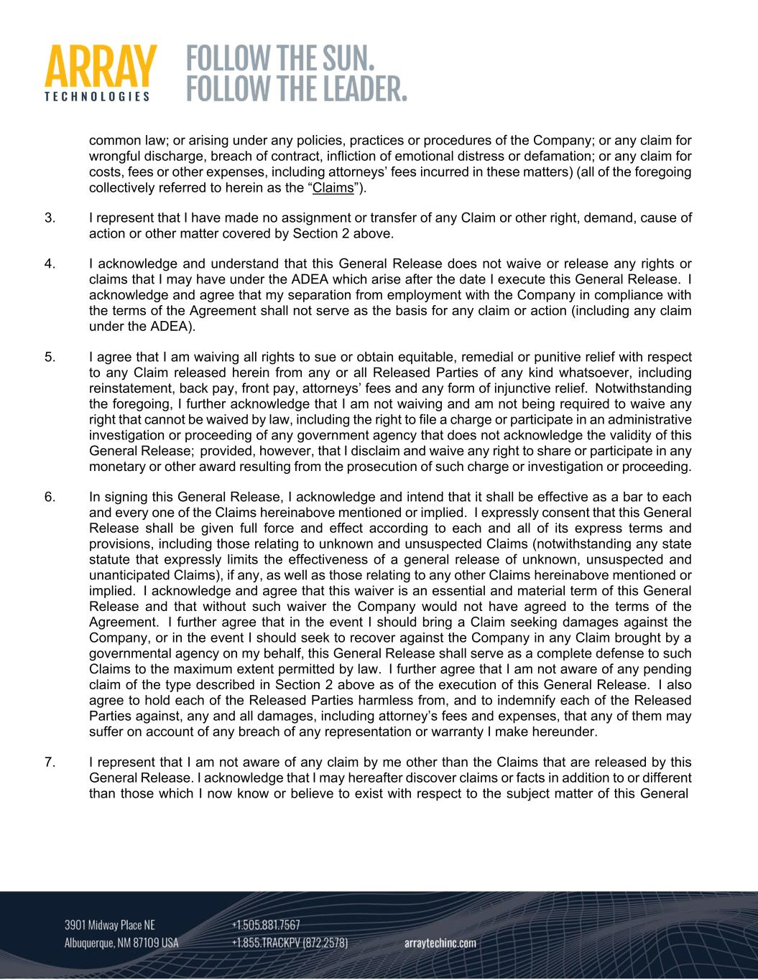
common law; or arising under any policies, practices or procedures of the Company; or any claim for wrongful discharge, breach of contract, infliction of emotional distress or defamation; or any claim for costs, fees or other expenses, including attorneys’ fees incurred in these matters) (all of the foregoing collectively referred to herein as the “Claims”). 3. I represent that I have made no assignment or transfer of any Claim or other right, demand, cause of action or other matter covered by Section 2 above. 4. I acknowledge and understand that this General Release does not waive or release any rights or claims that I may have under the ADEA which arise after the date I execute this General Release. I acknowledge and agree that my separation from employment with the Company in compliance with the terms of the Agreement shall not serve as the basis for any claim or action (including any claim under the ADEA). 5. I agree that I am waiving all rights to sue or obtain equitable, remedial or punitive relief with respect to any Claim released herein from any or all Released Parties of any kind whatsoever, including reinstatement, back pay, front pay, attorneys’ fees and any form of injunctive relief. Notwithstanding the foregoing, I further acknowledge that I am not waiving and am not being required to waive any right that cannot be waived by law, including the right to file a charge or participate in an administrative investigation or proceeding of any government agency that does not acknowledge the validity of this General Release; provided, however, that I disclaim and waive any right to share or participate in any monetary or other award resulting from the prosecution of such charge or investigation or proceeding. 6. In signing this General Release, I acknowledge and intend that it shall be effective as a bar to each and every one of the Claims hereinabove mentioned or implied. I expressly consent that this General Release shall be given full force and effect according to each and all of its express terms and provisions, including those relating to unknown and unsuspected Claims (notwithstanding any state statute that expressly limits the effectiveness of a general release of unknown, unsuspected and unanticipated Claims), if any, as well as those relating to any other Claims hereinabove mentioned or implied. I acknowledge and agree that this waiver is an essential and material term of this General Release and that without such waiver the Company would not have agreed to the terms of the Agreement. I further agree that in the event I should bring a Claim seeking damages against the Company, or in the event I should seek to recover against the Company in any Claim brought by a governmental agency on my behalf, this General Release shall serve as a complete defense to such Claims to the maximum extent permitted by law. I further agree that I am not aware of any pending claim of the type described in Section 2 above as of the execution of this General Release. I also agree to hold each of the Released Parties harmless from, and to indemnify each of the Released Parties against, any and all damages, including attorney’s fees and expenses, that any of them may suffer on account of any breach of any representation or warranty I make hereunder. 7. I represent that I am not aware of any claim by me other than the Claims that are released by this General Release. I acknowledge that I may hereafter discover claims or facts in addition to or different than those which I now know or believe to exist with respect to the subject matter of this General

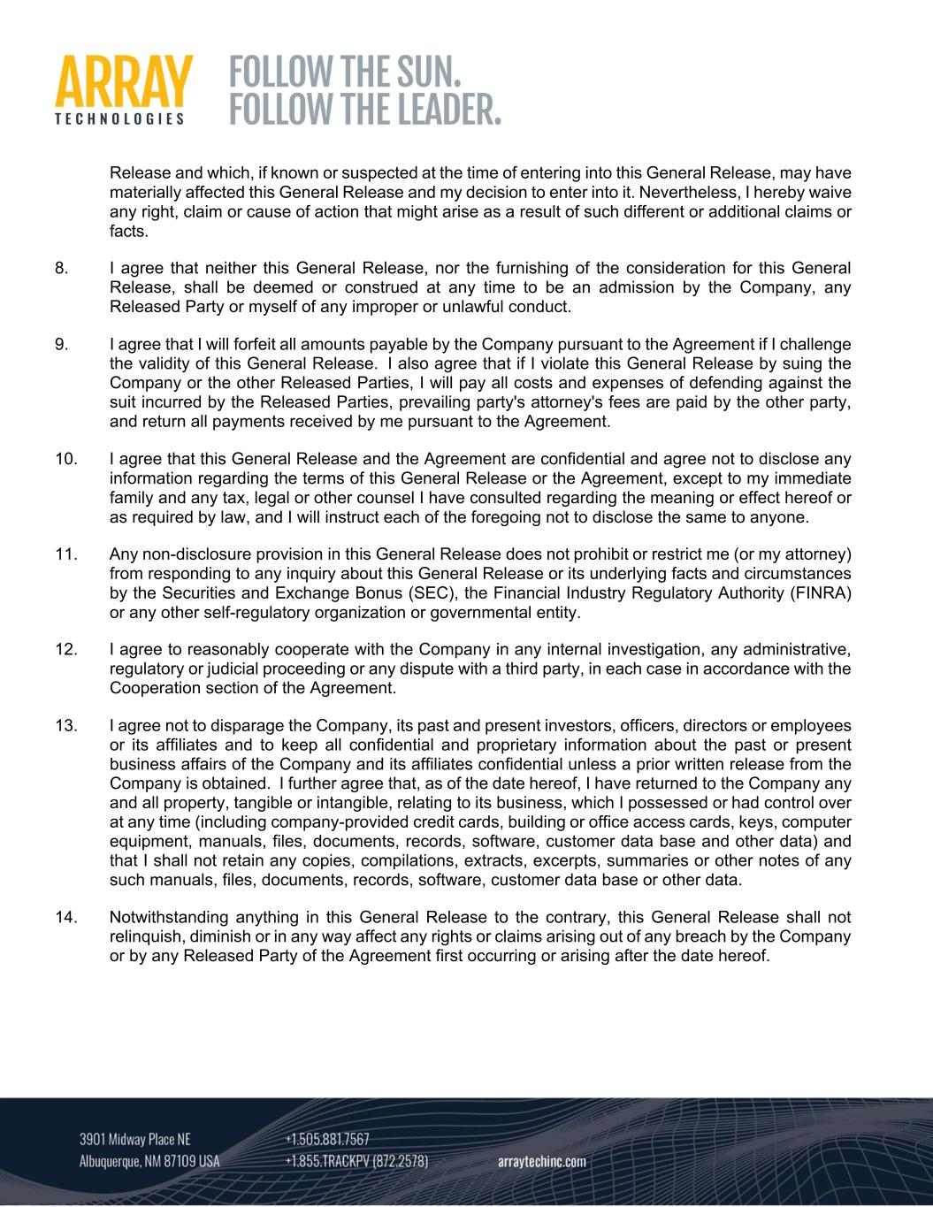
Release and which, if known or suspected at the time of entering into this General Release, may have materially affected this General Release and my decision to enter into it. Nevertheless, I hereby waive any right, claim or cause of action that might arise as a result of such different or additional claims or facts. 8. I agree that neither this General Release, nor the furnishing of the consideration for this General Release, shall be deemed or construed at any time to be an admission by the Company, any Released Party or myself of any improper or unlawful conduct. 9. I agree that I will forfeit all amounts payable by the Company pursuant to the Agreement if I challenge the validity of this General Release. I also agree that if I violate this General Release by suing the Company or the other Released Parties, I will pay all costs and expenses of defending against the suit incurred by the Released Parties, prevailing party's attorney's fees are paid by the other party, and return all payments received by me pursuant to the Agreement. 10. I agree that this General Release and the Agreement are confidential and agree not to disclose any information regarding the terms of this General Release or the Agreement, except to my immediate family and any tax, legal or other counsel I have consulted regarding the meaning or effect hereof or as required by law, and I will instruct each of the foregoing not to disclose the same to anyone. 11. Any non-disclosure provision in this General Release does not prohibit or restrict me (or my attorney) from responding to any inquiry about this General Release or its underlying facts and circumstances by the Securities and Exchange Bonus (SEC), the Financial Industry Regulatory Authority (FINRA) or any other self-regulatory organization or governmental entity. 12. I agree to reasonably cooperate with the Company in any internal investigation, any administrative, regulatory or judicial proceeding or any dispute with a third party, in each case in accordance with the Cooperation section of the Agreement. 13. I agree not to disparage the Company, its past and present investors, officers, directors or employees or its affiliates and to keep all confidential and proprietary information about the past or present business affairs of the Company and its affiliates confidential unless a prior written release from the Company is obtained. I further agree that, as of the date hereof, I have returned to the Company any and all property, tangible or intangible, relating to its business, which I possessed or had control over at any time (including company-provided credit cards, building or office access cards, keys, computer equipment, manuals, files, documents, records, software, customer data base and other data) and that I shall not retain any copies, compilations, extracts, excerpts, summaries or other notes of any such manuals, files, documents, records, software, customer data base or other data. 14. Notwithstanding anything in this General Release to the contrary, this General Release shall not relinquish, diminish or in any way affect any rights or claims arising out of any breach by the Company or by any Released Party of the Agreement first occurring or arising after the date hereof.

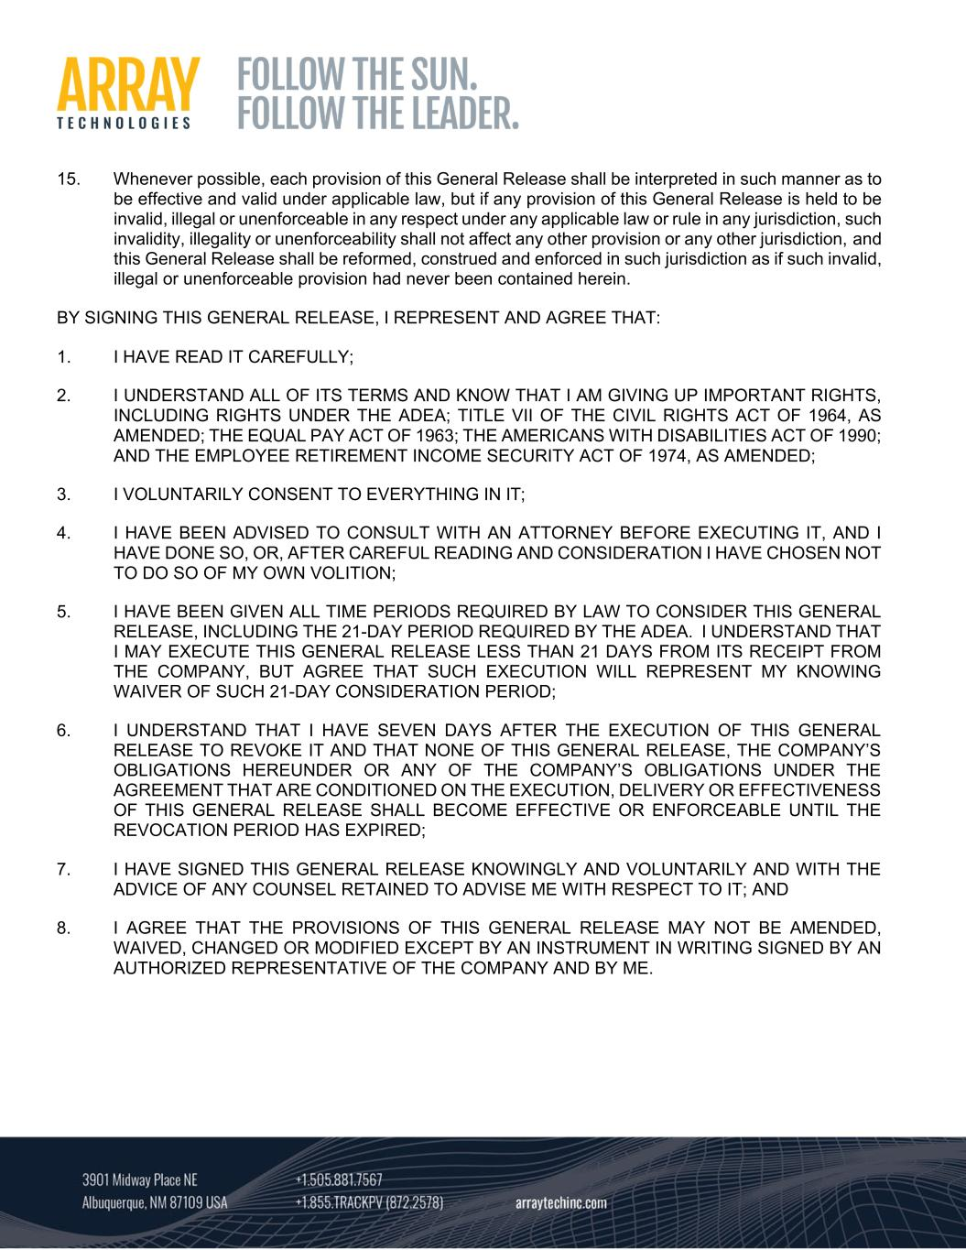
15. Whenever possible, each provision of this General Release shall be interpreted in such manner as to be effective and valid under applicable law, but if any provision of this General Release is held to be invalid, illegal or unenforceable in any respect under any applicable law or rule in any jurisdiction, such invalidity, illegality or unenforceability shall not affect any other provision or any other jurisdiction, and this General Release shall be reformed, construed and enforced in such jurisdiction as if such invalid, illegal or unenforceable provision had never been contained herein. BY SIGNING THIS GENERAL RELEASE, I REPRESENT AND AGREE THAT: 1. I HAVE READ IT CAREFULLY; 2. I UNDERSTAND ALL OF ITS TERMS AND KNOW THAT I AM GIVING UP IMPORTANT RIGHTS, INCLUDING RIGHTS UNDER THE ADEA; TITLE VII OF THE CIVIL RIGHTS ACT OF 1964, AS AMENDED; THE EQUAL PAY ACT OF 1963; THE AMERICANS WITH DISABILITIES ACT OF 1990; AND THE EMPLOYEE RETIREMENT INCOME SECURITY ACT OF 1974, AS AMENDED; 3. I VOLUNTARILY CONSENT TO EVERYTHING IN IT; 4. I HAVE BEEN ADVISED TO CONSULT WITH AN ATTORNEY BEFORE EXECUTING IT, AND I HAVE DONE SO, OR, AFTER CAREFUL READING AND CONSIDERATION I HAVE CHOSEN NOT TO DO SO OF MY OWN VOLITION; 5. I HAVE BEEN GIVEN ALL TIME PERIODS REQUIRED BY LAW TO CONSIDER THIS GENERAL RELEASE, INCLUDING THE 21-DAY PERIOD REQUIRED BY THE ADEA. I UNDERSTAND THAT I MAY EXECUTE THIS GENERAL RELEASE LESS THAN 21 DAYS FROM ITS RECEIPT FROM THE COMPANY, BUT AGREE THAT SUCH EXECUTION WILL REPRESENT MY KNOWING WAIVER OF SUCH 21-DAY CONSIDERATION PERIOD; 6. I UNDERSTAND THAT I HAVE SEVEN DAYS AFTER THE EXECUTION OF THIS GENERAL RELEASE TO REVOKE IT AND THAT NONE OF THIS GENERAL RELEASE, THE COMPANY’S OBLIGATIONS HEREUNDER OR ANY OF THE COMPANY’S OBLIGATIONS UNDER THE AGREEMENT THAT ARE CONDITIONED ON THE EXECUTION, DELIVERY OR EFFECTIVENESS OF THIS GENERAL RELEASE SHALL BECOME EFFECTIVE OR ENFORCEABLE UNTIL THE REVOCATION PERIOD HAS EXPIRED; 7. I HAVE SIGNED THIS GENERAL RELEASE KNOWINGLY AND VOLUNTARILY AND WITH THE ADVICE OF ANY COUNSEL RETAINED TO ADVISE ME WITH RESPECT TO IT; AND 8. I AGREE THAT THE PROVISIONS OF THIS GENERAL RELEASE MAY NOT BE AMENDED, WAIVED, CHANGED OR MODIFIED EXCEPT BY AN INSTRUMENT IN WRITING SIGNED BY AN AUTHORIZED REPRESENTATIVE OF THE COMPANY AND BY ME.

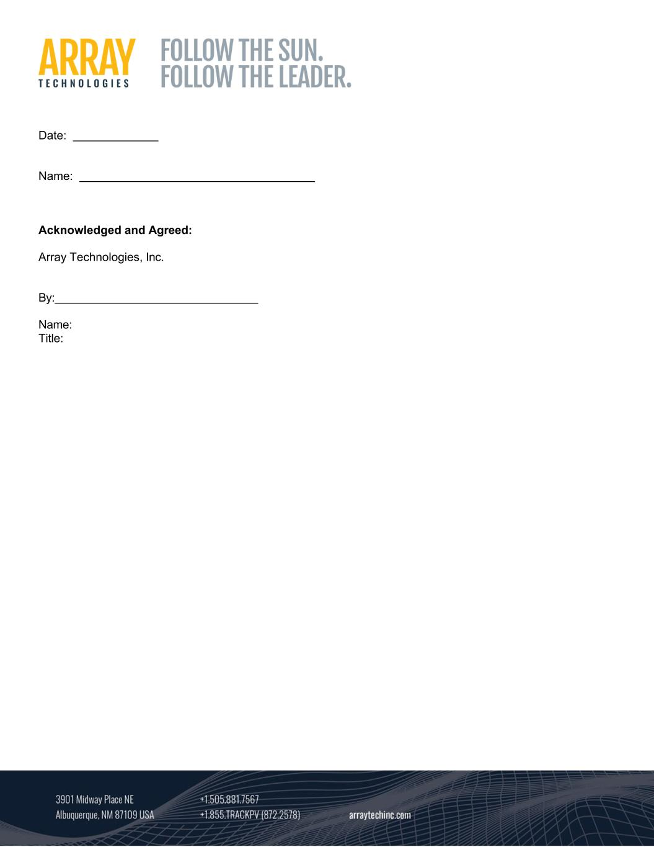
Date: Name: Acknowledged and Agreed: Array Technologies, Inc. By: Name: Title:

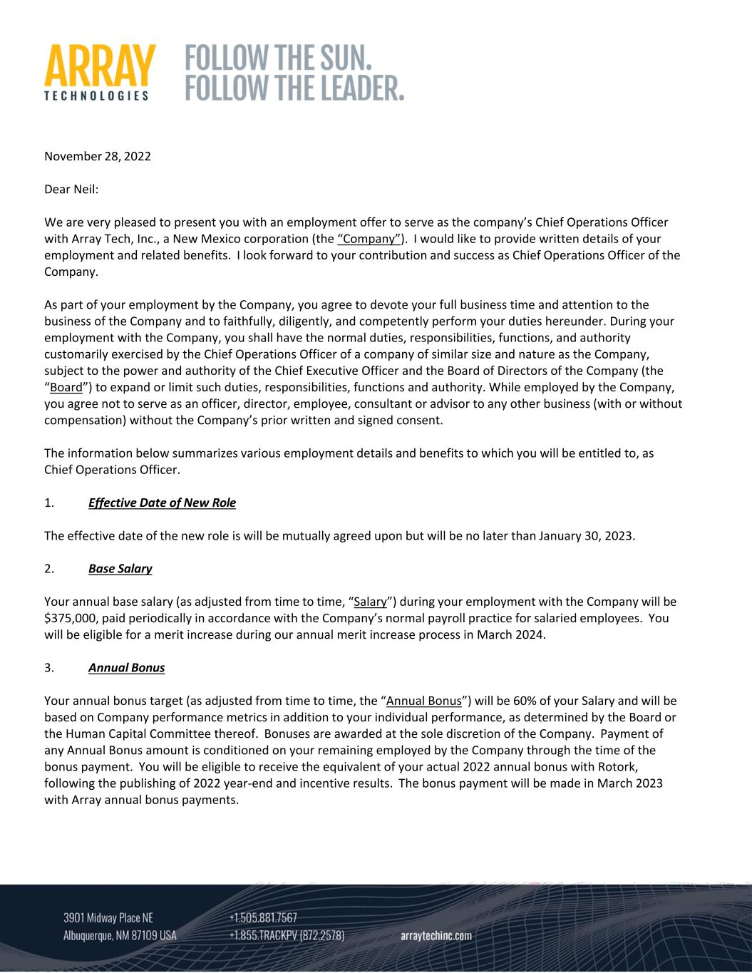
November 28, 2022 Dear Neil: We are very pleased to present you with an employment offer to serve as the company’s Chief Operations Officer with Array Tech, Inc., a New Mexico corporation (the “Company”). I would like to provide written details of your employment and related benefits. I look forward to your contribution and success as Chief Operations Officer of the Company. As part of your employment by the Company, you agree to devote your full business time and attention to the business of the Company and to faithfully, diligently, and competently perform your duties hereunder. During your employment with the Company, you shall have the normal duties, responsibilities, functions, and authority customarily exercised by the Chief Operations Officer of a company of similar size and nature as the Company, subject to the power and authority of the Chief Executive Officer and the Board of Directors of the Company (the “Board”) to expand or limit such duties, responsibilities, functions and authority. While employed by the Company, you agree not to serve as an officer, director, employee, consultant or advisor to any other business (with or without compensation) without the Company’s prior written and signed consent. The information below summarizes various employment details and benefits to which you will be entitled to, as Chief Operations Officer. 1. Effective Date of New Role The effective date of the new role is will be mutually agreed upon but will be no later than January 30, 2023. 2. Base Salary Your annual base salary (as adjusted from time to time, “Salary”) during your employment with the Company will be $375,000, paid periodically in accordance with the Company’s normal payroll practice for salaried employees. You will be eligible for a merit increase during our annual merit increase process in March 2024. 3. Annual Bonus Your annual bonus target (as adjusted from time to time, the “Annual Bonus”) will be 60% of your Salary and will be based on Company performance metrics in addition to your individual performance, as determined by the Board or the Human Capital Committee thereof. Bonuses are awarded at the sole discretion of the Company. Payment of any Annual Bonus amount is conditioned on your remaining employed by the Company through the time of the bonus payment. You will be eligible to receive the equivalent of your actual 2022 annual bonus with Rotork, following the publishing of 2022 year‐end and incentive results. The bonus payment will be made in March 2023 with Array annual bonus payments.

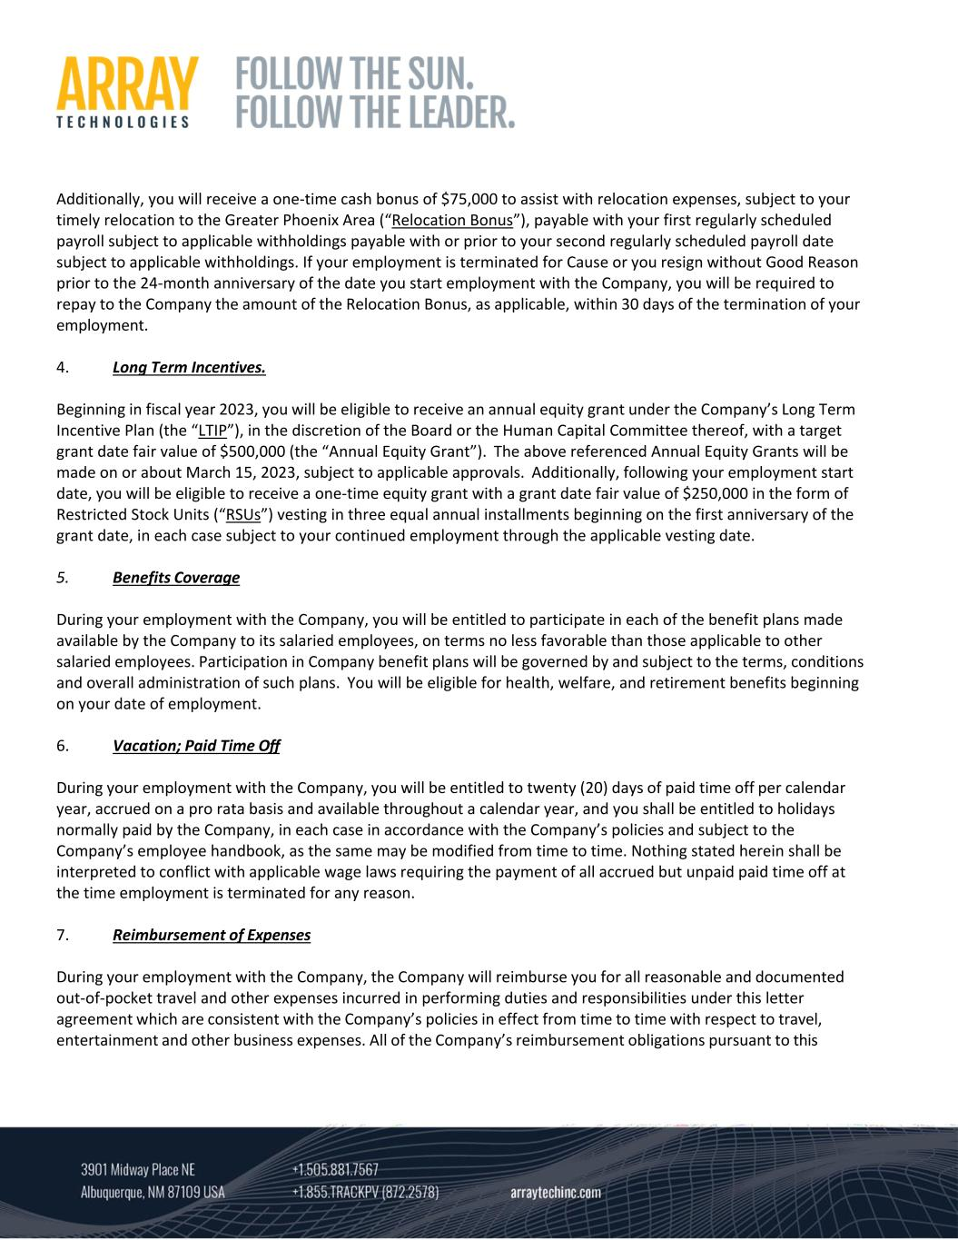
Additionally, you will receive a one‐time cash bonus of $75,000 to assist with relocation expenses, subject to your timely relocation to the Greater Phoenix Area (“Relocation Bonus”), payable with your first regularly scheduled payroll subject to applicable withholdings payable with or prior to your second regularly scheduled payroll date subject to applicable withholdings. If your employment is terminated for Cause or you resign without Good Reason prior to the 24‐month anniversary of the date you start employment with the Company, you will be required to repay to the Company the amount of the Relocation Bonus, as applicable, within 30 days of the termination of your employment. 4. Long Term Incentives. Beginning in fiscal year 2023, you will be eligible to receive an annual equity grant under the Company’s Long Term Incentive Plan (the “LTIP”), in the discretion of the Board or the Human Capital Committee thereof, with a target grant date fair value of $500,000 (the “Annual Equity Grant”). The above referenced Annual Equity Grants will be made on or about March 15, 2023, subject to applicable approvals. Additionally, following your employment start date, you will be eligible to receive a one‐time equity grant with a grant date fair value of $250,000 in the form of Restricted Stock Units (“RSUs”) vesting in three equal annual installments beginning on the first anniversary of the grant date, in each case subject to your continued employment through the applicable vesting date. 5. Benefits Coverage During your employment with the Company, you will be entitled to participate in each of the benefit plans made available by the Company to its salaried employees, on terms no less favorable than those applicable to other salaried employees. Participation in Company benefit plans will be governed by and subject to the terms, conditions and overall administration of such plans. You will be eligible for health, welfare, and retirement benefits beginning on your date of employment. 6. Vacation; Paid Time Off During your employment with the Company, you will be entitled to twenty (20) days of paid time off per calendar year, accrued on a pro rata basis and available throughout a calendar year, and you shall be entitled to holidays normally paid by the Company, in each case in accordance with the Company’s policies and subject to the Company’s employee handbook, as the same may be modified from time to time. Nothing stated herein shall be interpreted to conflict with applicable wage laws requiring the payment of all accrued but unpaid paid time off at the time employment is terminated for any reason. 7. Reimbursement of Expenses During your employment with the Company, the Company will reimburse you for all reasonable and documented out‐of‐pocket travel and other expenses incurred in performing duties and responsibilities under this letter agreement which are consistent with the Company’s policies in effect from time to time with respect to travel, entertainment and other business expenses. All of the Company’s reimbursement obligations pursuant to this

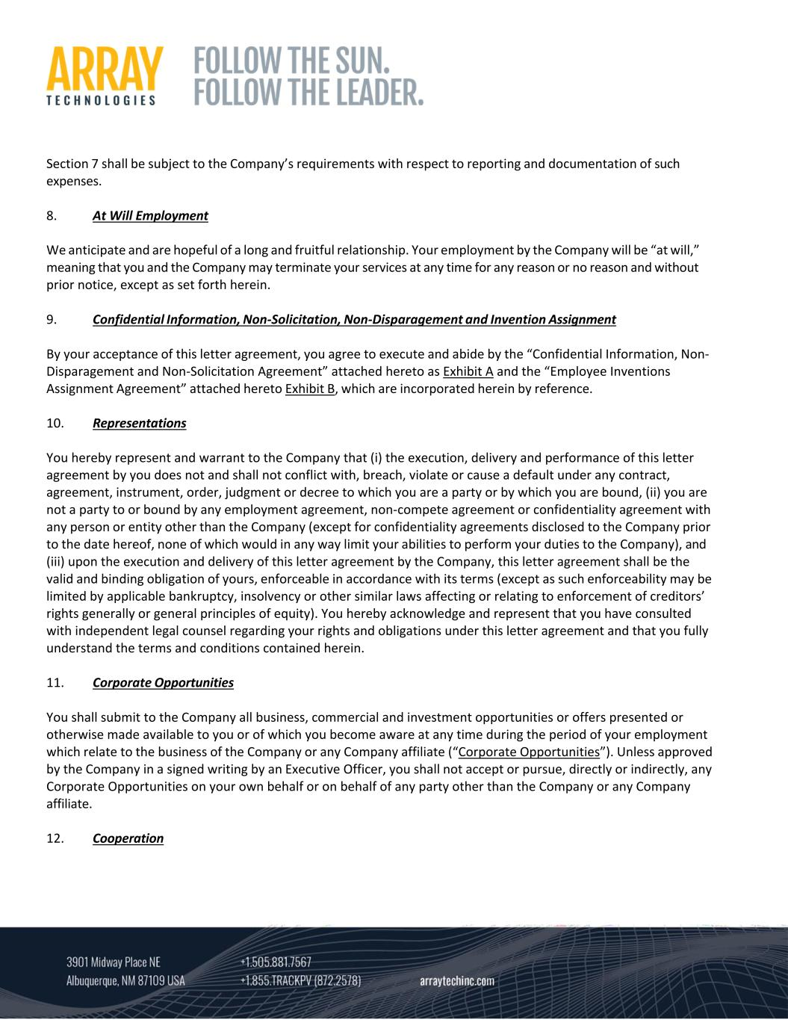
Section 7 shall be subject to the Company’s requirements with respect to reporting and documentation of such expenses. 8. At Will Employment We anticipate and are hopeful of a long and fruitful relationship. Your employment by the Company will be “at will,” meaning that you and the Company may terminate your services at any time for any reason or no reason and without prior notice, except as set forth herein. 9. Confidential Information, Non‐Solicitation, Non‐Disparagement and Invention Assignment By your acceptance of this letter agreement, you agree to execute and abide by the “Confidential Information, Non‐ Disparagement and Non‐Solicitation Agreement” attached hereto as Exhibit A and the “Employee Inventions Assignment Agreement” attached hereto Exhibit B, which are incorporated herein by reference. 10. Representations You hereby represent and warrant to the Company that (i) the execution, delivery and performance of this letter agreement by you does not and shall not conflict with, breach, violate or cause a default under any contract, agreement, instrument, order, judgment or decree to which you are a party or by which you are bound, (ii) you are not a party to or bound by any employment agreement, non‐compete agreement or confidentiality agreement with any person or entity other than the Company (except for confidentiality agreements disclosed to the Company prior to the date hereof, none of which would in any way limit your abilities to perform your duties to the Company), and (iii) upon the execution and delivery of this letter agreement by the Company, this letter agreement shall be the valid and binding obligation of yours, enforceable in accordance with its terms (except as such enforceability may be limited by applicable bankruptcy, insolvency or other similar laws affecting or relating to enforcement of creditors’ rights generally or general principles of equity). You hereby acknowledge and represent that you have consulted with independent legal counsel regarding your rights and obligations under this letter agreement and that you fully understand the terms and conditions contained herein. 11. Corporate Opportunities You shall submit to the Company all business, commercial and investment opportunities or offers presented or otherwise made available to you or of which you become aware at any time during the period of your employment which relate to the business of the Company or any Company affiliate (“Corporate Opportunities”). Unless approved by the Company in a signed writing by an Executive Officer, you shall not accept or pursue, directly or indirectly, any Corporate Opportunities on your own behalf or on behalf of any party other than the Company or any Company affiliate. 12. Cooperation

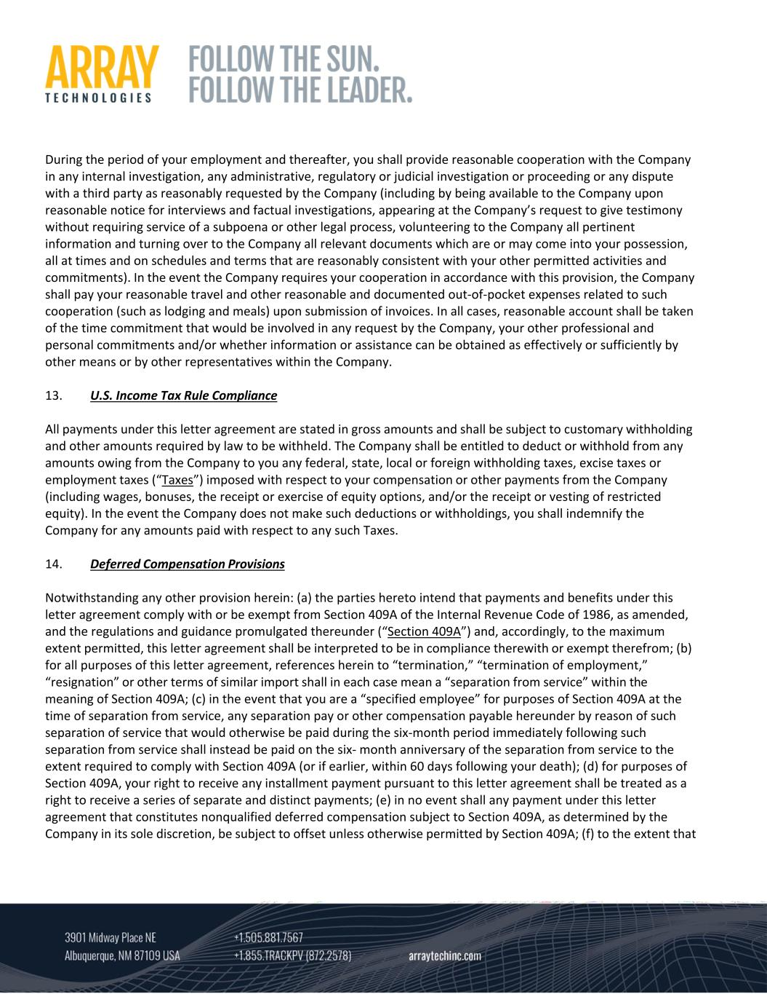
During the period of your employment and thereafter, you shall provide reasonable cooperation with the Company in any internal investigation, any administrative, regulatory or judicial investigation or proceeding or any dispute with a third party as reasonably requested by the Company (including by being available to the Company upon reasonable notice for interviews and factual investigations, appearing at the Company’s request to give testimony without requiring service of a subpoena or other legal process, volunteering to the Company all pertinent information and turning over to the Company all relevant documents which are or may come into your possession, all at times and on schedules and terms that are reasonably consistent with your other permitted activities and commitments). In the event the Company requires your cooperation in accordance with this provision, the Company shall pay your reasonable travel and other reasonable and documented out‐of‐pocket expenses related to such cooperation (such as lodging and meals) upon submission of invoices. In all cases, reasonable account shall be taken of the time commitment that would be involved in any request by the Company, your other professional and personal commitments and/or whether information or assistance can be obtained as effectively or sufficiently by other means or by other representatives within the Company. 13. U.S. Income Tax Rule Compliance All payments under this letter agreement are stated in gross amounts and shall be subject to customary withholding and other amounts required by law to be withheld. The Company shall be entitled to deduct or withhold from any amounts owing from the Company to you any federal, state, local or foreign withholding taxes, excise taxes or employment taxes (“Taxes”) imposed with respect to your compensation or other payments from the Company (including wages, bonuses, the receipt or exercise of equity options, and/or the receipt or vesting of restricted equity). In the event the Company does not make such deductions or withholdings, you shall indemnify the Company for any amounts paid with respect to any such Taxes. 14. Deferred Compensation Provisions Notwithstanding any other provision herein: (a) the parties hereto intend that payments and benefits under this letter agreement comply with or be exempt from Section 409A of the Internal Revenue Code of 1986, as amended, and the regulations and guidance promulgated thereunder (“Section 409A”) and, accordingly, to the maximum extent permitted, this letter agreement shall be interpreted to be in compliance therewith or exempt therefrom; (b) for all purposes of this letter agreement, references herein to “termination,” “termination of employment,” “resignation” or other terms of similar import shall in each case mean a “separation from service” within the meaning of Section 409A; (c) in the event that you are a “specified employee” for purposes of Section 409A at the time of separation from service, any separation pay or other compensation payable hereunder by reason of such separation of service that would otherwise be paid during the six‐month period immediately following such separation from service shall instead be paid on the six‐ month anniversary of the separation from service to the extent required to comply with Section 409A (or if earlier, within 60 days following your death); (d) for purposes of Section 409A, your right to receive any installment payment pursuant to this letter agreement shall be treated as a right to receive a series of separate and distinct payments; (e) in no event shall any payment under this letter agreement that constitutes nonqualified deferred compensation subject to Section 409A, as determined by the Company in its sole discretion, be subject to offset unless otherwise permitted by Section 409A; (f) to the extent that

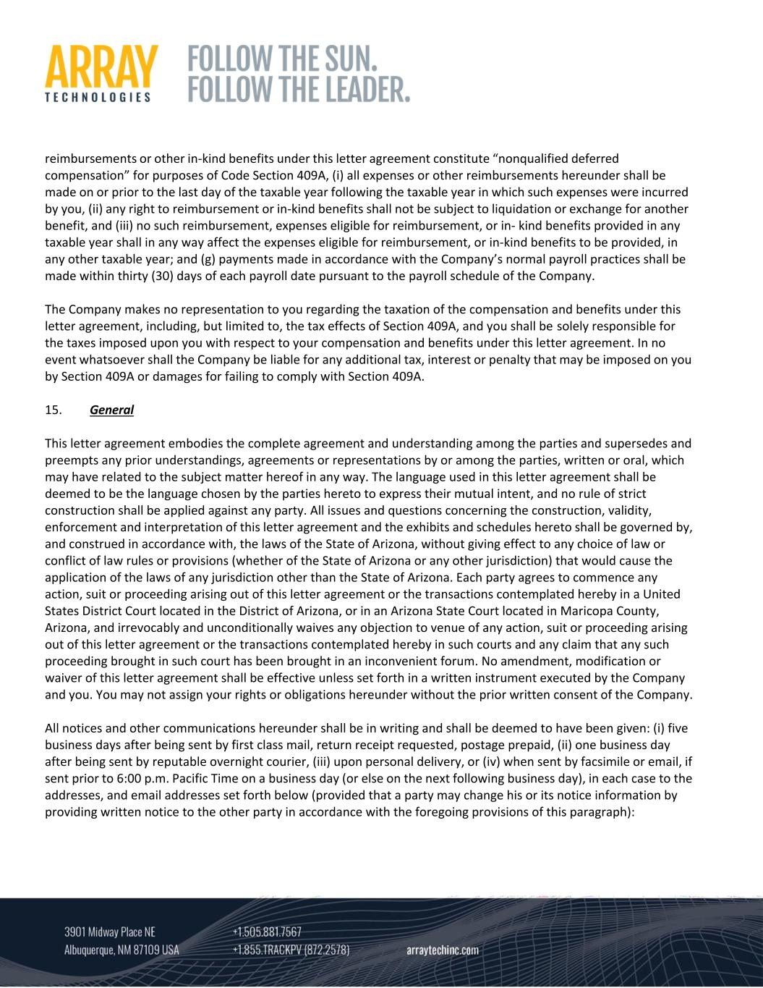
reimbursements or other in‐kind benefits under this letter agreement constitute “nonqualified deferred compensation” for purposes of Code Section 409A, (i) all expenses or other reimbursements hereunder shall be made on or prior to the last day of the taxable year following the taxable year in which such expenses were incurred by you, (ii) any right to reimbursement or in‐kind benefits shall not be subject to liquidation or exchange for another benefit, and (iii) no such reimbursement, expenses eligible for reimbursement, or in‐ kind benefits provided in any taxable year shall in any way affect the expenses eligible for reimbursement, or in‐kind benefits to be provided, in any other taxable year; and (g) payments made in accordance with the Company’s normal payroll practices shall be made within thirty (30) days of each payroll date pursuant to the payroll schedule of the Company. The Company makes no representation to you regarding the taxation of the compensation and benefits under this letter agreement, including, but limited to, the tax effects of Section 409A, and you shall be solely responsible for the taxes imposed upon you with respect to your compensation and benefits under this letter agreement. In no event whatsoever shall the Company be liable for any additional tax, interest or penalty that may be imposed on you by Section 409A or damages for failing to comply with Section 409A. 15. General This letter agreement embodies the complete agreement and understanding among the parties and supersedes and preempts any prior understandings, agreements or representations by or among the parties, written or oral, which may have related to the subject matter hereof in any way. The language used in this letter agreement shall be deemed to be the language chosen by the parties hereto to express their mutual intent, and no rule of strict construction shall be applied against any party. All issues and questions concerning the construction, validity, enforcement and interpretation of this letter agreement and the exhibits and schedules hereto shall be governed by, and construed in accordance with, the laws of the State of Arizona, without giving effect to any choice of law or conflict of law rules or provisions (whether of the State of Arizona or any other jurisdiction) that would cause the application of the laws of any jurisdiction other than the State of Arizona. Each party agrees to commence any action, suit or proceeding arising out of this letter agreement or the transactions contemplated hereby in a United States District Court located in the District of Arizona, or in an Arizona State Court located in Maricopa County, Arizona, and irrevocably and unconditionally waives any objection to venue of any action, suit or proceeding arising out of this letter agreement or the transactions contemplated hereby in such courts and any claim that any such proceeding brought in such court has been brought in an inconvenient forum. No amendment, modification or waiver of this letter agreement shall be effective unless set forth in a written instrument executed by the Company and you. You may not assign your rights or obligations hereunder without the prior written consent of the Company. All notices and other communications hereunder shall be in writing and shall be deemed to have been given: (i) five business days after being sent by first class mail, return receipt requested, postage prepaid, (ii) one business day after being sent by reputable overnight courier, (iii) upon personal delivery, or (iv) when sent by facsimile or email, if sent prior to 6:00 p.m. Pacific Time on a business day (or else on the next following business day), in each case to the addresses, and email addresses set forth below (provided that a party may change his or its notice information by providing written notice to the other party in accordance with the foregoing provisions of this paragraph):

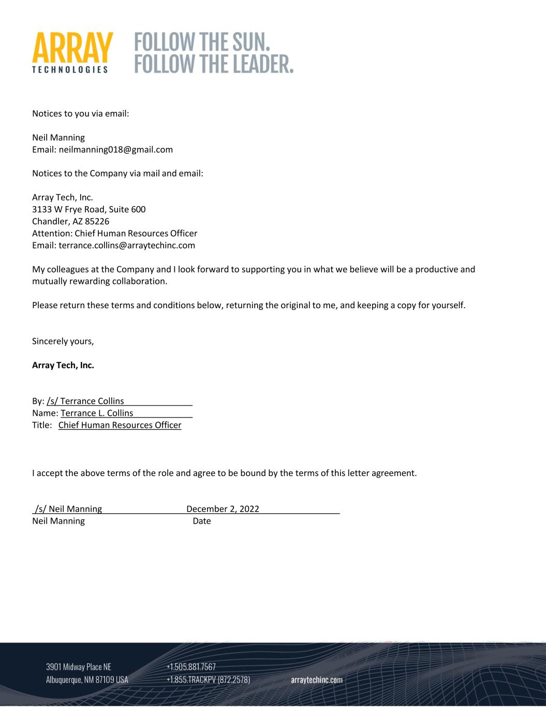
Notices to you via email: Neil Manning Email: neilmanning018@gmail.com Notices to the Company via mail and email: Array Tech, Inc. 3133 W Frye Road, Suite 600 Chandler, AZ 85226 Attention: Chief Human Resources Officer Email: terrance.collins@arraytechinc.com My colleagues at the Company and I look forward to supporting you in what we believe will be a productive and mutually rewarding collaboration. Please return these terms and conditions below, returning the original to me, and keeping a copy for yourself. Sincerely yours, Array Tech, Inc. By: /s/ Terrance Collins Name: Terrance L. Collins Title: Chief Human Resources Officer I accept the above terms of the role and agree to be bound by the terms of this letter agreement. /s/ Neil Manning December 2, 2022 Neil Manning Date

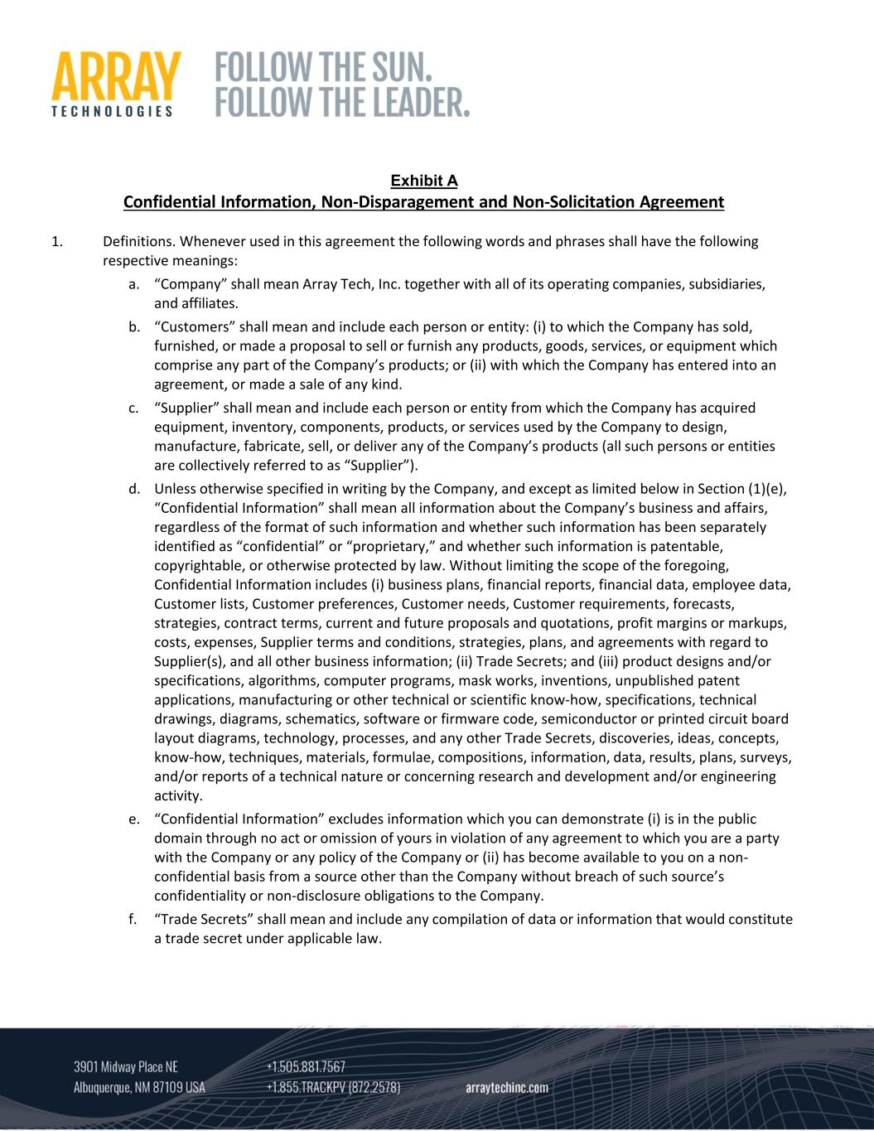
Exhibit A Confidential Information, Non‐Disparagement and Non‐Solicitation Agreement 1. Definitions. Whenever used in this agreement the following words and phrases shall have the following respective meanings: a. “Company” shall mean Array Tech, Inc. together with all of its operating companies, subsidiaries, and affiliates. b. “Customers” shall mean and include each person or entity: (i) to which the Company has sold, furnished, or made a proposal to sell or furnish any products, goods, services, or equipment which comprise any part of the Company’s products; or (ii) with which the Company has entered into an agreement, or made a sale of any kind. c. “Supplier” shall mean and include each person or entity from which the Company has acquired equipment, inventory, components, products, or services used by the Company to design, manufacture, fabricate, sell, or deliver any of the Company’s products (all such persons or entities are collectively referred to as “Supplier”). d. Unless otherwise specified in writing by the Company, and except as limited below in Section (1)(e), “Confidential Information” shall mean all information about the Company’s business and affairs, regardless of the format of such information and whether such information has been separately identified as “confidential” or “proprietary,” and whether such information is patentable, copyrightable, or otherwise protected by law. Without limiting the scope of the foregoing, Confidential Information includes (i) business plans, financial reports, financial data, employee data, Customer lists, Customer preferences, Customer needs, Customer requirements, forecasts, strategies, contract terms, current and future proposals and quotations, profit margins or markups, costs, expenses, Supplier terms and conditions, strategies, plans, and agreements with regard to Supplier(s), and all other business information; (ii) Trade Secrets; and (iii) product designs and/or specifications, algorithms, computer programs, mask works, inventions, unpublished patent applications, manufacturing or other technical or scientific know‐how, specifications, technical drawings, diagrams, schematics, software or firmware code, semiconductor or printed circuit board layout diagrams, technology, processes, and any other Trade Secrets, discoveries, ideas, concepts, know‐how, techniques, materials, formulae, compositions, information, data, results, plans, surveys, and/or reports of a technical nature or concerning research and development and/or engineering activity. e. “Confidential Information” excludes information which you can demonstrate (i) is in the public domain through no act or omission of yours in violation of any agreement to which you are a party with the Company or any policy of the Company or (ii) has become available to you on a non‐ confidential basis from a source other than the Company without breach of such source’s confidentiality or non‐disclosure obligations to the Company. f. “Trade Secrets” shall mean and include any compilation of data or information that would constitute a trade secret under applicable law.

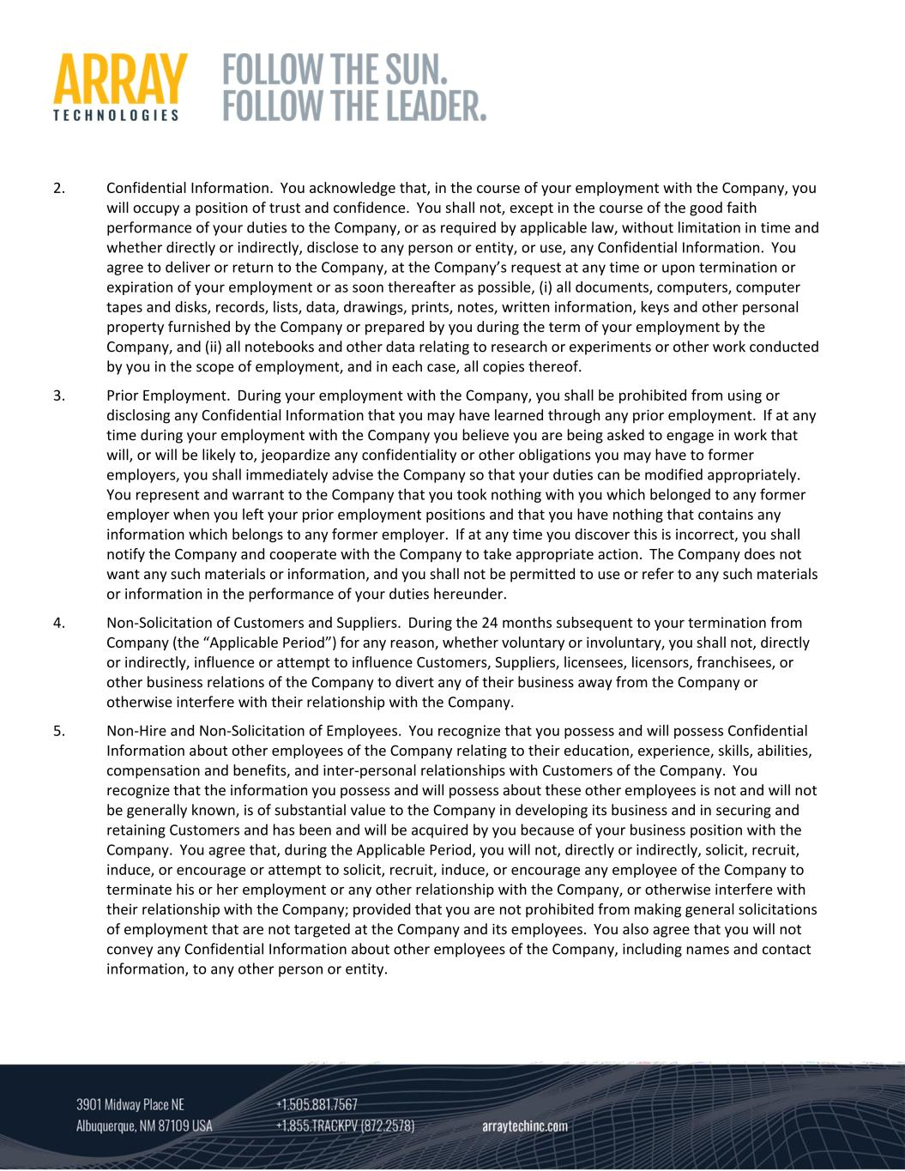
2. Confidential Information. You acknowledge that, in the course of your employment with the Company, you will occupy a position of trust and confidence. You shall not, except in the course of the good faith performance of your duties to the Company, or as required by applicable law, without limitation in time and whether directly or indirectly, disclose to any person or entity, or use, any Confidential Information. You agree to deliver or return to the Company, at the Company’s request at any time or upon termination or expiration of your employment or as soon thereafter as possible, (i) all documents, computers, computer tapes and disks, records, lists, data, drawings, prints, notes, written information, keys and other personal property furnished by the Company or prepared by you during the term of your employment by the Company, and (ii) all notebooks and other data relating to research or experiments or other work conducted by you in the scope of employment, and in each case, all copies thereof. 3. Prior Employment. During your employment with the Company, you shall be prohibited from using or disclosing any Confidential Information that you may have learned through any prior employment. If at any time during your employment with the Company you believe you are being asked to engage in work that will, or will be likely to, jeopardize any confidentiality or other obligations you may have to former employers, you shall immediately advise the Company so that your duties can be modified appropriately. You represent and warrant to the Company that you took nothing with you which belonged to any former employer when you left your prior employment positions and that you have nothing that contains any information which belongs to any former employer. If at any time you discover this is incorrect, you shall notify the Company and cooperate with the Company to take appropriate action. The Company does not want any such materials or information, and you shall not be permitted to use or refer to any such materials or information in the performance of your duties hereunder. 4. Non‐Solicitation of Customers and Suppliers. During the 24 months subsequent to your termination from Company (the “Applicable Period”) for any reason, whether voluntary or involuntary, you shall not, directly or indirectly, influence or attempt to influence Customers, Suppliers, licensees, licensors, franchisees, or other business relations of the Company to divert any of their business away from the Company or otherwise interfere with their relationship with the Company. 5. Non‐Hire and Non‐Solicitation of Employees. You recognize that you possess and will possess Confidential Information about other employees of the Company relating to their education, experience, skills, abilities, compensation and benefits, and inter‐personal relationships with Customers of the Company. You recognize that the information you possess and will possess about these other employees is not and will not be generally known, is of substantial value to the Company in developing its business and in securing and retaining Customers and has been and will be acquired by you because of your business position with the Company. You agree that, during the Applicable Period, you will not, directly or indirectly, solicit, recruit, induce, or encourage or attempt to solicit, recruit, induce, or encourage any employee of the Company to terminate his or her employment or any other relationship with the Company, or otherwise interfere with their relationship with the Company; provided that you are not prohibited from making general solicitations of employment that are not targeted at the Company and its employees. You also agree that you will not convey any Confidential Information about other employees of the Company, including names and contact information, to any other person or entity.

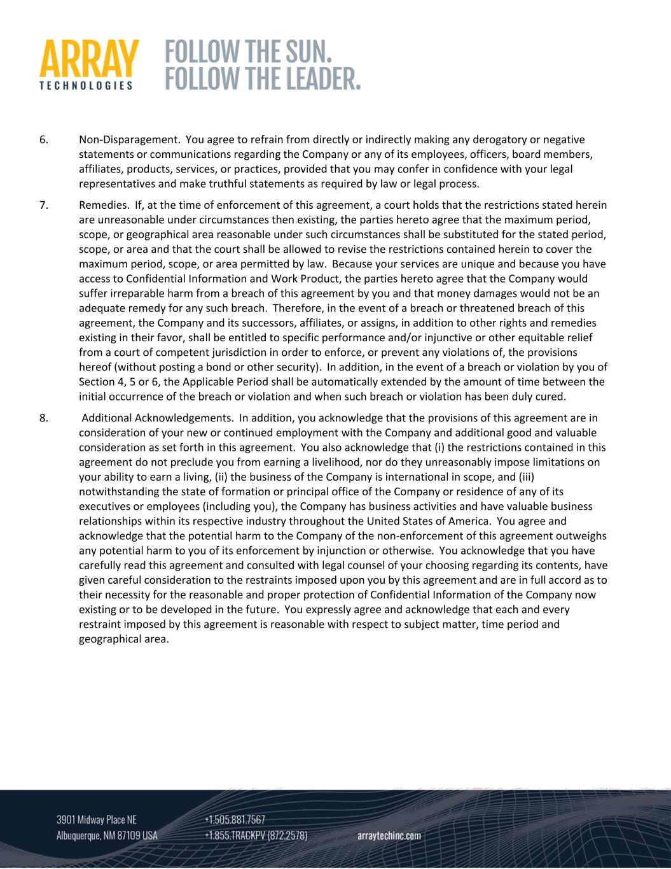
6. Non‐Disparagement. You agree to refrain from directly or indirectly making any derogatory or negative statements or communications regarding the Company or any of its employees, officers, board members, affiliates, products, services, or practices, provided that you may confer in confidence with your legal representatives and make truthful statements as required by law or legal process. 7. Remedies. If, at the time of enforcement of this agreement, a court holds that the restrictions stated herein are unreasonable under circumstances then existing, the parties hereto agree that the maximum period, scope, or geographical area reasonable under such circumstances shall be substituted for the stated period, scope, or area and that the court shall be allowed to revise the restrictions contained herein to cover the maximum period, scope, or area permitted by law. Because your services are unique and because you have access to Confidential Information and Work Product, the parties hereto agree that the Company would suffer irreparable harm from a breach of this agreement by you and that money damages would not be an adequate remedy for any such breach. Therefore, in the event of a breach or threatened breach of this agreement, the Company and its successors, affiliates, or assigns, in addition to other rights and remedies existing in their favor, shall be entitled to specific performance and/or injunctive or other equitable relief from a court of competent jurisdiction in order to enforce, or prevent any violations of, the provisions hereof (without posting a bond or other security). In addition, in the event of a breach or violation by you of Section 4, 5 or 6, the Applicable Period shall be automatically extended by the amount of time between the initial occurrence of the breach or violation and when such breach or violation has been duly cured. 8. Additional Acknowledgements. In addition, you acknowledge that the provisions of this agreement are in consideration of your new or continued employment with the Company and additional good and valuable consideration as set forth in this agreement. You also acknowledge that (i) the restrictions contained in this agreement do not preclude you from earning a livelihood, nor do they unreasonably impose limitations on your ability to earn a living, (ii) the business of the Company is international in scope, and (iii) notwithstanding the state of formation or principal office of the Company or residence of any of its executives or employees (including you), the Company has business activities and have valuable business relationships within its respective industry throughout the United States of America. You agree and acknowledge that the potential harm to the Company of the non‐enforcement of this agreement outweighs any potential harm to you of its enforcement by injunction or otherwise. You acknowledge that you have carefully read this agreement and consulted with legal counsel of your choosing regarding its contents, have given careful consideration to the restraints imposed upon you by this agreement and are in full accord as to their necessity for the reasonable and proper protection of Confidential Information of the Company now existing or to be developed in the future. You expressly agree and acknowledge that each and every restraint imposed by this agreement is reasonable with respect to subject matter, time period and geographical area.

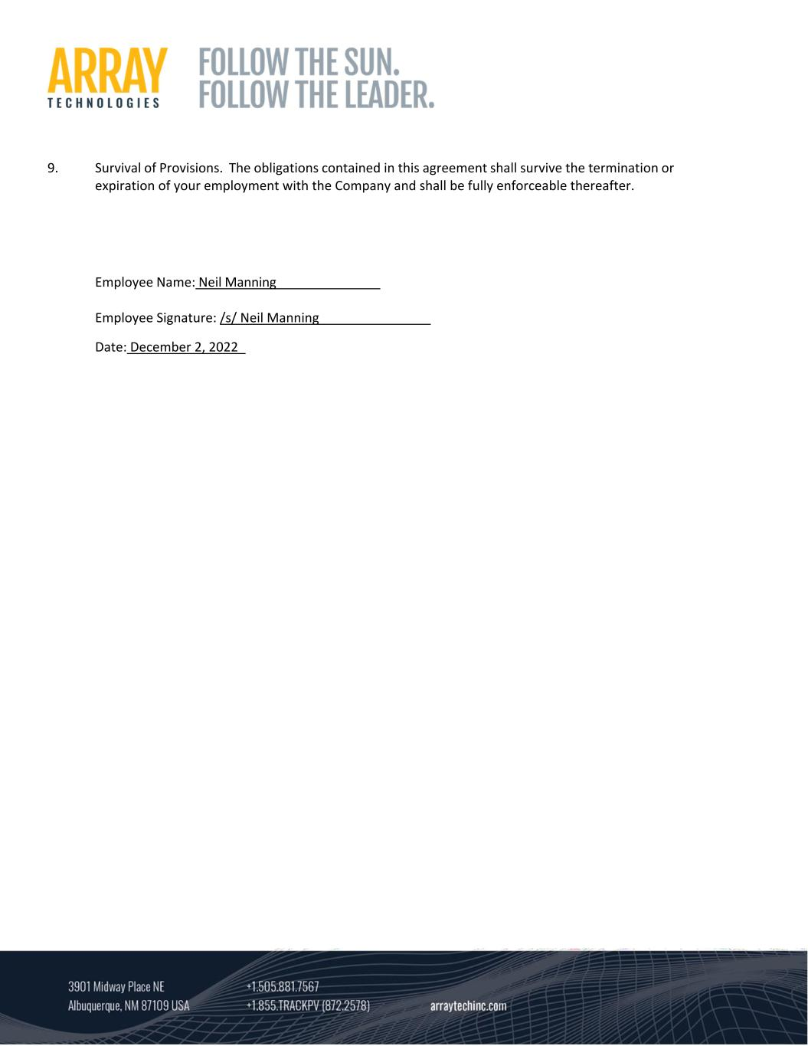
9. Survival of Provisions. The obligations contained in this agreement shall survive the termination or expiration of your employment with the Company and shall be fully enforceable thereafter. Employee Name: Neil Manning Employee Signature: /s/ Neil Manning Date: December 2, 2022

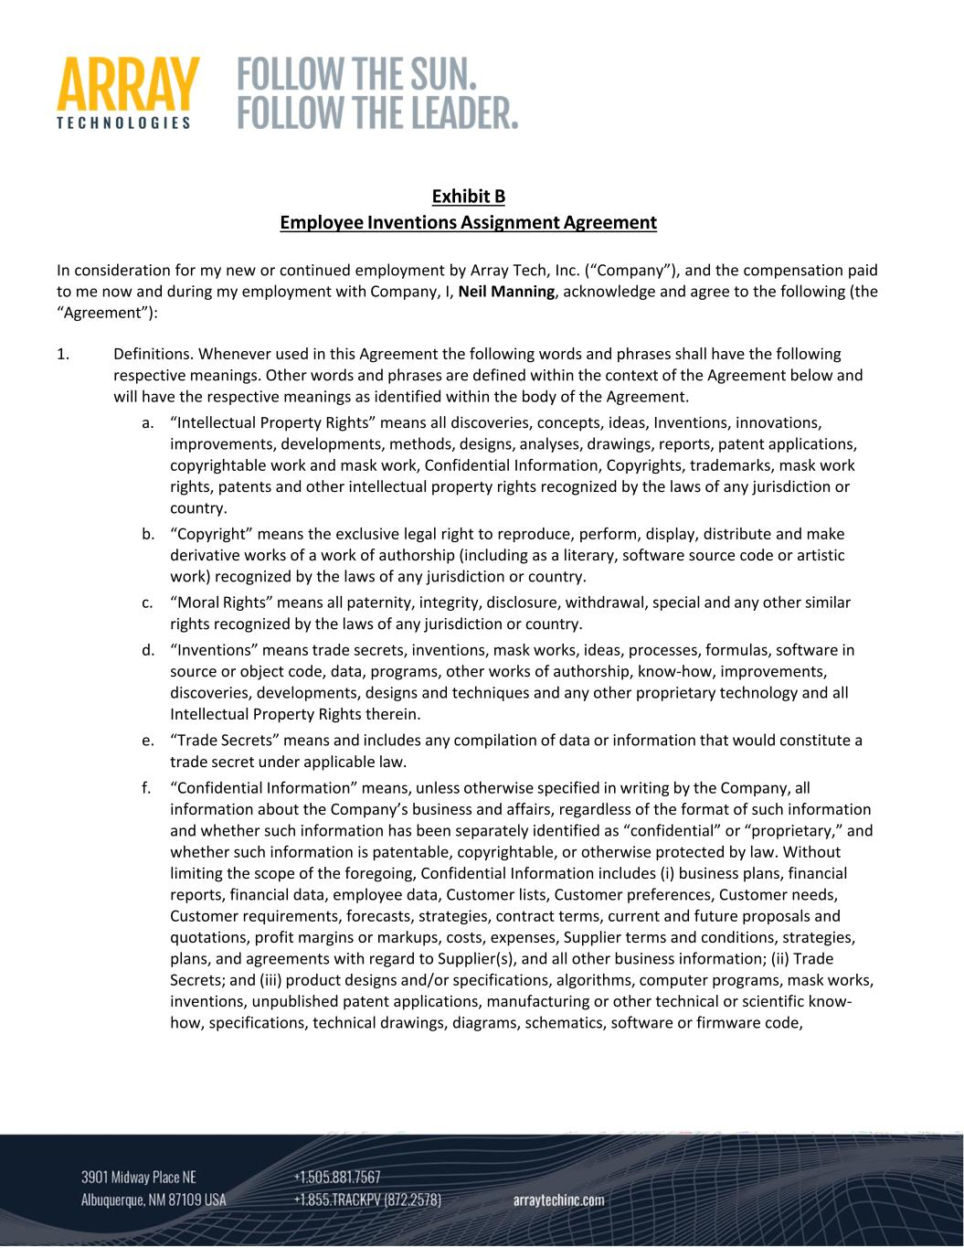
Exhibit B Employee Inventions Assignment Agreement In consideration for my new or continued employment by Array Tech, Inc. (“Company”), and the compensation paid to me now and during my employment with Company, I, Neil Manning, acknowledge and agree to the following (the “Agreement”): 1. Definitions. Whenever used in this Agreement the following words and phrases shall have the following respective meanings. Other words and phrases are defined within the context of the Agreement below and will have the respective meanings as identified within the body of the Agreement. a. “Intellectual Property Rights” means all discoveries, concepts, ideas, Inventions, innovations, improvements, developments, methods, designs, analyses, drawings, reports, patent applications, copyrightable work and mask work, Confidential Information, Copyrights, trademarks, mask work rights, patents and other intellectual property rights recognized by the laws of any jurisdiction or country. b. “Copyright” means the exclusive legal right to reproduce, perform, display, distribute and make derivative works of a work of authorship (including as a literary, software source code or artistic work) recognized by the laws of any jurisdiction or country. c. “Moral Rights” means all paternity, integrity, disclosure, withdrawal, special and any other similar rights recognized by the laws of any jurisdiction or country. d. “Inventions” means trade secrets, inventions, mask works, ideas, processes, formulas, software in source or object code, data, programs, other works of authorship, know‐how, improvements, discoveries, developments, designs and techniques and any other proprietary technology and all Intellectual Property Rights therein. e. “Trade Secrets” means and includes any compilation of data or information that would constitute a trade secret under applicable law. f. “Confidential Information” means, unless otherwise specified in writing by the Company, all information about the Company’s business and affairs, regardless of the format of such information and whether such information has been separately identified as “confidential” or “proprietary,” and whether such information is patentable, copyrightable, or otherwise protected by law. Without limiting the scope of the foregoing, Confidential Information includes (i) business plans, financial reports, financial data, employee data, Customer lists, Customer preferences, Customer needs, Customer requirements, forecasts, strategies, contract terms, current and future proposals and quotations, profit margins or markups, costs, expenses, Supplier terms and conditions, strategies, plans, and agreements with regard to Supplier(s), and all other business information; (ii) Trade Secrets; and (iii) product designs and/or specifications, algorithms, computer programs, mask works, inventions, unpublished patent applications, manufacturing or other technical or scientific know‐ how, specifications, technical drawings, diagrams, schematics, software or firmware code,

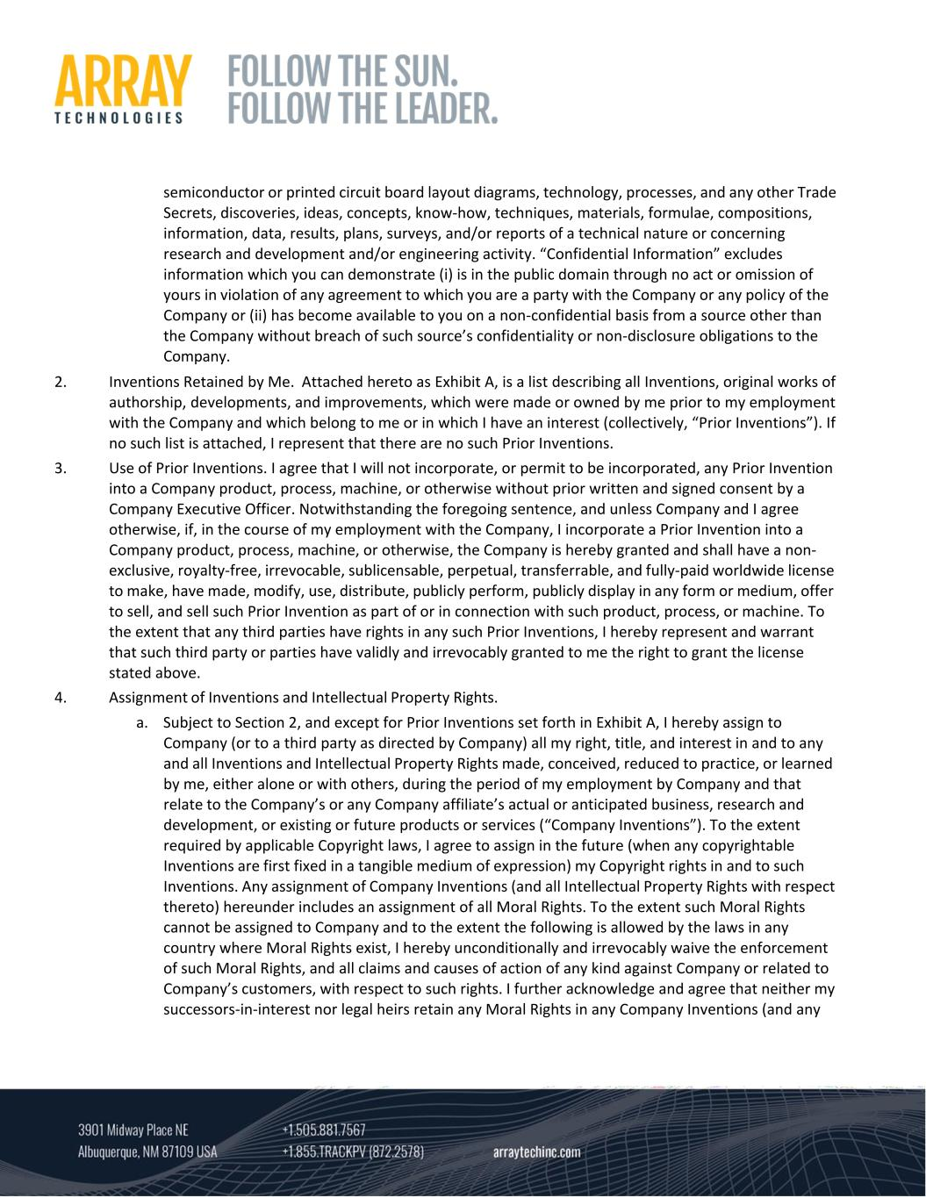
semiconductor or printed circuit board layout diagrams, technology, processes, and any other Trade Secrets, discoveries, ideas, concepts, know‐how, techniques, materials, formulae, compositions, information, data, results, plans, surveys, and/or reports of a technical nature or concerning research and development and/or engineering activity. “Confidential Information” excludes information which you can demonstrate (i) is in the public domain through no act or omission of yours in violation of any agreement to which you are a party with the Company or any policy of the Company or (ii) has become available to you on a non‐confidential basis from a source other than the Company without breach of such source’s confidentiality or non‐disclosure obligations to the Company. 2. Inventions Retained by Me. Attached hereto as Exhibit A, is a list describing all Inventions, original works of authorship, developments, and improvements, which were made or owned by me prior to my employment with the Company and which belong to me or in which I have an interest (collectively, “Prior Inventions”). If no such list is attached, I represent that there are no such Prior Inventions. 3. Use of Prior Inventions. I agree that I will not incorporate, or permit to be incorporated, any Prior Invention into a Company product, process, machine, or otherwise without prior written and signed consent by a Company Executive Officer. Notwithstanding the foregoing sentence, and unless Company and I agree otherwise, if, in the course of my employment with the Company, I incorporate a Prior Invention into a Company product, process, machine, or otherwise, the Company is hereby granted and shall have a non‐ exclusive, royalty‐free, irrevocable, sublicensable, perpetual, transferrable, and fully‐paid worldwide license to make, have made, modify, use, distribute, publicly perform, publicly display in any form or medium, offer to sell, and sell such Prior Invention as part of or in connection with such product, process, or machine. To the extent that any third parties have rights in any such Prior Inventions, I hereby represent and warrant that such third party or parties have validly and irrevocably granted to me the right to grant the license stated above. 4. Assignment of Inventions and Intellectual Property Rights. a. Subject to Section 2, and except for Prior Inventions set forth in Exhibit A, I hereby assign to Company (or to a third party as directed by Company) all my right, title, and interest in and to any and all Inventions and Intellectual Property Rights made, conceived, reduced to practice, or learned by me, either alone or with others, during the period of my employment by Company and that relate to the Company’s or any Company affiliate’s actual or anticipated business, research and development, or existing or future products or services (“Company Inventions”). To the extent required by applicable Copyright laws, I agree to assign in the future (when any copyrightable Inventions are first fixed in a tangible medium of expression) my Copyright rights in and to such Inventions. Any assignment of Company Inventions (and all Intellectual Property Rights with respect thereto) hereunder includes an assignment of all Moral Rights. To the extent such Moral Rights cannot be assigned to Company and to the extent the following is allowed by the laws in any country where Moral Rights exist, I hereby unconditionally and irrevocably waive the enforcement of such Moral Rights, and all claims and causes of action of any kind against Company or related to Company’s customers, with respect to such rights. I further acknowledge and agree that neither my successors‐in‐interest nor legal heirs retain any Moral Rights in any Company Inventions (and any

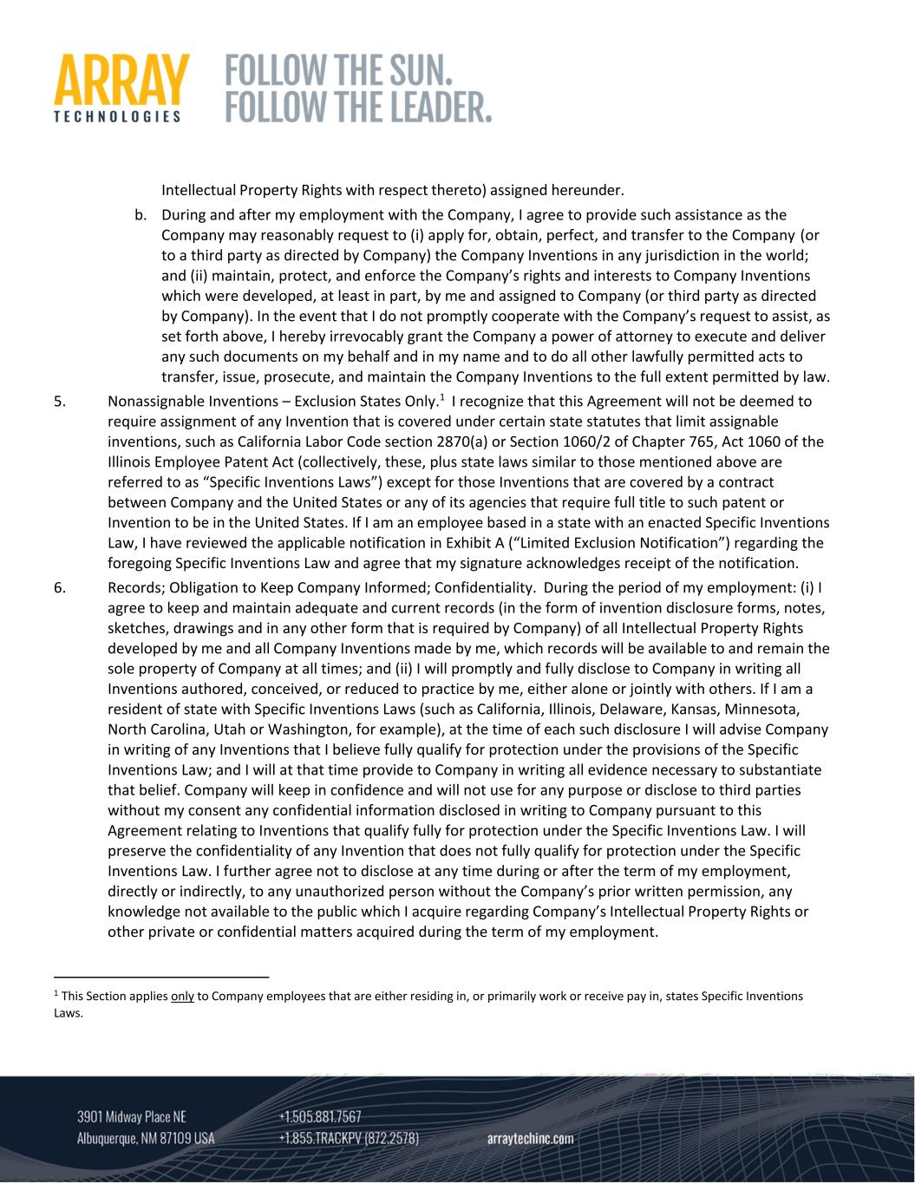
Intellectual Property Rights with respect thereto) assigned hereunder. b. During and after my employment with the Company, I agree to provide such assistance as the Company may reasonably request to (i) apply for, obtain, perfect, and transfer to the Company (or to a third party as directed by Company) the Company Inventions in any jurisdiction in the world; and (ii) maintain, protect, and enforce the Company’s rights and interests to Company Inventions which were developed, at least in part, by me and assigned to Company (or third party as directed by Company). In the event that I do not promptly cooperate with the Company’s request to assist, as set forth above, I hereby irrevocably grant the Company a power of attorney to execute and deliver any such documents on my behalf and in my name and to do all other lawfully permitted acts to transfer, issue, prosecute, and maintain the Company Inventions to the full extent permitted by law. 5. Nonassignable Inventions – Exclusion States Only.1 I recognize that this Agreement will not be deemed to require assignment of any Invention that is covered under certain state statutes that limit assignable inventions, such as California Labor Code section 2870(a) or Section 1060/2 of Chapter 765, Act 1060 of the Illinois Employee Patent Act (collectively, these, plus state laws similar to those mentioned above are referred to as “Specific Inventions Laws”) except for those Inventions that are covered by a contract between Company and the United States or any of its agencies that require full title to such patent or Invention to be in the United States. If I am an employee based in a state with an enacted Specific Inventions Law, I have reviewed the applicable notification in Exhibit A (“Limited Exclusion Notification”) regarding the foregoing Specific Inventions Law and agree that my signature acknowledges receipt of the notification. 6. Records; Obligation to Keep Company Informed; Confidentiality. During the period of my employment: (i) I agree to keep and maintain adequate and current records (in the form of invention disclosure forms, notes, sketches, drawings and in any other form that is required by Company) of all Intellectual Property Rights developed by me and all Company Inventions made by me, which records will be available to and remain the sole property of Company at all times; and (ii) I will promptly and fully disclose to Company in writing all Inventions authored, conceived, or reduced to practice by me, either alone or jointly with others. If I am a resident of state with Specific Inventions Laws (such as California, Illinois, Delaware, Kansas, Minnesota, North Carolina, Utah or Washington, for example), at the time of each such disclosure I will advise Company in writing of any Inventions that I believe fully qualify for protection under the provisions of the Specific Inventions Law; and I will at that time provide to Company in writing all evidence necessary to substantiate that belief. Company will keep in confidence and will not use for any purpose or disclose to third parties without my consent any confidential information disclosed in writing to Company pursuant to this Agreement relating to Inventions that qualify fully for protection under the Specific Inventions Law. I will preserve the confidentiality of any Invention that does not fully qualify for protection under the Specific Inventions Law. I further agree not to disclose at any time during or after the term of my employment, directly or indirectly, to any unauthorized person without the Company’s prior written permission, any knowledge not available to the public which I acquire regarding Company’s Intellectual Property Rights or other private or confidential matters acquired during the term of my employment. 1 This Section applies only to Company employees that are either residing in, or primarily work or receive pay in, states Specific Inventions Laws.

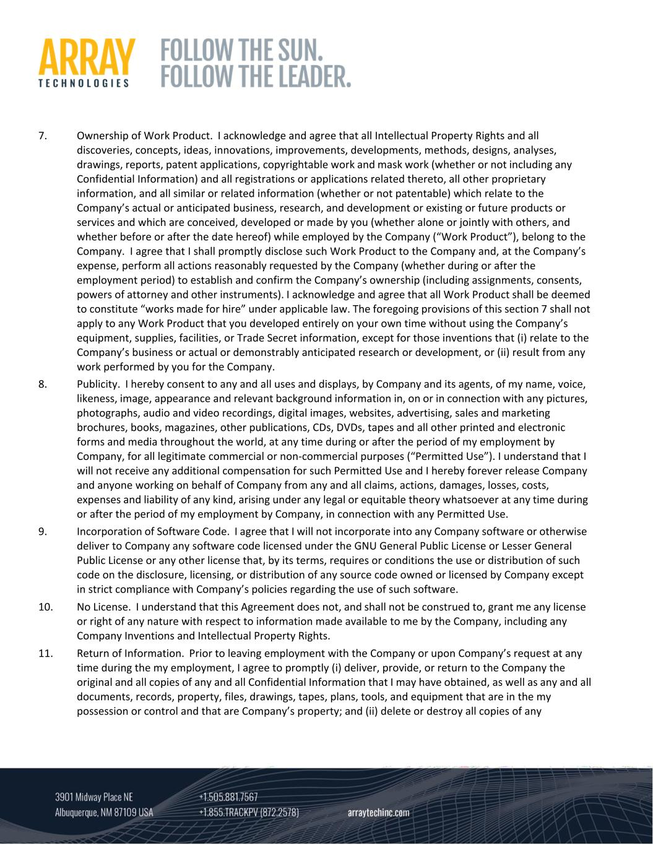
7. Ownership of Work Product. I acknowledge and agree that all Intellectual Property Rights and all discoveries, concepts, ideas, innovations, improvements, developments, methods, designs, analyses, drawings, reports, patent applications, copyrightable work and mask work (whether or not including any Confidential Information) and all registrations or applications related thereto, all other proprietary information, and all similar or related information (whether or not patentable) which relate to the Company’s actual or anticipated business, research, and development or existing or future products or services and which are conceived, developed or made by you (whether alone or jointly with others, and whether before or after the date hereof) while employed by the Company (“Work Product”), belong to the Company. I agree that I shall promptly disclose such Work Product to the Company and, at the Company’s expense, perform all actions reasonably requested by the Company (whether during or after the employment period) to establish and confirm the Company’s ownership (including assignments, consents, powers of attorney and other instruments). I acknowledge and agree that all Work Product shall be deemed to constitute “works made for hire” under applicable law. The foregoing provisions of this section 7 shall not apply to any Work Product that you developed entirely on your own time without using the Company’s equipment, supplies, facilities, or Trade Secret information, except for those inventions that (i) relate to the Company’s business or actual or demonstrably anticipated research or development, or (ii) result from any work performed by you for the Company. 8. Publicity. I hereby consent to any and all uses and displays, by Company and its agents, of my name, voice, likeness, image, appearance and relevant background information in, on or in connection with any pictures, photographs, audio and video recordings, digital images, websites, advertising, sales and marketing brochures, books, magazines, other publications, CDs, DVDs, tapes and all other printed and electronic forms and media throughout the world, at any time during or after the period of my employment by Company, for all legitimate commercial or non‐commercial purposes (“Permitted Use”). I understand that I will not receive any additional compensation for such Permitted Use and I hereby forever release Company and anyone working on behalf of Company from any and all claims, actions, damages, losses, costs, expenses and liability of any kind, arising under any legal or equitable theory whatsoever at any time during or after the period of my employment by Company, in connection with any Permitted Use. 9. Incorporation of Software Code. I agree that I will not incorporate into any Company software or otherwise deliver to Company any software code licensed under the GNU General Public License or Lesser General Public License or any other license that, by its terms, requires or conditions the use or distribution of such code on the disclosure, licensing, or distribution of any source code owned or licensed by Company except in strict compliance with Company’s policies regarding the use of such software. 10. No License. I understand that this Agreement does not, and shall not be construed to, grant me any license or right of any nature with respect to information made available to me by the Company, including any Company Inventions and Intellectual Property Rights. 11. Return of Information. Prior to leaving employment with the Company or upon Company’s request at any time during the my employment, I agree to promptly (i) deliver, provide, or return to the Company the original and all copies of any and all Confidential Information that I may have obtained, as well as any and all documents, records, property, files, drawings, tapes, plans, tools, and equipment that are in the my possession or control and that are Company’s property; and (ii) delete or destroy all copies of any

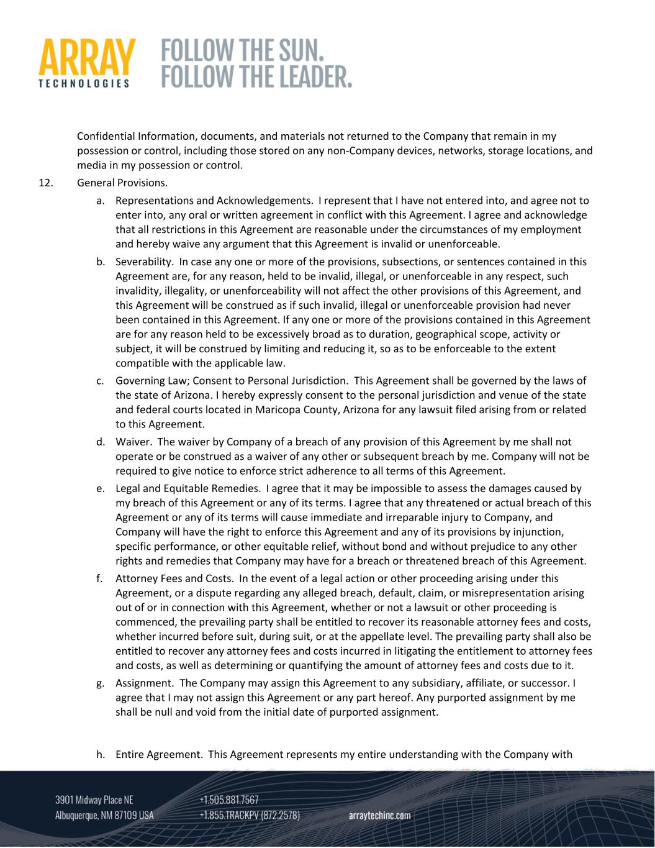
Confidential Information, documents, and materials not returned to the Company that remain in my possession or control, including those stored on any non‐Company devices, networks, storage locations, and media in my possession or control. 12. General Provisions. a. Representations and Acknowledgements. I represent that I have not entered into, and agree not to enter into, any oral or written agreement in conflict with this Agreement. I agree and acknowledge that all restrictions in this Agreement are reasonable under the circumstances of my employment and hereby waive any argument that this Agreement is invalid or unenforceable. b. Severability. In case any one or more of the provisions, subsections, or sentences contained in this Agreement are, for any reason, held to be invalid, illegal, or unenforceable in any respect, such invalidity, illegality, or unenforceability will not affect the other provisions of this Agreement, and this Agreement will be construed as if such invalid, illegal or unenforceable provision had never been contained in this Agreement. If any one or more of the provisions contained in this Agreement are for any reason held to be excessively broad as to duration, geographical scope, activity or subject, it will be construed by limiting and reducing it, so as to be enforceable to the extent compatible with the applicable law. c. Governing Law; Consent to Personal Jurisdiction. This Agreement shall be governed by the laws of the state of Arizona. I hereby expressly consent to the personal jurisdiction and venue of the state and federal courts located in Maricopa County, Arizona for any lawsuit filed arising from or related to this Agreement. d. Waiver. The waiver by Company of a breach of any provision of this Agreement by me shall not operate or be construed as a waiver of any other or subsequent breach by me. Company will not be required to give notice to enforce strict adherence to all terms of this Agreement. e. Legal and Equitable Remedies. I agree that it may be impossible to assess the damages caused by my breach of this Agreement or any of its terms. I agree that any threatened or actual breach of this Agreement or any of its terms will cause immediate and irreparable injury to Company, and Company will have the right to enforce this Agreement and any of its provisions by injunction, specific performance, or other equitable relief, without bond and without prejudice to any other rights and remedies that Company may have for a breach or threatened breach of this Agreement. f. Attorney Fees and Costs. In the event of a legal action or other proceeding arising under this Agreement, or a dispute regarding any alleged breach, default, claim, or misrepresentation arising out of or in connection with this Agreement, whether or not a lawsuit or other proceeding is commenced, the prevailing party shall be entitled to recover its reasonable attorney fees and costs, whether incurred before suit, during suit, or at the appellate level. The prevailing party shall also be entitled to recover any attorney fees and costs incurred in litigating the entitlement to attorney fees and costs, as well as determining or quantifying the amount of attorney fees and costs due to it. g. Assignment. The Company may assign this Agreement to any subsidiary, affiliate, or successor. I agree that I may not assign this Agreement or any part hereof. Any purported assignment by me shall be null and void from the initial date of purported assignment. h. Entire Agreement. This Agreement represents my entire understanding with the Company with

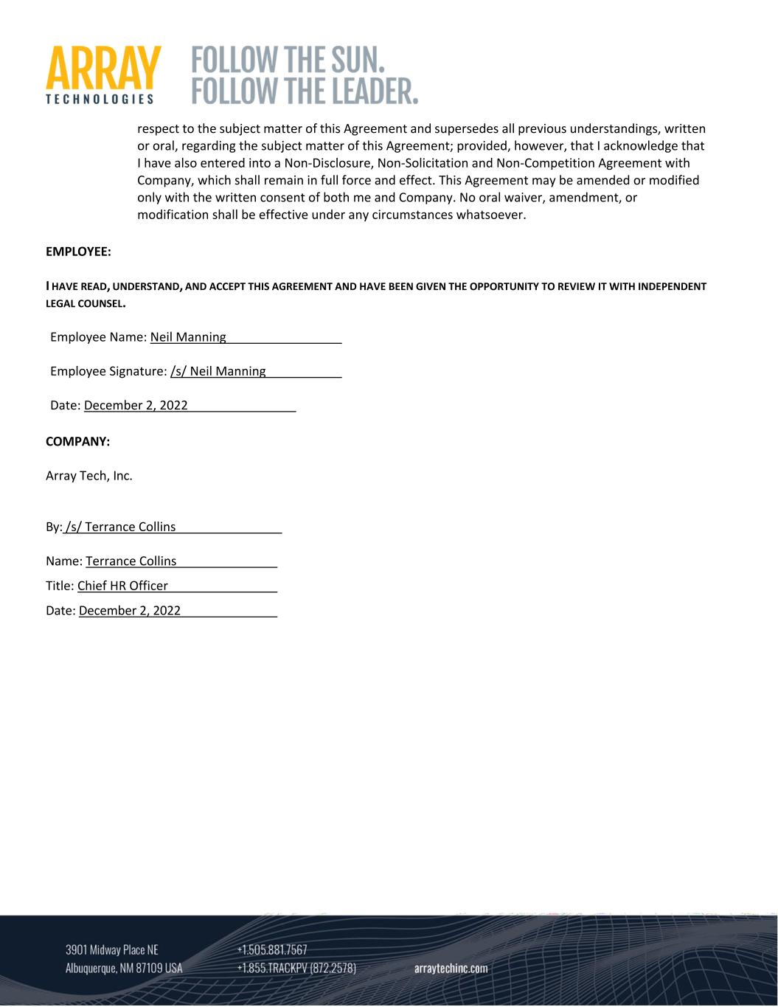
respect to the subject matter of this Agreement and supersedes all previous understandings, written or oral, regarding the subject matter of this Agreement; provided, however, that I acknowledge that I have also entered into a Non‐Disclosure, Non‐Solicitation and Non‐Competition Agreement with Company, which shall remain in full force and effect. This Agreement may be amended or modified only with the written consent of both me and Company. No oral waiver, amendment, or modification shall be effective under any circumstances whatsoever. EMPLOYEE: I HAVE READ, UNDERSTAND, AND ACCEPT THIS AGREEMENT AND HAVE BEEN GIVEN THE OPPORTUNITY TO REVIEW IT WITH INDEPENDENT LEGAL COUNSEL. Employee Name: Neil Manning Employee Signature: /s/ Neil Manning Date: December 2, 2022 COMPANY: Array Tech, Inc. By: /s/ Terrance Collins Name: Terrance Collins Title: Chief HR Officer Date: December 2, 2022

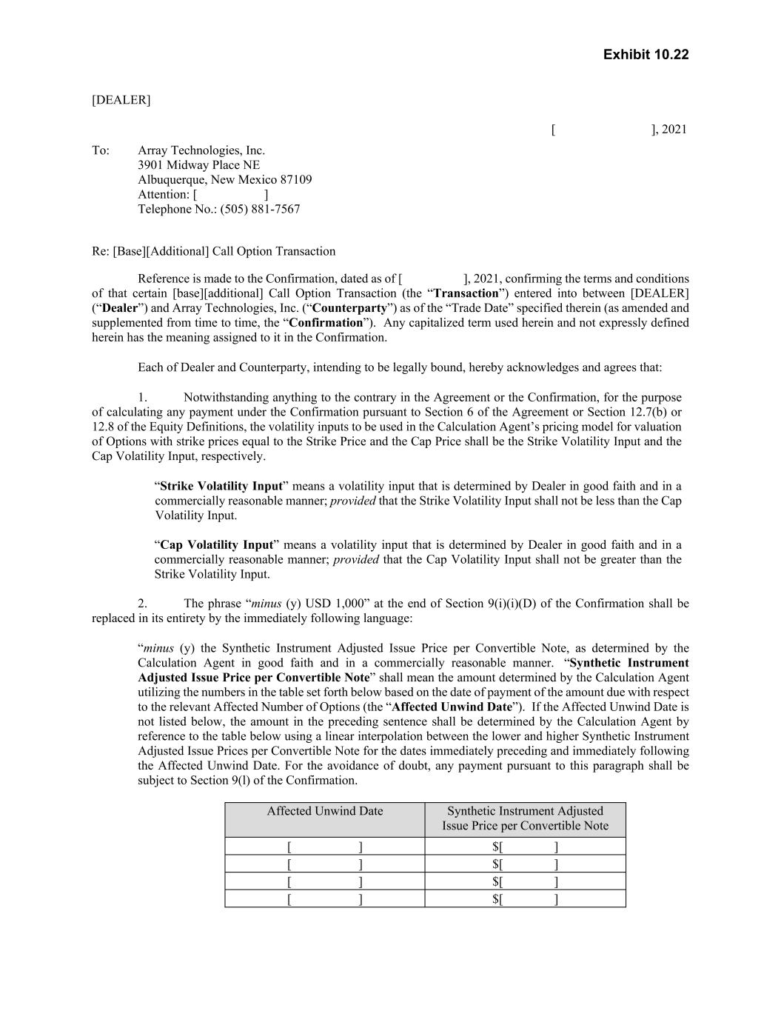
Exhibit 10.22 [DEALER] [ ], 2021 To: Array Technologies, Inc. 3901 Midway Place NE Albuquerque, New Mexico 87109 Attention: [ ] Telephone No.: (505) 881-7567 Re: [Base][Additional] Call Option Transaction Reference is made to the Confirmation, dated as of [ ], 2021, confirming the terms and conditions of that certain [base][additional] Call Option Transaction (the “Transaction”) entered into between [DEALER] (“Dealer”) and Array Technologies, Inc. (“Counterparty”) as of the “Trade Date” specified therein (as amended and supplemented from time to time, the “Confirmation”). Any capitalized term used herein and not expressly defined herein has the meaning assigned to it in the Confirmation. Each of Dealer and Counterparty, intending to be legally bound, hereby acknowledges and agrees that: 1. Notwithstanding anything to the contrary in the Agreement or the Confirmation, for the purpose of calculating any payment under the Confirmation pursuant to Section 6 of the Agreement or Section 12.7(b) or 12.8 of the Equity Definitions, the volatility inputs to be used in the Calculation Agent’s pricing model for valuation of Options with strike prices equal to the Strike Price and the Cap Price shall be the Strike Volatility Input and the Cap Volatility Input, respectively. “Strike Volatility Input” means a volatility input that is determined by Dealer in good faith and in a commercially reasonable manner; provided that the Strike Volatility Input shall not be less than the Cap Volatility Input. “Cap Volatility Input” means a volatility input that is determined by Dealer in good faith and in a commercially reasonable manner; provided that the Cap Volatility Input shall not be greater than the Strike Volatility Input. 2. The phrase “minus (y) USD 1,000” at the end of Section 9(i)(i)(D) of the Confirmation shall be replaced in its entirety by the immediately following language: “minus (y) the Synthetic Instrument Adjusted Issue Price per Convertible Note, as determined by the Calculation Agent in good faith and in a commercially reasonable manner. “Synthetic Instrument Adjusted Issue Price per Convertible Note” shall mean the amount determined by the Calculation Agent utilizing the numbers in the table set forth below based on the date of payment of the amount due with respect to the relevant Affected Number of Options (the “Affected Unwind Date”). If the Affected Unwind Date is not listed below, the amount in the preceding sentence shall be determined by the Calculation Agent by reference to the table below using a linear interpolation between the lower and higher Synthetic Instrument Adjusted Issue Prices per Convertible Note for the dates immediately preceding and immediately following the Affected Unwind Date. For the avoidance of doubt, any payment pursuant to this paragraph shall be subject to Section 9(l) of the Confirmation. Affected Unwind Date Synthetic Instrument Adjusted Issue Price per Convertible Note [ ] $[ ] [ ] $[ ] [ ] $[ ] [ ] $[ ]

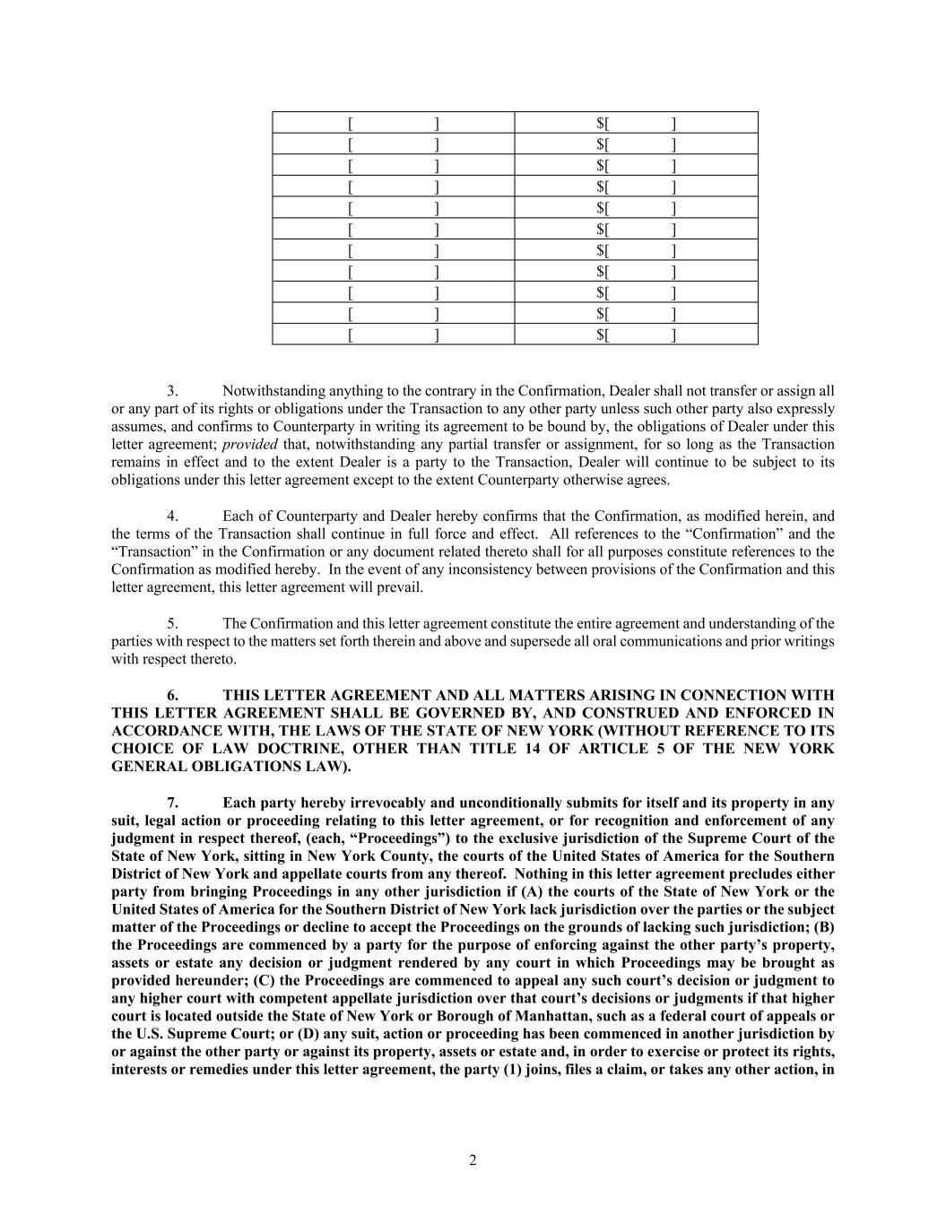
2 [ ] $[ ] [ ] $[ ] [ ] $[ ] [ ] $[ ] [ ] $[ ] [ ] $[ ] [ ] $[ ] [ ] $[ ] [ ] $[ ] [ ] $[ ] [ ] $[ ] 3. Notwithstanding anything to the contrary in the Confirmation, Dealer shall not transfer or assign all or any part of its rights or obligations under the Transaction to any other party unless such other party also expressly assumes, and confirms to Counterparty in writing its agreement to be bound by, the obligations of Dealer under this letter agreement; provided that, notwithstanding any partial transfer or assignment, for so long as the Transaction remains in effect and to the extent Dealer is a party to the Transaction, Dealer will continue to be subject to its obligations under this letter agreement except to the extent Counterparty otherwise agrees. 4. Each of Counterparty and Dealer hereby confirms that the Confirmation, as modified herein, and the terms of the Transaction shall continue in full force and effect. All references to the “Confirmation” and the “Transaction” in the Confirmation or any document related thereto shall for all purposes constitute references to the Confirmation as modified hereby. In the event of any inconsistency between provisions of the Confirmation and this letter agreement, this letter agreement will prevail. 5. The Confirmation and this letter agreement constitute the entire agreement and understanding of the parties with respect to the matters set forth therein and above and supersede all oral communications and prior writings with respect thereto. 6. THIS LETTER AGREEMENT AND ALL MATTERS ARISING IN CONNECTION WITH THIS LETTER AGREEMENT SHALL BE GOVERNED BY, AND CONSTRUED AND ENFORCED IN ACCORDANCE WITH, THE LAWS OF THE STATE OF NEW YORK (WITHOUT REFERENCE TO ITS CHOICE OF LAW DOCTRINE, OTHER THAN TITLE 14 OF ARTICLE 5 OF THE NEW YORK GENERAL OBLIGATIONS LAW). 7. Each party hereby irrevocably and unconditionally submits for itself and its property in any suit, legal action or proceeding relating to this letter agreement, or for recognition and enforcement of any judgment in respect thereof, (each, “Proceedings”) to the exclusive jurisdiction of the Supreme Court of the State of New York, sitting in New York County, the courts of the United States of America for the Southern District of New York and appellate courts from any thereof. Nothing in this letter agreement precludes either party from bringing Proceedings in any other jurisdiction if (A) the courts of the State of New York or the United States of America for the Southern District of New York lack jurisdiction over the parties or the subject matter of the Proceedings or decline to accept the Proceedings on the grounds of lacking such jurisdiction; (B) the Proceedings are commenced by a party for the purpose of enforcing against the other party’s property, assets or estate any decision or judgment rendered by any court in which Proceedings may be brought as provided hereunder; (C) the Proceedings are commenced to appeal any such court’s decision or judgment to any higher court with competent appellate jurisdiction over that court’s decisions or judgments if that higher court is located outside the State of New York or Borough of Manhattan, such as a federal court of appeals or the U.S. Supreme Court; or (D) any suit, action or proceeding has been commenced in another jurisdiction by or against the other party or against its property, assets or estate and, in order to exercise or protect its rights, interests or remedies under this letter agreement, the party (1) joins, files a claim, or takes any other action, in

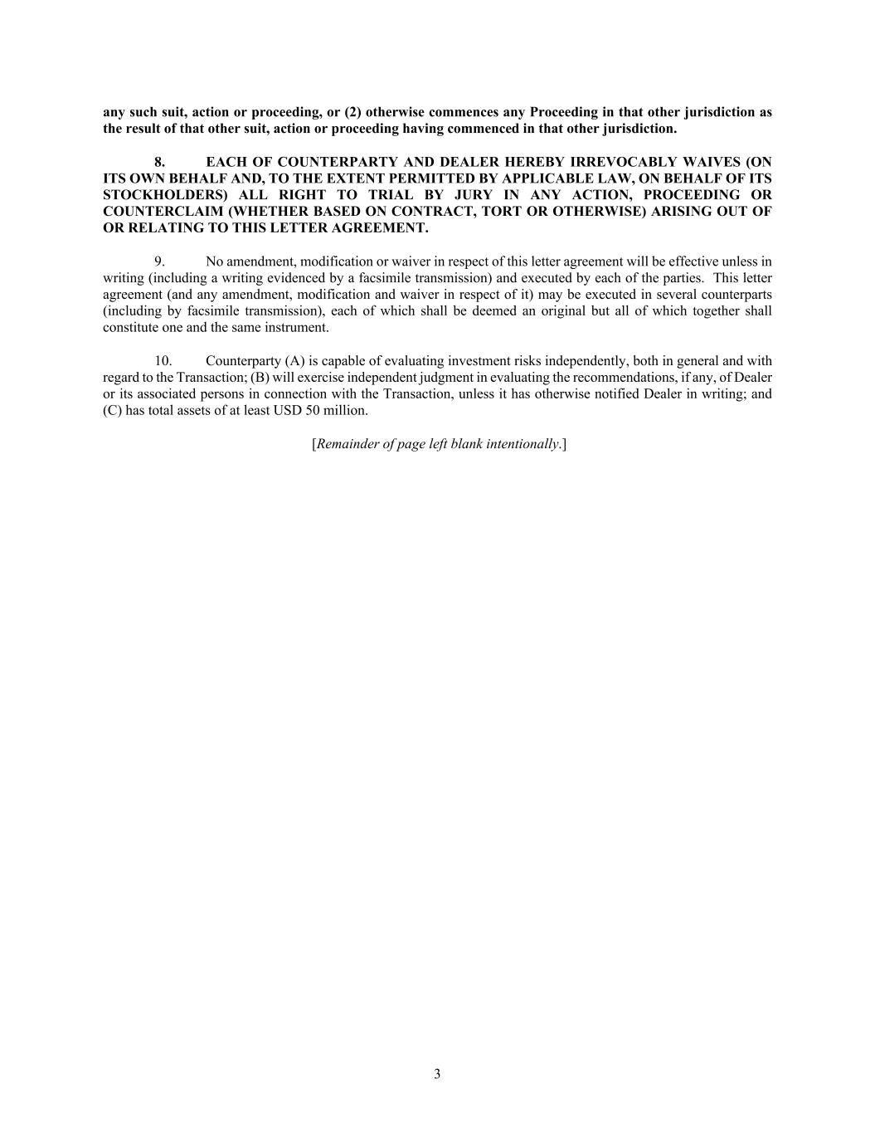
3 any such suit, action or proceeding, or (2) otherwise commences any Proceeding in that other jurisdiction as the result of that other suit, action or proceeding having commenced in that other jurisdiction. 8. EACH OF COUNTERPARTY AND DEALER HEREBY IRREVOCABLY WAIVES (ON ITS OWN BEHALF AND, TO THE EXTENT PERMITTED BY APPLICABLE LAW, ON BEHALF OF ITS STOCKHOLDERS) ALL RIGHT TO TRIAL BY JURY IN ANY ACTION, PROCEEDING OR COUNTERCLAIM (WHETHER BASED ON CONTRACT, TORT OR OTHERWISE) ARISING OUT OF OR RELATING TO THIS LETTER AGREEMENT. 9. No amendment, modification or waiver in respect of this letter agreement will be effective unless in writing (including a writing evidenced by a facsimile transmission) and executed by each of the parties. This letter agreement (and any amendment, modification and waiver in respect of it) may be executed in several counterparts (including by facsimile transmission), each of which shall be deemed an original but all of which together shall constitute one and the same instrument. 10. Counterparty (A) is capable of evaluating investment risks independently, both in general and with regard to the Transaction; (B) will exercise independent judgment in evaluating the recommendations, if any, of Dealer or its associated persons in connection with the Transaction, unless it has otherwise notified Dealer in writing; and (C) has total assets of at least USD 50 million. [Remainder of page left blank intentionally.]


[Signature Page to Base Capped Call Side Letter] Please confirm that the foregoing correctly sets forth the terms of our agreement by executing this letter agreement and returning it to Dealer. Very truly yours, [DEALER] By: Name: Title:


[Signature Page to Base Capped Call Side Letter] Accepted and confirmed as of the date first written above: Array Technologies, Inc. By: Name: Title:

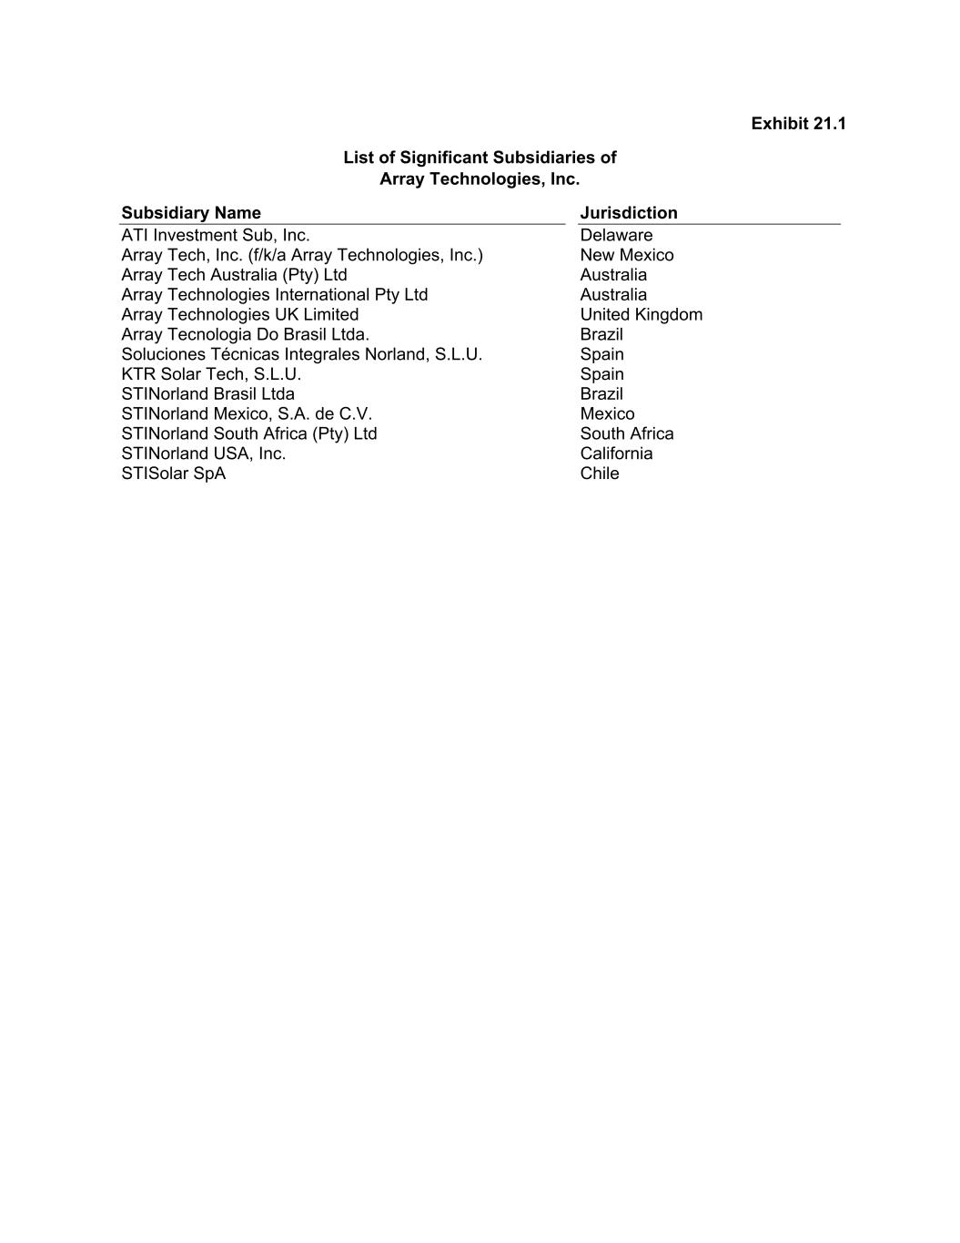
Exhibit 21.1 List of Significant Subsidiaries of Array Technologies, Inc. Subsidiary Name Jurisdiction ATI Investment Sub, Inc. Delaware Array Tech, Inc. (f/k/a Array Technologies, Inc.) New Mexico Array Tech Australia (Pty) Ltd Australia Array Technologies International Pty Ltd Australia Array Technologies UK Limited United Kingdom Array Tecnologia Do Brasil Ltda. Brazil Soluciones Técnicas Integrales Norland, S.L.U. Spain KTR Solar Tech, S.L.U. Spain STINorland Brasil Ltda Brazil STINorland Mexico, S.A. de C.V. Mexico STINorland South Africa (Pty) Ltd South Africa STINorland USA, Inc. California STISolar SpA Chile

Exhibit 23.1

CONSENT OF INDEPENDENT REGISTERED PUBLIC ACCOUNTING FIRM

We consent to the incorporation by reference in Registration Statement Nos. 333-265884 and 333-249552 on Form S-8 of our reports dated February 27, 2024, relating to the financial statements of Array Technologies, Inc. and the effectiveness of Array Technologies, Inc.'s internal control over financial reporting appearing in this Annual Report on Form 10-K for the year ended December 31, 2023.

/s/ DELOITTE & TOUCHE LLP
Tempe, Arizona
February 27, 2024

Exhibit 23.2

CONSENT OF INDEPENDENT REGISTERED PUBLIC ACCOUNTING FIRM

We hereby consent to the incorporation by reference in the Registration Statements on Form S-8 (No. 333-249552 and 333-265884) of Array Technologies, Inc. of our report dated March 22, 2023, relating to the consolidated financial statements which appear in this Form 10-K.

/s/ BDO USA, P.C.
Austin, Texas
February 27, 2024

EXHIBIT 31.1

CERTIFICATION BY CHIEF EXECUTIVE OFFICER PURSUANT TO
RULE 13a-14(a) AND 15d-14(a) UNDER THE EXCHANGE ACT

I, Kevin G. Hostetler, certify that:

1.I have reviewed this Annual Report on Form 10-K of Array Technologies, Inc.;

2.Based on my knowledge, this report does not contain any untrue statement of a material fact or omit to state a material fact necessary to make the statements made, in light of the circumstances under which such statements were made, not misleading with respect to the period covered by this report;

3.Based on my knowledge, the financial statements, and other financial information included in this report, fairly present in all material respects the financial condition, results of operations and cash flows of the registrant as of, and for, the periods presented in this report;

4.The registrant’s other certifying officer and I are responsible for establishing and maintaining disclosure controls and procedures (as defined in Exchange Act Rules 13a-15(e) and 15d-15(e)) and internal control over financial reporting (as defined in Exchange Act Rules 13a-15(f) and 15d-15(f)) for the registrant and have:

a)designed such disclosure controls and procedures, or caused such disclosure controls and procedures to be designed under our supervision, to ensure that material information relating to the registrant, including its consolidated subsidiaries, is made known to us by others within those entities, particularly during the period in which this report is being prepared;

b)designed such internal control over financial reporting, or caused such internal control over financial reporting to be designed under our supervision, to provide reasonable assurance regarding the reliability of financial reporting and the preparation of financial statements for external purposes in accordance with generally accepted accounting principles;

c)evaluated the effectiveness of the registrant’s disclosure controls and procedures and presented in this report our conclusions about the effectiveness of the disclosure controls and procedures, as of the end of the period covered by this report based on such evaluation; and

d)disclosed in this report any change in the registrant’s internal control over financial reporting that occurred during the registrant’s most recent fiscal quarter (the registrant’s fourth fiscal quarter in the case of an annual report) that has materially affected, or is reasonably likely to materially affect, the registrant’s internal control over financial reporting; and

5.The registrant’s other certifying officer and I have disclosed, based on our most recent evaluation of internal control over financial reporting, to the registrant’s auditors and the audit committee of the registrant’s board of directors (or persons performing the equivalent functions):

a)all significant deficiencies and material weaknesses in the design or operation of internal control over financial reporting which are reasonably likely to adversely affect the registrant’s ability to record, process, summarize and report financial information; and

b)any fraud, whether or not material, that involves management or other employees who have a significant role in the registrant’s internal control over financial reporting.

/s/ Kevin G. Hostetler
Kevin G. Hostetler
Chief Executive Officer

Date: February 27, 2024

EXHIBIT 31.2

CERTIFICATION BY CHIEF FINANCIAL OFFICER PURSUANT TO
RULE 13a-14(a) AND 15d-14(a) UNDER THE EXCHANGE ACT

I, Kurt Wood, certify that:

1.I have reviewed this Annual Report on Form 10-K of Array Technologies, Inc.;

2.Based on my knowledge, this report does not contain any untrue statement of a material fact or omit to state a material fact necessary to make the statements made, in light of the circumstances under which such statements were made, not misleading with respect to the period covered by this report;

3.Based on my knowledge, the financial statements, and other financial information included in this report, fairly present in all material respects the financial condition, results of operations and cash flows of the registrant as of, and for, the periods presented in this report;

4.The registrant’s other certifying officer and I are responsible for establishing and maintaining disclosure controls and procedures (as defined in Exchange Act Rules 13a-15(e) and 15d-15(e)) and internal control over financial reporting (as defined in Exchange Act Rules 13a-15(f) and 15d-15(f)) for the registrant and have:

a)designed such disclosure controls and procedures, or caused such disclosure controls and procedures to be designed under our supervision, to ensure that material information relating to the registrant, including its consolidated subsidiaries, is made known to us by others within those entities, particularly during the period in which this report is being prepared;

b)designed such internal control over financial reporting, or caused such internal control over financial reporting to be designed under our supervision, to provide reasonable assurance regarding the reliability of financial reporting and the preparation of financial statements for external purposes in accordance with generally accepted accounting principles;

c)evaluated the effectiveness of the registrant’s disclosure controls and procedures and presented in this report our conclusions about the effectiveness of the disclosure controls and procedures, as of the end of the period covered by this report based on such evaluation; and

d)disclosed in this report any change in the registrant’s internal control over financial reporting that occurred during the registrant’s most recent fiscal quarter (the registrant’s fourth fiscal quarter in the case of an annual report) that has materially affected, or is reasonably likely to materially affect, the registrant’s internal control over financial reporting; and

5.The registrant’s other certifying officer and I have disclosed, based on our most recent evaluation of internal control over financial reporting, to the registrant’s auditors and the audit committee of the registrant’s board of directors (or persons performing the equivalent functions):

a)all significant deficiencies and material weaknesses in the design or operation of internal control over financial reporting which are reasonably likely to adversely affect the registrant’s ability to record, process, summarize and report financial information; and

b)any fraud, whether or not material, that involves management or other employees who have a significant role in the registrant’s internal control over financial reporting.

/s/ Kurt Wood
Kurt Wood
Chief Financial Officer

Date: February 27, 2024

EXHIBIT 32.1

CERTIFICATION BY CHIEF EXECUTIVE OFFICER
PURSUANT TO 18 U.S.C. SECTION 1350,
AS ADOPTED PURSUANT TO
SECTION 906 OF THE SARBANES-OXLEY ACT OF 2002

In connection with this Annual Report of Array Technologies, Inc. (the "Company") filed on Form 10-K for the year ended December 31, 2023, as filed with the Securities and Exchange Commission on the date hereof (the “Report”), I, Kevin G. Hostetler, Chief Executive Officer of the Company, certify, pursuant to 18 U.S.C. Section 1350, as adopted pursuant to Section 906 of the Sarbanes-Oxley Act of 2002, that to my knowledge:

(1)the Report fully complies with the requirements of Section 13(a) or 15(d) of the Securities Exchange Act of 1934, as amended; and

(2)the information contained in the Report fairly presents, in all material respects, the financial condition and results of operations of the Company.

/s/ Kevin G. Hostetler
Kevin G. Hostetler
Chief Executive Officer

Date: February 27, 2024

EXHIBIT 32.2

CERTIFICATION BY CHIEF FINANCIAL OFFICER
PURSUANT TO 18 U.S.C. SECTION 1350,
AS ADOPTED PURSUANT TO
SECTION 906 OF THE SARBANES-OXLEY ACT OF 2002

In connection with this Annual Report of Array Technologies, Inc. (the "Company") filed on Form 10-K for the year ended December 31, 2023, as filed with the Securities and Exchange Commission on the date hereof (the “Report”), I, Kurt Wood, Chief Financial Officer of the Company, certify, pursuant to 18 U.S.C. Section 1350, as adopted pursuant to Section 906 of the Sarbanes-Oxley Act of 2002, that to my knowledge:

(1)the Report fully complies with the requirements of Section 13(a) or 15(d) of the Securities Exchange Act of 1934, as amended; and

(2)the information contained in the Report fairly presents, in all material respects, the financial condition and results of operations of the Company.

/s/ Kurt Wood
Kurt Wood
Chief Financial Officer

Date: February 27, 2024

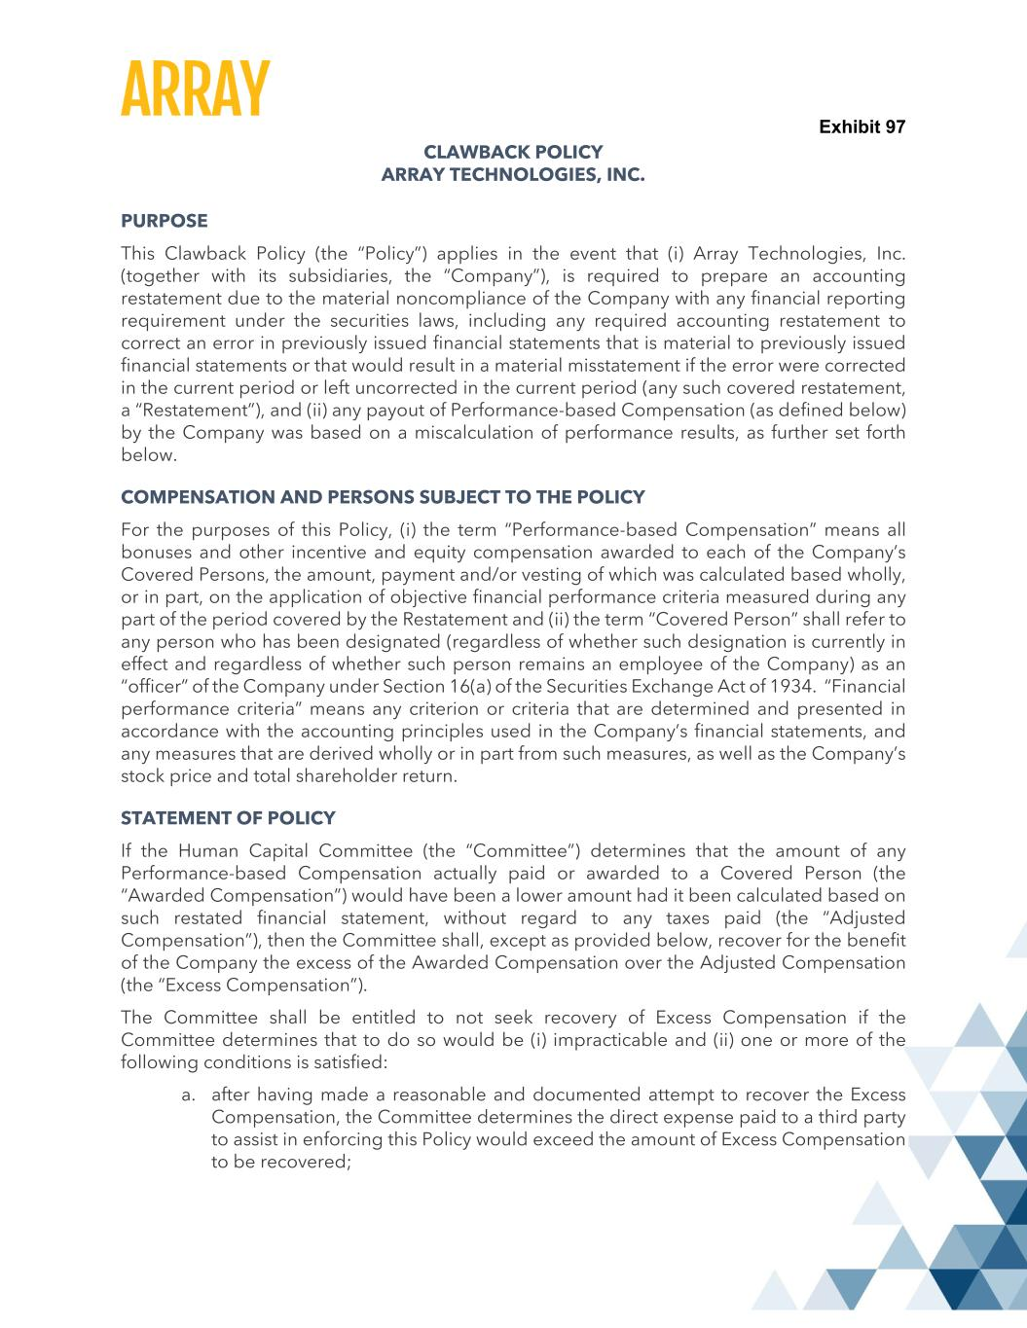

Exhibit 97 CLAWBACK POLICY ARRAY TECHNOLOGIES, INC. PURPOSE This Clawback Policy (the “Policy”) applies in the event that (i) Array Technologies, Inc. (together with its subsidiaries, the “Company”), is required to prepare an accounting restatement due to the material noncompliance of the Company with any financial reporting requirement under the securities laws, including any required accounting restatement to correct an error in previously issued financial statements that is material to previously issued financial statements or that would result in a material misstatement if the error were corrected in the current period or left uncorrected in the current period (any such covered restatement, a “Restatement”), and (ii) any payout of Performance-based Compensation (as defined below) by the Company was based on a miscalculation of performance results, as further set forth below. COMPENSATION AND PERSONS SUBJECT TO THE POLICY For the purposes of this Policy, (i) the term “Performance-based Compensation” means all bonuses and other incentive and equity compensation awarded to each of the Company’s Covered Persons, the amount, payment and/or vesting of which was calculated based wholly, or in part, on the application of objective financial performance criteria measured during any part of the period covered by the Restatement and (ii) the term “Covered Person” shall refer to any person who has been designated (regardless of whether such designation is currently in effect and regardless of whether such person remains an employee of the Company) as an “officer” of the Company under Section 16(a) of the Securities Exchange Act of 1934. “Financial performance criteria” means any criterion or criteria that are determined and presented in accordance with the accounting principles used in the Company’s financial statements, and any measures that are derived wholly or in part from such measures, as well as the Company’s stock price and total shareholder return. STATEMENT OF POLICY If the Human Capital Committee (the “Committee”) determines that the amount of any Performance-based Compensation actually paid or awarded to a Covered Person (the “Awarded Compensation”) would have been a lower amount had it been calculated based on such restated financial statement, without regard to any taxes paid (the “Adjusted Compensation”), then the Committee shall, except as provided below, recover for the benefit of the Company the excess of the Awarded Compensation over the Adjusted Compensation (the “Excess Compensation”). The Committee shall be entitled to not seek recovery of Excess Compensation if the Committee determines that to do so would be (i) impracticable and (ii) one or more of the following conditions is satisfied: a. after having made a reasonable and documented attempt to recover the Excess Compensation, the Committee determines the direct expense paid to a third party to assist in enforcing this Policy would exceed the amount of Excess Compensation to be recovered;

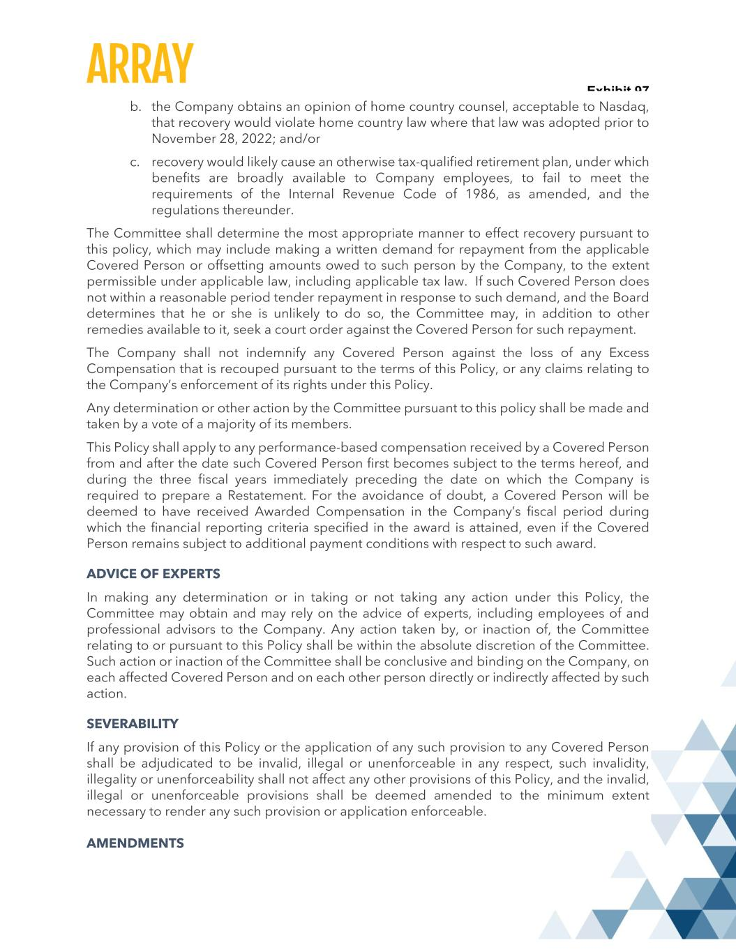
Exhibit 97 b. the Company obtains an opinion of home country counsel, acceptable to Nasdaq, that recovery would violate home country law where that law was adopted prior to November 28, 2022; and/or c. recovery would likely cause an otherwise tax-qualified retirement plan, under which benefits are broadly available to Company employees, to fail to meet the requirements of the Internal Revenue Code of 1986, as amended, and the regulations thereunder. The Committee shall determine the most appropriate manner to effect recovery pursuant to this policy, which may include making a written demand for repayment from the applicable Covered Person or offsetting amounts owed to such person by the Company, to the extent permissible under applicable law, including applicable tax law. If such Covered Person does not within a reasonable period tender repayment in response to such demand, and the Board determines that he or she is unlikely to do so, the Committee may, in addition to other remedies available to it, seek a court order against the Covered Person for such repayment. The Company shall not indemnify any Covered Person against the loss of any Excess Compensation that is recouped pursuant to the terms of this Policy, or any claims relating to the Company’s enforcement of its rights under this Policy. Any determination or other action by the Committee pursuant to this policy shall be made and taken by a vote of a majority of its members. This Policy shall apply to any performance-based compensation received by a Covered Person from and after the date such Covered Person first becomes subject to the terms hereof, and during the three fiscal years immediately preceding the date on which the Company is required to prepare a Restatement. For the avoidance of doubt, a Covered Person will be deemed to have received Awarded Compensation in the Company’s fiscal period during which the financial reporting criteria specified in the award is attained, even if the Covered Person remains subject to additional payment conditions with respect to such award. ADVICE OF EXPERTS In making any determination or in taking or not taking any action under this Policy, the Committee may obtain and may rely on the advice of experts, including employees of and professional advisors to the Company. Any action taken by, or inaction of, the Committee relating to or pursuant to this Policy shall be within the absolute discretion of the Committee. Such action or inaction of the Committee shall be conclusive and binding on the Company, on each affected Covered Person and on each other person directly or indirectly affected by such action. SEVERABILITY If any provision of this Policy or the application of any such provision to any Covered Person shall be adjudicated to be invalid, illegal or unenforceable in any respect, such invalidity, illegality or unenforceability shall not affect any other provisions of this Policy, and the invalid, illegal or unenforceable provisions shall be deemed amended to the minimum extent necessary to render any such provision or application enforceable. AMENDMENTS

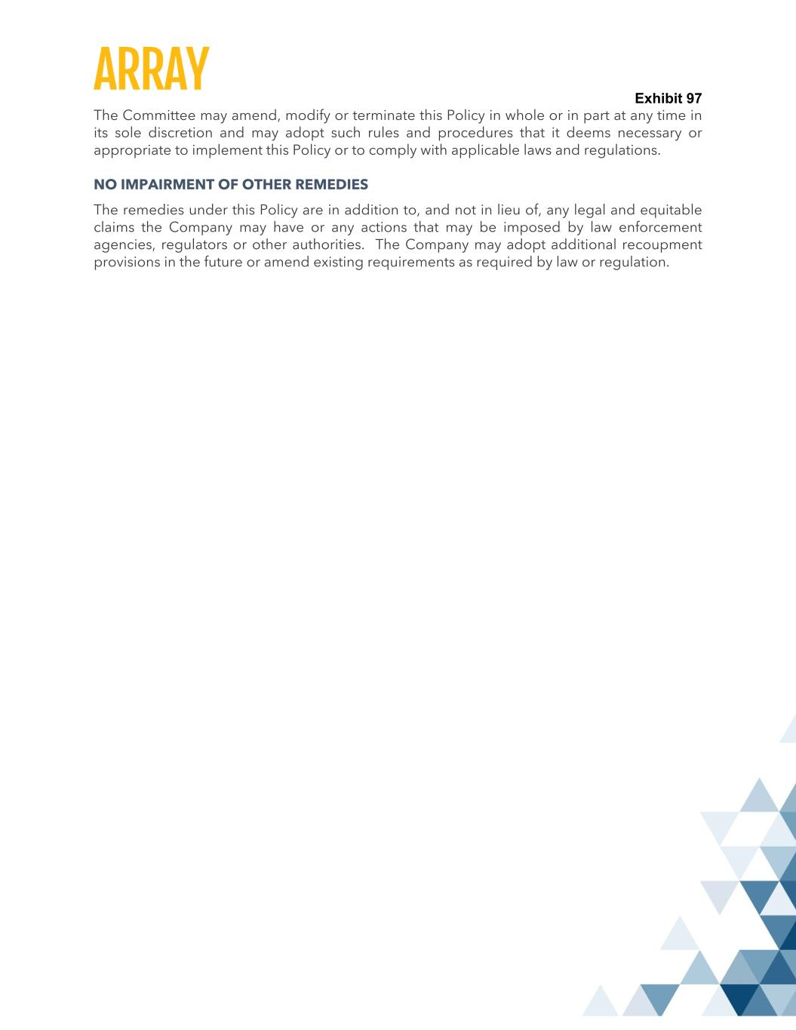
Exhibit 97 The Committee may amend, modify or terminate this Policy in whole or in part at any time in its sole discretion and may adopt such rules and procedures that it deems necessary or appropriate to implement this Policy or to comply with applicable laws and regulations. NO IMPAIRMENT OF OTHER REMEDIES The remedies under this Policy are in addition to, and not in lieu of, any legal and equitable claims the Company may have or any actions that may be imposed by law enforcement agencies, regulators or other authorities. The Company may adopt additional recoupment provisions in the future or amend existing requirements as required by law or regulation.

