UNITED STATES SECURITIES AND EXCHANGE COMMISSION
Washington, D.C. 20549

FORM 10-Q

☒ QUARTERLY REPORT PURSUANT TO SECTION 13 OR 15(d) OF THE SECURITIES EXCHANGE ACT OF 1934
For the quarterly period ended June 30, 2024

or

☐ TRANSITION REPORT PURSUANT TO SECTION 13 OR 15(d) OF THE SECURITIES EXCHANGE ACT OF 1934
For the transition period from _________ to _________

Commission File Number: 001-39613



ARRAY TECHNOLOGIES, INC.
(Exact Name of Registrant as Specified in its Charter)

Delaware |  |  |  |  |  |  |  |  |  |  |  |  |  |  | 83-2747826
(State or Other Jurisdiction) |  |  |  |  |  |  |  |  | (I.R.S. Employer Identification No.)
3901 Midway Place NE |  |  | Albuquerque |  |  |  |  |  | New Mexico |  |  |  |  |  | 87109
(Address of principal executive offices) |  |  |  |  |  |  |  |  |  |  |  |  |  |  | (Zip Code)

(Registrant’s telephone number, including area code) |  |  | (505) |  |  | 881-7567

(Former name, former address and former fiscal year, if changed since last report) N/A

Securities registered pursuant to Section 12(b) of the Act:
Title of each class |  |  |  |  |  | Trading Symbol(s) |  |  |  |  |  | Name of each exchange on which registered
Common stock, $0.001 par value |  |  |  |  |  | ARRY |  |  |  |  |  | Nasdaq Global Market

Indicate by check mark whether the registrant (1) has filed all reports required to be filed by Section 13 or 15(d) of the Securities Exchange Act of 1934 during the preceding 12 months (or for such shorter period that the registrant was required to file such reports), and (2) has been subject to such filing requirements for the past 90 days. ☒ Yes ☐ No

Indicate by check mark whether the registrant has submitted electronically every Interactive Data File required to be submitted pursuant to Rule 405 of Regulation S-T (§232.405 of this chapter) during the preceding 12 months (or for such shorter period that the registrant was required to submit such files). ☒ Yes ☐ No
Indicate by check mark whether the registrant is a large accelerated filer, an accelerated filer, a non-accelerated filer, a smaller reporting company, or an emerging growth company. See the definitions of “large accelerated filer,” “accelerated filer,” “smaller reporting company,” and "emerging growth company" in Rule 12b-2 of the Exchange Act.
Large accelerated filer |  |  | ☒ |  |  | Accelerated filer |  |  | ☐
Non-accelerated filer |  |  | ☐ |  |  | Smaller reporting company |  |  | ☐
 |  |  |  |  |  | Emerging growth company |  |  | ☐

If an emerging growth company, indicate by check mark if the registrant has elected not to use the extended transition period for complying with any new or revised financial accounting standards provided pursuant to Section 13(a) of the Exchange Act. ☐

Indicate by check mark whether the registrant is a shell company (as defined in Rule 12b-2 of the Exchange Act). ☐ Yes ☒ No

Indicate the number of shares outstanding of each of the issuer’s classes of common stock, as of the latest practicable date:
As of August 5, 2024, there were 151,926,428 shares of common stock, par value $0.001 per share, issued and outstanding.

Array Technologies, Inc.
Index to Form 10-Q

PART I - FINANCIAL INFORMATION
Item 1. |  |  | Unaudited Condensed Consolidated Financial Statements
 |  |  | Condensed Consolidated Balance Sheets |  |  | 1
 |  |  | Condensed Consolidated Statements of Operations |  |  | 3
 |  |  | Condensed Consolidated Statements of Comprehensive Income (Loss) |  |  | 4
 |  |  | Condensed Consolidated Statements of Changes in Redeemable Perpetual Preferred Stock and Stockholders’ Equity |  |  | 5
 |  |  | Condensed Consolidated Statements of Cash Flows |  |  | 9
 |  |  | Notes to Condensed Consolidated Financial Statements |  |  | 11
Item 2. |  |  | Management’s Discussion and Analysis of Financial Condition and Results of Operations |  |  | 34
Item 3. |  |  | Quantitative and Qualitative Disclosures About Market Risk |  |  | 49
Item 4. |  |  | Controls and Procedures |  |  | 49
PART II - OTHER INFORMATION
Item 1. |  |  | Legal Proceedings |  |  | 51
Item 1A. |  |  | Risk Factors |  |  | 51
Item 2. |  |  | Unregistered Sales of Equity Securities and Use of Proceeds |  |  | 56
Item 3. |  |  | Defaults Upon Senior Securities |  |  | 56
Item 4. |  |  | Mine Safety Disclosures |  |  | 56
Item 5. |  |  | Other Information |  |  | 56
Item 6. |  |  | Exhibits |  |  | 56

PART I—FINANCIAL INFORMATION

Item 1. Financial Statements.

Array Technologies, Inc.
Condensed Consolidated Balance Sheets (unaudited)
(in thousands, except per share and share amounts)

 |  |  | June 30, 2024 |  |  |  |  |  | December 31, 2023
ASSETS
Current assets
Cash and cash equivalents |  |  | $ | 282,320 |  |  |  |  | $ | 249,080
Accounts receivable, net of allowance of $4,911 and $3,824, respectively |  |  | 309,719 |  |  |  |  |  | 332,152
Inventories |  |  | 165,639 |  |  |  |  |  | 161,964
Prepaid expenses and other |  |  | 91,259 |  |  |  |  |  | 89,085
Total current assets |  |  | 848,937 |  |  |  |  |  | 832,281
Property, plant and equipment, net |  |  | 26,677 |  |  |  |  |  | 27,893
Goodwill |  |  | 402,501 |  |  |  |  |  | 435,591
Other intangible assets, net |  |  | 307,591 |  |  |  |  |  | 354,389
Deferred income tax assets |  |  | 13,369 |  |  |  |  |  | 15,870
Other assets |  |  | 52,447 |  |  |  |  |  | 40,717
Total assets |  |  | $ | 1,651,522 |  |  |  |  | $ | 1,706,741
LIABILITIES, REDEEMABLE PERPETUAL PREFERRED STOCK AND STOCKHOLDERS' EQUITY
Current liabilities
Accounts payable |  |  | $ | 112,489 |  |  |  |  | $ | 119,498
Accrued expenses and other |  |  | 57,265 |  |  |  |  |  | 70,211
Accrued warranty reserve |  |  | 1,639 |  |  |  |  |  | 2,790
Income tax payable |  |  | 3,368 |  |  |  |  |  | 5,754
Deferred revenue |  |  | 90,982 |  |  |  |  |  | 66,488
Current portion of contingent consideration |  |  | 1,918 |  |  |  |  |  | 1,427
Current portion of debt |  |  | 29,221 |  |  |  |  |  | 21,472
Other current liabilities |  |  | 40,697 |  |  |  |  |  | 48,051
Total current liabilities |  |  | 337,579 |  |  |  |  |  | 335,691
Deferred income tax liabilities |  |  | 54,512 |  |  |  |  |  | 66,858
Contingent consideration, net of current portion |  |  | 6,786 |  |  |  |  |  | 8,936
Other long-term liabilities |  |  | 18,613 |  |  |  |  |  | 20,428
Long-term warranty |  |  | 4,035 |  |  |  |  |  | 3,372
Long-term debt, net of current portion |  |  | 651,522 |  |  |  |  |  | 660,948
Total liabilities |  |  | 1,073,047 |  |  |  |  |  | 1,096,233
1
Array Technologies, Inc.
Condensed Consolidated Balance Sheets (unaudited) (continued)
(in thousands, except per share and share amounts)
 |  |  | June 30, 2024 |  |  |  |  |  | December 31, 2023
Commitments and contingencies (Note 11)
Series A Redeemable Perpetual Preferred Stock of $0.001 par value; 500,000 authorized; 446,541 and 432,759 shares issued as of June 30, 2024 and December 31, 2023, respectively; liquidation preference of $493.1 million at both dates |  |  | 378,512 |  |  |  |  |  | 351,260
Stockholders’ equity
Preferred stock of $0.001 par value - 4,500,000 shares authorized; none issued at respective dates |  |  | — |  |  |  |  |  | —
Common stock of $0.001 par value - 1,000,000,000 shares authorized; 151,875,097 and 151,242,120 shares issued at respective dates |  |  | 151 |  |  |  |  |  | 151
Additional paid-in capital |  |  | 320,379 |  |  |  |  |  | 344,517
Accumulated deficit |  |  | (102,367) |  |  |  |  |  | (130,230)
Accumulated other comprehensive income |  |  | (18,200) |  |  |  |  |  | 44,810
Total stockholders’ equity |  |  | 199,963 |  |  |  |  |  | 259,248
Total liabilities, redeemable perpetual preferred stock and stockholders’ equity |  |  | $ | 1,651,522 |  |  |  |  | $ | 1,706,741

See accompanying Notes to Condensed Consolidated Financial Statements.

2

Array Technologies, Inc.
Condensed Consolidated Statements of Operations (unaudited)
(in thousands, except per share amounts)

 |  |  | Three Months Ended June 30, |  |  |  |  |  |  |  |  |  |  |  | Six Months Ended June 30,
 |  |  | 2024 |  |  |  |  |  | 2023 |  |  |  |  |  | 2024 |  |  |  |  |  | 2023
Revenue |  |  | $ | 255,766 |  |  |  |  | $ | 507,725 |  |  |  |  | $ | 409,169 |  |  |  |  | $ | 884,498
Cost of revenue
Cost of product and service revenue |  |  | 166,173 |  |  |  |  |  | 357,683 |  |  |  |  |  | 260,847 |  |  |  |  |  | 633,277
Amortization of developed technology |  |  | 3,640 |  |  |  |  |  | 3,640 |  |  |  |  |  | 7,279 |  |  |  |  |  | 7,279
Total cost of revenue |  |  | 169,813 |  |  |  |  |  | 361,323 |  |  |  |  |  | 268,126 |  |  |  |  |  | 640,556
Gross profit |  |  | 85,953 |  |  |  |  |  | 146,402 |  |  |  |  |  | 141,043 |  |  |  |  |  | 243,942
Operating expenses
General and administrative |  |  | 36,971 |  |  |  |  |  | 40,250 |  |  |  |  |  | 74,755 |  |  |  |  |  | 78,392
Change in fair value of contingent consideration |  |  | 503 |  |  |  |  |  | 705 |  |  |  |  |  | (232) |  |  |  |  |  | 2,043
Depreciation and amortization |  |  | 8,877 |  |  |  |  |  | 9,206 |  |  |  |  |  | 18,504 |  |  |  |  |  | 19,808
Total operating expenses |  |  | 46,351 |  |  |  |  |  | 50,161 |  |  |  |  |  | 93,027 |  |  |  |  |  | 100,243
Income from operations |  |  | 39,602 |  |  |  |  |  | 96,241 |  |  |  |  |  | 48,016 |  |  |  |  |  | 143,699
Other (loss) income, net |  |  | (1,794) |  |  |  |  |  | 125 |  |  |  |  |  | (980) |  |  |  |  |  | 319
Interest income |  |  | 4,782 |  |  |  |  |  | 1,468 |  |  |  |  |  | 8,462 |  |  |  |  |  | 2,699
Foreign currency (loss) gain, net |  |  | (468) |  |  |  |  |  | 260 |  |  |  |  |  | (967) |  |  |  |  |  | 66
Interest expense |  |  | (8,614) |  |  |  |  |  | (11,577) |  |  |  |  |  | (17,554) |  |  |  |  |  | (22,308)
Total other expense, net |  |  | (6,094) |  |  |  |  |  | (9,724) |  |  |  |  |  | (11,039) |  |  |  |  |  | (19,224)
Income before income tax expense |  |  | 33,508 |  |  |  |  |  | 86,517 |  |  |  |  |  | 36,977 |  |  |  |  |  | 124,475
Income tax expense |  |  | 7,810 |  |  |  |  |  | 21,352 |  |  |  |  |  | 9,114 |  |  |  |  |  | 29,675
Net income |  |  | 25,698 |  |  |  |  |  | 65,165 |  |  |  |  |  | 27,863 |  |  |  |  |  | 94,800
Preferred dividends and accretion |  |  | 13,749 |  |  |  |  |  | 12,784 |  |  |  |  |  | 27,251 |  |  |  |  |  | 25,268
Net income to common shareholders |  |  | $ | 11,949 |  |  |  |  | $ | 52,381 |  |  |  |  | $ | 612 |  |  |  |  | $ | 69,532
Income per common share
Basic |  |  | $ | 0.08 |  |  |  |  | $ | 0.34 |  |  |  |  | $ | 0.00 |  |  |  |  | $ | 0.47
Diluted |  |  | $ | 0.08 |  |  |  |  | $ | 0.34 |  |  |  |  | $ | 0.00 |  |  |  |  | $ | 0.46
Weighted average number of common shares outstanding
Basic |  |  | 151,797 |  |  |  |  |  | 150,919 |  |  |  |  |  | 151,574 |  |  |  |  |  | 150,763
Diluted |  |  | 152,207 |  |  |  |  |  | 152,129 |  |  |  |  |  | 152,170 |  |  |  |  |  | 151,970

See accompanying Notes to Condensed Consolidated Financial Statements.

3

Array Technologies, Inc.
Condensed Consolidated Statements of Comprehensive Income (Loss) (unaudited)
(in thousands)

 |  |  | Three Months Ended June 30, |  |  |  |  |  |  |  |  |  |  |  | Six Months Ended June 30,
 |  |  | 2024 |  |  |  |  |  | 2023 |  |  |  |  |  | 2024 |  |  |  |  |  | 2023
Net income |  |  | $ | 25,698 |  |  |  |  | $ | 65,165 |  |  |  |  | $ | 27,863 |  |  |  |  | $ | 94,800
Foreign currency translation(1) |  |  | (43,768) |  |  |  |  |  | 23,912 |  |  |  |  |  | (63,010) |  |  |  |  |  | 37,784
Comprehensive (loss) income |  |  | $ | (18,070) |  |  |  |  | 89,077 |  |  |  |  |  | $ | (35,147) |  |  |  |  | $ | 132,584
(1) There are no tax effects on foreign currency adjustments.

See accompanying Notes to Condensed Consolidated Financial Statements.

4

Array Technologies, Inc.
Condensed Consolidated Statements of Changes in Redeemable Perpetual Preferred Stock and Stockholders’ Equity
(unaudited)
(in thousands)

Three Months Ended June 30, 2024
 |  |  | Temporary Equity |  |  |  |  |  |  |  |  |  |  |  |  |  |  | Permanent Equity
 |  |  | Series A Redeemable Perpetual Preferred Stock |  |  |  |  |  |  |  |  |  |  |  |  |  |  | Preferred Stock |  |  |  |  |  |  |  |  |  |  |  | Common Stock
 |  |  | Shares |  |  |  |  |  | Amount |  |  |  |  |  |  |  |  | Shares |  |  |  |  |  | Amount |  |  |  |  |  | Shares |  |  |  |  |  | Amount |  |  |  |  |  | Additional Paid-In Capital |  |  |  |  |  | Accumulated Deficit |  |  |  |  |  | Accumulated Other Comprehensive Income |  |  |  |  |  | Total Stockholders’ Equity
Balance at March 31, 2024 |  |  | 439 |  |  |  |  |  | $ | 364,762 |  |  |  |  |  |  |  | — |  |  |  |  |  | $ | — |  |  |  |  | 151,727 |  |  |  |  |  | $ | 151 |  |  |  |  | $ | 333,570 |  |  |  |  | $ | (128,065) |  |  |  |  | $ | 25,568 |  |  |  |  | $ | 231,224
Equity-based compensation |  |  | — |  |  |  |  |  | — |  |  |  |  |  |  |  |  | — |  |  |  |  |  | — |  |  |  |  |  | 148 |  |  |  |  |  | — |  |  |  |  |  | 559 |  |  |  |  |  | — |  |  |  |  |  | — |  |  |  |  |  | 559
Tax withholding related to vesting of equity-based compensation |  |  | — |  |  |  |  |  | — |  |  |  |  |  |  |  |  | — |  |  |  |  |  | — |  |  |  |  |  | — |  |  |  |  |  | — |  |  |  |  |  | — |  |  |  |  |  | — |  |  |  |  |  | — |  |  |  |  |  | —
Preferred cumulative dividends plus accretion |  |  | 7 |  |  |  |  |  | 13,750 |  |  |  |  |  |  |  |  | — |  |  |  |  |  | — |  |  |  |  |  | — |  |  |  |  |  | — |  |  |  |  |  | (13,750) |  |  |  |  |  | — |  |  |  |  |  | — |  |  |  |  |  | (13,750)
Net income |  |  | — |  |  |  |  |  | — |  |  |  |  |  |  |  |  | — |  |  |  |  |  | — |  |  |  |  |  | — |  |  |  |  |  | — |  |  |  |  |  | — |  |  |  |  |  | 25,698 |  |  |  |  |  | — |  |  |  |  |  | 25,698
Foreign currency translation |  |  | — |  |  |  |  |  | — |  |  |  |  |  |  |  |  | — |  |  |  |  |  | — |  |  |  |  |  | — |  |  |  |  |  | — |  |  |  |  |  | — |  |  |  |  |  | — |  |  |  |  |  | (43,768) |  |  |  |  |  | (43,768)
Balance at June 30, 2024 |  |  | 446 |  |  |  |  |  | $ | 378,512 |  |  |  |  |  |  |  | — |  |  |  |  |  | $ | — |  |  |  |  | 151,875 |  |  |  |  |  | $ | 151 |  |  |  |  | $ | 320,379 |  |  |  |  | $ | (102,367) |  |  |  |  | $ | (18,200) |  |  |  |  | $ | 199,963

5

Array Technologies, Inc.
Condensed Consolidated Statements of Changes in Redeemable Perpetual Preferred Stock and Stockholders’ Equity (continued)
(unaudited)
(in thousands)
Three Months Ended June 30, 2023
 |  |  | Temporary Equity |  |  |  |  |  |  |  |  |  |  |  |  |  |  | Permanent Equity
 |  |  | Series A Redeemable Perpetual Preferred Stock |  |  |  |  |  |  |  |  |  |  |  |  |  |  | Preferred Stock |  |  |  |  |  |  |  |  |  |  |  | Common Stock
 |  |  | Shares |  |  |  |  |  | Amount |  |  |  |  |  |  |  |  | Shares |  |  |  |  |  | Amount |  |  |  |  |  | Shares |  |  |  |  |  | Amount |  |  |  |  |  | Additional Paid-In Capital |  |  |  |  |  | Accumulated Deficit |  |  |  |  |  | Accumulated Other Comprehensive Income |  |  |  |  |  | Total Stockholders’ Equity
Balance at March 31, 2023 |  |  | 413 |  |  |  |  |  | $ | 312,054 |  |  |  |  |  |  |  | — |  |  |  |  |  | $ | — |  |  |  |  | 150,823 |  |  |  |  |  | $ | 150 |  |  |  |  | $ | 373,307 |  |  |  |  | $ | (237,835) |  |  |  |  | $ | 22,297 |  |  |  |  | $ | 157,919
Equity-based compensation |  |  | — |  |  |  |  |  | — |  |  |  |  |  |  |  |  | — |  |  |  |  |  | — |  |  |  |  |  | 226 |  |  |  |  |  | 1 |  |  |  |  |  | 4,944 |  |  |  |  |  | — |  |  |  |  |  | — |  |  |  |  |  | 4,945
Preferred cumulative dividends plus accretion |  |  | 6 |  |  |  |  |  | 12,784 |  |  |  |  |  |  |  |  | — |  |  |  |  |  | — |  |  |  |  |  | — |  |  |  |  |  | — |  |  |  |  |  | (13,541) |  |  |  |  |  | — |  |  |  |  |  | — |  |  |  |  |  | (13,541)
Net income |  |  | — |  |  |  |  |  | — |  |  |  |  |  |  |  |  | — |  |  |  |  |  | — |  |  |  |  |  | — |  |  |  |  |  | — |  |  |  |  |  | — |  |  |  |  |  | 65,165 |  |  |  |  |  | — |  |  |  |  |  | 65,165
Other comprehensive income |  |  | — |  |  |  |  |  |  |  |  |  |  |  |  |  |  | — |  |  |  |  |  | — |  |  |  |  |  | — |  |  |  |  |  | — |  |  |  |  |  | — |  |  |  |  |  | — |  |  |  |  |  | 23,912 |  |  |  |  |  | 23,912
Balance at June 30, 2023 |  |  | 419 |  |  |  |  |  | $ | 324,838 |  |  |  |  |  |  |  | — |  |  |  |  |  | $ | — |  |  |  |  | 151,049 |  |  |  |  |  | $ | 151 |  |  |  |  | $ | 364,710 |  |  |  |  | $ | (172,670) |  |  |  |  | $ | 46,209 |  |  |  |  | $ | 238,400
6

Array Technologies, Inc.
Condensed Consolidated Statements of Changes in Redeemable Perpetual Preferred Stock and Stockholders’ Equity (continued)
(unaudited)
(in thousands)
Six Months Ended June 30, 2024
 |  |  | Temporary Equity |  |  |  |  |  |  |  |  |  |  |  |  |  |  | Permanent Equity
 |  |  | Series A Redeemable Perpetual Preferred Stock |  |  |  |  |  |  |  |  |  |  |  |  |  |  | Preferred Stock |  |  |  |  |  |  |  |  |  |  |  | Common Stock
 |  |  | Shares |  |  |  |  |  | Amount |  |  |  |  |  |  |  |  | Shares |  |  |  |  |  | Amount |  |  |  |  |  | Shares |  |  |  |  |  | Amount |  |  |  |  |  | Additional Paid-In Capital |  |  |  |  |  | Accumulated Deficit |  |  |  |  |  | Accumulated Other Comprehensive Income |  |  |  |  |  | Total Stockholders’ Equity
Balance at December 31, 2023 |  |  | 432 |  |  |  |  |  | $ | 351,260 |  |  |  |  |  |  |  | — |  |  |  |  |  | $ | — |  |  |  |  | 151,242 |  |  |  |  |  | $ | 151 |  |  |  |  | $ | 344,517 |  |  |  |  | $ | (130,230) |  |  |  |  | $ | 44,810 |  |  |  |  | $ | 259,248
Equity-based compensation |  |  | — |  |  |  |  |  | — |  |  |  |  |  |  |  |  | — |  |  |  |  |  | — |  |  |  |  |  | 633 |  |  |  |  |  | — |  |  |  |  |  | 4,836 |  |  |  |  |  | — |  |  |  |  |  | — |  |  |  |  |  | 4,836
Tax withholding related to vesting of equity-based compensation |  |  | — |  |  |  |  |  | — |  |  |  |  |  |  |  |  | — |  |  |  |  |  | — |  |  |  |  |  | — |  |  |  |  |  | — |  |  |  |  |  | (1,722) |  |  |  |  |  | — |  |  |  |  |  | — |  |  |  |  |  | (1,722)
Preferred cumulative dividends plus accretion |  |  | 14 |  |  |  |  |  | 27,252 |  |  |  |  |  |  |  |  | — |  |  |  |  |  | — |  |  |  |  |  | — |  |  |  |  |  | — |  |  |  |  |  | (27,252) |  |  |  |  |  | — |  |  |  |  |  | — |  |  |  |  |  | (27,252)
Net income |  |  | — |  |  |  |  |  | — |  |  |  |  |  |  |  |  | — |  |  |  |  |  | — |  |  |  |  |  | — |  |  |  |  |  | — |  |  |  |  |  | — |  |  |  |  |  | 27,863 |  |  |  |  |  | — |  |  |  |  |  | 27,863
Foreign currency translation |  |  | — |  |  |  |  |  | — |  |  |  |  |  |  |  |  | — |  |  |  |  |  | — |  |  |  |  |  | — |  |  |  |  |  | — |  |  |  |  |  | — |  |  |  |  |  | — |  |  |  |  |  | (63,010) |  |  |  |  |  | (63,010)
Balance at June 30, 2024 |  |  | 446 |  |  |  |  |  | $ | 378,512 |  |  |  |  |  |  |  | — |  |  |  |  |  | $ | — |  |  |  |  | 151,875 |  |  |  |  |  | $ | 151 |  |  |  |  | $ | 320,379 |  |  |  |  | $ | (102,367) |  |  |  |  | $ | (18,200) |  |  |  |  | $ | 199,963

7

Array Technologies, Inc.
Condensed Consolidated Statements of Changes in Redeemable Perpetual Preferred Stock and Stockholders’ Equity (continued)
(unaudited)
(in thousands)
Six Months Ended June 30, 2023
 |  |  | Temporary Equity |  |  |  |  |  |  |  |  |  |  |  |  |  |  | Permanent Equity
 |  |  | Series A Redeemable Perpetual Preferred Stock |  |  |  |  |  |  |  |  |  |  |  |  |  |  | Preferred Stock |  |  |  |  |  |  |  |  |  |  |  | Common Stock
 |  |  | Shares |  |  |  |  |  | Amount |  |  |  |  |  |  |  |  | Shares |  |  |  |  |  | Amount |  |  |  |  |  | Shares |  |  |  |  |  | Amount |  |  |  |  |  | Additional Paid-In Capital |  |  |  |  |  | Accumulated Deficit |  |  |  |  |  | Accumulated Other Comprehensive Income |  |  |  |  |  | Total Stockholders’ Equity
Balance at December 31, 2022 |  |  | 406 |  |  |  |  |  | $ | 299,570 |  |  |  |  |  |  |  | — |  |  |  |  |  | $ | — |  |  |  |  | 150,513 |  |  |  |  |  | 150 |  |  |  |  |  | 383,176 |  |  |  |  |  | (267,470) |  |  |  |  |  | 8,425 |  |  |  |  |  | 124,281
Equity-based compensation |  |  | — |  |  |  |  |  | — |  |  |  |  |  |  |  |  | — |  |  |  |  |  | — |  |  |  |  |  | 536 |  |  |  |  |  | 1 |  |  |  |  |  | 8,310 |  |  |  |  |  | — |  |  |  |  |  | — |  |  |  |  |  | 8,311
Preferred cumulative dividends plus accretion and commitment fees |  |  | 13 |  |  |  |  |  | 25,268 |  |  |  |  |  |  |  |  | — |  |  |  |  |  | — |  |  |  |  |  | — |  |  |  |  |  | — |  |  |  |  |  | (26,776) |  |  |  |  |  | — |  |  |  |  |  | — |  |  |  |  |  | (26,776)
Net income |  |  | — |  |  |  |  |  | — |  |  |  |  |  |  |  |  | — |  |  |  |  |  | — |  |  |  |  |  | — |  |  |  |  |  | — |  |  |  |  |  | — |  |  |  |  |  | 94,800 |  |  |  |  |  | — |  |  |  |  |  | 94,800
Foreign currency translation |  |  | — |  |  |  |  |  | — |  |  |  |  |  |  |  |  | — |  |  |  |  |  | — |  |  |  |  |  | — |  |  |  |  |  | — |  |  |  |  |  | — |  |  |  |  |  | — |  |  |  |  |  | 37,784 |  |  |  |  |  | 37,784
Balance at June 30, 2023 |  |  | 419 |  |  |  |  |  | $ | 324,838 |  |  |  |  |  |  |  | — |  |  |  |  |  | $ | — |  |  |  |  | 151,049 |  |  |  |  |  | 151 |  |  |  |  |  | 364,710 |  |  |  |  |  | (172,670) |  |  |  |  |  | 46,209 |  |  |  |  |  | 238,400

See accompanying Notes to Condensed Consolidated Financial Statements.

8

Array Technologies, Inc.
Condensed Consolidated Statements of Cash Flows (unaudited)
(in thousands)

 |  |  | Six Months Ended June 30,
 |  |  | 2024 |  |  |  |  |  | 2023
Operating activities
Net income |  |  | $ | 27,863 |  |  |  |  | $ | 94,800
Adjustments to net income:
Provision for bad debts |  |  | 1,696 |  |  |  |  |  | (141)
Deferred tax benefit |  |  | (3,501) |  |  |  |  |  | (1,796)
Depreciation and amortization |  |  | 19,456 |  |  |  |  |  | 20,413
Amortization of developed technology |  |  | 7,279 |  |  |  |  |  | 7,279
Amortization of debt discount and issuance costs |  |  | 3,101 |  |  |  |  |  | 4,998
Equity-based compensation |  |  | 4,836 |  |  |  |  |  | 8,311
Change in fair value of contingent consideration |  |  | (232) |  |  |  |  |  | 2,043
Warranty provision |  |  | (61) |  |  |  |  |  | 479
Write-down of inventories |  |  | 1,227 |  |  |  |  |  | 3,458
Changes in operating assets and liabilities, net of business acquisition:
Accounts receivable |  |  | (1,379) |  |  |  |  |  | (81,039)
Inventories |  |  | (7,207) |  |  |  |  |  | 22,844
Income tax receivables |  |  | (1,313) |  |  |  |  |  | 3,220
Prepaid expenses and other |  |  | (3,453) |  |  |  |  |  | (3,292)
Accounts payable |  |  | (2,932) |  |  |  |  |  | 30,542
Accrued expenses and other |  |  | (15,172) |  |  |  |  |  | 7,097
Income tax payable |  |  | (2,684) |  |  |  |  |  | 9,838
Lease liabilities |  |  | (3,135) |  |  |  |  |  | 1,414
Deferred revenue |  |  | 27,070 |  |  |  |  |  | (64,112)
Net cash provided by operating activities |  |  | 51,459 |  |  |  |  |  | 66,356
Investing activities
Purchase of property, plant and equipment |  |  | (4,527) |  |  |  |  |  | (9,424)
Retirement/disposal of property, plant and equipment |  |  | 39 |  |  |  |  |  | —
Net cash used in investing activities |  |  | (4,488) |  |  |  |  |  | (9,424)
Financing activities
Series A equity issuance costs |  |  | — |  |  |  |  |  | (1,508)
Tax withholding related to vesting of equity-based compensation |  |  | (580) |  |  |  |  |  | —
Proceeds from issuance of other debt |  |  | 12,684 |  |  |  |  |  | 23,801
Principal payments on other debt |  |  | (12,671) |  |  |  |  |  | (38,257)
Principal payments on term loan facility |  |  | (2,150) |  |  |  |  |  | (22,150)
Contingent consideration payments |  |  | (1,427) |  |  |  |  |  | (1,200)
Net cash used in financing activities |  |  | (4,144) |  |  |  |  |  | (39,314)
Effect of exchange rate changes on cash and cash equivalent balances |  |  | (9,587) |  |  |  |  |  | 4,447
Net change in cash and cash equivalents |  |  | 33,240 |  |  |  |  |  | 22,065
Cash and cash equivalents, beginning of period |  |  | 249,080 |  |  |  |  |  | 133,901
9

Array Technologies, Inc.
Condensed Consolidated Statements of Cash Flows (unaudited) (continued)
(in thousands)
 |  |  | Six Months Ended June 30,
 |  |  | 2024 |  |  |  |  |  | 2023
Cash and cash equivalents, end of period |  |  | $ | 282,320 |  |  |  |  | $ | 155,966
Supplemental cash flow information
Cash paid for interest |  |  | $ | 17,819 |  |  |  |  | $ | 15,880
Cash paid for income taxes (net of refunds) |  |  | $ | 17,001 |  |  |  |  | $ | 18,484
Non-cash investing and financing activities
Dividends accrued on Series A Preferred |  |  | $ | 13,782 |  |  |  |  | $ | 12,871

See accompanying Notes to Condensed Consolidated Financial Statements.

10
Array Technologies, Inc.
Notes to Condensed Consolidated Financial Statements (Unaudited)

1. Organization, Business and Out-of-Period Adjustments

Array Technologies, Inc. (the “Company”), formerly ATI Intermediate Holdings, LLC, is a Delaware corporation formed in December 2018 as a wholly owned subsidiary of ATI Investment Parent, LLC (“Former Parent”). On October 14, 2020, the Company converted from a Delaware limited liability company to a Delaware corporation and changed the Company’s name to Array Technologies, Inc.

Headquartered in Albuquerque, New Mexico, the Company is a leading global manufacturer and supplier of utility-scale solar tracking systems and technologies.

2. Summary of Significant Accounting Policies

Basis of Accounting and Presentation
The accompanying unaudited condensed consolidated financial statements have been prepared on the accrual basis of accounting in accordance with accounting principles generally accepted in the United States of America (“U.S. GAAP”), pursuant to the rules and regulations of the SEC. The unaudited interim financial statements have been prepared on the same basis as the audited annual financial statements and, in the opinion of management, reflect all adjustments, which include only normal recurring adjustments, necessary for the fair statement of results for the interim periods reported. The results for the three and six months ended June 30, 2024, are not necessarily indicative of results to be expected for the year ending December 31, 2024, or any other interim periods, or any future year or period. The balance sheet as of December 31, 2023, included herein was derived from the audited financial statements as of that date. Certain disclosures have been condensed or omitted from the interim financial statements. These condensed consolidated financial statements should be read in conjunction with the Company’s audited consolidated financial statements included in our Annual Report on Form 10-K for the year ended December 31, 2023, filed with the SEC on February 28, 2024.

Unless expressly stated or the context otherwise requires, the terms “the Company”, “we”, “us”, “our”, “Array”, and “Array Technologies” refer to Array Technologies, Inc. and its consolidated subsidiaries, and the term “condensed consolidated financial statements” refers to the accompanying unaudited condensed consolidated financial statements contained in this Quarterly Report.

Reclassifications
Software Implementation Costs
During the first quarter the Company reclassified capitalized software costs recorded as Property, plant and equipment, net to Intangible assets, net on the condensed consolidated balance sheets. The reclassification was recorded retrospectively and resulted in a $4.0 million increase to Intangible assets, net at December 31, 2023, with a corresponding decrease in the same amount to Property, plant and equipment, net.

These reclassifications did not impact the Company’s operating income (loss), net income (loss), earnings (loss) per share, or statements of cash flows for any current or historical periods.

11

Amortization of Developed Technology
Beginning in the third quarter of 2023, the Company retrospectively reclassified amounts recorded for amortization of certain acquired intangible assets in prior presentations from Total operating expenses under the caption "Depreciation and amortization" to Total cost of revenue under the caption "Amortization of developed technology" in the condensed consolidated statements of operations. The Company believes this presentation enhances the comparability of the Company’s financial statements to industry peers.

These reclassifications did not impact the Company’s operating income (loss), net income (loss) or earnings (loss) per share for any current or historical periods. These reclassifications also did not impact the condensed consolidated balance sheets or condensed consolidated statements of cash flows.

Brazil Value-Added Tax Benefit
Revenue in 2023, excludes a Brazil value-added tax benefit, Imposto sobre Circulação de Mercadorias e Servicos (“ICMS”), that has been reclassified and included in cost of revenues for all periods presented. For the six months ended June 30, 2023, the Brazil ICMS value-added tax benefit was $13.2 million, which has been included in cost of sales.

This reclassification had no impact on the Company’s gross profit, income (loss) from operations, net income or income (loss) per common share in the current period. These reclassifications also did not impact the condensed consolidated balance sheets or condensed consolidated statements of cash flows.

Divestiture of Investment in Equity Securities
In June 2024, we divested 100% percent of our equity investment in preferred stock of a private company we purchased in 2021. We received $12.0 million in proceeds for the divestiture in July 2024. We recorded a receivable in the amount of $12.0 million included in Prepaid expenses and other on the condensed consolidated balance sheet at June 30, 2024. No gain or loss resulted from this transaction.

Principles of Consolidation
The condensed consolidated financial statements include the accounts of the Company and its subsidiaries. All intercompany accounts and transactions have been eliminated upon consolidation.

Use of Estimates
The preparation of condensed consolidated financial statements in conformity with U.S. GAAP requires management to make estimates and assumptions that affect the reported amounts of assets and liabilities, the disclosure of contingent assets and liabilities and the reported amounts of revenues and expenses during the reporting period.

Actual results may differ from previously estimated amounts, and such differences may be material to the condensed consolidated financial statements; however, management believes that these estimates and assumptions provide a reasonable basis for the fair presentation of the condensed consolidated financial statements. Estimates and assumptions are reviewed periodically, and the effects of revisions are reflected in the period they occur.

12

Research and Development
The Company incurs research and development costs during its process of researching and developing new products and significant enhancements to existing products. Research and development costs consist primarily of personnel-related costs associated with our team of internal engineers, third-party consultants, materials and overhead. The Company expenses these costs as incurred prior to a respective product being ready for commercial production. Research and development expense was $1.8 million and $2.3 million during the three months ended June 30, 2024 and 2023, respectively, and $3.7 million and $4.4 million during the six months ended June 30, 2024 and 2023, respectively.

Impact of the Ongoing Russian-Ukraine Conflict
The ongoing Russian-Ukraine conflict has reduced the availability of material that can be sourced in Europe and, as a result, increased logistics costs for the procurement of certain inputs and materials used in our products. We do not know the ultimate severity or duration of the conflict, but we continue to monitor the situation and evaluate our procurement strategy and supply chain as to reduce any negative impact on our business, financial condition, and results of operations.

Impact of Attacks on Shipping in the Red Sea
The disruption of container shipping traffic through the Red Sea has created port congestion, especially in Asia, again temporarily elongating transit times, capacity, and shipping costs for routes connecting the rest of the world with Asia. To address the challenges arising from prolonged transit times, we have increased our local sourcing efforts where feasible within certain regions. These measures are required to ensure we fulfill our delivery commitments to customer projects on time. There is still uncertainly on how long these disruptions and the severity of their impact on our operations will last, but we continue to monitor the situation and evaluate our procurement and supply chain strategies, as to reduce any negative impact on our business, financial condition, and results of operations.

Inflation
Inflationary pressures persist and may continue to negatively impact our results of operations. To mitigate the inflationary pressures on our business, despite our ASPs decreasing due to the current deflationary environment for steel more than offsetting the inflationary environment for aluminum, we have continued to accelerate our productivity initiatives, expanded our supplier base, and continued to execute on our cost containment practices.

Vendor Rebates
On August 16, 2022, the Inflation Reduction Act of 2022 (“IRA”) was enacted into law, which includes numerous green energy credits. The 45X Advanced Manufacturing Production Tax Credit (“45X Credit”) was established as part of the IRA. The 45X Credit is a per-unit tax credit that is earned over time for each clean energy component domestically produced and sold by a manufacturer. The Company has, and will continue to, enter into arrangements with manufacturing vendors that produce 45X Credit eligible parts, in which the vendors agree to share a portion of the benefit received related to Array purchases, in the form of “Vendor Rebates”.

The Company accounts for these Vendor Rebates as a reduction of the purchase prices of the vendors’ products and therefore a reduction in the cost of inventory until the inventory is sold, at which time the Company recognizes such rebates as a reduction of cost of revenues on the consolidated statements of
13

operations. As of June 30, 2024, the Company had outstanding Vendor Rebates of $68.4 million, of which $45.8 million was included in Prepaid expenses and other and $22.6 million was included in Other assets on the condensed consolidated balance sheets. As of December 31, 2023, the Company had outstanding Vendor Rebates of $48.4 million included in Prepaid expenses and other.

Inflation Reduction Act 45X Credits
The Company accounts for the 45X Advanced Manufacturing Production Credit established by the IRA, under IAS 20, Accounting for Government Grants and Disclosure of Government Assistance, as a reduction to production costs. The reduction to production costs, from the 45X Advanced Manufacturing Tax credit, is excluded from federal and state income taxes. The tax credit is included in Prepaid and other assets on the condensed consolidated balance sheet dated June 30, 2024.

During the three months ended June 30, 2024, the Company concluded that certain parts manufactured by the Company qualify for the 45X Advanced Manufacturing Production Credits. As a result, the Company recorded it an immaterial cumulative catch-up for 45X Advanced Manufacturing Production Credits related to torque tubes manufactured by the Company and sold from January 1, 2023 through March 31, 2024.

Foreign Currency Translation
Our foreign subsidiaries have functional currencies that are different than our reporting currency. When translating balances from the functional currency to the reporting currency, assets and liabilities are translated into U.S. dollars at period end exchange rates, retained earnings is translated at historical rates, and income, expenses, and cash flow items are translated at average exchange rates prevailing during the period. Translation adjustments for these subsidiaries are accumulated within accumulated other comprehensive income. In situations when a foreign subsidiary has a local currency that is different than the functional currency, monetary assets and liabilities are translated into the functional currency at the period end exchange rates, and non-monetary assets and the related income statement effects are translated into the functional currency using historical rates. Gains and losses that result from remeasurement from a local currency to the functional currency are included in earnings.

Recent Accounting Pronouncements
In December 2023, the FASB issued ASU 2023-09, Income Taxes (Topic 740): Improvements to Income Tax Disclosures, which requires disclosure of disaggregated income taxes paid, prescribes standard categories for the components of the effective tax rate reconciliation, and modifies other income tax-related disclosures. The standard will become effective for the Company’s fiscal year ended December 31, 2025, with early adoption permitted. The Company does not expect to early adopt this reporting standard and expects no material impacts upon adoption.

In November 2023, the Financial Accounting Standards Board (the “FASB”) issued ASU 2023-07, Segment Reporting (Topic 280): Improvements to Reportable Segment Disclosures. The amendments in this ASU will require public entities to disclose significant segment expenses and other segment items and to provide in interim periods all disclosures about a reportable segment’s profit or loss and assets that are currently required annually. Public entities with a single reportable segment will also be required to provide the new disclosures and all the disclosures required under ASC 280. The guidance is effective for fiscal years beginning after December 15, 2023, and for interim periods within fiscal years beginning after December 15, 2024, with early adoption permitted. The amendments in this ASU should be applied retrospectively to all periods presented
14

unless it is impracticable. The Company is assessing the effect on our consolidated financial statement disclosures; however, adoption will not impact our consolidated balance sheets or statements of operations.

In March 2023, the Company adopted ASU 2020-04 and 2022-06, Reference Rate Reform (Topic 848), and amended an existing debt agreement to replace the London Interbank Offered Rate (“LIBOR”) interest rate provisions with interest rate provisions based on a forward-looking term rate based on the secured overnight funding rate (“SOFR”) (see Note 7 – Debt). There were no other changes to the agreement. There was no significant impact to the Company’s condensed consolidated financial statements.

Immaterial Correction of 2023 Interim Period Condensed Consolidated Financial Statements
Capped Calls
In connection with the pricing of the Convertible Notes, we entered into capped call transactions with the Option Counterparties. At issuance the Company concluded that the Capped Calls met the criteria for equity classification because they are indexed to the Company’s common stock and the Company has discretion to settle the Capped Calls in shares or cash. As a result, the amount paid for the Capped Calls was recorded as a reduction to additional paid-in capital. When the Company entered into the Capped Calls, the Company executed certain side letters (the “Side Letters”) with the counterparties that replaced some of the terms described in the primary contract including the volatility inputs used to value the Capped Calls under certain circumstances. Upon further evaluation of the accounting during the three months ended March 31, 2023, the Company concluded that the modification to the volatility inputs in the side letters precluded the Capped Calls from being accounted for as an equity instrument indexed to its own stock and should be accounted for as a freestanding derivative instrument asset recognized at fair value, with subsequent changes in fair value recognized in earnings. During the three months ended March 31, 2023, the Company began to account for the Capped Calls as derivative assets, with subsequent changes in fair value being recorded through earnings. During the three months ended December 31, 2023, after consultation with the staff of the Office of the Chief Accountant of the SEC, the Company concluded that the original equity classification accounting treatment was acceptable. As a result, the Company reclassified the derivative asset recognized at June 30, 2023, as a reduction to equity and reversed the related mark to market adjustments recognized during the six months ended June 30, 2023.

Redeemable Perpetual Preferred Stock
At issuance, the Company evaluated the accounting for the instruments issued pursuant to the SPA and determined the Series A Shares and common stock issued in the Initial Closing, as well as the Prepaid Forward Contract, and Put Option are freestanding instruments that are classified in equity. During the first quarter of 2023, the Company reconsidered the provisions of the Put Option and concluded that it should be accounted for as a freestanding derivative instrument asset accounted for at fair value with subsequent fair value adjustments recognized in earnings. During the fourth quarter of 2023, after consultation with the staff of the Office of the Chief Accountant of the SEC, the Company concluded that the original equity accounting classification was correct. As a result, the Company reclassified the derivative asset recognized during the six months ended June 30, 2023, as a reduction of equity and also reversed the related fair value adjustments.

Management evaluated the above misstatements and concluded they were not material to the six months ended June 30, 2023, individually or in aggregate.

15

The following tables reflect the effects of the correction on all affected line items of the Company’s previously reported condensed consolidated financial statements to be presented as comparative in the Form 10-Q for the six months ended June 30, 2024:
Condensed Consolidated Statements of Operations (unaudited)
 |  |  | Three Months Ended June 30, 2023 |  |  |  |  |  |  |  |  |  |  |  |  |  |  |  |  |  | Six Months Ended June 30, 2023
(in thousands) |  |  | As Previously Reported |  |  |  |  |  | Adjustments |  |  |  |  |  | As Corrected |  |  |  |  |  | As Previously Reported |  |  |  |  |  | Adjustments |  |  |  |  |  | As Corrected
Change in fair value of derivative assets |  |  | $ | 694 |  |  |  |  | $ | (694) |  |  |  |  | $ | — |  |  |  |  | $ | (1,256) |  |  |  |  | $ | 1,256 |  |  |  |  | $ | —
Total other income (expense) |  |  | (9,030) |  |  |  |  |  | (694) |  |  |  |  |  | (9,724) |  |  |  |  |  | (20,480) |  |  |  |  |  | 1,256 |  |  |  |  |  | (19,224)
Income (loss) before income tax expense |  |  | 87,211 |  |  |  |  |  | (694) |  |  |  |  |  | 86,517 |  |  |  |  |  | 123,219 |  |  |  |  |  | 1,256 |  |  |  |  |  | 124,475
Income tax expense (benefit) |  |  | 22,403 |  |  |  |  |  | (1,051) |  |  |  |  |  | 21,352 |  |  |  |  |  | 32,279 |  |  |  |  |  | (2,604) |  |  |  |  |  | 29,675
Net income |  |  | 64,808 |  |  |  |  |  | 357 |  |  |  |  |  | 65,165 |  |  |  |  |  | 90,940 |  |  |  |  |  | 3,860 |  |  |  |  |  | 94,800
Net income to common shareholders |  |  | 52,024 |  |  |  |  |  | 357 |  |  |  |  |  | 52,381 |  |  |  |  |  | 65,672 |  |  |  |  |  | 3,860 |  |  |  |  |  | 69,532
Income per common share
Basic |  |  | $ | 0.34 |  |  |  |  | $ | — |  |  |  |  | $ | 0.34 |  |  |  |  | $ | 0.44 |  |  |  |  | $ | 0.03 |  |  |  |  | $ | 0.47
Diluted |  |  | $ | 0.34 |  |  |  |  | $ | — |  |  |  |  | $ | 0.34 |  |  |  |  | $ | 0.43 |  |  |  |  | $ | 0.03 |  |  |  |  | $ | 0.46

Condensed Consolidated Statements of Comprehensive Income (Loss) (unaudited)
 |  |  | Three Months Ended June 30, 2023 |  |  |  |  |  |  |  |  |  |  |  |  |  |  |  |  |  | Six Months Ended June 30, 2023
(in thousands) |  |  | As Previously Reported |  |  |  |  |  | Adjustments |  |  |  |  |  | As Corrected |  |  |  |  |  | As Previously Reported |  |  |  |  |  | Adjustments |  |  |  |  |  | As Corrected
Net income |  |  | $ | 64,808 |  |  |  |  | $ | 357 |  |  |  |  | $ | 65,165 |  |  |  |  | $ | 90,940 |  |  |  |  | $ | 3,860 |  |  |  |  | $ | 94,800
Comprehensive income |  |  | $ | 88,720 |  |  |  |  | $ | 357 |  |  |  |  | $ | 89,077 |  |  |  |  | $ | 128,724 |  |  |  |  | $ | 3,860 |  |  |  |  | $ | 132,584

16

Condensed Consolidated Statements of Changes in Redeemable Perpetual Preferred Stock and Stockholders’ Equity (unaudited)
 |  |  | Three Months Ended June 30, 2023
(in thousands) |  |  | Additional Paid-In Capital |  |  |  |  |  | Accumulated Deficit |  |  |  |  |  | Total Stockholders’ Equity
As Previously Reported
Balance at March 31, 2023 |  |  | $ | 426,221 |  |  |  |  | $ | (241,338) |  |  |  |  | $ | 207,330
Net income |  |  | — |  |  |  |  |  | 64,808 |  |  |  |  |  | 64,808
Balance at June 30, 2023 |  |  | 417,624 |  |  |  |  |  | (176,530) |  |  |  |  |  | 287,454
Adjustments
Balance at March 31, 2023 |  |  | (52,914) |  |  |  |  |  | 3,503 |  |  |  |  |  | (49,411)
Net income |  |  | — |  |  |  |  |  | 357 |  |  |  |  |  | 357
As Corrected
Balance at March 31, 2023 |  |  | 373,307 |  |  |  |  |  | (237,835) |  |  |  |  |  | 157,919
Net income |  |  | — |  |  |  |  |  | 65,165 |  |  |  |  |  | 65,165
Balance at June 30, 2023 |  |  | $ | 364,710 |  |  |  |  | $ | (172,670) |  |  |  |  | $ | 238,400
 |  |  | Six Months Ended June 30, 2023
(in thousands) |  |  | Additional Paid-In Capital |  |  |  |  |  | Accumulated Deficit |  |  |  |  |  | Total Stockholders’ Equity
As Previously Reported
Balance at December 31, 2022 |  |  | $ | 383,176 |  |  |  |  | $ | (267,470) |  |  |  |  | $ | 124,281
Correction of the Capped Call and Put Option errors |  |  | 52,914 |  |  |  |  |  | — |  |  |  |  |  | 52,914
Net income |  |  | — |  |  |  |  |  | 90,940 |  |  |  |  |  | 90,940
Balance at June 30, 2023 |  |  | 417,624 |  |  |  |  |  | (176,530) |  |  |  |  |  | 287,454
Adjustments
Correction of the Capped Call and Put Option errors |  |  | (52,914) |  |  |  |  |  | — |  |  |  |  |  | (52,914)
Net income |  |  | — |  |  |  |  |  | 3,860 |  |  |  |  |  | 3,860
As Corrected
Balance at December 31, 2022 |  |  | 383,176 |  |  |  |  |  | (267,470) |  |  |  |  |  | 124,281
Correction of the Capped Call and Put Option errors |  |  | — |  |  |  |  |  | — |  |  |  |  |  | —
Net income |  |  | — |  |  |  |  |  | 94,800 |  |  |  |  |  | 94,800
Balance at June 30, 2023 |  |  | $ | 364,710 |  |  |  |  | $ | (172,670) |  |  |  |  | $ | 238,400
17

Condensed Consolidated Statements of Cash Flows (unaudited)
 |  |  | Six Months Ended June 30, 2023
(in thousands) |  |  | As Previously Reported |  |  |  |  |  | Adjustments |  |  |  |  |  | As Corrected
Net income |  |  | $ | 90,940 |  |  |  |  | $ | 3,860 |  |  |  |  | $ | 94,800
Deferred tax expense (benefit) |  |  | 816 |  |  |  |  |  | (2,612) |  |  |  |  |  | (1,796)
Change in fair value of derivative assets |  |  | 1,256 |  |  |  |  |  | (1,256) |  |  |  |  |  | —
Income tax payable |  |  | $ | 9,830 |  |  |  |  | $ | 8 |  |  |  |  | $ | 9,838

3. Inventories

Inventories consisted of the following (in thousands):
 |  |  | June 30, 2024 |  |  |  |  |  | December 31, 2023
Raw materials |  |  | $ | 47,140 |  |  |  |  | $ | 86,614
Finished goods |  |  | 118,499 |  |  |  |  |  | 75,350
Inventories |  |  | $ | 165,639 |  |  |  |  | $ | 161,964

The Company values a portion of its inventory using the moving average cost method that approximates the first-in, first-out method (“FIFO”). As of June 30, 2024, inventory valued using moving average cost and FIFO was $137.1 million and $28.5 million, respectively. As of December 31, 2023, inventory valued using moving average cost and FIFO, was $129.5 million and $32.5 million, respectively.

4. Property, Plant and Equipment, Net

Property, plant and equipment consisted of the following (in thousands, except useful lives):
 |  |  | Estimated Useful Lives (Years) |  |  |  |  |  | June 30, 2024 |  |  |  |  |  | December 31, 2023
Land |  |  | N/A |  |  |  |  |  | $ | 1,636 |  |  |  |  | $ | 1,634
Buildings and land improvements |  |  | 15-39 |  |  |  |  |  | 9,440 |  |  |  |  |  | 9,344
Manufacturing equipment |  |  | 7 |  |  |  |  |  | 26,539 |  |  |  |  |  | 22,962
Furniture, fixtures and equipment |  |  | 5-7 |  |  |  |  |  | 4,754 |  |  |  |  |  | 4,770
Vehicles |  |  | 5 |  |  |  |  |  | 614 |  |  |  |  |  | 688
Hardware |  |  | 3-5 |  |  |  |  |  | 3,518 |  |  |  |  |  | 3,114
Construction in progress |  |  | N/A |  |  |  |  |  | 2,821 |  |  |  |  |  | 6,199
Total |  |  |  |  |  |  |  |  | 49,322 |  |  |  |  |  | 48,711
Less: accumulated depreciation |  |  |  |  |  |  |  |  | (22,645) |  |  |  |  |  | (20,818)
Property, plant and equipment, net |  |  |  |  |  |  |  |  | $ | 26,677 |  |  |  |  | $ | 27,893

Depreciation expense was $1.1 million and $0.6 million for the three months ended June 30, 2024 and 2023, respectively, of which $0.4 million and $0.3 million, respectively, was included in cost of revenue and $0.7 million and $0.3 million, respectively, was included in depreciation and amortization on the accompanying condensed consolidated statements of operations.

18

Depreciation expense was $2.0 million and $1.2 million for the six months ended June 30, 2024 and 2023, respectively, of which $0.9 million and $0.6 million, respectively, was included in cost of revenue and $1.1 million and $0.6 million, respectively, was included in depreciation and amortization on the accompanying condensed consolidated statements of operations.

5. Goodwill and Other Intangible Assets, Net

Goodwill
Changes in the carrying amount of goodwill by operating segment during the six months ended June 30, 2024, consisted of the following (in thousands):
 |  |  | Array Legacy Operations(1) |  |  |  |  |  | STI Operations |  |  |  |  |  | Total
Beginning balance |  |  | $ | 69,727 |  |  |  |  | $ | 365,864 |  |  |  |  | $ | 435,591
Foreign currency translation |  |  | — |  |  |  |  |  | (33,090) |  |  |  |  |  | (33,090)
Ending balance |  |  | $ | 69,727 |  |  |  |  | $ | 332,774 |  |  |  |  | $ | 402,501
(1) Goodwill attributable to Array Legacy Operations is net of impairment of $51.9 million.

Each quarter the Company evaluates if facts and circumstances indicate that it is more-likely-than-not that the fair value of its reporting units is less than their carrying value, which would require the Company to perform an interim goodwill impairment test During our most recent evaluation, the Company noted facts and circumstances around its STI Operations, were indicative that the fair value of the STI reporting unit could be less than its carrying value. Accordingly, with the assistance of a third-party specialist, the Company performed the first step of the goodwill impairment test (“Step One”). Based on the results of the Step One test, the Company concluded there were no indicators of impairment as of June 30, 2024.

The Company concluded there were no indicators of impairment of the Array Legacy Operations operating unit as of June 30, 2024.

19

Other Intangible Assets, Net
Other intangible assets consisted of the following (in thousands, except useful lives):
 |  |  | Estimated Useful Lives (Years) |  |  |  |  |  | June 30, 2024 |  |  |  |  |  | December 31, 2023
Amortizable:
Developed technology |  |  | 14 |  |  |  |  |  | $ | 203,800 |  |  |  |  | $ | 203,800
Computer software |  |  | 3 |  |  |  |  |  | 1,452 |  |  |  |  |  | 5,267
Customer relationships |  |  | 10 |  |  |  |  |  | 313,563 |  |  |  |  |  | 336,134
Backlog |  |  | 1 |  |  |  |  |  | 49,124 |  |  |  |  |  | 54,438
Trade name |  |  | 20 |  |  |  |  |  | 25,147 |  |  |  |  |  | 27,061
Total amortizable intangibles |  |  |  |  |  |  |  |  | 593,086 |  |  |  |  |  | 626,700
Accumulated amortization:
Developed technology |  |  |  |  |  |  |  |  | 116,183 |  |  |  |  |  | 108,905
Computer software |  |  |  |  |  |  |  |  | 932 |  |  |  |  |  | 1,274
Customer relationships |  |  |  |  |  |  |  |  | 126,450 |  |  |  |  |  | 115,444
Backlog |  |  |  |  |  |  |  |  | 49,124 |  |  |  |  |  | 54,322
Trade name |  |  |  |  |  |  |  |  | 3,106 |  |  |  |  |  | 2,666
Total accumulated amortization |  |  |  |  |  |  |  |  | 295,795 |  |  |  |  |  | 282,611
Total amortizable intangibles, net |  |  |  |  |  |  |  |  | 297,291 |  |  |  |  |  | 344,089
Non-amortizable:
Trade name |  |  |  |  |  |  |  |  | 10,300 |  |  |  |  |  | 10,300
Total other intangible assets, net |  |  |  |  |  |  |  |  | $ | 307,591 |  |  |  |  | $ | 354,389

Amortization expense related to intangible assets was $11.8 million and $12.6 million for the three months ended June 30, 2024 and 2023, respectively, of which $3.6 million was included in amortization of developed technology, a component of cost of revenue, in both periods and $8.1 million and $9.0 million, respectively, was included in depreciation and amortization, on the accompanying condensed consolidated statements of operations.

Amortization expense related to intangible assets was $24.7 million and $26.5 million for the six months ended June 30, 2024 and 2023, respectively, of which $7.3 million was included in amortization of developed technology, a component of cost of revenue, in both periods and $17.4 million and $19.2 million, respectively, was included in depreciation and amortization, on the accompanying condensed consolidated statements of operations.

20

Estimated future amortization expense of intangible assets as of June 30, 2024, is as follows (in thousands):
 |  |  | Amount
Remainder of 2024 |  |  | $ | 23,928
2025 |  |  | 47,594
2026 |  |  | 42,817
2027 |  |  | 38,300
2028 |  |  | 38,300
Thereafter |  |  | 106,352
 |  |  | $ | 297,291

Long-lived assets, including both amortizable and non-amortizable intangible assets, are reviewed for impairment whenever events or changes in circumstances indicate the carrying amount of an asset group may not be recoverable.

During the second quarter of 2024, the Company noted facts and circumstances around asset groups at its STI reporting unit were indicative that the fair value could be less than its carrying value. The Company performed a recoverability test by comparing the sum of the estimated undiscounted future cash flows attributable to the STI asset groups to the net carrying value of the STI asset groups as of June 30, 2024. The result of the recoverability test indicated the sum of the expected future undiscounted cash flows was greater than the carrying amount of the asset groups of the STI. Accordingly, we concluded the asset groups of the STI reporting unit were not impaired as of June 30, 2024.

As of June 30, 2024, no events or circumstances were noted that would indicate the carrying amount of any of Legacy Array’s asset groups may not be recoverable.

6. Income Taxes

The Company follows guidance under ASC Topic 740-270 Income Taxes, which requires that an estimated annual effective tax rate is applied to year-to-date ordinary income (loss). At the end of each interim period, the Company estimates the effective tax rate expected to be applicable for the full fiscal year. The tax effect of discrete items is recorded in the quarter in which the discrete events occur.

The Company recorded income tax expense of $7.8 million and $21.4 million for the three months ended June 30, 2024 and 2023, respectively, and an expense of $9.1 million and $29.7 million for the six months ended June 30, 2024 and 2023, respectively. The income tax expense for the six months ended June 30, 2024, was impacted by legislation in Brazil which resulted in a local tax incentive no longer being exempt from Federal income tax beginning in 2024. Additionally, tax expense of $0.5 million was recorded discretely related to equity-based compensation. The tax expense for the six months ended June 30, 2023, was unfavorably impacted by higher income reported in non-U.S. jurisdictions, offset by a tax benefit of $1.2 million related to excess equity-based compensation recorded discretely.

For the six months ended June 30, 2024 and 2023, no reserves for uncertain tax positions have been recorded. The Company will continue to monitor this position each interim period.

21

7. Debt

The following table summarizes the Company’s total debt (in thousands):
 |  |  | June 30, 2024 |  |  |  |  |  | December 31, 2023
Senior Secured Credit Facility:
Term loan facility |  |  | $ | 236,025 |  |  |  |  | $ | 238,175
Revolving credit facility |  |  | — |  |  |  |  |  | —
Total secured credit facility |  |  | 236,025 |  |  |  |  |  | 238,175
Convertible notes |  |  | 425,000 |  |  |  |  |  | 425,000
Other debt |  |  | 37,676 |  |  |  |  |  | 39,889
Total principal |  |  | 698,701 |  |  |  |  |  | 703,064
Unamortized discount and issuance costs, total |  |  | (17,958) |  |  |  |  |  | (20,644)
Current portion of debt |  |  | (29,221) |  |  |  |  |  | (21,472)
Total long-term debt, net of current portion |  |  | $ | 651,522 |  |  |  |  | $ | 660,948

Senior Secured Credit Facility
On October 14, 2020, the Company entered into a credit agreement (as amended, the “Credit Agreement”) governing the Company’s senior secured credit facility, consisting of (i) a $575 million senior secured 7-year term loan facility (the “Term Loan Facility”) and (ii) a $200 million senior secured 5-year revolving credit facility (the “Revolving Credit Facility” and, together with the Term Loan Facility, the “Senior Secured Credit Facility”). The Credit Agreement was amended on February 23, 2021 (the “First Amendment”), on February 26, 2021 (the “Second Amendment”) and again on March 2, 2023 (the “Third Amendment”).

Revolving Credit Facility
The Company had no outstanding balance under the Revolving Credit Facility as of both June 30, 2024 and December 31, 2023, $15.9 million and $24.8 million, respectively, in standby letters of credit, and $184.1 million and $175.2 million, respectively, available to withdraw. In accordance with the Third Amendment, the Revolving Credit Facility pays interest at the Company’s election, at either (x) for SOFR Loans at Adjusted Term SOFR (as defined in the Credit Agreement) plus 3.25% or (y) for Base Rate Loans at the higher of the Prime Rate, one half of 1.00% above the Federal Funds Rate or the Adjusted Term SOFR for one-month interest period, after giving effect to any floor plus 1.00%, plus 2.25%.

Term Loan Facility
The outstanding balance on the Term Loan Facility was $236.0 million and $238.2 million as of June 30, 2024 and December 31, 2023, respectively. The Term Loan Facility is presented in the accompanying condensed consolidated balance sheets, net of debt discount and issuance costs of $9.5 million and $11.3 million as of June 30, 2024 and December 31, 2023, respectively. In accordance with the Third Amendment, the Term Loan Facility pays interest at the Company’s election, at either (x) for SOFR Loans at Adjusted Term SOFR (subject to a floor of 0.50%) plus 3.25% or (y) for Base Rate Loans at the higher of the Prime Rate, one half of 1.00% above the Federal Funds Rate or the Adjusted Term SOFR for one-month interest period, after giving effect to any floor plus 1.00%, plus 2.25%. The debt discount and issuance costs are being amortized using the effective interest method and the effective interest rate of the Term Loan Facility as of June 30, 2024, was
22

10.27%. The Term Loan Facility has an annual excess cash flow calculation, for which the prescribed formula did not result in requiring the Company to make an advance principal payment for the year ended December 31, 2023.

Convertible Notes
On December 3, 2021 and December 9, 2021, the Company completed a $425 million private offering ($375 million and $50 million, respectively), of its 1.00% Convertible Senior Notes due 2028 (the “Convertible Notes”), resulting in proceeds of $413.3 million ($364.7 million and $48.6 million, respectively), after deducting the original issue discount of 2.75%. The Convertible Notes were issued pursuant to an indenture, dated December 3, 2021, between the Company and U.S. Bank National Association, as trustee.

The Convertible Notes are senior unsecured obligations of the Company and will mature on December 1, 2028, unless earlier converted, redeemed, or repurchased. The Convertible Notes bear interest at a rate of 1.00% per year, payable semiannually in arrears on June 1 and December 1 of each year, beginning on June 1, 2022. As of June 30, 2024 and December 31, 2023, the principal balance of the Convertible Notes was $425.0 million with unamortized discount and issuance costs of $8.4 million and $9.4 million, respectively, for a net carrying amount of $416.6 million and $415.6 million, respectively.

The conversion rate for the Convertible Notes was initially 41.9054 shares of the Company’s common stock per $1,000 principal amount of Convertible Notes, which was equivalent to an initial conversion price of approximately $23.86 per share of common stock or 10.1 million shares of common stock. The Convertible Notes were not convertible during the six months ended June 30, 2024, and none have been converted to date. Also, given that the average market price of the Company’s common stock has not exceeded the exercise price since inception, there was no dilutive impact for the three and six months ended June 30, 2024.

Capped Calls
In connection with the issuances of the Convertible Notes, the Company paid $52.9 million, in aggregate, to enter into capped call option agreements to reduce the potential dilution to holders of the Company’s common stock after a conversion of the Convertible Notes. Specifically, upon the exercise of the capped call instruments issued pursuant to the agreements (the “Capped Calls”), the Company would receive shares of its common stock equal to approximately 17.8 million shares (a) multiplied by (i) the lower of $36.0200 or the then-current market price of its common stock, less (ii) the applicable exercise price, $23.86, and (b) divided by the then-current market price of its common stock. The results of this formula are that the Company would receive more shares as the market price of its common stock exceeds the exercise price and approaches the cap, which was initially, and remains currently, $36.02 per share.

Consequently, if the Convertible Notes are converted, then the number of shares to be issued by the Company would be effectively partially offset by the shares of common stock received by the Company under the Capped Calls as they are exercised. The formula above would be adjusted in the event of certain specified extraordinary events affecting the Company, including: a merger; a tender offer; nationalization, insolvency or delisting of the Company’s common stock; changes in law; failure to deliver; insolvency filing; stock splits, combinations, dividends, repurchases or similar events; or an announcement of certain of the preceding actions.

The Company can also elect to receive the equivalent value of cash in lieu of shares of common stock upon settlement, except in certain circumstances. The Capped Calls expire on December 1, 2028, and terminate
23

upon the occurrence of certain extraordinary events such as a merger, tender offer, nationalization, insolvency, delisting, event of default, a change in law, failure to deliver, an announcement of certain of these events, or an early conversion of the Convertible Notes. Although intended to reduce the net number of shares of common stock issued after a conversion of the Convertible Notes, the Capped Calls were separately negotiated transactions, are not a part of the terms of the Convertible Notes, and do not affect the rights of the holders of the Convertible Notes. See Note 2 – Summary of Significant Accounting Policies for information regarding the accounting for the Capped Calls.

Other Debt
Other debt consists of the debt obligations of STI (“Other Debt”). Interest rates on other debt range from 0.4% to 15.17% annually. Of the $37.7 million Other Debt balance, the equivalent of $28.7 million is denominated in Euros and $9.0 million is denominated in Brazilian Real.

8. Redeemable Perpetual Preferred Stock

Series A Redeemable Perpetual Preferred Stock
The Company entered into a Securities Purchase Agreement (the “SPA”) with certain investors (the “Purchasers”) pursuant to which, on August 11, 2021, the Company issued 350,000 shares of its newly designated Series A Redeemable Perpetual Preferred Stock (the “Series A Shares”) and 7,098,765 shares of the Company’s common stock for an aggregate purchase price of $346.0 million (the “Initial Closing”). Further, pursuant to the SPA, on September 27, 2021, the Company issued and sold to the Purchasers 776,235 shares of common stock for an aggregate purchase price of $776 (the “Prepaid Forward Contract”). The Company used the net proceeds from the initial Closing to repay the $102.0 million outstanding balance under its existing Revolving Credit Facility and prepay $100.0 million of the Company’s Term Loan Facility. The Series A Shares have no maturity date.

The Put Option included in the SPA required the Purchasers to purchase up to an additional 150,000 shares of Series A Shares and up to 3,375,000 shares of common stock (or up to 6,100,000 shares of common stock in the event of certain price-related adjustments) until June 30, 2023, subject to certain equitable adjustments pursuant to any stock dividend, stock split, stock combination, reclassification or similar transaction, for an aggregate purchase price up to $148.0 million (the “Delayed Draw Commitment” or the “Put Option”). The Put Option expired effective June 30, 2023.

On January 7, 2022, pursuant to the Put Option, the Company issued and sold to the Purchasers 50,000 shares of Series A Shares and 1,125,000 shares of the Company’s common stock in an additional closing for an aggregate purchase price of $49.4 million (the “Additional Closing”).

The Company has classified the Series A Shares as temporary equity and is accreting the carrying amount to its full redemption amount from the date of issuance to the earliest redemption date using the effective interest method. Such accretion totaled $13.5 million and $12.4 million for the six months ended June 30, 2024 and 2023, respectively.

Dividends
On or prior to the fifth anniversary of the Initial Closing, the Company may pay dividends on the Series A Shares either in (i) cash at the then-applicable Cash Regular Dividend Rate (as defined below), (ii) through accrual to the Liquidation Preference at the Accrued Regular Dividend Rate of 6.25% (the “Permitted Accrued
24

Dividends”), or (iii) a combination thereof. Following the fifth anniversary of the Initial Closing, dividends are payable only in cash. To the extent the Company does not declare such dividends and pay in cash following the fifth anniversary of the Initial Closing, the dividends accrue to the Liquidation Preference (“Default Accrued Dividends”) at the then-applicable Cash Regular Dividend Rate plus 200 basis points. In the event there are Default Accrued Dividends outstanding for six consecutive quarters, the Company, at the option of the holders of the Series A Shares, will pay 100% of the amount of Default Accrued Dividends by delivering to such holder a number of shares of the Company’s common stock equal to the quotient of (i) the amount of Default Accrued Dividends divided by (ii) 95% of the 30-day VWAP of the Company’s common stock (“Non-Cash Dividend”).

The “Cash Regular Dividend Rate” of the Series A Shares means (i) initially, 5.75% per annum on the Liquidation Preference and (ii) increased by (a) 50 basis points on each of the fifth, sixth and seventh anniversaries of the Initial Closing and (b) 100 basis points on each of the eighth, ninth and tenth anniversaries of the Initial Closing. The “Accrued Regular Dividend Rate” on the Series A Shares means 6.25% per annum on the Liquidation Preference.

As used herein, “Liquidation Preference” means, with respect to the Series A Shares, the initial liquidation preference of $1,000 per share, plus accrued dividends of such share at the time of the determination.

During the six months ended June 30, 2024, the Company accrued dividends on the Series A Shares at the Accrued Regular Dividend rate of 6.25% totaling $13.8 million. As of June 30, 2024, total accrued and unpaid dividends were $46.5 million.

The Series A Shares have similar characteristics of an “Increasing Rate Security” as described by SEC Staff Accounting Bulletin Topic 5Q, Increasing Rate Preferred Stock. As a result, the discount on Series A Shares is considered an unstated dividend cost that is amortized over the period preceding commencement of the perpetual dividend using the effective interest method, by charging imputed dividend cost against retained earnings, or additional paid in capital in the absence of retained earnings, and increasing the carrying amount of the Series A Shares by a corresponding amount. Accordingly, the discount is amortized over five years using the effective yield method.

Fees
During the three months ended June 30, 2023, the Company paid the Purchasers a per annum cash commitment fee totaling $1.5 million on the unpurchased portion of the Put Option. The Put Option expired effective June 30, 2023.

9. Revenue

The Company disaggregates its revenue from contracts with customers by sales recorded over time and sales recorded at a point in time. The following table presents the Company’s disaggregated revenues (in thousands):
 |  |  | Three Months Ended June 30, |  |  |  |  |  |  |  |  |  |  |  | Six Months Ended June 30,
 |  |  | 2024 |  |  |  |  |  | 2023 |  |  |  |  |  | 2024 |  |  |  |  |  | 2023
Over-time revenue |  |  | $ | 209,598 |  |  |  |  | $ | 417,448 |  |  |  |  | $ | 333,934 |  |  |  |  | $ | 703,759
Point in time revenue |  |  | 46,168 |  |  |  |  |  | 90,277 |  |  |  |  |  | 75,235 |  |  |  |  |  | 180,739
Total revenue |  |  | $ | 255,766 |  |  |  |  | $ | 507,725 |  |  |  |  | $ | 409,169 |  |  |  |  | $ | 884,498

25

Contract Balances
The timing of revenue recognition, billings and cash collections results in billed accounts receivable, unbilled receivables (“contract assets”), and deferred revenue (“contract liabilities”) on the condensed consolidated balance sheets. The majority of the Company’s contract amounts are billed as work progresses, in accordance with agreed-upon contractual terms, which generally coincide with the shipment of one or more phases of the project. Billing sometimes occurs subsequent to revenue recognition, resulting in contract assets. The changes in contract assets and the corresponding amounts recorded in revenue relate to fluctuations in the timing and volume of billings.

Contract assets consisting of unbilled receivables are recorded within accounts receivable, net on the condensed consolidated balance sheets on a contract-by-contract basis at the end of the reporting period and consisted of the following (in thousands):
 |  |  | June 30, 2024 |  |  |  |  |  | December 31, 2023
Unbilled receivables |  |  | $ | 78,505 |  |  |  |  | $ | 102,603

The Company also receives advances or deposits from its customers, before revenue is recognized, resulting in contract liabilities recorded within Deferred revenue. The changes in contract liabilities relate to advanced orders and payments received by the Company.

Contract liabilities are recorded on a contract-by-contract basis and consisted of the following at the end of each reporting period (in thousands):
 |  |  | June 30, 2024 |  |  |  |  |  | December 31, 2023
Deferred revenue |  |  | $ | 90,982 |  |  |  |  | $ | 66,488

During the six months ended June 30, 2024, the Company converted $30.5 million in deferred revenue to revenue, which represented 45.8% of the prior year’s deferred revenue balance.

Bill-and-Hold Arrangements
Revenue recognized for the Company’s federal investment tax credit (“ITC”) contracts and standalone system component sales is recorded at a point in time and recognized when obligations under the terms of the contract with the Company’s customer are satisfied. Generally, this occurs with the transfer of control of the asset, which is typically upon delivery to the customer in line with shipping terms.

In certain situations, the Company recognizes revenue under a bill-and-hold arrangement with its customers. An example of such a situation is when customers purchase material prior to the start of construction of a solar project in order to meet the Five Percent Safe Harbor test to qualify for the ITC. Because the customers lack sufficient storage capacity to accept a large amount of material prior to the start of construction, they request that the Company keep the product in its custody. All bill-and-hold inventory is bundled or palletized in the Company’s warehouses, separately identified as not belonging to the Company and ready for immediate transport to the customer project upon request. Additionally, title and risk of loss has passed to the customer and the Company does not have the ability to use the product or direct it to another customer.

During the three and six months ended June 30, 2023, the Company recognized $3.5 million and $22.8 million, respectively, in revenue from one customer for the sale of goods and services under bill-and-hold arrangements. During the three and six months ended June 30, 2024, the Company recognized $0.0 and $1.9
26

million, respectively, in revenue from one customer for the sale of goods and services under bill-and-hold arrangements.

Remaining Performance Obligations
As of June 30, 2024, the Company had $333.9 million of remaining performance obligations. The Company expects to recognize revenue on 100% of these performance obligations in the next twelve months.

10. Earnings Per Share

The following table sets forth the computation of basic and diluted (loss) income per share (in thousands, except per share amounts):
 |  |  | Three Months Ended June 30, |  |  |  |  |  |  |  |  |  |  |  | Six Months Ended June 30,
 |  |  | 2024 |  |  |  |  |  | 2023 |  |  |  |  |  | 2024 |  |  |  |  |  | 2023
Net income |  |  | $ | 25,698 |  |  |  |  | $ | 65,165 |  |  |  |  | $ | 27,863 |  |  |  |  | $ | 94,800
Less: preferred dividends and accretion |  |  | 13,749 |  |  |  |  |  | 12,784 |  |  |  |  |  | 27,251 |  |  |  |  |  | 25,268
Net income to common shareholders |  |  | $ | 11,949 |  |  |  |  | $ | 52,381 |  |  |  |  | $ | 612 |  |  |  |  | $ | 69,532
Basic:
Weighted average shares |  |  | 151,797 |  |  |  |  |  | 150,919 |  |  |  |  |  | 151,574 |  |  |  |  |  | 150,763
(Loss) income per share |  |  | $ | 0.08 |  |  |  |  | $ | 0.34 |  |  |  |  | $ | — |  |  |  |  | $ | 0.47
Diluted:
Effect of restricted stock and performance awards |  |  | 410 |  |  |  |  |  | 1,210 |  |  |  |  |  | 596 |  |  |  |  |  | 1,207
Weighted average shares |  |  | 152,207 |  |  |  |  |  | 152,129 |  |  |  |  |  | 152,170 |  |  |  |  |  | 151,970
Income per share |  |  | $ | 0.08 |  |  |  |  | $ | 0.34 |  |  |  |  | $ | — |  |  |  |  | $ | 0.46

Potentially dilutive common shares issuable pursuant to equity-based awards of 479,623 and 473,074 were not included for the three and six months ended June 30, 2024, respectively, as their potential impact was anti-dilutive. Common shares issuable pursuant to equity-based awards of 52,609 and 57,263 were excluded from the Company’s diluted EPS calculation for the three and six months ended June 30, 2023, respectively, as their potential impact was anti-dilutive.

There were no potentially dilutive common shares issuable pursuant to the Convertible Notes for both the six months ended June 30, 2024 and 2023, as the average market price of the Company’s common stock has not exceeded the exercise price since their issuance.

11. Commitments and Contingencies

Legal Proceedings
The Company, in the normal course of business, is subject to claims and litigation. The Company reviews the status of each matter and assesses its potential financial exposure. If the potential loss from any claim or legal proceeding is considered probable and the amount can be reasonably estimated, the Company would accrue a liability for the estimated loss.

On May 14, 2021, a putative class action was filed in the U.S. District Court for the Southern District of New York against the Company and certain officers and directors alleging violations of Sections 10(b) and 20(a) of
27

the Securities Exchange Act of 1934, and Rule 10b-5, promulgated thereunder, and Sections 11, 12(a)(2) and 15 of the Securities Exchange Act of 1933 (“Plymouth Action”). The complaint alleges misstatements and/or omissions in the Company’s registration statements and prospectuses related to the Company’s October 2020 initial public offering (“IPO”), the Company’s December 2020 offering, and the Company’s March 2021 offering during the putative class period of October 14, 2020 through May 11, 2021. A consolidated amended class action complaint was filed on December 7, 2021, with additional allegations regarding misstatements and/or omissions in: (1) in the Company’s Annual Report on Form 10-K and associated press release announcing results for the fourth quarter and full fiscal year 2020; and (2) in the Company’s November 5, 2020, and March 9, 2021, earnings calls.

On June 30, 2021, a substantially similar second putative class action was filed in the Southern District of New York against the Company and certain officers and directors alleging violations of Sections 10(b) and 20(a) of the Securities Exchange Act of 1934, and Rule 10b-5, promulgated thereunder, and Sections 11 and 15 of the Securities Exchange Act of 1933 (“Keippel Action”), which was consolidated with the Plymouth Action.

All Defendants in the Plymouth Action, including the Company, moved to dismiss the consolidated amended complaint. On May 19, 2023, the Court granted the Company’s motion to dismiss and, on July 5, 2023, denied a request from the Plymouth Action plaintiffs for leave to amend the consolidated amended complaint and dismissed the Plymouth Action in its entirety with prejudice.

On August 4, 2023, the lead plaintiffs filed a notice of appeal of the Court’s dismissal of the consolidated amended complaint to the U.S. Court of Appeals for the Second Circuit. After full briefing, the Court of Appeals heard oral argument on June 26, 2024 and the case is pending decision by the Court.

On July 16, 2021, a verified derivative complaint was filed in the Southern District of New York against certain officers and directors of the Company. The complaint alleges: (1) violations of Section 14(a) of the Securities Exchange Act of 1934 for misleading proxy statements, (2) breach of fiduciary duty, (3) unjust enrichment, (4) abuse of control, (5) gross mismanagement, (6) corporate waste, (7) aiding and abetting breach of fiduciary duty, and (8) contribution under sections 10(b) and 21D of the Securities Exchange Act of 1934. On July 30, 2021, a second verified derivative complaint was filed in the Southern District of New York against certain officers and directors of the Company. The complaint alleges: (1) violations of Section 14(a) of the Securities Exchange Act of 1934 for causing the issuance of a false/misleading proxy statement, (2) breach of fiduciary duty, and (3) aiding and abetting breaches of fiduciary duty.

On August 24, 2021, the Southern District of New York derivative actions were consolidated and the Court appointed co-lead counsel. The consolidated cases remain stayed pending the outcome of the appeal of the Plymouth Action.

On August 3, 2022, a verified derivative complaint was filed in the Court of Chancery of the State of Delaware against certain officers and directors of the Company, asserting claims for: (1) breach of fiduciary duty and (2) unjust enrichment. On August 11, 2022, a second verified derivative complaint was filed against certain officers and directors of the Company Court of Chancery, asserting claims for: (1) breach of fiduciary duty; (2) aiding and abetting breaches of fiduciary duty; (3) waste of corporate assets; (4) unjust enrichment; (5) insider selling; and (6) aiding and abetting insider selling.

28

On September 2, 2022, the Chancery Court derivative cases were consolidated and the Court appointed co-lead counsel. The consolidated cases have been stayed pending the outcome of the appeal of the Plymouth Action.

At this time the Company believes that the likelihood of any material loss related to these matters is remote given the preliminary stage of the claims and strength of the Company’s defenses. The Company has not recorded any material loss contingency in the condensed consolidated balance sheets as of June 30, 2024.

Commercial Supplier Settlement
During March 2024, the Company reached a settlement with one of its vendors, in which the Company received $4.0 million in the form of a one-time $2.6 million cash payment due immediately, and $1.4 million in credits with the vendor which can be applied by the Company to future orders from the respective vendor. If the Company does not utilize all of the credits by January 2026, it will receive a one-time cash payment from the vendor for the remaining unused credit balance. As of March 31, 2024, the Company recognized $4.0 million in Prepaid and other expenses, net on the condensed consolidated balance sheet and for the three months ended March 31, 2024, a $4.0 million reduction to Cost of revenue on the condensed consolidated statement of operations.

The Company is party to various other legal proceedings, claims, governmental and/or regulatory inspections, inquiries and investigations arising out of the ordinary course of its business. The Company believes that, there are no other proceedings or claims pending against it, the ultimate resolution of which could have a material adverse effect on its financial condition or results of operations. In all cases, at each reporting period, the Company evaluates whether or not a potential loss amount or a potential range of loss is probable and reasonably estimable under ASC 450, Contingencies (ASC 450). Legal costs are expensed as incurred. It is possible that future results for any particular quarter or annual period may be materially affected by changes in our assumption or the effectiveness of the Company’s strategies relating to these proceedings.

Contingent Consideration
Tax Receivable Agreement
Concurrent with the Former Parent’s acquisition of Array Technologies Patent Holdings Co., LLC on July 8, 2016, the Company’s operating subsidiary, Array Tech, Inc. (f/k/a Array Technologies, Inc.), entered into a Tax Receivable Agreement (the “TRA”) with the former majority shareholder of Array. The TRA is valued based on the future expected payments under the agreement. The TRA provides for the payment by Array Tech, Inc., to the former owners for certain federal, state, local and non-U.S. tax benefits deemed realized in post-closing taxable periods by Array Tech, Inc., from the use of certain deductions generated by the increase in the tax value of the developed technology. The TRA is accounted for as contingent consideration and subsequent changes in fair value of the contingent liability are recognized in contingent consideration on the condensed consolidated statements of operations. As of June 30, 2024 and December 31, 2023, the fair value of the TRA was $8.7 million and $10.4 million, respectively.

Estimating the amount of payments that may be made under the TRA is by nature imprecise. The significant fair value inputs used to estimate the future expected TRA payments to the former owners include the timing of tax payments, a discount rate, book income projections, timing of expected adjustments to calculate taxable income and the projected rate of use for attributes defined in the TRA.

29

Payments made under the TRA consider tax positions taken by the Company and are due within 125 days following the filing of the Company’s U.S. federal and state income tax returns under procedures described in the agreement. The current portion of the TRA liability is based on tax returns. The TRA will continue until all tax benefit payments have been made or the Company elects early termination under the terms described in the TRA.

The following table summarizes the activity related to the estimated TRA liability (in thousands):
 |  |  | Three Months Ended June 30, |  |  |  |  |  |  |  |  |  |  |  | Six Months Ended June 30,
 |  |  | 2024 |  |  |  |  |  | 2023 |  |  |  |  |  | 2024 |  |  |  |  |  | 2023
Beginning balance |  |  | $ | 8,201 |  |  |  |  | $ | 8,724 |  |  |  |  | $ | 10,363 |  |  |  |  | $ | 8,586
Payments |  |  | — |  |  |  |  |  | — |  |  |  |  |  | (1,427) |  |  |  |  |  | (1,200)
Fair value adjustment |  |  | 503 |  |  |  |  |  | 705 |  |  |  |  |  | (232) |  |  |  |  |  | 2,043
Ending balance |  |  | $ | 8,704 |  |  |  |  | $ | 9,429 |  |  |  |  | $ | 8,704 |  |  |  |  | $ | 9,429

The TRA liability requires significant judgment and is classified as Level 3 in the fair value hierarchy.

Surety Bonds
As of June 30, 2024, the Company posted surety bonds in the total amount of $197.8 million. The Company is required to provide surety bonds to various parties as required for certain transactions initiated during the ordinary course of business to guarantee the Company’s performance in accordance with contractual or legal obligations. These off-balance sheet arrangements do not adversely impact the Company’s liquidity or capital resources.

12. Fair Value of Financial Instruments

The carrying values and estimated fair values of the Company’s debt financial instruments were as follows (in thousands):
 |  |  | June 30, 2024 |  |  |  |  |  |  |  |  |  |  |  | December 31, 2023
 |  |  | Carrying Value |  |  |  |  |  | Fair Value |  |  |  |  |  | Carrying Value |  |  |  |  |  | Fair Value
Convertible Notes |  |  | $ | 416,573 |  |  |  |  | $ | 343,719 |  |  |  |  | $ | 415,632 |  |  |  |  | $ | 416,500

The fair value of the Convertible Notes is estimated using Level 2 inputs, as they are not registered securities nor listed on any securities exchange but may be traded by qualified institutional buyers.

The fair value of the Term Loan Facility and Other Debt is estimated using Level 2 inputs. The carrying values of the Term Loan Facility outstanding under the Senior Secured Credit facility recorded in the condensed consolidated balance sheets approximate fair value due to the variable nature of the interest rates.

Other Debt with an aggregate carrying value of $37.7 million, consists only of variable rate obligations. The carrying value of these variable rate obligations approximate fair value due to the variable nature of the interest rates.

30

13. Equity-Based Compensation

2020 Equity Incentive Plan
On October 14, 2020, the Company’s 2020 Equity Incentive Plan (the “2020 Plan”) became effective. The 2020 Plan authorized 6,683,919 new shares, subject to adjustments pursuant to the 2020 Plan.

Restricted Stock Units
Pursuant to the 2020 Plan, the Company grants restricted stock units (“RSUs”) to employees and members of the Company’s board of directors. The fair value of the RSUs is determined using the market value of the Company’s common stock on the grant date.

RSU activity under the 2020 Plan during the six months ended June 30, 2024, was as follows:
 |  |  | Number of Shares |  |  |  |  |  | Weighted Average Grant Date Fair Value
Outstanding non-vested, December 31, 2023 |  |  | 1,670,509 |  |  |  |  |  | $ | 15.44
Shares granted |  |  | 1,104,000 |  |  |  |  |  | 12.19
Shares vested |  |  | (681,353) |  |  |  |  |  | 15.49
Shares forfeited |  |  | (141,562) |  |  |  |  |  | 15.11
Outstanding non-vested, June 30, 2024 |  |  | 1,951,594 |  |  |  |  |  | $ | 13.57

31

Performance Stock Units
The Company has granted performance stock units (“PSUs”) to certain employees. The PSUs cliff vest after three years and upon meeting certain revenue and adjusted EPS targets. The PSUs also contain a modifier based on the total stock return (“TSR”) compared to a certain index which modifies the number of PSUs that vest. The PSUs were valued using a Monte-Carlo simulation method on the date of grant based on the U.S. Treasury Constant Maturity rates. The following assumptions were used in the Monte Carlo simulation for computing the grant date fair value of the PSUs issued during the six months ended June 30, 2024 and 2023:
 |  |  | 2024 |  |  |  |  |  | 2023
Volatility |  |  | 79 |  | % |  |  |  | 90 |  | %
Risk-free interest rate |  |  | 4.62 |  | % |  |  |  | 3.74 |  | %
Dividend yield |  |  | — |  | % |  |  |  | — |  | %

PSU activity under the 2020 Plan during the six months ended June 30, 2024, was as follows:
 |  |  | Number of Shares |  |  |  |  |  | Weighted Average Grant Date Fair Value
Outstanding non-vested, December 31, 2023 |  |  | 692,473 |  |  |  |  |  | $ | 14.54
Shares granted |  |  | 586,316 |  |  |  |  |  | 11.74
Shares vested |  |  | — |  |  |  |  |  | —
Shares forfeited |  |  | (128,399) |  |  |  |  |  | 21.53
Outstanding non-vested, June 30, 2024 |  |  | 1,150,390 |  |  |  |  |  | $ | 12.80

For three months ended June 30, 2024 and 2023, the Company recognized $0.8 million and $5.2 million, respectively, in equity-based compensation costs. For six months ended June 30, 2024 and 2023, the Company recognized $4.8 million and $8.6 million, respectively, in equity-based compensation costs. At June 30, 2024, the Company had $26.7 million of unrecognized compensation costs related to RSUs and PSUs, which are expected to be recognized over 2.2 years each.

Deferred Compensation Plan
On May 21, 2024, the Human Capital Committee (the “Committee”) of the Board of Directors (the “Board”) of Array Technologies, Inc. adopted the Array Tech, Inc. Deferred Compensation Plan (the “Plan”). The Plan is a non-qualified deferred compensation plan intended to comply with Section 409A of the Internal Revenue Code of 1986, as amended (the “Code”). Participation in the Plan is voluntary and is currently available to U.S. employees of the Company and its subsidiaries at the level of Vice President and above.

The Plan allows participants to defer up to 50% of their base salary and/or up to 100% of their cash incentive compensation. There is no maximum dollar limit on the amount that may be deferred by a participant in any year.

In addition, the Company will make a matching contribution to the Plan in respect of cash compensation that could not be recognized under the Company’s 401(k) plan due to the Code Section 401(a)(17) compensation limit ($0.3 million for 2024). The Plan matching contribution will be equal to the matching contribution for the Company’s 401(k) plan for the applicable year. Under the terms of the Plan, the Company may also provide discretionary contributions to participants annually as determined by the Committee. The participants are 100%
32

vested in the amount they defer, and any Company contributions will vest fully on the second anniversary of the date on which the Company contribution was made.

Compensation deferred pursuant to the Plan, along with any Company contributions to the Plan, may be invested by participants in various investment fund vehicles, which mirror the investment fund vehicles offered to participants as part of the Company’s 401(k) plan.

Compensation deferred pursuant to the Plan will be distributed in accordance with elections made by the participant. Participants may elect to receive distributions upon a separation from service or a specified date in the form of a lump sum payment or annual installment payments for up to ten years, for distributions following a separation from service, or five years, for distributions upon a specified date. Compensation deferred pursuant to the Plan may also be distributed in the form of a lump sum benefit in the event of the participant’s death, disability, or unforeseeable emergency that results in “severe financial hardship,” as contemplated by Section 409A of the Code.

The Plan does not require the Company to establish any trust, escrow account, or other mechanism to hold the participant deferrals and Company contributions. The obligations of the Company under the Plan are general unsecured obligations.

The Company may amend the Plan at any time, except that no such amendment or termination may adversely affect a participant’s right with respect to the amount of the participant’s accounts as of the date of such amendment or termination. The Company may terminate the Plan at any time, in accordance with the requirements of Section 409A of the Code, and pay the participants their vested amounts in a single lump sum or on a schedule determined by the Committee.

14 Segment Reporting

ASC 280 Segment Reporting establishes standards for reporting information about operating segments. Operating segments are defined as components of an enterprise about which separate financial information is available that is evaluated regularly by the chief operating decision maker in deciding how to allocate resources and in assessing performance. Historically, the Company managed its business on the basis of one operating and reportable segment. Concurrent with the acquisition of STI in January 2022, the Company began operating as two segments; Array Legacy Operations and STI Operations.

The following table provides a reconciliation of certain financial information for the Company’s reportable segments to information presented in its condensed consolidated financial statements for the three and six months ended June 30, 2024 and 2023 (in thousands):
 |  |  | Three Months Ended June 30, |  |  |  |  |  |  |  |  |  |  |  | Six Months Ended June 30,
 |  |  | 2024 |  |  |  |  |  | 2023 |  |  |  |  |  | 2024 |  |  |  |  |  | 2023
Revenue
Array Legacy Operations |  |  | $ | 185,160 |  |  |  |  | $ | 345,261 |  |  |  |  | $ | 299,541 |  |  |  |  | $ | 650,465
STI Operations |  |  | 70,606 |  |  |  |  |  | 162,464 |  |  |  |  |  | 109,628 |  |  |  |  |  | 234,033
Total |  |  | $ | 255,766 |  |  |  |  | $ | 507,725 |  |  |  |  | $ | 409,169 |  |  |  |  | $ | 884,498
Gross Profit
Array Legacy Operations |  |  | $ | 77,306 |  |  |  |  | $ | 102,950 |  |  |  |  | $ | 126,392 |  |  |  |  | $ | 182,785
STI Operations |  |  | 8,647 |  |  |  |  |  | 43,452 |  |  |  |  |  | 14,651 |  |  |  |  |  | 61,157
Total |  |  | $ | 85,953 |  |  |  |  | $ | 146,402 |  |  |  |  | $ | 141,043 |  |  |  |  | $ | 243,942

33

Item 2. Management’s Discussion and Analysis of Financial Condition and Results of Operations.

Management’s Discussion and Analysis of Financial Condition and Results of Operations
The following discussion and analysis should be read in conjunction with our unaudited condensed consolidated financial statements and related notes and other financial information included in Part I, “Item 1. Financial Statements” of this Quarterly Report on Form 10-Q (this “Quarterly Report”), as well as our audited financial statements and notes thereto as of and for the year ended December 31, 2023, and the related Management’s Discussion and Analysis of Financial Condition and Results of Operations included in our Annual Report on Form 10-K for the year ended December 31, 2023 (“2023 Annual Report”). Each of the terms the “Company,” “Array,” “we,” or “us” as used herein refers collectively to Array Technologies, Inc. and its wholly owned subsidiaries, unless otherwise stated. In addition to historical financial information, the following discussion and analysis contains forward-looking statements that involve risks, uncertainties and assumptions. Our actual results and timing of selected events may differ materially from those anticipated in these forward-looking statements as a result of many factors, including those discussed under the sections captioned “Forward-Looking Statements” and “Risk Factors” in this Quarterly Report and our 2023 Annual Report.

CAUTIONARY NOTE REGARDING FORWARD-LOOKING STATEMENTS
This report contains forward-looking statements that are based on our management’s beliefs and assumptions and on information currently available to our management. Forward-looking statements include information concerning our possible or assumed future results of operations, business strategies, technology developments, financing and investment plans, dividend policy, competitive position, industry and regulatory environment, potential growth opportunities and the effects of competition. Forward-looking statements include statements that are not historical facts and can be identified by terms such as “anticipate,” “believe,” “could,” “estimate,” “expect,” “intend,” “may,” “plan,” “potential,” “predict,” “project,” “seek,” “should,” “will,” “would” or similar expressions and the negatives of those terms.

Forward-looking statements involve known and unknown risks, uncertainties and other factors that may cause our actual results, performance or achievements to be materially different from any future results, performance or achievements expressed or implied by the forward-looking statements. Given these uncertainties, you should not place undue reliance on forward-looking statements. Also, forward-looking statements represent our management’s beliefs and assumptions only as of the date of this report. You should read this report with the understanding that our actual future results may be materially different from what we expect.

Important factors that could cause actual results to differ materially from our expectations include factors in “Summary Risk Factors” and the “Risk Factors” sections of this Quarterly Report. Except as required by law, we assume no obligation to update these forward-looking statements, or to update the reasons actual results could differ materially from those anticipated in these forward-looking statements, even if new information becomes available in the future.

Overview
We are one of the world’s largest manufacturers of ground-mounting tracking systems used in solar energy projects at utility scale. Our principal products are a portfolio of integrated solar tracking systems comprised of steel supports, electric motors, gearboxes and electronic controllers commonly referred to as a single-axis “tracker.” Trackers move solar panels throughout the day to maintain an optimal orientation to the sun, which significantly increases their energy production. Solar energy projects that use trackers typically generate more energy and deliver a lower Levelized Cost of Energy (“LCOE”) than projects that use “fixed tilt” mounting systems, which do not move. The vast majority of ground mounted solar systems in the U.S. use trackers.

34

Our flagship tracker uses a patented design that allows one motor to drive multiple rows of solar panels through articulated driveline joints. To avoid infringing on our U.S. patent, our competitors must use designs that we believe are inherently less efficient and reliable. For example, our largest competitor’s design requires one motor for each row of solar panels. As a result, we believe our products have greater reliability, lower installation costs, reduced maintenance requirements and competitive manufacturing costs. Our core U.S. patent is on a linked-row, single-driving apparatus that rotates a plurality of tracker rows connected by an articulating drive shaft. This patent does not expire until February 5, 2030.

With our acquisition of STI in January of 2022, we added a dual-row tracker design to our product portfolio. This tracker uses one motor to drive two connected rows and is ideally suited for sites with irregular and highly angled boundaries or fragmented project areas. To offer a comprehensive set of solutions to the growing market, in September of 2022, we also introduced a third tracker product requiring significantly less grading and civil works permitting prior to installation in addition to accommodating uneven terrain. This suite of products extends our target applications and ability to deliver the best utility-scale solar tracker solutions to the market.

We sell our products to engineering, procurement and construction firms (“EPCs”) that build solar energy projects and to large solar developers, independent power producers and utilities, often under master supply agreements or multi-year procurement contracts. During the six months ended June 30, 2024, we derived 72% and 28% of our revenues from customers in the U.S. and the rest of the world, respectively. As of June 30, 2024, we had shipped more than 77.4 gigawatts of trackers to customers worldwide.

Our corporate headquarters are located in Albuquerque, New Mexico. As of June 30, 2024, we had 1,013 full-time employees.

Research and Development
The Company incurs research and development (“R&D”) costs during its process of researching and developing new products and significant enhancements to existing products. R&D costs are a subset of our total engineering spend and consist primarily of personnel-related costs associated with our team of internal engineers, third-party consultants, materials and overhead. The Company expenses these costs as incurred prior to a respective product being ready for commercial production. Total engineering expense was $4.1 million and $4.3 million during the three months ended June 30, 2024 and 2023, respectively, of which $1.8 million and $2.3 million were related to R&D activities performed by the Company during the same period, respectively. Total engineering expense was $8.3 million and $8.2 million during the six months ended June 30, 2024 and 2023, respectively, of which $3.7 million and $4.4 million were related to R&D activities performed by the Company during the same period, respectively.

Acquisition of STI Norland
On January 11, 2022, we completed our acquisition of STI, which resulted in the Company owning 100% of the equity interests in STI. Similar to Array Legacy operations, STI generates revenue through the design, manufacture and sale of its utility-scale solar tracker systems to customers in global markets that include Spain, Brazil, the U.S. and South Africa. The integration of STI has allowed us to accelerate our international expansion and better address rising global demand for utility-scale solar projects, particularly in developing countries in Latin America and Africa.
35

Reversal of Out-of-Period Adjustment Recorded During 2023 Interim Periods
Capped Calls and Put Option
During the three months ended December 31, 2023, the Company consulted with the staff of the Office of the Chief Accountant of the SEC, and after consultation with the staff, the Company concluded that the change from its historical accounting treatment for its Capped Calls and its Put Option that were made during the three months ended March 31, 2023, was not required. As a result, the Company has chosen to revert to its historical accounting and reverse the initial cumulative catch-up recorded during the three months ended March 31, 2023. as well as any subsequent fair value adjusting entries recorded during the interim periods in 2023. See Note 2 – Summary of Significant Accounting Policies.

Factors Affecting Results of Operations
Project Timing
Because we recognize revenue on projects as legal title to equipment is transferred from us to the customer, any delays in large projects from one quarter to another for any reason may cause our results of operations for a particular period to fall below expectations and make the timing of revenue difficult to forecast. Our end-users’ ability to install solar energy systems has been affected by a number of factors including:

•Weather. Inclement weather can affect our customers’ ability to install their systems, particularly in the northeastern United States and in Europe. In addition, weather delays can adversely affect our logistics and operations by causing delays in the shipping and delivery of our materials.
•The interest rate environment. As interest rates have risen, we have seen customers looking to renegotiate power purchase agreements to improve project returns. Any unexpected or protracted negotiation can cause installation delays and delay our ability to recognize revenue relating to the relevant projects. In addition, we have had customers delay planned installations in anticipation of interest reductions and more favorable project financing conditions later in 2024.
•Uncertainty regarding potential tariffs. On April 24, 2024, the American Alliance for Solar Manufacturing Trade Committee, an ad hoc coalition of domestic producers of CSPV cells and modules, filed a petition with the USDOC and the U.S. International Trade Commission (the “USITC”) seeking the imposition of AD/CVD tariffs on imports of CSPV cells and modules from Cambodia, Malaysia, Thailand and Vietnam. The USITC made a preliminary affirmative determination on June 7, 2024, and the USDOC is expected to make its preliminary determination in November of 2024. As a result of these preliminary and expected preliminary determinations, we have had customers determine to pre-emptively change panel selection or plan on project delays in consideration of a potential panel selection change. Once the impact of any potential tariffs is clear, customers can better understand their impact on panel costs and can make relevant timing decisions for specific projects.
•Availability of necessary equipment. We have a broad portfolio of customer relationships including presence with every Tier 1 utility in the United States. Each utility has unique specifications for access to its grid, which is generally not consistent across the industry. As the supply of renewables projects has increased, severe shortages and long lead-times in the supply of switches, transformers and HV breakers used in the interconnection of utility scale solar power plants to the grid, has affected the timing and completion of these projects, including for some of our customers.
•Macroeconomic factors. There has been a rapid depreciation of the Brazilian Real in conjunction with existing pricing pressures on energy in the Brazilian market. Due to these dynamics, the economic cases for the power purchase agreements, or PPAs, for many solar projects have become less
36

attractive for our customers. Many of the developers of these projects are now signaling delays as they renegotiate the pricing of these PPAs.
•Local permitting. If our customers cannot receive permitting for their projects, they are unable to begin and ultimately complete them in a timely manner. A dramatic increase in solar and battery storage sites has increased the average permitting time in many geographies in which our customers operate.

Impact of IRA
While solar power is cost-competitive with conventional forms of generation in many U.S. states even without the ITC, we believe step-downs in the ITC have influenced the timing and quantity of some customers’ orders. With the passage of the Inflation Reduction Act (“IRA”) in August 2022, the ITC was raised to 30% with no step downs before 2032. Accordingly, we do not anticipate the ITC rate to impact our seasonality during that timeframe.

45X Credit
After a period of uncertainty, in December the IRS published proposed regulations on 45X manufacturing credit benefits that largely confirmed our previous understanding around the eligibility of our torque tube. Beginning in late 2023 and continuing into 2024, we have and continue to successfully negotiate agreements with key suppliers around 45X manufacturing credit benefits associated with the torque tube.

During the six months ended June 30, 2024, we entered into vendor rebate agreements pertaining to additional parts we concluded qualify as structural fasteners in accordance with the IRC 45X Advanced Manufacturing Production Credit. We are pursuing initiatives to obtain further clarity regarding the eligibility of additional parts that qualify for the 45X Manufacturing Credit in conjunction with negotiating the split of the 45X benefits with suppliers for parts we do not manufacture internally.

Domestic Content Safe Harbor Guidance
The IRS issued Notice 2023-38 in May of 2023 setting forth guidance on the domestic content bonus tax credits under the IRA. Uncertainties still exist under this guidance, like whose costs would be used (the manufacturer’s cost, a vendor’s cost to acquire, etc.) and how to define manufactured product components associated with trackers. In May of 2024, the IRS issued Notice 2024-41 setting forth further guidance on the domestic content bonus tax credits, including a safe harbor method for calculating domestic content percentages. Notice 2024-41 and the elective safe harbor described therein has clarified some pre-existing uncertainty in the industry from Notice 2023-38, , but it has also introduced uncertainty of its own regarding issues such as what qualifies as a “fastener.” These uncertainties have and could continue to cause our customers to delay projects as they navigate the existing guidance in qualifying for the tax credit and possibly wait for further clarity.

Structured Cost Management
We actively manage the risk from certain types of customer contracts, including, for example, multi-year contracts that require fixed pricing or pricing tied to certain commodity indices. Depending on the totality of the circumstances and our ability to mitigate risk, we may or may not pursue such contractual arrangements. Where we decline, this may have the effect of driving certain customers or projects to our competitors. We believe this is the right way to manage a high-quality portfolio and drive consistent margins over time.

Impact of Attacks on Shipping in the Red Sea
The disruption of container shipping traffic through the Red Sea has created port congestion, especially in Asia, affecting transit times, capacity, and shipping costs for routes connecting the rest of the world with Asia. To
37

address the challenges arising from prolonged transit times, we have increased our local sourcing efforts where feasible within certain regions. These measures aim to reduce delays to get the product to project sites on time. There is still uncertainty on how long these disruptions and the severity of their impact on our operations will last, but we continue to monitor the situation and evaluate our procurement and supply chain strategies, as to reduce any negative impact on our business, financial condition, and results of operations.

Inflation
Inflationary pressures persist and may continue to negatively impact our results of operations. To mitigate the inflationary pressures on our business, despite our ASPs decreasing due to the current deflationary environment for commodities like steel, we have continued to accelerate our productivity initiatives, expanded our supplier base, and continued to execute on our overhead cost containment practices.

Impact of AD/CVD Petitions and Determinations
The United States currently imposes antidumping and countervailing duties (“AD/CVD”) on certain imported crystalline silicon PV(“CSPV”) cells and modules from China and Taiwan. Such AD/CVD can change over time pursuant to annual reviews conducted by the U.S. Department of Commerce (“USDOC”). In August 2023, the USDOC issued final affirmative circumvention rulings, finding that solar panels completed in Cambodia, Malaysia, Thailand, and Vietnam using parts and components produced in China circumvent the pre-existing AD/CVD orders on China. While we do not sell solar modules, the degree of our exposure is dependent on, among other things, the impact of the AD/CVD orders on the projects that are also intended to use our products, with such impact being largely out of our control. We have seen a number of projects in our order book delayed as a result of the USDOC investigation, and effective enforcement of the AD/CVD orders could negatively impact our results of operations.

More broadly, legislation has been proposed that would make it easier for domestic companies to obtain affirmative determinations in antidumping and countervailing duty investigations. The proposed USICA/America COMPETES Act, if enacted, could result in future successful petitions that limit imports from Asia and other regions.

Additionally, in October 2023, a coalition of U.S. aluminum extruders and a labor union filed AD/CVD cases on aluminum extrusions from fifteen countries. The USDOC has initiated investigations based on the petitions. Certain components in our trackers, including certain clamps, U-joints, and bearing housings are made using extruded aluminum. Our operating results could be adversely impacted if the USDOC imposes duties on such imports. We continue to monitor developments in the above petition and investigation processes and work to mitigate their impact on our supply chain, but if we are unable to do so, the imposition of AD/CVD orders could negatively impact our business, financial condition, and results of operations.

The possibility of additional tariffs and duties in the future like those described above has created uncertainty in the industry. If the price of solar systems in the U.S. increases, the use of solar systems could become less economically feasible and could reduce our gross margins or reduce the demand of solar systems manufactured and sold, which in turn may decrease demand for our products. Additionally, existing or future tariffs may negatively affect key customers, suppliers, and manufacturing partners. Such outcomes could adversely affect the amount or timing of our revenues, results of operations or cash flows, and continuing uncertainty could cause sales volatility, price fluctuations or supply shortages or cause our customers to advance or delay their purchase of our products. It is difficult to predict what further trade-related actions governments may take, which may include additional or increased tariffs and trade restrictions, and we may be unable to quickly and effectively react to such actions.

38

Foreign Currency Translation
For non-U.S. subsidiaries that operate in a local currency environment, assets and liabilities are translated into U.S. dollars at period-end exchange rates. Income, expense, and cash flow items are translated at average exchange rates prevailing during the period. For non-U.S. subsidiaries that operate in a U.S. dollar functional currency, local currency inventories and property, plant and equipment are translated into U.S. dollars at rates prevailing when acquired, and all other assets and liabilities are translated at period-end exchange rates. Income and expense items are translated at average exchange rates prevailing during the period. Gains and losses which result from remeasurement are included in earnings.

Performance Measures
In managing our business and assessing financial performance, we supplement the information provided by the financial statements with other operating metrics. These operating metrics are utilized by our management to evaluate our business, measure our performance, identify trends affecting our business, and formulate projections. The primary operating metric we use to evaluate our sales performance and to track market acceptance of our products is megawatts (“MWs”) shipped and specifically the change in MW shipped from period to period. MWs are measured for each individual project and are calculated based on the respective project’s expected megawatt output once installed and fully operational.

We also utilize metrics related to price and cost of goods sold per MW, including average selling price (“ASP”) and cost per watt (“CPW”). ASP is calculated by dividing total applicable revenues by total applicable MWs, whereas CPW is calculated by dividing total applicable costs of goods sold by total applicable MWs. These metrics enable us to evaluate trends in pricing, manufacturing cost, and customer profitability.

Key Components of Our Results of Operations
The following discussion describes certain line items in our consolidated statements of operations.

Revenue
We generate revenue from the sale of solar tracking systems, parts, software, and services. Our customers include EPCs, utilities, solar developers, and independent power producers. For each individual solar project, we enter into a contract with our customers covering the price, specifications, delivery dates, and warranty for the products being purchased, among other things. Our contractual delivery period for the tracker system and parts can vary from days to several months. Contracts can range in value from hundreds of thousands to tens of millions of dollars.

Our revenue is affected by changes in the volume and ASPs of solar tracking systems purchased by our customers. The quarterly volume and ASP of our systems is driven by the supply of, and demand for, our products, changes in project mix between module type and wattage, geographic mix of our customers, strength of competitors’ product offerings, and availability of government incentives to the end-users of our products.

Our revenue growth is dependent on continued growth in the size and number of solar energy projects installed each year, as well as our ability to maintain market share in each geography where we compete, expand our global footprint to new and evolving markets, grow our production capabilities to satisfy demand, and continue to develop and introduce new innovative products that integrate emerging technologies and the performance requirements of our customers.

39

Cost of Revenue and Gross Profit
Cost of revenue consists primarily of product costs, including raw materials, purchased components, salaries, wages and benefits of manufacturing personnel, freight, tariffs, customer support, product warranty, amortization of developed technology, and depreciation of manufacturing and testing equipment. Our product costs are affected by (i) the underlying cost of raw materials, including steel and aluminum, (ii) component costs, including electric motors and gearboxes, (iii) technological innovation, and (iv) economies of scale and improvements in production processes and automation. We may experience disruptions to our supply chain and increased material and freight costs like those experienced in 2021 and 2022 during the COVID-19 pandemic. When possible, we modify our production schedules and processes to mitigate the impact of these disruptions and cost increases on our margins. We do not currently hedge against changes in the price of our raw materials.

Gross profit may vary from quarter to quarter and is primarily affected by our volume, ASPs, product costs, project mix, customer mix, geographical mix, commodity prices, logistics rates, warranty costs, and seasonality.

Inflation Reduction Act Vendor Rebates
On August 16, 2022, the Inflation Reduction Act of 2022 (“IRA”) was enacted into law, which includes numerous green energy credits. The 45X Advanced Manufacturing Production Tax Credit (“45X Credit”) was established as part of the IRA. The 45X Credit is a per-unit tax credit that is earned over time for each clean energy component domestically produced and sold by a manufacturer. We have, and will continue to, enter into arrangements with manufacturing vendors that produce 45X Credit eligible parts, in which the vendors agree to share a portion of the benefit received related to our purchases, in the form of “Vendor Rebates”.

We account for these Vendor Rebates as a reduction of the purchase prices of the vendors’ products and therefore a reduction in the cost of inventory until the inventory is sold, at which time we recognize such rebates as a reduction of cost of revenues on the condensed consolidated statements of operations. Rebates related to purchases that were made prior to the execution of the agreements are deferred and recognized as a reduction of the prices of future purchases.

Inflation Reduction Act 45X Credits
During the three months ended June 30, 2024, the Company concluded that certain parts manufactured by the Company qualify for the 45X Advanced Manufacturing Production Credits. As a result, the Company recorded it an immaterial cumulative catch-up for 45X Advanced Manufacturing Production Credits related to torque tubes manufactured by the Company and sold from January 1, 2023 through March 31, 2024.

Operating Expenses
General and administrative expense consists primarily of salaries, benefits, and equity-based compensation related to our executive, sales, engineering, finance, human resources, information technology, and legal personnel, as well as travel, facility costs, marketing, bad debt provision, and professional fees. The majority of our sales in the first quarter of 2024 and 2023, were in the U.S.; however, in January 2022, we expanded our international operations with the STI Acquisition. We currently have a sales presence in the U.S., Spain, Brazil, South Africa, Australia, and the U.K. We intend to continue to expand our sales presence and marketing efforts to additional countries.

Contingent consideration consists of the changes in fair value of the tax receivable agreement (“TRA”) entered into with a former indirect stockholder, concurrent with the acquisition of Patent LLC by Former Parent. The TRA liability was recorded at fair value as of July 8, 2016 (the “Patent Acquisition Date”) and subsequent
40

changes in the fair value are recognized in earnings. For discussion and analysis of the TRA see Note 11 – Commitments and Contingencies.
Depreciation consists of costs associated with property, plant and equipment not used in manufacturing of our products. We expect that as we continue to grow both our revenue and our general and administrative personnel, we may require some additional property, plant and equipment to support this growth resulting in additional depreciation expense.

Amortization consists of the expense recognized over the expected period of use of our customer relationships, contractual backlog, and STI trade name intangible assets. Amortization related to certain acquired intangible assets is recorded as Total cost of revenue under the caption "Amortization of developed technology".

Non-Operating Expenses
Interest income consists of interest earned on our cash and cash equivalents balance.

Interest expense consists of interest and other charges paid in connection with our Senior Secured Credit Facility, the Convertible Notes, and Other Debt held by our STI Operations.

We are subject to U.S. federal, state and non-U.S. income taxes. As we expand into additional foreign markets, we may be subject to additional foreign tax.

Reportable Segments
Subsequent to the acquisition of STI, the Company began reporting its results of operations in two segments; the Array Legacy operating segment and the newly acquired STI Legacy operating segment (“STI Legacy Operations”) pertaining to legacy STI operations. The segment amounts included in this Item 2. Management’s Discussion and Analysis are presented on a basis consistent with our internal management reporting. Additional information on our reportable segments is contained in Note 14 – Segment Reporting in the accompanying notes to the condensed consolidated financial statements.

41

Results of Operations
The following table sets forth our consolidated statement of operations (dollars in thousands):
 |  |  | Three Months Ended June 30, |  |  |  |  |  |  |  |  |  |  |  | Increase/(Decrease) |  |  |  |  |  |  |  |  |  |  |  | Six Months Ended June 30, |  |  |  |  |  |  |  |  |  |  |  | Increase/(Decrease)
 |  |  | 2024 |  |  |  |  |  | 2023 |  |  |  |  |  | $ |  |  |  |  |  | % |  |  |  |  |  | 2024 |  |  |  |  |  | 2023 |  |  |  |  |  | $ |  |  |  |  |  | %
Revenue |  |  | $ | 255,766 |  |  |  |  | $ | 507,725 |  |  |  |  | $ | (251,959) |  |  |  |  | (50) |  | % |  |  |  | $ | 409,169 |  |  |  |  | $ | 884,498 |  |  |  |  | $ | (475,329) |  |  |  |  | (54) |  | %
Cost of revenue
Cost of product and service revenue |  |  | 166,173 |  |  |  |  |  | 357,683 |  |  |  |  |  | (191,510) |  |  |  |  |  | (54) |  | % |  |  |  | 260,847 |  |  |  |  |  | 633,277 |  |  |  |  |  | (372,430) |  |  |  |  |  | (59) |  | %
Amortization of developed technology |  |  | 3,640 |  |  |  |  |  | 3,640 |  |  |  |  |  | — |  |  |  |  |  | — |  | % |  |  |  | 7,279 |  |  |  |  |  | 7,279 |  |  |  |  |  | — |  |  |  |  |  | — |  | %
Total cost of revenue |  |  | 169,813 |  |  |  |  |  | 361,323 |  |  |  |  |  | (191,510) |  |  |  |  |  | (53) |  | % |  |  |  | 268,126 |  |  |  |  |  | 640,556 |  |  |  |  |  | (372,430) |  |  |  |  |  | (58) |  | %
Gross profit |  |  | 85,953 |  |  |  |  |  | 146,402 |  |  |  |  |  | (60,449) |  |  |  |  |  | (41) |  | % |  |  |  | 141,043 |  |  |  |  |  | 243,942 |  |  |  |  |  | (102,899) |  |  |  |  |  | (42) |  | %
Operating expenses
General and administrative |  |  | 36,971 |  |  |  |  |  | 40,250 |  |  |  |  |  | (3,279) |  |  |  |  |  | (8) |  | % |  |  |  | 74,755 |  |  |  |  |  | 78,392 |  |  |  |  |  | (3,637) |  |  |  |  |  | (5) |  | %
Change in fair value of contingent consideration |  |  | 503 |  |  |  |  |  | 705 |  |  |  |  |  | 202 |  |  |  |  |  | 29 |  | % |  |  |  | (232) |  |  |  |  |  | 2,043 |  |  |  |  |  | 2,275 |  |  |  |  |  | 111 |  | %
Depreciation and amortization |  |  | 8,877 |  |  |  |  |  | 9,206 |  |  |  |  |  | (329) |  |  |  |  |  | (4) |  | % |  |  |  | 18,504 |  |  |  |  |  | 19,808 |  |  |  |  |  | (1,304) |  |  |  |  |  | (7) |  | %
Total operating expenses |  |  | 46,351 |  |  |  |  |  | 50,161 |  |  |  |  |  | (3,810) |  |  |  |  |  | (8) |  | % |  |  |  | 93,027 |  |  |  |  |  | 100,243 |  |  |  |  |  | (7,216) |  |  |  |  |  | (7) |  | %
Income from operations |  |  | 39,602 |  |  |  |  |  | 96,241 |  |  |  |  |  | (56,639) |  |  |  |  |  | (59) |  | % |  |  |  | 48,016 |  |  |  |  |  | 143,699 |  |  |  |  |  | (95,683) |  |  |  |  |  | (67) |  | %
Other (loss) income, net |  |  | (1,794) |  |  |  |  |  | 125 |  |  |  |  |  | (1,919) |  |  |  |  |  | (1535) |  | % |  |  |  | (980) |  |  |  |  |  | 319 |  |  |  |  |  | (1,299) |  |  |  |  |  | (407) |  | %
Interest income |  |  | 4,782 |  |  |  |  |  | 1,468 |  |  |  |  |  | 3,314 |  |  |  |  |  | 226 |  | % |  |  |  | 8,462 |  |  |  |  |  | 2,699 |  |  |  |  |  | 5,763 |  |  |  |  |  | 214 |  | %
Foreign currency (loss) gain, net |  |  | (468) |  |  |  |  |  | 260 |  |  |  |  |  | (728) |  |  |  |  |  | (280) |  | % |  |  |  | (967) |  |  |  |  |  | 66 |  |  |  |  |  | (1,033) |  |  |  |  |  | (1565) |  | %
Interest expense |  |  | (8,614) |  |  |  |  |  | (11,577) |  |  |  |  |  | (2,963) |  |  |  |  |  | (26) |  | % |  |  |  | (17,554) |  |  |  |  |  | (22,308) |  |  |  |  |  | (4,754) |  |  |  |  |  | (21) |  | %
Total other expense, net |  |  | (6,094) |  |  |  |  |  | (9,724) |  |  |  |  |  | (2,296) |  |  |  |  |  | (24) |  | % |  |  |  | (11,039) |  |  |  |  |  | (19,224) |  |  |  |  |  | (8,185) |  |  |  |  |  | (43) |  | %
Income before income tax expense |  |  | 33,508 |  |  |  |  |  | 86,517 |  |  |  |  |  | (58,935) |  |  |  |  |  | (68) |  | % |  |  |  | 36,977 |  |  |  |  |  | 124,475 |  |  |  |  |  | (87,498) |  |  |  |  |  | (70) |  | %
Income tax expense |  |  | 7,810 |  |  |  |  |  | 21,352 |  |  |  |  |  | (13,542) |  |  |  |  |  | (63) |  | % |  |  |  | 9,114 |  |  |  |  |  | 29,675 |  |  |  |  |  | (20,561) |  |  |  |  |  | (69) |  | %
Net income |  |  | $ | 25,698 |  |  |  |  | $ | 65,165 |  |  |  |  | $ | (45,393) |  |  |  |  | (70) |  | % |  |  |  | $ | 27,863 |  |  |  |  | $ | 94,800 |  |  |  |  | $ | (66,937) |  |  |  |  | (71) |  | %
42

The following table provides details on our operating results by reportable segment for the respective periods (dollars in thousands):
 |  |  | Three Months Ended June 30, |  |  |  |  |  |  |  |  |  |  |  | Increase/(Decrease) |  |  |  |  |  |  |  |  |  |  |  | Six Months Ended June 30, |  |  |  |  |  |  |  |  |  |  |  | Increase/(Decrease)
 |  |  | 2024 |  |  |  |  |  | 2023 |  |  |  |  |  | $ |  |  |  |  |  | % |  |  |  |  |  | 2024 |  |  |  |  |  | 2023 |  |  |  |  |  | $ |  |  |  |  |  | %
Revenue
Array Legacy Operations |  |  | $ | 185,160 |  |  |  |  | $ | 345,261 |  |  |  |  | $ | (160,101) |  |  |  |  | (46) |  | % |  |  |  | $ | 299,541 |  |  |  |  | $ | 650,465 |  |  |  |  | $ | (350,924) |  |  |  |  | (54) |  | %
STI Operations |  |  | 70,606 |  |  |  |  |  | 162,464 |  |  |  |  |  | (91,858) |  |  |  |  |  | (57) |  | % |  |  |  | 109,628 |  |  |  |  |  | 234,033 |  |  |  |  |  | (124,405) |  |  |  |  |  | (53) |  | %
Total |  |  | $ | 255,766 |  |  |  |  | $ | 507,725 |  |  |  |  | $ | (251,959) |  |  |  |  | (50) |  | % |  |  |  | $ | 409,169 |  |  |  |  | $ | 884,498 |  |  |  |  | $ | (475,329) |  |  |  |  | (54) |  | %
Gross Profit
Array Legacy Operations |  |  | $ | 77,306 |  |  |  |  | $ | 102,950 |  |  |  |  | $ | (25,644) |  |  |  |  | (25) |  | % |  |  |  | $ | 126,392 |  |  |  |  | $ | 182,785 |  |  |  |  | $ | (56,393) |  |  |  |  | (31) |  | %
STI Operations |  |  | 8,647 |  |  |  |  |  | 43,452 |  |  |  |  |  | (34,805) |  |  |  |  |  | (80) |  | % |  |  |  | 14,651 |  |  |  |  |  | 61,157 |  |  |  |  |  | (46,506) |  |  |  |  |  | (76) |  | %
Total |  |  | $ | 85,953 |  |  |  |  | $ | 146,402 |  |  |  |  | $ | (60,449) |  |  |  |  | (41) |  | % |  |  |  | $ | 141,043 |  |  |  |  | $ | 243,942 |  |  |  |  | $ | (102,899) |  |  |  |  | (42) |  | %

Comparison of the three months ended June 30, 2024 and 2023

Revenue
Consolidated revenue decreased $252.0 million, or 50%, driven by a decrease in Array Legacy Operations of 46% and STI Operations of 57%.

The $160.1 million, or 46%, revenue decrease in Array Legacy Operations was driven by a decrease in the number of megawatts shipped, due primarily to project delays from our customers and an ASP decrease on lower input costs per watt.

The $91.9 million, or 57%, revenue decrease in STI Operations was driven by a decrease in the number of megawatts shipped, largely due to a year-over-year shift from larger utility-scale projects to smaller distributed generation projects and an ASP decrease due to a smaller percentage of projects with construction services.

Cost of Revenue and Gross Profit
Consolidated cost of revenue decreased by $191.5 million, or 53%, driven primarily by a reduction in revenue combined with lower input costs per watt resulting from commodities coupled with supply chain and engineering cost out initiatives and the realization of 45X benefits associated with torque tubes and structural fasteners.

Consolidated gross profit decreased by $60.4 million, or 41%. As a percentage of revenue, consolidated gross profit increased to 34% for the three months ended June 30, 2024, as compared to 29% during the same period in the prior year.

Array Legacy Operations gross profit decreased by $25.6 million, or 25%. As a percentage of revenue, gross profit increased to 42% from 30% for the three months ended June 30, 2024 and 2023, respectively. The increase in gross profit as a percent of revenue was driven by continued performance of our core gross margins, enhanced by the realization of 45X benefits associated with torque tubes and structural fasteners.

43

STI Operations gross profit decreased by $34.8 million, or 80%. As a percentage of revenue, gross profit for STI Operations decreased to 12% from 27% for the three months ended June 30, 2024 and 2023, respectively, driven primarily by higher costs of locally sourced material to support on-time delivery for customers.

Operating Expenses
Consolidated general and administrative expenses decreased by $3.3 million, or 8%. The decrease was primarily due to a change in estimate related to performance-based equity compensation and lower professional and consulting fees as a result of our initiative to reduce fees and internalize activities that were historically outsourced, more than offsetting incremental recruiting costs, and incremental severance costs

Change in the fair value of contingent consideration resulted in a loss of $0.5 million.

Consolidated depreciation and amortization decreased by $0.3 million or 4%, effectively flat when compared to the same period in the prior year.

Interest Income
Consolidated interest income increased by $3.3 million, or 226%, due to higher cash on hand during the second quarter of 2024, coupled with higher interest rates.

Interest Expense
Consolidated interest expense decreased by $3.0 million, or 26%, primarily due to impact of the $74.3 million of principal pay downs on our Term Loan during 2023. These pay downs were the result of focused efforts to decrease our outstanding debt balance with free cash flows from operations.

Income Tax Expense
Consolidated income tax decreased by $13.5 million, or 63%. The Company recorded income tax expense of $7.8 million for the three months ended June 30, 2024, compared to income tax expense of $21.4 million for the three months ended June 30, 2023. Our effective tax rate was 23.3% for the three months ended June 30, 2024, and 24.7% for the three months ended June 30, 2023. The tax expense for the three months ended June 30, 2024, was impacted by legislation in Brazil which resulted in a local tax incentive no longer being exempt from federal income tax beginning in 2024. Additionally, tax expense of $0.1 million was recorded discretely related to equity-based compensation. The tax expense for the three months ended June 30, 2023, was unfavorably impacted by higher income reported in non-U.S. jurisdictions, partially offset by benefits related to excess stock compensation deductions of $0.8 million recorded discretely during the quarter.

Comparison of the six months ended June 30, 2024 and 2023

Revenue
Consolidated revenue decreased, $475.3 million, or 54%, driven by a decrease at Array Legacy Operations of $350.9 million and a decrease at STI Operations of $124.4 million.

The $350.9 million, or 54%, revenue decrease at Array Legacy Operations was driven by a decrease in the number of megawatts shipped and an ASP decrease due to lower input costs per watt.

The $124.4 million, or 53%, revenue decrease at STI Operations was driven by a decrease in the number of megawatts shipped, largely due to a year-over-year shift from larger utility-scale projects to smaller distributed generation projects and an ASP decrease due to a smaller percentage of projects with construction services.
44

Cost of Revenue and Gross Profit
Consolidated cost of revenue decreased by $372.4 million, or 58%, driven primarily by a reduction in revenue combined with lower input costs per watt resulting from commodities coupled with supply chain and engineering cost out initiatives and the realization of 45X benefits associated with torque tubes and structural fasteners.

Consolidated gross profit decreased by $102.9 million, or 42%. As a percentage of revenue, consolidated gross profit increased to 34% for the six months ended June 30, 2024, as compared to 28% during the same period in the prior year.

Array Legacy Operations gross profit decreased by $56.4 million, or 31%. As a percentage of revenue, gross profit at Array Legacy Operations increased to 42% from 28% for the six months ended June 30, 2024 and 2023, respectively. The increase in gross profit as a percent of revenue was primarily driven by the realization of 45X benefits associated with torque tubes and structural fasteners. The Company also recognized a one-time $4.0 million settlement with one of our vendors during the first quarter as a reduction of Cost of revenue.

STI Operations gross profit decreased by $46.5 million, or 76%. As a percentage of revenue, gross profit for STI Operations decreased to 13% from 26% for the six months ended June 30, 2024 and 2023, respectively, driven primarily by higher costs of locally sourced material to support on-time delivery for customers.

Operating Expenses
Consolidated general and administrative expenses decreased by $3.6 million, or 5%. The decrease was primarily due to a change in estimate related to performance-based equity compensation and lower professional and consulting fees as a result of our initiative to reduce fees and internalize activities that were historically outsourced, more than offsetting incremental recruiting costs, and incremental severance costs.

Change in the fair value of contingent consideration resulted in a gain of $0.2 million.

Consolidated depreciation and amortization expense decreased by $1.3 million, or 7%, due to the decrease in the amortization of intangibles of $1.8 million, driven by a subset of intangible assets acquired in January 2022, becoming fully amortized during the first quarter of 2023.

Interest Income
Consolidated interest income increased by $5.8 million, or 214%, due to higher cash on hand during the six months ended June 30, 2024, coupled with higher interest rates.

Interest Expense
Consolidated interest expense decreased by $4.8 million, or 21%, primarily due to $74.3 million of principal pay downs on our Term Loan during 2023. These pay downs were the result of focused efforts to decrease our outstanding debt balance with free cash flows from operations.

Income Tax Expense
Consolidated income tax decreased by $20.6 million, or 69%. The Company recorded income tax expense of $9.1 million for the six months ended June 30, 2024, compared to an expense of $29.7 million for the six months ended June 30, 2023. Our effective tax rate was 24.6% and 23.8% for the six months ended June 30, 2024 and 2023, respectively. The income tax expense for the six months ended June 30, 2024, was impacted
45

by legislation in Brazil which resulted in a local tax incentive no longer being exempt from federal income tax beginning in 2024. Additionally, tax expense of $0.5 million was recorded discretely related to equity-based compensation. The tax expense for the six months ended June 30, 2023, was unfavorably impacted by higher income reported in non-U.S. jurisdictions, partially offset by benefits related to excess stock compensation deductions of $1.2 million recorded discretely.

Liquidity and Capital Resources
Divestiture of Investment in Equity Securities
In June 2024, we divested 100 percent of our equity investment in preferred stock of a private company we purchased in 2021. We received $12.0 million in proceeds for the divestiture. The proceeds were received in July 2024, therefore we recorded a receivable in the amount of $12.0 million in Prepaid expenses and other on the condensed consolidated balance sheet at June 30, 2024. No gain or loss resulted from the transaction.

Cash Flows (in thousands)
 |  |  | Six Months Ended June 30,
 |  |  | 2024 |  |  |  |  |  | 2023
Net cash provided by operating activities |  |  | $ | 51,459 |  |  |  |  | $ | 66,356
Net cash used in investing activities |  |  | (4,488) |  |  |  |  |  | (9,424)
Net cash used in financing activities |  |  | (4,144) |  |  |  |  |  | (39,314)
Effect of exchange rate changes on cash and cash equivalents |  |  | (9,587) |  |  |  |  |  | 4,447
Net change in cash and cash equivalents |  |  | $ | 33,240 |  |  |  |  | $ | 22,065

We have historically financed our operations primarily with the proceeds from contributions, operating cash flows and short and long-term borrowings. Our ability to generate positive cash flow from operations is dependent on the strength our gross margins as well as our ability to quickly turn our working capital. Based on our past performance and current expectations, we believe that operating cash flows will be sufficient to meet our future cash needs.

As of June 30, 2024, our cash balance was $282.3 million, of which $45.5 million was held outside the U.S., and net working capital was $511.4 million. We had outstanding borrowings of $236.0 million under our $575 million Term Loan Facility and $184.1 million available to us under our $200 million Revolving Credit Facility.

The Company continually monitors and reviews its liquidity position and funding needs. Management believes that the Company’s ability to generate operating cash flows in the future and available borrowing capacity under its Senior Secured Credit Facility will be sufficient to meet its future liquidity needs.

Operating Activities
For the six months ended June 30, 2024, cash provided by operating activities was $51.5 million, of which $61.7 million was generated from net income as adjusted for the impact of non-cash expenses, consisting primarily of depreciation and amortization, amortization of developed technology, and equity-based compensation.

For the six months ended June 30, 2023, cash provided by operating activities was $66.4 million, of which $139.8 million was generated from net income as adjusted for the impact of non-cash expenses, consisting primarily of deferred tax expense, depreciation and amortization, equity-based compensation and both a $30.5
46

million increase in accounts payable and a $22.8 million decrease in inventory. These increases were partially offset by an $81.0 million increase in accounts receivable and a $64.1 million decrease in deferred revenue.

Investing Activities
For the six months ended June 30, 2024, net cash used in investing activities was $4.5 million, all of which was related to the purchase of property, plant and equipment, net of dispositions.

For the six months ended June 30, 2023, net cash used in investing activities was $9.4 million, all of which was related to the purchase of property, plant and equipment.

Financing Activities
For the six months ended June 30, 2024, net cash used in financing activities was $4.1 million, driven primarily by a $12.7 million net reduction of other debt and $2.2 million in payments on our Term Loan Facility, as well as $1.4 million in TRA payments issued during the six months ended June 30, 2024.

For the six months ended June 30, 2023, net cash used in financing activities was $39.3 million, driven primarily by $22.2 million in payments on our Term Loan Facility and a $14.5 million net reduction of other debt.

Series A Redeemable Perpetual Preferred Stock
On August 10, 2021, we entered into a Securities Purchase Agreement (the “Securities Purchase Agreement”) with certain investors (the “Purchasers”). Pursuant to the Securities Purchase Agreement, on August 11, 2021, we issued and sold to the Purchaser 350,000 shares of a newly designated Series A Redeemable Perpetual Preferred Stock, par value $0.001 per share (the “Series A Shares”), having the powers, designations, preferences, and other rights set forth in the Certificate of Designations, and 7,098,765 shares of our common stock, par value $0.001 per share, for an aggregate purchase price of $346.0 million. Further, pursuant to the Securities Purchase Agreement, and subject to the terms and conditions set forth therein, as amended, we have issued and sold to the Purchasers 776,235 shares of common stock for an aggregate purchase price of $776.

In January 2022, we issued 50,000 of Series A Shares, and 1,125,000 shares of our common stock in the Additional Closing for an aggregate purchase price of $49.4 million.

For more information related to the Series A Shares, see Note 8 – Redeemable Perpetual Preferred Stock,” to the accompanying condensed consolidated financial statements.

Debt Obligations
For a discussion of our debt obligations see Note 7 – Debt to our condensed consolidated financial statements included in this Quarterly Report.

Surety Bonds
We are required to provide surety bonds to various parties as required for certain transactions initiated during the ordinary course of business to guarantee our performance in accordance with contractual or legal obligations. As of June 30, 2024, we posted surety bonds in the total amount of approximately $197.8 million. These off-balance sheet arrangements do not adversely impact our liquidity or capital resources.

47

Critical Accounting Policies and Significant Management Estimates
Our condensed consolidated financial statements are prepared in accordance with accounting principles generally accepted in the (“U.S. GAAP”). In connection with the preparation of our condensed consolidated financial statements, we are required to make assumptions and estimates about future events and apply judgments that affect the reported amounts of assets, liabilities, revenue, expenses and related disclosures. We base our assumptions, estimates and judgments on historical experience, current trends and other factors that management believes to be relevant at the time our condensed consolidated financial statements are prepared. On a regular basis, we review the accounting policies, assumptions, estimates and judgments to ensure that our condensed consolidated financial statements are presented fairly and in accordance with U.S. GAAP. However, because future events and their effects cannot be determined with certainty, actual results could differ from our assumptions and estimates. To the extent that there are material differences between these estimates and actual results, our future financial statement presentation, financial condition, results of operations and cash flows will be affected.
We consider an accounting policy to be critical if it requires an accounting estimate to be made based on assumptions about matters that are highly uncertain at the time the estimate is made, and if different estimates that reasonably could have been used, or changes in the accounting estimates that are reasonably likely to occur periodically, could materially impact the condensed consolidated financial statements.

Fair Value of Financial Instruments
The capped call option agreements associated with conversion of the Convertible Notes (the “Capped Calls”) are accounted for as an asset that is recorded at fair value within Derivative assets in the consolidated balance sheets. The changes in fair value to Derivative assets are recorded within change in fair value of derivative assets in the Condensed Consolidated Statements of Operations. See Note 1 – Organization, Business and Out of Period Adjustments, and Note 2 – Summary of Significant Accounting Policies, of the condensed consolidated financial statements for further information regarding the accounting of these instruments.

The Capped Calls are valued using a Black-Scholes model, with the most judgmental non-observable input being the volatility measure. Changes in the assumptions around the volatility can cause significant changes in the estimated fair value of the Capped Call.

Goodwill
Our goodwill represents the excess of the purchase price of business combinations over the fair value of the net assets acquired. Goodwill impairment testing requires significant judgment and management estimates, including, but not limited to, the determination of (i) the number of reporting units, (ii) the goodwill and other assets and liabilities to be allocated to the reporting units and (iii) the fair values of the reporting units. The estimates and assumptions described above, along with other factors such as discount rates, will significantly affect the outcome of the impairment tests and the amounts of any resulting impairment losses. We may use either a qualitative or quantitative approach when testing a reporting unit’s goodwill for impairment on an annual basis during the fourth quarter of each year, and between annual tests whenever events or changes in circumstances indicate that the carrying amount may not be recoverable.

If we use a qualitative approach and determine that it is more likely than not that the fair value of a reporting unit is less than its carrying value, we would then perform the first step of the goodwill impairment test, which would consist primarily of a discounted cash flow (“DCF”) analysis compared to a guideline publicly-traded companies (“GPC”) analysis to determine the fair value of the reporting unit.

48

During the second quarter of 2024, we noted facts and circumstances around our STI Operations reporting unit Goodwill, were indicative that the fair value could be less than its carrying value. Accordingly, with the assistance of a third-party specialist, we performed the first step of the goodwill impairment test (“Step One”).

The Step One impairment test consisted primarily of a DCF analysis compared to a GPC analysis to determine the fair value of the STI reporting unit. The significant assumptions used in determining the fair values primarily related to the selection of EBITDA multiples used in the GPC analysis, and the revenue growth rate, the forecasted EBITDA margin, and the selected discount rate used in the DCF model. As a result of the Step One impairment test performed, we concluded the fair value of Goodwill of the STI reporting unit was greater than its carrying value, thus the STI reporting unit was not impaired as of June 30, 2024.

Long-lived Assets
We review long-lived assets, including our finite-lived intangible assets, for impairment whenever events or changes in circumstances, indicate that the carrying value of the long-lived assets may not be recoverable. Determination of recoverability is based on the lowest level of identifiable estimated undiscounted cash flows resulting from use of the asset and its eventual disposition. Measurement of any impairment loss is based on the excess of the carrying value of the asset over its fair value.

During the second quarter of 2024, we noted facts and circumstances indicated that the STI asset groups may not be recoverable, and that the carrying value may not be recoverable. We performed a recoverability test over our asset groups by comparing the sum of the estimated undiscounted future cash flows of the STI asset groups to the carrying amounts at June 30, 2024. The result of the recoverability test indicated the sum of the expected future undiscounted cash flows was greater than the carrying amount of the STI asset groups. Accordingly, we concluded the long-lived assets of STI were not impaired as of June 30, 2024.

Adoption of New and Recently Issued Accounting Pronouncements

Refer to Note 2 – Summary of Significant Accounting Policies to our condensed consolidated financial statements for a discussion of adoption of new and recently issued accounting pronouncements.

Item 3. Quantitative and Qualitative Disclosures About Market Risk.

We are exposed to market risk in the ordinary course of our business. Market risk represents the risk of loss that may impact our financial position due to adverse changes in financial market prices and rates. Our market risk exposure is primarily a result of fluctuations in steel and aluminum prices and customer concentrations. We do not hold or issue financial instruments for trading purposes.

There have been no material changes to the information previously provided under Item 7A. of our 2023 Annual Report.

Item 4. Controls and Procedures

Evaluation of Disclosure Controls and Procedures.
We maintain “disclosure controls and procedures,” as defined in Rules 13a-15(e) and 15d-15(e) under the Securities Exchange Act of 1934, as amended (the “Exchange Act”), that are designed to ensure that information required to be disclosed in the reports that we file or submit under the Exchange Act is (1) recorded, processed, summarized and reported, within the time periods specified in the SEC’s rules and forms and (2) accumulated and communicated to our management, including our principal executive officer, also acting as interim Chief Financial Officer, to allow timely decisions regarding required disclosure. Management
49

recognizes that any controls and procedures, no matter how well designed and operated, can provide only reasonable assurance of achieving their objectives and management necessarily applies its judgment in evaluating the cost-benefit relationship of possible controls and procedures.

Our management, with the participation of our Chief Executive Officer and Chief Accounting Officer, evaluated the effectiveness of our disclosure controls and procedures as of June 30, 2024. Based upon the evaluation, our Chief Executive Officer concluded that, as of such date, our disclosure controls and procedures were not effective at a reasonable assurance level, due to the following outstanding material weakness previously reported in Part II, Item 9A. “Controls and Procedures” of our Annual Report on Form 10-K for the year ended December 31, 2023, as described below.

•Control Activities – STI. We did not design, implement, and monitor general information technology controls in the areas of program change management, user access, and segregation of duties for systems supporting substantially all of STI’s internal control processes and we did not design and implement formal accounting policies, procedures, and controls across substantially all of the STI’s business processes to achieve timely, complete, accurate financial accounting, reporting, and disclosures.

After giving full consideration to this material weakness, and the additional analyses and other procedures that we performed to ensure that our condensed consolidated financial statements included in this Quarterly Report were prepared in accordance with U.S. GAAP, our management has concluded that our condensed consolidated financial statements present fairly, in all material respects, our financial position, results of operations and cash flows for the periods disclosed in conformity with U.S. GAAP.

Remediation of Previously Identified Material Weakness
The following entity level material weakness was previously disclosed in our Annual Report on Form 10-K for the year ended December 31, 2023:

•We have identified a material weakness due to a deficiency in one of the principles associated with the Control Environment component of the COSO framework, specifically relating to a lack of a sufficient complement of qualified personnel at the appropriate levels to perform control activities in support of preparing the financial statements in accordance with U.S. GAAP.

Since the fourth quarter of 2023, management has been executing plans to remediate the above material weakness by hiring a robust team of experienced personnel at the appropriate levels. These personnel have been hired at our international and domestic locations, and have prior public accounting and public company experience, technical accounting experience, and financial reporting experience. In connection with these remediation efforts, we have also realigned the accounting functions to strengthen the performance of controls, and enhanced monitoring activities. Considering the fact these individuals have been in their respective roles and were able to effectively perform control activities as part of the first and second quarter 2024 financial reporting process, management concluded sufficient evidence has been obtained to demonstrate the previously identified material weakness has been remediated as of June 30, 2024.

Remediation Plan for Previously Identified Material Weakness
We are actively focusing on effectively strengthening our ICFR and remediating the remaining material weakness by designing and implementing the following actions:

50

Control Activities – (STI): During the second quarter of 2024, we implemented an Enterprise Resource Planning system (“ERP”) for our operations in Brazil, which resulted in our ability to be able to implement automated controls and General Information Technology Controls, which will allow for less reliance on manual controls.

The steps involved to remediate the material weakness are subject to ongoing management review, as well as oversight by the audit committee of our board of directors. Additional or modified measures may also be required to remediate the material weakness. We will not be able to conclude that we have completely remediated the material weakness until the applicable controls are fully implemented and have operated for a sufficient period of time and management has concluded, through formal testing, that the remediated controls are operating effectively. We will continue to monitor the design and effectiveness of these and other processes, procedures, and controls and make any further changes management deems appropriate.

Changes in Internal Control over Financial Reporting
During the quarter ended June 30, 2024, except for the changes discussed above, there have been no other changes in the Company’s internal control over financial reporting that have materially affected, or are reasonably likely to materially affect, the Company’s internal control over financial reporting.

PART II—OTHER INFORMATION

Item 1. Legal Proceedings

See Note 11 – Commitments and Contingencies under the heading “Legal Proceedings” of our condensed consolidated financial statements for legal proceedings and related matters. In addition to the lawsuits described in Note 11 to our condensed consolidated financial statements, from time to time we may be involved in claims arising in the ordinary course of business. To our knowledge, other than the cases described in Note 11 to our condensed consolidated financial statements, no material legal proceedings, governmental actions, investigations or claims are currently pending against us or involve us that, in the opinion of our management, could reasonably be expected to have a material adverse effect on our business and financial condition.

Item 1A. Risk Factors

Except as set forth below, and to the extent additional factual information disclosed elsewhere in this Quarterly Report relates to such risk factors (including, without limitation, the matters discussed in Part I, Item 2, “Management’s Discussion and Analysis of Financial Condition and Results of Operations”), there were no material changes to the risk factors disclosed in Part I, Item 1A, in our 2023 Annual Report.

Our results of operations may fluctuate across fiscal periods, which could make our future performance difficult to predict and could cause our results of operations for a particular period to fall below expectations, resulting in a decline in the price of our common stock.

Our quarterly results of operations are difficult to predict and fluctuate significantly. Because we recognize revenue on projects as legal title to equipment is transferred from us to the customer, any delays in large projects from one quarter to another for any reason may cause our results of operations for a particular period to fall below expectations.

We have experienced seasonal and quarterly fluctuations in the past as a result of seasonal fluctuations in our customers’ business. Our end-users’ ability to install solar energy systems is affected by weather, as for
51

example during the winter months in Europe and the northeastern U.S. Such installation delays can impact the timing of orders for our products. Inclement weather may also affect our logistics and operations by causing delays in the shipping and delivery of our materials, components and products which may, in turn, cause delays in our customers’ solar projects.

In addition, we have had, and may continue to have, customers experience project delays for reasons as varied as changes in government regulations, including the impact of U.S. trade tariffs and uncertainty relating to the imposition of additional potential tariffs, supply chain challenges, tax incentives, macroeconomic factors abroad, and the interest rate environment. Any unexpected delay in a material project could materially adversely affect our financial performance in a fiscal period. Our financial performance, sales, working capital requirements and cash flow may fluctuate, and our past results of operations may not be good indicators of future performance. Any substantial decrease in revenues would have an adverse effect on our financial condition, results of operations, cash flows and stock price for any given period.

Changes in the global trade environment, including the imposition of import tariffs, could adversely affect the amount or timing of our revenues, results of operations or cash flows.

Escalating trade tensions, particularly between the U.S. and China, have led to increased tariffs and trade restrictions, including tariffs applicable to certain materials and components for our products or for products used in solar energy projects more broadly, such as module supply and availability. More specifically, in March 2018, the U.S. imposed a 25% tariff on steel imports and a 10% tariff on aluminum imports pursuant to Section 301 of the Trade Act of 1974 and has imposed additional tariffs on steel and aluminum imports pursuant to Section 232 of the Trade Expansion Act of 1962. To the extent we continue to use overseas suppliers of steel and aluminum, these tariffs could result in interruptions in the supply chain and impact costs and our gross margins. In addition, the threat of potential tariffs can create uncertainty among our customers and slow down the rate of existing projects and projects in our orderbook.

For example, in January 2018, the U.S. adopted a tariff on imported solar modules and cells pursuant to Section 201 of the Trade Act of 1974. The tariff was initially set at 30%, with a gradual reduction over four years to 15%. While this tariff does not apply directly to the components we import, it may indirectly affect us by impacting the financial viability of solar energy projects, which could in turn reduce demand for our products. On February 4, 2022, President Biden extended the safeguard tariff for an additional four years, starting at a rate of 14.75% and reducing that rate each year to 14% in 2026, and directed the U.S. Trade Representative to conclude agreements with Canada and Mexico on trade in solar products. On July 7, 2022, the U.S. and Canada entered into a non-binding memorandum of understanding in which the U.S. agreed to suspend application of the safeguard tariff to Canadian crystalline silicon photovoltaic cells imported as of February 1, 2022. While this tariff does not apply directly to the components we import, it may indirectly affect us by impacting the financial viability of solar energy projects, which could in turn reduce demand for our products. Furthermore, in July 2018, the U.S. adopted a 10% tariff on a long list of products imported from China under Section 301 of the Trade Act of 1974, including, inverters and power optimizers, which became effective on September 24, 2018. In June 2019, the U.S. Trade Representative increased the rate of such tariffs from 10% to 25%. While these tariffs are not directly applicable to our products, they could impact the solar energy projects in which our products are used, which could lead to unexpected delays or decreased demand for our products.

In June 2022, the U.S. President authorized the U.S. Secretary of Commerce to provide a 24-month antidumping and countervailing duty (“AD/CVD”) tariff exemption for imported solar panels from certain Southeast Asian countries. The U.S. Department of Commerce (“USDOC”) previously issued regulations implementing the AD/CVD moratorium in the event that it found circumvention with respect to such Southeast
52

Asian countries. In August 2023, the USDOC issued final affirmative circumvention rulings, finding that solar panels completed in Cambodia, Malaysia, Thailand, and Vietnam using parts and components produced in China circumvent pre-existing AD/CVD orders on China. At this time, it is expected that duties will apply to such solar panels unless they are imported, used, and installed by certain dates in June 2024. While we do not sell solar modules, the degree of our exposure is dependent on, among other things, the impact of the investigation on the projects that are also intended to use our products, with such impact being largely out of our control. We have seen a number of projects in our order book delayed as a result of the USDOC investigation. The repeal of the 24-month exemption, and any affirmative determinations made once the exemption expires in any event, would have an adverse effect on our business, financial condition, and results of operations. More broadly, legislation has been proposed that would make it easier for domestic companies to obtain affirmative determinations in antidumping and countervailing duties investigations. The proposed USICA/America COMPETES Act, if enacted, could result in future successful petitions that limit imports from Asia and other regions.

Additionally, in October 2023, a coalition of U.S. aluminum extruders and a labor union filed AD/CVD cases on aluminum extrusions from fifteen countries. The USDOC has initiated investigations based on the petitions. Certain components in our trackers, including certain clamps, U-joints, and bearing housings are made using extruded aluminum. Our operating results could be adversely impacted if the USDOC imposes duties on such imports. In April 2024, the American Alliance for Solar Manufacturing Trade Committee, an ad hoc coalition of domestic producers of CSPV cells and modules, filed a petition with the USDOC and the U.S. International Trade Commission (the “USITC”) seeking the imposition of AD/CVD tariffs on imports of CSPV cells and modules from Cambodia, Malaysia, Thailand and Vietnam. The USITC made a preliminary affirmative determination on June 7, 2024, and the USDOC is expected to make its preliminary determination in November of 2024. We have been told by our customers that the uncertainty around the implementation of these tariffs has and could continue to result in delays in plans for their projects, which in turn has an impact on the timing of our project delivery.

Tariffs and the possibility of additional tariffs in the future like those described above have created uncertainty in the industry. If the price of solar systems in the U.S. increases, the use of solar systems could become less economically feasible and could reduce our gross margins or reduce the demand of solar systems manufactured and sold, which in turn may decrease demand for our products. Additionally, existing or future tariffs may negatively affect key customers, suppliers, and manufacturing partners. Such outcomes could adversely affect the amount or timing of our revenues, results of operations or cash flows, and continuing uncertainty could cause sales volatility, price fluctuations or supply shortages or cause our customers to advance or delay their purchase of our products. It is difficult to predict what further trade-related actions governments may take, which may include additional or increased tariffs and trade restrictions, and we may be unable to quickly and effectively react to such actions.

Our results of operations may ﬂuctuate from quarter to quarter, which could make our future performance difficult to predict and could cause our results of operations for a particular period to fall below expectations.

Our quarterly results of operations are diﬃcult to predict and may ﬂuctuate signiﬁcantly in the future. Because we recognize revenue on projects as legal title to equipment is transferred from us to the customer, any delays in large projects from one quarter to another may cause our results of operations for a particular period to fall below expectations. We have experienced seasonal and quarterly ﬂuctuations in the past as a result of ﬂuctuations in our customers’ businesses, changes in local and global market trends, seasonal weather-related disruptions, regulatory uncertainty, uncertainty regarding tariffs, permitting and interconnection delays and equipment shortages. For example, our customers’ ability to install solar energy systems is aﬀected by
53

weather, such as during the winter months. Inclement weather may also aﬀect our logistics and operations by causing delays in the shipping and delivery of our materials, components and products which may, in turn, cause delays in our customers’ solar projects.

Further, given that we operate in a rapidly growing industry, the true extent of these fluctuations may be difficult to predict. Our financial performance, sales, working capital requirements and cash flows may fluctuate, and our past quarterly results of operations may not be good indicators of future performance or prospects. Any substantial fluctuation in revenues could have an adverse effect on our financial condition, results of operations, cash flows and stock price for any given period. In addition, revenue, and other operating results in future fiscal quarters may fall short of the expectations of investors and financial analysts, which could have an adverse effect on the price of our common stock.

The reduction, elimination, expiration, or our failure to optimize the benefits of government incentives for, or regulations mandating the use of, renewable energy and solar energy, particularly in relation to our competitors, could reduce demand for solar energy systems and harm our business.

Federal, state, local and foreign government bodies provide incentives to owners, end users, distributors, system integrators and manufacturers of solar energy systems to promote solar electricity in the form of rebates, tax credits and other financial incentives. The range and duration of these incentives varies widely by jurisdiction. Our customers typically use our systems for grid-connected applications wherein solar power is sold under a power purchase agreement or into an organized electric market. This segment of the solar industry has historically depended in large part on the availability and size of government incentives supporting the use of renewable energy. Consequently, the reduction, elimination or expiration of government incentives for grid-connected solar electricity may negatively affect the competitiveness of solar electricity relative to conventional and non-solar renewable sources of electricity and could harm or halt the growth of the solar electricity industry and our business. These reductions, eliminations or expirations could occur without warning. Any changes to the existing framework of these incentives could cause fluctuation in our results of operations.

The IRA makes significant changes to the tax credit regime that applies to solar facilities. As a result of changes made by the IRA, U.S. taxpayers generally will be entitled to a 30% ITC for projects placed in service after 2021, increased to 40% if certain “domestic content” requirements are satisfied, subject, in each case, to an 80% reduction if certain wage and apprenticeship requirements are not satisfied or deemed satisfied (either because the project has a net output of less than 1 megawatt or because construction begins before January 29, 2023, the date that is 60 days after the IRS released guidance relating to the prevailing wage and apprenticeship requirements). The IRS issued Notice 2023-38 in May of 2023 setting forth guidance on the domestic content bonus tax credits under the IRA. Uncertainties still exist under this guidance, like whose costs would be used (the manufacturer’s cost, a vendor’s cost to acquire, etc.) and how to define manufactured product components associated with trackers. In May of 2024, the IRS issued Notice 2024-41 setting forth further guidance on the domestic content bonus tax credits, including a safe harbor method for calculating domestic content percentages. Notice 2024-41 and the elective safe harbor described therein has clarified some pre-existing uncertainty in the industry from Notice 2023-38, , but it has also introduced uncertainty of its own regarding issues such as what qualifies as a “fastener.” These uncertainties have and could continue to cause our customers to delay projects as they navigate the existing guidance in qualifying for the tax credit and possibly wait for further clarity, thereby having a negative effect on our results of operations.

As a result of changes made by the IRA, U.S. taxpayers will generally also be allowed to elect to receive a PTC in lieu of the ITC for qualified solar facilities the construction of which begins before January 1, 2025 that are placed in service after 2021. The PTC is available for electricity produced and sold to unrelated persons in the ten years following a project’s placement in service and is equal to an inflation-adjusted amount (currently 2.75
54

cents per kilowatt hour, assuming the prevailing wage requirements described above are satisfied or deemed satisfied, reduced by 80% if those requirements are not satisfied) for every kilowatt-hour of electricity produced by a facility. The available credit amount is increased by 10% if the domestic content requirements described above are satisfied. Certain additional incremental PTCs are also available similar to the incremental ITCs described above.

In the case of projects placed in service after 2024, each of the ITC and PTC will be replaced by similar “technology neutral” tax credit incentives that mimic the ITC and PTC but also require that projects satisfy a “zero greenhouse gas emissions” standard (which solar does) in order to qualify for the credits. This new credit regime will continue to apply to projects that begin construction prior to the end of 2033 (and possibly later), at which point the credits will become subject to a phase-out schedule.

While these changes are intended to encourage investments in new solar projects, the impact these changes will have on our results of operations is unclear. In particular, the tax credit regime in place prior to the IRA’s enactment provided annual reductions in the applicable credit amount at the beginning of 2023 and 2024 and therefore encouraged customers to acquire our products prior to calendar year-end dates in order to qualify for a higher tax credit available for projects that commenced construction (within the meaning of IRS guidance) prior to those dates. As a result of the changes made by the IRA, while there may continue to be an incentive for taxpayers to commence construction on facilities before certain dates, the tax credits will not experience annual reductions similar to those that would have occurred at the end of 2022 and 2023 for at least ten years and therefore customer sales may not be as high as they otherwise would have been through 2023 with the prior ITC step-down schedule. This change could have an adverse impact on our results of operations in the near term, as we anticipated an increase in demand for our products in calendar years 2022 and 2023 (and our fiscal years 2023 and 2024) related to the prior ITC step-down schedule.

In addition, if we are unable to meet the domestic content requirements necessary for customers using our tracker products to qualify for the incremental domestic content bonus credit and our competitors are able to do so, we might experience a decline in sales for U.S. projects. The timing and nature of implementing regulations clarifying the domestic content requirements as applied to our products remain uncertain. Depending on the criteria set forth in those regulations, we may not have an adequate supply of tracker products satisfying the requirements, which could put us at a competitive disadvantage relative to suppliers who are able to maintain a more robust domestic supply chain. In addition, compliance with this requirement may increase our production costs. As a result of these risks, the domestic content requirement may have a material adverse impact on our U.S. sales, business and results of operations.

The international markets in which we operate or may operate in the future may have or may put in place policies to promote renewable energy, including solar. These incentives and mechanisms vary from country to country. In seeking to achieve growth internationally, we may make investments that, to some extent, rely on governmental incentives and support in a new market. We may not be able to optimize the benefits offered by these incentives or realize the growth that we expect from investments in the incentives, particularly in relation to competitors whose products might benefit disproportionately from these incentives.

There is no assurance that these governments will continue to provide sufficient incentives and support to the solar industry and that the industry in any particular country will not suffer significant downturns in the future as the result of changes in public policies or government interest in renewable energy, any of which would adversely affect demand for our solar products.

55

Item 2. Unregistered Sales of Equity Securities, Use of Proceeds and Issuer Purchases of Equity Securities

None.

Item 3. Defaults Upon Senior Securities

None.

Item 4. Mine Safety Disclosures

Not applicable.

Item 5. Other Information

From time to time, our directors and officers may adopt plans for the purchase or sale of our securities. Such plans may be designed to satisfy the affirmative defense conditions of Rule 10b5-1 under the Exchange Act or may constitute non-Rule 10b5-1 trading arrangements (as defined in Item 408(c) of Regulation S-K). During the three months ended June 30, 2024, none of our directors or officers adopted, amended or terminated any such plan or trading arrangement.

Item 6. Exhibits

Number |  |  |  |  |  | Exhibit Description |  |  |  |  |  | Form |  |  |  |  |  | Date |  |  |  |  |  | No.
3.1 |  |  |  |  |  | Amended and Restated Certificate of Incorporation of Array Technologies, Inc., dated October 19, 2020 |  |  |  |  |  | 8-K |  |  |  |  |  | 10/19/2020 |  |  |  |  |  | 3.1
3.2 |  |  |  |  |  | Amended and Restated Bylaws of Array Technologies, Inc., dated October 19, 2020 |  |  |  |  |  | 8-K |  |  |  |  |  | 10/19/2020 |  |  |  |  |  | 3.2
3.3 |  |  |  |  |  | Certificate of Designations of Series A Perpetual Preferred Stock |  |  |  |  |  | 8-K |  |  |  |  |  | 8/11/2021 |  |  |  |  |  | 3.1
10.1 |  |  |  |  |  | Array Technologies, Inc. Deferred Compensation Plan |  |  |  |  |  | 8-K |  |  |  |  |  | 5/24/2024 |  |  |  |  |  | 10.1
10.2 |  |  |  |  |  | Transition and Separation Agreement, dated June 5, 2024, by and between Array Technologies, Inc. and Kurt Wood
31.1* |  |  |  |  |  | Certification of the Chief Executive Officer and Interim Chief Financial Officer, as required by Section 302 of the Sarbanes- Oxley Act of 2002 (18 U.S.C. 1350)
32.1** |  |  |  |  |  | Certification of the Chief Executive Officer and Interim Chief Financial Officer, as required by Section 906 of the Sarbanes-Oxley Act of 2002 (18 U.S.C. 1350)
101.INS |  |  |  |  |  | XBRL Instance Document – the instance document does not appear in the Interactive Data file because its XBRL tags are embedded within the Inline XBRL document
101.SCH |  |  |  |  |  | XBRL Taxonomy Extension Schema Document
101.CAL |  |  |  |  |  | XBRL Taxonomy Extension Calculation Linkbase Document
101.DEF |  |  |  |  |  | XBRL Taxonomy Extension Definition Linkbase Document
101.LAB |  |  |  |  |  | XBRL Taxonomy Extension Presentation Linkbase Document
56

Number |  |  |  |  |  | Exhibit Description |  |  |  |  |  | Form |  |  |  |  |  | Date |  |  |  |  |  | No.
101.PRE |  |  |  |  |  | XBRL Taxonomy Extension Presentation Linkbase Document
104 |  |  |  |  |  | Cover Page Interactive Data Files

* Filed herewith
** Furnished herewith

57

SIGNATURES

Pursuant to the requirements of the Securities Exchange Act of 1934, as amended, the registrant has duly caused this report to be signed on its behalf by the undersigned, thereunto duly authorized.

Array Technologies, Inc.

By: |  |  | /s/ Kevin G. Hostetler |  |  | Date: |  |  | August 8, 2024
 |  |  | Kevin G. Hostetler
Chief Executive Officer and
Interim Chief Financial Officer

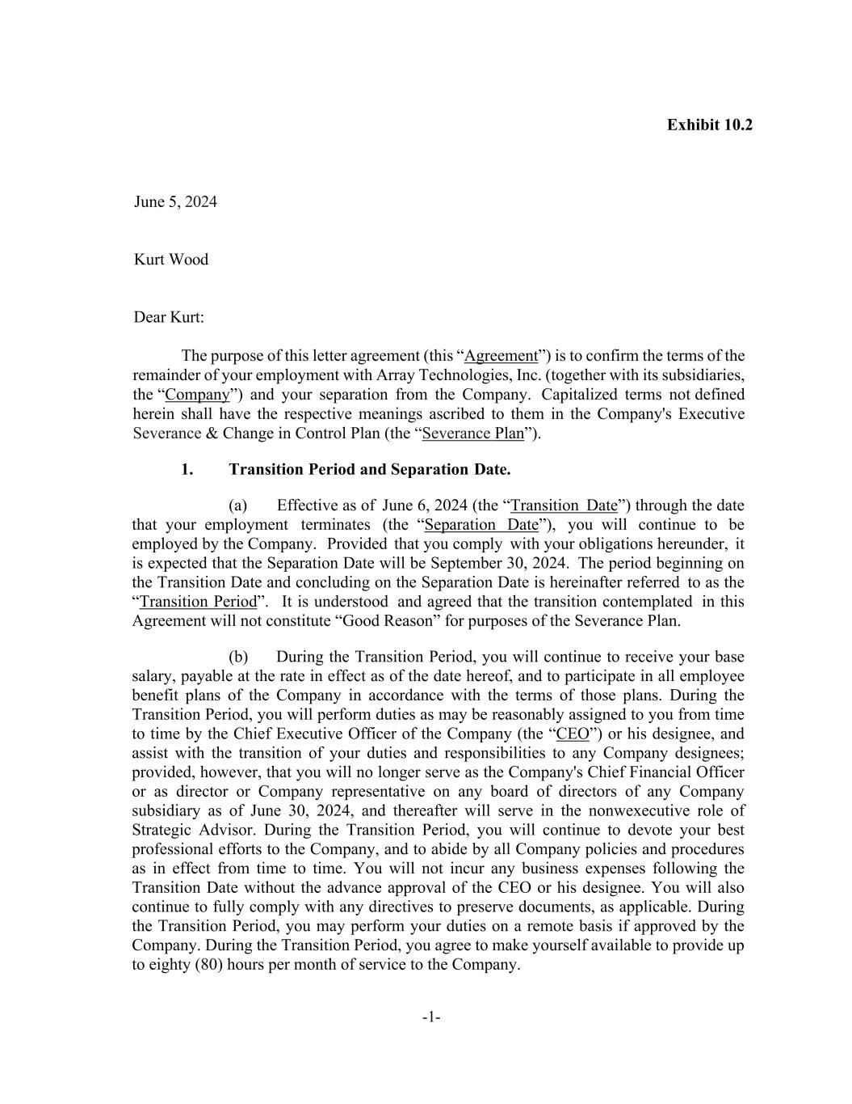
58
-1- Exhibit 10.2 June 5, 2024 Kurt Wood Dear Kurt: The purpose of this letter agreement (this “Agreement”) is to confirm the terms of the remainder of your employment with Array Technologies, Inc. (together with its subsidiaries, the “Company”) and your separation from the Company. Capitalized terms not defined herein shall have the respective meanings ascribed to them in the Company's Executive Severance & Change in Control Plan (the “Severance Plan”). 1. Transition Period and Separation Date. (a) Effective as of June 6, 2024 (the “Transition Date”) through the date that your employment terminates (the “Separation Date”), you will continue to be employed by the Company. Provided that you comply with your obligations hereunder, it is expected that the Separation Date will be September 30, 2024. The period beginning on the Transition Date and concluding on the Separation Date is hereinafter referred to as the “Transition Period”. It is understood and agreed that the transition contemplated in this Agreement will not constitute “Good Reason” for purposes of the Severance Plan. (b) During the Transition Period, you will continue to receive your base salary, payable at the rate in effect as of the date hereof, and to participate in all employee benefit plans of the Company in accordance with the terms of those plans. During the Transition Period, you will perform duties as may be reasonably assigned to you from time to time by the Chief Executive Officer of the Company (the “CEO”) or his designee, and assist with the transition of your duties and responsibilities to any Company designees; provided, however, that you will no longer serve as the Company's Chief Financial Officer or as director or Company representative on any board of directors of any Company subsidiary as of June 30, 2024, and thereafter will serve in the nonwexecutive role of Strategic Advisor. During the Transition Period, you will continue to devote your best professional efforts to the Company, and to abide by all Company policies and procedures as in effect from time to time. You will not incur any business expenses following the Transition Date without the advance approval of the CEO or his designee. You will also continue to fully comply with any directives to preserve documents, as applicable. During the Transition Period, you may perform your duties on a remote basis if approved by the Company. During the Transition Period, you agree to make yourself available to provide up to eighty (80) hours per month of service to the Company.

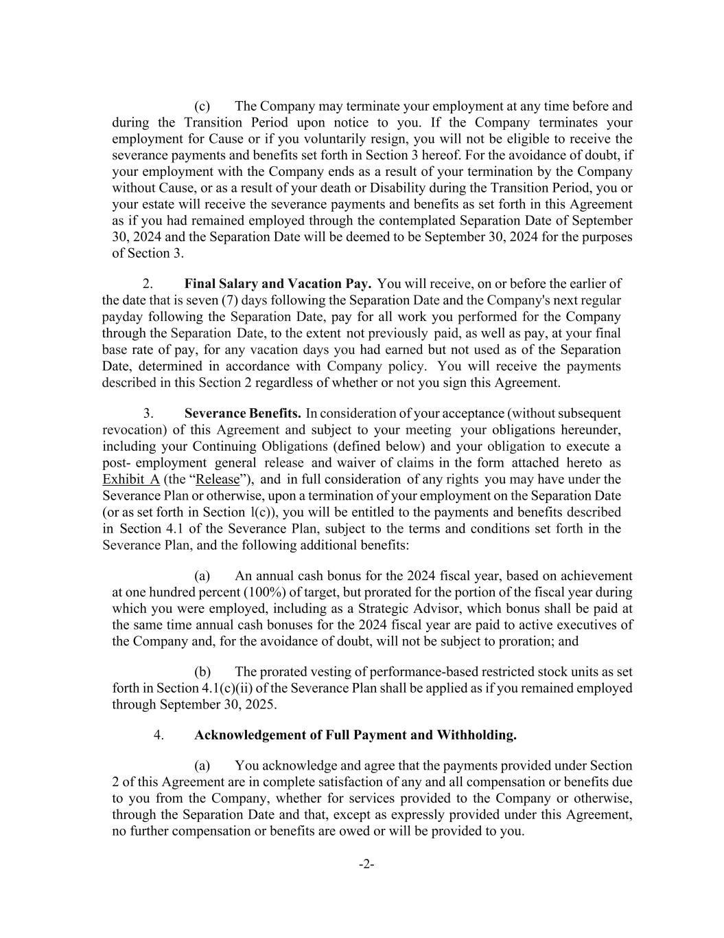
-2- (c) The Company may terminate your employment at any time before and during the Transition Period upon notice to you. If the Company terminates your employment for Cause or if you voluntarily resign, you will not be eligible to receive the severance payments and benefits set forth in Section 3 hereof. For the avoidance of doubt, if your employment with the Company ends as a result of your termination by the Company without Cause, or as a result of your death or Disability during the Transition Period, you or your estate will receive the severance payments and benefits as set forth in this Agreement as if you had remained employed through the contemplated Separation Date of September 30, 2024 and the Separation Date will be deemed to be September 30, 2024 for the purposes of Section 3. 2. Final Salary and Vacation Pay. You will receive, on or before the earlier of the date that is seven (7) days following the Separation Date and the Company's next regular payday following the Separation Date, pay for all work you performed for the Company through the Separation Date, to the extent not previously paid, as well as pay, at your final base rate of pay, for any vacation days you had earned but not used as of the Separation Date, determined in accordance with Company policy. You will receive the payments described in this Section 2 regardless of whether or not you sign this Agreement. 3. Severance Benefits. In consideration of your acceptance (without subsequent revocation) of this Agreement and subject to your meeting your obligations hereunder, including your Continuing Obligations (defined below) and your obligation to execute a post- employment general release and waiver of claims in the form attached hereto as Exhibit A (the “Release”), and in full consideration of any rights you may have under the Severance Plan or otherwise, upon a termination of your employment on the Separation Date (or as set forth in Section l(c)), you will be entitled to the payments and benefits described in Section 4.1 of the Severance Plan, subject to the terms and conditions set forth in the Severance Plan, and the following additional benefits: (a) An annual cash bonus for the 2024 fiscal year, based on achievement at one hundred percent (100%) of target, but prorated for the portion of the fiscal year during which you were employed, including as a Strategic Advisor, which bonus shall be paid at the same time annual cash bonuses for the 2024 fiscal year are paid to active executives of the Company and, for the avoidance of doubt, will not be subject to proration; and (b) The prorated vesting of performance-based restricted stock units as set forth in Section 4.1(c)(ii) of the Severance Plan shall be applied as if you remained employed through September 30, 2025. 4. Acknowledgement of Full Payment and Withholding. (a) You acknowledge and agree that the payments provided under Section 2 of this Agreement are in complete satisfaction of any and all compensation or benefits due to you from the Company, whether for services provided to the Company or otherwise, through the Separation Date and that, except as expressly provided under this Agreement, no further compensation or benefits are owed or will be provided to you.

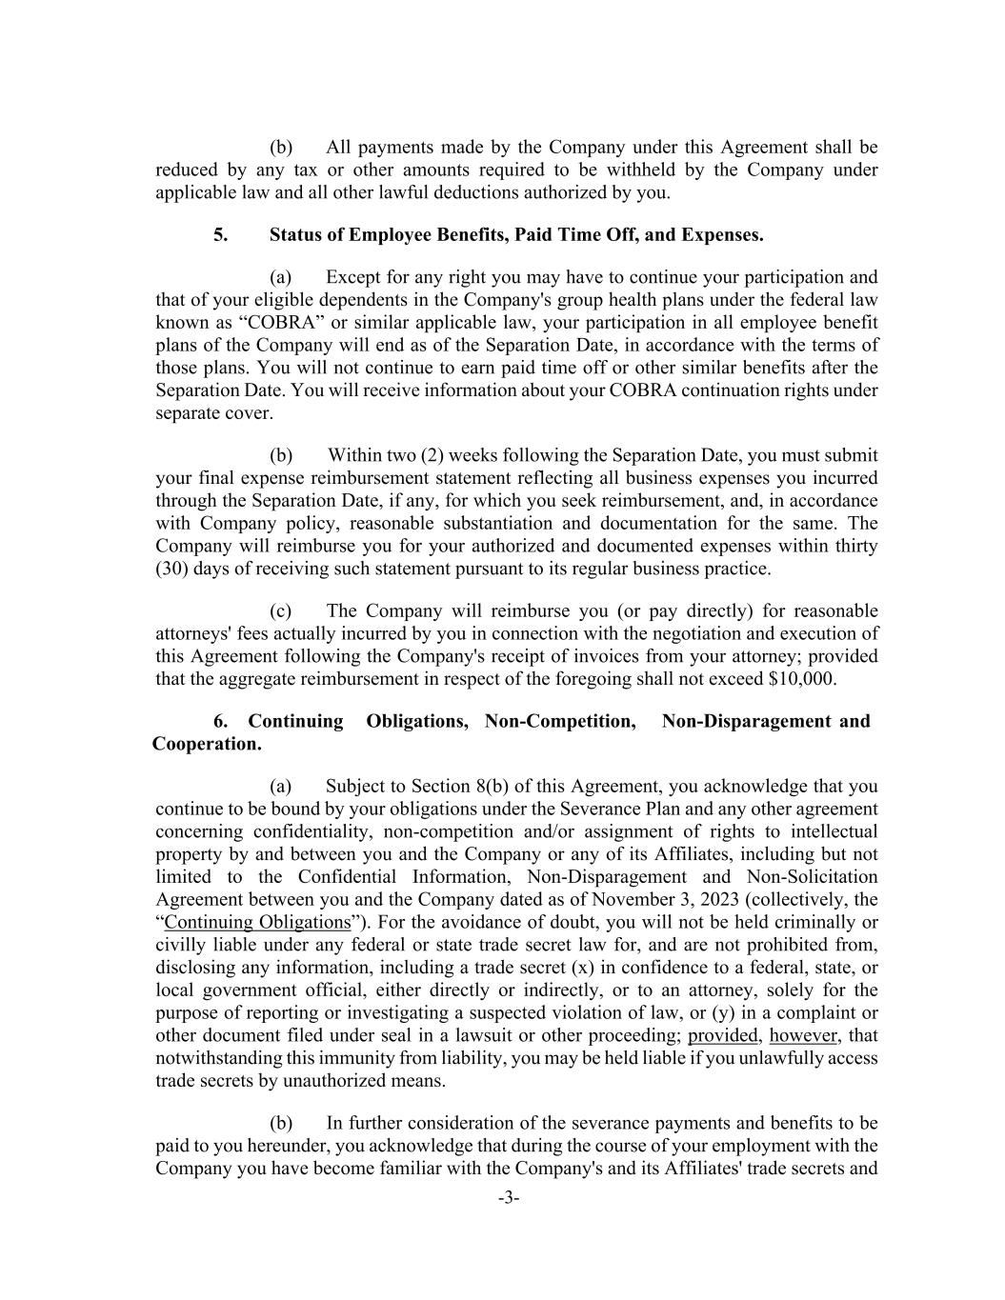
-3- (b) All payments made by the Company under this Agreement shall be reduced by any tax or other amounts required to be withheld by the Company under applicable law and all other lawful deductions authorized by you. 5. Status of Employee Benefits, Paid Time Off, and Expenses. (a) Except for any right you may have to continue your participation and that of your eligible dependents in the Company's group health plans under the federal law known as “COBRA” or similar applicable law, your participation in all employee benefit plans of the Company will end as of the Separation Date, in accordance with the terms of those plans. You will not continue to earn paid time off or other similar benefits after the Separation Date. You will receive information about your COBRA continuation rights under separate cover. (b) Within two (2) weeks following the Separation Date, you must submit your final expense reimbursement statement reflecting all business expenses you incurred through the Separation Date, if any, for which you seek reimbursement, and, in accordance with Company policy, reasonable substantiation and documentation for the same. The Company will reimburse you for your authorized and documented expenses within thirty (30) days of receiving such statement pursuant to its regular business practice. (c) The Company will reimburse you (or pay directly) for reasonable attorneys' fees actually incurred by you in connection with the negotiation and execution of this Agreement following the Company's receipt of invoices from your attorney; provided that the aggregate reimbursement in respect of the foregoing shall not exceed $10,000. 6. Continuing Obligations, Non-Competition, Non-Disparagement and Cooperation. (a) Subject to Section 8(b) of this Agreement, you acknowledge that you continue to be bound by your obligations under the Severance Plan and any other agreement concerning confidentiality, non-competition and/or assignment of rights to intellectual property by and between you and the Company or any of its Affiliates, including but not limited to the Confidential Information, Non-Disparagement and Non-Solicitation Agreement between you and the Company dated as of November 3, 2023 (collectively, the “Continuing Obligations”). For the avoidance of doubt, you will not be held criminally or civilly liable under any federal or state trade secret law for, and are not prohibited from, disclosing any information, including a trade secret (x) in confidence to a federal, state, or local government official, either directly or indirectly, or to an attorney, solely for the purpose of reporting or investigating a suspected violation of law, or (y) in a complaint or other document filed under seal in a lawsuit or other proceeding; provided, however, that notwithstanding this immunity from liability, you may be held liable if you unlawfully access trade secrets by unauthorized means. (b) In further consideration of the severance payments and benefits to be paid to you hereunder, you acknowledge that during the course of your employment with the Company you have become familiar with the Company's and its Affiliates' trade secrets and

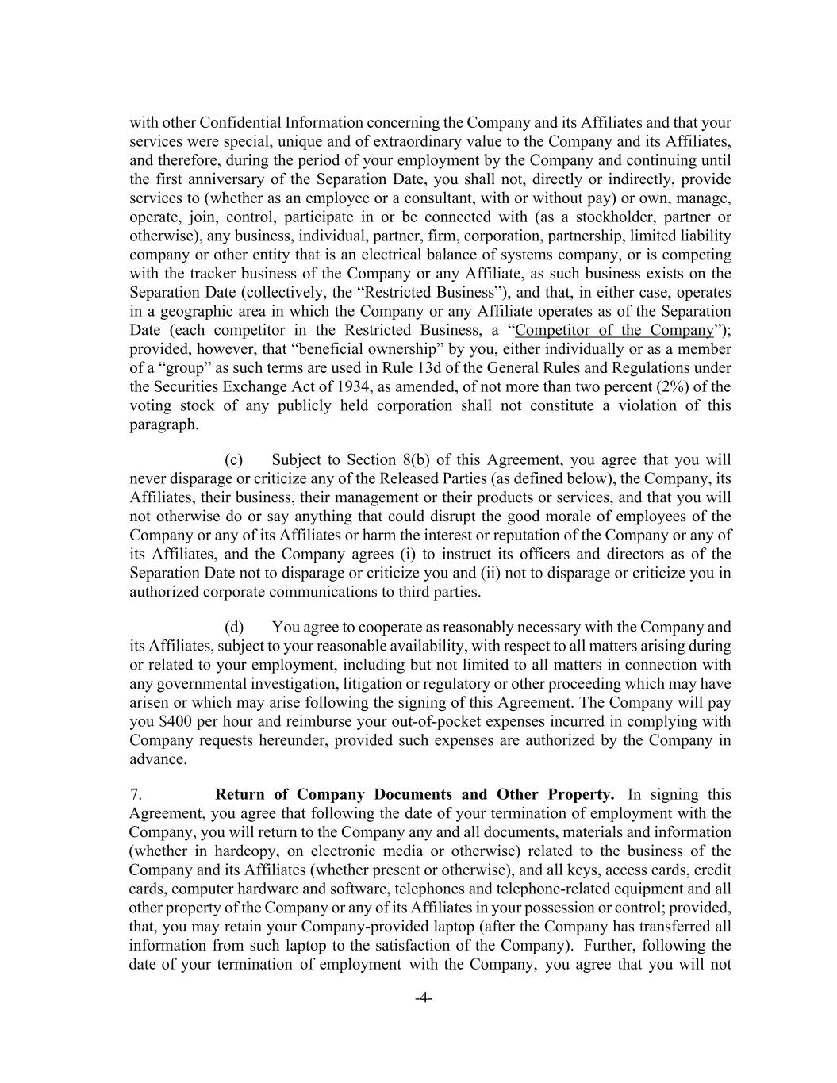
-4- with other Confidential Information concerning the Company and its Affiliates and that your services were special, unique and of extraordinary value to the Company and its Affiliates, and therefore, during the period of your employment by the Company and continuing until the first anniversary of the Separation Date, you shall not, directly or indirectly, provide services to (whether as an employee or a consultant, with or without pay) or own, manage, operate, join, control, participate in or be connected with (as a stockholder, partner or otherwise), any business, individual, partner, firm, corporation, partnership, limited liability company or other entity that is an electrical balance of systems company, or is competing with the tracker business of the Company or any Affiliate, as such business exists on the Separation Date (collectively, the “Restricted Business”), and that, in either case, operates in a geographic area in which the Company or any Affiliate operates as of the Separation Date (each competitor in the Restricted Business, a “Competitor of the Company”); provided, however, that “beneficial ownership” by you, either individually or as a member of a “group” as such terms are used in Rule 13d of the General Rules and Regulations under the Securities Exchange Act of 1934, as amended, of not more than two percent (2%) of the voting stock of any publicly held corporation shall not constitute a violation of this paragraph. (c) Subject to Section 8(b) of this Agreement, you agree that you will never disparage or criticize any of the Released Parties (as defined below), the Company, its Affiliates, their business, their management or their products or services, and that you will not otherwise do or say anything that could disrupt the good morale of employees of the Company or any of its Affiliates or harm the interest or reputation of the Company or any of its Affiliates, and the Company agrees (i) to instruct its officers and directors as of the Separation Date not to disparage or criticize you and (ii) not to disparage or criticize you in authorized corporate communications to third parties. (d) You agree to cooperate as reasonably necessary with the Company and its Affiliates, subject to your reasonable availability, with respect to all matters arising during or related to your employment, including but not limited to all matters in connection with any governmental investigation, litigation or regulatory or other proceeding which may have arisen or which may arise following the signing of this Agreement. The Company will pay you $400 per hour and reimburse your out-of-pocket expenses incurred in complying with Company requests hereunder, provided such expenses are authorized by the Company in advance. 7. Return of Company Documents and Other Property. In signing this Agreement, you agree that following the date of your termination of employment with the Company, you will return to the Company any and all documents, materials and information (whether in hardcopy, on electronic media or otherwise) related to the business of the Company and its Affiliates (whether present or otherwise), and all keys, access cards, credit cards, computer hardware and software, telephones and telephone-related equipment and all other property of the Company or any of its Affiliates in your possession or control; provided, that, you may retain your Company-provided laptop (after the Company has transferred all information from such laptop to the satisfaction of the Company). Further, following the date of your termination of employment with the Company, you agree that you will not

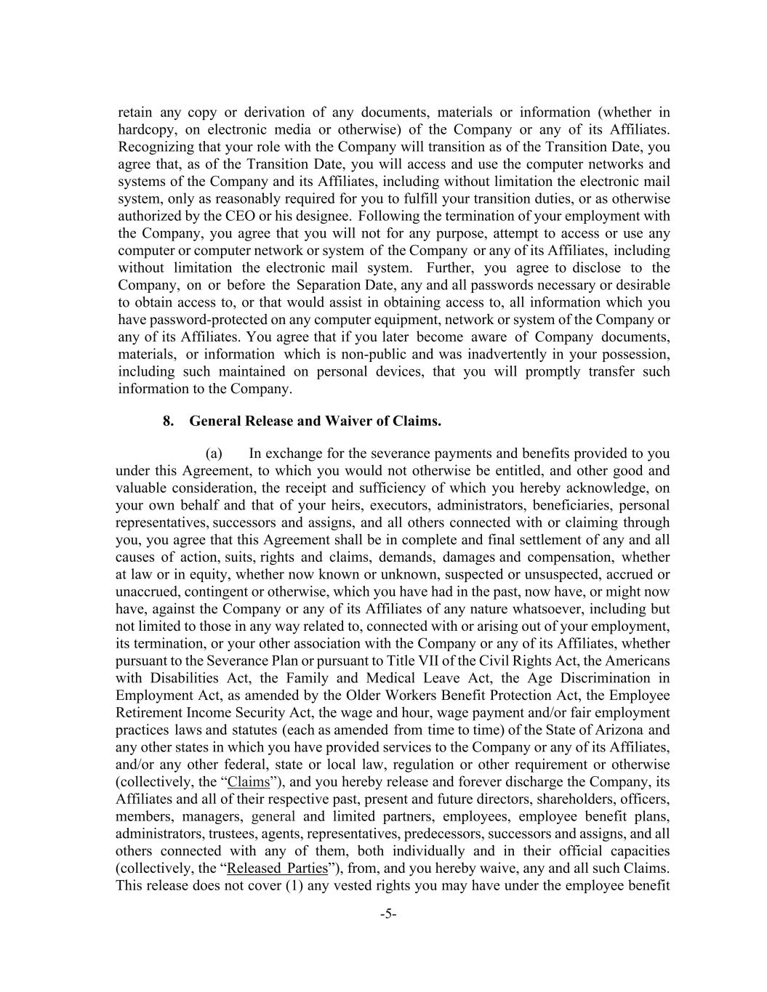
-5- retain any copy or derivation of any documents, materials or information (whether in hardcopy, on electronic media or otherwise) of the Company or any of its Affiliates. Recognizing that your role with the Company will transition as of the Transition Date, you agree that, as of the Transition Date, you will access and use the computer networks and systems of the Company and its Affiliates, including without limitation the electronic mail system, only as reasonably required for you to fulfill your transition duties, or as otherwise authorized by the CEO or his designee. Following the termination of your employment with the Company, you agree that you will not for any purpose, attempt to access or use any computer or computer network or system of the Company or any of its Affiliates, including without limitation the electronic mail system. Further, you agree to disclose to the Company, on or before the Separation Date, any and all passwords necessary or desirable to obtain access to, or that would assist in obtaining access to, all information which you have password-protected on any computer equipment, network or system of the Company or any of its Affiliates. You agree that if you later become aware of Company documents, materials, or information which is non-public and was inadvertently in your possession, including such maintained on personal devices, that you will promptly transfer such information to the Company. 8. General Release and Waiver of Claims. (a) In exchange for the severance payments and benefits provided to you under this Agreement, to which you would not otherwise be entitled, and other good and valuable consideration, the receipt and sufficiency of which you hereby acknowledge, on your own behalf and that of your heirs, executors, administrators, beneficiaries, personal representatives, successors and assigns, and all others connected with or claiming through you, you agree that this Agreement shall be in complete and final settlement of any and all causes of action, suits, rights and claims, demands, damages and compensation, whether at law or in equity, whether now known or unknown, suspected or unsuspected, accrued or unaccrued, contingent or otherwise, which you have had in the past, now have, or might now have, against the Company or any of its Affiliates of any nature whatsoever, including but not limited to those in any way related to, connected with or arising out of your employment, its termination, or your other association with the Company or any of its Affiliates, whether pursuant to the Severance Plan or pursuant to Title VII of the Civil Rights Act, the Americans with Disabilities Act, the Family and Medical Leave Act, the Age Discrimination in Employment Act, as amended by the Older Workers Benefit Protection Act, the Employee Retirement Income Security Act, the wage and hour, wage payment and/or fair employment practices laws and statutes (each as amended from time to time) of the State of Arizona and any other states in which you have provided services to the Company or any of its Affiliates, and/or any other federal, state or local law, regulation or other requirement or otherwise (collectively, the “Claims”), and you hereby release and forever discharge the Company, its Affiliates and all of their respective past, present and future directors, shareholders, officers, members, managers, general and limited partners, employees, employee benefit plans, administrators, trustees, agents, representatives, predecessors, successors and assigns, and all others connected with any of them, both individually and in their official capacities (collectively, the “Released Parties”), from, and you hereby waive, any and all such Claims. This release does not cover (1) any vested rights you may have under the employee benefit

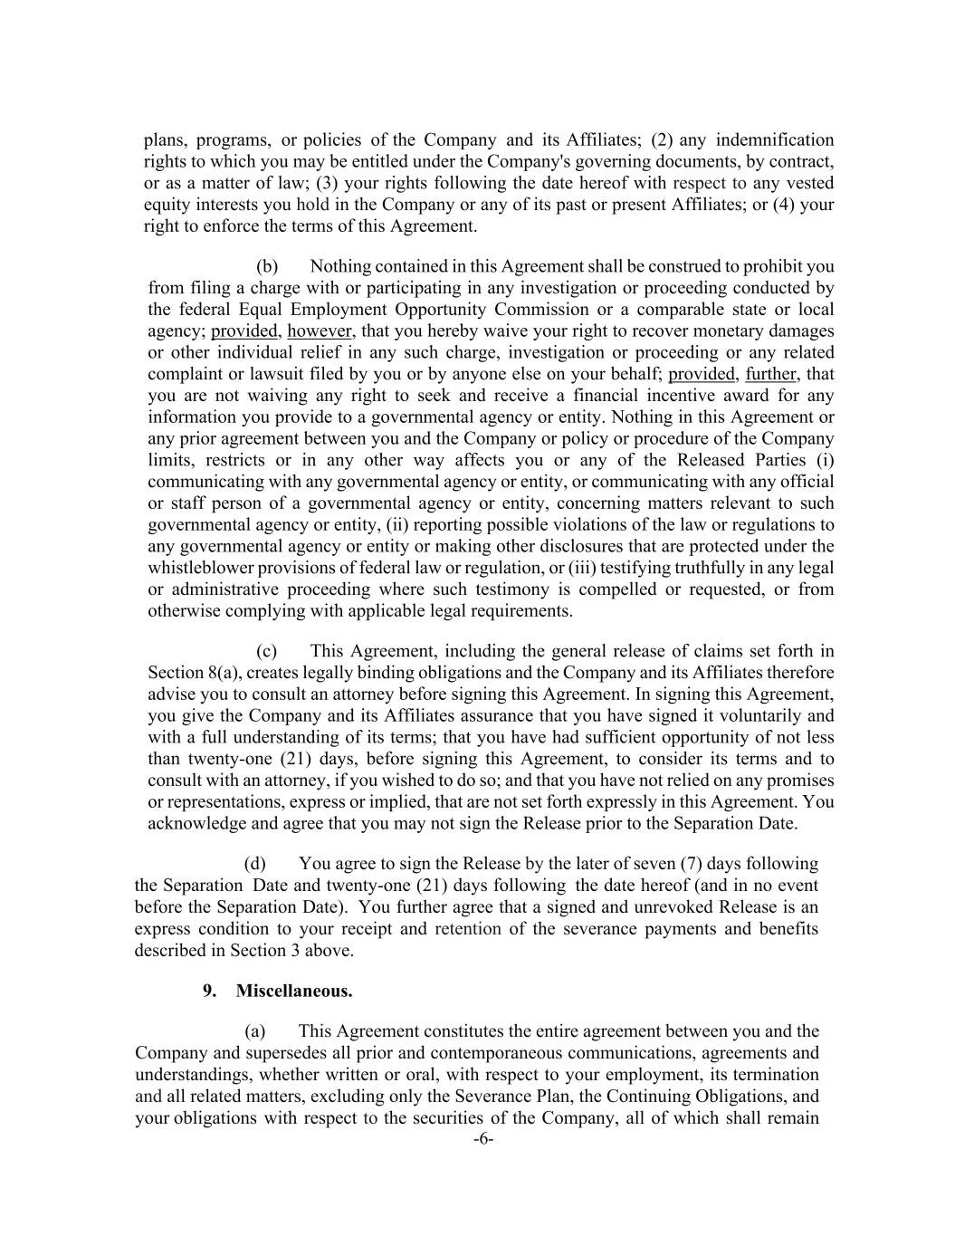
-6- plans, programs, or policies of the Company and its Affiliates; (2) any indemnification rights to which you may be entitled under the Company's governing documents, by contract, or as a matter of law; (3) your rights following the date hereof with respect to any vested equity interests you hold in the Company or any of its past or present Affiliates; or (4) your right to enforce the terms of this Agreement. (b) Nothing contained in this Agreement shall be construed to prohibit you from filing a charge with or participating in any investigation or proceeding conducted by the federal Equal Employment Opportunity Commission or a comparable state or local agency; provided, however, that you hereby waive your right to recover monetary damages or other individual relief in any such charge, investigation or proceeding or any related complaint or lawsuit filed by you or by anyone else on your behalf; provided, further, that you are not waiving any right to seek and receive a financial incentive award for any information you provide to a governmental agency or entity. Nothing in this Agreement or any prior agreement between you and the Company or policy or procedure of the Company limits, restricts or in any other way affects you or any of the Released Parties (i) communicating with any governmental agency or entity, or communicating with any official or staff person of a governmental agency or entity, concerning matters relevant to such governmental agency or entity, (ii) reporting possible violations of the law or regulations to any governmental agency or entity or making other disclosures that are protected under the whistleblower provisions of federal law or regulation, or (iii) testifying truthfully in any legal or administrative proceeding where such testimony is compelled or requested, or from otherwise complying with applicable legal requirements. (c) This Agreement, including the general release of claims set forth in Section 8(a), creates legally binding obligations and the Company and its Affiliates therefore advise you to consult an attorney before signing this Agreement. In signing this Agreement, you give the Company and its Affiliates assurance that you have signed it voluntarily and with a full understanding of its terms; that you have had sufficient opportunity of not less than twenty-one (21) days, before signing this Agreement, to consider its terms and to consult with an attorney, if you wished to do so; and that you have not relied on any promises or representations, express or implied, that are not set forth expressly in this Agreement. You acknowledge and agree that you may not sign the Release prior to the Separation Date. (d) You agree to sign the Release by the later of seven (7) days following the Separation Date and twenty-one (21) days following the date hereof (and in no event before the Separation Date). You further agree that a signed and unrevoked Release is an express condition to your receipt and retention of the severance payments and benefits described in Section 3 above. 9. Miscellaneous. (a) This Agreement constitutes the entire agreement between you and the Company and supersedes all prior and contemporaneous communications, agreements and understandings, whether written or oral, with respect to your employment, its termination and all related matters, excluding only the Severance Plan, the Continuing Obligations, and your obligations with respect to the securities of the Company, all of which shall remain


-7- in full force and effect in accordance with their terms; provided, however, that to the extent that the Severance Plan conflicts with any term set forth herein, the term in this Agreement will be controlling. (b) If any portion or provision of this Agreement shall to any extent be declared illegal or unenforceable by a court of competent jurisdiction, then the remainder of this Agreement, or the application of such portion or provision in circumstances other than those as to which it is so declared illegal or unenforceable, shall not be affected thereby, and each portion and provision of this Agreement shall be valid and enforceable to the fullest extent permitted by law; provided, however, and for the avoidance of doubt, in no event shall the Company be required to provide payments or benefits to you pursuant to Section 3 of this Agreement if all or part of the general release in Section 8 of this Agreement is held to be invalid or unenforceable. (c) This Agreement may not be modified or amended, and no breach shall be deemed to be waived, unless agreed to in writing by you and the Chair of the Board of Directors of the Company or his expressly authorized designee. The captions and headings in this Agreement are for convenience only, and in no way define or describe the scope or content of any provision of this Agreement. (d) The obligation of the Company to make payments or provide benefits to you or on your behalf under this Agreement, and your right to retain the same, is expressly conditioned upon your continued performance of your obligations under this Agreement and of the Continuing Obligations. (e) All issues and questions concerning the construction, validity and enforcement and interpretation of this Agreement shall be governed by, and construed in accordance with, the laws of the State of Arizona, without giving effect to any choice of law or conflict of law rules or provisions (whether of the State of Arizona or any other jurisdiction) that would cause the application of the laws of any jurisdiction other than the State of Arizona. Each party agrees to commence any action, suit or proceeding arising out of this Agreement or the transactions contemplated hereby in a United States District Court located in the State of Arizona and irrevocably and unconditionally waives any objection to the laying of venue of any action, suit or proceeding arising out of this Agreement or the transactions contemplated hereby in such court and any claim that any such proceeding brought in such court has been brought in an inconvenient forum. You and the Company (after having the opportunity to consult with an attorney) hereby waive trial by jury as to any and all litigation arising out of and/or relating to this Agreement. (f) This Agreement may be executed in any number of counterparts, any of which may be executed and transmitted by DocuSign, facsimile, electronic mail (including “pdf'), and any other means of electronic transmission complying with the U.S. federal ESIGN Act of 2000, and each of which shall be deemed to be an original, but all of which together shall be deemed to be one and the same instrument. If the terms of this Agreement are acceptable to you, please sign, date and return it to me within twenty-one (21) days of the date that you receive it. You may revoke

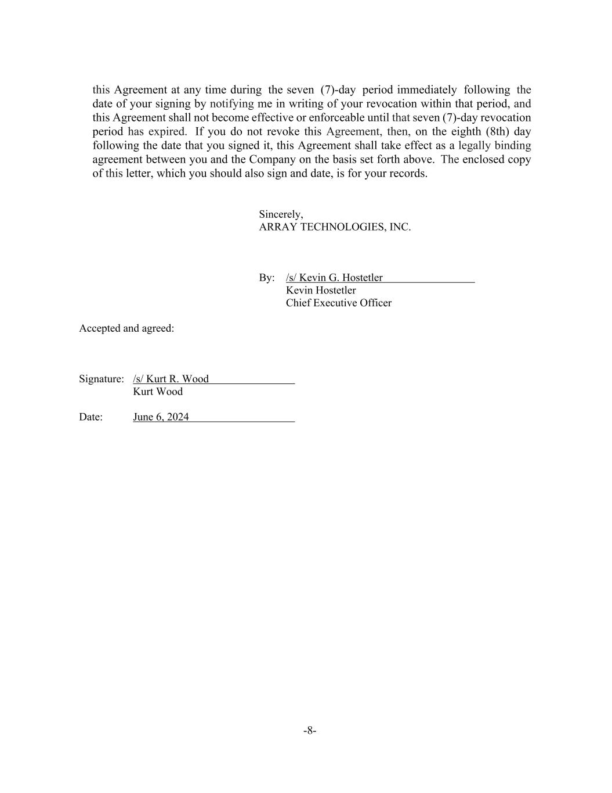
-8- this Agreement at any time during the seven (7)-day period immediately following the date of your signing by notifying me in writing of your revocation within that period, and this Agreement shall not become effective or enforceable until that seven (7)-day revocation period has expired. If you do not revoke this Agreement, then, on the eighth (8th) day following the date that you signed it, this Agreement shall take effect as a legally binding agreement between you and the Company on the basis set forth above. The enclosed copy of this letter, which you should also sign and date, is for your records. Sincerely, ARRAY TECHNOLOGIES, INC. By: /s/ Kevin G. Hostetler Kevin Hostetler Chief Executive Officer Accepted and agreed: Signature: /s/ Kurt R. Wood Kurt Wood Date: June 6, 2024

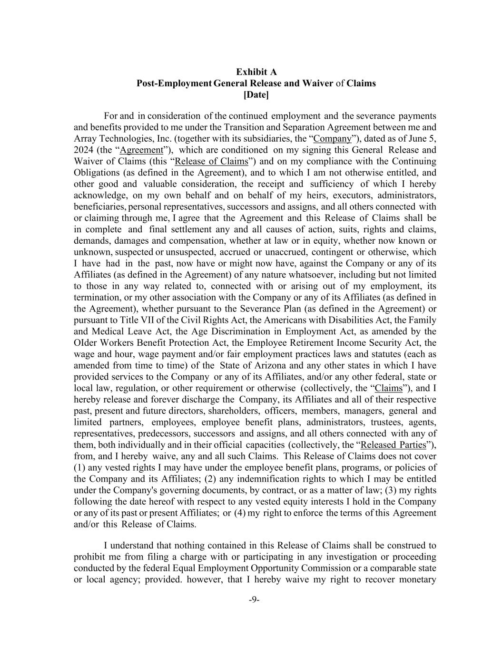
-9- Exhibit A Post-Employment General Release and Waiver of Claims [Date] For and in consideration of the continued employment and the severance payments and benefits provided to me under the Transition and Separation Agreement between me and Array Technologies, Inc. (together with its subsidiaries, the “Company”), dated as of June 5, 2024 (the “Agreement”), which are conditioned on my signing this General Release and Waiver of Claims (this “Release of Claims”) and on my compliance with the Continuing Obligations (as defined in the Agreement), and to which I am not otherwise entitled, and other good and valuable consideration, the receipt and sufficiency of which I hereby acknowledge, on my own behalf and on behalf of my heirs, executors, administrators, beneficiaries, personal representatives, successors and assigns, and all others connected with or claiming through me, I agree that the Agreement and this Release of Claims shall be in complete and final settlement any and all causes of action, suits, rights and claims, demands, damages and compensation, whether at law or in equity, whether now known or unknown, suspected or unsuspected, accrued or unaccrued, contingent or otherwise, which I have had in the past, now have or might now have, against the Company or any of its Affiliates (as defined in the Agreement) of any nature whatsoever, including but not limited to those in any way related to, connected with or arising out of my employment, its termination, or my other association with the Company or any of its Affiliates (as defined in the Agreement), whether pursuant to the Severance Plan (as defined in the Agreement) or pursuant to Title VII of the Civil Rights Act, the Americans with Disabilities Act, the Family and Medical Leave Act, the Age Discrimination in Employment Act, as amended by the OIder Workers Benefit Protection Act, the Employee Retirement Income Security Act, the wage and hour, wage payment and/or fair employment practices laws and statutes (each as amended from time to time) of the State of Arizona and any other states in which I have provided services to the Company or any of its Affiliates, and/or any other federal, state or local law, regulation, or other requirement or otherwise (collectively, the “Claims”), and I hereby release and forever discharge the Company, its Affiliates and all of their respective past, present and future directors, shareholders, officers, members, managers, general and limited partners, employees, employee benefit plans, administrators, trustees, agents, representatives, predecessors, successors and assigns, and all others connected with any of them, both individually and in their official capacities (collectively, the “Released Parties”), from, and I hereby waive, any and all such Claims. This Release of Claims does not cover (1) any vested rights I may have under the employee benefit plans, programs, or policies of the Company and its Affiliates; (2) any indemnification rights to which I may be entitled under the Company's governing documents, by contract, or as a matter of law; (3) my rights following the date hereof with respect to any vested equity interests I hold in the Company or any of its past or present Affiliates; or (4) my right to enforce the terms of this Agreement and/or this Release of Claims. I understand that nothing contained in this Release of Claims shall be construed to prohibit me from filing a charge with or participating in any investigation or proceeding conducted by the federal Equal Employment Opportunity Commission or a comparable state or local agency; provided. however, that I hereby waive my right to recover monetary

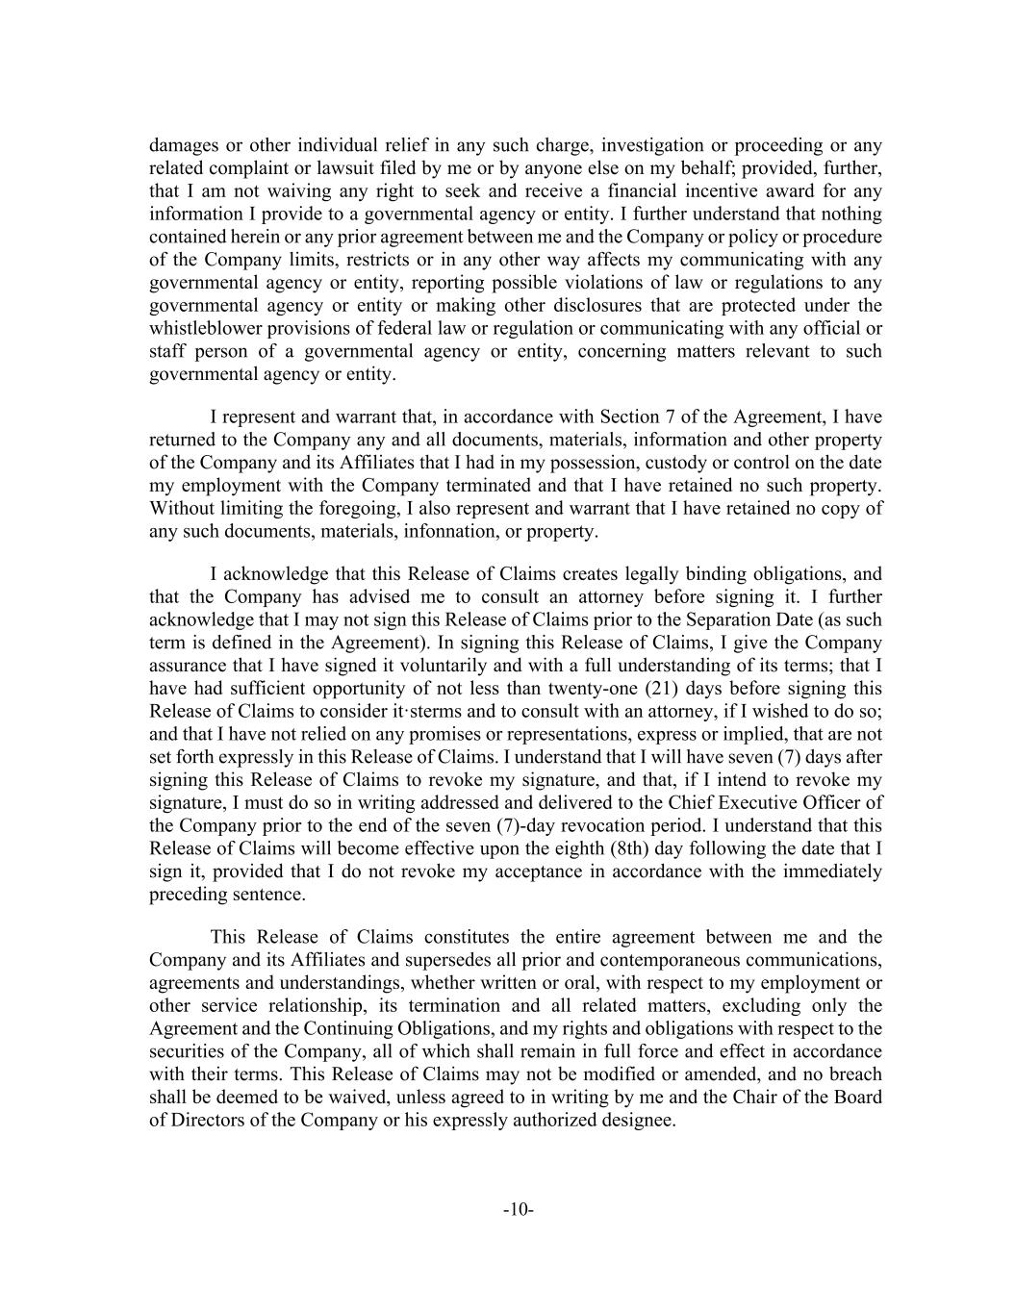
-10- damages or other individual relief in any such charge, investigation or proceeding or any related complaint or lawsuit filed by me or by anyone else on my behalf; provided, further, that I am not waiving any right to seek and receive a financial incentive award for any information I provide to a governmental agency or entity. I further understand that nothing contained herein or any prior agreement between me and the Company or policy or procedure of the Company limits, restricts or in any other way affects my communicating with any governmental agency or entity, reporting possible violations of law or regulations to any governmental agency or entity or making other disclosures that are protected under the whistleblower provisions of federal law or regulation or communicating with any official or staff person of a governmental agency or entity, concerning matters relevant to such governmental agency or entity. I represent and warrant that, in accordance with Section 7 of the Agreement, I have returned to the Company any and all documents, materials, information and other property of the Company and its Affiliates that I had in my possession, custody or control on the date my employment with the Company terminated and that I have retained no such property. Without limiting the foregoing, I also represent and warrant that I have retained no copy of any such documents, materials, infonnation, or property. I acknowledge that this Release of Claims creates legally binding obligations, and that the Company has advised me to consult an attorney before signing it. I further acknowledge that I may not sign this Release of Claims prior to the Separation Date (as such term is defined in the Agreement). In signing this Release of Claims, I give the Company assurance that I have signed it voluntarily and with a full understanding of its terms; that I have had sufficient opportunity of not less than twenty-one (21) days before signing this Release of Claims to consider itꞏsterms and to consult with an attorney, if I wished to do so; and that I have not relied on any promises or representations, express or implied, that are not set forth expressly in this Release of Claims. I understand that I will have seven (7) days after signing this Release of Claims to revoke my signature, and that, if I intend to revoke my signature, I must do so in writing addressed and delivered to the Chief Executive Officer of the Company prior to the end of the seven (7)-day revocation period. I understand that this Release of Claims will become effective upon the eighth (8th) day following the date that I sign it, provided that I do not revoke my acceptance in accordance with the immediately preceding sentence. This Release of Claims constitutes the entire agreement between me and the Company and its Affiliates and supersedes all prior and contemporaneous communications, agreements and understandings, whether written or oral, with respect to my employment or other service relationship, its termination and all related matters, excluding only the Agreement and the Continuing Obligations, and my rights and obligations with respect to the securities of the Company, all of which shall remain in full force and effect in accordance with their terms. This Release of Claims may not be modified or amended, and no breach shall be deemed to be waived, unless agreed to in writing by me and the Chair of the Board of Directors of the Company or his expressly authorized designee.


-11- Accepted and agreed: Signature: ____________________________ Kurt Wood Date: ____________________________

EXHIBIT 31.1

CERTIFICATION BY CHIEF EXECUTIVE OFFICER PURSUANT TO
RULE 13a-14(a) AND 15d-14(a) UNDER THE EXCHANGE ACT

I, Kevin G. Hostetler, certify that:

1.I have reviewed this Quarterly Report on Form 10-Q of Array Technologies, Inc.;

2.Based on my knowledge, this report does not contain any untrue statement of a material fact or omit to state a material fact necessary to make the statements made, in light of the circumstances under which such statements were made, not misleading with respect to the period covered by this report;

3.Based on my knowledge, the financial statements, and other financial information included in this report, fairly present in all material respects the financial condition, results of operations and cash flows of the registrant as of, and for, the periods presented in this report;

4.The registrant’s other certifying officer and I are responsible for establishing and maintaining disclosure controls and procedures (as defined in Exchange Act Rules 13a-15(e) and 15d-15(e)) and internal control over financial reporting (as defined in Exchange Act Rules 13a-15(f) and 15d-15(f)) for the registrant and have:

a)designed such disclosure controls and procedures, or caused such disclosure controls and procedures to be designed under our supervision, to ensure that material information relating to the registrant, including its consolidated subsidiaries, is made known to us by others within those entities, particularly during the period in which this report is being prepared;

b)designed such internal control over financial reporting, or caused such internal control over financial reporting to be designed under our supervision, to provide reasonable assurance regarding the reliability of financial reporting and the preparation of financial statements for external purposes in accordance with generally accepted accounting principles;

c)evaluated the effectiveness of the registrant’s disclosure controls and procedures and presented in this report our conclusions about the effectiveness of the disclosure controls and procedures, as of the end of the period covered by this report based on such evaluation; and

d)disclosed in this report any change in the registrant’s internal control over financial reporting that occurred during the registrant’s most recent fiscal quarter (the registrant’s fourth fiscal quarter in the case of an annual report) that has materially affected, or is reasonably likely to materially affect, the registrant’s internal control over financial reporting; and

5.The registrant’s other certifying officer and I have disclosed, based on our most recent evaluation of internal control over financial reporting, to the registrant’s auditors and the audit committee of the registrant’s board of directors (or persons performing the equivalent functions):

a)all significant deficiencies and material weaknesses in the design or operation of internal control over financial reporting which are reasonably likely to adversely affect the registrant’s ability to record, process, summarize and report financial information; and

b)any fraud, whether or not material, that involves management or other employees who have a significant role in the registrant’s internal control over financial reporting.

/s/ Kevin G. Hostetler
Kevin G. Hostetler
Chief Executive Officer and
Interim Chief Financial Officer

Date: August 8, 2024

EXHIBIT 32.1

CERTIFICATION BY CHIEF EXECUTIVE OFFICER
PURSUANT TO 18 U.S.C. SECTION 1350,
AS ADOPTED PURSUANT TO
SECTION 906 OF THE SARBANES-OXLEY ACT OF 2002

In connection with this Quarterly Report of Array Technologies, Inc. (the "Company") filed on Form 10-Q for the quarter ended June 30, 2024, as filed with the Securities and Exchange Commission on the date hereof (the “Report”), I, Kevin G. Hostetler, Chief Executive Officer and Interim Chief Financial Officer of the Company, certify, pursuant to 18 U.S.C. Section 1350, as adopted pursuant to Section 906 of the Sarbanes-Oxley Act of 2002, that to my knowledge:

(1)the Report fully complies with the requirements of Section 13(a) or 15(d) of the Securities Exchange Act of 1934, as amended; and

(2)the information contained in the Report fairly presents, in all material respects, the financial condition and results of operations of the Company.

/s/ Kevin G. Hostetler
Kevin G. Hostetler
Chief Executive Officer and
Interim Chief Financial Officer

Date: August 8, 2024

